

Tash Halley
2417049
Operating Systems
Computing (Cybersecurity & Computer Networks)

Table of Contents
Introduction 3
Project Scope & Proposal Solution 3
Required Technologies / Resources 3
Project Timeline 4
Project Schedule 4
Project Constraints 5
Gnatt Chart 5
Development Method 6
Project Design – Flowchart 7
Project Design - Wireframes 7
Enterprise – SWOT Analysis 14
Strengths 14
Weaknesses 14
Opportunities 14
Threats 14
Legal & Ethical Considerations 15
PEST Analysis 15
Political 15
Economic 15
Social 15
Technological 15
Legal Considerations 16
Tech Start Up Name 16
Tech Start Up Logo 16
Business Type 17
Business Strategy 18
Mission Statement 18
Values 18
Initiatives 19
Project Reflection 19
Conclusion 20
Bibliography 20
Appendices 22
Introduction
This report aims to explore the relationship between social media use and emotional wellbeing by combining digital behaviour tracking with self-reported mood data.
The project scope will be documented with evidence of a Gnatt chart to show the tasks along with the timelines. It will be accompanied by evidence of the project design with flowcharts and wireframes.
SWOT and PEST analysis with considerations of legal and ethical issues will also be discussed.
Finally, the report will conclude with a reflection to identify how the project could have a positive impact on society whilst also mentioning the risks and challenges and what could be done to overcome them.

Project Scope & Proposal Solution
This project seeks to address the growing concern over the impact of social media addiction on mental health by developing a digital wellbeing tracker. The tool will monitor users’ social media activities. This includes platform type, session duration, emotional response and will store the data for analysis.
The solution combines the behaviour tracking in real-time with self-reported mood data to identify patterns and potential correlations between usage habits and changes in emotional wellbeing. Supplementary data will be gathered through questionnaires and semi-structured interviews to add qualitative insights.

Required Technologies / Resources
Along with a set of aims and objectives, the scope must include the required technologies and resources. Several types of technologies have been used to develop the project.
- Glide App Builder – to design and implement the digital wellbeing tracker.
- Mind Meister – to create the mind map that led to the decision of the project.
- Team Gnatt – to create the Gnatt Chart showing the project timeline.
- Google Forms – to create the questionnaire and semi-structured interview.
- Canva – to create flowcharts to show the user journey on the digital tracker.

Project Timeline
Phase | Tasks | Timeframe
Planning & Design | Finalise research approval, ethics approval, tracker design. | Week 1 - 2
Development | Build tracker in Glide, set up questionnaires. | Week 3 - 4
Pilot Testing | Run tracker and questionnaires with a small sample. | Week 5
Data Collection | Implement tracker and questionnaires, conduct interviews. | Week 6 - 8
Analysis | Quantitative and qualitative analysis. | Week 9 - 10
Reporting | Draft report, review and submit. | Week 11 - 12
Figure 1 – Table to show Project Timeline

Project Schedule
As suggested by Lowe, Woolard & D’ Onofrio [1] the schedule is the tool that guides the project to a successful and timely completion. Once the schedule has been determined, it is important to update this with changes to ensure accuracy [1] goes onto mention.
Schedule | Task
Daily | Check tracker entries and monitor technical functionality.
Weekly | Review participant engagement, address any issues.
Fortnightly | Conduct interviews and review any data trends.
Figure 2 – Table to show Project Schedule

Project Constraints
Projects can be managed effectively whilst also having constraints. By using SWOT analysis, this identifies the strengths and weaknesses and examines if the project has any threats involved according to Sabbaghi & Vaidyanathan [2]. By identifying the constraints that may overwhelm the project, it gives the team time to allocate the tasks and resources to stop them from becoming a bigger issue further down the line [2] goes on to mention.
The constraints of this project are shown below.
- Time Limitations – The project must be completed in 12 weeks which limits the length of the data collection period.
- Sample Size – Recruitment challenges may affect the number of participants.
- Self-Report Bias – Participants mood responses may be subjective and influenced by memory or perception.
- Ethical Constraints – Sensitive nature of mental health data requires strict confidentiality.

Gnatt Chart
According to Kumar [3] a Gnatt Chart is a powerful use of visual reporting and is used to display project schedules.
The advantages of using a Gnatt Chart in project management are that they help clarify what needs to be done, when they need to be completed and the team member who has the responsibility of the task as mentioned by Wadhwa [4]
Figure 3 shows the Gnatt Chart for the development team of Check In Tech.
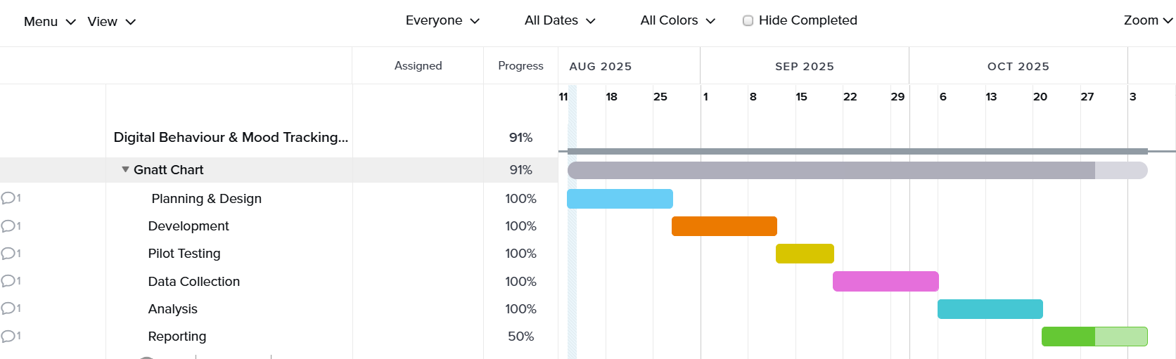
Figure 3 – Image of Gnatt Chart

Development Method
Given the scope, time constraints and research-focused nature of this project, an agile development method was chosen. This allows the team to work in short cycles, test with the pilot group and adapt quickly based on user feedback.
According to Samar, Sawalha & Abdelnabi [5] the main advantage to agile development is that it improves communication between team members. In addition, due to the adaptability of change, the prototypes can be refined quickly and released again for further feedback.
This development method also works well for small teams and projects that are short-term, which is another reason as to why agile was chosen.

Project Design – Flowchart
As shown in Figure 4, the flowchart illustrates the user journey within the digital well-being tracker. It shows what they can do once the app has been opened and where the data gets stored.
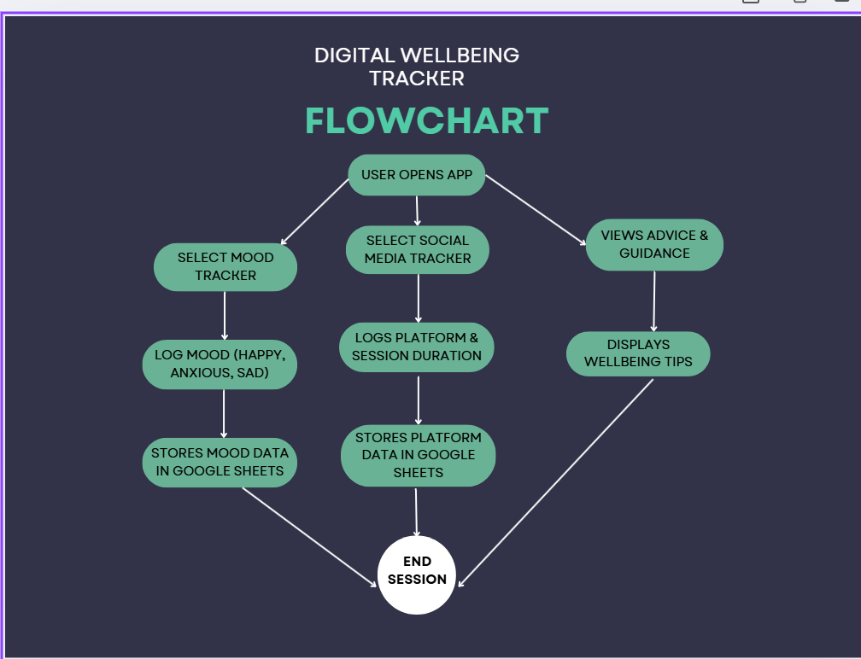

Figure 4 – Image of Flowchart – User Navigation

Project Design - Wireframes
This application was created using Glide. The wireframes show a visual representation of the tracker and demonstrate how data collection and wellbeing resources are integrated into a user-friendly interface.
Figure 5 shows the homepage of the digital tracker, they can choose an option which will take them to the relevant page.
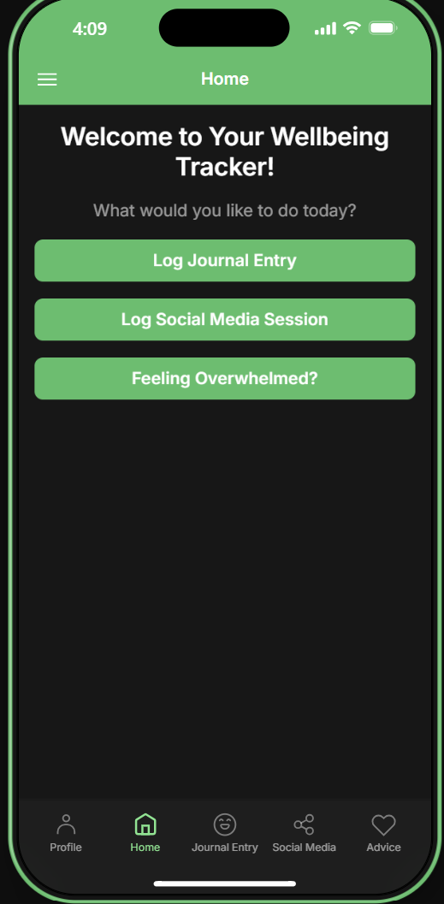
Figure 5 – Image of Digital Tracker Homepage

Figure 6 shows the journal entry page, this is where users can log how they felt before and after using a social media platform.
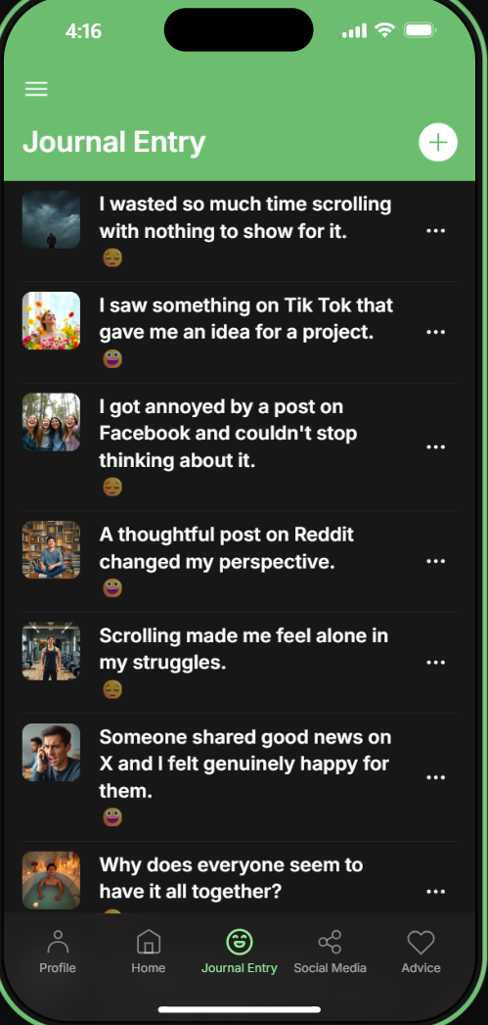
Figure 6 – Image of Journal Entry Page

Users can click on their journal entry to edit or delete them, Figure 7 shows the editable screen. The rating and the choice of mood rating depends on whether a happy or sad emoji appears on the journal entry summary screen.
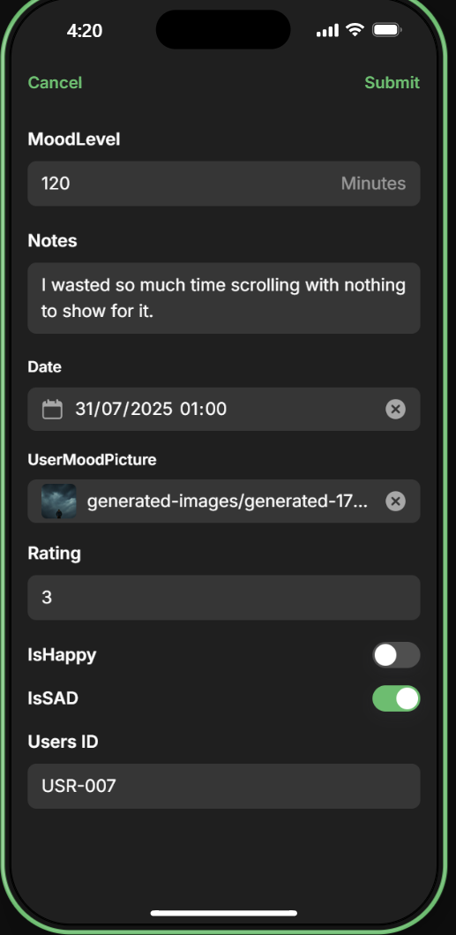
Figure 7 – Image of Editable Entry

Figure 8 shows the Social Media page, a list of platforms are displayed for users to log their sessions.
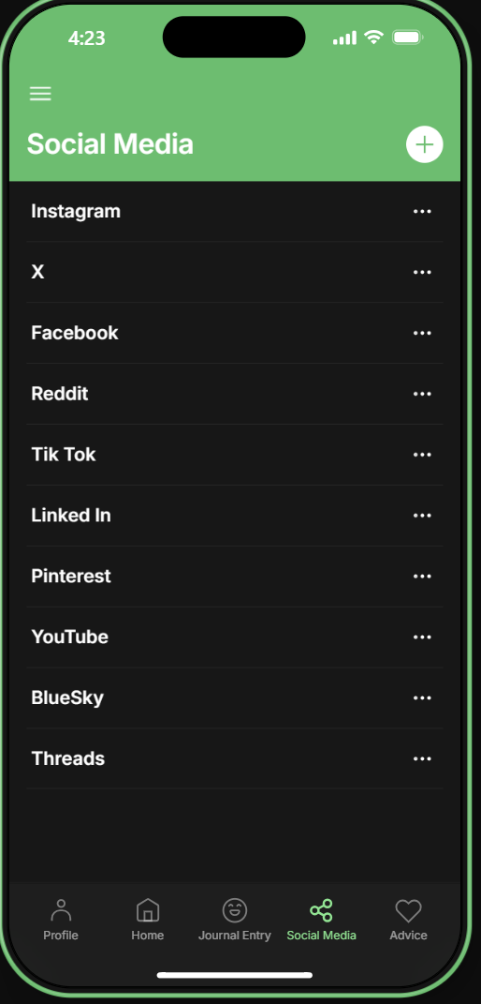
Figure 8 – Image of Social Media Page

Figure 9 shows that two sessions have been logged for Instagram.
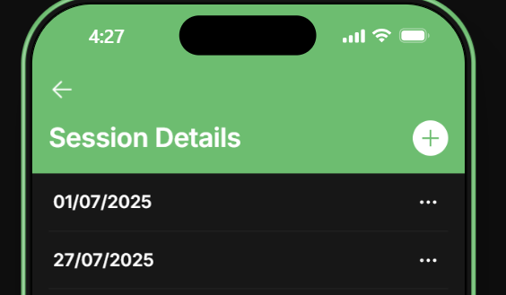
Figure 9 – Image of Session Summary Page

Figure 10 shows how the user felt after scrolling Instagram and the session duration.
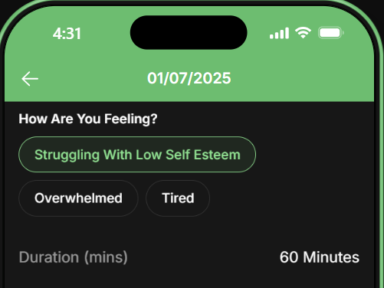

Figure 10 – Image of Session Notes Screen

Figure 11 shows the Advice page where users can go for some guidance if they are feeling negative emotions after using social media.
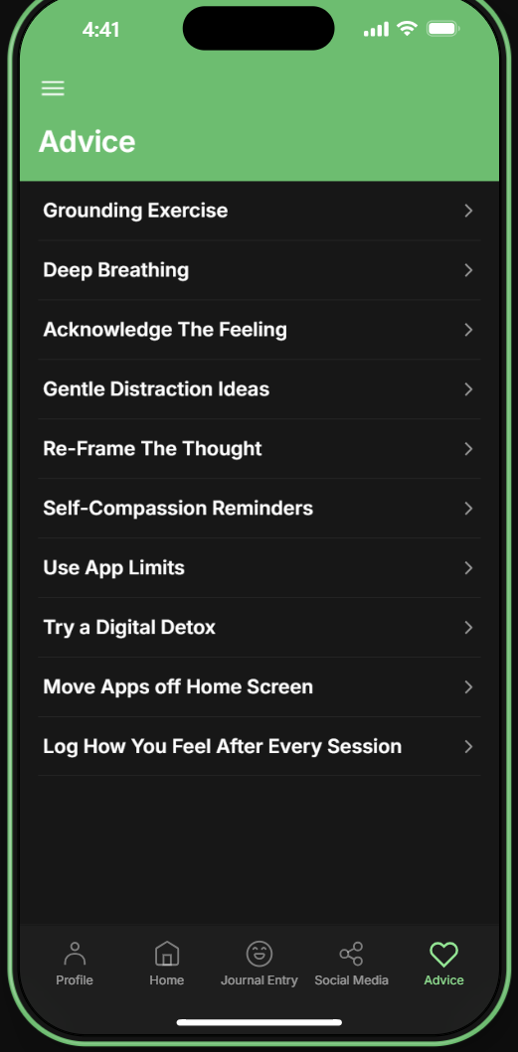
Figure 11 – Image of Advice Page.

Enterprise – SWOT Analysis
As stated by Namugenyia, Nimmagaddab & Reinersc [6] SWOT stands for Strengths, Weaknesses, Opportunities & Threats. This is where the management team identify internal and external factors that could either benefit or hinder the company.
Headspace Health is a company that provides services designed to improve mental wellbeing. Their products include a mobile application and website that offer accessible and engaging mindfulness mediation according to MBA [7].

Strengths
- Strong brand recognition.
- Large user base.
- Strong leadership team.

Weaknesses
- Competition from other mental health apps.
- Dependence on subscription revenue.
- Limited integration with healthcare systems.

Opportunities
- Growing demand for mental health and wellness services.
- Expansion into new markets.
- Focus on corporate wellness programs.

Threats
- Cybersecurity & data breaches.
- Regulatory changes and data privacy concerns.
- Increased competition from established healthcare providers.

Legal & Ethical Considerations
Regulatory changes and data privacy concerns need to be considered legally MBA [7] goes onto mention. As governments are becoming stricter around security and data privacy, this could hinder Headspace and their ability to collect user data.
The collection of data can also be considered an ethical issue, Headspace needs to ensure they are doing this through the correct paths and are safeguarding the users along with their data, breaches would tamper their reputation [7] states.

PEST Analysis
According to Carruthers [8] the acronym PEST stands for Political, Economic, Social & Technological and is analysed when organizations are looking at the pressures of change to their business.

Political
- Government initiatives & funding.
- Political stability & prioritization of mental health.
- Healthcare policy & integration.

Economic
- Growth in the mental health market.
- Increased disposable income and wellness spending.
- Accessibility of digital mental health.

Social
- Decreasing stigma around mental health.
- Increased awareness of mental wellbeing.
- Changing lifestyles and stressors.

Technological
- Advancements in mobile technology and apps.
- Integration of AI and machine learning.
- Data security and privacy technologies.

Legal Considerations
Canva [9] have outlined the PEST analysis and also mentioned legal factors. In the USA, there are regulations on digital health technologies. Headspace must comply with the consistent changing of classification of medical devices and the claims on efficiency. In addition, there are regulations on telehealth and licensing. Headspace must also comply with these in order to offer their subscriptions, this includes the coaching, therapy and psychiatry services that are provided by them as [9] suggests.

Tech Start Up Name
As the project is predominantly focused on mental health and wellbeing, the name of the tech startup company is “Check In Tech”.
This name was chosen for several reasons, it lets people know that it is a technological company but also links in with the theme of mental health and wellbeing by ‘checking in.’
It is easy to remember whilst also being approachable and modern for a topic that is important in modern society.

Tech Start Up Logo
Figure 12 shows the logo for Check In Tech.
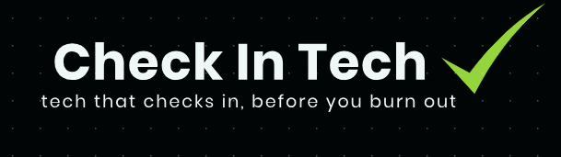
Figure 12 – Image of Logo

This logo was chosen due to a few factors, the black background, white text and green tick work well together. Green is mostly seen as a positive colour and can be associated with growth and progress which ties in with the theme of mental wellbeing. In addition, the green tick is visually striking and may suggest trust, approval and safety with its users.

Business Type
A private limited company (LTD) is the best option for a business type for Check In Tech. As stated by Moore [10] a private company is where the shares of the business are split between the shareholders. It is separated from the owners, which is a main advantage and must be registered with Companies House.

Figure 13 shows that Check In Tech can be registered with Companies House as the company with the same name has been dissolved and should be removed from the register.
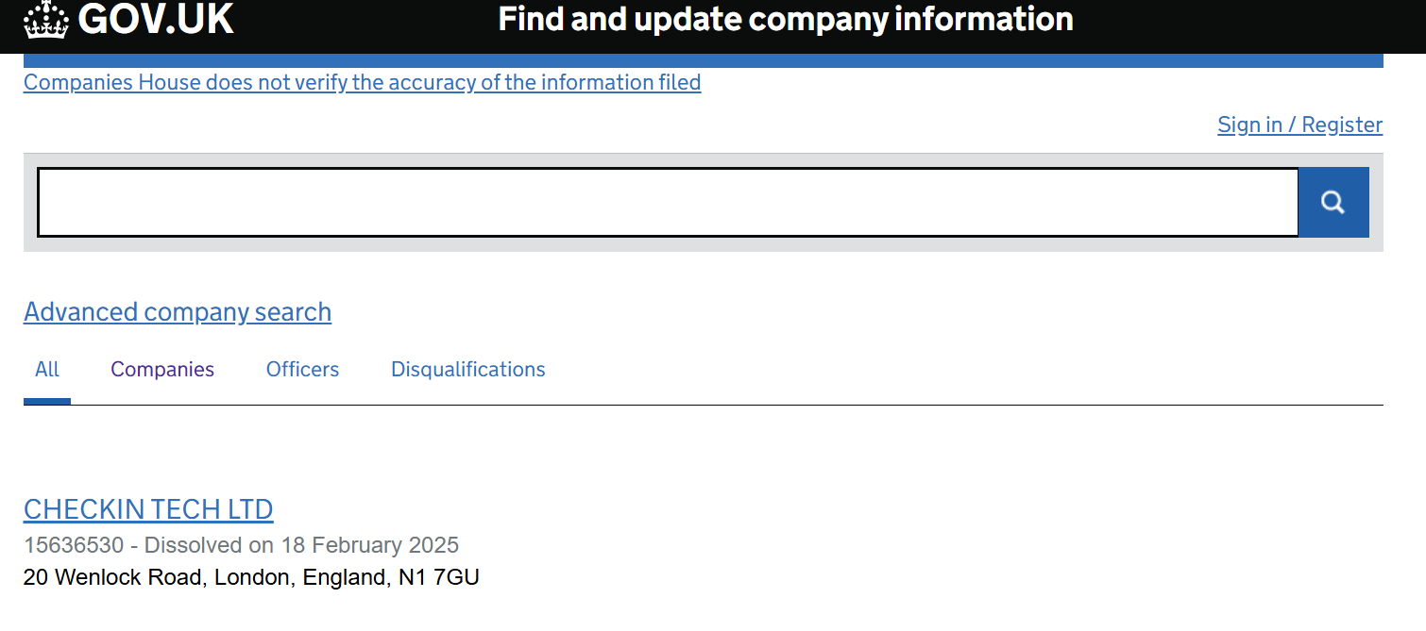

Figure 13 – Image of Companies House Register

There are a few advantages to owning a private company as suggested by [10].
- There are less personal liability risks as the owners are only liable for debts up to the value of their share in the business.
- The owners have a reduced taxation by only paying corporation tax which is based off the business’s income, excluding the expenses.
- The business name is protected so no one else can use it once it is registered with Companies House.
As mentioned, a private company is suitable for Check In Tech as it has a separate legal entity, it is easier to attract investors, and it will be protected.

Business Strategy
Staples & Black [11] state that the purpose of a business strategy is to provide direction for those who work in the company.
A business strategy includes a mission statement, company objectives and values, this is stated below for Check In Tech.

Mission Statement
“Helping individuals check in with themselves, make mindful choices, and build a healthier relationship with technology”
Objectives
- Help users develop balanced technology habits by providing tools to track screen time, mood, and social media usage.
- Maintain the highest standards of data protection, ensuring user information is stored securely and used ethically.
- Continuously evaluate user feedback and data to assess the app’s effectiveness in improving digital wellbeing and adapt accordingly.

Values
- Every feature we design should prioritise the mental and emotional health of our users.
- We harness technology to create positive changes, not increased screen time.
- We protect user data as if it were our own, complying with all relevant privacy laws.
- We adapt based on user feedback and new research to keep our tools effective and relevant.
- We believe wellbeing support should be available to all, regardless of income, background, or location.

Initiatives
An important factor in a business strategy is the initiatives that can help fund the organization. Check In Tech could benefit from wellbeing and mental health grants that could be offered by the government or the NHS. According to the UK Department of Health & Social Care [12] the mental health bill aims to give people more control over their treatment and to help ensure that they receive the care and respect they deserve.
In addition, UWTSD could offer enterprise grants or hold student competitions if the startup company was launched whilst studying for a degree.

Project Reflection
Chang [13] states that reflection is necessary for students to look back on what they have achieved and where they can improve.
This project has provided the opportunity for skills to be strengthened in several areas. For instance, building the pilot tracker in Glide has enabled the ability to create user-friendly interfaces and to structure a digital tool effectively.
Collecting qualitative and quantitative data has improved the statistical skills and how to communicate with people online and face-face. Furthermore, managing a timeline, resources and an agile development cycle will enhance the organisational and problem-solving capabilities.
More importantly, this project could have a positive impact on society by reducing stress, anxiety and feelings of comparison. It could improve productivity and focus by encouraging minimal screen time as well as providing valuable insights into the research around mental health.
The risks around this project may be that the user engagement is low, the tracker could be developed with gentle reminders to remind users to log their sessions to overcome this. Users being concerned about their privacy and date could be another risk, the company could overcome this by clearly communicating their polices on GDPR and storing information securely. In addition, there is a risk of bias when collecting data as users may not be entirely truthful in their logs. A way to overcome this is by honing down on how important honesty is when it comes to mental health and to remind users that it is the best policy.

Conclusion
This report has explored the relationship between social media use and emotional wellbeing through the development of Check In Tech, a tool that combines digital behaviour tracking with self-reported mood data.
In line with the aims outlined at the start, the project scope was documented using a Gnatt chart to track timelines and tasks, and the design process was supported by a flowchart and wireframes. The SWOT and PEST analysis was included alongside legal and ethical considerations which provided an example of a strategic and responsible framework for the project’s development.
Reflecting on the process, this project not only demonstrates the practical use of research, design and data handling skills but also highlights the potential of modern technology to support positive mental health outcomes.
Overall, this project highlights the power of combining research, design, and ethical considerations to create solutions that inspire healthier online behaviour and long-term wellbeing.

Bibliography

[1] | N. W. &. R. D. O. Richard Lowe, "How to Effectively Develop & Manage the Project Schedule," The Construction Lawyer, vol. 39, no. 6, p. 6, 2019.
[2] | A. S. &. G. Vaidyanathan, "SWOT Analysis and Theory of Constraint in Information Technology," Information Systems Education Journal , vol. 2, no. 23, 2004.
[3] | P. P. Kumar, "Effective Use of Gantt Chart for Managing Large Scale Projects," Cost Engineering, vol. 47, no. 7, 2005.
[4] | K. Wadhwa, "The Role of Gantt Chart in the Project Management," THESUS, 2024.
[5] | S. S. S. a. H. A. Al-Saqqa, "Agile Software Development: Methodologies and Trends," International Journal of Interactive Mobile Technologies, vol. 14, no. 11, 2020.
[6] | S. L. N. &. T. R. Christine Namugenyia, "Design of a SWOT Analysis Model and its Evaluation in Diverse Digital Business Ecosystems Context," Science Direct , vol. 159, no. 1, 2019.
[7] | M. S. Writer, "Free Headspace Health SWOT Analysis, Weighted SWOT, SWOT Matrix," 02 August 2025. [Online]. Available: https://fernfortuniversity.com/essay/swot1/headspace-health-18. [Accessed 13th August 2025].
[8] | H. Carruthers, "Using PEST Analysis to Improve Business Performance," In Practice , vol. 31, no. 1, 2009.
[9] | Canva, "Headspace Pestel Analysis," Canva, August 2025. [Online]. Available: https://canvasbusinessmodel.com/products/headspace-pestle-analysis. [Accessed 13th August 2025].
[10] | A. Moore, "Advantages and Disadvantages of Private Limited Companies," Crunch, 24th October 2024. [Online]. Available: https://www.crunch.co.uk/knowledge/article/advantages-and-disadvantages-of-private-limited-companies. [Accessed 13th August 2025].
[11] | W. S. &. K. Black, "Defining Your Business Mission: A Strategic Perspective," Journal of Business Strategies, vol. 1, no. 1, 1989.
[12] | D. o. H. &. S. Care, "Mental Health Bill," GOV.UK, 14th November 2024. [Online]. Available: https://www.gov.uk/government/collections/mental-health-bill-2025. [Accessed 14th August 2025].
[13] | B. Chang, "Reflection in Learning," Eric, vol. 23, no. 1, 2019.
[14] | J. Moustafaev, "Project Scope Management," in Project Scope Management, Auerbach Publishers, Incorporated , 2014.

Appendices
Activity Notes: Unit 3 Topic 4 – Making It Happen
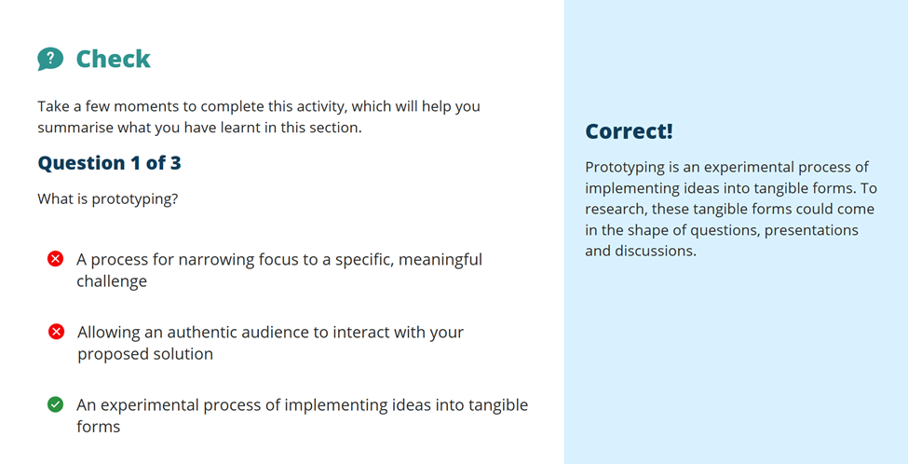
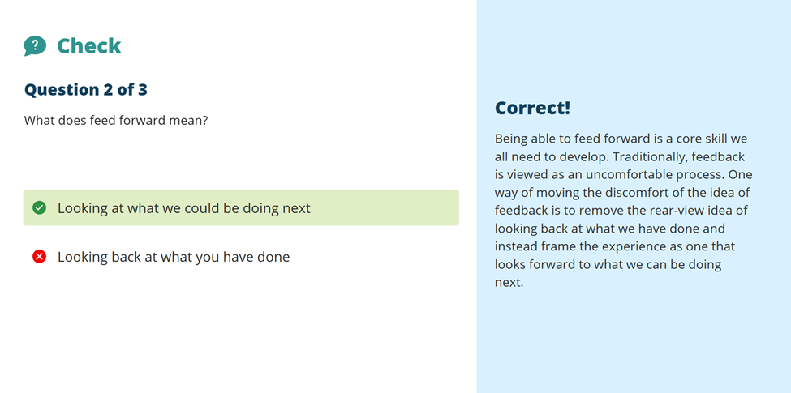
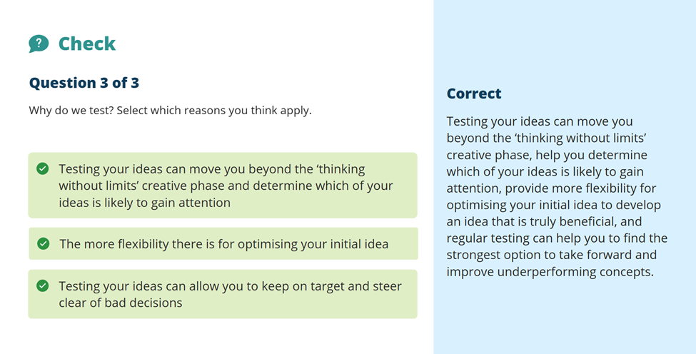
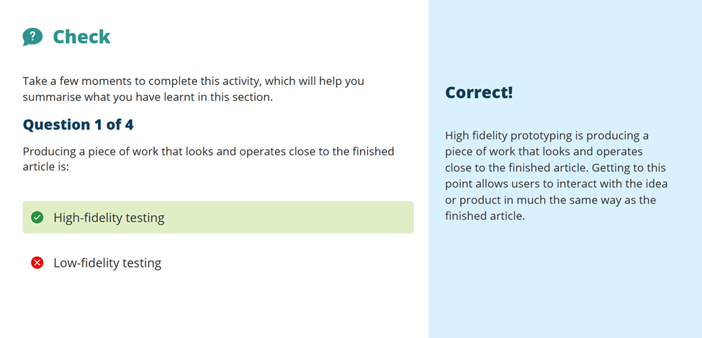

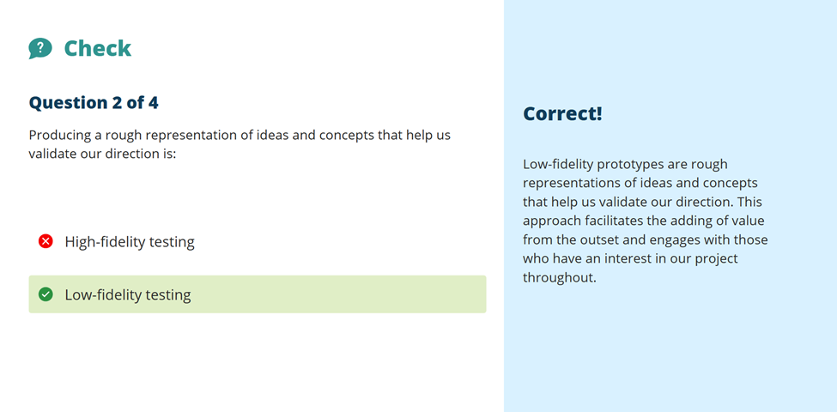
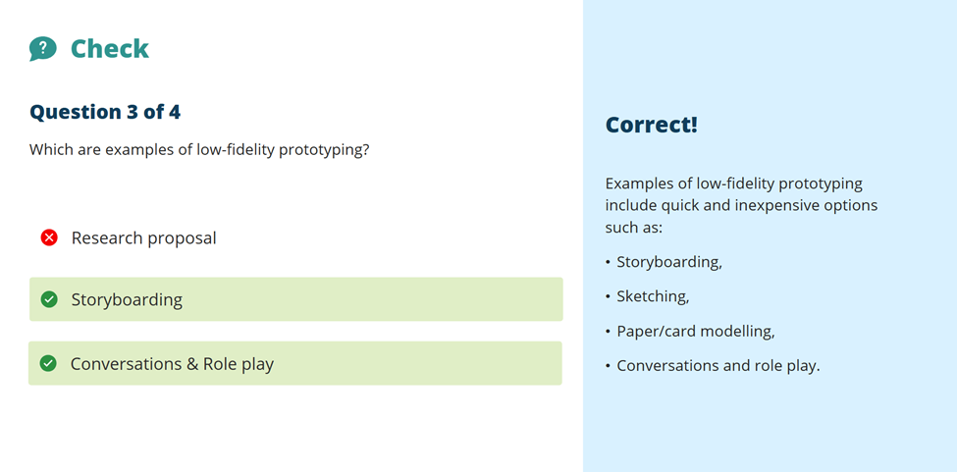

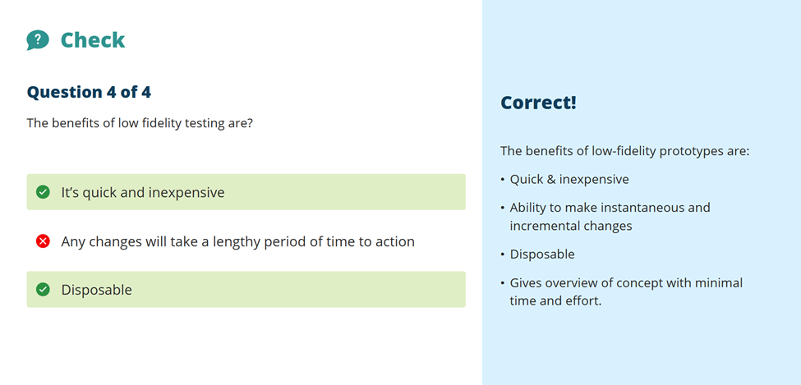

Activity Notes – Unit 3 Topic 1 – Power of Networks


We have to get out there and meet new people who aren’t in our close knit groups to really see how creative we can be, the ideas that we have and the relationships that we can build, all by talking to new people with different ideas and opinions.
I had the opportunity to do this degree by talking to my other colleagues who had enrolled.


