
Applied Leadership and Management in the Workplace
Module Assignment Submission
Student Name: | KIM BOUKERAS
Student Number: | 2226794
Module No: | BMSK 5011
Module Title: | Developing Workplace Critical Thinking

Statement of Confirmation of Authenticity
By the act of making this submission, the student declares that this is the work of the student named above. The work has not, in whole or in part, been knowingly presented elsewhere for assessment, or where assessment has been built on a previous assessment, this has been identified. Where materials have been used from other sources it has been properly acknowledged. If this statement is untrue, the student acknowledges that an assessment offence has been committed.
Attention is drawn to the plagiarism and unfair practice policies of both the University and of ILM./

DEVELOPING WORKPLACE CRITICAL THINKING

TABLE OF CONTENTS

A. CRITICALLY ASSESS THE IMPACT OF BELIEFS, ATTITUDES AND VALUES ON MY OWN WORKPLACE BEHAVIOUR 3
Discriminate and analyse the difference between beliefs, attitudes and values within my workplace context 3
WHAT IS CRITICAL THINKING? 3
KEY CRITICAL THINKING SKILLS: WHAT SKILLS ARE NEEDED FOR CRITICAL THINKING? 6
Critically assess my own beliefs, attitudes and value systems and their impact on workplace behaviour 7
ATTITUDES, BELIEFS and VALUES 7
B. IDENTIFY A MANAGEMENT THEORY RELEVANT TO MY ROLE AND CRITICALLY ASSESS ITS IMPACT ON MY OWN BELIEFS, ATTITUDES AND VALUES. 8
Apply the critical assessment of an appropriate management theory to evaluate how someone with different beliefs, attitudes and values might interpret the theory differently. 8
A CASE STUDY 8
BLOOMIAN SKILLS 9
CRITICAL THINKING AND DECISION MAKING 12
Deduction and induction 12
Positive and Normative Statements and Questions 13
CONCLUSION 13
REFERENCES 14

A. CRITICALLY ASSESS THE IMPACT OF BELIEFS, ATTITUDES AND VALUES ON MY OWN WORKPLACE BEHAVIOUR

Discriminate and analyse the difference between beliefs, attitudes and values within my workplace context

WHAT IS CRITICAL THINKING?

Critical thinking is a type of emotional intelligence. (Golman, 1996 and 1998). Critical thinking is the ability to gather evidence, analyse facts and make judgements. It helps in making sensible decisions.
Different authors have got slightly different ideas about critical thinking. I have found the following sources as examples. I will give an overview of each and a more detailed view of one author (Woolls).
Tom Chatfield’s view on things is that critical thinking is a tool kit, and the tools are skills to make you sharper and express your ideas clearly, build a solid argument, evaluate evidence and be reasonable. (Chatfield, 2017)
Cyndy Scheibe and Chris Sperry aim their writing at teachers and trainers working with the younger generation, being manipulated by social media. In the world we live in today they need to see the dangers of false news and also bias, stereotype and controlling behaviours. (Scheibe and Sperry, 2022)
In Jonathan Haber’s book, the bit that I picked out straight away is the link with emotions and the idea that people make many decisions on emotions rather than facts. Iin the 21st century there is a lot of fake news, often designed to whip up emotions. It is important to take account of people’s feelings and to have emotional intelligence, but facts are also important. (Haber, 2020))
Frank Fair and Daniel Fasko, like Johnathan Haber, are looking to the future, saying that critical thinking skills will be more important in the workplace and in schools and colleges. Exams used to be based on memory of facts but today, we need to find better ways of assessing a wider range of skills. (Fair and Fasko, 2021)
Steven Silberger puts “thoughts, feelings and behaviours” at the centre of his organisational model. This is an interesting model which I might be able to use again on this degree. It seems to me that as you go further into the model from the outside environment to the organisation to the individual, at the centre you have people with their thoughts and emotions. His model is shown below (Silberger, 1993).
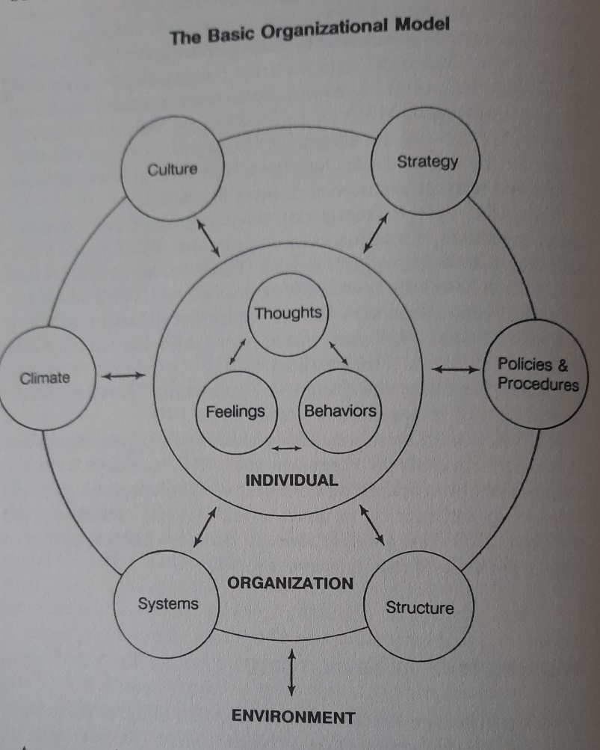

According to Wooll (March, 2022) there are 5 characteristics of critical thinking. By characteristics we mean ways in which we can recognise or identify critical thinking and distinguish it from non-critical thinking, in the same way that knowing the characteristics of a dog (four legs, fur, it barks) helps us to identify a dog and distinguish it from a cat.
Wooll’s characteristics are dispositions, argument, reasoning, criteria, and metacognition. What do these mean? Can I relate them to my own thinking and my workplace?
Dispositions
Wooll talks about “traits” which is a word I have seen before but never thought about much. I think it is very much to do with personality.
Going back in time people were ready to believe all sorts of things without evidence, such as superstitions, and the idea of facts and evidence did not figure even in courts of law, where people were prosecuted for murder with no evidence, but just on people’s word, and sometimes the so-called evidence was obtained through torture.
Witch trials are a good example of uncritical thinking, and the so-called evidence was just word of mouth. The accused could not win, they were ducked in water, if they drowned, they were innocent, if they floated, they were guilty and then burnt at the stake.
In my workplace, how do we assess a customer’s needs? We need to avoid bias. It is also important to think before you speak. A man might come in dressed scruffily, but he could be a millionaire. Just because of the way he is dressed people should not assume he is looking for a £5 T shirt. He might be looking for something very classy, but he does not know how to dress in a way that suits his body shape, and how to put colours together in a way that suits him. This is why critical thinking is used every day for good customer service.
Customers would benefit from the salesperson being open minded, respecting the customer’s opinions, flexible in giving alternatives, encouraging the customer not to be stuck with one option (what Woolls would call “cognitive flexibility”, which means open to various options) and being clear and precise in the service being provided. It is also important to be skeptical, for example the customer might say “this colour does not suit me” when you can see that it does, and it is necessary to be diplomatic and break it to them gently that what they have always believed is wrong. They need to be told this in a way that does not offend.
Argument
Critical thinkers need to make good arguments supported by evidence and not just opinions.
Reasoning
Critical thinking also needs logical thinking using deduction and induction. I investigate this in more detail later in this assignment.
Criteria
Critical thinking involves telling truth from fiction and knowing that not all facts presented are at the same level of truth. It is not as simple as truth and lies. Sometimes facts are exaggerated or embellished.
Embellished means when someone is telling a story or conversation, they tend to a add lot more to what it is to make the story or conversation better. It is also important to see the difference between facts and opinions. I look at this further on in the assignment.
Metacognition
This is the ability to think about our own thinking. For example, is my memory clear or have I forgotten bits about what happened? Am I being fair? Is there any evidence I haven’t thought about or discovered? Think before you speak. Make sure you gather all evidence before giving your opinion. Am I biased without realising it? Am I jumping to conclusions? With all these questions it leads to making sure that you have gathered all evidence before really making your own judgment.

KEY CRITICAL THINKING SKILLS: WHAT SKILLS ARE NEEDED FOR CRITICAL THINKING?

According to Wooll (March, 2022) there are 6 key critical thinking skills, which are: identifying biases, inference, research, identification, curiosity, and judging relevance. Using these we will be able to think about an issue or topic in an objective and critical way.

I think the six different critical thinking skills listed by Wooll are very useful ideas which would be very helpful in the workplace dealing with colleagues, senior managers and dealing with customers.
Identifying biases
This means when knowing that others have a cognitive bias and when you have one yourself. The word cognitive means to do with thinking so this is a bias which effects the way you think.
Inference
As discussed above this is using logic to come to conclusions.
Research
This is finding out what the facts are. And sometimes you need to search people’s opinions for example in retail market research discovers what our opinions are.
Identification
Identifying a problem and identifying what is creating the problem.
Curiosity
This means not being afraid of asking questions and keeping an open mind. Do not dismiss evidence just because it does not fit in with one’s thoughts. I think this is really important for myself as I am not afraid to ask questions or look for evidence to back my story and to make sure that I have covered every aspect.
Judging relevance
Not all facts are equally important. We need to judge which facts are most relevant. I would say business meetings are sometimes side tracked by too much irrelevant detail.

Critically assess my own beliefs, attitudes and value systems and their impact on workplace behaviour

ATTITUDES, BELIEFS and VALUES

Attitudes, beliefs, and values are very important parts of our personality because they affect our behaviour every day.
Training material from the New Zealand Immigration Advisers Authority includes a useful diagram suggesting that our beliefs are formed first. They come from sources such as culture, faith, education, experience, and mentors. I would most definitely add family to that list.
(iaa.govt.nz, 2014)

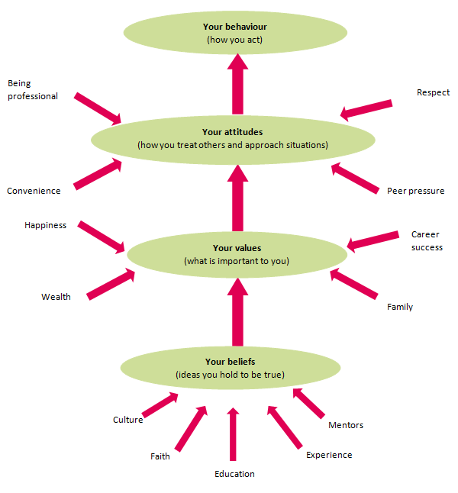
In class we were given a list of beliefs, and I think lots of the words on the list relate to myself, but the ones that I would pick out to identify myself the most are hardworking and being a good parent. The third is not listed, but under the “other” heading, I would add being respectful of others. This does not mean that I respect people just because they have a high position, it means recognising that every human being is equally deserving of respect as a human being, without regard to wealth or status or any other characteristic.
Beliefs do not rely on evidence, as people think what they want to think once they accept that a belief is true.
Values are collections of beliefs that are important to yourself as an individual. They include happiness, wealth family and career success. Of these, family comes first in my opinion as family can give you all of these things. I would put these values in the following order: family, happiness, career success and wealth. I have often said that if I was suddenly given wealth I would give most of it away to help people. Wealth does not guarantee happiness or health. Donald Trump is a prime example of a wealthy but obviously unhappy person.
Attitudes affect how you behave on a day-to-day basis, dealing with other people and managing situations. They include being professional, peer pressure, respect, and convenience. The word “convenience” here is puzzling, but I take it to mean that sometimes decisions are made to try to put an end to a problem that would otherwise drag on. Sometimes it is convenient to say “whatever” and compromise rather than continue with an argument that is getting nowhere.

B. IDENTIFY A MANAGEMENT THEORY RELEVANT TO MY ROLE AND CRITICALLY ASSESS ITS IMPACT ON MY OWN BELIEFS, ATTITUDES AND VALUES.

Apply the critical assessment of an appropriate management theory to evaluate how someone with different beliefs, attitudes and values might interpret the theory differently.

A CASE STUDY

My appropriate management theory is Bloomian Skills which we have covered in class, and which I discuss further below. This theory is closely related to two other class topics, (1) deduction and induction, and (2) positive and normative statements (facts and opinions).
I chose this article from the Guardian to use as a case study because it is in retail which is the sector where I work, and I think the basic problem is poor training from management. As one of my possible future career options I would like to be working in is HR, especially in a training role, this case study is of interest to me.
The Guardian article was headed: “Hobbycraft refused to sell paint to black man as ‘he may use it for graffiti’ “. (Pidd, 26 February, 2024)
The store Hobbycraft is in Newport. A man went into the store to buy aerosol paint to do his son’s helmet the same as his favourite mountain biker star. When the man went to the till to purchase the spray paint, he was refused the sale. The man was confused and asked why, and the cashier said that you could be using it to do graffiti. The cashier said that they were implementing the challenge 25 policy, but you could clearly see that from the picture in the newspaper Mr Gray is over 25 years of age and also has a 4-year-old son who looks six. Mr Gray then thought to himself that this is racial profiling and unconscious bias. The store’s ID policy covers products like knives, aerosol paints and helium. This is not a sort of thing Mr Gray, a man in his thirties, accompanied with his son, would be misusing. Afterwards Mr Gray complained to head office. Head office was not happy with this, they said this is not the service we deliver and is a matter of urgency to be resolved. In an email to Mr Gray they said they would be implementing a training policy to all staff.
You need to be skeptical about the whole story in case Mr Gray has been oversensitive. He works as a diversity officer so he might be more on the lookout for racial discrimination than most people. On the other hand, the article contains plenty of evidence that the under 25 policy does not fully support the store’s point of view. Mr Gray does not look under 25 he looks like a responsible father, and he does not look like a graffiti vandal, but he does look dark skinned. There was no problem when the white grandfather bought the aerosol paint.
The cashiers claimed that they were implementing an under 25 policy when it seems that they were really showing unconscious bias. I would not blame the front-line workers for this sort of mistake, I would blame poor management and poor training where the workers have not been shown how to use critical thinking. One thing the company could do is set role plays for staff to practice interacting with each other in different situations. It will help to improve their customer service skills and help not to be biased and help to think critically.

BLOOMIAN SKILLS
Bloom’s Taxonomy dates from the 1950s. Bloom was an educator who realised that different skills could be put on different levels. It is called a taxonomy because this is a scientific word that puts things in groups which gives us a better understanding. So, for example knowledge is a lower skill in Blooms Taxonomy and critical thinking (evaluation) is a higher skill. (Bloom, 1956; Rule, 2024; Englehart, 2015).

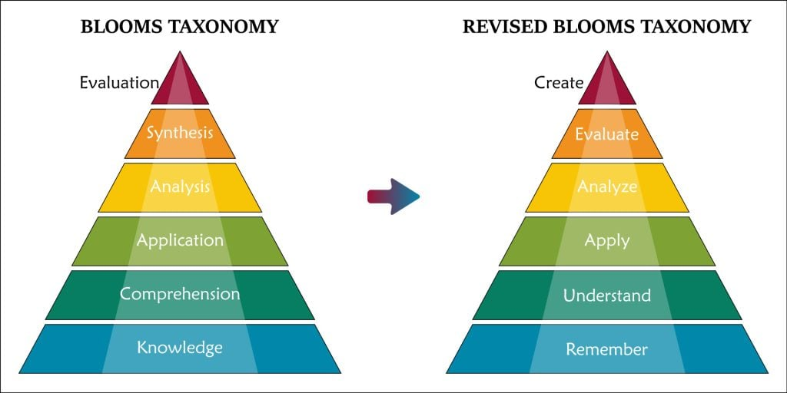

Knowledge is recall or remembering facts. Such as London is the capital of England.
Comprehension is understanding facts such as knowing that a capital city is the city where the national government is.
Application means using a knowledge and comprehension to solve a problem. For example, using a calculator to work out 36 times 42 when we understand tables, but we don’t know our 36 times table or 42 times table.
Analysis means taking something apart to see how it works. For example, a child might take a toy apart and then put it back together.
Synthesis means using lots of different skills to understand a whole system. For example, knowing mechanics, electronics, and other skills to build a car. Putting a car together is more difficult than taking it apart as every child with a toy car knows. Therefore, synthesis is more difficult than analysis.
Evaluation is the highest skill. It uses all the other skills to gather evidence and then to make a judgement on the whole process, to come to conclusions, make recommendations and justify the conclusions. So evaluation is very close to critical thinking.
Comparing the two triangles the one on the left dates to the twentieth century and the one on the right I think updates to the twenty first century when more jobs involve thinking skills and creativity as well as manual work.
In my line of work, I must think all the time because people ask me daily how and what to wear and what colours suit them. It is evaluative and creative and it all depends on the person, all with different shapes, sizes and personalities.
The two cashiers in Hobbycraft were operating on a very low level of knowledge and understanding, and not using critical skills, in my opinion due to their inadequate training.
Hobbycraft managers might benefit from reading an article by James Timpson, Chief Executive Officer (CEO) of the Timpson Locksmith and Shoe Repair chain entitled “Britain needs upside-down management”.
It contains some interesting ideas which might have benefitted the training given to the young staff at Hobbycraft. I agree with what he says about a “culture of kindness” and how investing in this makes the business. There are very few rules and colleagues are trusted to make correct decisions. Maybe if the young persons at Hobbycraft had engaged their brains and used critical thinking, instead of mindlessly following the rule book there might have been a better decision made and better outcomes for the customer, without the negative publicity this matter has attracted in the media. (Timpson, 6 March 2024).
My evaluation of this article is that I agree 100% with what James Timpson is saying. I particularly like the idea of “Upside Down Management”. This is the way I would want to run any business of my own. The saying “look after your staff and they will look after you” is the right way of doing things for a business. It applies in wider life as well, treat people with respect and they respect you back. Respect is earned, it is a two-way process. The same applies to loyalty. A leader will expect loyalty but will also show loyalty to their staff when they need support.
In a letter to the same newspaper, Ian Barclay (7 March 2024), says that Timpson makes a powerful statement that colleagues are human beings not “units of production”, and he also agrees with Timpson that “put money in the till and look the part” are the two best rules. He also mentions that the customer service focussed Nordstrom Stores in the USA only have one rule “Use good judgement in all situations”. Simple and effective, and putting trust in people to use critical thinking.
I found another article, this one with an example of a company with so many rules it was very difficult for staff to cope. The company owner was micromanaging in a very destructive way. The exact opposite of critical thinking, no confidence in their staff at all, so they are only working for the money not for the company’s profits nor its public image, which now is at rock bottom. The CEO also allegedly made racist remarks which are totally unacceptable. (Weaver, Mason and Dyer, 11 March 2024)
We can see from the above that the culture of a business can affect how people think. It seems to me that where an employer respects the opinions of their employees, critical thinking is supported. Petty rules which are disrespect the individual discourage critical thinking and the results can be bad for the business.

CRITICAL THINKING AND DECISION MAKING
Adair (2022) uses the term “Effective thinking” to describe three “meta functions” that interlock like a jigsaw puzzle: analysing, synthesising, and valuing. These are just like the three highest of Bloom’s skills.

Deduction and induction
Adair describes a step-by-step approach to logical thinking, using deduction and induction.
Deduction starts with a general statement and leads to particular conclusions. For example, in my line of work, designer clothing retail, managers might say “People like a bargain”. There might be strong evidence for this, or there might not be, but it is widely held belief. We can go from this general belief to a particular conclusion, like this: if we have a sale and reduce our prices, more customers will come in and spend more money. We can then test the conclusion to bring in the evidence, which might or might not support our starting idea. Only the numbers will tell.
Induction goes in the other direction, we start by looking at examples, and then try to explain them with a general rule. Such as when Hugo Boss had a sale, and it seemed to do well, Ted Baker also had a sale and did well. Therefore, we think sales generally do well. This will work as a general rule until we come across an example that breaks the rule. Perhaps some shops try a promotion that doesn’t work and shut it down after a few months. Then we need to come up with another theory, taking account for some other possibilities. For example, some customers might assume cheap goods are “fake”, and this has happened to me many times, I’ve been asked “Why are the clothes in this shop so cheap, are they fake?”. It could be that some customers think low prices mean low quality. So, we have to reassure them.
In another book, Adair (2002) goes beyond the step-by-step approach and looks at the importance of “holistic” decision making, which means looking at a problem as a whole, and his idea of “holism”. These holistic ideas seem to me to be very similar to the approach taken by John Timpson in the article I mentioned earlier.
There is a need in business to be able to see the wood for the trees (holism) rather than only look at an individual tree (step by step analysis). Not just seeing things as a problem of for instance marketing, production or a people problem. Look at the whole organisation to see what can be done to solve a problem.

Positive and Normative Statements and Questions

Positive statements can be proved true or false, using methods which most people can agree with. They tell us something about the world around us. An example of a positive or objective statement is “this table is made of wood”. It could be put as a question: is this table made of wood or metal?
Normative statements can never be proved true or false. They tell us something not about the world around us, but about people’s opinions. An example of a normative or value statement is “this table is beautiful”. It could be put as a question: is this table beautiful or ugly?
Often, a positive question is difficult to answer, but it might be possible to answer one day. “Is there intelligent life on other planets?” is difficult to answer, because we do not yet have the means to test it out. But in principle life on other planets can one day be proved true or false. We are just not clever enough yet to give a definite answer one way or the other.
In these times of false news, conspiracy theories, persuasive advertising, and social media, it is very important to be able to tell facts from opinions. If someone gives an opinion and pretends it is a fact the best thing to do is say “prove it!” or more politely ask “where’s the evidence?”. We should not dismiss other people’s opinions but we need to be skeptical and try to be evidence based.

CONCLUSION

The employees at Hobbycraft mentioned in my case study would benefit from training based on Kolb’s Learning Cycle (Kolb, 1976; Crainer, 1995; Englehart, 2015).

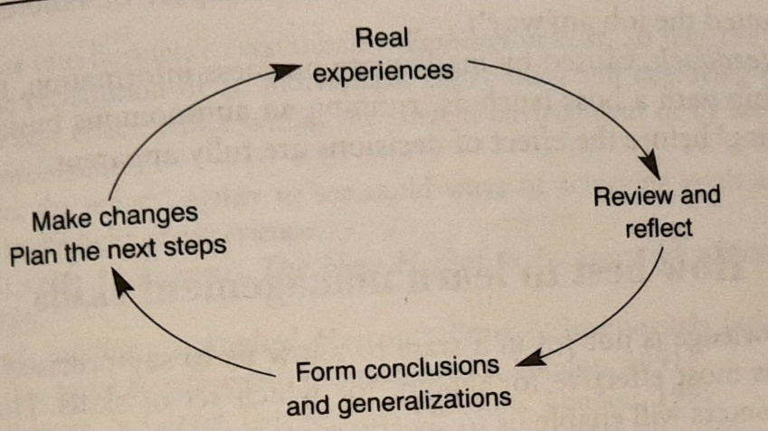

They would reflect on their recent experience, evaluate their actions and make changes so as to make better decisions in future.
Good employers will encourage critical thinking and will build this into their training schemes. Especially when employees are dealing with customers, they need to use emotional intelligence and also engage the higher skills of analysing, synthesis and evaluation, instead of just mindlessly following a script or a set of rules.

REFERENCES

Adair, John (2022) Decision making and problem solving, Kogan Page, London.
Adair, John (2002) 100 greatest idea for effective leadership and management, Capstone Books, Chichester
Barclay, I. (7 March 2024) Guardian, Letter about James Timpson https://www.theguardian.com/global/2024/mar/06/one-rule-for-good-employee-relations
Bloom, B. and others (1956) Taxonomy of educational objectives, David McKay Company, New York
Englehart, Max (2015), A guide to Bloom’s taxonomy, Johns Hopkins University, Baltimore https://ii.library.jhu.edu/2015/01/30/a-guide-to-blooms-taxonomy/
Chatfield, Tom (2017), Critical thinking, Sage, London.
Crainer, Stuart (1995) The Financial Times Handbook of Management, Pitman, London.
Fair, Frank, and Fasko, Daniel, eds., (2021) Critical thinking, Brill Sense, Leiden and Boston
Goleman, Daniel (1996) Emotional intelligence, Bloomsbury, London
Goleman, Daniel (1998) Working with emotional intelligence, Bloomsbury, London
Haber. Jonathan (2020) Critical thinking, MIT Press, Boston.
iaa.govt.nz (2014) Information for immigration advisers https://www.iaa.govt.nz/for-advisers/adviser-tools/ethics-toolkit/personal-beliefs-values-attitudes-and-behaviour/
Kolb (1976) The Learning Style Inventory, McBer & Co, Boston
Pidd, Helen, (26 February 2024) Guardian, Incident at Hobbycraft, Newport https://www.theguardian.com/world/2024/feb/25/hobbycraft-refuse-to-sell-paint-to-black-man-as-he-may-use-it-for-graffiti
Rule, Charlotte (2024) Bloom’s taxonomy https://www.simplypsychology.org/blooms-taxonomy.html#What%20Is%20Bloom%E2%80%99s%20Taxonomy?
Scheibe, Cyndy and Sperry, Chris (2022) Teaching students to decode the world: media literacy and critical thinking across the curriculum, ASCD, London
Silberger, Steven (1993) The 10 day MBA, Piatkus, London.
Timpson, James, The Guardian (6 March 2024) Britain needs upside-down management https://www.theguardian.com/commentisfree/2024/mar/05/burnt-out-britain-workers-management-strike-sick
Weaver, Mason and Dyer, (11 March 2024) Guardian, Strict rules at Tory donor’s firm https://www.theguardian.com/politics/2024/mar/11/strict-rules-at-tory-donor-frank-hester-firm-tpp?CMP=Share_AndroidApp_Other,
Wooll, Maggie Critical thinking skills https://www.betterup.com/blog/critical-thinking-skills 14 March, 2022
(Internet sources all accessed February/ March, 2024)

