Kieran Brown (2204069)
University Of Wales Trinity St David
Applied Computing – Network Operating Systems and Services
Assignment 2

Table of Contents

Page 3 – 10 – Swansea Network Evidence

Page 11 – 14 - Cardiff Network Evidence

Page 15 – 16 – Connectivity

Page 17 – 18 – Sharing Disk Drive

Page 19 – 21 : IIS Server

Evidence

Swansea Network

1.1. Install Routing and Remote access Service and modify firewall rules to allow ICMP Traffic.

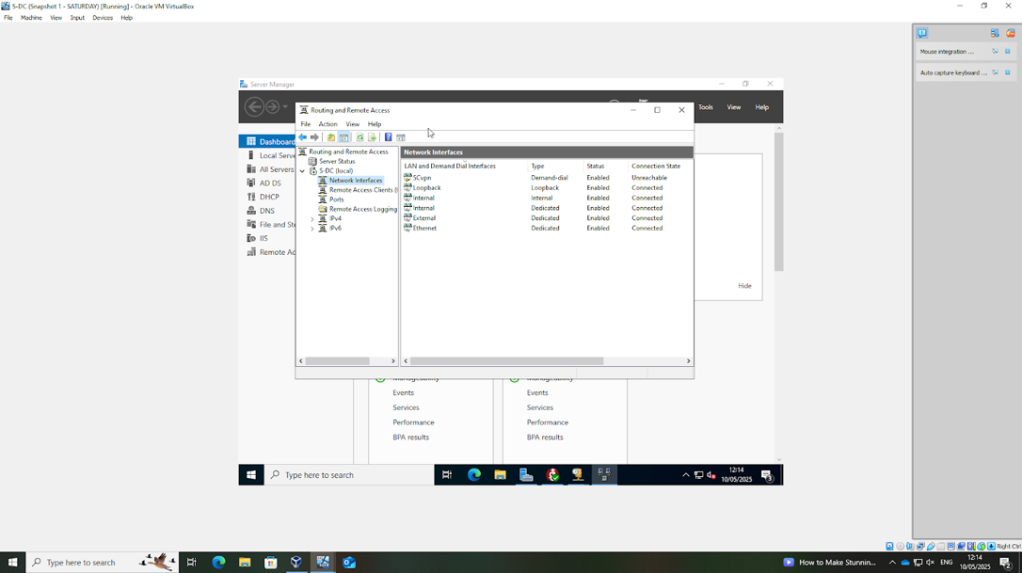

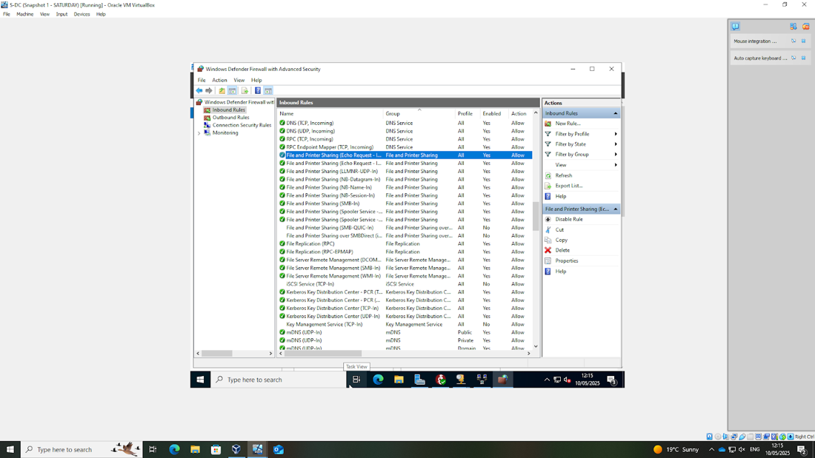

The first step in configuring the network was to install the Routing and Remote Access Service on the server. Also firewall rules were modified to allow ICMP traffic, This ensures that the devices within the network could communicate

1.2. Configure Site-to-Site VPN to London Network. Set the connection type to “persistent connection”.
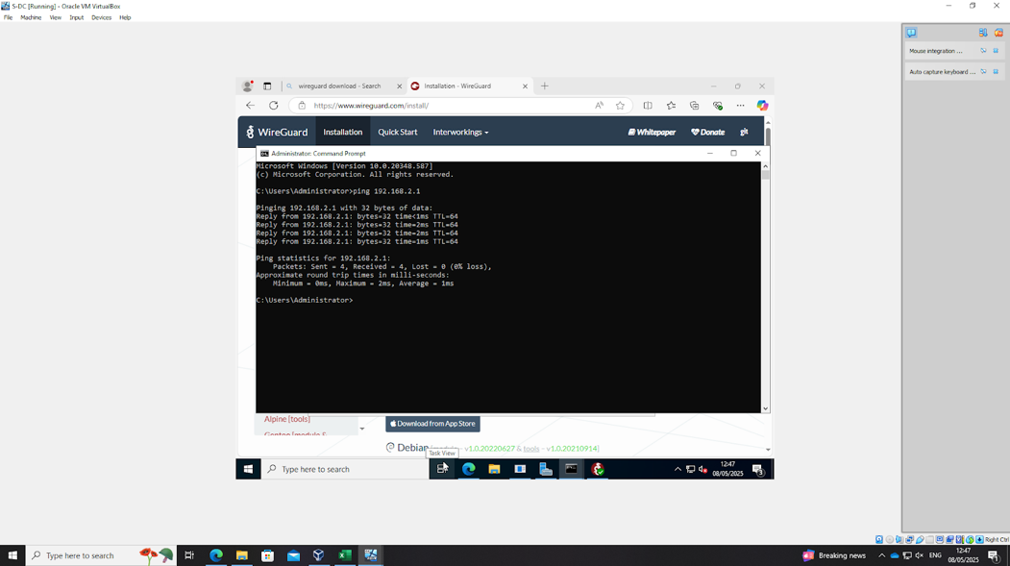

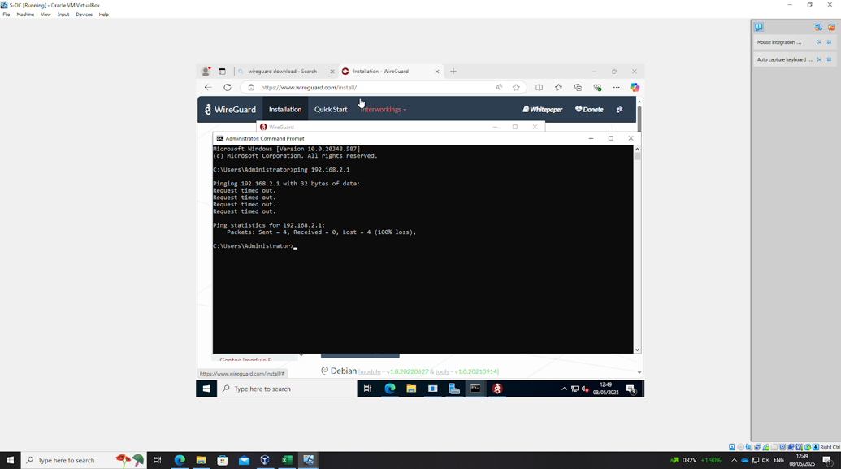

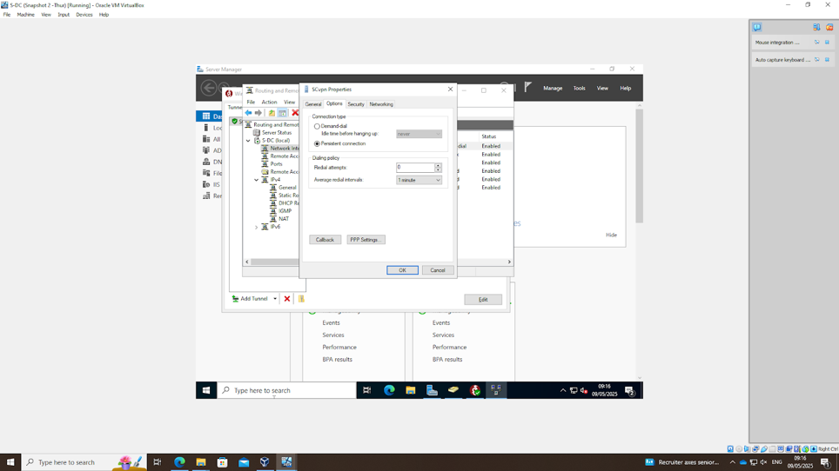

A site to site VPN was configured using wireguard to securely connect to the Cardiff network. The VPN remained continuously active as it was set to persistent
1.3. Create a forest named yourname.acca (For example: nitheesh.acca)

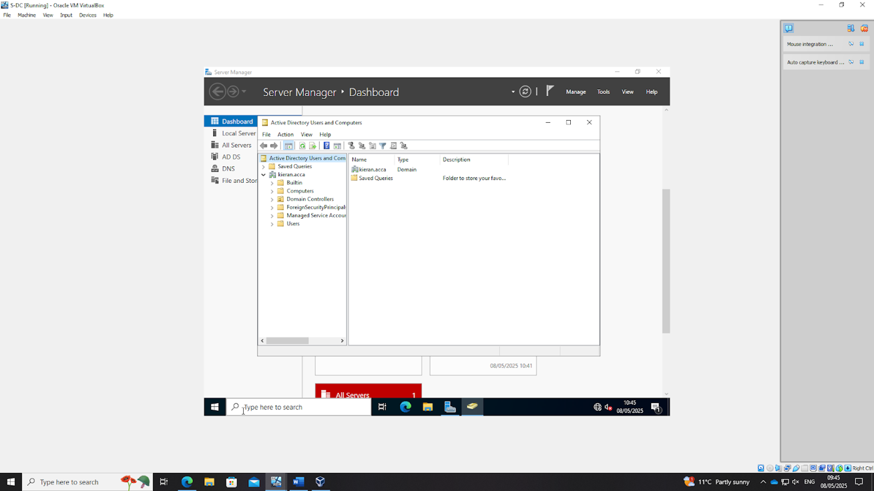

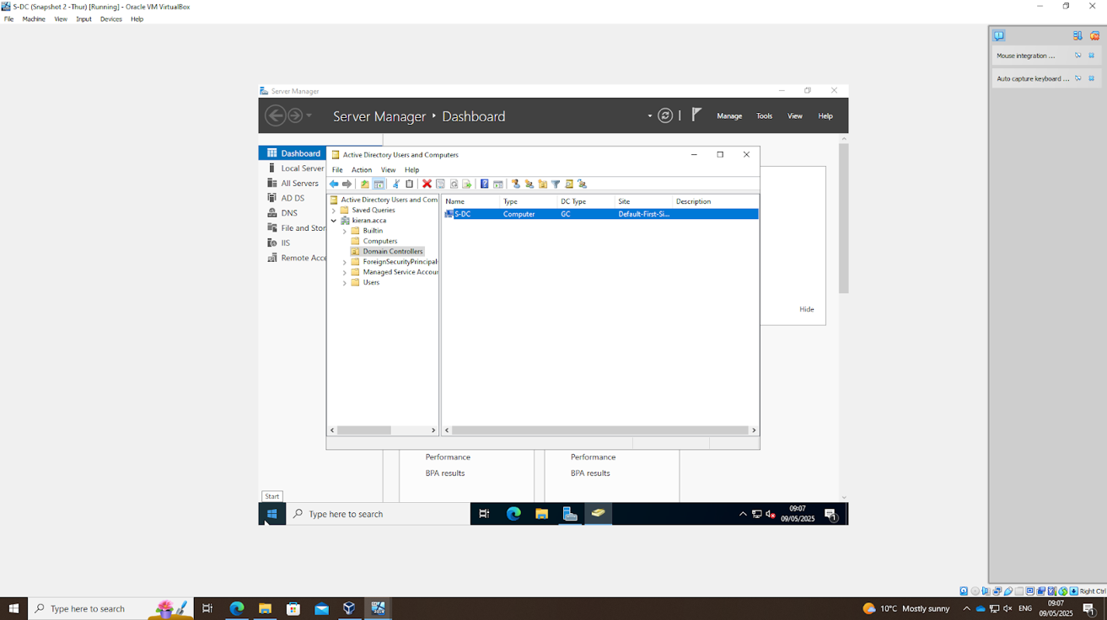

A new Active Directory forest named kieran.acca was created to establish the domain structure for the network environment

1.4. Create all appropriate A records for all servers on 10.1.1.0/24 and 172.16.1.0/24.

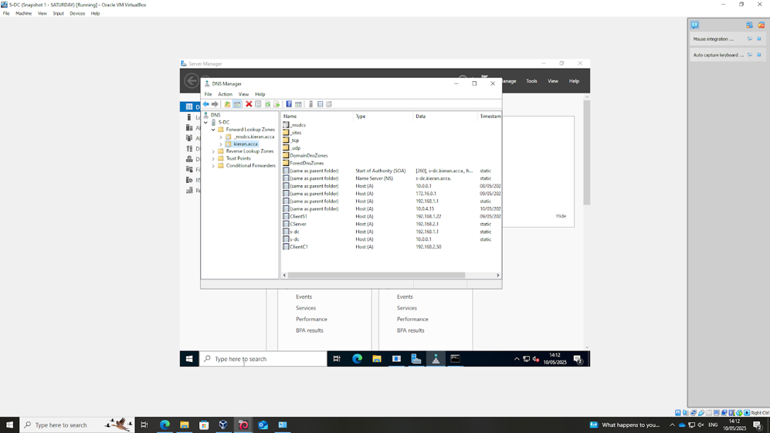

All appropriate A records for the servers were successfully created, ensuring correct name resolution across the network subnets

1.5. Create a reverse lookup zone creating PTR records for all servers.

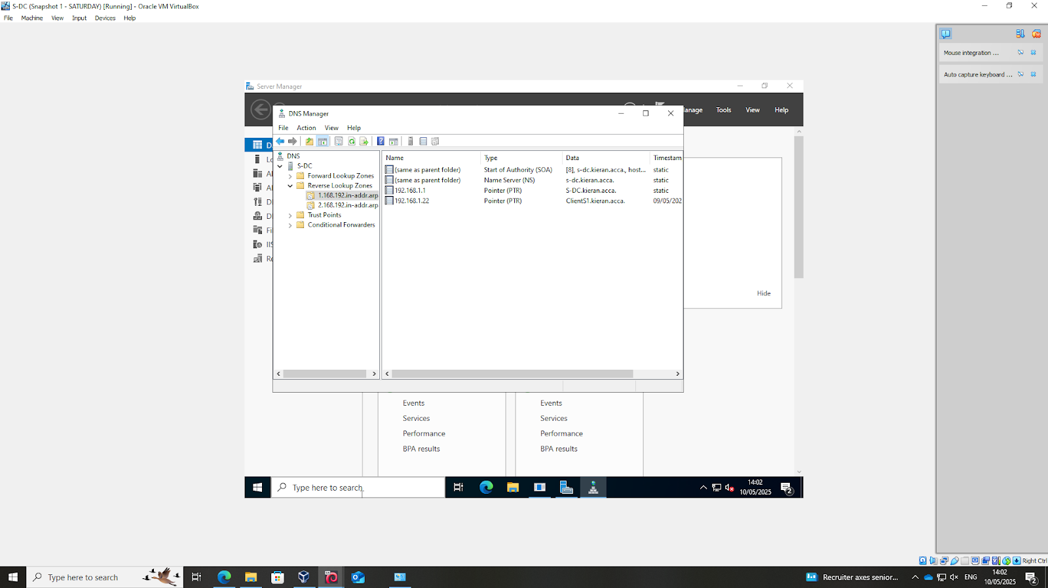

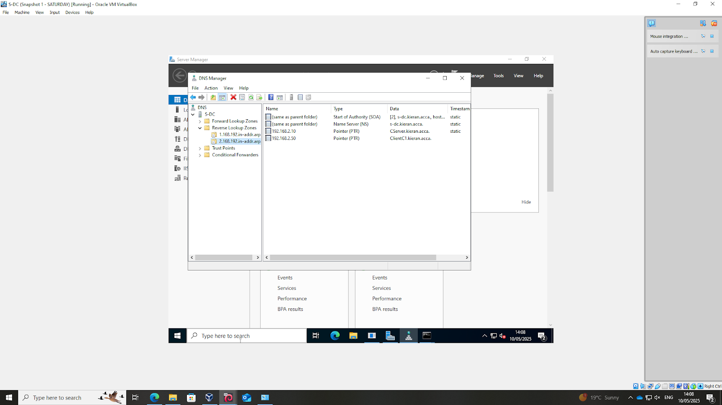

A reverse lookup zone was created. Then the PTR records were added for all of the servers to enable IP-to-hostname resolution

1.6. Create user accounts for yourname.acca domain with all the parameters defined in the users_list_updated.xlsx document. This document will be shared by your lecturer. You must use first letter from first name with a dot and last name as SAM Account Name. Eg: First Name: Nitheesh Last Name: Kaliyamurthy. à n.kaliyamurthy.

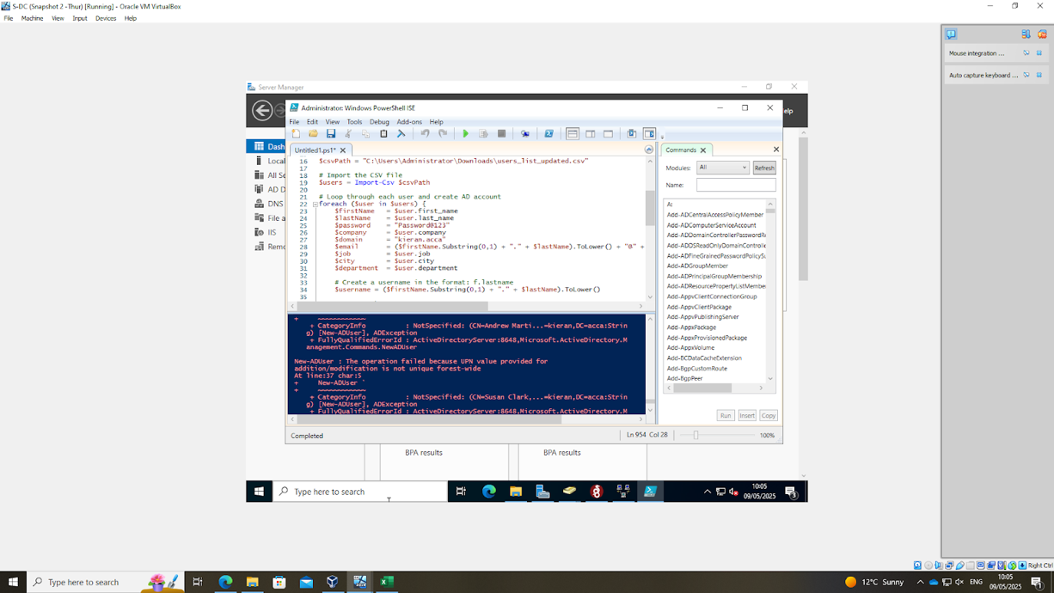

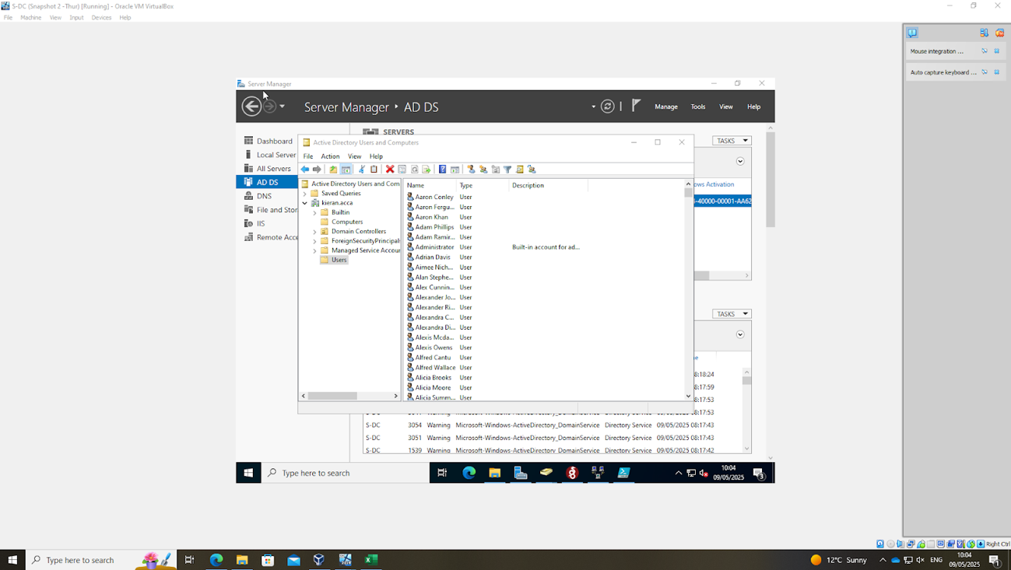

The user accounts for the domain were created using PowerShell, following the naming convention: first initial, dot, and last name as specified in the users_list_updated.xlsx file

1.7. Mount second disk drive to D:\SwanseaFiles.

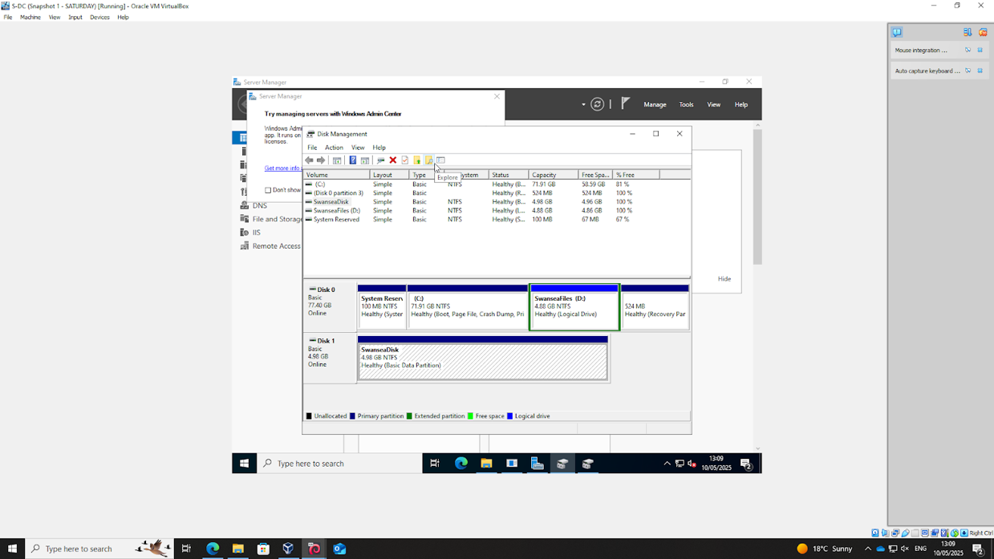

The second disk drive created and was mounted to D:\SwanseaFiles to provide dedicated storage space for shared files

1.8. Configure DHCP Services. The range is 172.16.1.10 – 172.16.1.20. Determine other DHCP options as per the infrastructure.

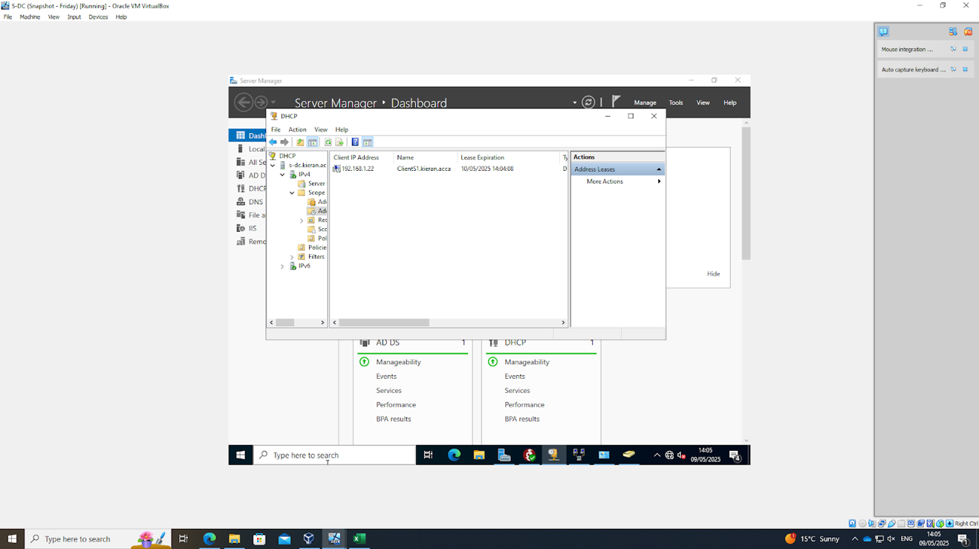

DHCP Services were implemented with an appropriate IP address range, and options such as the default gateway and DNS server were set, with 192.168.1.1 specified as the domain server.

1.9. Join the ClientS1 to yourname.acca domain.

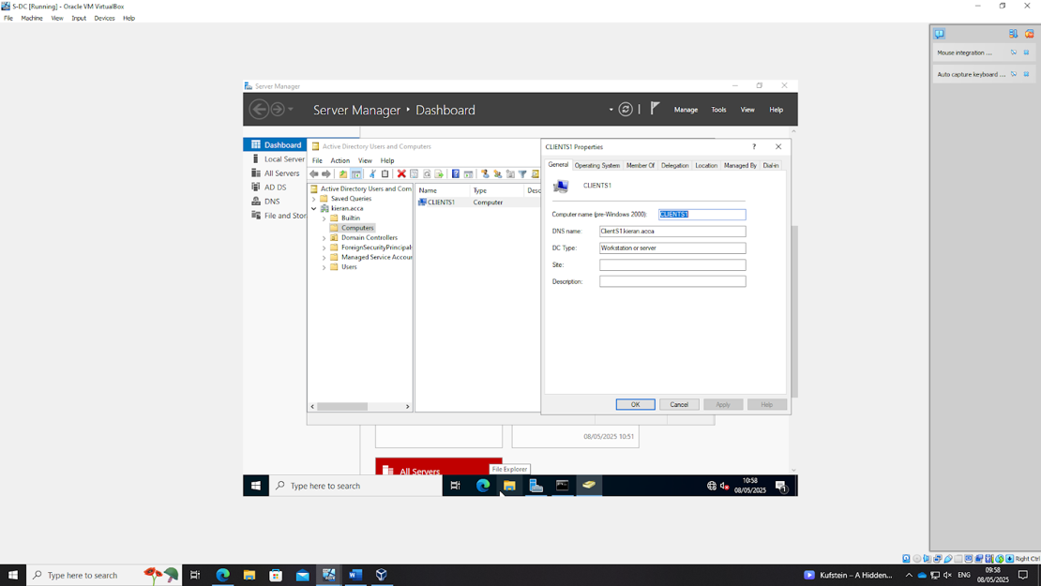

ClientS1 was successfully joined to the domain, allowing it to authenticate and communicate within the environment

1.10. Assign ClientS1 with DHCP IP Address.

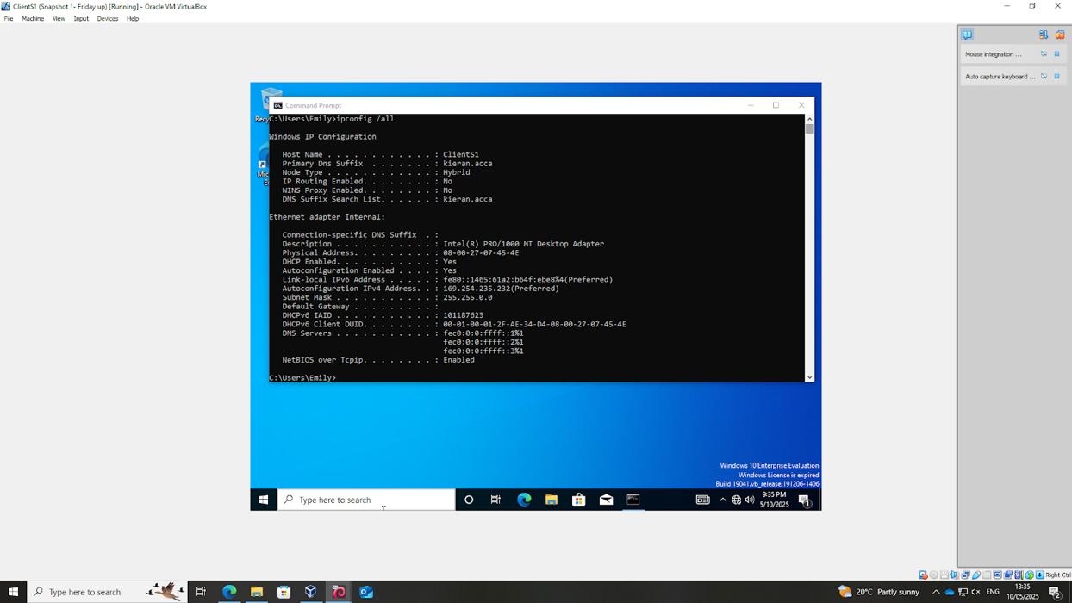

ClientS1 was assigned an IP address via DHCP, which resulted in an Auto Configuration IPv4 Address of 169.254.235.232, indicating that the DHCP server successfully provided an IP configuration
Cardiff Network

2.1. Install Routing and Remote access Service (equivalent) and modify firewall rules to allow ICMP Traffic.

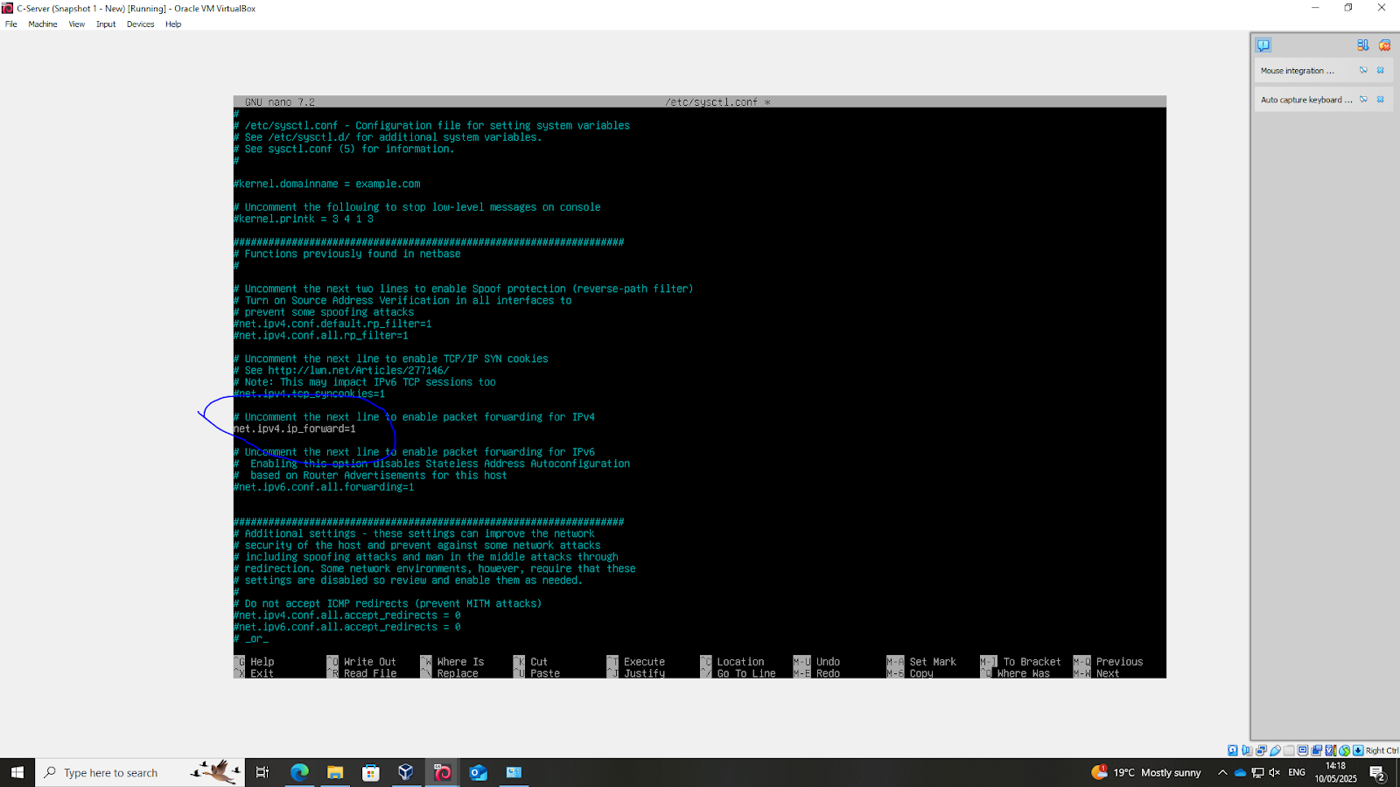

The routing and remote access service was installed on the Linux server, firewall rules were updated to allow ICMP traffic to flow which enabled network communication.

2.2. Configure Site-to-Site VPN to Swansea Network. Set the connection type to “persistent connection”.

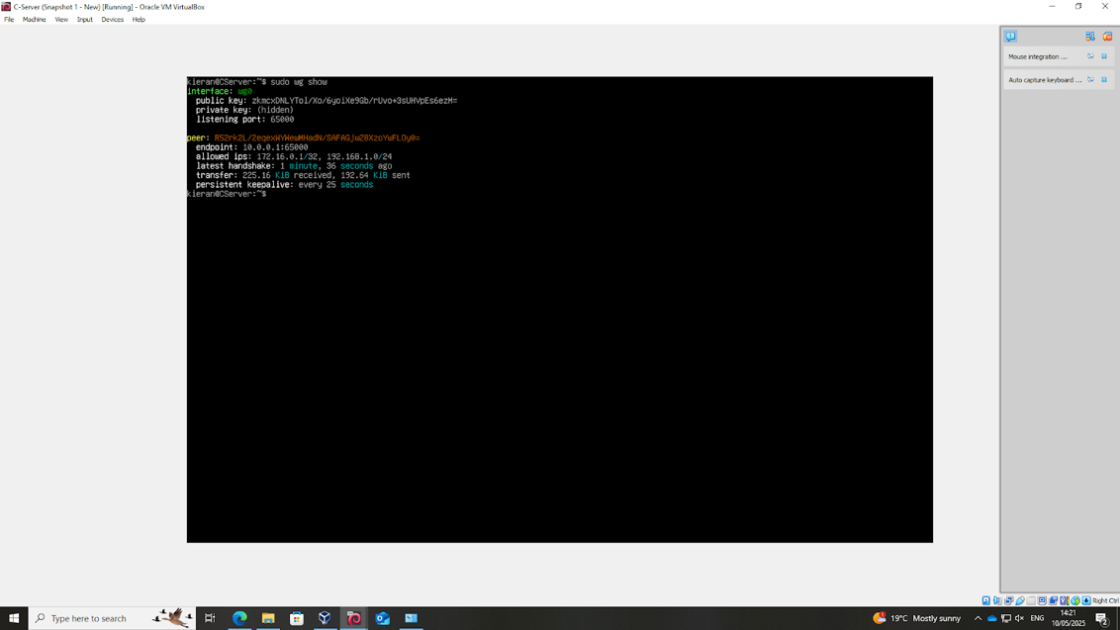

A site to site VPN was configured using WireGuard to connect to the Swansea network

2.3. Create a child domain named car.yourname.acca in yourname.acca tree (Eg: car.nitheesh.acca) or Join devices in this network to the yourname.acca domain. Justify your action.

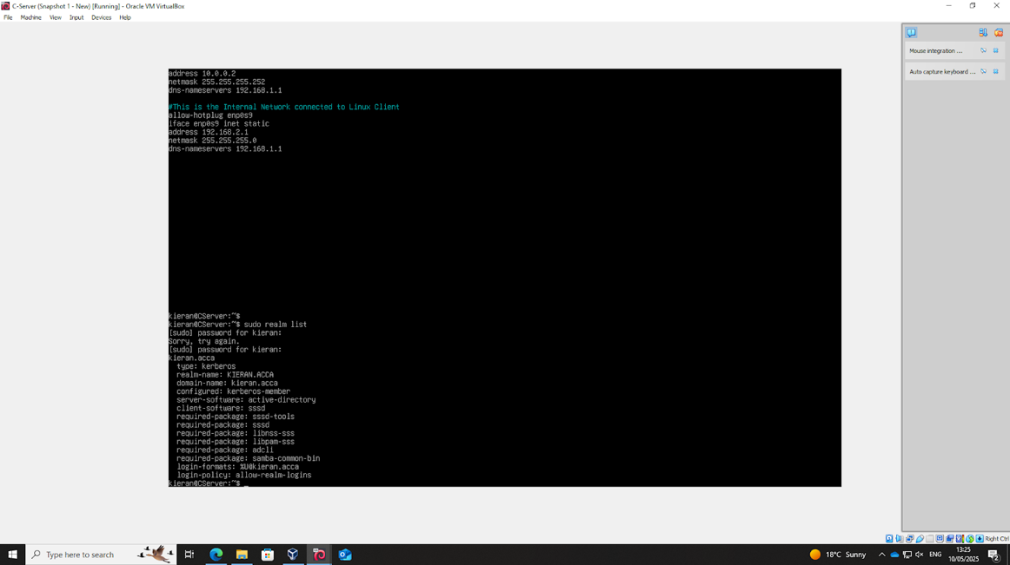

Devices in the network were joined to the domain to ensure seamless authentication and resource access across the network, promoting centralized management and security

2.4. Configure DHCP Services. The range is 10.1.1.10 – 10.1.1.20. Determine other DHCP options as per the infrastructure.

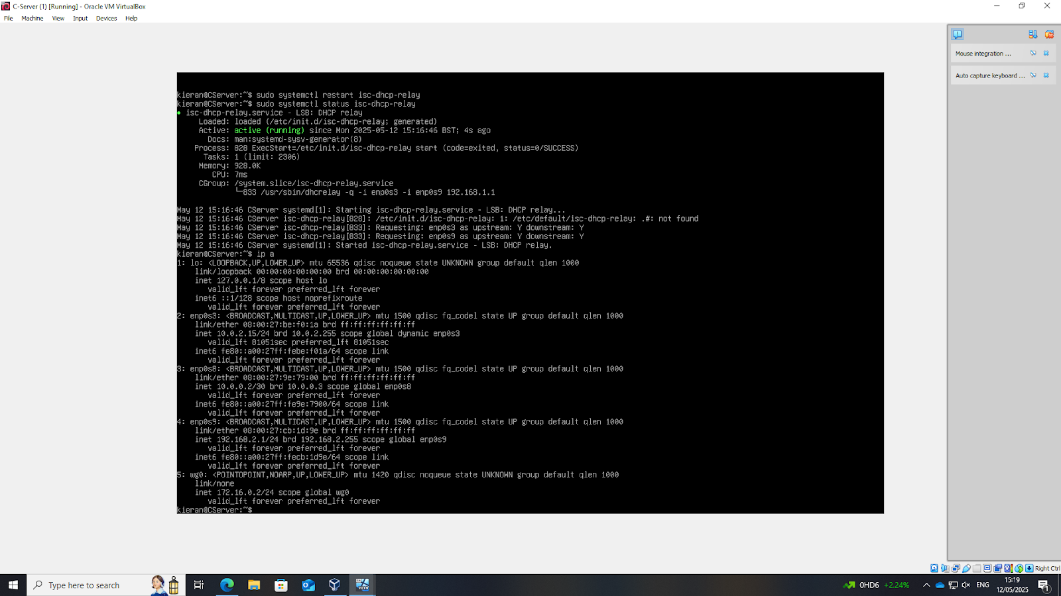

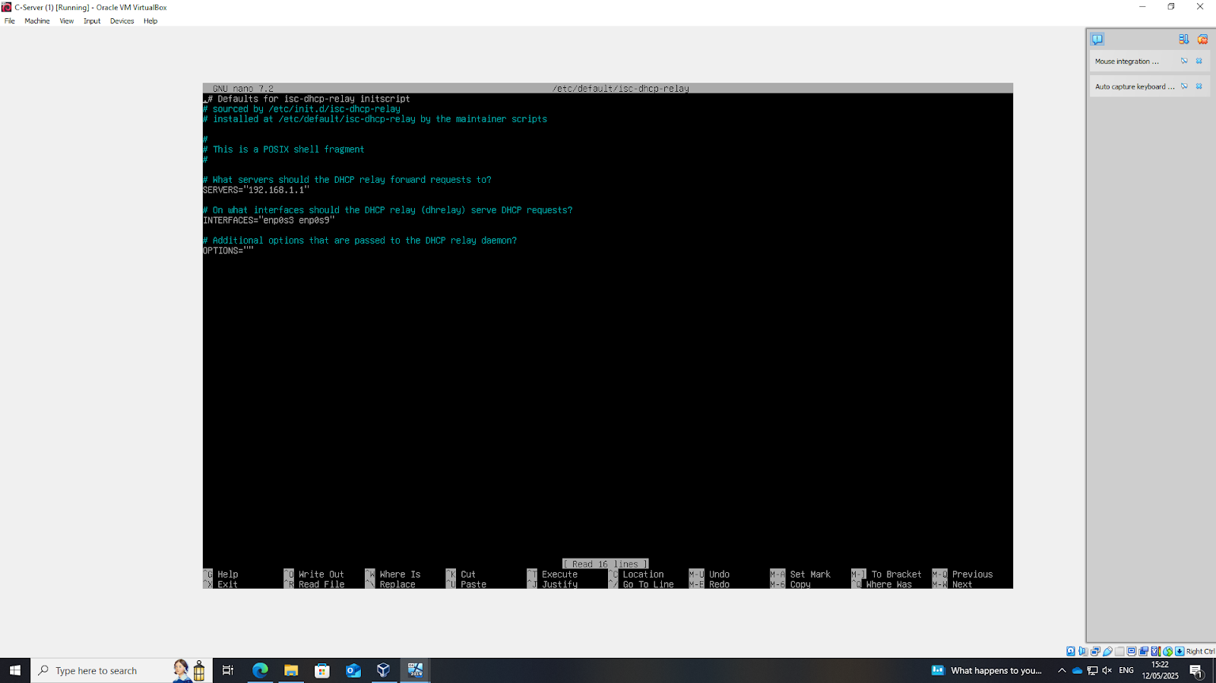

The DHCP for the Linux server was set using isc-dhcp-relay and successfully run

2.5. Depending on step no. 2.3, join the ClientC1 to appropriate domain and assign DHCP IP address.

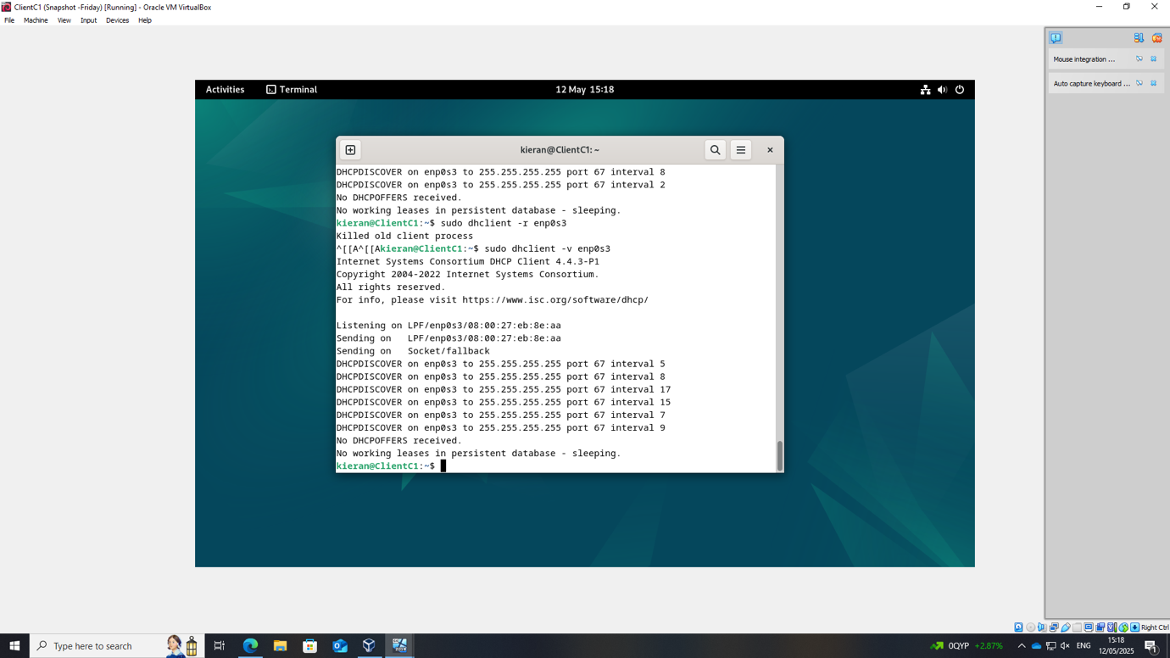

The Linux client could not locate the DHCP which meant that something must have gone wrong with the configuration either server or client side

3. Test the network for Connectivity. Note that at this stage, the Swansea and Cardiff networks are connected and fully operational. If not, Troubleshoot.

Windows Server Pings

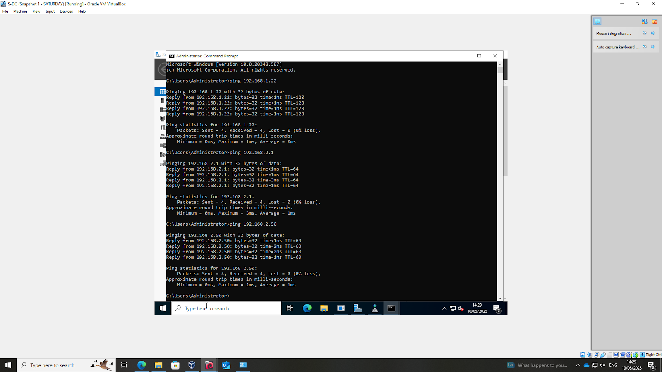

Windows server successfully pinged all members of the network

Linux Pings



Linux server and client successfully pinged all members of the networ

Windows Client Pings

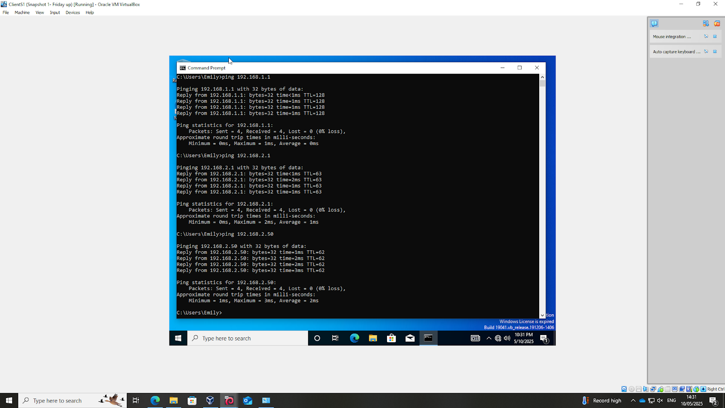

Windows client successfully pinged all members of the network

4. Sharing Disk Drive: To the earlier created D:\SwanseaFiles, set access permissions to allow users in the users_list_updated.xlsx has full control permissions and other network users have only read access. Share the drive to both Cardiff and Swansea network.

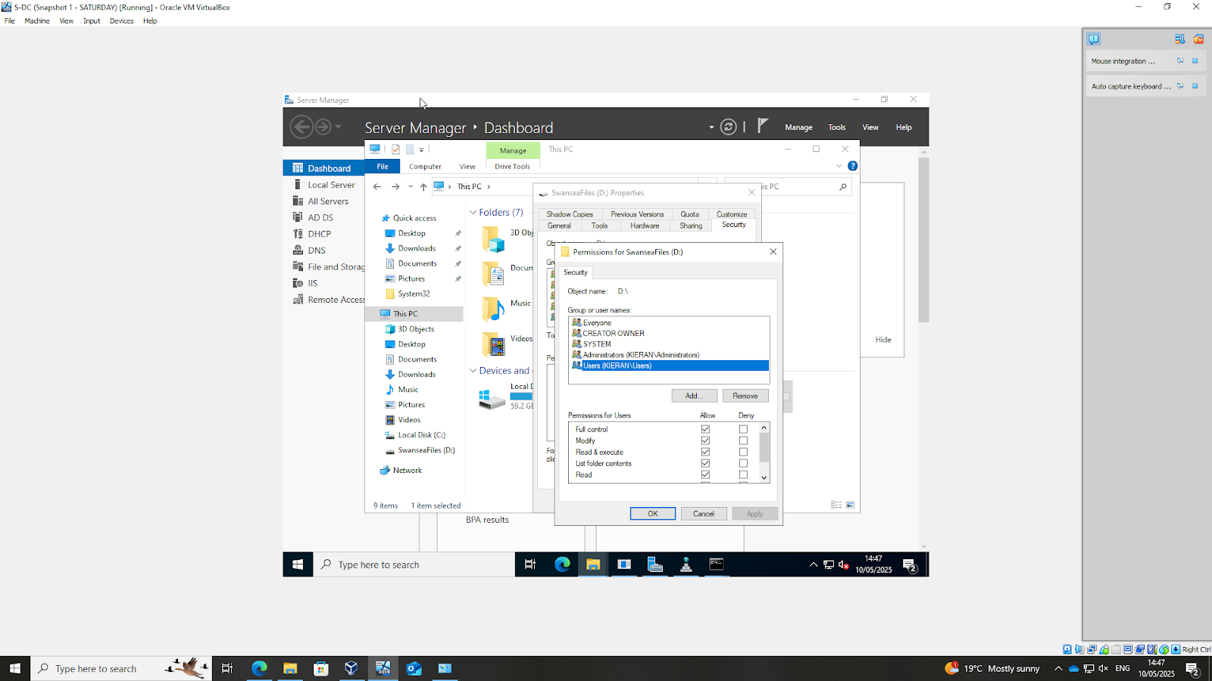

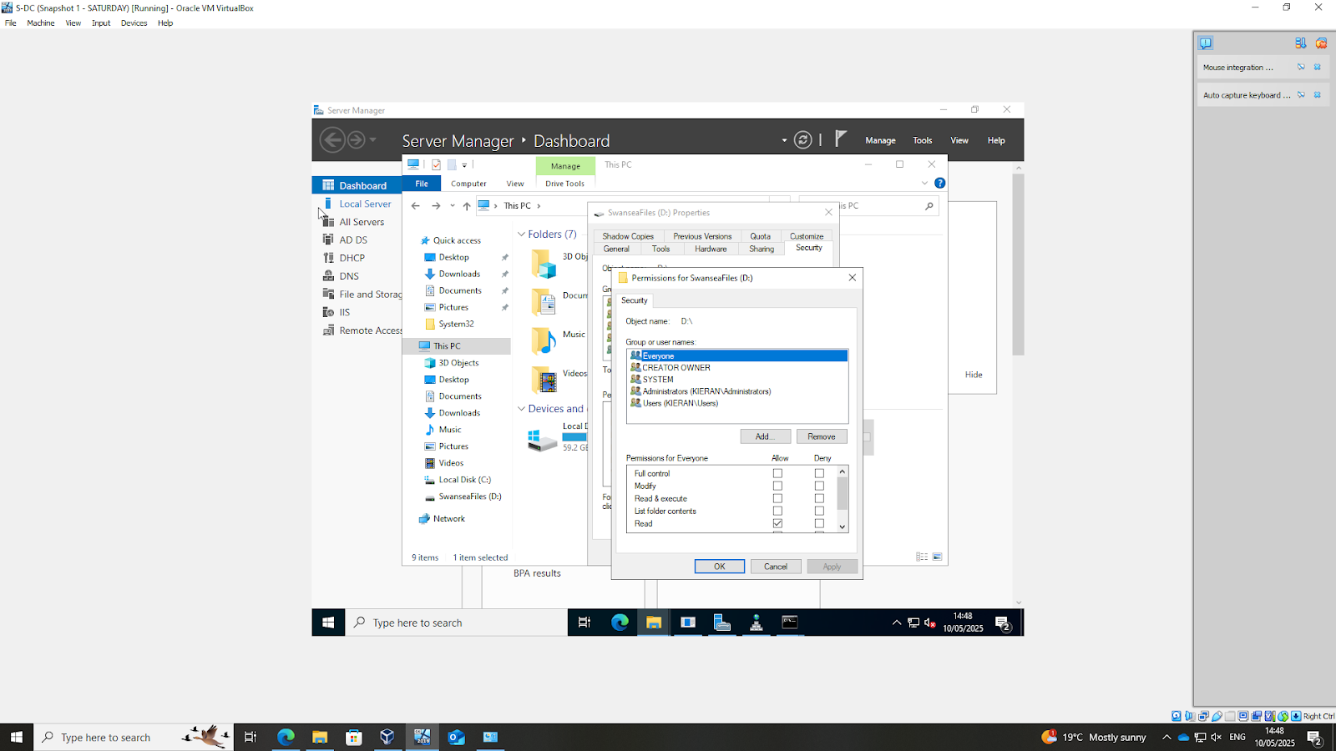

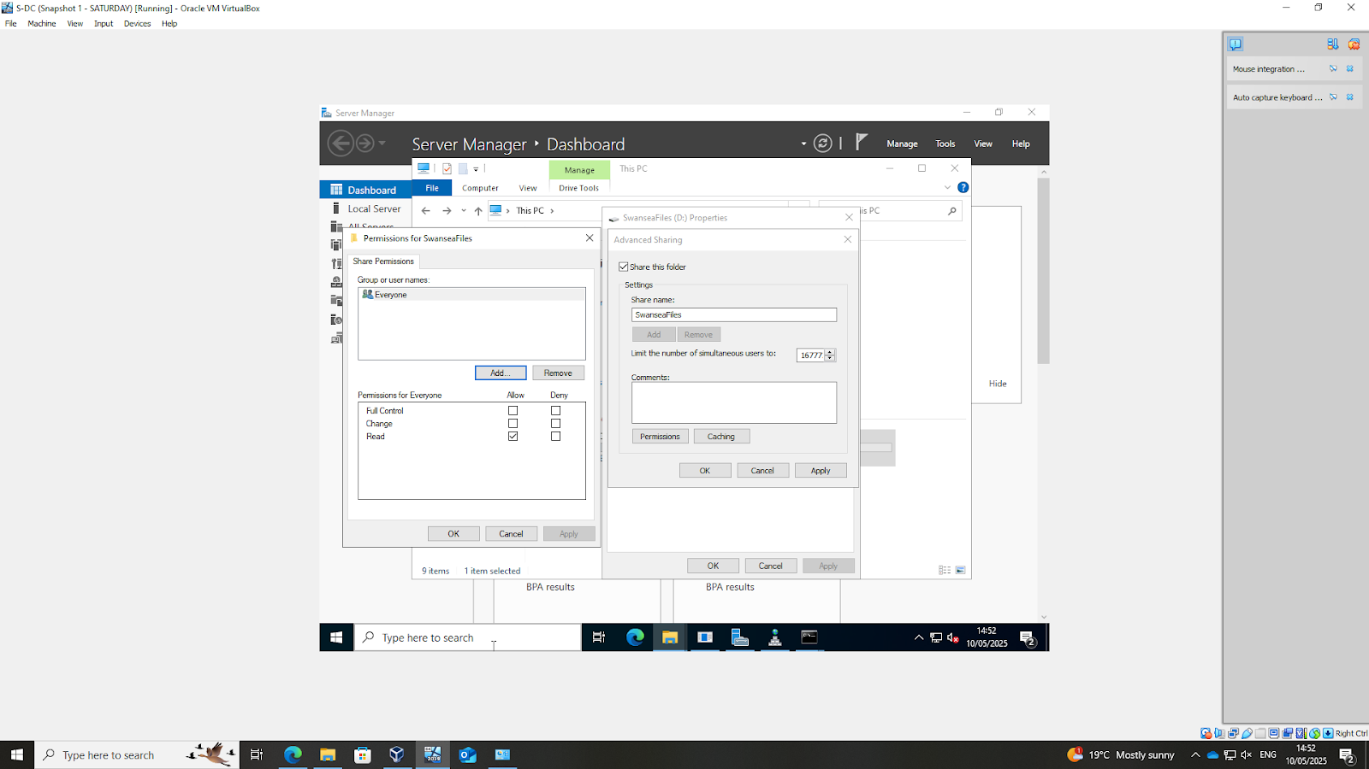

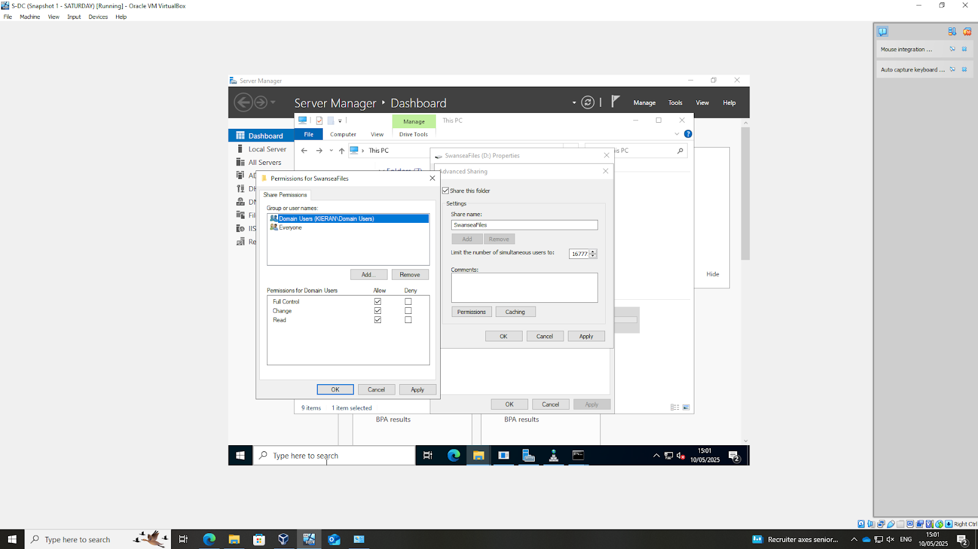

The D:\SwanseaFiles drive was shared, with access permissions configured to grant full control to users listed in the user list and read-only access to other network users. The drive was then shared to both the Swansea and cardiff networks for seamless file access

5. Configure IIS Server
5.1. Create https://webs. yourname.acca website and enable windows internal authentication.

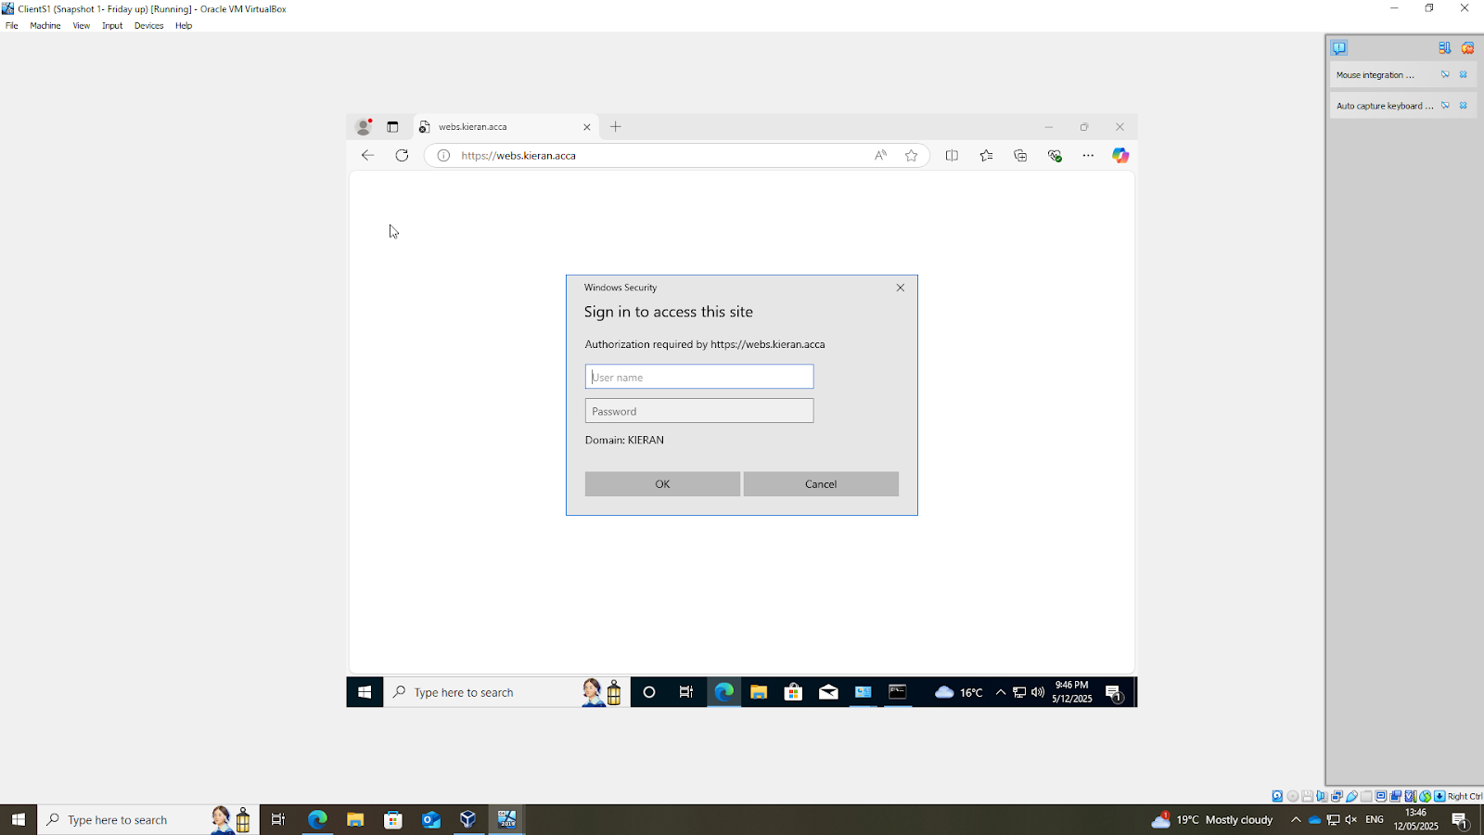

The IIS Server was configured to host the https://webs.kieran.acca website, with windows internal authentication enabled to ensure secure access and authentication for users within the domain

5.2. All the users can be authenticated.

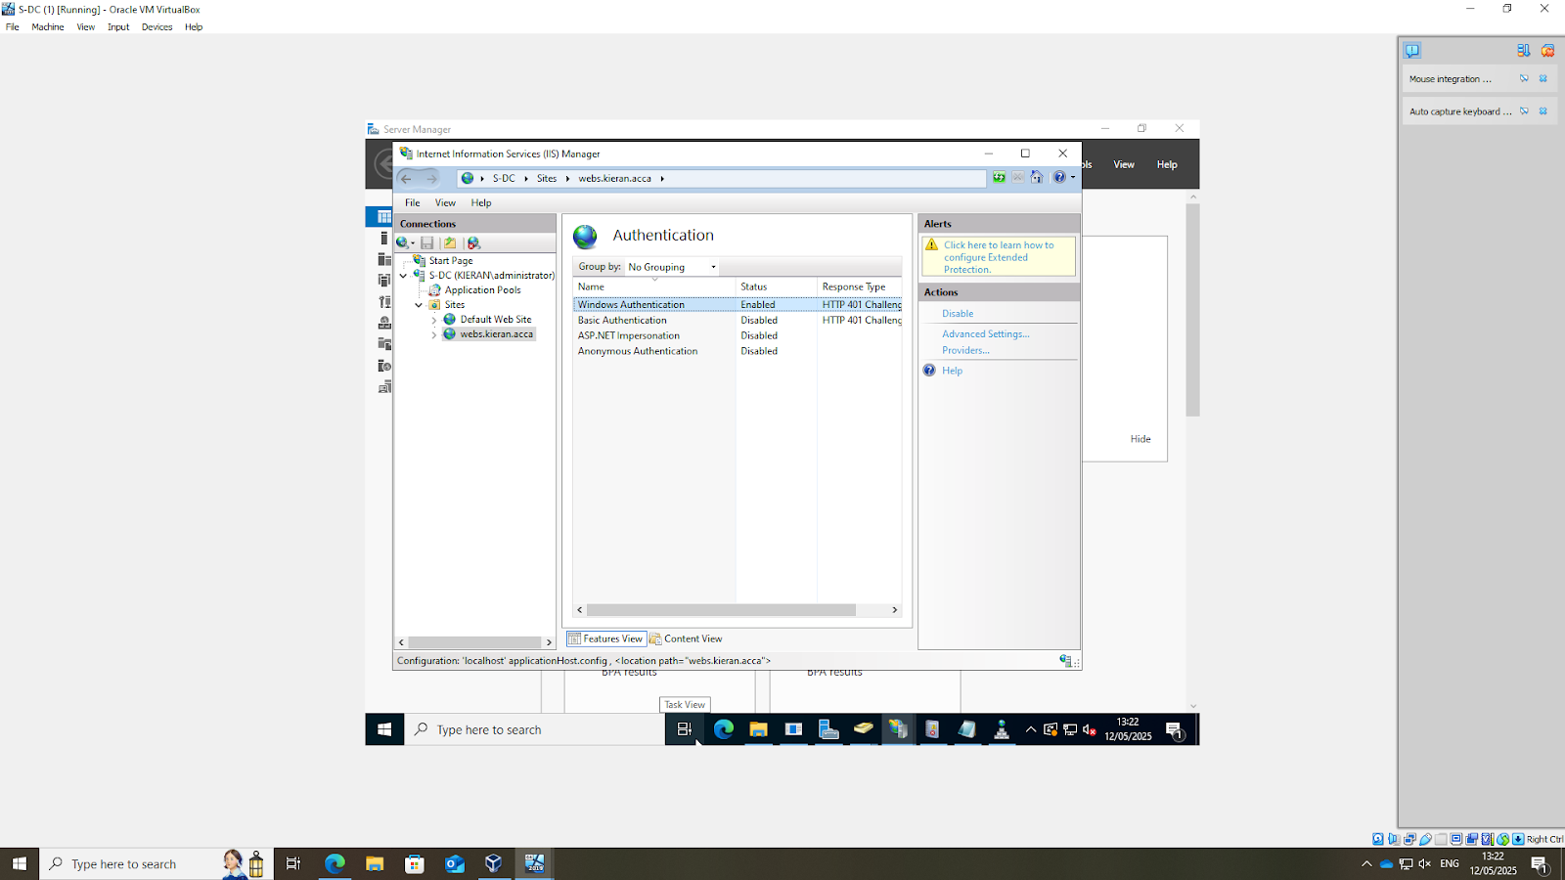
All users were authenticated by using windows authentication

5.3. All authenticated users should be presented a text “Welcome to Swansea Website”.

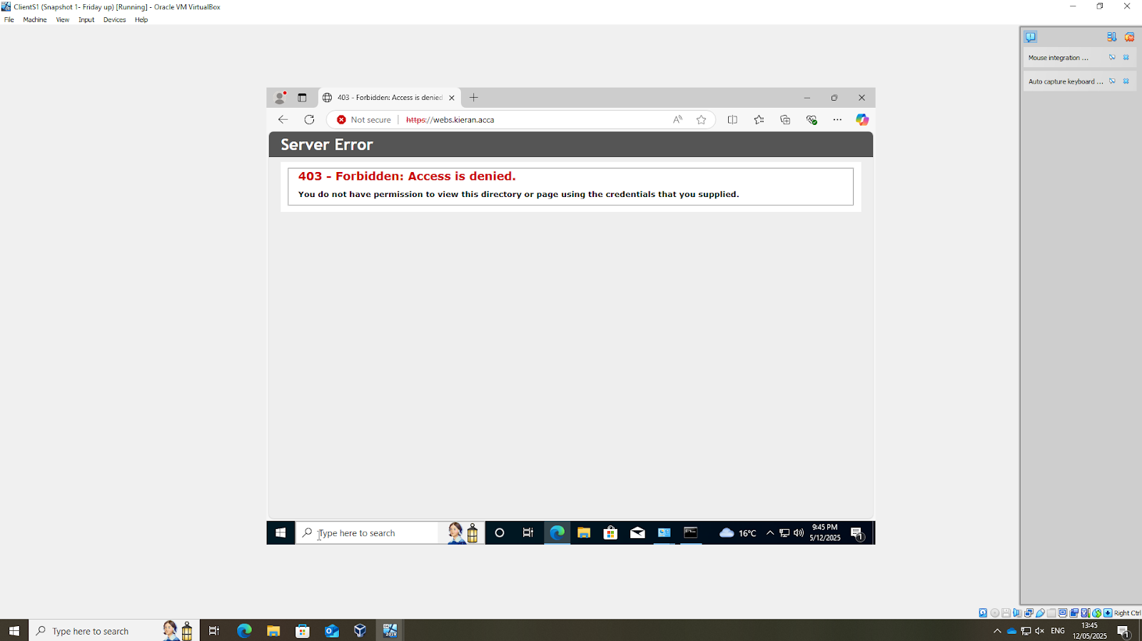

After successfully logging on using user details. The 403 access denied error message was showing which implies that something must have gone wrong with the authentication of the domain users

