Essential Skills for Study and Employment

Personal Development
Learning to utilise your strengths and weaknesses can be very powerful in the future, you will be able to assess the issues you encounter and find ways to overcome them. It is also important to work on your weaknesses to develop and overcome them by changing them from negatives to positives. Developing a realistic picture of who you are is the first step in planning your personal development, identifying your strengths, areas for development, and opportunities for development together with any threats or barriers to achievements [1].
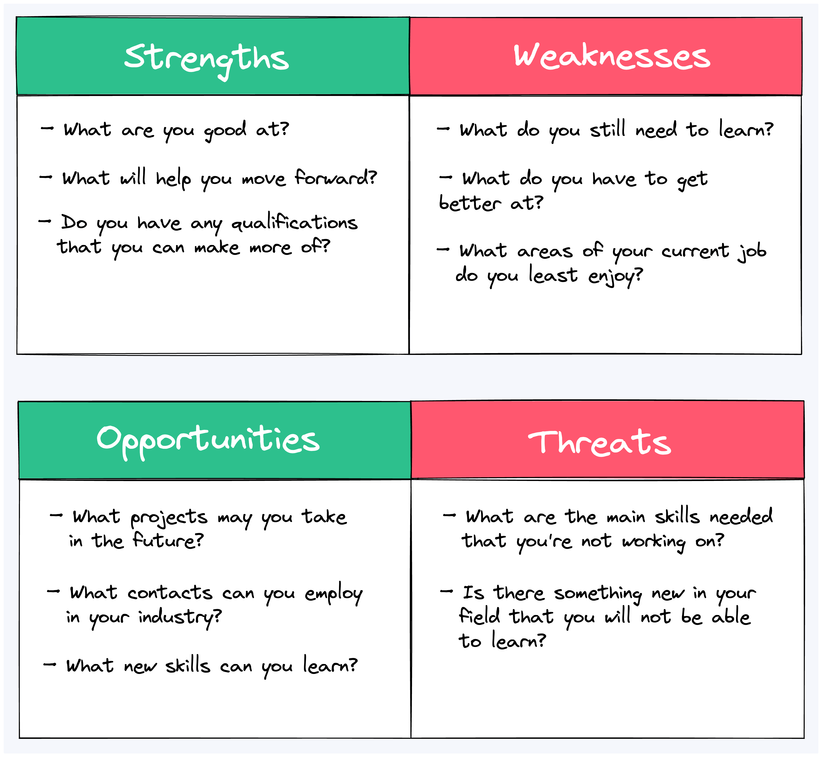

Time Management
Improving your time management can give you a better perspective on forthcoming activities and priorities, more opportunities to be creative, less stress, more leisure time and greater achievements of goals and objectives. As a student you need to plan your academic workload, employment, social life and domestic commitments so that you allocate the required amount of time to all your modules [2]. This could be helpful in the future as you pursue your career, allowing you to follow a timeline that helps you meet deadlines at work or with other responsibilities. By following these steps, you can create a more organized lifestyle and find everything much easier and efficient.
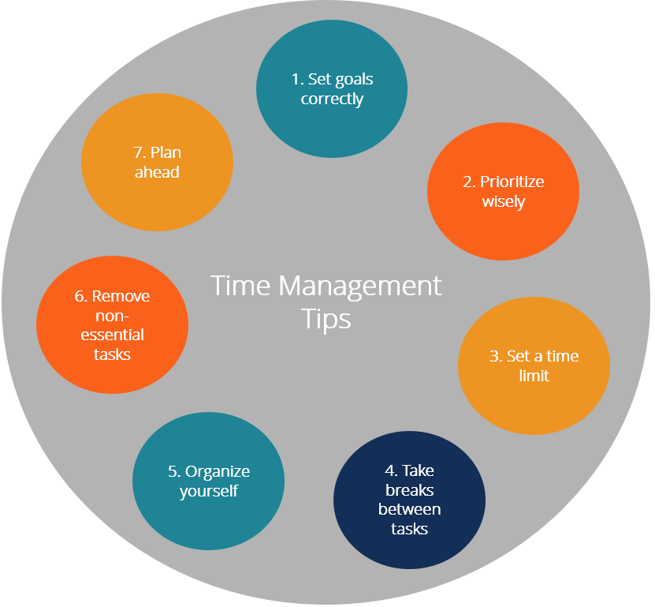

Creativity/Problem Solving
High school is the ideal stage to develop these problem-solving skills, which can later be applied to real-world issues, whether in science, technology, business, or social and environmental change. Top executives are those that employ both the right and left sides of their brains. Innovation and creative thinking go hand-in-hand with critical problem-solving. For example, I believe that we aren’t creative or analytical but rather we can be taught to think both ways. By teaching students to approach challenges with an open mind and eye towards creative problem solving, educators can enable them to identify unique solutions by thinking both visually and analytically. [3]. Developing this skillset in advance can give you a clear edge in such situations. Being a creative problem solver can be a significant advantage, especially in scenarios like interviews where you may be asked to tackle specific problems.

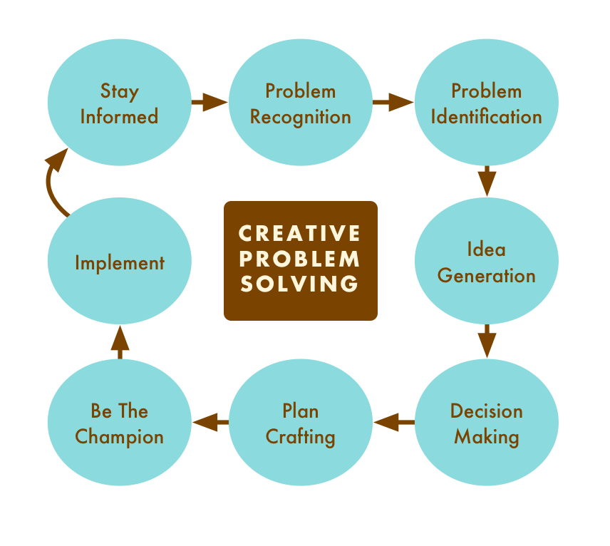

Accessing Help and Support
Universities offer various resources, such as academic support services, tutoring, and career guidance, to help students improve their essential skills. Utilizing these support systems ensures continuous improvement, better academic performance, and increased employability. Seeking assistance from lecturers, study groups, and online resources can enhance understanding and confidence in key areas like communication, problem-solving, and time management. Accessing help and support is essential for developing the skills needed for both study and employment [4]
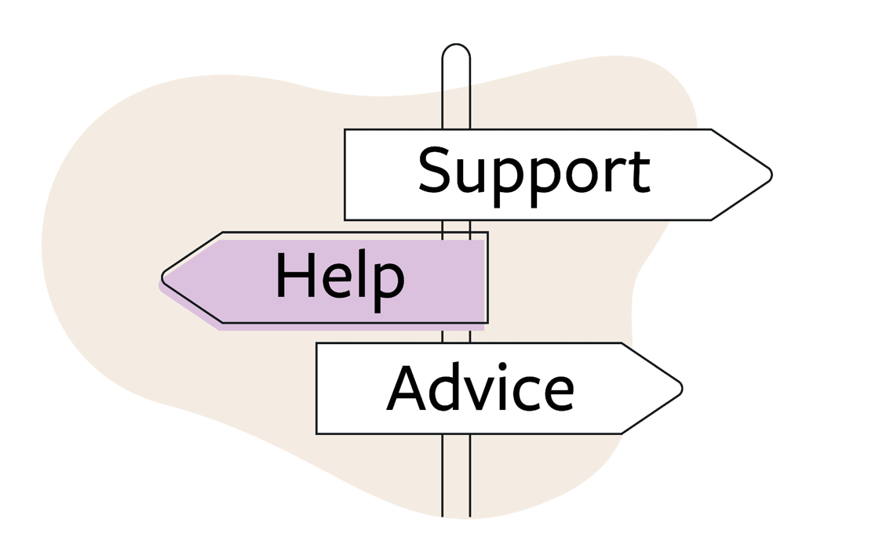

References

[1] | B. Smale and J. Fowlie, How to Succeed at University 2nd Edition, Sage Publications.
[2] | B. Smale and Julie Fowlie, How to Succeed at University 2nd Edition, Sage Publications.
[3] | LinkedIn, “Unlocking the Future: Why Innovation and Creative Thinking Should Be Taught in High Schools,” [Online]. Available: https://www.linkedin.com/pulse/unlocking-future-why-innovation-creative-thinking-should-arvin-patel. [Accessed 28 January 2025].
[4] | OpenAI, “ChatGPT, OpenAI [Online],” [Online]. Available: https://chatgpt.com/c/67a10eb6-e070-800e-94aa-09672e502452. [Accessed 03 Febuary 2025].

