￼Programme: BA Business Management
Module: Academic Skills
Module code: LCBB4006
Assignment Title: Component 2:
Coursework: Group Written Report
Group 4 Students: Mihaela Voicu (leader) ID: 2328066
Sofik Slavova ID: 2326064
Svetlin Kondakov ID: 2326084
Mihaela Teodorescu ID: 2233479

Contents
Report 1
Introduction 1
Referencing 1
Paraphrasing and Summarizing 5
Time management 8
Team working 12
Conclusion 15
References 16

Introduction
In accordance with the task requirement of the given assignment a report to be drafted shortly discussing extensively on few selected topics. A total of 4 different topics have been selected for this purpose. An elaborate discussion on time management, team working, referencing, and paraphrasing and summarising shall be carried out in the following sections. While discussing on the selected topics focus shall be given to address each topic in a detailed approach assuring complete explanation on the same. Relevant literatures and article to be considered as key references for discussing on the identified topics assuring authenticity of information through adequate referencing.

Referencing
In academic writing the task of referencing is a crucial part of emphasis for the concerned authors aiming to restore the authenticity and validity of information. Referencing is hence described as how an individual acknowledge the source of the information extracted and incorporated in personal writing work. Referencing is vital in academic as it helps to clarify the reader regarding how the author have utilised the work or published data of others to establish personal ideas and or arguments. Therefore, this process is believed as an approach to give credit to the writer(s) from whom another individual has borrowed the information or ideas (Marsh and Campion, 2018).
Referencing a vital component in the academic writing practices has certain importance. To mention referencing accurately is recognised as a vital skill of a scholar or an author. It is while drafting an assignment the concerned scholar is expected to acknowledge other author’s literacy work which is accomplished by referencing maintaining a valid format or style of referencing. Also correct referencing is academic is important enabling the concerned scholar to demonstrate the ability of reading widely on a particular topic and being able to support a given them with relevant evidences and comments from the experts. Lastly referencing of the academic sources used by a scholar is crucial as it eliminate the issues related to plagiarism thereby indicating the work produced in academic is thoroughly validated (Marsh and Campion, 2018).
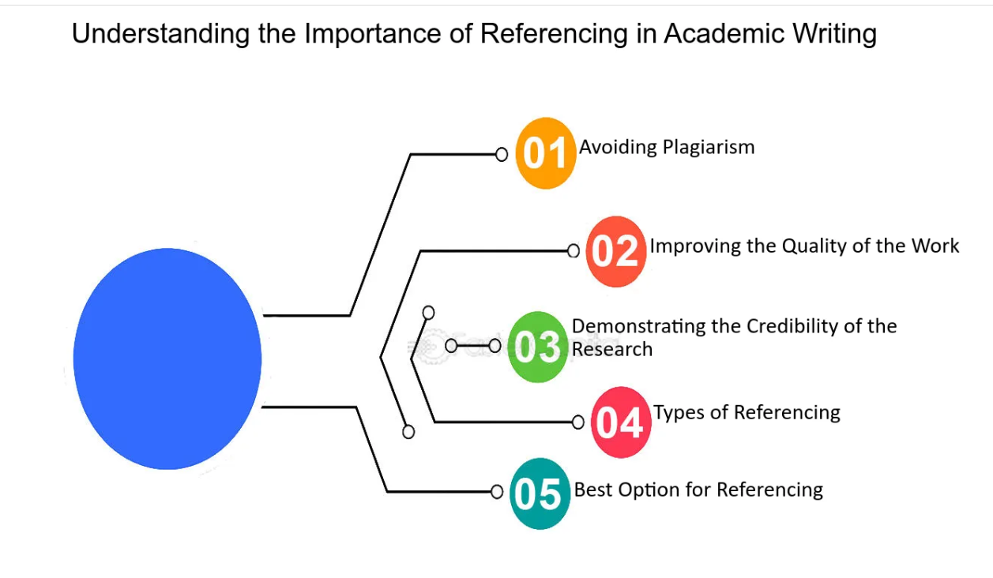
Source: (Marsh and Campion, 2018)
As indicated earlier proper referencing avoids plagiarism and hence it is important for the author to use a quotation within the quotation marks and should not be more than two or three lines. Interesting to add, in documenting an academic wrote up thee exist two distinct ways wherein the author can use a source without resulting to plagiarism. They are through paraphrasing and summarising (Silvia, 2018).

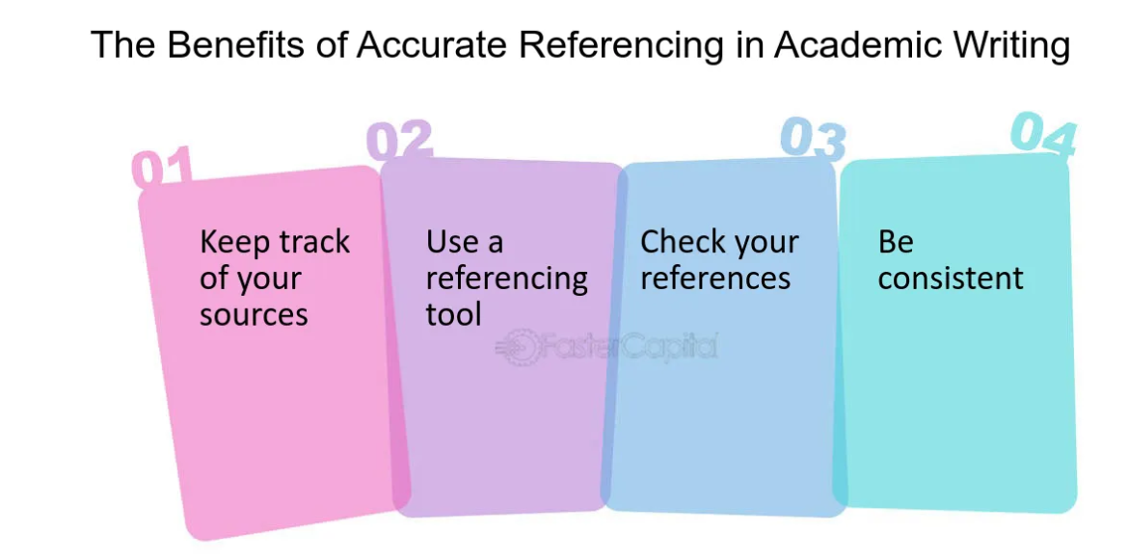
Source: (Marsh and Campion, 2018).
In the field of academics, referencing can be done using various referencing styles. Harvard referencing is one of the popular referencing styles preferred in majority of academic works. The details of the same is available to access on the UWTSD website and ‘Cite them Right’ web link which are easily accessible (Silvia, 2018).
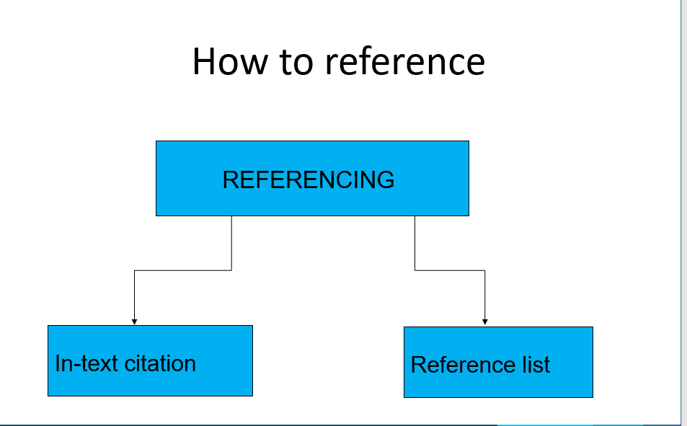
Source: (Silvia, 2018).
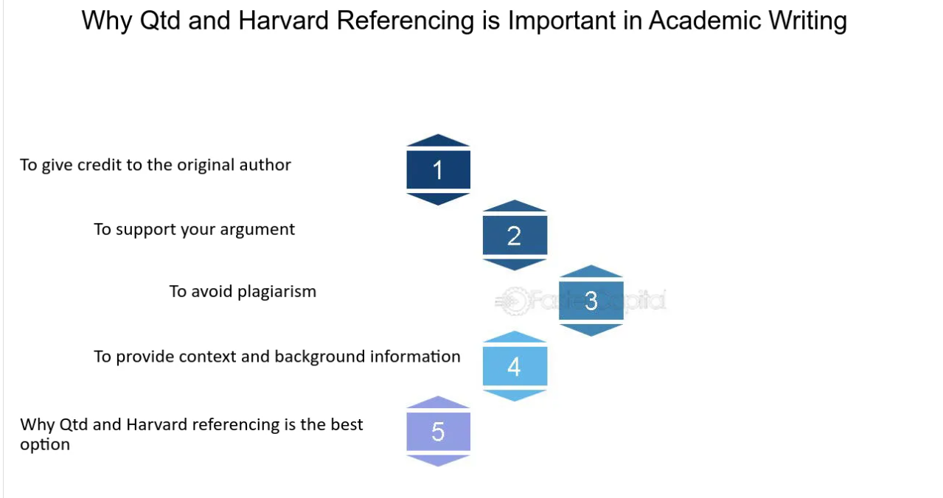
Source: (Silvia, 2018).
The process of referencing is accomplished embedding two distinct processed namely in text citation and by generating a valid reference list. In-text citation is mandatory to be incorporated within the main body of the assignment contents each time when there is mentioning of an idea or theme extracted from an outside source. In-text citation is also required while paraphrasing of a content of information is done or during drafting a summary on topic. Hence while incorporating in-text citation it is mandatory to incorporate the surname of the author and publication year. Producing a valid reference list is another crucial activity of referencing. The generated reference list is accommodated at the end segment of the assignment and it depicts all the information regarding the sources used in the main body of an academic writing work. To mention it is important to accommodate a reference list in an alphabetical manner in new page. The authors, surname with initials, publication year, title of book or article referred, place of publication and the publishers name are key inclusions within a reference list (Biber and Gray, 2016).
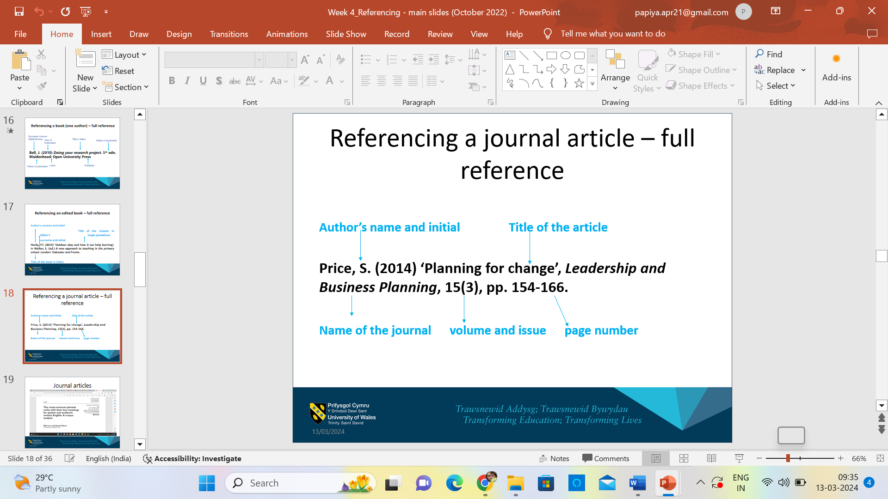
Source: (Biber and Gray, 2016.)
Understanding the key vitals of referencing focus shall be given to explore the challenges surfaced during the same. frequently it is observed that students lack knowledge regarding the different referencing styles and fall short of time citing correctly the main problem in this context is unclear understanding of the citing concepts resulting to referencing task become a highly complicated one. Hence correct referencing demand significant extent of format accuracy for which adequate knowledge on referencing styles is vital. Poor time management, lack of patience and accuracy, mental pressure to product high quality standard of academic write up, accessibility issues, absence of proper training are identified as other major challenges encountered by students during referencing. Responding to the same it is vital for a scholar to acquire proper knowledge on referencing prior undertaking such academic activities (Biber and Gray, 2016).

Paraphrasing and Summarizing
According to the definition given by Cambridge Online Dictionary, the concept of paraphrasing is to state something writing or spoken in different words focussing to keep the overall meaning of the words same or similar by using different set of related words or phrases. It can be simply defined as restating a written or spoken lines through own idea or expressions. In academics paraphrasing is important failing which chances of plagiarism dominant thereby minimising the overall quality of an academic task. Hence paraphrasing is vital while an individual is using or referring to the work of another individual to support the own view of ideas. Acknowledging through relevant references is vital while paraphrasing assuring the authenticity of a work done (Bailey, 2015).
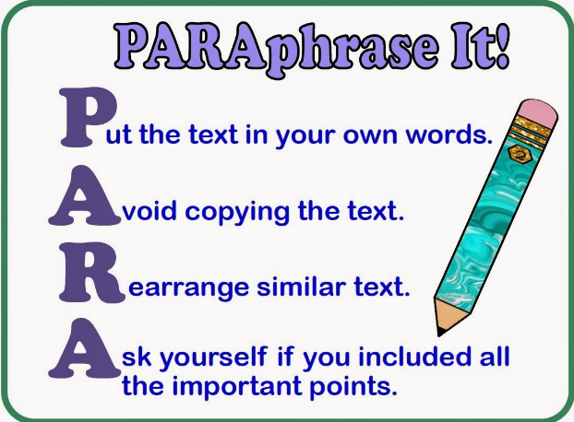
Source: (Bailey, 2015).
Exploring the key reasons for paraphrasing it can be stated that paraphrasing is important to facilitate adequate support for the claims of a word dome and adds credibility to the writing. Moreover, it is considered an approach to exhibit personal level understanding of information by the concerned scholar. Paraphrasing is also essential to eliminate chances of plagiarism (Bailey, 2015).
The process of paraphrasing come with certain techniques to follow. For example, paraphrasing can be done by using synonyms, changing word class, changing word order and or by using active and passive voices. In paraphrasing it is observed that majority of the scholars refer using synonyms for the sae wherein the students tend to highlight nouns, verbs, and or adjectives while incorporating a relevant synonym. Apart from using synonyms it is also essential to modify the overall structure of the original text assuring successful paraphrasing of a given document. Importantly it is the responsibility of the concerned scholar to assure that the paraphrased sentences are grammatically correct (Zemach and Rumisek, 2005).
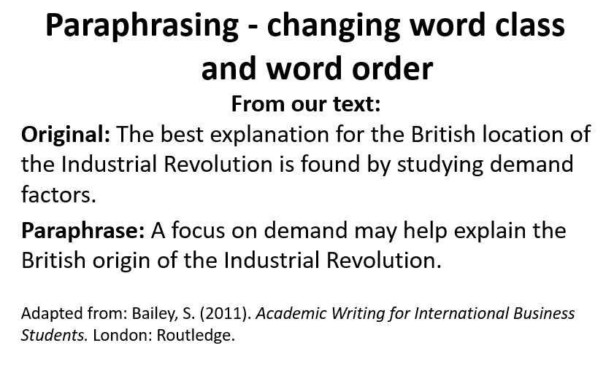
Source: (Zemach and Rumisek, 2005).
Explaining the concept of paraphrasing it is important to consider that irrespective of the techniques used in this process, the sentences paraphrased must retain their original meaning. Incorporate different structure, need to be grammatically accurate, demand correctly spelled and should be approximately of similar word counts. Inclusion of proper references is mandatory in a paraphrased work depicting the source of information extracted and the validity of the paraphrased work (Zemach and Rumisek, 2005).
A scholar while carrying out paraphrasing need to follow certain steps. To begin with paraphrasing is initiated through reading and understanding of a text, making list of the main ideas, finding alternative words for restructuring the texts to be paraphrased. This needs to follow with changing the grammar of the text, rewriting of the main idea, and finally checking of the contents written. Language of the text is crucial in a paraphrasing process and it directly influence the overall meaning of the given texts.
The process of summarising in academic is to express the key facts or ideas in short and simple sentences. This process is accomplished by reading the given text, breaking the text into smaller section, extracting the key points from each section writing the summary. Like paraphrasing in summarising, it is vital to ensure the developed contents to be grammatically correct (Betti, 2023).

Time management
The process of time management is considered as a core skill of the scholars and is considered as a process of conscious planning and regulating the time spent on tasks or activities. The practice of deadlines setting, incorporation of to-do lists are vital parameters helpful for effective time management. interestingly time management can be carried out by setting work reminders, creating a daily planner. Allocating specific time slot for each task to complete, blocking of distractions and sincere adherence to a set routine (Cottrell, 2019).
In academics’ time management is highly crucial for the students to achieve their academic goals. This skill also promotes individual level productivity and working efficiently. Moreover, embedding the skill of time management, a scholar may experience a sense of fulfilment and effective in reducing stress and or anxiety. Furthermore, an individual can set work related priorities embedding an effective time management practice (Cottrell, 2019).
An insight into the core principles of time management has revealed the fact that for successfully managing time an individual need to direct the effort properly particularly aligning with the priorities set. Moreover, it is important to direct the effort efficiently assuring a maximum output with respect to the time and energy invested. Also, efficient time management can be assured out by minimising time wastage.
A scholar intending to excel with time management need to review the use of personal time by addressing the following questions sincerely (Cottrell, 2019).

Source: (Cameron, 2008).
Time management on daily basis can be assured by listing the time needed for the daily activities on priority basis furthermore it is important to estimate the time required for daily activities and incorporate a definite time slot for planning and problem-solving activities. Emphasis on reviewing of daily planner, re-planning is vital aspect of daily time management (Cameron, 2008).
Organising skill can be linked with the skill of time management as both tend to complement each other. Organising skill can be developed by a scholar by inheriting the habit of using dairies, action logs, lists, tidy working space, organised paper works and filing system. For a student dairies and action log are considered sufficient for organising their daily activities (Cameron, 2008).

Source: (DeBeliso et al., 2022).
Several tools can be utilised to set work priorities, get organised and subsequently manage time effectively. To-do lists, The Eisenhower method, Promodoro technique, SMART Goals are cited in this context. Eisenhower matrix is a simple decision-making tool facilitating an individual to set priorities between tasks and manage time accordingly. The tasks are segregated on urgent and not urgent basis helping to effective time management. This matrix is presented with four distinct quadrants namely Urgent, not urgent, delegate and delete. An individual may segregate the works according to priorities in each quadrant thereby helping them to allocate time accordingly (DeBeliso et al., 2022).
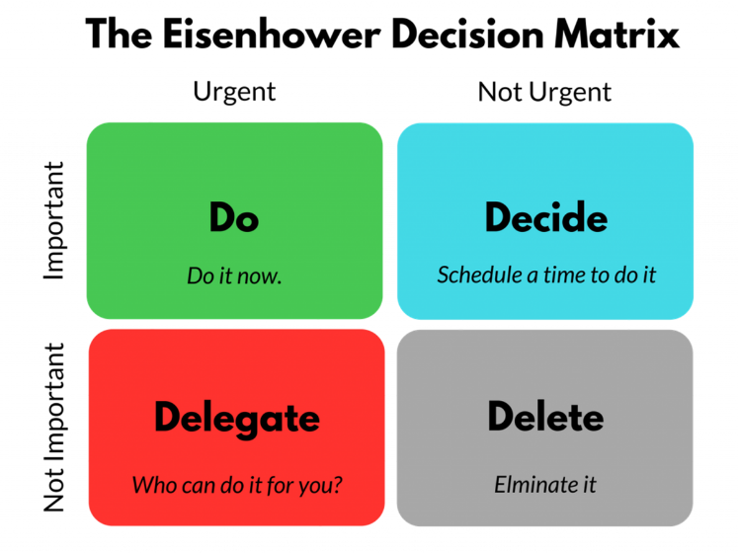
Source: (Alvarez Sainz et al., 2019).
Pomodoro technique is another time management method conceived by Francesco Cirillo providing work focussed intervals, break from work and repeat of the same process. This technique of time management has considered including intervals time slots for time for break from work after each task completed. Hence the preferred method of time management is beneficial as it improves the overall planning skill of an individual, help fighting procrastination, breaks the habit of multitasking, reduces errors in work and restores motivation of the concerned individual (Alvarez Sainz et al., 2019).

Source: (Cameron, 2008).
SMART goal setting is another important approach towards efficient time management wherein objectives are set adhering with five distinct variables. SMART goals imply inclusion of specific objectives, that can be measured, realistic in nature, achievable and can be completed within a stipulated time frame. The preferred method is beneficial for time management as it provides a specific direction to achieve the set objectives (Cameron, 2008).
Therefore, in academic, time management identified as a core skill of the student is helpful in learning and skill development process. Embedding this skill, a student or scholar can complete assignments within schooled time and also become capable of setting work priorities and complete task s in an organised manner (Cameron, 2008).

Team working
The phenomena of team working are defined as the essence of a team to achieve a shared objective and to deliver a collective performance. In teamwork commitment is important. Also, the primary focus on to solve problems and building mutual trust. Team working is considered as a vital skill to be embedded in academic wherein the scholars are enormously benefitted by the same. To begin with teamwork, facilitate higher degree of work productivity and support network. Team working tends to promote innovation and creative skill development within the scholar helping them to excel in academic. Furthermore, on professional ground, team working ability delivers job satisfaction. Attracts talents and contribute in establishing strong relationship while working as team member. It is observed that by nurturing this skill the quality of work outcome is improved along with promoting flexibility in working regime (Maund, 2017).
Intending to explore the fundamentals of team working few models can be highlighted. Tuckman’s team development model can be cited in this context. The referred model was conceived by Bruce Tuckman in 1965 which has been popular and accepted globally to understand the team development process. According to this model, team formation is carried out in a sequential manner comprising of four distinct stages, namely forming, storming, norming and performing. The forming stage identified as the first stage of team development facilitate first time meeting of the team members wherein each member considers assessing others. Forming stage of team development demands application of formal leadership practices (Tuckman, 1965).
The next stage of team formation identified as storming wherein the members are likely to enter conflicting situations that further help the to sort out their respective team roles and responsibilities, at this stage the involved team members may resist the task on an emotional level. Norming, recognised as the third stage of team development wherein cooperation within the team members is required. At this stage mutual conflicts and differences of opinions are resolved and views are exchanged formally. The fourth stage of team development is performing identified as a crucial stage. At this stage primary concern is to execute the teamwork efficiently. The team roles allocated are flexible and fully supported. At this stage solution to the identified problem are revealed and excellence is achieved with respect to standards of working. Application of external leadership is reduced as the team is now capable of self-managing its team members. Performing stage of team development is passed on to the final stage called adjourning. At this stage the team members are gradually dispersed with an aim to form a new team to accomplish another team objective (Zirar, et al., 2023).
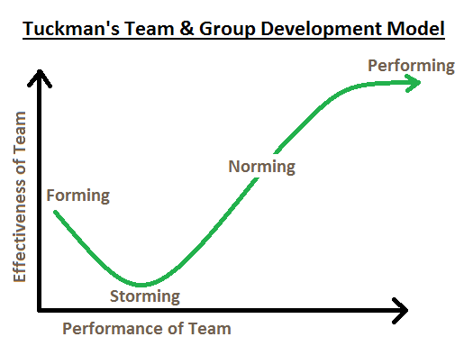
Source: (Tuckman, 1965).
Although team working is crucial for academics and professional ground but the team is also vulnerable to experience certain challenging situation. Issues related with lack of commitment within the team members, loss of overall productivity, compromised mutual synchronisation within the team members, poor team level communication, evidences of internal conflicts and compromised leadership practices are identified as key challenges to be experienced by the team members. Responding to such challenges is important for assuring the effective team working (West and Borrill, 2023).
In team working team roles are crucial to decide which further help the concerned team to achieve its team objectives successfully. In this context Belbin team role theory can be cited. The theory was founded by R. Meredith Belbin who considered defining team roles based on few selected traits namely: intelligence, dominance, extroversion or introversion, stability, or anxiety. Adhering to such traits 8 distinct team roles were enlisted by Belbin. Coordinator identified as an important team role is concerned to coordinate the objectives and act as a two-way communicator. The team role of implementor is concerned to achieve feasible team goals and is responsible to execute the tasks allotted. An implementor is efficient, systematic, and methodical in nature. Plant is identified as another team role who is most imaginative and intelligent. Monitor or evaluator is the team role responsible for stopping the team from getting misguided in project and has a good analytical skill (West and Borrill, 2023).
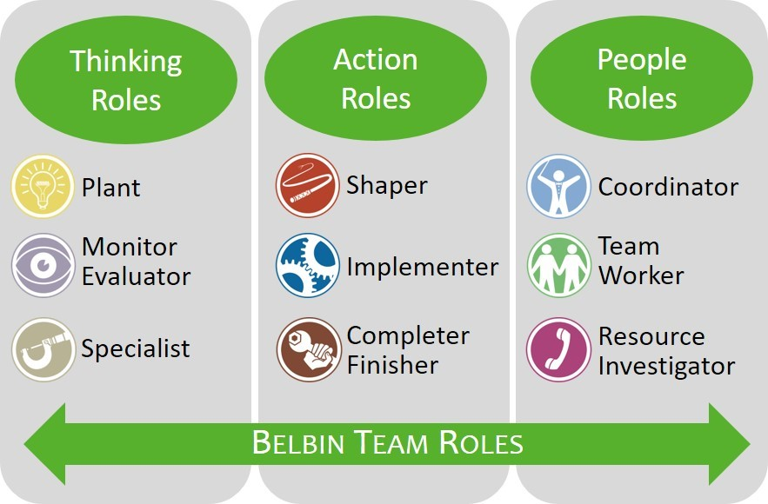
Source: (Volkov and Volkov, 2015).
The team role of resource investigator is accountable for prevention the team from losing touch with the practical situation and is evident to be sociable, gregarious, and positive in nature. The team role identified as team working is evident to be highly aware of individual requirement and emotional undercurrents within team and act as the most active internal communicator. Individuals playing the role of team worker tend to be loyal to their team and dislikes internal conflicting situations and capable of managing stressful situations. Shaper helps the team in shaping the team works by converting ideas into decisions and actions. Completer is responsible to address related with meeting deadlines and to maintain a permanent source sense of urgency (Volkov and Volkov, 2015).
Therefore, referring to the above discussed theoretical principles on team working it can be stated the team formation and deciding the team roles are crucial assuring formation of high performing team.

Conclusion
To infer referring to the above conducted discussion the process of paraphrasing, time management, team working and referencing are considered as vital aspects of academics. It is important for any scholar to embed these skills to excel in their respective academic courses. Although each of the discussed skills and attributes are distinctly important but share a common objective of improving the overall academic background of a concerned student along with promoting future academic growth and development.

References
Alvarez Sainz, M., Ferrero, A.M. and Ugidos, A., 2019. Time management: skills to learn and put into practice. Education+ Training, 61(5), pp.635-648.
Bailey, S., 2015. Academic writing for international students of business. Routledge.
Betti, M.J., 2023. Paraphrase in Linguistics. Diambil dari https://www. researchgate. net/publication/357661190_Paraphrase_in_Linguistics/cita tion/download. diakses tanggal, 12.
Biber, D. and Gray, B., 2016. Grammatical complexity in academic English: Linguistic change in writing. Cambridge University Press.
Cameron, S., 2008. The business student's handbook: learning skills for study and employment. Pearson Education.
Cottrell, S., 2019. The study skills handbook (Vol. 30). Bloomsbury Publishing.
Marsh, J.D. and Campion, J., 2018. Academic integrity and referencing: whose responsibility is it?. Journal of Academic Language and Learning, 12(1), pp.A213-A226.
Maund, A., Schreik, M. and Tinkler, P. eds., 2017. Certificate in Higher Education: Skills for the Workplace Student Yearbook. SAGE Publications Limited.
Silvia, P.J., 2018. How to write a lot: A practical guide to productive academic writing. American Psychological Association.
Tuckman, B.W., 1965. Developmental sequence in small groups. Psychological bulletin, 63(6), p.384.
Volkov, A. and Volkov, M., 2015. Teamwork benefits in tertiary education: Student perceptions that lead to best practice assessment design. Education+ training, 57(3), pp.262-278.
West, M. and Borrill, C., 2023. The influence of team working. In Understanding doctors' performance (pp. 106-122). CRC Press.
Zemach, D.E. and Rumisek, L.A., 2005. Academic Writing: From paragraph to Essay. Oxford: McMillan
Zirar, A., Muhammad, N., Upadhyay, A., Kumar, A. and Garza-Reyes, J.A., 2023. Exploring lean team development from the Tuckman’s model perspective. Production Planning & Control, pp.1-22.

