A Reflective Report on-
Managing enterprise in the 21st century
Student Name: Andre Cadogan
Student ID: 1712352

Acknowledgement:
In this assessment, I have used Gibbs model of reflection to show the knowledge, skills and experiences gained by my team throughout the teamwork. I have analysed my self-employment skill development strategy to benefit my career.

A Table of Contents
Introduction 4
Main body 5
Description 6
Feeling 6
Evaluation 7
Analysis 8
Conclusion 8
Action plan 8
Conclusion 9
References 10

Introduction
The writing of an effective business plan for a project works as an important inceptive for attracting investors and stimulates the success of the business (Chawla, 2015). For the business plan of my project I analysed various sources of information in touch with my team. To develop a successful business plan we analysed the feasibility using market research, customer demand and hence product feasibility (Parker, 2009). We made a buying intention survey to assess the likelihood of buying the products and the way they want to purchase the products from us. This method was so simple cost-effective in segmenting and identifying the target customers for our project. We also offered some of our food items to them for testing and they also provided greater feedback. These helped us to assess product demand and product desirability and thus product feasibility. This part is very essential for evaluating the viability of the business project. We gained different knowledge in our courses and also tried to apply the knowledge and experiences in the real life analysis and researches. We applied the experiences gained through the research while writing the business plan (Chawla, 2015). The skills and knowledge acquired through the courses also helped us to write a successful business plan on Bits and Bagel.
It is also necessary to have and develop some personal and professional skills to be successful in one’s career. Through the course of managing enterprise in 21st century and research I along with my team members learned many important personal skills that are essential to be successful in business. I tried to acquire and develop those skills to make an effective business plan and hence be successful in the project.

Main body
In this assessment, I am going to use Gibbs reflecting style consisting of description stage, feeling stage, evaluation stage, analysis stage, conclusion stage and action plan stage. Using this model I have descried my observation of things and experiences that I gained. In the description stage I will describe about what I have learned in the business project. In the feeling stage I will describe my feeling and learning about the essential skills that I acquired and the skills that I lack. Then I will evaluate elements of the business plan in the evaluation stage. In the analysis stage I will describe the skills that I need to develop, then in the conclusion stage, I will reflect how I can use these skills and finally in the action plan stage, I will determine what I want to do to improve my career (Lawrence, 2008) and will take feedback from my start-up for further self-improvement.

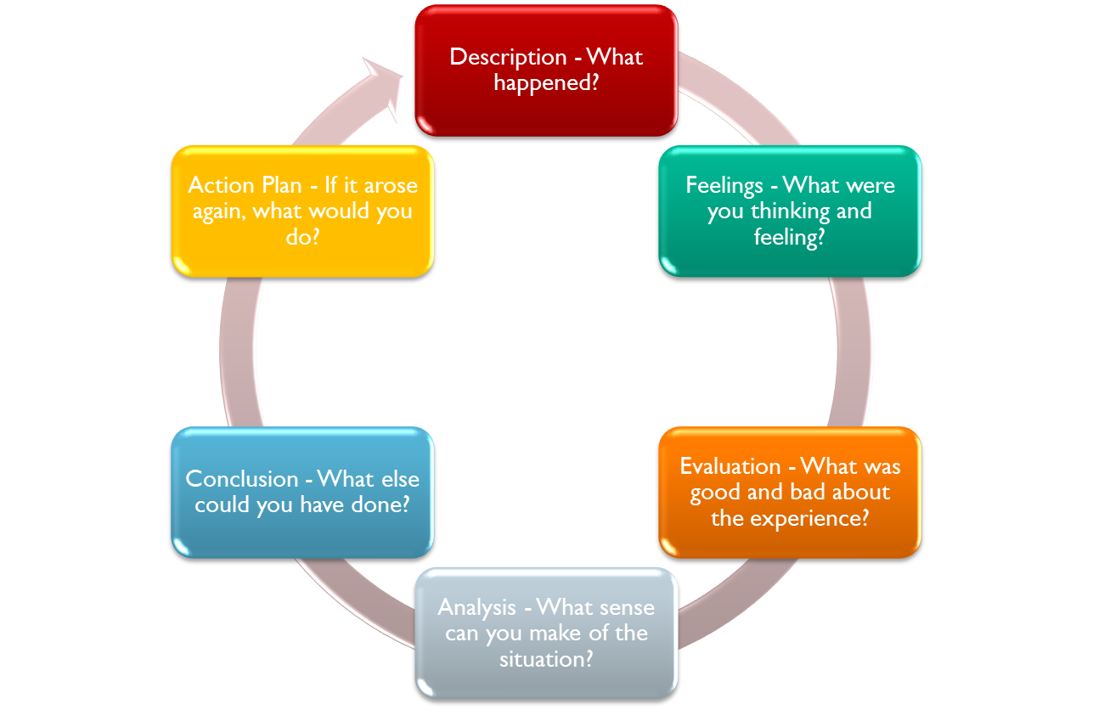
(University, 2019)

Description
This stage is about the description of particular task or segment that has been completed and particular skills that I have gained. I am going to explain what I have learned in my academic life. I have learned different skills like communication skills, teamwork, technical skills, listening skills and time management in my last course on managing enterprise in the 21st century. I learned which skills are most important to be self-employed and be successful in the venture. I also learned about the team work where I gained knowledge about how to respond in a team and collaborate with the team members. The course enabled me to directly involve with the real life experiences, taking managerial decisions and leading the team. These experiences undoubtedly help to improve my skills to be self-employed. This course also helped me to enhance my writing skill as I used to write many research reports and assignments instructed by the respective course instructor. This writing skill will help me to compose an effective business plan. The course provided us with some work simulated tests which can increase the knowledge and experiences that is required to run a business effectively. We are also provided with the opportunity to work in a group which will enable us to enhance our interpersonal skills and increasing network with different people. I participated on the case competitions where I solved many business cases and developed my critical thinking ability to solve puzzles. I have also developed my hardware and software skills when I was given tasks on preparing assignments and slides on the reports and this will work as an important capital for my business. To start a new venture one should first determine the scope of the business, how the costs will be financed and what resources will be needed. The relevant risks also need to be identified before making the plan to a viable business. However, these are the core skills that I have to have to be self-employed.

Feeling
I have gained different experiences and learning throughout the course and I have a strong feeling that these experiences have enriched my knowledge. Throughout the journey I have come to know that I have some personal skills that will be very helpful to write a successful business plan. I have develop my communication skill which can help me to effectively communicate with different people like colleagues, staff and customers and create a good relationship with them. I worked within a group and I learned how to effectively work in a team. Working in a team I have developed my leadership skills. I can now direct my teammates. I also try to listen to them clearly and make decisions respecting their thoughts and ideas. I also have critical thinking ability which helps me to solve critical business related problems. But still I have some lacking regarding managing my team works and I have to overcome this drawback to effectively handle my whole team.

Evaluation
This stage reveals the good and bad experiences that we gathered from the teamwork (Parker, 2009). We all tried our level best to apply the knowledge learned in academic course into our business plan. As an operation manager I always try to manage the operations effectively and give the finest service at the best competitive price. These all are possible only if the functions of my teammates perfectly incorporate with my operation such as financial operation, capital management, and human resource management, marketing and sales. We have performed different roles in developing our business plan. At first, we analysed the industry where we belong. We analysed the profitability and the competitiveness of the food industry. We found that the industry is very much competitive as well as profitable. We also tested the product feasibility and financial feasibility of the proposed business before writing the business plan. For this we prepared questionnaire and asked people to fill it. We provided some food items to them to know their taste and preferences. For the financial feasibility we made some analysis to figure out the start-up capital requirement, financing source, tenure, repayment schedule and thus the profitability of the business. Then we developed our product and turned our idea into viable business. I learned that to be a successful entrepreneur I must have passion for the business. Moreover some other skills like critical thinking ability, innovation, team management, communication, technical skills and time management are essential to be a successful entrepreneur. I tried my best to improve my communication and interpersonal skills to handle my operational activities optimally. Furthermore, I need to improve my leadership skills to effectively cooperate with my teammates.

Analysis
The practical knowledge and experiences gained on working as an operating manager in Bits and Bagels played a revolutionary part in my self-improvement. The skills I developed through the teamwork will help me in opening a new business and to be self-employed. . I always like to do things at my will and wish for a flexible lifestyle and this tendency inspires me to be self-employed. I am planning to open a new food shop in Jamaica. By opening a new outlet I can use my own ideas and thoughts. I will be able to manage the costs and reduce it to an optimum level. Working in Bits and Bagels, I had the experiences of how to satisfy customers and using this knowledge I will be able to attract more new customers at my own business. My dream job will also help people by providing good quality product and creating employment. Owning an own business can enable me to make more money than I could make working as an employee. There is also the advantage of tax deductions in self-employment. The tax liability can be lessened by several ways such as deducting the costs of health care premium or business expenses incurred. By keeping the records and receipts of the business costs and presenting it to the tax preparer, I can get the privilege of tax deductions.

Conclusion
I have learned a lot in the business planning process and my feelings after evaluating the business plan gave me the ability to implement the learning of industry, competitor analysis, team management and what not. If I am to open another business, I can now figure out what I need to do, what I should go through and how I can manage the resources need for any business idea. The project initiated by my team gave me the courage to establish the business and plan for the goals in my later life. I also think that I result of the evaluation of my skills in team business plan helped me become self-employed.

Action plan
The final stage is the action plan where I can finalize the plan into a lively outcome. As I have learned and developed the business planning process throughout the time of the project with the team mates, I have learned that I can become self-employed with the experience, knowledge I have acquired during the project planning and can establish a new project for my own employment hoarding up the resources, skills and techniques. But I analysed some loops and holes while implementing my ability in the project regarding my self-employment technique. I lack in time management, I can’t face any instant problem with 100% accuracy, and I lack analytical thinking and can’t gather much information and networking compared to the ability while I was in the group where I could gather much information and networking. So, I think I need to fill these skill gaps in case of my self-employment as well as team business planning. I need to be open-minded and always updated with the market information with access to the internet and be modest and helpful towards others so that other people can picture me as a reliable persona and my networking skill will develop. I need to take online course regarding problem solving that will help me improve my analytical ability. Thus I can be more than asset to myself for the self-employment and business planning process.

Conclusion
An effective business plan is the most integral part of a business before implementing the business project and attracting the investors for raising fund. Various factors affect the writing of a successful business plan such as financial feasibility analysis, market research, budgeting and the mission and vision of the company and so on. I have analysed my potentiality in the reflection writing and judged my ability of being self-employed. I have used the Gibbs cycle to evaluate my abilities, skills and made out what I need to do and what I should improve in my career (Bäckström and Gustafsson, 2017).

References

Chawla, K. (2015). BUSINESS PLANNING ESSENTIALS: PREPARING A BUSINESS PLAN. Journal of Advances in Business Management, 1(3), pp.93-99.
Lawrence, P. (2008). Reflecting on events. Emergency Nurse, 15(9), pp.16-18.
Bäckström, S. and Gustafsson, M. (2017). Skill, Drill, and Intelligent Performance: Ryle and Intellectualism. Journal for the History of Analytical Philosophy, 5(5).
Parker, G. (2009). Team leadership. Amherst, MA.: HRD Press.
University, O. (2019). Reflective writing: About Gibbs reflective cycle - Oxford Brookes University. [online] Brookes.ac.uk. Available at: https://www.brookes.ac.uk/students/upgrade/study-skills/reflective-writing-gibbs/

