

NAME: Iuliana Andronic
STUDENT ID: 1813619
MODULE TITLE: Marketing Essentials – M4X01916
LECTURER’S NAME: Dr. Olu Adegbite

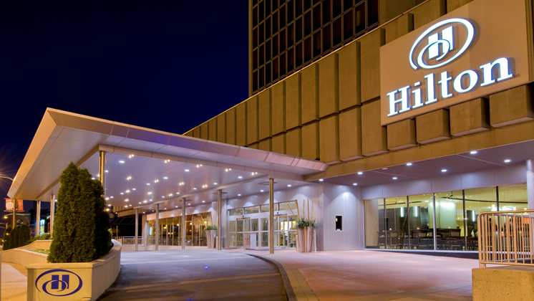

TABLE OF CONTENTS
Introduction 3
Company background 3
MIS – applied in Hilton Worldwide 3
Conclusion 5
References 5

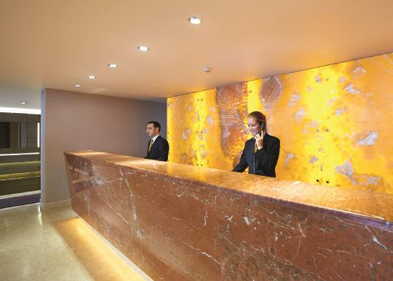

Hilton Worldwide – in-depth Analysis

Introduction

Marketing information system (MIS) has at its base the most important factor within a company, the customer segment. The marketing information system operates between two sectors: the one that the value proposition is delivered to and the one that delivers the value proposition. Nevertheless, it is a closed process because MIS gathers data from the customer, analyses it through different manners and it has to be worked on and improved in order to give satisfaction to the initial factor. The marketing research that is conducted through this whole process of MIS also “investigates the impact of marketing strategies and tactics” (Baines, 2017). However, it is not enough to be having a simple research done, while the MIS stands for gathering results, data and information from the marketing environment, developing all the details by assessing, analysing and using it (Kotler, 2017). Hilton Hotel and Resorts is present in 78 countries and more than 6 continents is one hotels than is present in all around the world, some of the top destination is , New York, Chicago, Miami, Atlanta, Boston, Hawaii, Los Angeles, Dallas, Orlando, San Diego, San Francisco and Washington DC. Everything is start with one hunter years ago in 1919 when Conrad Hilton is start to buy the first hotel (Hilton Travel, 2019).
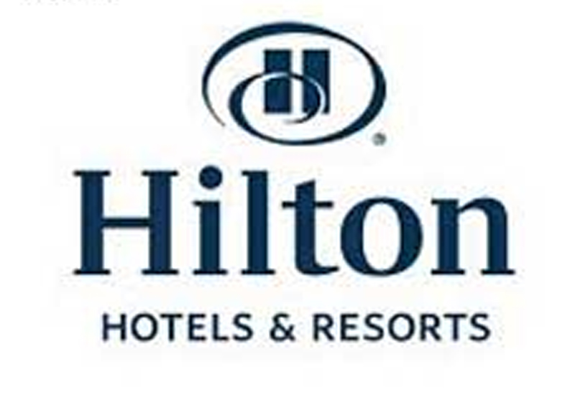

Company background

The values Hilton has come originally from its own name: H for hospitality, I for integrity, L for leadership, T for teamwork, O for ownership, N for now (the time of operating is in a sense of urgency and discipline) (Hilton, 2019). Its headquarters is in U.S.A. as this hospitality service is operated worldwide. Full of opportunities are available since the Anoff Matrix applied on the Hilton Worldwide shows us that Market Development is growing since Hilton has a lot of brands such as Double Tree by Hilton, Embassy Suites by Hilton, Motto, Hampton, Waldorf Astoria etc. (Baines, 2017). Every business is seeking for stability and for making profit. Therefore, in each situation exists risks such as not analysing the situation as it should be? A wrong interpretation would lead to disastrous wrong decisions that would affect in a very negative way the revenues. Hilton Worldwide provides us different brands that have different strategies based on the customer segment they are covering. Of course, these brands have similarities but the most important aspect between them is that they keep the values and premium hospitality service Hilton is offering. The values Hilton is to achieve by 2030 are located within the environmental external factor which affects any business by trying to decrease their footprint in nature.

MIS – Applied in Hilton Worldwide

The marketing information system (MIS) describes a specific background into even developing and expanding something or to give up on other plans. MIS is based on the information managers are required to obtain even if it is internal or external data. “Internal data usually is only of operational importance, whereas strategic decisions require information on market trends, competitor strategies and economic and political fluctuations” (Wood, 2001). Therefore, with an in-sight evaluation upon Hilton Worldwide and their strategic decisions into creating brand after brand, the result are seen in the incomes. Moreover, as the company is in a continuous development throughout the world, it is needed a meticulous research plan in order to expand the growth in different areas or regions. This progress is measured in time from the start point and where the decision has led. Any new brand or addition of a hotel to an existing brand of Hilton Worldwide is a reflection of what the marketing information system has done. However, MIS starts with the customer review or their concerns regarding the specific hotel and ends with the customer’s feedback. This way, managers can evaluate the significance and the level of their accuracy regarding tourists who are using their value propositions.
The process of sharing information on the internet surface has led to a numerous new marketing trends such as personalizing data and content in an ethically manner (CMO, 2018). As clients’ preferences are various and extensive, the decisions are now based on an algorithm built to adapt to customers’ behaviour as well as to the buying behaviour within the hospitality service. After a data base has been built, the system only transposes its knowledge into actions. These actions are interpreted as reports for managers or decision makers, charts, statistics, personalized offers sent automatically to customers etc. “Managing marketing information by means of IT has become one of the most vital elements of effective marketing” (Talien, 1995, p. 8). As here is an increasing usage of internet and its access is becoming easier by day and day, marketing managers have noticed this behaviour regarding people: the youngsters (15-35 years) are the ones who are using the internet the most even when they have a lunch break or during their journey to the work or anything. Therefore, Hilton Worldwide has adapted to the requirements and to the characteristics these youngsters have. In an urge to finding and to predicting the next move or next trend that is going to be viral, Hilton uses its resources in order to take the best out of the actual trends. “In 2019 we’ll see enterprises focused on building a seamless flow of connected customer data—behavioural, transactional, financial, operational, and more—to get a true end-to-end view of their customers for immediate action ability.” (CMO, 2018)
As data is driven from the customers, the brands Hilton Worldwide meets a couple of similarities, but they are differentiated by the small details. For example, Waldorf Astoria is a brand that focuses on the architectural details (the historical and antique one) together with the marvellous luxurious suites that are welcoming the guests (Figure 1). As a contrast-example, the Homewood Suites are the ones that put emphasize on the comfort from the residential homes with a particular atmosphere that drives to the casual one (Figure 2). Both of these two brands focus on different customer segments that are completely different (from the eccentric to the normal one). Of course, they do have the same values and cultures, but the marketing mix changed due to the different customer segment and what value they add to the heritages. So, these brands are built up (Waldorf-Astoria in 1931 and Homewood Suites in 1989) on the customers’ preferences and their needs. Paradoxical, as it is a continuous process from the customer to the managers and back (in an indirectly manner conducted by the customers feedback within the rooms rent per night or their amount on money spent on different segments and products in the hotels), it can stop when the needs of the customers’ would not fulfil their happiness or their satisfaction anymore no matter how many tries or how many decisions were made. After all, there is the buyer power that is an enormous force that could drive the business on one path or another one followed by the others from the Porter’s 5 forces (Baines, 2017). 

Figure 1

Conclusion

As a continuous fluctuation that occurs in the marketing information system, it is well-known that Hilton Worldwide needs to keep a daily track of their customers and others (such as new events, news etc.) in order to take the best decisions at a managerial level that would lead the company into building something bigger based on the forecasting of different events. Marketing information system is very important in any business since this is the best way to take care about the customers’ views upon the specific business. In other words, any company is based on this system since they are operating even B2B (business to business) where they are meeting the expectations of other businesses and their feedback (the suppliers for Hilton Worldwide for example) or B2C (business to consummator) that is taking place at the very first step of the check-in online and even after the tourist left the hotel (sending him reminders or new special offers about upcoming events that are hold in the proximity of the hotel).
Hilton Worldwide, founded in 1919 and still after 100 full years almost of operating, it is one of the best companies in the hospitality services because of their values that I have stated in the introduction (Hospitality, Integrity, Leadership, Teamwork, Ownership and Now). Their top service and premium quality products add a lot of value not only to their own brand hotel, but also to the whole corporation. Therefore, this name branding of HILTON would indirectly attract more customers because they already know the culture and values it has.

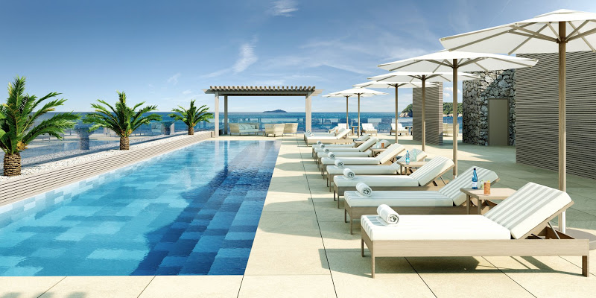

Figure 2

References

1. BAINES, P., Fill, C. and Rosengren, S. (2017). Marketing. 5th ed. Oxford University Press.
2. KOTLER, P., Armstrong, G. and Opresnik, M. (2017). Principles of Marketing.
3. HILTON (2019). Hilton Brands | Global Hospitality Company. [Online] Available at: https://www.hilton.com/en/corporate/ [Accessed 21 Feb. 2019].
4. WOOD, E., (2001). Marketing Information Systems in Tourism and Hospitality Small- And Medium-Sized Enterprises: A Study of Internet Use for Market Intelligence. The International Journal of Tourism Research, 3(4), pp. 283.
5. ABRAVOMICH, G., (2018). The 5 Biggest Marketing Trends For 2019. [Online] Cmo.com. Available at: https://www.cmo.com/features/articles/2018/12/12/the-5-biggest-marketing-trends-for-2019.html#gs.0iotsCnR [Accessed 22 Feb. 2019].
6. TALVINEN, J., (1995). Information Systems in Marketing, European Journal of Marketing, Vol. 29 (1), pp. 8 -26
7. Hilton Travel (2017). Go. Explore, available @: https://travel.hilton.com/en_us/?
WT_srch=1&WT_mc_id=zIMDPDA0EMEA1MB2PSH3PPC_Bing_search4cid91195861_aid2881191080_mp_kkwd-32910659774%3Aloc-1885Brand_TopLevel6MULTIBR7en&utm_source=Bing&utm_medium=ppc&utm_campaign=paidsearch&campaignid=91195861&adgroupid=2881191080&targetid=kwd-32910659774%3Aloc-188, (accessed 19/02/2019)

