Smart and Connected Devices II

Internet of Things – Smart Cities Applications

Austin Hooper (1700481)
BSc Computing (Software Engineering)

Prof. John Rees

13th December 2019

Abstract
The aim of this assignment was to answer the question “How can cities leverage the benefits of digitalization to relieve stress on overstretched services and resources?” This was achieved using two objectives, which were to research literature in IoT, specifically focused at smart energy solutions, and to implement a Packet Tracer simulation of an energy saving system. Research has shown that smart cities are evolving rapidly due to factors such as accessibility of hardware, improved performance, and introduction of standardisation. A solution was simulated using Cisco Packet Tracer. This simulation could be adapted to fit a wide range of applications suitable for smart cities of the future.

Table of Contents
1. Introduction 1
2. Background and Related Work 2
2.1. Smart Cities and IoT Background 2
2.1.1. Applications of IoT 2
2.1.2. Standardisation of IoT 2
2.1.3. Computer Networking in IoT 2
2.1.4. Artificial Intelligence in IoT 3
2.1.5. IoT Security and Ethics 3
2.2. Related Work 4
2.2.1. Smart Cities Implementations 4
2.2.2. IoT Smart Energy Solutions 5
3. Problem Statement and Hardware Considerations 6
4. Design and Simulation 8
4.1. Network Architecture 8
4.2. Software Implementation 12
4.3. Testing 15
5. Discussion and Conclusion 16
5.1. Recommendations and Future Work 16
5.2. Conclusion 16
References 17
Background Reading 20
Animal Requirements 20
Sensors 21
Appendices 22
Appendix A – Animal Requirements 22
Appendix B – Sensors 23
Appendix C – Simulation Notes 24

Table of Figures
Figure 1 – Prototype hardware 7
Figure 2 – Simulation overview 8
Figure 3 – WSN specifics 8
Figure 4 - Physical design 9
Figure 5 - IoT web server output 10
Figure 6 - Example tree topology 11
Figure 7 - Sensor reading 12
Figure 8 - Writing to pins 12
Figure 9 - Node mail setup 12
Figure 10 - Node mail sending 12
Figure 11 - Node LCD output 13
Figure 12 - Node server connection 13
Figure 13 - Node states setup 13
Figure 14 - Node states reporting 14
Figure 15 - Node input handling 14
Figure 16 - Testing 1 15
Figure 17 - Testing 2 15

Table of Tables
Table 1 – IoT prototyping boards 6

Introduction
This report details research into smart cities, and simulation of a smart energy saving solution for a zoo setting. This simulation aims to demonstrate how cities can benefit from IoT to relieve stress on overstretched services and resources.
Section 2 details the background and literature in IoT relevant to smart cities. Section 3 discusses the problem statement and recommends hardware devices, and section 4 discusses design and simulation. Finally, section 5 evaluates and concludes this report.

Background and Related Work
IoT prototyping is becoming increasingly accessible with devices such as the Arduino and Raspberry Pi series becoming less expensive and more feature-rich. Developments in network performance, especially wireless, have allowed for smart cities to become a reality.

Smart Cities and IoT Background

Applications of IoT
IoT now has a wide variety of applications, some examples being environmental monitoring, home security and automation, energy management, industrial / manufacturing, medical, and agriculture [1]. Some primary benefits of IoT applications are improved data analytics, increased productivity, increased security, and more informed decision-making [2], [3]. All of these benefits and applications, among many more, are shaping our cities.

Standardisation of IoT
Efforts to standardise IoT, led by the World Wide Web Consortium (W3C) [4], with contributions from many organisations such as Intel, Oracle, Huawei and Mozilla, have aided the development of IoT as an field. This allows for compatibility and interoperability between IoT hardware, platforms and applications. W3C has named this standard the “Web of Things” (WoT). Standardisation documents detail specific approaches to elements of IoT, primarily the WoT architecture [5], an API and data model [6], a WoT application layer model, and a “thing” description, describing IoT device metadata and interfaces [7]. The WoT is a continually updating standard, with the latest contributions being made by Mozilla during the time of writing, on 26th November, 2019 [6].

Computer Networking in IoT
Wireless sensor networks have enabled larger scale IoT solutions and allowed for devices to leverage the benefits of off-site services such as centralised logic, databases and cloud computing.
With developments in networking performance and capabilities, many applications are now running as cloud services. An example is Singapore implementing a smart city benefiting from cloud computing [8]. Cloud computing provides three primary benefits in context with smart cities [9]:
- Scalable services on demand
- Services are location independent – especially important for WSNs
- Guaranteed service quality

Artificial Intelligence in IoT
Many current “smart” devices are not what we would consider to be truly smart. In order for a system to be smart, it must be able to see the longer-term purpose of its functionality, which is often achieved using data science, considering properties such as data volatility [10]. IoT is expected to become a key enabler of sustainable development, though likely through incorporating AI [11].
Fuzzy logic allows for more “smart” actions based on parameters and sensor readings, by removing the true or false component, and allowing for degrees of membership. Some examples of scenarios where fuzzy logic is beneficial are wearable devices [12], temperature monitoring systems [13], and patient monitoring [13], [14].

IoT Security and Ethics
Ethics and security are a current concern in IoT applications [15],[16]. Smart cities may achieve their objectives through continuous monitoring, which is often felt to be an intrusion of privacy. Security also poses this problem, as unintended data acquisition could result in a breach of data protection laws.
The application this assignment proposes should not encounter these problems. Should an enclosure or room’s sensor readings be accessed without permission, there will likely be no impact as this information has no use outside of the system. The primary concern would be unauthorised access to the control system, allowing for control of actuators such as heating elements. This is a concern as it could cause harm to animals relying on specific habitat conditions.

Related Work
This section reviews relevant literature in both the wider area of smart cities, and in smart energy solutions.

Smart Cities Implementations
One of the best known smart cities implementations is the district of Kalasatama, in Helsinki, Finland [17]. Its goal is to explore how various IoT projects can be beneficial to smart cities, with a completion target in 2030. It is a pilot project in one area of the city of Helsinki. Some current implementations in the district are shared electric cars, smart home control, and automatic waste collection and sorting. The project has a goal of saving each citizen one hour per day, and is expected to create 10,000 jobs, while the area will contain “200 football fields-worth” of new housing [18].
Alongside this, the Kalasatama digital twins project aims to model the district area for a smart development platform and simulation [19]. This will be used to prototype smart city development. Aerial photography is being used to gather data and create 3D meshes of the district.
Barcelona has also begun implementing a smart city [20], again with a focus on sustainable growth and development. Some primary goals of the smart city are smart data, smart energy, improved mobility, improved education, and smart waste collection. Some examples of how it will achieve these goals are to implement smart lighting, heating, cooling and transport, as well as to make data more accessible.
The project takes the approach that technology is not the goal, but the enabler. It is indented to improve everyday life and be self-sufficient. The primary industrial partners are Cisco and IBM.
Tokyo is also developing a smart city, primarily focusing on smart energy, reduction of wasted resources, helping nature and the environment, and developing transport networks. These goals are in place in order to improve the productivity of enterprises, becoming a global financial city, and bringing people closer to nature, among other reasons [21].
Tokyo is also working towards sustainable energy, with smart LEDs being implemented for streetlights and other applications – though this is less of a focus. It is described as the most advanced smart city in Japan [22]. It also shows a cultural difference between Japan and many other European smart cities as it focuses more on directly aiding its citizens and businesses.

IoT Smart Energy Solutions
The approach this assignment takes is ensuring that actuators are powered only when necessary. This approach would benefit both animals’ welfare, and energy consumption.
This concept was recently explored by Marwell Zoo, in collaboration with IBM [23]. Using the Watson IoT platform, a system was prototyped, using an array of temperature sensors and machine learning algorithms, to detect occupancy in animal enclosures. Heating elements were then only powered for enclosures with animals present.
In [24], a similar concept was proposed to control HVAC systems, though these were connected in a wireless sensor network. The system was built to reduce energy usage at any given “user comfort” temperature level. The system predicted temperature over time to better manage its energy efficiency. The nodes were based on the Zolertia Z1 mote, using inbuilt temperature sensors. These communicated in a Zigbee network. A web application allowed for both temperature target input, and monitoring of temperature in real-time using graphs. This system was able to maintain temperature within a 2°C range.
Another paper took a similar approach, though on a smaller scale. P. Santos et al. [25] developed an Arduino based reptile enclosure monitoring and control system. It used custom calibrated thermistors connected to the Arduino, and relayed data back to a MySQL database and PHP-enabled web server. The goal of this paper was to improve reptiles’ quality of life in a zoo setting, not to reduce energy consumption. However, this logic could prove beneficial for energy saving as it reduces the on-time of heating elements to a minimum.
Beng L. T. et al. [26] also discussed energy usage concerns within IoT, implementing a wireless power delivery system for farm animals’ WSN-connected collars. As consumer wireless charging standards are only capable of short range power transfer, such as 2.5mm for Qi charging [27], the authors developed a wireless power transfer system with the aim of transferring power over two metres. The paper does not state whether this aim was reached. However, this approach could be useful in other areas such as power delivery for static node devices as it could reduce strain on current services due to reduced maintenance time.

Problem Statement and Hardware Considerations
Electricity can be wasted when powering devices not currently in use. This issue translates to a zoo setting, powering actuators to provide environmental conditions for animals, even when absent. As discussed further in Appendix A, many animals kept by zoos have specific habitat requirements which must be met, often by actuators such as heating elements.
A simulation will be created of a solution to manage actuators and reduce their on-time, saving energy. The proposed solution requires a variety of hardware to complete its tasks. This section will discuss the node and sensor devices. The types of sensors used consist of:
- Temperature sensors – habitat ambient / surface temperature
- Humidity sensor – habitat relative humidity
- Light sensor (LDR) – monitor external ambient light to match for indoor animals, if diurnal
- Passive infrared (PIR) sensor - detect animal presence

When the infrared sensor detects animal presence (through heat), the system will begin monitoring temperature, humidity and light, and powering actuators appropriately based on sensor readings.
See the below table summarising the three most common IoT prototyping board families, taking information from [28]–[30]:
Table 1 – IoT prototyping boards
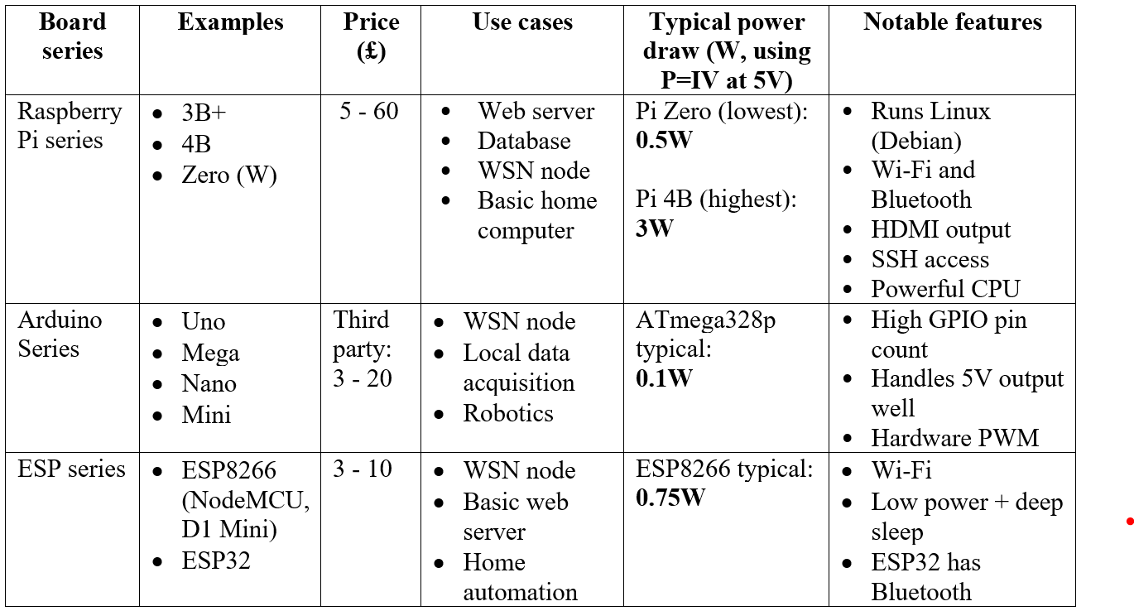

The chosen prototyping board is the ESP32 due to its low price, power efficiency and connectivity. However, a custom PCB and microcontroller would be more appropriate for deployment after prototyping.
The chosen light sensor is the A960 as it is simple to interface with and has a small form factor. For an embedded system, the ALS-PT19 would be more appropriate due to accuracy and improved voltage response.
The chosen PIR sensor is the HC-SR501 due to its wide field of view and low power consumption. For a production system, however, the more specialist AK9750 may be appropriate due to increased accuracy.
The chosen temperature and humidity sensor is the DHT22 due to its reasonably accuracy and price. In a production system, the temperature and humidity sensor of choice would be the AM2315 due to its accuracy of ±2% humidity and ±0.1°C [31].
More detail on available sensors is provided in Appendix B.

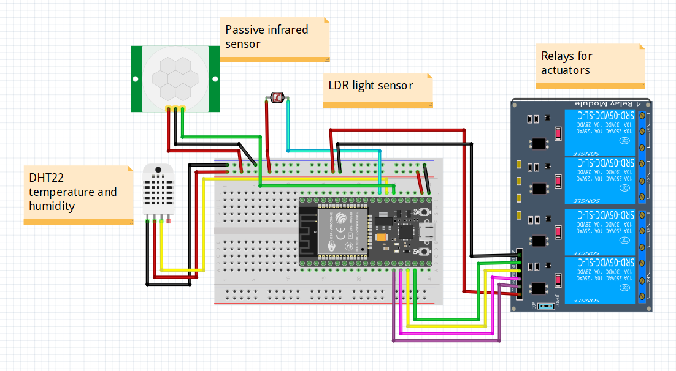
Below is a figure showing wiring for a prototype, created in Fritzing:
Figure 1 – Prototype hardware

Design and Simulation

Network Architecture
The system architecture consists of two main switches connected to the central router - a switch for handling public internet access, and an internal switch dedicated to IoT devices. The IoT switch allows for administrative devices to connect over a wireless access point to monitor and control node devices. Appendix C contains notes on the simulation for demonstration purposes.
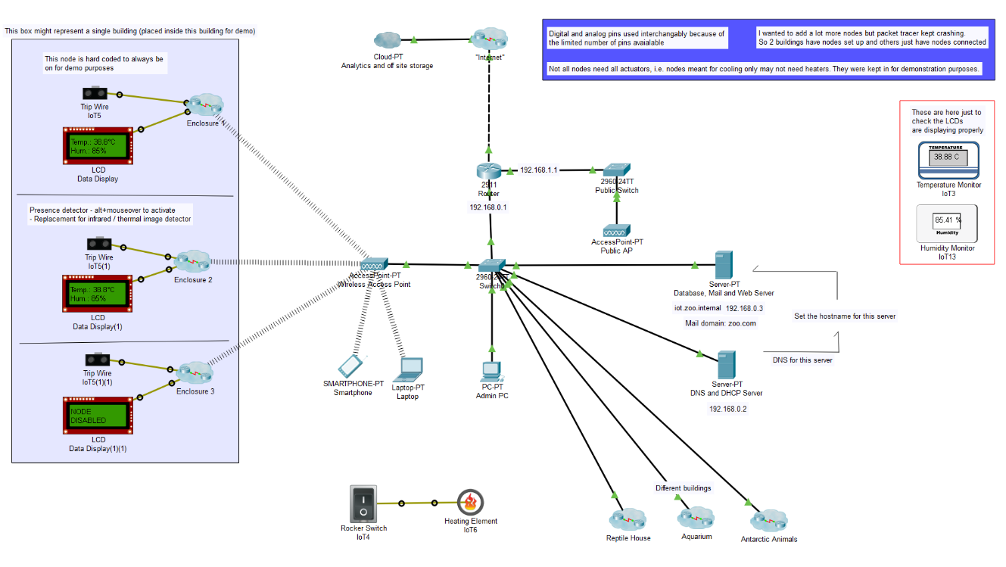
Below is a screenshot of the overall network architecture:
Figure 2 – Simulation overview
See in the following figure specifics for an individual node device cluster:
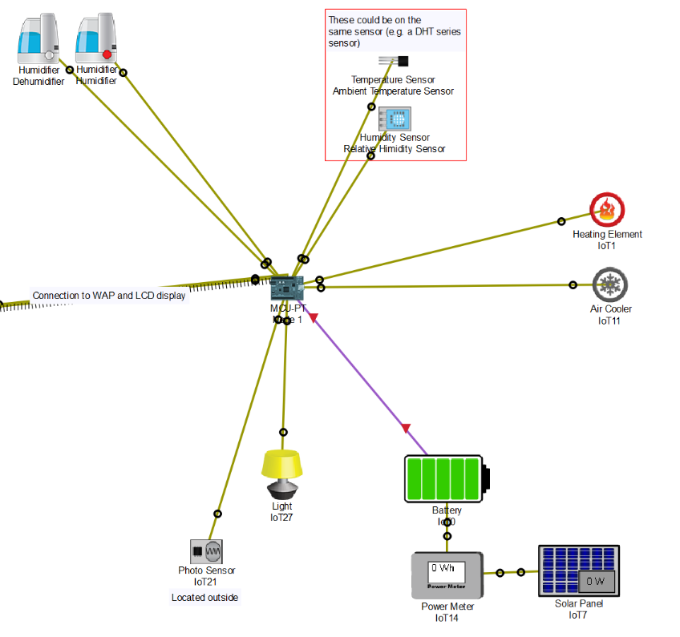

Figure 3 – WSN specifics
The physical design incorporates four buildings across a zoo, as seen below:
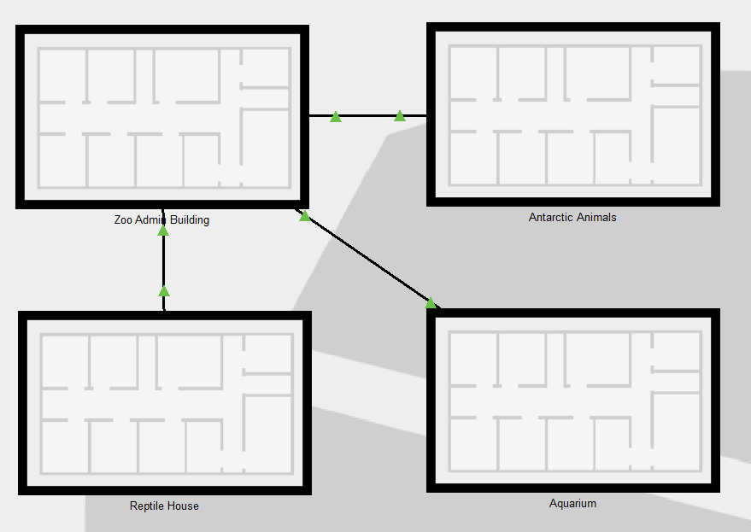
Figure 4 - Physical design

Each building contains several animal enclosures for demonstration purposes.

The web server can be accessed on iot.zoo.internal. See below output from the web page:
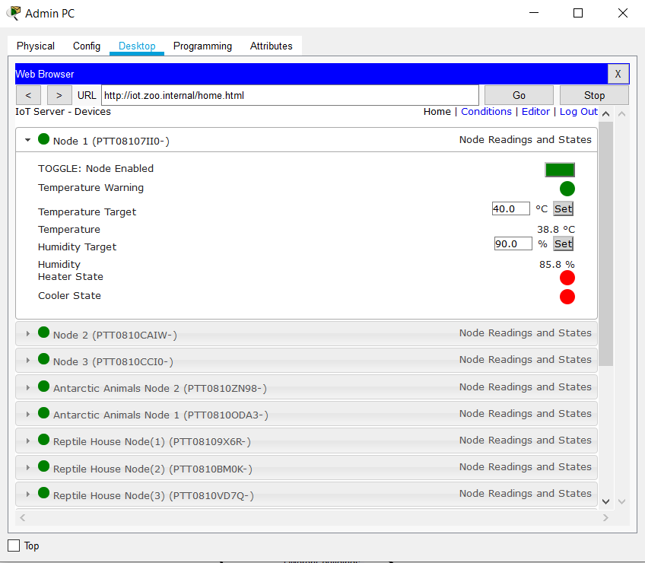
Figure 5 - IoT web server output

The simulation uses a tree topology to allow for greater distance between the nodes and the server without packet loss. However, this was only implemented in Packet Tracer using wireless access points, wired to a switch, as sink nodes. These sink nodes would ideally be additional sensor nodes.
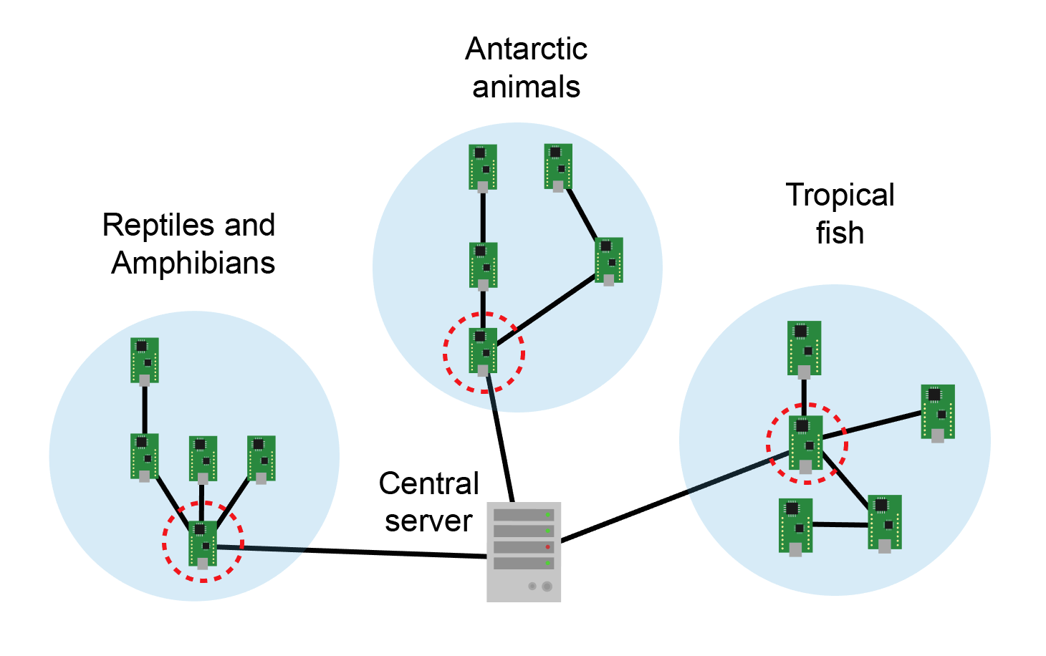
See below a diagram illustrating a possible tree node topology using sensor nodes as sinks, with each circle representing a building, and each circled node acting as a sink:
Figure 6 - Example tree topology
Each node reads its target parameters from a central server, then continuously polls sensors and powers or un-powers actuators if their respective sensor readings are outside of the parameter threshold.
In a real-world application, the communication protocol of choice would be ZigBee, due to its low power consumption compared with Wi-Fi and Bluetooth [32], [33].

Software Implementation
The node device program was written in Packet Tracer’s custom JavaScript API for IoT. The code structure consists of an infinite loop, inside of which sensors are read, actuators are controlled, and connections with servers are made. Below are screenshots and explanations of the more significant segments of code.

Below is an example of reading from a custom temperature sensor using analogRead(PinNumber). The analog signal readings 0 to 1023 represent temperatures of -100 to +100 °C. The below code was written to map the analog value to an appropriate temperature value.
Figure 7 - Sensor reading

Actuator or relay pins can be toggled on or off using the digitalWrite() or analogWrite() functions, as shown below:
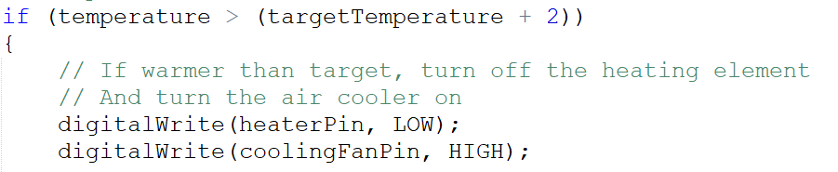
Figure 8 - Writing to pins
analogWrite() would take in a value between 0 and 1023.

An email client is set up on the node device using the below function:
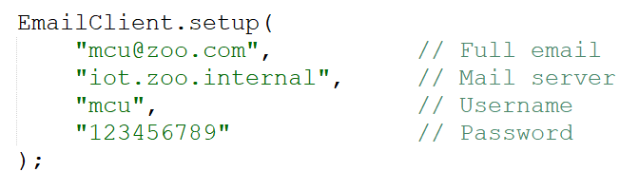
Figure 9 - Node mail setup

Emails can then be sent using the below syntax:
Figure 10 - Node mail sending

The LCD display can be written to using the customWrite() function, passing in the pin number and text to be printed.
Figure 11 - Node LCD output

The node can be set up to communicate with the IoT server using the below settings and programming syntax. Each state represents a list item on the web server.
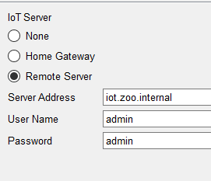
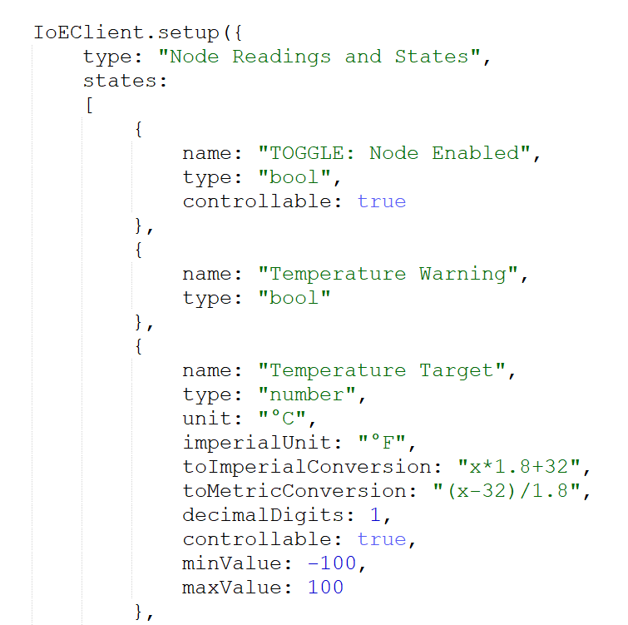
Figure 12 - Node server connection

Figure 13 - Node states setup

The states on the IoT gateway can be updated using IoEClient.reportStates(), as follows:
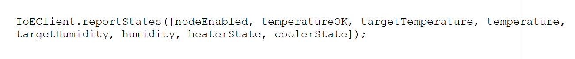
Figure 14 - Node states reporting

Finally, input from the web server (for example, to increase target temperature), is handled using the onStateSet() function:
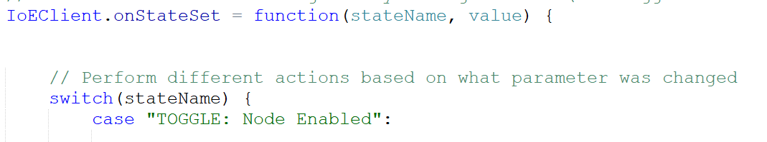
Figure 15 - Node input handling
A switch statement checks the name of the parameter which was changed, and performs actions accordingly.

Testing
See below simulation results from Packet Tracer, showing packet transmission for various network protocols:
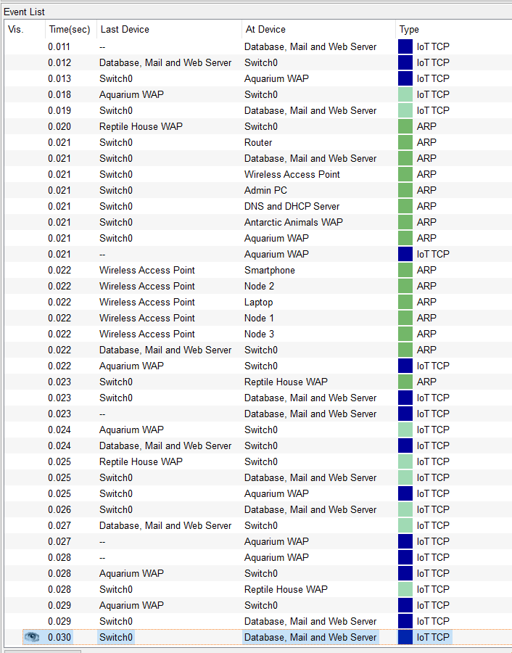
Figure 16 - Testing 1

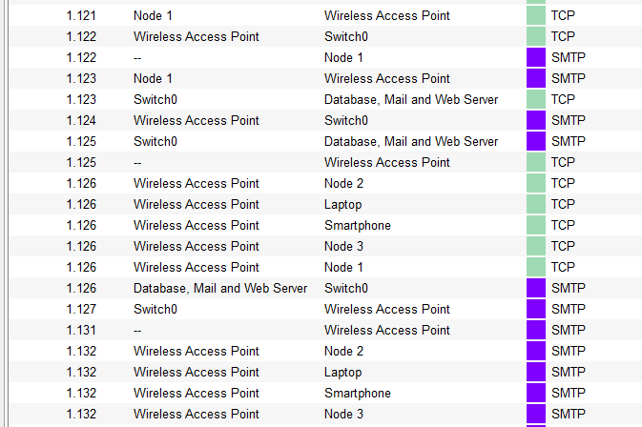
Figure 17 - Testing 2

Discussion and Conclusion
This section reviews the outcome of the report and simulation, lists recommendations and discusses future work, and finally concludes the report.

Recommendations and Future Work
Based on research and shortcomings of the simulated solution, the following recommendations have been identified:
- A tree or mesh topology could be further investigated to increase reach and reliability
- The network protocol should be changed to Zigbee – possibly requiring a change in IoT board
- A temperature and humidity prediction algorithm could be implemented to avoid overshooting targets
- More environmental control could be added, for example pH levels for tropical fish
Future work based on this assignment could involve implementing the simulated design and scaling it to fit a variety of settings. This could include a larger network connecting multiple locations for separate zoos, or a smaller network to suit pet stores, animal hospitals or domestic animals.

Conclusion
IoT is an emerging trend that is becoming more accessible to both enthusiasts and organisations. As technology has evolved, the concept of a smart city has become a reality, providing benefits such as improved decision making, data analytics, and sustainable development.
This report has identified current developments in IoT, its applications and benefits, and reviewed relevant literature to both smart cities and smart energy solutions. A smart energy solution was simulated in Cisco Packet Tracer, demonstrating the potential benefits of IoT to a zoo setting.

References
[1] M. T. Reddy and R. K. Mohan, “Applications of IoT: A Study,” in National Conference on Emerging Trends in Computing (NCETC-2K17), 2017, pp. 87–88.
[2] Nicole Dyess, “Top six benefits of the IoT,” Control Eng., vol. 65, no. 7, pp. 50–51, 2018.
[3] Cisco, “Internet of Things: Connected Means Informed,” 2016. [Online]. Available: https://www.cisco.com/c/dam/en/us/products/collateral/se/internet-of-things/at-a-glance-c45-731471.pdf. [Accessed: 25-Nov-2019].
[4] W3C, “W3C Web of Things at W3C,” 2018. [Online]. Available: https://www.w3.org/WoT/. [Accessed: 26-Nov-2019].
[5] W3C, “Web of Things (WoT) Architecture,” 2019. [Online]. Available: https://www.w3.org/TR/wot-architecture/. [Accessed: 26-Nov-2019].
[6] Mozilla, “Web Thing API,” 2019. [Online]. Available: https://iot.mozilla.org/wot/. [Accessed: 26-Nov-2019].
[7] W3C, “Web of Things (WoT) Thing Description,” 2019. [Online]. Available: https://www.w3.org/TR/wot-thing-description/. [Accessed: 26-Nov-2019].
[8] E. S. Chia, “Singapore’s Smart Nation Program – Enablers and Challenges,” in 2016 11th System of Systems Engineering Conference (SoSE), 2016, pp. 1–5.
[9] R. Ng, “Cloud Computing in Singapore: Key Drivers and Recommendations for a Smart Nation,” Polit. Gov., vol. 6, no. 4, pp. 39–47, 2018.
[10] A. Ghosh, D. Chakraborty, and A. Law, “Artificial intelligence in Internet of things,” CAAI Trans. Intell. Technol., vol. 3, no. 4, pp. 208–218, 2018.
[11] M. R. Jabłońska and R. Zajdel, “Artificial intelligence and internet of things for sustainable development-emerging techno-logical and social opportunities and threats,” in SHS Web of Conferences 57, 2018.
[12] A. F. Santamaria, P. Raimondo, F. De Rango, and A. Serianni, “A two stages fuzzy logic approach for Internet of Things (IoT) wearable devices,” 2016, pp. 1–6.
[13] S. Mandala, N. Anggis, M. S. Mubarok, and Shamila, “Energy Efficient IoT Thermometer based on Fuzzy Logic for Fever Monitoring,” in Fifth International Conference on Information and Communication Technology (ICoICT), 2017, pp. 1–6.
[14] A. Al-Adhab, H. Altmimi, M. Alhawashi, H. Alabduljabbar, F. Harrathi, and H. Almubarek, “IoT for Remote Elderly Patient Care based on Fuzzy Logic,” in International Symposium on Networks, Computers and Communications (ISNCC), 2016, pp. 1–5.
[15] M. A. Khan and K. Salah, “IoT security: Review, blockchain solutions, and open challenges,” Futur. Gener. Comput. Syst., vol. 82, no. 2018, pp. 395–411, 2018.
[16] S. G. Tzafestas, “Ethics and Law in the Internet of Things World,” Smart Cities, vol. 1, no. 1, pp. 98–120, 2018.

[17] Virium-Helsinki, “Smart districts make smart cities - Smart Kalasatama,” 2017. [Online]. Available: https://fiksukalasatama.fi/en/smart-districts-make-smart-cities/. [Accessed: 08-Dec-2019].
[18] European Commission, “Smart Kalasatama project | The European Commission’s Digital Cities Challenge.” [Online]. Available: https://www.digitallytransformyourregion.eu/good-practices/smart-kalasatama-project. [Accessed: 08-Dec-2019].
[19] City of Helsinki, “The Kalasatama Digital Twins Project,” 2019.
[20] J.-R. Ferrer, “Barcelona’s Smart City vision: an opportunity for transformation,” J. F. actions, no. Special Issue 16, pp. 70–75, 2017.
[21] Tokyo Metropolitan Government, “New Tokyo. New Tomorrow. The Action Plan for 2020 Safe City Diverse City Smart City.”
[22] K. J. Fietkiewicz and W. G. Stock, “How ‘smart’ are Japanese Cities? An empirical investigation of infrastructures and governmental programs in Tokyo, Yokohama, Osaka, and Kyoto,” in 2015 48th Hawaii International Conference on System Sciences, 2015, vol. 2015-March, no. June, pp. 2345–2354.
[23] K. Lewis, “How to build a better bed: IoT and AI at the zoo - Internet of Things blog,” 2017. [Online]. Available: https://www.ibm.com/blogs/internet-of-things/iot-how-to-build-a-better-zoo-bed/. [Accessed: 27-Oct-2019].
[24] Jordi Serra, David Pubill, Angelos Antonopoulos, and Christos Verikoukis, “Smart HVAC Control in IoT: Energy Consumption Minimization with User Comfort Constraints - University of Wales Trinity Saint David,” vol. 2014, pp. 1–11, 2014.
[25] P. Santos, J. Alves, and P. Carneiro, “Monitoring and control of a reptile terrarium,” in Proceedings of 2014 11th International Conference on Remote Engineering and Virtual Instrumentation, REV 2014, 2014, pp. 438–439.
[26] L. T. Beng, P. B. Kiat, L. N. Meng, and P. N. Cheng, “Field testing of IoT devices for livestock monitoring using Wireless Sensor Network, near field communication and Wireless Power Transfer,” in 2016 IEEE Conference on Technologies for Sustainability (SusTech), 2016, pp. 169–173.
[27] The Wireless Power Consortium, “The Qi Wireless Power Transfer System - Power Class 0 Specification - Parts 1 and 2: Interface Definitions,” 2017.
[28] Sparkfun, “Reducing Arduino Power Consumption.” [Online]. Available: https://learn.sparkfun.com/tutorials/reducing-arduino-power-consumption/all. [Accessed: 09-Dec-2019].
[29] Raspberry Pi Foundation, “FAQs - Raspberry Pi Documentation.” [Online]. Available: https://www.raspberrypi.org/documentation/faqs/. [Accessed: 09-Dec-2019].
[30] Espressif, “ESP8266 Power Consumption - ESP8266 Developer Zone,” 2015. [Online]. Available: https://bbs.espressif.com/viewtopic.php?t=133. [Accessed: 09-Dec-2019].
[31] Aosong(Guangzhou) Electronics Co Ltd, “AM2315 Product Manual.”

[32] K. Pothuganti and A. Chitneni, “A Comparative Study of Wireless Protocols: Bluetooth, UWB, ZigBee, and Wi-Fi,” vol. 4, no. 6, pp. 655–662, 2014.
[33] Y. Idris and N. A. Muhammad, “A Comparative Study of Wireless Communication Protocols: Zigbee vs Bluetooth,” Int. J. Eng. Sci. Comput., pp. 3741–3744, 2016.

Background Reading
City of Helsinki, “Smart districts make smart cities - Smart Kalasatama,” 2017. [Online]. Available: https://fiksukalasatama.fi/en/smart-districts-make-smart-cities/. [Accessed: 11-Dec-2019].
D. Guinard and V. M. Trifa, Building the Web of Things. Manning, 2016.
J. Schönig, “Welcome to the City 4.0 | Infrastructure | Siemens,” 2019. [Online]. Available: https://new.siemens.com/global/en/company/stories/infrastructure/welcome-to-the-city-4-0.html. [Accessed: 11-Dec-2019].
L. Atzori, A. Iera, and G. Morabito, “The Internet of Things: A survey,” Int. J. Comput. Telecommun. Netw., no. 2010, pp. 1–19, 2010.
M. Senges, P. S. Ryan, and R. S. Whitt, “Composite Ethical Frameworks for IoT and other Emerging Technologies,” 2017.

Animal Requirements
Aquacadabra, “How to Look After Your Tropical Fish – Aquacadabra,” 2018. [Online]. Available: https://www.aquacadabra.com/blogs/news/how-to-look-after-your-tropical-fish. [Accessed: 13-Dec-2019].
Aqueon, “Freshwater Aquarium Water Quality: The Nitrogen Cycle & Optimal Water Chemistry,” 2017. [Online]. Available: https://www.aqueon.com/articles/freshwater-aquarium-water-quality. [Accessed: 13-Dec-2019].
AZA Penguin Taxon Advisory Group, “Penguin (Spheniscidae) Care Manual,” 2014.
Devin Edmonds, “Red-eyed Tree Frog (Agalychnis callidryas) >> Amphibian Care.” [Online]. Available: http://amphibiancare.com/2007/11/19/redeyedtreefrog/. [Accessed: 13-Dec-2019].
RSPCA, “Bearded Dragon Care Sheet,” 2015.
UK Parliament, “Good Practice Guidelines For the Welfare of Privately Kept Reptiles & Amphibians,” 2014.
Victoria State Government, “Code of Practice for the Welfare of Animals - Private Keeping of Reptiles,” 2017. [Online]. Available: http://agriculture.vic.gov.au/pets/other-pets/reptiles/code-of-practice-for-the-private-keeping-of-reptiles. [Accessed: 23-Oct-2019].

Sensors
Adafruit, “PIR Motion Sensor,” 2018. Available: https://cdn-learn.adafruit.com/downloads/pdf/pir-passive-infrared-proximity-motion-sensor.pdf.
AKM, “AK9750 IR Sensor IC with I2C I/F,” 2015. Available: https://cdn.sparkfun.com/assets/parts/1/2/2/4/8/AK9750_2.pdf.
Aosong(Guangzhou) Electronics Co Ltd, “AM2315 Product Manual.” Accessed: https://cdn-shop.adafruit.com/datasheets/AM2315.pdf.
Everlight, “Ambient Light Sensor Surface - Mount ALS-PT19-315C/L177/TR8,” 2014. Accessed: http://www.everlight.com/file/ProductFile/201407061531031645.pdf.
Excelitas Technologies, “Photocells A 9050, A 9060,” 2012. Accessed: https://www.tme.eu/Document/1d1ebb278692fa06bbb17893d3d8d7b7/A%209060%2011.pdf
LPRS, “LDR CdS Photo Cell,” 2012. Accessed: http://www.farnell.com/datasheets/1580320.pdf?_ga=2.13365815.1655588527.1576162455-851368792.1576162455&_gac=1.118662907.1576162455.CjwKCAiA58fvBRAzEiwAQW-hzf1UZWclTlKdje5A-KYJDdyceMMxU0tq6gRPR5kpaZdE3klhaiVPZxoCJtEQAvD_BwE.
Maxim Integrated, “DS18B20 Programmable Resolution 1-Wire Digital Thermometer ,” 2019. Accessed: https://datasheets.maximintegrated.com/en/ds/DS18B20.pdf.
Mouser Electronics, “DHT11 Humidity & Temperature Sensor.” Accessed: https://www.mouser.com/datasheet/2/758/DHT11-Technical-Data-Sheet-Translated-Version-1143054.pdf.
MPJA, “HC-SR501 PIR MOTION DETECTOR.” Available: https://www.mpja.com/download/31227sc.pdfhttps://www.mpja.com/download/31227sc.pdf.
TruSens, “PIR Motion Module HC-SR505,” 2015. Available: https://static.rapidonline.com/pdf/78-4110_v1.pdf.
T. Liu, “Digital relative humidity & temperature sensor AM2302/DHT22.” Accessed: https://cdn-shop.adafruit.com/datasheets/Digital+humidity+and+temperature+sensor+AM2302.pdf

Appendices

Appendix A – Animal Requirements
Sources for animal requirements are listed in background reading.
Some examples of the requirements for captive animals are as follows:
- Antarctic animals require consistent cold environments. An example would be Emperor Penguins requiring ambient temperatures between -6°C - 0°C, and water temperatures between 1°C - 7°C.
- Reptiles are ectothermic, meaning they are unable to maintain their own body temperature and thus rely on external sources of heat. An example is the Bearded Dragon’s requirement of an ambient basking temperature between 38°C - 42°C.
- Tropical fish typically require a water temperature around 25°C, along with a pH level between 6.8 – 7.6
- Amphibians require consistent high humidity levels. An example is the Red-eyed Tree Frog, needing a humidity around 60%

Appendix B – Sensors
Sensor data acquired from sources listed in background reading.
Most common sensors:
PIR sensors
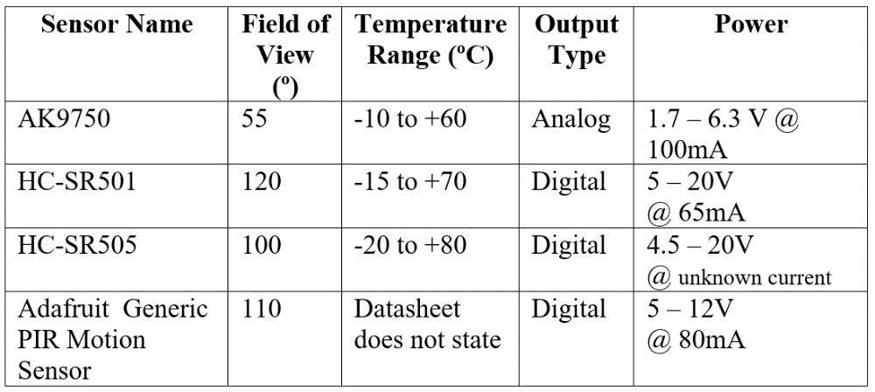

Temperature / humidity sensors
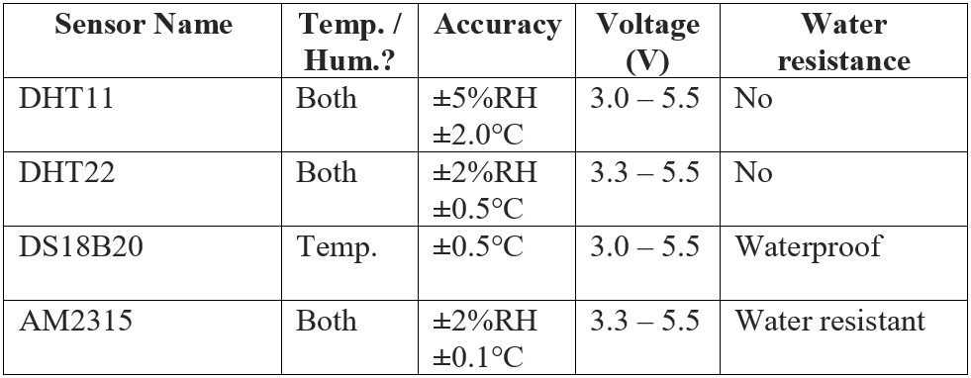

Light sensors
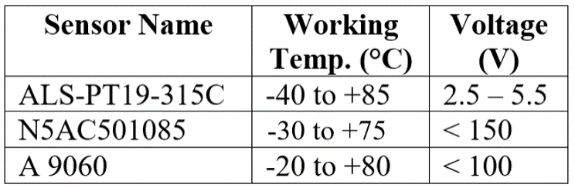

Appendix C – Simulation Notes
Start up and fast forward ~5-10 times, so that the web server has started up and the nodes have connected.
On any of the computers connected to the IoT switch or its access point, go to the web browser and access the IoT server on “iot.zoo.internal”, with the username and password of “admin”. The node devices should appear in a list after logging in.
Only the top left node (“Test Node 1”) is enabled by default for demonstration purposes. Its target temperature and humidity are 40°C and 50%. After a while its readings should stabilise at this, as shown on its LCD. Its targets can be changed on the web server, along with toggling it on or off. It has an override to enable it no matter what, so that one is always on for the purposes of a demo.
The other nodes only activate on alt-mouse over their trip sensor, to simulate an animal being detected. Doing this will start environment regulation for a given node.
The light control doesn’t quite work, admittedly. The idea is that the lighting in enclosures inside matches the day light. Unfortunately, the lamp is detected by the light sensor so it gets in an infinite loop.
There are clusters for each building of the zoo, limited at 4 because more devices in buildings crashes Packet Tracer.
Other than the servers, every node and admin device is allocated an IP through DHCP.
For initial temperature control, there is a heating element attached to a switch which can be used to speed up the heating process until it is near the target temperature (for demonstration purposes). After turning this heater off, the temperature will remain consistent.

