LCBB-4004
Module Title: BA Business Management
Assignment Title:
Marketing Fundamentals
Lecturer’s Name:
EFUA ADAMS
Name: ANA MARIA PARAU
Student Number: 2123792

Table of Contents
INTRODUCTION 1
Main Body 1
1. Various marketing directions to create customer value 1
2. Impact of the globalisation along with examining its markets as well as its competitors 5
3. Organisation positions itself in the global business environment along with reviewing the effect of its stakeholders 7
Conclusion 9
REFERENCES 10

INTRODUCTION
The concept of marketing is related with the process of the exploring, creating as well as delivering of the value to meet the needs of target market by the way of setting a connection and effective communication with the customers (Umar and et. al., 2021). The organisation selected for current project is Next plc which is tend to be a well known and famous British multinational retailer organisation that is basically operating and dealing in clothing, footwear and home products. The main headquarter of Next plc is tend to be located in the the Enderby, England along with several stores and branches across the various nation of world. Further, current essay comprises of a discussion about the various marketing directions to create higher customer value along with impact of globalisation on the business.

Main Body

1. Various marketing directions to create customer value
A competitive business environment is a the ne which comprises of a system where a set of different business organisation tend to compete with each other by the way of making effective use of the various marketing channels as well as effective promotional strategies and pricing method to cater and attract larger number of customers (Ftiti, Ameur and Louhichi, 2021). The Next plc is a well known British fashion retailer that is dealing in clothing, footwear, accessories as well as beauty and home products. The fashion retail industry of UK is tend to be one of the most dynamic as well as high competitive business environment that comprise of many big organisation such as Burberry, Marks and Spencer, Asos, BOOH, Net-a-Porter, etc. Thus, an analysis can be made that the Next plc is being working and operating in a highly competitive business environment which faced cut throat competition from the many organisation such as Burberry, Asos, etc which are key competitors of this firm. It has been seen to ensure and lead out attraction and catering interest of larger number of customer within a competitive business environment making use and implication of suitable set of marketing strategy becomes important and vital for all business organisations (Umar and et. al., 2021). Thus, Next plc has also adopted and make use of effective marketing strategy and direction to attract larger number of customer through setting better communication as well as leading higher value creation for consumers.
The concept of the value creation is related with the increasing of the customer satisfaction as well as positive customer experience by the way of meeting there expectation and needs. The best and most effective way to analysis and meet the customer value is having an effective and proper understanding about the behaviour of customer. Therefore, the managers of the Next plc tend to apply and make use of the Behaviour theory to effectively analysis and meet the value and satisfaction level of the customer (Fu, and et. al., 2021). The application and making use of the Behavioural theory tend to supports and provide an effective way for the managers of the Stakeholder to seeks and explain human the behaviour by analyzing the antecedents and consequences present in the individual's environment thus supports a better understanding and review of previous experience which supports the better determination of the purchasing and buying pattern as well as the needs of customers. Along with this, the behaviour theory also tend to brings out and supports the better focus and analysis of the set behaviour of customer as well as there interaction level with the environment to lead to a better understanding in managers of Next plc about the key expectation and needs of customers so that better strategy and framework can be used and applied to have better value creation (He and Harris, 2020). The application of the Behavioural theory by the Next plc also supports and helps in determining the fact that the reducing the price and providing of the better quality products ad services plays a most vital role in creating value for the customer through satisfying there needs. Along with this, it has been also seen that the applying and making use of the effective as well as suitable marketing strategy and direction supports a positive influence in the mind set of customers and influence the towards purchasing and use of a product and services. Thus, applying effective set of marketing direction as well as suitable marketing strategy has become important and vital for the Next plc to operate successfully in a competitive environment by the way of attracting and catering interest of larger number of customers (Kumar and et. al., 2019).
The key set of the various marketing directions that is being used and applied by the Next plc to create customer value includes of determining the suitable target audience which is the most vital ad effective marketing direction tend to includes and comprises of the determining and making selection of a suitable target audience the needs and demand of which best fit to the product and services offered. Further, it tends to be the most basic principle of marketing direction that adhere and give shape to the entire marketing strategy to create value for customers. The Next plc is operating within a Fashion retailer sector the most suitable and appropriate target audience for Next plc includes of young Boys and girls as well as men and women of middle age who are more attracted and cater by the fashionable clothing, footwear and other accessories (Ma and Sun, 2020). Along with this Personalisation of marketing strategy is also effective as the making application of the personalization supports an effective way of marketing by the way of supporting communication of needed and suitable information to a customer that is valuable for them. Along with this, the personalisation of marketing also supports an effective way of improved customer engagement as well as driving and brining in a better emotional connection with the customers. Along with this, personalisation of marketing strategy also supports a higher brand loyalty by the way of supporting mouth referrals as well as leading positive online reviews that attract and cater larger number of customer and also supports better customer feedback to ensure regular improvement in order to best fit and meet the satisfaction level of customers (Li, Larimo and Leonidou, 2021).
Apart from this, it has been also analysed that the making use of content marketing has been seen that the content plays a most vital role in attracting and capturing the interest of customer within a competitive business environment. Thus, Next plc tend to make use of the content marketing that includes of quality content comprising of videos, images and other attractive content to ensure the communication of suitable and relevant information about product and services with the customers. Along with this, the application of graphic design and so that attractive tools are also made to create an attractive as well as meaningful content for customer which best fit their desires and expectation level to ensure higher value creation for them. Along with this use of social media marketing is another effective and vital marketing direction that has been used by Next Plc to create value for its customers comprises of the use of the social media marketing (Dolnicar, Grün and Leisch, 2018). It has been seen and analysed that the making use of the social media marketing supports an effective way to set a direct connection with customers by the way supporting regular communication. Along with this, the making use of the social media also brings out the better way to conduct and lead out regular marketing survey and research about the key preference and trends so that suitable product and services can be offered by the Next plc to best meet those needs and have higher value creation for its customer within a commutative business environment (NEXT plc, 2022).
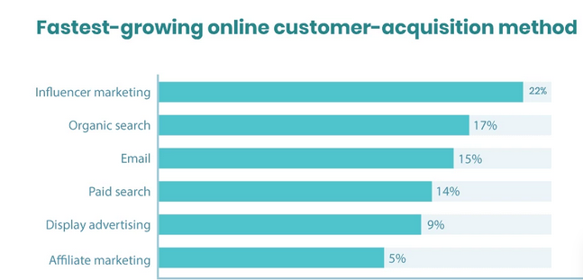
Figure 1: Fastest growing online method, 2021
Beside this, the making use of social media marketing also supports a more effective and suitable way of advertising and promotion for the Next plc to supports a higher loyalty and commitment level in customers and also brings improved satisfaction and customer value (Rather, 2020). Beside this, leveraging email marketing is also an effective form of the marketing strategy and direction provides and supports a best way to create higher awareness in the customers about the key features and exclusive characteristics of the product and services to supports higher attraction in customers.
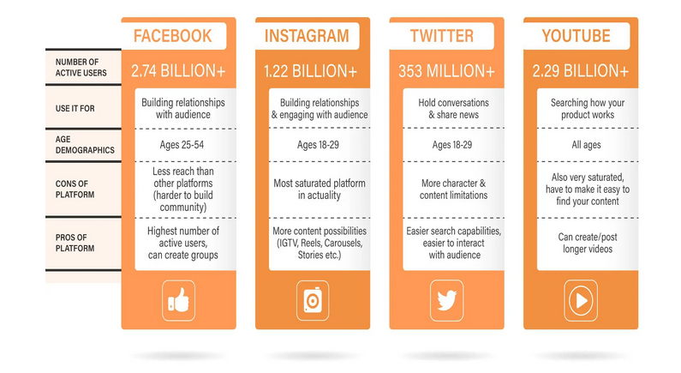
Figure 2: Use of social media platforms, 2021
Along with this, making use of the email marketing also tend to brings out and supports a personalised sense of services for the customer’s through providing regular notification about the product and services that is being needed and expected by customers (Matarazzo and et. al., 2021). Thus, supports timely awareness as well as notification to fulfil the desires of the customers which supports higher value creation in target audience of Next plc.

2. Impact of the globalisation along with examining its markets as well as its competitors
The concept of the globalisation is being related and associated with the growing level of the interdependence of the economies of world along with exchange and higher movement of people and cultures as well as the cross border trade of goods and services, technology and higher flow of investment and information across nations. Further, it has been seen that the globalisation have both positive as well as negative impact on the business as the positive impact of globalisation includes of higher growth opportunity while its negative impact comprises of higher competition level (Riikkinen and et. al., 2018). The implication of the globalisation leads to the higher movement and shift of people as well as technology across the birders thus, it supports use of improved technology as well as hiring and recruitment of the more talented and skilled employees. Therefore, the globalisation brings out a positive impact on the business through supporting higher efficiency and effectiveness in way of better utilisation of technology and other resource to achieve higher success level. Apart from this, globalisation also supports and brings out higher movement of people and services across nation therefore brings out and lead to the better expansion opportunity and growth rate for business operations and also supports reaching of economies of scale. Along with this, globalisation also lead to higher cross border investment that enhance the welfare and supports capital benefits to earn higher return and profit level. Thus, an analysis can be made that a positive impact of the globalisation is being seen on the Next plc as supported easy movement of gods and services across various nation of world to lead better expansion and growth opportunity. Along with this, the globalisation has also brings out a higher level of innovation and creativity with Next plc through supporting hiring of more skilled and talented candidates across the world (Freudenreich, Lüdeke-Freund and Schaltegger, 2020). Thus, a positive impact of the globalisation is being seen on the business operation of the Next plc as it supports higher economic and growth opportunity as well as better utilisation of technology and other resources to effectively meet and achieve the set goals and supports higher productivity level.
Apart from these, positive impact of globalisation certain negative effects are also lead by globalisation on business operation which includes of the increased level of competition. It has been seen that the globalisation leads to business operation at global level which lead to increase in the competition with the multinational company that are operating within the international and global business. Thus, the globalisation tend to enhance the competition level for Next plc as now it have to compete with the many larger firms such as Burberry, Asda, Asos, etc that is eating many challenges. Along with this, with the implication of the globalisation it has been seen that the higher chances of cultural difference is being faced which is also a vital challenge lead by globalisation (Elia, and et. al., 2020). Beside this, globalisation has also created and enhanced the chances of having miss communication and higher chaos while communicating and coordinating with the workers operating in some other nations. Thus, an analysis can be made that the globalisation has both positive as well as negative impact on the business operation of Next plc but globalisation has supported higher growth and enhanced scope for business operation of Next plc through supporting easy movement of people, goods, services, information, investment and technology across the various nation of world.
Next Plc is tend to be a multinational company that source over 200 million products and services within more than 70 countries of world through its online stores and physical stores. Further, Next PLC is tend to be a British multinational retailer which is dealing in the clothing, footwear and other set of the home products that is being headquartered in Leicestershire (Delpechitre, Beeler-Connelly and Chaker, 2018). Beside this, the Next plc tend to have an 700 stores out of which 550 were situated in the United Kingdom and Ireland together with the around 200 that are operating and present in the continental Europe, Asia as well as many parts of the Middle East. Further, the main competitors of the Next plc comprises and includes of the Marks and Spencer which is having which is also a British retailer providing the general stores and grocery items along with home products at global level. Along with this, the New Look Retailers Ltd, Arcadia Group Ltd, River Island Billion, Superdry and Monsoon Accessorize Ltd are also the key competitors of the Next plc. Beside this, it has been also seen that the at the global level big retailers such as Tesco, Asda, Burberry, Asos etc, are also leading a tough and cut throat competition for Next plc which are also being the retailer and supplying home products, clothing and other accessories to its customers. Thus, an analysis can be made out that the Next plc is facing a high level of competition at the global market that is creating affect on its overall productivity and sales level (Umar and et. al., 2021). Therefore, to operate successful at global level it has become important and vital for Next plc to provide better quality product and services as well as having effective marketing strategy to promote and advertise its product and services at global level in order to attract and cater a larger number of customers.

3. Organisation positions itself in the global business environment along with reviewing the effect of its stakeholders
It has been seen that the Next plc is operating in a competitive global market thus, it become important and vital to adopt and have some effective marketing strategy to have improved marketing positioning in the global market. Marketing positioning tend to comprises and includes of the strategic exercise and ways which are opted by an organisation to establish and build a better brand image and positive mind set for the product and services of a firm. The Next plc tend to hold a strong market position in the marketplace that is tend to be steady in nature and also shows higher growth through effective marketing and positioning strategy. The use of the differentiation positioning strategy is being made by the Next plc to effectively position and creates a positive brand image at the global business environment (Fu, and et. al., 2021). The Next plc tend to focus on creating improved feature as well as show higher creativity and innovation in its product and services on a continuous basis to earmark and attract a larger number of customer at global business environment and make itself exclusive and better than competitors. Beside this, it has been also seen that the Next plc is targeting a same target audience includes of young and middle age people which lead to better positing in the mind set of audience by the way of providing of a quality as well as fashionable products and services at a more affordable and reasonable price which make it differentiated and better than other competitors in global market (He and Harris, 2020).
Further, it has been seen that to effectively operate and successfully work at the global market it is vital and important for an organization to have proper management of stakeholders that is important to ensure timely delivery of products and services. There are various stakeholders which are related and associated with the working of Next plc that is having a positive effect on its global positioning. It has been seen that the differentiation positioning is mainly based on providing of a different and better quality product and services to the customer which can only be possible through having suitable suppliers to ensure the higher quality of the product and services (Kumar and et. al., 2019). Apart from this, having success at global level is mainly associated and related with the creation of higher value and satisfaction for the customers. Along with this, it has been also seen and analyse that the making the use and application of the stakeholder theory and value creation also brings out an effective way to support higher value creation and customer satisfaction by the way of leading better management. The implication and use of the stakeholder theory and value creation provides a systematic and effective way for the managers of the Next plc to think and review about the stakeholder management including its global customers which act as the key to achieving competitive advantages. Along with this, better management of all the associated stakeholders comprises of setting better balance among suppliers as well as production and logistic department set a better and timely delivery of product and services as well as ensure maintaining of quality standard within Next plc that enable and supports the sustained growth of economic value (Ma and Sun, 2020). Apart from this, the stakeholder theory and value creation also supports a better review of the consumer and other stakeholder perception to supports effective adoption of promotional and marketing strategy that ensures cost and risk reduction at global level as well as also brings out the customer loyalty building and more favourable treatment from regulators or public opinion to ensure creation of improve brand image.
Further, it has been also seen and reviewed that adoption and making use of the Stakeholder Matrix also supports a better analysis and review about the effect of various stakeholders on the organisation.
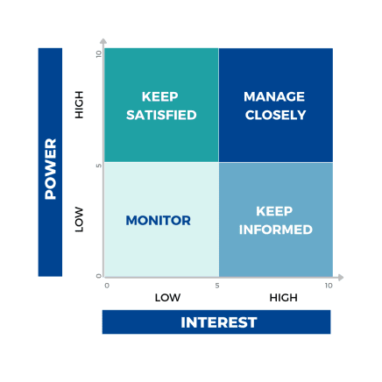
Figure 3: The Stakeholder Matrix, 2022
Based on stakeholder matrix or grid matrix the stakeholder of a firm are divided into four main types includes of the stakeholders with the High power, and the highly interested people which comprises of all the executives and department heads along with board members. Thus, these are the stakeholder who has great impact on the organisation and they need to be Manage Closely. Within Next plc, high power and highly interest stakeholders are responsible to take all the major decision such as the executives and department heads which are responsible for strategy formulation thus have great effect on the business operation of Next plc (Li, Larimo and Leonidou, 2021). The next type of stakeholder includes of the High power people but less interested people who includes of the customers and suppliers that have high power but less interest in day to day business activity. Thus, it is important and vital for the Next plc to keep them highly satisfied as on customer the overall productivity depends while suppliers are important to ensure timely delivery of product and services. The type of stakeholder comprises of the Low power but the highly interested people which need to be keep informed. This form of stakeholders comprises of employees and workers working in different department which have significant effect on business operation but have limited power to make decisions. Within Next plc, employee’s ad colleagues are well informed to set better coordination and higher productivity that reflects the positive effect of stakeholders to effectively work at global level. Along with this, Low power and less interested people are also forms the stakeholder of a firm which includes of third parties such as government the compliance of which is important and vital but they do not have any direct link or relationship with the day to day working. Thus, an analysis can be made out that the stakeholders have a vital effect on organisation as suppliers who are a key stakeholder of Next plc ensures timely delivery of quality products to effectively meet the satisfaction level of customer and create higher value (Dolnicar, Grün and Leisch, 2018). Along with this, employees who are also an important internal stakeholders plays an important role in creating better brand positioning through supporting higher efficiency in business operation in leading higher creativity and innovation to attract and cater a larger number of customer at global level.

Conclusion
On the basis of current essay, a conclusion can be made that the marketing fundamental are basically related and associated with the setting a better connection and interaction with customers through use of various advertising and promotional tool to ensure higher awareness in customers to attract ad cater the interest of the target customers. Further, it has been also summarised that the making use of social media as well as having effective content and email marketing are effective marketing direction that supports higher value creation for customer through setting positive connection. Apart from this, it has been also summarised that globalisation has both positive as well as negative impact on business operation in form of higer growth opportunity along with rising threat of competition. Finally, it has been concluded that differentiation positioning supports creation of positive mind set of customer through offering better quality and affordable products.

REFERENCES
Books and journal
Delpechitre, D., Beeler-Connelly, L.L. and Chaker, N.N., 2018. Customer value co-creation behavior: A dyadic exploration of the influence of salesperson emotional intelligence on customer participation and citizenship behavior. Journal of Business Research, 92, pp.9-24.
Dolnicar, S., Grün, B. and Leisch, F., 2018. Market segmentation analysis: Understanding it, doing it, and making it useful (p. 324). Springer Nature.
Elia, G. and et. al., 2020. A multi-dimension framework for value creation through big data. Industrial Marketing Management, 90, pp.617-632.
Freudenreich, B., Lüdeke-Freund, F. and Schaltegger, S., 2020. A stakeholder theory perspective on business models: Value creation for sustainability. Journal of Business Ethics, 166(1), pp.3-18.
Ftiti, Z., Ameur, H.B. and Louhichi, W., 2021. Does non-fundamental news related to COVID-19 matter for stock returns? Evidence from Shanghai stock market. Economic Modelling, 99, p.105484.
Fu, X. and et. al., 2021. New institutional investors in the IPO secondary market: Sentiment or fundamentals?. Journal of Financial Research, 44(2), pp.299-341.
He, H. and Harris, L., 2020. The impact of Covid-19 pandemic on corporate social responsibility and marketing philosophy. Journal of business research, 116, pp.176-182.
Kumar, V. and et. al., 2019. Understanding the role of artificial intelligence in personalized engagement marketing. California Management Review, 61(4), pp.135-155.
Li, F., Larimo, J. and Leonidou, L.C., 2021. Social media marketing strategy: definition, conceptualization, taxonomy, validation, and future agenda. Journal of the Academy of Marketing Science, 49(1), pp.51-70.
Ma, L. and Sun, B., 2020. Machine learning and AI in marketing–Connecting computing power to human insights. International Journal of Research in Marketing, 37(3), pp.481-504.
Matarazzo, M. and et. al., 2021. Digital transformation and customer value creation in Made in Italy SMEs: A dynamic capabilities perspective. Journal of Business Research, 123, pp.642-656.
Rather, R.A., 2020. Customer experience and engagement in tourism destinations: the experiential marketing perspective. Journal of Travel & Tourism Marketing, 37(1), pp.15-32.
Riikkinen, M. and et. al., 2018. Using artificial intelligence to create value in insurance. International Journal of Bank Marketing.
Umar, M. and et. al., 2021. Driven by fundamentals or exploded by emotions: Detecting bubbles in oil prices. Energy, 231, p.120873.
Umar, Z. and et. al., 2021. A tale of company fundamentals vs sentiment driven pricing: The case of GameStop. Journal of Behavioral and Experimental Finance, 30, p.100501.

Online:
NEXT plc, 2022. [Online] Available Through:< https://www.zoominfo.com/c/next-plc/85951313 >.

