Albert Sefa, 2112523.

MODULE CODE: BMSW4002_BIRM.

Lecturer: Chijioke Uba

Solving the complex problem of staff absenteeism in MCHT

Table of Contents
Overview: 1
Introduction: 1
Nature of the problem 2
Scope and Impact: 2
Analysis of the organisation and problem: 3
Alternative solutions: 4
PMI Evaluation: 4
Plan for implementing solutions, Monitoring and Review Process/System: 7
Conclusion: 9
Reference: 9

Overview:
The aim of this report is to understand how to identify complex problems that are occurring in Mid Cheshire Hospital Trust by examining the nature of the problem and identifying the scope and the impact of the problem. Different types of analyses such as PESTEL analyses and Fishbone diagram is used to identify the external factors affecting the organization, and the cause and effect of the problem. PMI is used in this report to select the appropriate solution. The effectiveness of the solution chosen is measured by using the Monitoring and Review Process/System.

Introduction:
Many organizations go through a lot of complex problems that cause major issues for them. Recognizing that there is a problem and identifying the root cause is the first step in resolving organizational issues. Identifying where problems originate and coming up with appropriate solutions to each problem takes time, but it is an essential first step for any organization that wants to grow and thrive. Organizations and employees both benefit from identifying and addressing organizational issues. Resolving organizational issues sooner rather than later, creates a healthier work environment and devotes more time to other aspects of a business. It is important for a company to have good organizational practices in order to motivate employees and boost the company's performance. In addition, organizational improvements can serve as a motivator for an organization to seek out more solutions or take practical measures to avoid the same problems in the future. This report covers a common organizational issue which is staff absenteeism. It explains what causes it and explains some possible solutions it is used to fix the issues. A good starting point for understanding how to tackle a problem is identifying its nature. The scope and impact of a problem can then be determined by identifying its reach, who is affected, and how they are affected. PESTEL and Fishbone analysis are implemented to identify factors that affect the Mid Cheshire Hospital Trust from the outside and for identifying all the possible causes associated with the effect of absenteeism before narrowing it down to the small number of the main root causes which need to be addressed. The alternative solution helps with effective problem solving since it generates multiple options for managing a problem from which the most appropriate one or combination of approaches can be selected. PMI evaluation is then used to strengthen critical thinking skills in order to review the negatives, positives, and implications of the solutions. An action plan is then used to Monitor and Review the Process/System of the best solution that is selected.

Nature of the problem:
There is a high level of absenteeism among staff at Mid Cheshire Hospital Trust. In its most basic sense, absenteeism is any failure to report to work or not exhibiting regular attendance, regardless of the reason. There are a lot of contributing factors that are causing absenteeism in Mid Cheshire Hospital Trust. In situations where employees have been bullied in the workplace or feel their hard work isn't appreciated, this can lead to them being absent as a result of their unhappiness at work. ( Law 2014). Also, a job that isn't inspiring or engaging to an employee will inevitably impact productivity and result in increased absenteeism. Absenteeism has a lot to do with mental health since mental illness can affect attendance and productivity. In most cases, when an employee experiences discrimination at work, it can make them feel unfairly treated. As a result, they are more likely to be disengaged and absent from work.

Scope and Impact:
The impact of staff absenteeism has been costing the hospital £1 million every year per percentage point. It is mostly due to the fact they have been using a lot of temporary agency workers to replace the absent employees and as a result, the performance and productivity have been very poor. Consequently, the hospital does not provide a level of quality service that satisfies the patients' expectations.

Analysis of the organisation and problem:
A PESTEL analysis would be appropriate for understanding the organization's potential and direction. This method identifies the external factors affecting the organization and it examines factors from the perspectives of political, economic, sociological, technological, environmental, and legal factors.
- Political Factors- In the wake of Brexit, many foreigners have been unable to acquire a permanent status, especially from European countries. Consequently, staff members will have to take time off before returning to work to acquire their permanent status documents.
- Economic Factors- Economic downturn in the global economy has led to financial difficulties for MCHT, and employees are losing their jobs due to covid19
- Sociological Factors- Involvement in Covid19 gradually spreading throughout the UK may have played a role in employees' health causing them to stay at home and quarantine.
- Technological Factors- Innovation is stagnant at the hospital. As a result of insufficient technology training, employees do not have adequate technological awareness.
- Legal Factors- Due to the poor quality of care, they receive from employees, many patients are threatening legal action against them.

A Fishbone diagram will be used to identify the problem's root causes by combining brainstorming with a type of mind-map in this case study because it is used to identify the cause and effect of a problem ( Lewis 2020).
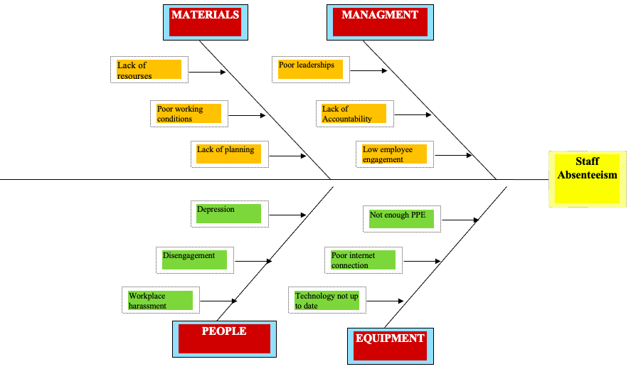

Fishbone diagram

Alternative solutions:
The use of alternative solutions is a vital part of effective problem solving since it generates multiple options for managing a problem from which the most appropriate one or combination of approaches can be selected. In order to combat the issues facing Mid Cheshire Hospital Trust, it may be necessary to create a policy on employee attendance that everyone, including management, should adhere to. This policy should be enforced regularly, and that will ensure accountability. The creation of a clock-in/clock-out time clock, which keeps records of employee absences and can help solve staff absenteeism, is another feasible solution. Whenever there is an unscheduled absence, they must address it immediately and they will do so by holding a formal return-to-work interview depending on how long an employee's absence has been. Another important solution that they could implement is rewarding good behaviour, which means that if they notice employees who are working hard and demonstrating a high level of commitment to their work this has to be recognized.

PMI Evaluation:
A PMI is a tool used to brainstorm, make decisions, and strengthen critical thinking skills in order to review the negatives, positives, and implications of a particular concept or idea.
Attendance Policy
Attendance policies define rules for employee attendance. These policies outline company policies regarding absenteeism, i.e., the number of leaves an employee can take, such as sick leave, casual leave, vacation leave, or a combination of these.
Plus | Minus | Interesting/implications
Everyone will be held accountable if it is implemented (+5) | A tricky set terms and conditions (3) | Sense of equity (+3)
Provide stability to the organization (+4 | Unfollowing policies may lead to dismissal from employment (5) | Reduced legal exposure and liability (+2)
Total= +9 | Total= -8 | Total= +5

Results

Table scores:
- 9 (plus)
- -8 (minus)
- 5 (interesting/implication)
- Total= 6

The outcomes:
- The benefits of the attendance policy solution outweigh its disadvantage. When implementing this solution, it is important to discuss it with employees and management when changes are made.

Clocking system (absence tracking for employees)
Employees use a clocking system to keep track of how many hours they have worked. When employees start their work, they must sign in, and when they finish, they must sign out. A clocking system is also used to record and monitor absenteeism and punctuality

Plus | Minus | Interesting/implications
Good time management from employees (+5) | The possibility of technical failure (4) | Attendance issues can be identified by managers (+3)
Help to reduce absenteeism (+3) | Fears in the event of loss or forgotten clocking tool (1) | Vacation scheduling is easier with absence tracking (+2)
Total= +8 | Total= -5 | Total= +5

Results
Table score:
- 8 (plus)
- -5 (minus)
- 5 (interesting/implications)
- Total= 8
The outcome:
The benefits of absence tracking for employees outweigh its disadvantage. The implementation of this solution will benefit the organization, but it is extremely important to train staff on how to use it.

Return-to-work interview.
Return-to-work interviews are held after an employee has been absent for a period. The purpose of the return meeting is to welcome back the employee, discuss the reasons for their absence, and confirm that the employee is fit to return to work

Plus | Minus | Interesting/implications
Responsible Employees (+4) | Time wasting (5) | Absences of various types can be easily handled (+2)
Help ensure the employee is fit for work after taking time off (+5) | Creating unnecessary inconveniences (2) | Recognize any trends or patterns occurring in their absence. (+3)
Total= +9 | Total= -6 | Total= +5

Results
Table score:
- 9 (plus)
- -6 (minus)
- 5 (interesting/implications
- Total= 8
The outcome:
The benefits of the return-to-work interview solution outweigh its disadvantage. When questioned about their absence, employees are more likely to provide genuine reasons for their absence by using this solution.

Employee recognition.
The act of publicly thanking employees for their efforts is called employee recognition. Rewarding employees for their efforts is a key contributing factor to employee retention, engagement, and productivity.

Plus | Minus | Interesting/implications
Increase in productivity (+3) | An increase in favouritism and bias (2) | This is the most effective method for boosting employee morale (+3)
Help increase self-esteem (+5) | Create a sense of entitlement (3) | When employees feel valued and appreciated, they will go the extra mile for the company. (+4)
Total= +8 | Total= -5 | Total= +7

Results
Table score:
- 8 (plus)
- -5 (minus)
- 7 (interesting/implications)
- Total= 10
The outcome:
The benefits of the employee recognition solution outweigh its disadvantage. By implementing this solution, hard work will be acknowledged more frequently at work.

Plan for implementing solutions, Monitoring and Review Process/System:
According to the PMI analysis, employee recognition was the best solution for the action plan.

Action Plan (before implementation):
The action plan is the implementation of the solution chosen to solve the complex problem that has been identified.

Action | Description | Timeline | Staff Responsible
Build a case for recognition | Set objectives that encourage employees to uphold and grow the organisation's culture | 1/1/2022 – 7/1/2022 | HR/ Line Manager
Put together a team of champions | Identify leaders who can communicate, promote, and implement the organization's new recognition program. | 9/1/2022 – 28/1/2022 | HR/ Line Manager
Allow employees to voice their opinions | Identify the rewards that employees are most interested in by engaging them | 2/2/2022 – 17/2/2022 | HR/Line Manager
Launch and implement an effective strategy | The benefits of a recognition program should be made clear to employees. Senior management should also be aligned to this purpose. | 21/2/2022 – 21/2/2022 | HR/Line Manager

Monitoring:
Monitoring can be defined as the collection and analysis of data about an ongoing project or program, while that project or program is in progress.

Action | Description | Timeline | Staff Responsible
Assess employee satisfaction | Using a survey, measure the level of employee satisfaction before and after the program. Assess their views of the organization's rewards and recognition program. | Monthly | HR/Line Manager
Measure employee satisfaction | Ask direct questions and use quizzes | Daily | HR/Line Manager
Participation rate | The percentage of team members using the system to send gifts or to nominate people. | Daily | HR/Line Manager
Evaluation:
Evaluation is used to evaluate the outcome of a decision after its implementation.

Performance indicator | Description | Timeline | Staff Responsible
Direct Feedback from employees | Employee feedback can be obtained through a targeted employee survey. | Weekly | HR/Line Manager

Conclusion:
After identifying the nature of the problem. The scope and impact were used to determine the identification of its reach, whom it was affected, and how they were affected. PESTEL and Fishbone analysis was then implemented to identify factors that affect the Mid Cheshire Hospital Trust from the outside and for identifying all the possible causes associated with the effect of absenteeism before narrowing it down to the small number of the main root causes which was addressed. The alternative solution assisted with effective problem solving since it makes multiple options for managing a problem from which the most appropriate one or combination of approaches was selected. PMI evaluation was used to strengthen critical thinking skills in order to review the negatives, positives, and implications of the solutions. An action plan was then used to Monitor and Review the Process/System of the best solution that was picked.

Reference:
Indeed Editorial Team (2021) 7 Organizational Issues and Ways To Overcome Them. Available at: https://www.indeed.com/career-advice/career-development/organizational-issues (Accessed: 5 April 2022)

Harris, W. (2014) Harris Law. Available at: https://harrislawsouthwest.co.uk/hr-advice-reducing-absenteeism-workplace/ (Accessed: 5 April 2022)

Lewis, S. (2020) Fishbone diagram (Ishikawa cause and effect). Available at: https://www.techtarget.com/whatis/definition/fishbone-diagram (Accessed: 6 April 2022)

Fleming, E. (2021) What are the disadvantages of policy. Available at https://www.sidmartinbio.org/what-are-the-disadvantages-of-policy/ (Accessed: 7 April 2022)

Hawker, N. (2016) Fun facts: Policies make your life easier. Available at: https://www.linkedin.com/pulse/fun-fact-policies-make-your-life-easier-natasha-hawker (Accessed: 7 April 2022)

Computime (2019) What is a clocking in system? Available at: https://www.computimeuk.com/blog/2019/07/14/what-is-a-clocking-in-system/ (Accessed: 8 April 2022)

Mitrefinch (2016) 9 Benefits of Employee Attendance Tracking. Available at: https://mitrefinch.com/blog/9-benefits-employee-attendance-tracking/ (Accessed: 8 April 2022)

Kate, L. (2019) Get the best out of return-to-work interviews. Available at: https://citrushr.com/blog/leave-absence/return-to-work-interview/ (Accessed: 9 April 2022)

Vantage Circle (2021) 7 Effects of Employee Recognition on Business. Available at: https://blog.vantagecircle.com/effects-of-employee-recognition-on-business/ (Accessed: 10 April 2022)

Eddy (2021) How to Create an Employee Recognition Program (With Ideas) Available at: https://eddy.com/how-to-create-an-employee-recognition-program-with-ideas/ (Accessed: 12 April 2022)

HiFives (2020) Measuring the Success of Employee Recognition Program. Available at: https://www.hifives.in/most-effective-ways-for-measuring-the-success-of-an-employee-recognition-program/ (Accessed: 123April 2022)

