Title: Business Data and Analysis
Assignment Name: Collated Files Report
Student Name: Daniel Ramsey
Course Name and Number: Generating Business Data and Analysis BMSP4004
Lecturer: Dr Roisin Mullins
Date: 4th May 2018

Introduction
The technology age we live in has abled data to be collected with great ease. Originally, data and number crunching was seen as a specialised subject, with only a concentrated few savvy enough to analyse and describe large data sets. As with technology, teaching methods have also have advanced, with both undergraduate and graduate students in all aspects of business required to run regression analysis, create optimization models, describe large data sets and make quantitive forecasts (Albright & Winston, 2016).
In business, planning, organisation, the making of operational decisions, and strategic decisions is the responsibility of the manager, and for these tasks to be completed to high standard, a knowledge of business analytics is paramount. The applications and methods use enable these individuals to make better fact based decisions and gain insight about their business (Camm, Cochran, Fry, Ohlmann, & Anderson, 2014). The data collated can be used for customer segmentation, merchandising, pricing and social media marketing.
For this assignment, we have been allocated four data files. The task is to utilise the different database tools and skills we have learned to report key performance measures, data visualization, statistical methods, forecasting, statistical methods and data optimization.

Weather Data
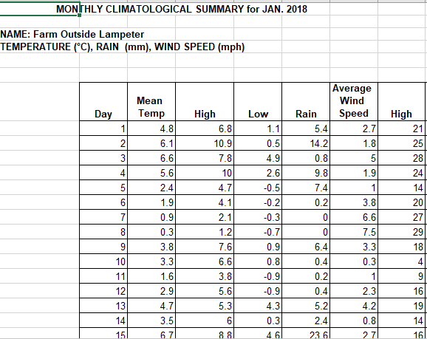
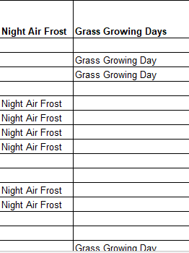
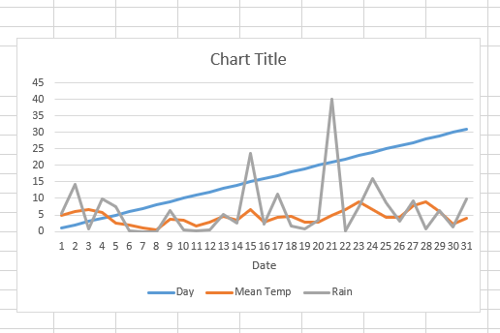

Collated Prosumer Survey
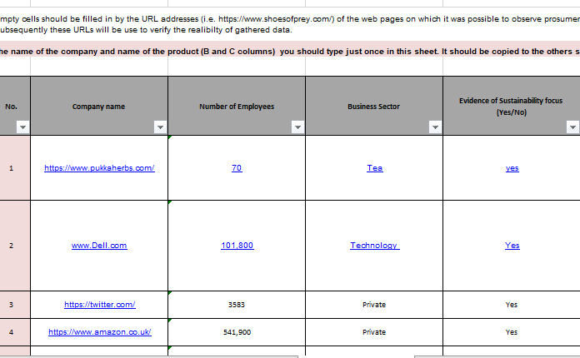

Swansea Business School- Half Hourly Data
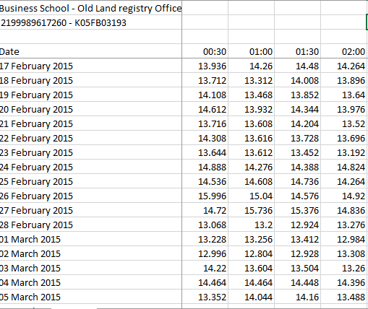

Collated Carbon Data File


