Student Name: Lauren Stokes
P Number: 2305024
Programme of Study: Surface Pattern and Textiles
Module: ADAD4018 Ways of Thinking

Tasks in the order I received them:
Task One: Manifesto = words
Task Two: Semiotic Analysis = words
Task Three: Practice-based writing = words

Task 1: Manifesto
- My art will be loud
- My art will be therapy for me
- My art will bring joy
- My art will be my mark on earth
- My art will be about creating, not just fulfilling a brief
- My art will be originals
- My art will be practice and an experimentation
- Find art everywhere

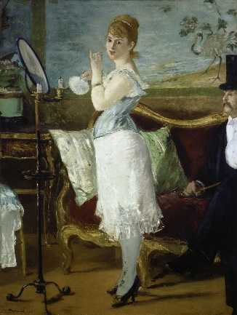
“1. My art will be loud”
My first point states the “my art will be loud”, meaning that the art I create will be both expressive and powerful in look and aesthetic as well as theme and message. Emile Zola said, in “Nana”, “If you ask me what I came to do in this world, I, an artist, will answer you: I am here to live out loud”[1]. This means the drive and passions of being an artist suggests that we live life differently; and that while others may express their love and emotions quietly and within, some artists feel they must express their emotions outwardly and to the world.

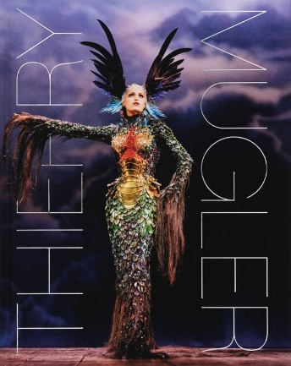
“5. My art will be about creating, not just fulfilling a brief”
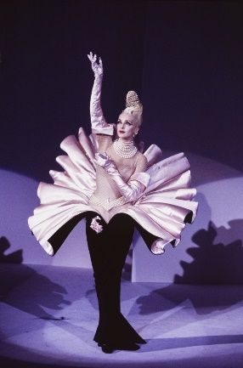
My fifth point states that “my art will be about creating, not just fulfilling a brief”, meaning my art will be about the process of making it not only the finished product or the purpose it is intended for. When asked about changes in the fashion industry, Thierry Mugler said “I think now it’s the money who tells the artist what to do—it’s not the artist who tells the money what to do. [] They don’t dare to scream loudly what they think. [] It’s great to make it as art. But first, it’s a service for someone”[2]. This means that while we sometimes design for a purpose or a client or for money, it is also about creating artwork that brings joy to the artist, client, consumer and public. Particularly in the textiles industry, the purpose of most art is to facilitate a service, however an artist can turn this need into aesthetic creations.
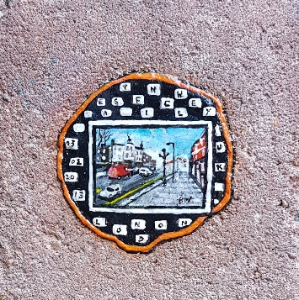
“8. Find art everywhere”
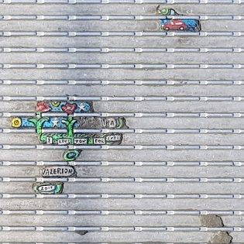
My eighth point states that I will “find art everywhere”, meaning I will always aim to find beauty and art in the simple things in life and explore how everything can be turned into something with meaning. An artist who encapsulates this is Ben Wilson, “The Chewing Gum Man”[3]. He paints on pieces of gum that have been discarded on the streets of London, which he then photographs before they get worn away from people walking over the top without noticing them. I want to be one of the people who spots all the most beautiful intricate details in life and can turn someone’s discarded waste and turned it into a piece of art.

Bibliography:
[1] Zola, E 1880, Nana, OUP Oxford; 2nd edition (26 Mar. 2020)
[2] Long, A. (2017) Thierry Mugler Glances Back At His Fantastical Past. Available at: https://www.elle.com/beauty/a12468934/magic-man-november-2017/ (Accessed: 01/11/2023)
[3] Wilson, B. () Ben Wilson “Chewing Gum Man”. Available at: https://benwilsonchewinggumman.com/ (Accessed: 01/11/2023)

Task 2: Semiotic Analysis

What is semiotic analysis? Semiology is defined as “the study of signs and processes from cultural representations to language, to warning signs, brands and emojis”[1]. In design, this means using different symbols and objects to convey a certain kind of message to the consumer. This section will explore theories of semiotics as well as how this can be applied to modern advertising campaigns; the knowledge gained from this piece will aid in finding different ways of seeing in design.

In a world of creation, every detail has a meaning this is conveyed to the consumer, whether that be visually or through the use of language. In Barthes’ book, “Writing Degree Zero and Elements of Semiology”, he states that “there is no meaning which is not designated, and the world of signifieds is none other than that of language”[2]. In semiology, the signifier refers to any object, word, image or action, whereas the signified is the meaning behind the signifier. Many of these signifieds, especially when used in advertising campaigns, have cultural, historical and societal references that convey different messages to the consumer. In Gillian Rose’s book, “Visual Methodologies”, when discussing the changes in culture for social scientists, Rose quotes Stuart Hall who says “culture is concerned with the production and exchange of meanings [] between members of a society… Thus culture depends on its participants interpreting meaningfully what is around them, and “making sense” of the world (Hall 1997a:2)”[3]. To explore the theories of semiology further, I will apply my knowledge to a modern advertising campaign.

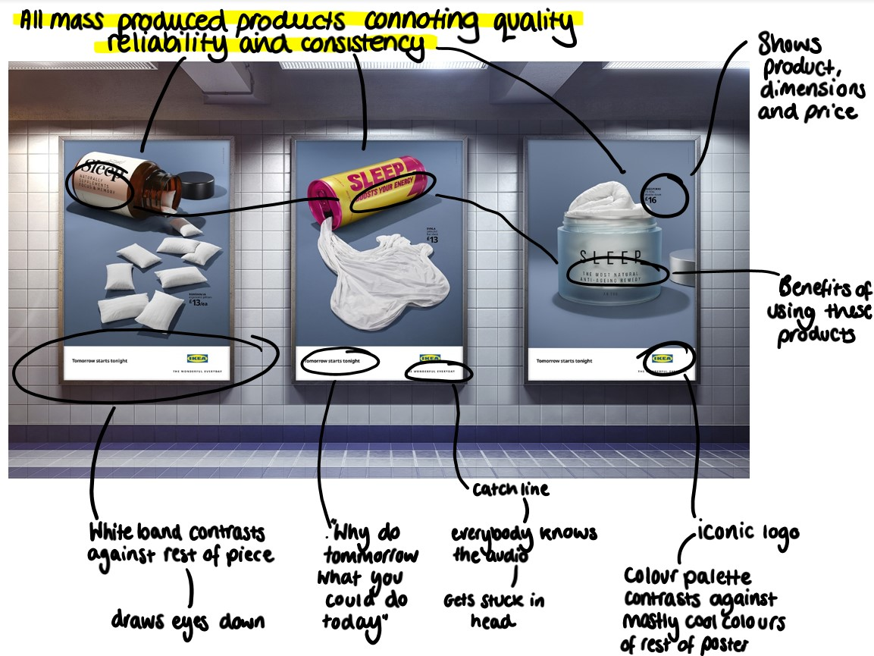
In 2020, IKEA, a Swedish furniture company, released an advertising campaign, displaying pillows, duvets and sheets, called “tomorrow starts tonight”. In these 3 posters, it showed pillows spilling out of a pill bottle, sheets coming out of an upturned energy drink can and a duvet in a pot of skincare. On the sides of each of these objects, it has the word “sleep” in large fonts as well as the benefits of using said product. By displaying their products coming out of these mass-produced items, that are consistent in quality, it implies to the consumer, subconsciously, that these products are going to be reliable and have consistent quality, as well as the idea that you would be getting the same thing every night.

In summary, the theories of semiology can be applied to different areas of design so as to influence the consumer into perceiving different things in certain ways.

Bibliography:
[1] What is Semiotic Analysis?. Available at: https://squareholes.com/blog/2019/03/14/semiotic-decoding-of-categories-and-culture/#:~:text=Semiotics%20is%20the%20study%20of,the%20signs%20and%20its%20meanings. (Accessed: 26/11/2023)
[2] Barthes, R. (1967) Writing Degree Zero and Elements of Semiology. Vintage Classics (4 Nov. 2010)
[3] Rose, G. (2007) Visual Methodologies. Sage Publications, London
https://www.mytutor.co.uk/answers/7825/A-Level/Media-Studies/what-is-the-difference-between-the-signifier-and-the-signified/

