Daniel Davies
2013713
25/04/2023

Power Electronics and Drives – ACDA6004
Assignment: Design Assignment
Contents
Introduction 2
Task 1 3
Background Information 3
Drive Selection 3
Motor A – Rolling Mill 4
Motor B – Gantry Crane 4
Motor C - Conveyor 5
Motor D - Cutting Machine 5
Motor E – Pumps/Fans 6
Discussion 6
Conclusion 6
Task 2 7
Background Information 7
Rectification 7
Diodes 7
Thyristors 9
IGBTs 9
Effects of Harmonic Noise on Power 9
Harmonic Noise Minimisation 10
Discussion 10
Conclusion 10
References 11

Introduction
This report will be used to analyse and design power electronic systems employing established and emerging techniques, and to analyse electrical drive systems and apply established and emerging techniques to ensure the effective operation of these systems.
In this report there two sections, section one is related to the selection of drives for various motors in an industrial setting. Section two is related to the rectification of incoming mains, harmonic noise minimisation through rectifier design and the effects of harmonics on power and power factor.
Each section will contain background information, the solutions for each task, a discussion and conclusion.

Task 1

Background Information
A drive is a device used to control a motor, usually in an industrial setting, such as a steel works. There are various types of drives available, the one used will be dependant on the requirements for the motor and that motors task.
Drive types are as follows:
- Adjustable Speed Drive: A drive that has various set motor operating speeds.
- Variable Speed Drive: A drive that is continuously variable in speed output.
If speeds can be selected from various pre-set ranges, the drive is adjustable speed. This differs to a variable speed drive, where the speed can be altered without steps over a range.
There are two main reasons for an adjustable speed drive, one is process control, the other is energy conservation.
An example of a system needing an adjustable speed drive is a wet well where a motor would be started when water reaches a certain level and is turned off if lower than that level. This can cause the pipes and pump to be subjected to mechanical and hydraulic stresses. As well as causing power surges when the motor starts. If a variable speed drive was used to control the motor, then the system could run at a lower speed and increase in speed as the water level rises, this makes the process smoother and reduces stress induced into the system.

Drive Selection
The drives required are for the motors shown in the table below:
 | Motor A | Motor B | Motor C | Motor D | Motor E
Power | 500 kW | 80 kW | 10 kW | 5 kW | 1 kW
Phases | 3 | 3 | 3 | 3 | 1
Voltage | 400 | 400 | 400 | 400 | 230
Required to be Reversible? | Yes | Yes | No | Yes | No
Variable speed required? | Yes | Yes | Yes | No | No
Quantity Installed | 5 | 10 | 23 | 17 | 127
Example Application | Rolling Mill | Gantry Crane | Conveyor | Cutting machine | Pumps / Fans

Motor A – Rolling Mill
Drive | Sinamics G120X | Schnieder Altivar 61Q | VYBO Electric V800
Communication Type | Profinet PN | Modbus | Modbus
Power | 500kW | 500kW | 500kW
Current | 890A | 876A | 835A
Phases | 3 | 3 | 3
Supply Voltage | 380-480V AC | 380-480V AC | 400V AC
Reversible | Yes | Yes | Yes
Variable Speed | Yes | Yes | Yes
Common DC Bus Functionality | Yes | Yes | No
Braking Type | Rheostatic | DC Injection | Rheostatic
Cost | £27,206 | Not available | Not Available
The above drives are all suitable for the purpose of being used for motors in a rolling mill. In this case, the Schneider drive is the best option, it meets all the requirements for the system and uses Modbus for communication, meaning it is compatible with other devices using this communication system. It uses DC injection for the braking system. The cost is unavailable on the website without getting a quote. For this circumstance, only one motor should be run off each drive.

Motor B – Gantry Crane
Drive | Schneider Altivar ATV900 | Siemens PM240-2 | Danfoss Inverter Drive P90K
Communication Type | Ethernet/Modbus | Profinet/Profibus | Modbus
Power | 90kW | 90kW | 90kW
Current | 140A | 290A | 177A
Phases | 3 | 3 | 3
Supply Voltage | 380-480V AC | 380-480V AC | 380-480V AC
Reversible | Yes | Yes | Yes
Variable Speed | Yes | Yes | Yes
Common DC Bus Functionality | Yes | Yes | Yes
Braking Type | DC Injection | Rheostatic | Rheostatic
Cost | £9,661 | £10,089 | £9,542
For the Gantry Crane motors, the best option would be the Schneider Altivar ATV900, it has the lowest current input requirement and uses DC injection for braking. It meets all the requirements of the system and has Modbus communication to be able to communicate with other devices on the same control system. In the case of this system, each motor should be driven independently instead of using one drive for more than one motor.

Motor C - Conveyor
Drive | RS PRO Inverter Drive | Allen Bradley Powerflex 525 | Schneider Variable Speed Drive ATV212
Communication Type | BACnet, Modbus, RS485 | Devicenet | Modbus
Power | 11kW | 11kW | 11kW
Current | 26.4A | 24A | 21.1A
Phases | 3 | 3 | 3
Supply Voltage | 380-480V AC | 400V AC | 400V AC
Reversible | No | Yes | Yes
Variable Speed | Yes | Yes | Yes
Common DC Bus Functionality | Yes | Yes | Yes
Braking Type | DC Injection | Dynamic | DC Injection
Cost | £688.30 | £2,147.47 | £1,523.85
For this motor, the RS Pro inverter drive would be the best option, it is by far the cheapest and can use Modbus to communicate with the other devices on the system. It meets all requirements for the conveyor systems, this particular drive would only be suitable for driving one motor of each type. Although the other drives are capable of reversable speeds, the conveyor doesn’t need to be reversible making this drive ideal.

Motor D - Cutting Machine
Drive | Parker Inverter Drive AC10 | Schneider Electric ATV63 | Schneider Electric ATV212
Communication Type | RS485 Modbus | Profibus | Modbus
Power | 5.5kW | 5.5kW | 5.5kW
Current | 12A | 10.4A | 8.6A
Phases | 3 | 3 | 3
Supply Voltage | 400V AC | 400V AC | 400V AC
Reversible | Yes | Yes | Yes
Variable Speed | Yes | Yes | Yes
Common DC Bus Functionality | No | Yes | Yes
Braking Type | Dynamic | DC Injection | DC Injection
Cost | £634.62 | £1,529.98 | £1,049.39
The Schneider Electric ATV212 is the best option for the cutting machine, it meets all the criteria for the application and uses Modbus to communicate which means it will easily integrate with the rest of the system. Although variable speed is not required all the drives has this function.

Motor E – Pumps/Fans
Drive | Danfoss Inverter Drive VLT FC51 | Allen Bradley Powerflex 4 Series | Mitsibushi Inverter Drive FR-D720S
Communication Type | Modbus | Modbus | Modbus
Power | 1.5kW | 1.5kW | 2.2kW
Current | 6.8A | 8A | 10A
Phases | 1 | 1 | 1
Supply Voltage | 230V AC | 230V AC | 230V AC
Reversible | Yes | Yes | Yes
Variable Speed | Yes | Yes | Yes
Common DC Bus Functionality | No | Yes | Yes
Braking Type | DC Injection | Dynamic | Dynamic
Cost | £382.72 | £624.29 | £343.80
The Mitsubishi drive would be the best option, it is the cheapest option and communicates using Modbus making it easy to integrate and use with other devices using that communication systems. It is also rated at 2.2kW which is more than double the required for a fan on the system, this means that more than one fan can be run off one drive.

Discussion
In an ideal world all selected drives would be from one manufacturer as there is a higher chance of seamless integration between the drives and the control system, although the key factor in ensuring all drives work on the system will be its communication system. In the case of the drives selected above, all communicate using Modbus which is an industrial communications protocol. Some of the options for the braking type will be explained below:
DC Injection: This type of braking where DC is injected into the windings of an AC motor after the AC voltage has been removed, this provides a braking force to the motor.
Dynamic: This is where an electric traction motor is used as a generator when slowing down a motor, it can be rheostatic or regenerative.
Regenerative: Regenerative is where the electrical power generated by the traction motor is returned to the supply line.
Rheostatic: This is where the electrical power that is generated is dissipated as heat I the brake resistors.
The DC common bus is used, it means that all the connected devices can share energy efficiently. For example, if one motor slows down and uses regenerative braking, the generated energy can be shared to other devices on the system.

Conclusion
As long as the all the devices on the control system use the same communications protocol there should be no problem with integrating all the devices into the system. Preferably all devices would be of the same manufacturer but in the case of the motors above, some drives of other manufacturers are better suited and cheaper to the stated application. In most cases, it is one motor per drive, but this could possibly be increased if the drive rating is increased.

Task 2

Background Information
Incoming mains can be rectified into DC by numerous means, such as by using diodes, thyristors and IGBTs. Rectification is required due to the fact that alternating current reverses direction periodically, while direct current flows consistently in one direction, this makes it easy to control.
There are various types of rectification:
Half wave rectification: This is where only half of the AC signal is permitted to pass to the output
Full wave rectification: This is where the full AC signal is permitted to pass, this requires an additional transformer.
Positive half cycle rectification: This is where diodes in positive polarity are used to allow current to pass while negative polarity diodes are used to block it.
Negative half cycle rectification: This is where the polarity of the diodes is reversed compared the method above.

Rectification

Diodes
Diodes are used to control the rectification as seen below. The top diodes allow the positive polarity of the sinusoidal wave to pass through while blocking the negative polarity, with the use of a 3 phase input, this allows the output to become more like DC, as can be seen by the output graph (yellow line)
6 Pulse
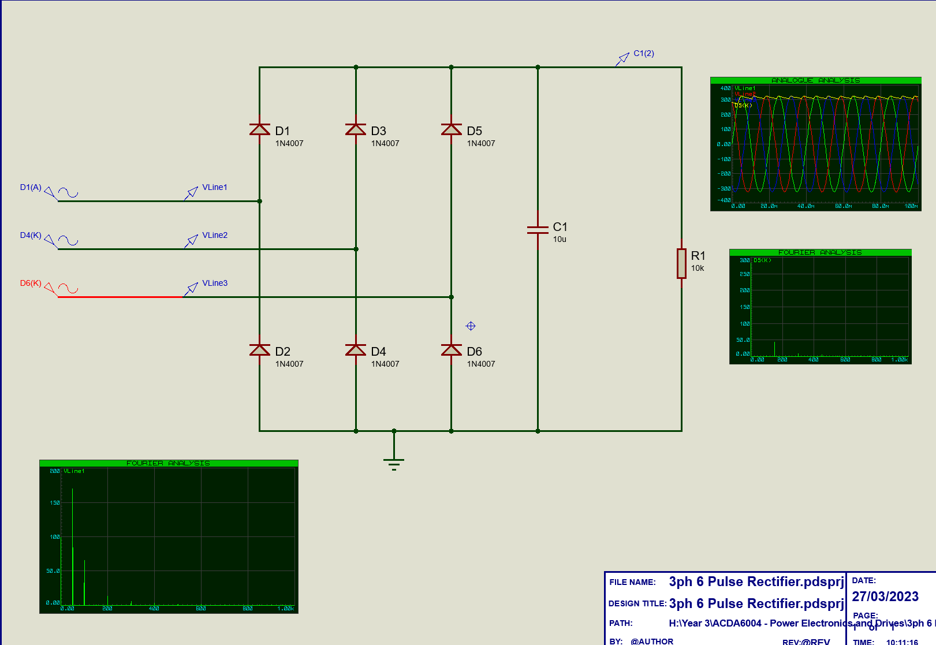
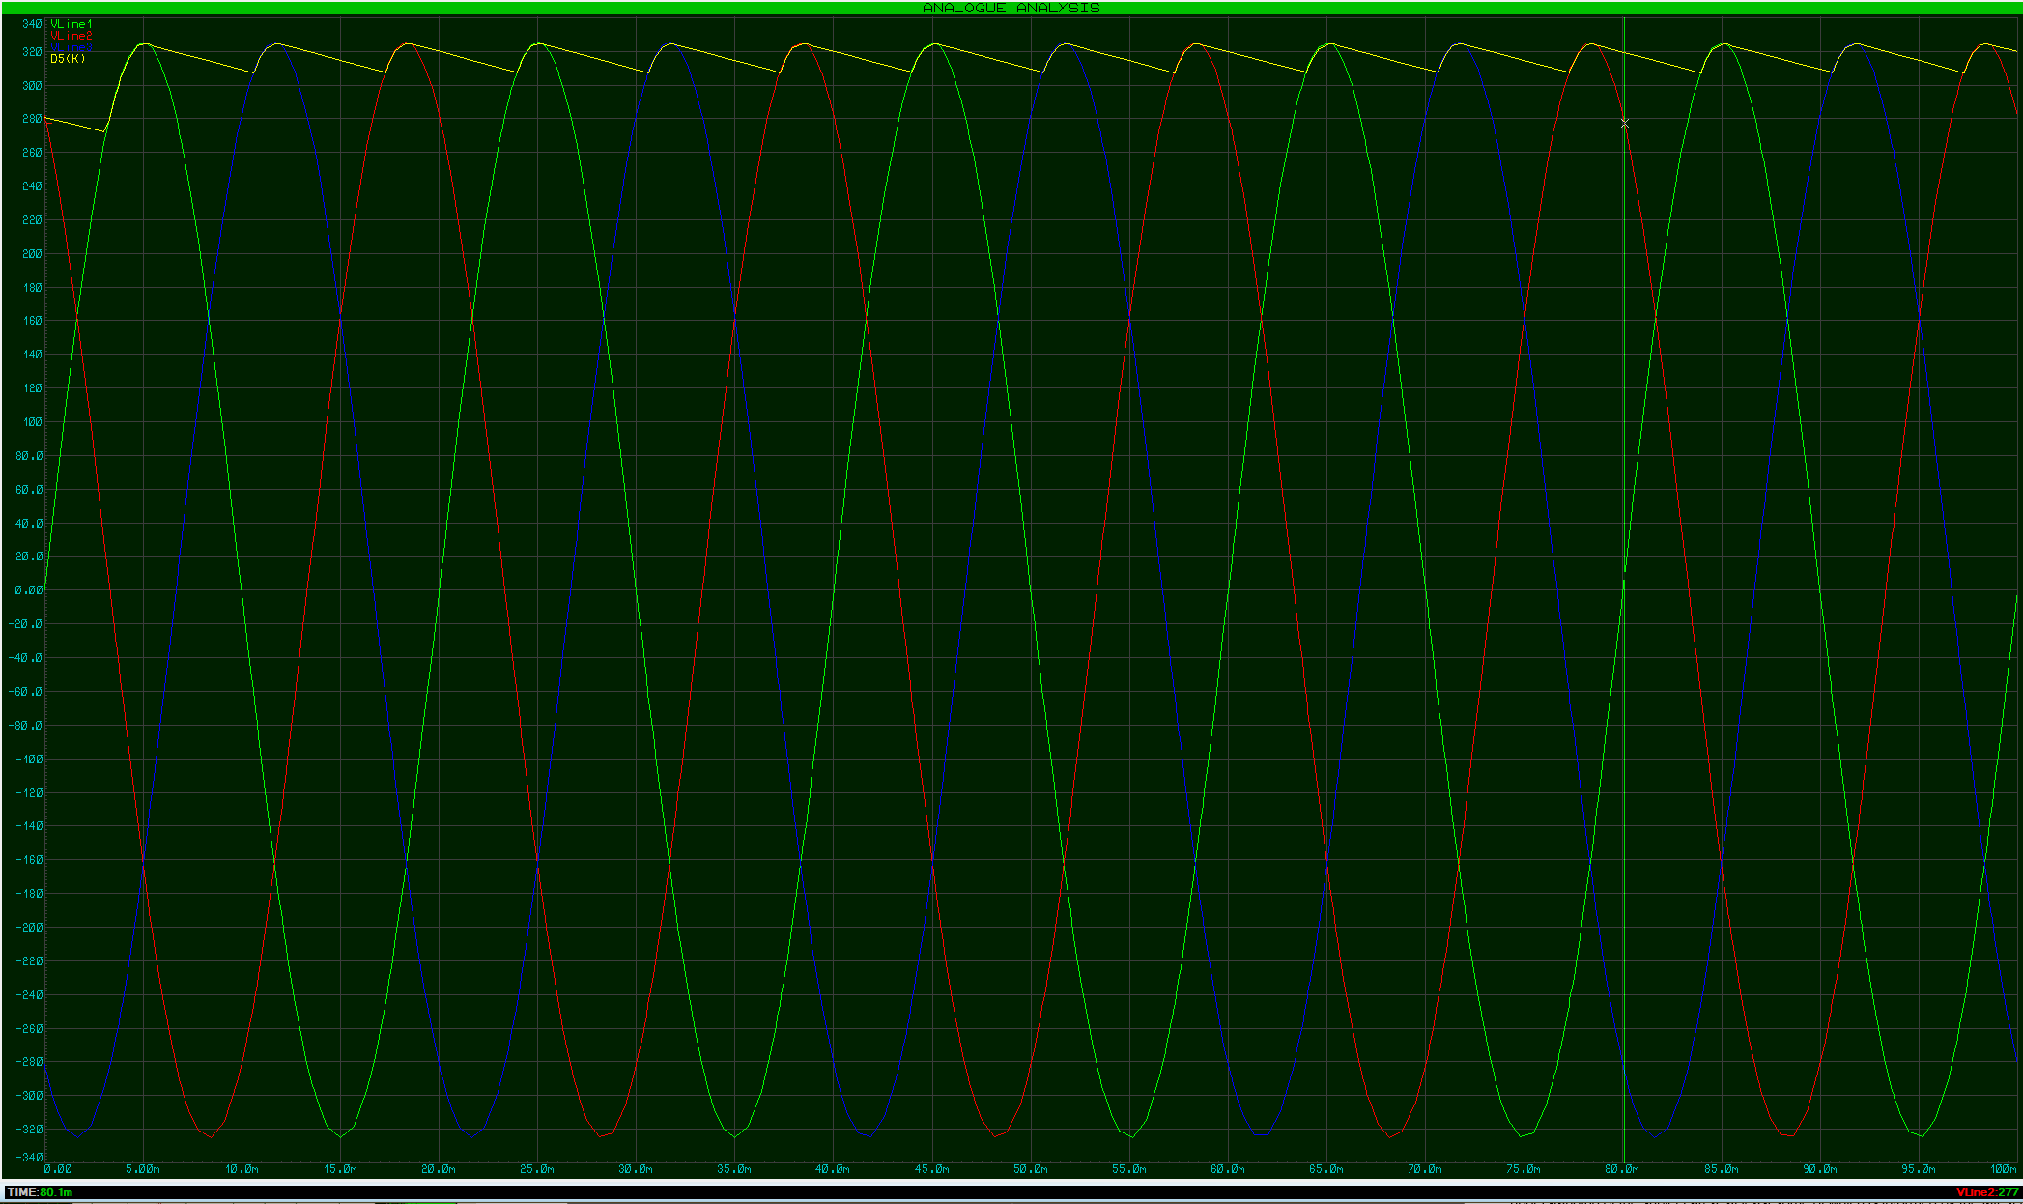
12 Pulse
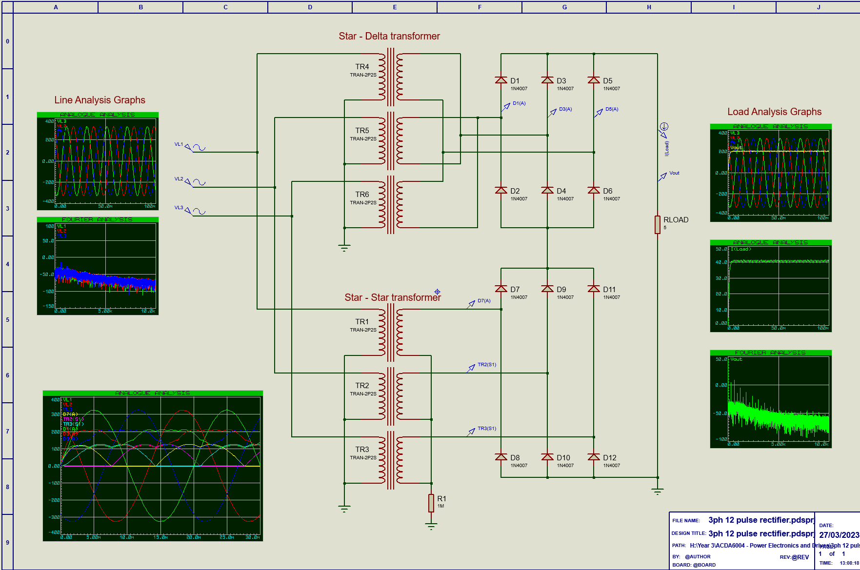
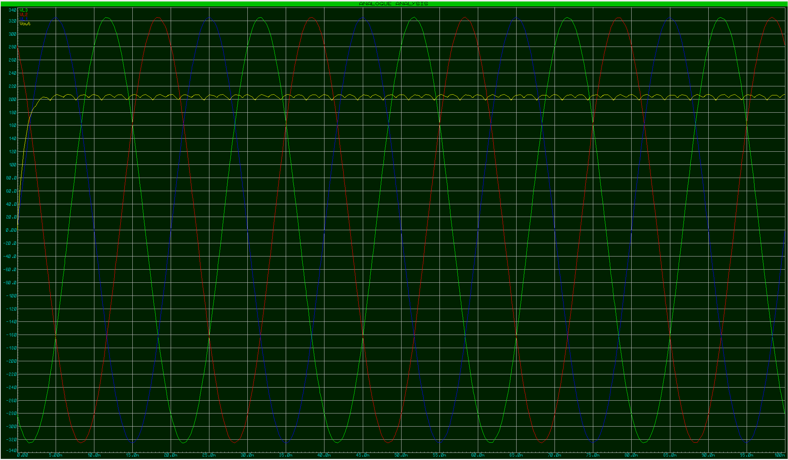
In the above 12 pulse circuit, diodes are used to control the DC output the same as the 6 pulse circuit, the main difference being the use of a star and delta transformer combination. This allows much more stable DC output although at a lower voltage level.

Thyristors
A thyristor is used to switch current on or off. When used in rectifiers, current can be controlled more accurately than using diodes. When using half wave rectification, either the top or bottom diodes are replaced, whereas in a fully controlled rectifier both sides are replaced. The benefit of using thyristors instead of diodes is that the thyristors can allow current to pass in a graduated way by turning the thyristors on and off at precise times, therefor allowing control of the conduction angle.

IGBTs
An IGBT rectifier works in the same way as the 12 pulse rectifier except that it uses IGBTs instead of diodes, IGBTs are essentially switches that are controlled electronically. The main advantage of using IGBTs instead of diodes is that it has a better power factor and harmonic content as well as it operates in 4 quadrants instead of 2. The main downside is that it is more expensive to build an IGBT rectifier compared to a diode based rectifier. The fact that it operates in 4 quadrants also provides versatility and a better response. In all, the IGBT rectifier produces a sinusoidal current input with unity power factor and low harmonics through the majority of the load range.

Effects of Harmonic Noise on Power
Harmonics are where the current and voltage in an electrical system are distorted and are deviated from the sinusoidal waveforms.
They are caused by non-linear loads being connected to a distribution system. A load is non-linear when the current draw has a different waveform to the voltage. Harmonic currents through impedances in a system cause harmonics in the voltage, these distort the supply voltage.
Current harmonic noise causes unwanted current and overheating. Voltage harmonics can cause equipment failure. Some symptoms of harmonic noise are as follows:
- Overheating (Cables, Motors, Transformers etc)
- Motor vibrations
- Audible noise
- Electrical fires
- Voltage notching
- Voltage regulator malfunction
- Timing errors
- LED light flickering
- Low power factor
- Efficiency losses
- Capacitor failure
- Breaker/Fuse nuisance tripping
When the harmonics are generated by a non-linear load, will introduce distortion reactive power, this reduces the power factor. Conventional methods of using capacitors to improve power factor are not effective in increasing power factor in these conditions.

Harmonic Noise Minimisation
Various corrective actions can be taken to reduce/remove harmonics.
Transformers: When wired in particular set ups can actually discriminate against certain harmonics and instead of eliminating them, can circulate them up stream.
In Delta-Star: Harmonics in the secondary of the power distribution system are unable to circulate in the primary, as they are confined in the neutral of the star connection.
Delta-Star-Delta: Two non-linear loads placed on each of the secondaries of the transformers will cancel 5th and 7th harmonics in the delta primary.

Reactors AC Line/DC Link: harmonics can be minimised by connecting a series inductor either in the AC line or the DC link circuit, this filters upstream harmonic current and limits the current peaks.

Passive harmonic filters: These are composed of inductors and capacitors that are used to cancel or trap harmonic frequencies. A downside of these however is that they only have a certain working point, this means that when away from that point, the harmonic distortion is no longer minimised. They also cause the reduction of the power factor and can also introduce resonance.

Active harmonic filters: An active harmonic filter measures the harmonics in the load and then produces the same harmonics but in the opposite phase, therefor cancelling each other out.

Conclusion
As shown, power circuits can be rectified in various ways using diodes, thyristors and IGBTs. Power circuits can also have voltage and current harmonics that need to be minimised in order to ensure proper working order of the equipment and optimal performance of that equipment. Faults that can be caused by harmonics are shown above as well as the ways to minimise them. In some cases, the errors caused by harmonics are not always rectifiable using usual methods, meaning other methods need to be used.

References
Power Products International, “Thyristor controlled rectifiers,” Home – Power Products International, 05-Sep-2016. [Online]. Available: https://www.ppi-uk.com/news/thyristor-controlled-rectifiers/. [Accessed: 16-Apr-2023].
E. Granath, “What are diodes and rectifiers?,” Power & Beyond, 08-Sep-2021. [Online]. Available: https://www.power-and-beyond.com/what-are-diodes-and-rectifiers-a-909411/#:~:text=A%20rectifier%20is%20a%20special,making%20it%20simple%20to%20control. [Accessed: 16-Apr-2023].
“Rectifier circuits: Diodes and rectifiers: Electronics textbook,” All About Circuits, 2020. [Online]. Available: https://www.allaboutcircuits.com/textbook/semiconductors/chpt-3/rectifier-circuits/. [Accessed: 16-Apr-2023].
D. Collins, “What is DC injection braking and how does it compare with other methods?,” Motion Control Tips, 2023. [Online]. Available: https://www.motioncontroltips.com/what-is-dc-injection-braking-and-how-does-it-compare-with-other-methods/. [Accessed: 16-Apr-2023].
T. Agarwal, “Dynamic braking : Connection diagram, Working & Applications,” ElProCus, 21-May-2020. [Online]. Available: https://www.elprocus.com/what-is-dynamic-braking-working-its-applications/. [Accessed: 16-Apr-2023].
S. Electric, Common DC bus, 2019. [Online]. Available: https://product-help.schneider-electric.com/Machine%20Expert/V1.1/en/Lx32sDr/Lx32sDr/Engineering/Engineering-13.htm. [Accessed: 16-Apr-2023].
E. Alves, “IGBT rectifier vs 12 pulse rectifier. which one should you choose?,” LinkedIn, 26-Nov-2020. [Online]. Available: https://www.linkedin.com/pulse/igbt-rectifier-vs-12-pulse-which-one-should-you-choose-edward-alves/. [Accessed: 16-Apr-2023].

