
Programme : Master of Business Administration
Module : Human Capital Management
Module Code : LCMB7023
Assignment Title : Assessment Component 1 : Individual Report
Lecturer : Ejike Udeogu
Student Name : Bhargav jagdishbhai khunt
Student Id Number : 2435433
Word Count : 2690
Submission Date : 17/10/2025

Assignment Title
“The Influence of National and International Labour Markets on HRM and IHRM Strategies”

Table of Content

1. Introduction 1
2. Technological Advancements and Their Implications for HRM and IHRM 2
2.1 Impact of Technological Change on Labour Markets 2
2.2 Implications for HRM and IHRM Strategies 4
2.3 Strategic and Theoretical Insights 5
2.4 Critical Evaluation and Summary 6
3. Demographic and Geopolitical Factors Influencing Employment Markets 6
3.1 Demographic Shifts and Workforce Dynamics 7
3.2 Geopolitical Forces and Labour Mobility 7
3.3 HR Challenges and IHRM Responses 8
4. Addressing Skills Gaps and Talent Shortages through Strategic HRM 8
4.1 Understanding the Skills Gap 8
4.2 Strategic HRM Tools and Solutions 8
4.3 Applying Theories and Models 9
4.4 Summary 10
5. Reflective Report on Personal Capabilities 10
5.1 Framework and Purpose 10
5.2 Technology Competence 11
5.3 Communication Skills 11
5.4 Teamwork and Leadership 11
5.5 Self-Directed Learning 11
5.6 Personal Development Plan 11
5.7 Summary 12
6. Conclusion 12
References 12

1. Introduction
In this fast-changing business environment, Human Capital Management (HCM) has evolved into a strategic operation to enable organisations to attract, develop and retain that talent so vital in ensuring their continued competitiveness. Human Resource Management (HRM) and International Human Resource Management (IHRM) have evolved beyond their administrative support roles, into strategic fields of study which have a direct impact on the global organisational performance. Constantly shifting labour market because of technological changes, demographic transformation, geopolitical instability, demand for HR specialists to implement flexible, evidence-based & futuristic strategies.
Automation, digitalisation and more sophisticated data systems are technologies that not only create new jobs, but also change standard job roles, transforming the way organisations recruit, learn and manage employees. Simultaneously, demographic changes such as working populations aged in the Global North and across more youth in the Global South have changed the make-up and demands of the workforce. What is more, the geopolitical pressures of the post-pandemic economy and increased demands on global labour movements (Brexit, local conflicts etc) further stratify the challenges related to the workforce set and strategy.
This report is a critical analysis of such developments in four parts. First, it examines the impact technological change is having on labour markets and the effect on HRM and IHRM strategies. Second, it considers the impact of demographic and geopolitical elements. Third is to evaluate the ability of organisations to surmount skills shortage and talent gaps through strategic human resource programmes. Lastly, it offers a contemplative evaluation of employability international skills. The general aim is to demonstrate, within a globalised setting, how organisational flexibility and individual ability can work together to achieve long term workforce sustainability.

2. Technological Advancements and Their Implications for HRM and IHRM

2.1 Impact of Technological Change on Labour Markets
Technological innovation is one of the strongest shaping forces altering labor markets on a global scale. Automation, artificial intelligence (AI) and machine learning have now radically changed the nature of work processes and employment patterns. The World Economic Forum (2023) predicts that existing worker skills will be disrupted in 44% of the next five years and that new jobs rooted in thinking analytically and creatively and coupled with digital literacy will be more common in the labor market. This shift has led to two improvements occurring at the same time: displacing jobs, especially low and non-skill jobs, in routine sectors; and jobs created in techno-forces. As such people in HR solutions have the double duty of reallocating the employees who have been laid off at the same time as filling new, niche jobs.
Digital employment platforms such as LinkedIn, Upwork and Fiverr have disrupted the distribution system of the employment industry by facilitating on-demand and mobile work opportunities. Gig economy has brought increased labor mobility at the cost of job security, benefits, and time-honored job protection (ILO, 2024). With growth in contingent and freelance labor, HRM will need to develop inclusive paradigms of managing these emerging types of employment relationships with the challenge of dealing with compensation, performance appraisal, legal considerations and required compliance across various jurisdictions.
Automation makes things more efficient but also threatens to drive greater social disparities between high and low skilled laborers. A study by the OECD (2024) suggests that polarization around technology is contributing to growing income inequalities within modern economies and developing economies. Consequently, HRM policies should not embrace innovation for the sake of it but rather support practices of digital inclusion through the extension of reskilling to vulnerable groups to enable a more even distribution of technological advantages.
Figure 1: Effects of Technology on Labour Markets and HRM Functions
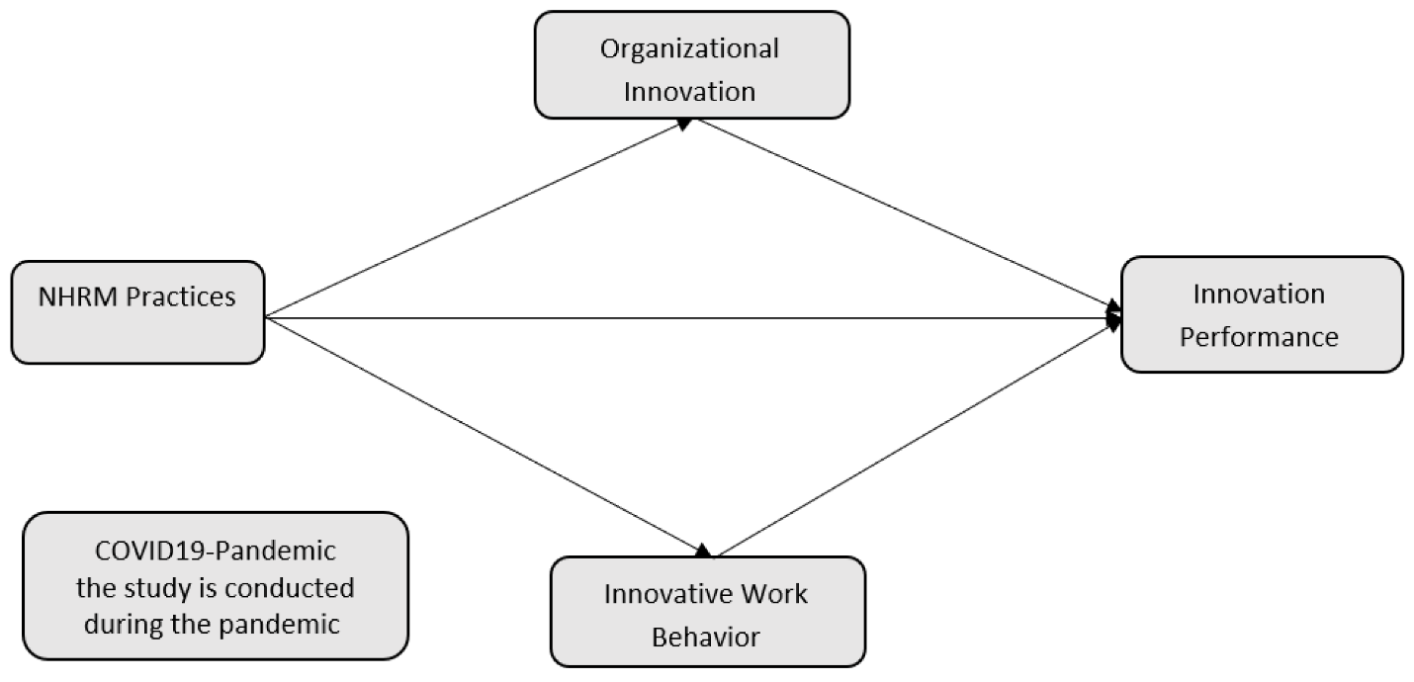
Table 1: Effects of Technology on Labour Markets and HRM Functions
Technological Trend | Labour Market Effect | HRM/IHRM Response
Automation & AI | Job displacement in routine work | Reskilling and redeployment programs
Digital collaboration tools | Rise of hybrid and remote work | Global virtual team management
Data analytics | Evidence-based HR decision-making | HR analytics integration
Digital platforms | Expansion of gig economy | Contractor management frameworks
(Source: WEF, 2023; CIPD, 2024)
Further, the global Human Resources (HR) tech market size has expanded to more than USD 12 billion in 2023, with an annualization rate of 30% (Deloitte, 2024). However, as per the reports submitted by CIPD (2024), just 54% of HR professionals are confident about using analytics tools. The presence of an internal competency gap at the HR level alone can itself be an important guiding light of the need for ongoing digital upskilling of HR professionals.

2.2 Implications for HRM and IHRM Strategies
HRM is shifting its focus in many ways; technology change is one example of a shifting emphasis on HRM as a business partner, as the creative force for sustainability. Instead, HR analytics systems can now be leveraged to accurately determine patterns of employee engagement, employee turnover, and employee productivity using AI, to thereby make data-driven decisions (Armstrong & Taylor, 2023). For instance, which staff members are at risk can be predicted and preemptive interventions can be taken to retain them.
In the IHRM, HR activities in the countries can be managed centrally, using Human Resources Information Systems (HRIS), such as Workday and SAP SuccessFactors. Tools provide improved consistency in enforcing policy, support data-driven performance management, and facilitate the cross-border management of expatriates. However, with the emergence of digitalization, comes concerns about data privacy, algorithmic bias, and digital surveillance, all which risk eroding the trust that is at their core. The challenge for HR professionals is to find the golden balance, which would be not only technically possible but also socially reasonable, given the international instruments adopted by institutions (as the General Data Protection Regulation (GDPR)), while maintaining the proven transparency and fairness of the algorithm used to make the decision.
However, amid all these good things, the unintended consequence of dependence on technology is making human relations impersonal. In response, HR leaders are adopting human-centered digital strategies that include both automation and empathy-that are communicating the world that technology doesn't replace human skills, only augments it.

2.3 Strategic and Theoretical Insights
In the context of strategic human resource management, the resource-based view (RBV) assumes that all technological infrastructure and digital capabilities of an organization are distinctive but valuable resources that can be defined as the source of a sustainable competitive advantage (Barney, 1991). So, not only are human resources departments responsible for improving digital literacy skills among their talented workforce, but not just within the IT departments. Learning is being culturalized and much digitalization is part of HRM strategy.
For further proof, there is another theory known as Social-Technical Systems Theory (Trist, Bamford, 1951) which maintains that organizational effectiveness results from the simultaneous optimization of the technology and the social system. This essentially means that if HR technologies are implemented without empowering the employees or adding the cultural factor, it will alienate the workers. In fact, to achieve HR digitalization, it is necessary to re-engineer processes, redesign jobs and re-define managerial responsibility.
In the field of IHRM, convergence-divergence theory states that globally oriented corporations share the technology of HR practice (convergence), but tailor it to their cultural, legal, and business practices (divergence). For example, Unilever has the same digital Hr platform across the world, but the content of the learning design and complaint modules is adapted to local legislation. Similarly, IBM's Skills Build program leverages AI to personalize learning for over two million learners around the world and tailor trainings to address national skills gaps and demand (IBM, 2024). This is part of the traditional multinationals' strategy of transferring technologies that allow them to reconcile international HR experiences with responsiveness to local situations.

2.4 Critical Evaluation and Summary
Convenience from technological innovation leaves us vulnerable. Algorithmic addiction can lead to a less ethical form of blind facilitation and reduced accountability by managers. Automated decision-making has been found to reduce levels of trust and interest because employees will consider that it isn't transparent (Brynjolfsson and McAfee, 2022). That means that HRM in the digital age works only if you have both the human touch - and the automation - in one place. Technology HRM/IHRM: An opportunity as well as a challenge. It's no secret that automation, analytics, digital collaboration tools help organizations remain competitive and retain employees but what sets the morally driven models apart is the nature of the information that's being produced. HR professionals will play a strategic role in building well-prepared, resilient and inclusive global workforces through innovative use of technology, while promoting inclusion, reskilling and transparency.

3. Demographic and Geopolitical Factors Influencing Employment Markets

3.1 Demographic Shifts and Workforce Dynamics
Demographic change is an important factor in shaping the global supply and demand for labor. Increasing ageing and declining workforces, growing dependency and rise of high dependency pressures are all converging in European and Japanese space, making migration a necessity for the years ahead (OECD, 2024). On the other hand, a youth bulge is unfolding in Africa and South Asia, presenting both opportunity and challenge in terms of the generation of sufficient jobs.
Another key factor that is driving HRM policies is workforce diversity in terms of gender, ethnicity, age and ability. Organizations are also beginning to realize diversity provides greater creativity and problem solving (Shore et al., 2018). However, if workplace generational differences (Baby Boomer vs. Gen z) are to be addressed, then adaptive HR policies can support differing values and digital capabilities.

3.2 Geopolitical Forces and Labour Mobility
Geopolitical events have a direct influence on the flow of international labour. Brexit has created a UK labor shortage in the hospitality and agriculture industries, forcing employers to reconsider compensation and automation policy as well as domestic training policy. Similarly, wars such as that in Ukraine have led to the displacement of millions of people, impacting trends in European access to labor and HR issues at MNCs. Talent mobility and workforce stability are also impacted with the supply chain disruption and economic sanctions across the globe. The International Labour Organization (2024) forecasts that global unemployment will not reach the pre-pandemic level, given geopolitical and economic uncertainties in several regions.
Table 2: PESTLE Summary of External Labour Market Factors
Factor | Example | HRM/IHRM Implication
Political | Brexit, sanctions | Restriction on labour migration
Economic | Inflation, cost of living | Pressure on wage policies
Social | Ageing population, diversity | Need for inclusive HR policies
Technological | AI, automation | Workforce reskilling
Legal | GDPR, visa regulations | Compliance challenges
Environmental | Green jobs, sustainability | New skills demand in renewable sectors
(Source: CIPD, 2024)

3.3 HR Challenges and IHRM Responses
For HR professionals, the changes are leading to workforce planning, compliance and cross-cultural management challenges. HRM will need to consider the deployment of talent across the world, expatriate services and telecommuting. Brewster et al., (2022) the main challenge with globalization and local adaptation is balancing the two strategies to successfully address cross-border HR functions. Companies like global firm Siemens and Accenture have developed global mobility frameworks with flexible assignment models that can be quickly adapted to geopolitical changes. HR also needs diversity, equity and inclusion (DEI) programs in place to build resilience and innovation in global teams.

4. Addressing Skills Gaps and Talent Shortages through Strategic HRM

4.1 Understanding the Skills Gap
The technological and industrial evolution has been very fast; it has overtaken the traditional education system, creating a huge disproportion of competences. According to a 2023 report by the World Economic Forum, half of all workers will have to reskill by 2027. Skills shortages for nurses and allied health professionals and the skills shortage in the technology industry including cybersecurity and data analytics.

4.2 Strategic HRM Tools and Solutions
These gaps can be bridged by an integrated HR strategy; one connecting workforce planning with organizational strategy. Part Four: Intervention in Practice:
- Upskilling and Reskilling: Partnering with e-learning platforms (Coursera, LinkedIn Learning) for lifelong learning.
- Employer Branding: Meaning and Belonging to Attract Rarity.
- Talent Pipelines: Building Universities and Apprenticeships Relationships for the Long-Term.
- Flexible Working: How to hire flexibly, expanding positions to increase the talent pool.

4.3 Applying Theories and Models
Becker (1993) human capital theory reasserts the importance of investment in human capital from the standpoint of economics and puts training into the investment cost bucket. Against this background, based on Ulrich's (2012) model, HR would be considered strategic if its role is perceived to be a key factor in transforming human capital to meet business goals and interests. For instance, the NHS has an international recruitment and mentorship program that lowers the supply of temporary workers, and Amazon has a Career Choice Program that subsidizes tuition for employees who are trying to advance within the organization. One finding is that both regions have a similar systemic HRM reaction to labour market crises.
Figure 2: Conceptual Framework, Strategic HRM Responses to Skills Gaps
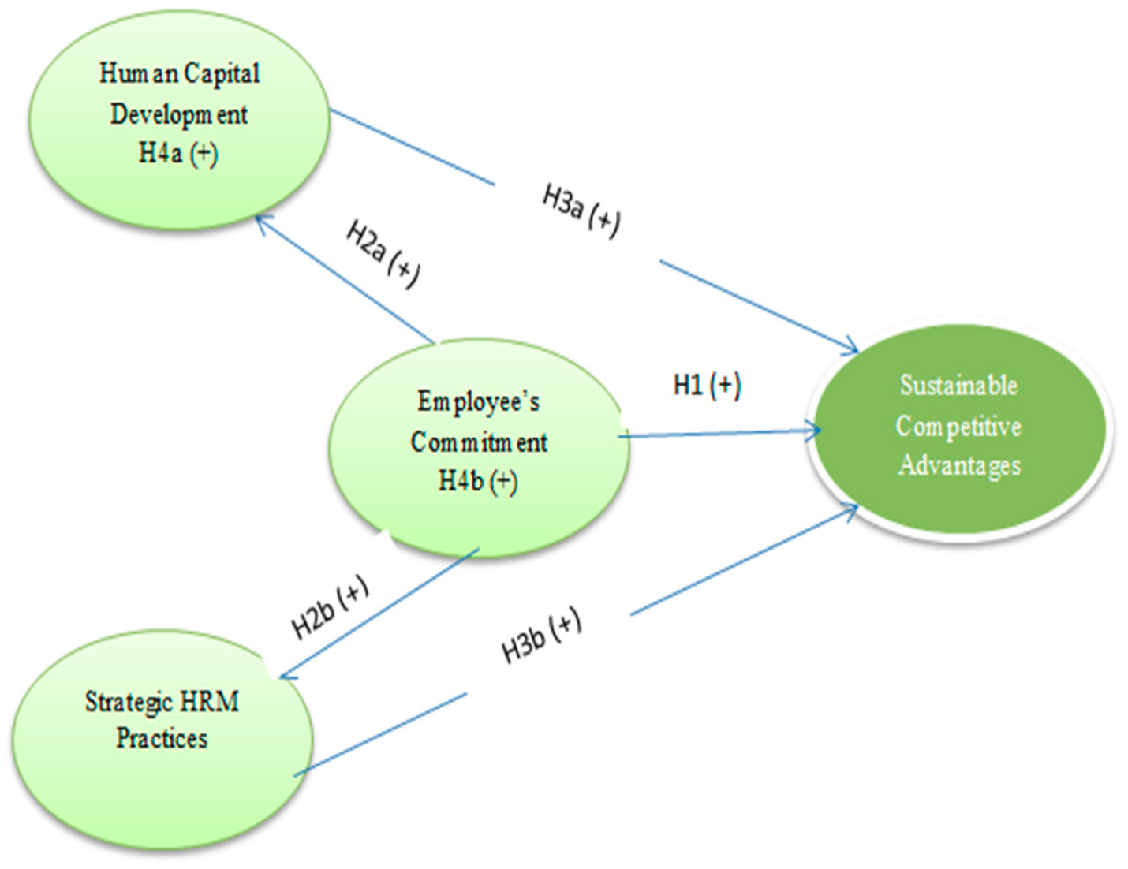

4.4 Summary
By adding the strategic management practices of HRM based on data and human capital investments, companies will be able to maintain a competitive advantage. The highest performing, forward-thinking employers are those that are able to proactively anticipate skill shortages and take preemptive action.

5. Reflective Report on Personal Capabilities

5.1 Framework and Purpose
This part uses Gibbs Reflective Cycle (1988) and identifies the competencies that I draw from in technology, communication, teamwork, leadership, and self-directed learning. Metacognition or the ability to learn how to learn and evolve is essential in today's globalized labor market and is only possible with reflection.

5.2 Technology Competence
Intermediate level skills in digital tools such as Microsoft Office, HRIS and Collaborative technologies. I am adaptable and inquisitive, but need a deeper analytical skillset involving Power BI and SPSS. To close this gap, over the next six months, I'm going to be completing online qualifications in data analysis and attending digital HR workshops.

5.3 Communication Skills
Communication is important when managing remote and multicultural teams. I'm always vocal and assertive and responsive and spouty and such, but sometimes I am simply not able to assert an opinion under pressure. I will do this by learning to be assertive and intercultural (CIPD, 2024).

5.4 Teamwork and Leadership
I have a transformational leadership style, which I think has the benefit of allowing group projects to foster teamwork and creativity. Through volunteering and leadership simulations, I will attempt to work on my conflict management skills and my delegation skills.

5.5 Self-Directed Learning
Continuous improvement applies to self-directed learning as well. I'm an active setter of academic and professional goals and thoughtful evaluator of current results in the form of journal entries. In order to ensure the continuity of my learning I'll be using SMART goals (Specific, Measurable, Achievable, Relevant, Time-bound).

5.6 Personal Development Plan
Skill Area | Current Level | Target | Action Plan | Timeline
Digital Skills | Intermediate | Advanced | Complete HR Analytics Certificate | 6 months
Communication | Good | Excellent | Enrol in intercultural communication course | 4 months
Leadership | Moderate | Strong | Attend leadership development workshops | 6 months
Teamwork | Strong | Excellent | Volunteer in cross-functional projects | Ongoing
Learning | Good | Excellent | Implement SMART-based reflection plan | Continuous

5.7 Summary
This confirms, I am already well established as a cross-border professional though there is still a need for digital literacy and impact. A permanent education and the need to be aware of the world will guarantee a professional evolution.

6. Conclusion
Technological change, demographic change, and the reshaping of national boundaries are creating fundamental structural changes in national and global labour markets. We have seen how these forces are pushing for a re-brand of an organization, such as Human Resource Management (HRM) and International Human Resource Management (IHRM), into something that is more agile, inclusive and data-driven. Cultivating a workforce that can learn continuously, plan strategically, and develop talent can also help organizations build resilience and maintain competitiveness in an increasingly volatile environment. Also, HR professionals should look towards ethically grounded, global solutions to find a balance between automation and human potential. In the private domain, competencies that allow individuals to flourish in the highly interconnected and dynamic world of work appear to be adaptability, reflective learning, and digital fluency. And even if it did, why should we care? It is the integration of technological revolution, population awareness and knowledge, and the approach of human resource management that will determine the success of organizations and the viability of human resources in the twenty-first century.

References
Armstrong, M. and Taylor, S. (2023) Armstrong’s handbook of human resource management practice. 17th edn. London: Kogan Page.
Barney, J. B. (1991) ‘Firm resources and sustained competitive advantage’, Journal of Management, 17(1), pp. 99–120.
Bartlett, C. A. and Ghoshal, S. (1989) Managing across borders: the transnational solution. Boston, MA: Harvard Business School Press.
BBC (2023) Brexit: labour shortages continue to impact UK sectors. Available at: https://www.bbc.co.uk/news/business (Accessed: 5 October 2025).
Becker, G. S. (1993) Human capital: a theoretical and empirical analysis with special reference to education. 3rd edn. Chicago, IL: University of Chicago Press.
Brewster, C., Chung, C. and Sparrow, P. (2022) Globalizing human resource management. 3rd edn. London: Routledge.
Brynjolfsson, E. and McAfee, A. (2022) The second machine age: work, progress, and prosperity in a time of brilliant technologies. New York: W. W. Norton & Company.
Chartered Institute of Personnel and Development (CIPD) (2024) HR analytics and digital transformation report. London: CIPD.
Chartered Institute of Personnel and Development (CIPD) (2024) Workforce planning and diversity report 2024. London: CIPD.
Deloitte (2024) Global human capital trends 2024: navigating the new digital workplace. London: Deloitte Insights.
Ernst & Young (EY) (2023) Gen Z and the future of work report. London: Ernst & Young.
Gibbs, G. (1988) Learning by doing: a guide to teaching and learning methods. Oxford: Oxford Polytechnic.
IBM Corporation (2024) SkillsBuild impact report 2024. Armonk, NY: IBM Corporation.
International Labour Organization (ILO) (2024) World employment and social outlook 2024. Geneva: International Labour Organization.
Kolb, D. A. (1984) Experiential learning: experience as the source of learning and development. Englewood Cliffs, NJ: Prentice Hall.
Organisation for Economic Co-operation and Development (OECD) (2024) Skills outlook 2024: strengthening global workforce resilience. Paris: OECD Publishing.
Shore, L. M., Randel, A. E., Chung, B. G., Dean, M. A., Ehrhart, K. H. and Singh, G. (2018) ‘Inclusive workplaces: a review and model’, Human Resource Management Review, 28(2), pp. 176–189.
Trist, E. L. and Bamforth, K. W. (1951) ‘Some social and psychological consequences of the longwall method’, Human Relations, 4(1), pp. 3–38.
World Economic Forum (WEF) (2023) The future of jobs report 2023. Geneva: World Economic Forum.

