Appendices

Lesson Study 1
Figure 1 – Lesson Plan
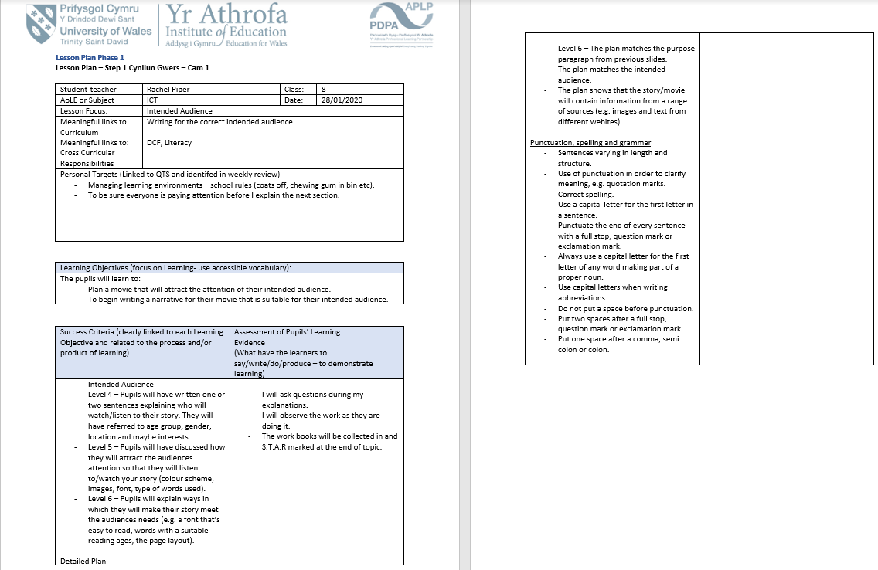
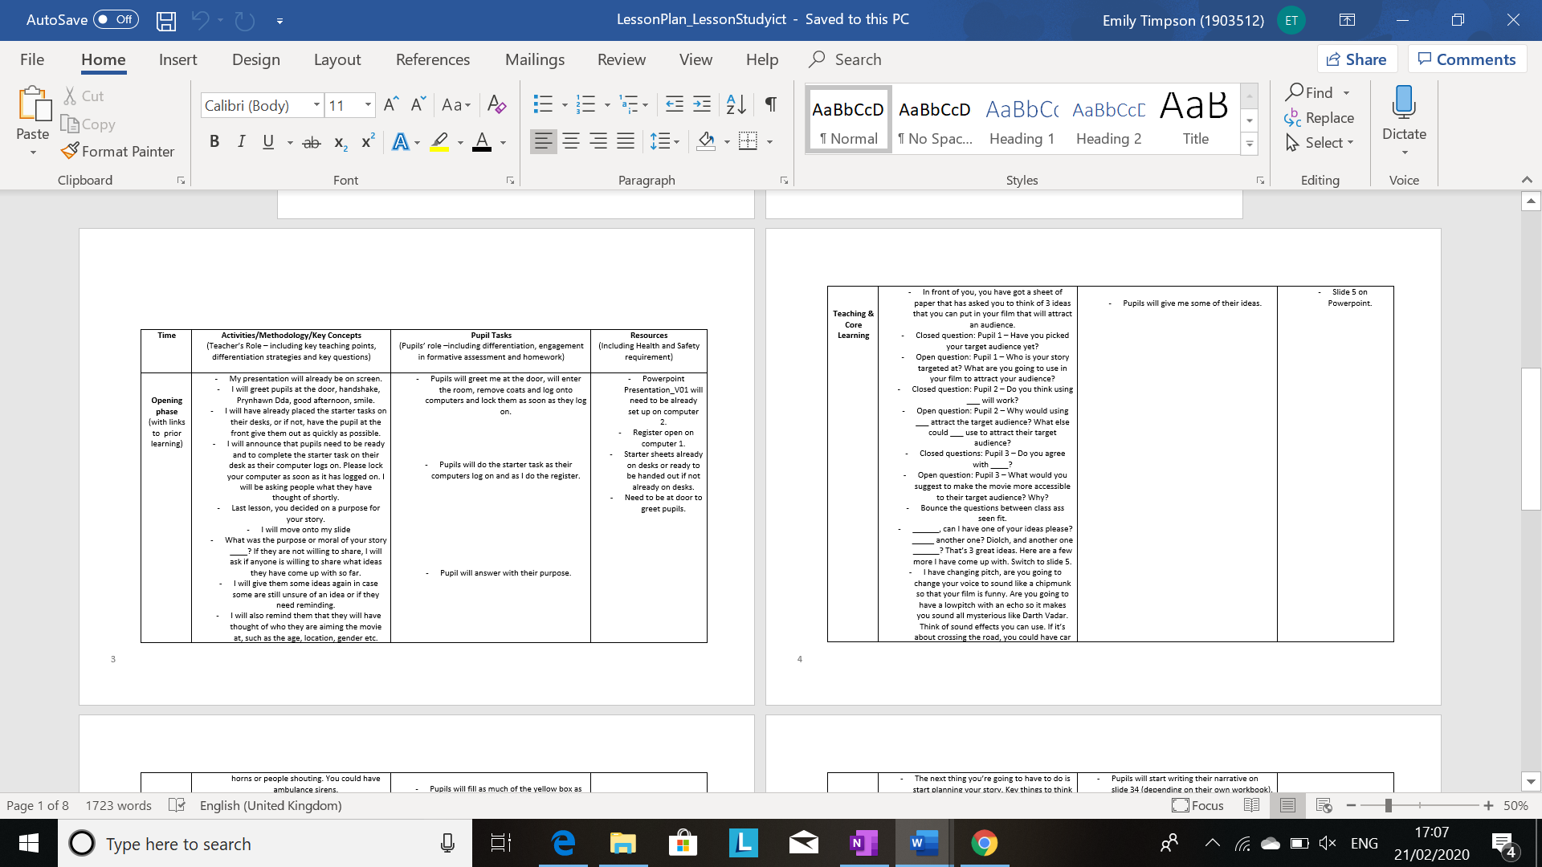

Figure 2 – Observation Notes
Figure 2.1 –
Figure 2.2 –

Figure 3 – Focus Group Interview
Figure 3.1
Figure 3.2

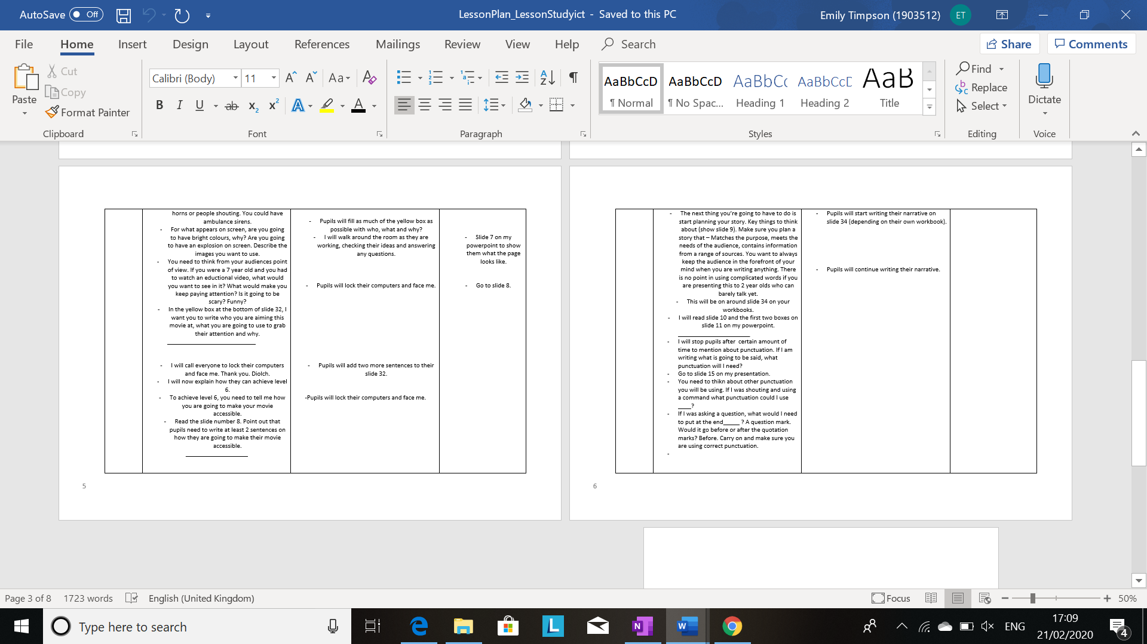

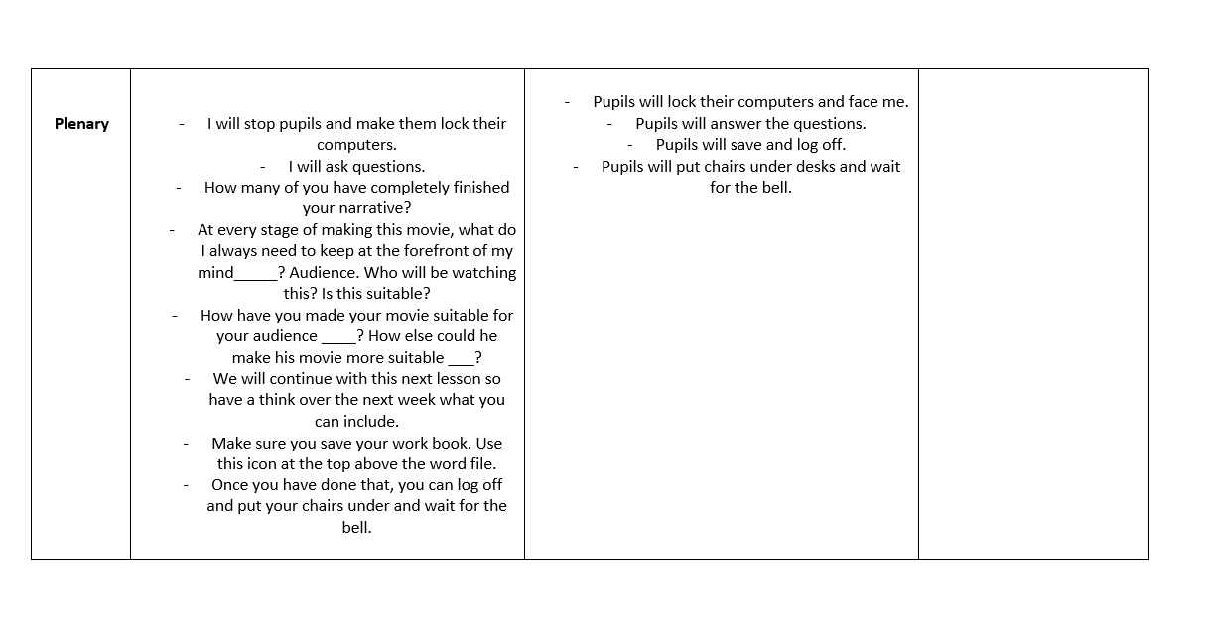

Figure 2 – Observation Notes
Figure 2.1
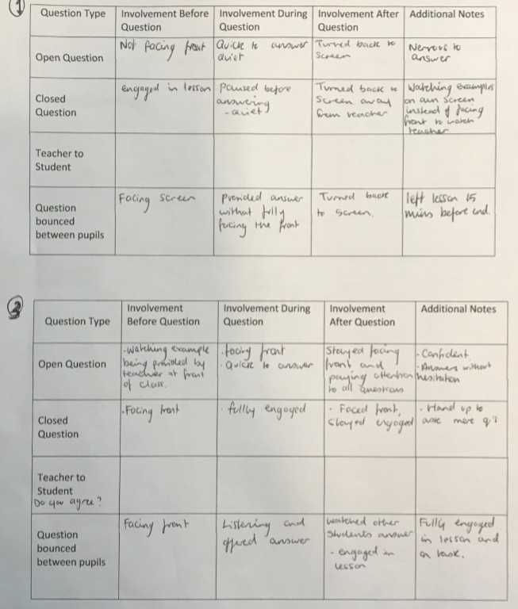
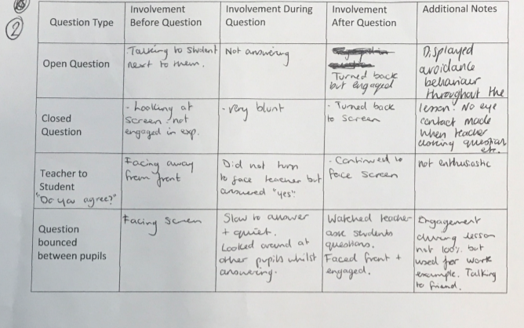
Figure 2.2
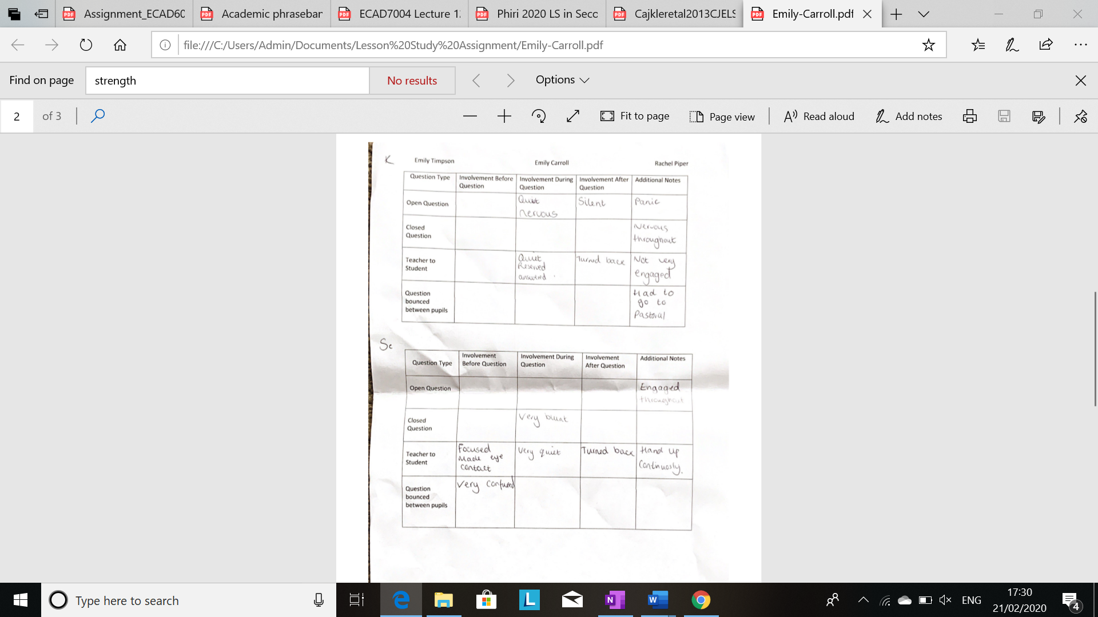
Pupil 1
Pupil 3

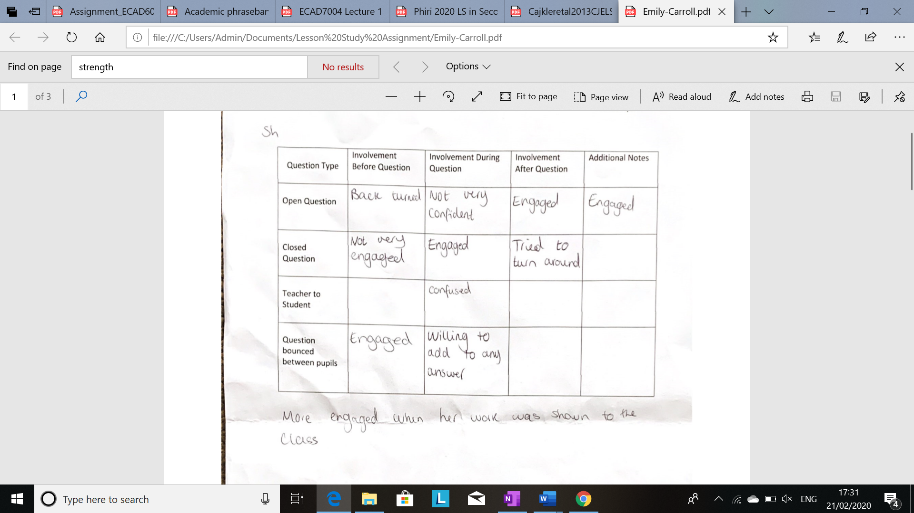
Pupil 2
Figure 3 – Focus Group Interview Questions

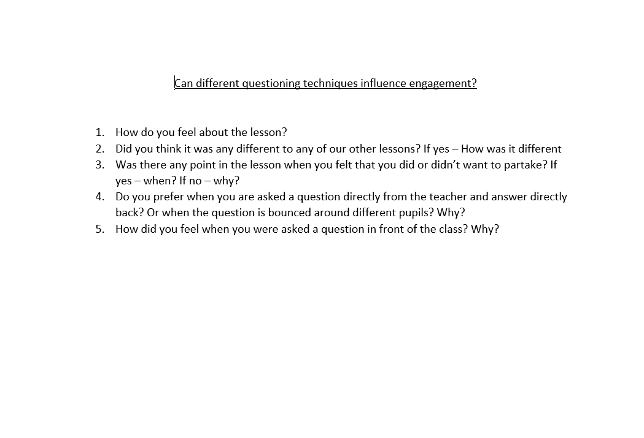

Figure 4 – Reflection
Figure 4.1 –

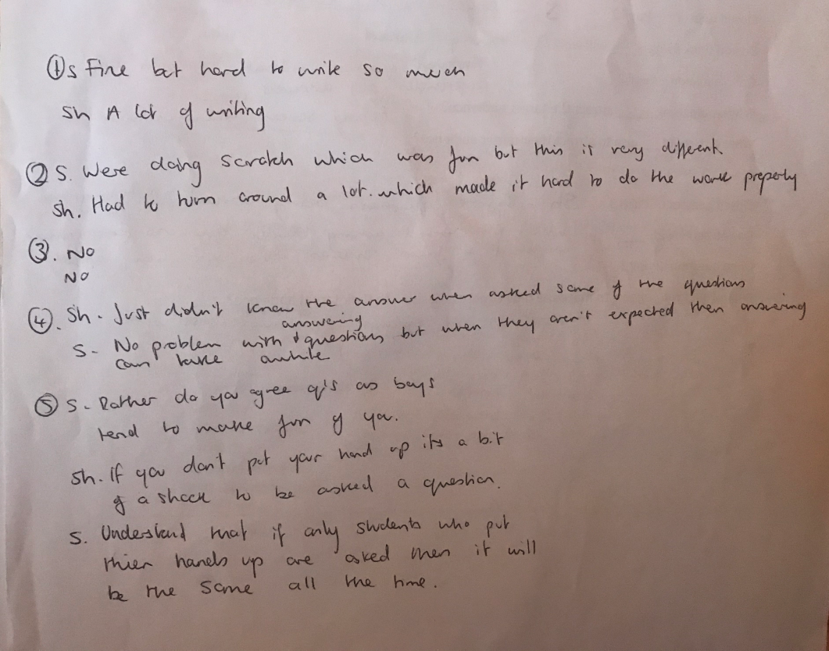
S = Pupil 3 SH = Pupil 2
Figure 4 - Reflection
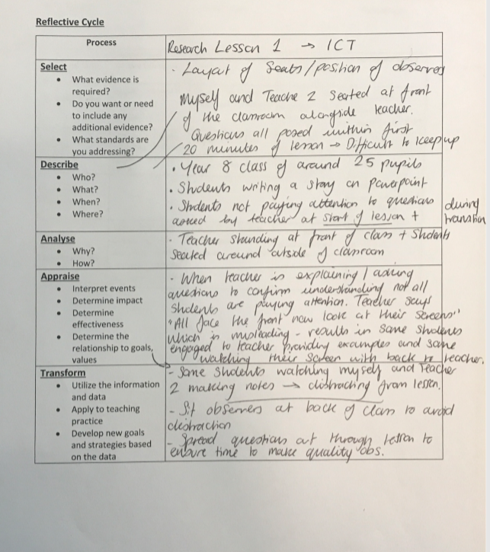

Lesson Study Two
Figure 5 – Lesson Plan
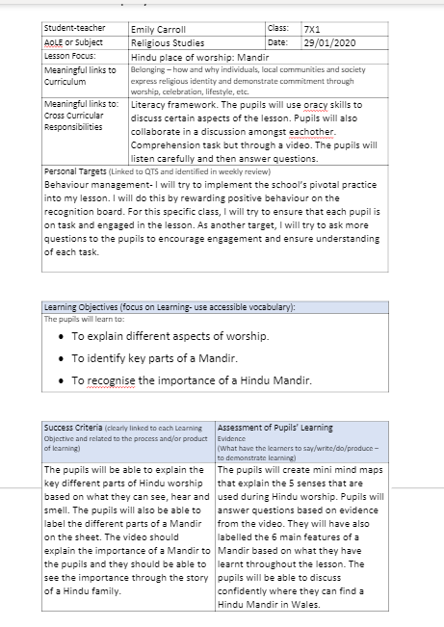

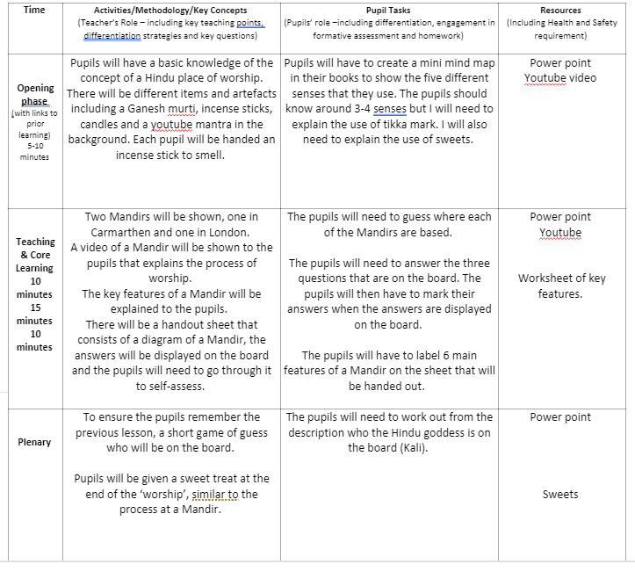

Figure 6 – Observation Notes - Figure 6.1
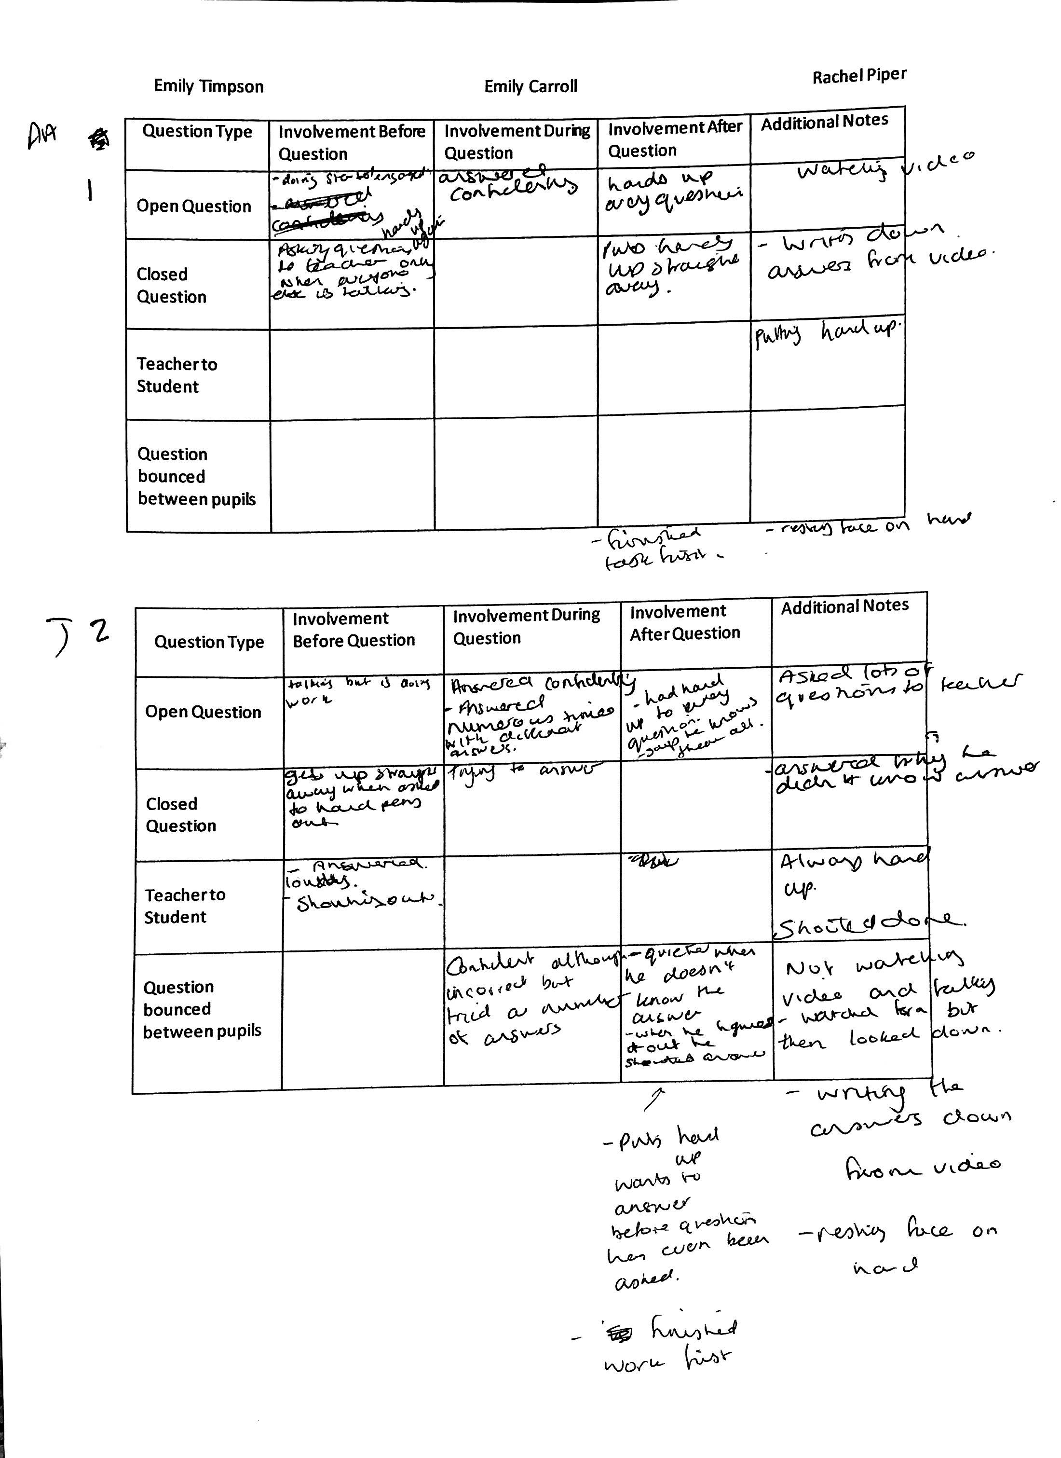
Pupil 2
Pupil 3

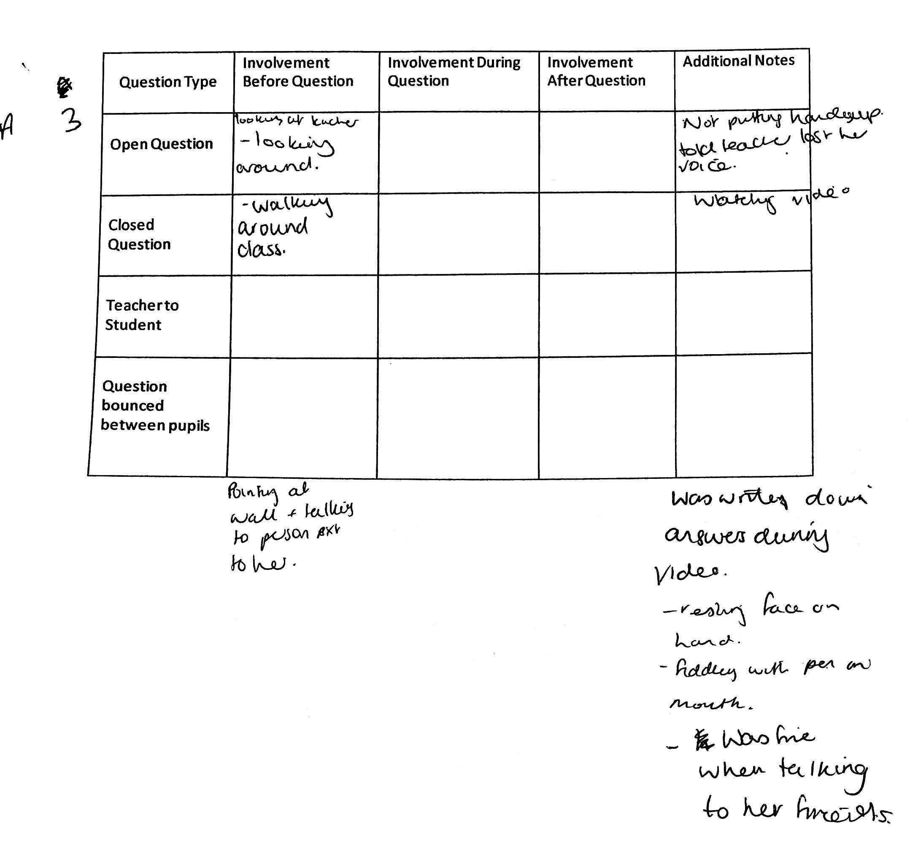
Pupil 1

Figure 6.2
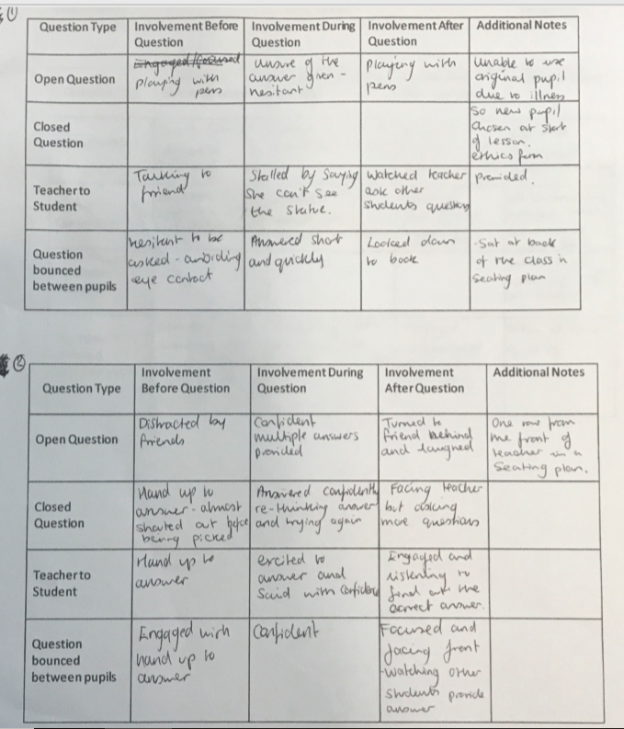
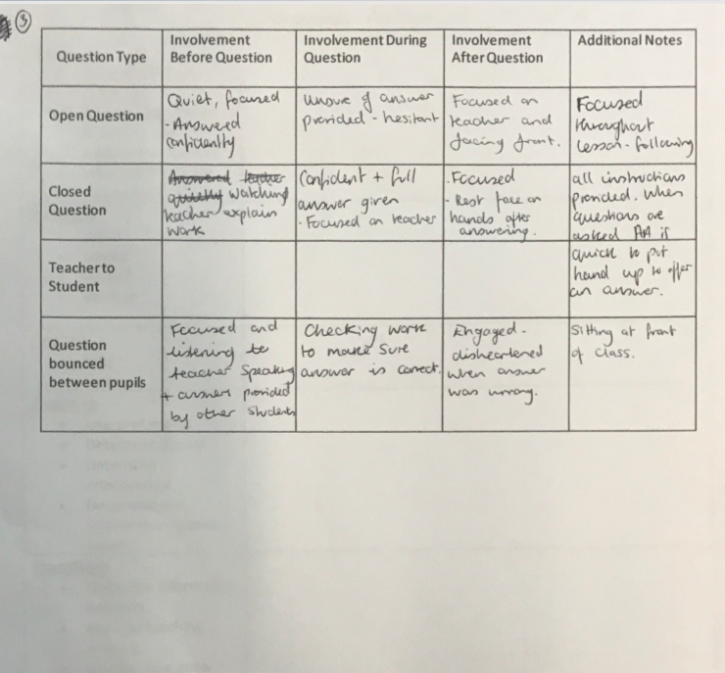

Figure 7 – Focus Group Interview
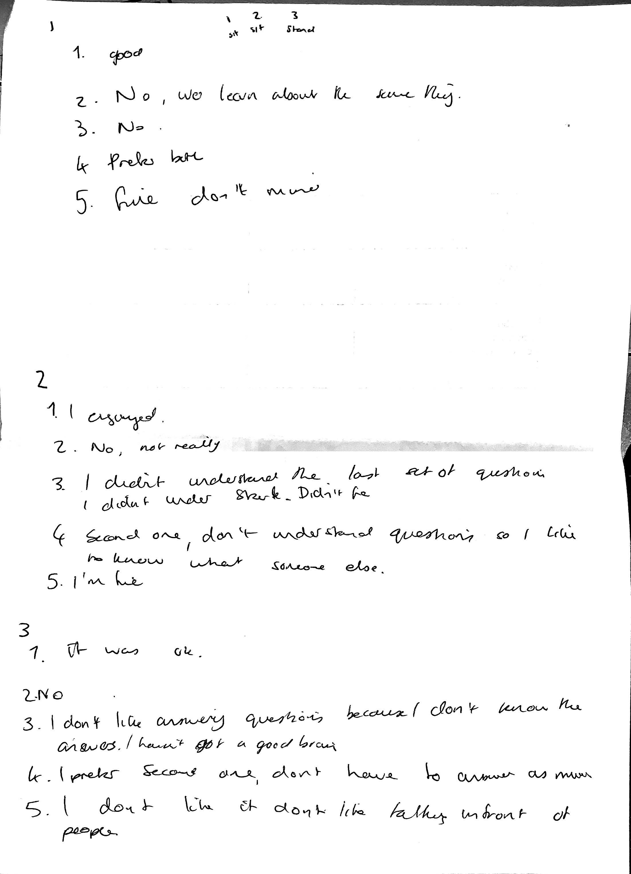
Pupil 1
Pupil 2
Pupil 3

Figure 8 – Reflection
Figure 8.1
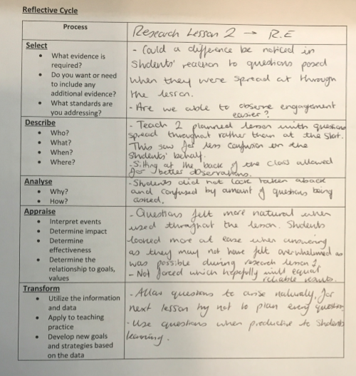
Lesson Study Three
Figure 9 – Lesson Plan
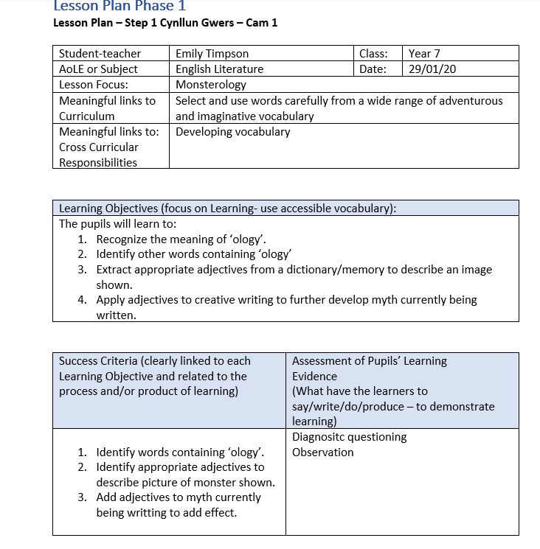

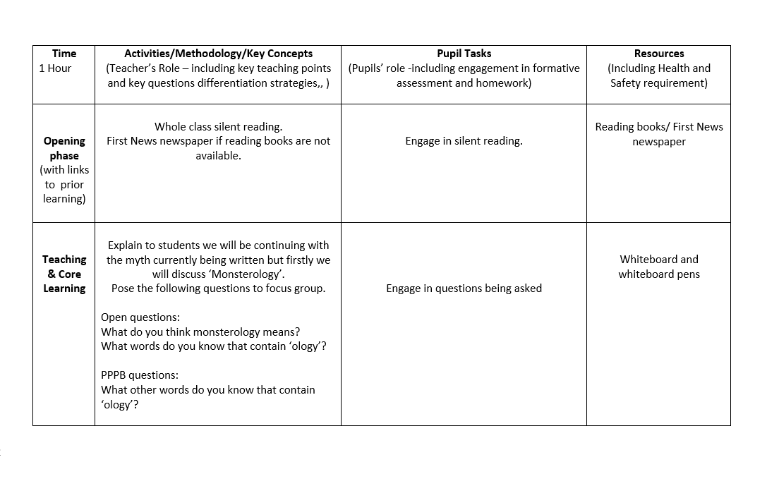
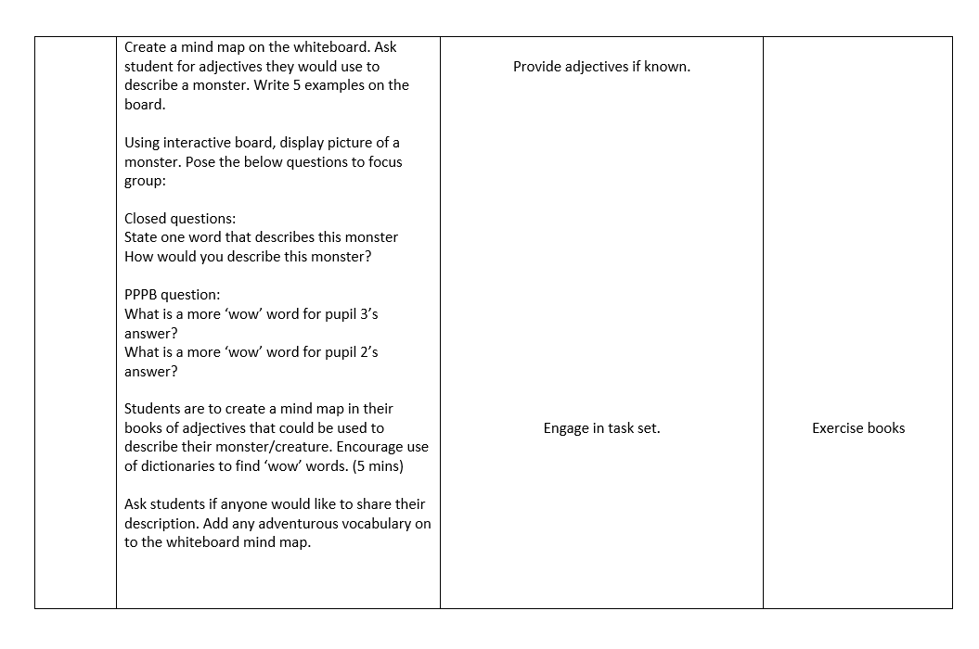

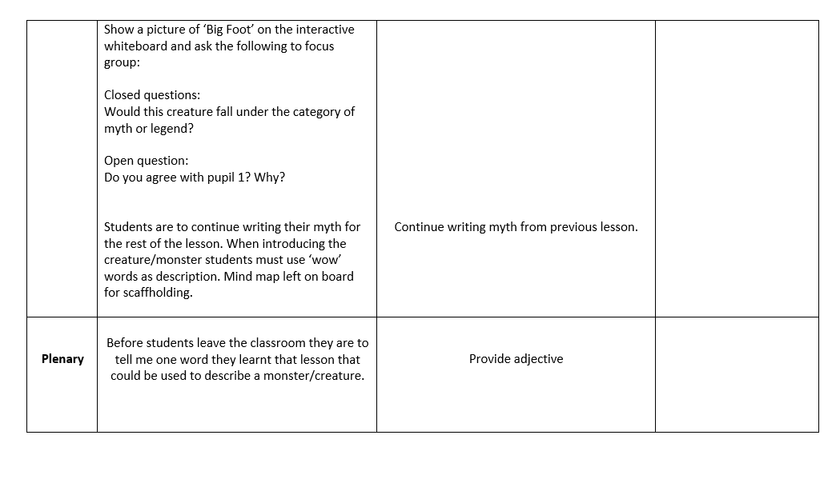
Figure 10 – Observation Notes
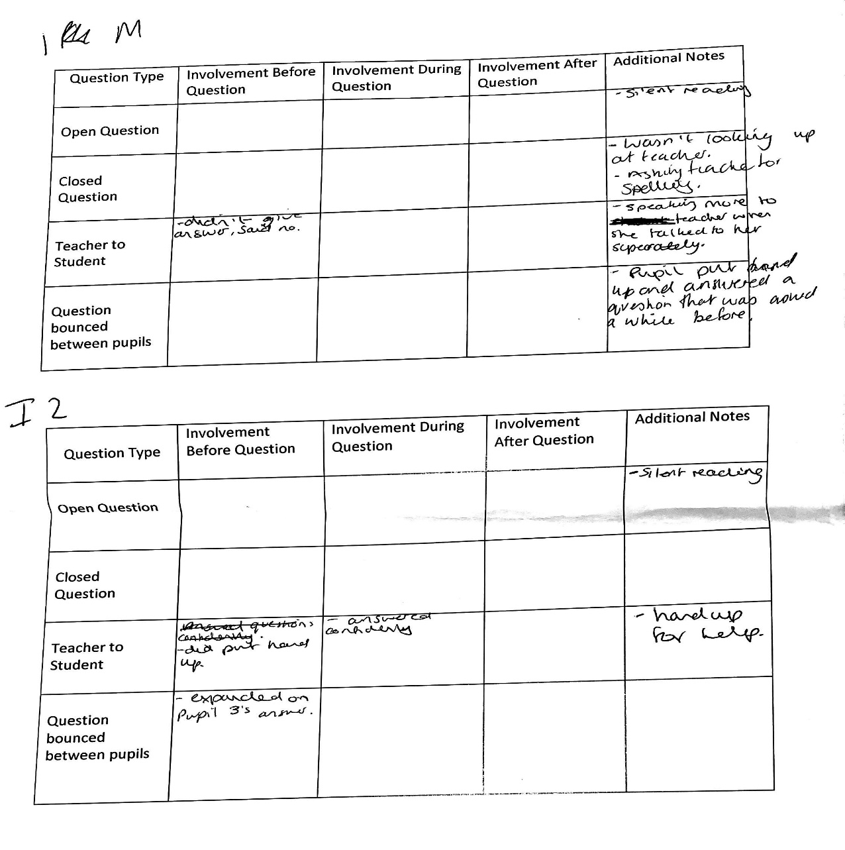
Figure 10.1
Pupil 2
Pupil 3
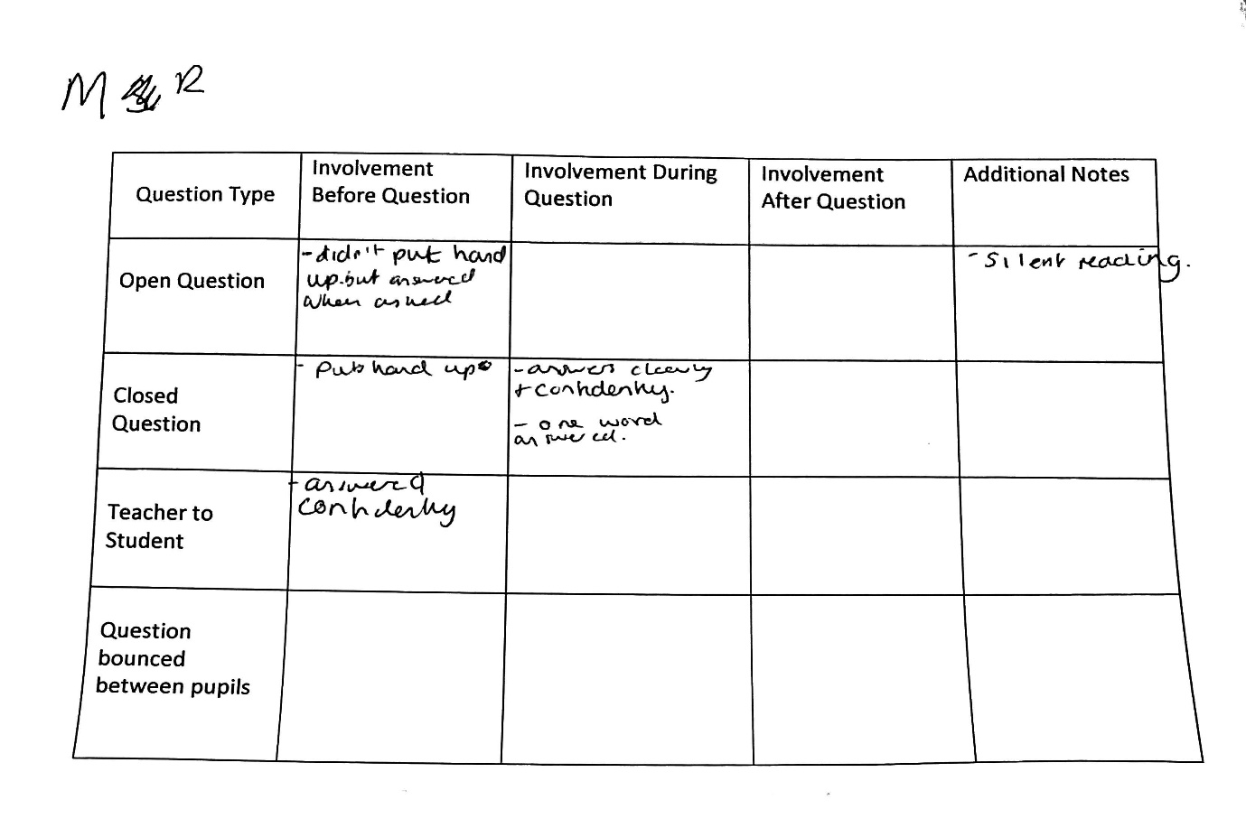
Pupil 1
Figure 10.2
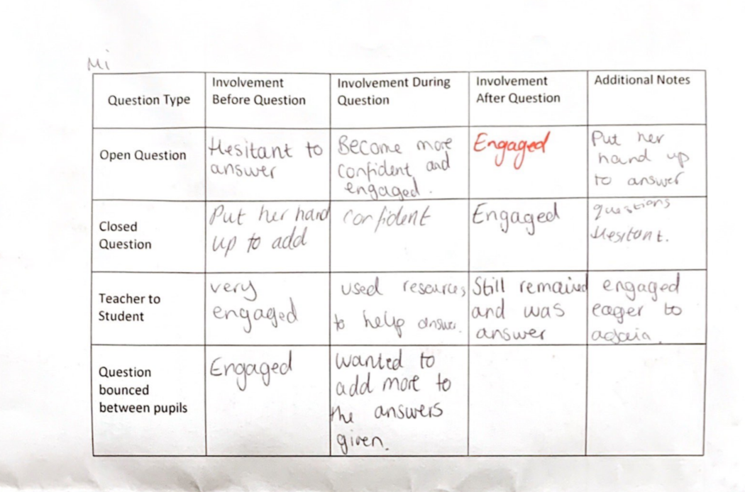
Pupil 3

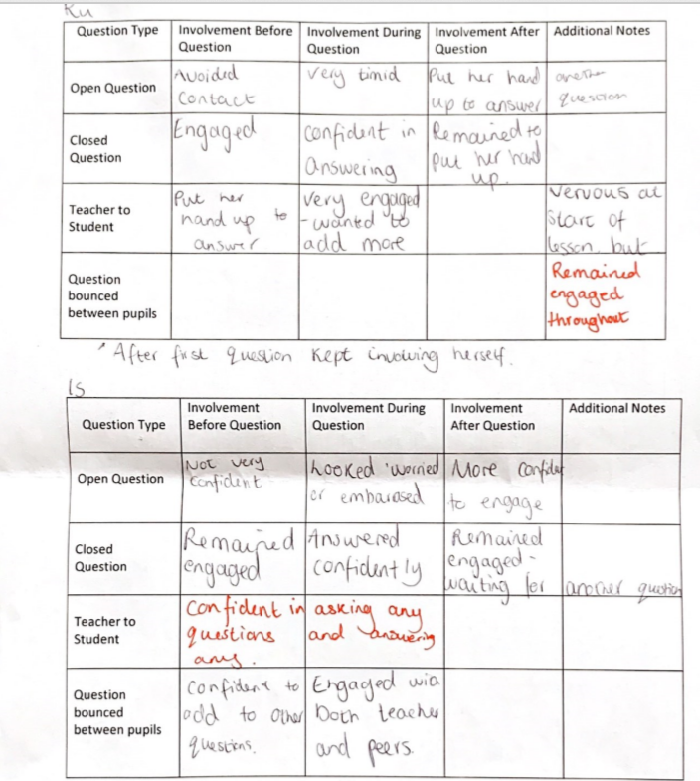
Pupil 2
Pupil 1
Figure 11 – Focus Group Interview
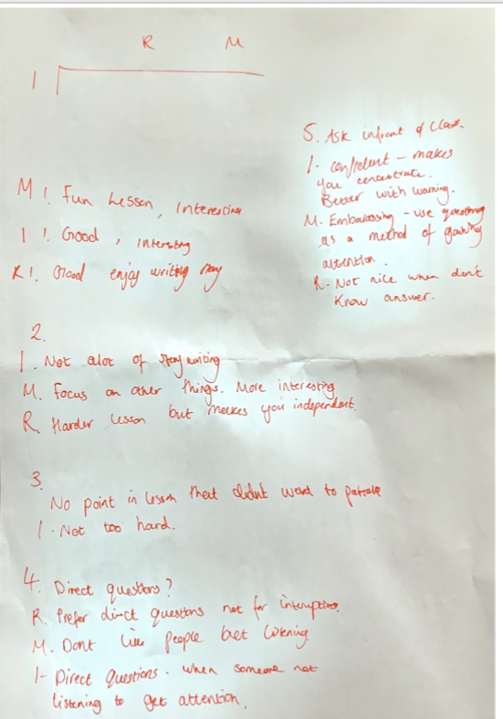
M = Pupil 3 R = Pupil 2 I = Pupil 1

Figure 12 – Reflection
Figure 12.1
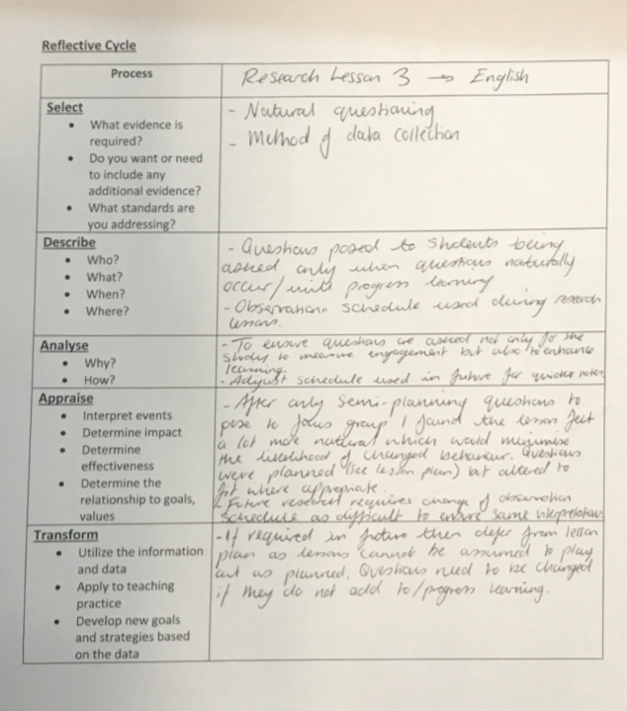

This sentence has been added only for the purpose of the Turnitin requirement to include twenty words and should not be marked

