University of Wales Trinity Saint David

Visions for the Future Theoretical Perspectives on Management (LCDB7006)
Lecturer’s Name: Dr. Nandish V Patel
Student Name: Mohammad Abu Samar
Student No. 1907390

Example-2: How technology advances (mainly e-Commerce and e-Business) have rendered traditional models of organizational structure and theories of management roles obsolete in the light of the changing nature of 21st century corporations

Executive summary
The underlying report highlights, the statement “How technology advances (mainly e-Commerce and e-Business) have rendered traditional models of organizational structure and theories of management roles obsolete in the light of the changing nature of 21st century corporations”. The report first introduces the concept, and then reviews the closely related literatures including the role of IT in organization along with challenges for businesses during the IT advancement. Thirdly, the report sorts out some organizational structures from the literature along with management philosophies from the very beginning of the management history to 2100s via 1900s. Fourthly, the report tries to analyze and validate all the relationships among IT, organizational structure and management philosophies. In addition, the report tries to unveil the relation in case of Toyota Motor Corporation (TMC) and its automobile manufacturing systems and the report eventually finishes with the closing statements.

TABLE OF CONTENTS
Executive summary II
1. Introduction 15
2. Review of literatures 2
2.1. Impact of IT in present era 2
2.2. Advancement of IT and e-Business & e-commerce 3
2.3. Business challenges for 21st century and IT innovation 5
3. Managerial philosophies and its impact on organizational structures 7
3.1. Organizational arrangements and structures in existing literatures 7
3.2. Philosophical concepts in management practices (from 19th century to 21st century) 15
4. Analysis and discussion 21
4.1. Relationship validation between IT and organizational structure 21
4.2. Relationship validation between IT and management philosophies 24
4.3. Relationship validation among IT advancement on management philosophies along with organization structure in 2100s. 27
4.4. Impact of IT advancement in automobile industry (A case of (TMC) Toyota Motor Corporation ) 28
5. Conclusion 33
References 33

- Introduction
In 21st century, Businesses and management are on the edge of a modern era of change at the beginning of the digital era, a knowledge era that transforms the essence of enterprise, culture, commerce, society and so on (Aggarwal, 1999). Globalization and technology; more specifically information technology (IT) reinforced one another. Technology allows globalization possible for industry whereas globalization enables technology highly competitive. The convergence of both the technology as well as globalization, additionally to faster worldwide economic prosperity, also indicates significant shifts in community along with business conditions as existing control systems collapse and newer model emerge (Karimi, Gupta, & Somers, 1996; Aggarwal, 1999). Nevertheless, the majority of business literature has concentrated on IT, globalization or else an extra specific feature of these developments and transformations with very few considerations to actual gesture.

Latest developments in the strength of international rivalry culminated in the establishment of numerous quantities of national financial, trade as well as commercial alliances in Asia, Europe, America, Australia, Africa and everywhere across the globe (Karimi et al., 1996). There is general consensus that IT helps to facilitate globalization, and this certain effect is conveyed via a broad range of diverse instruments, where all the instruments are on the overall economy, several of those instruments influence commerce, trade and business between walk-alone companies on the other hand the rest of others affect internal-firm commerce, trade and business inside multinational corporations (James, 2002). An example of European multi-national bank named Barclays Bank Group PLC regarding the significance of IT as well as globalization of its business in 21st century. In this case of Barclays Bank Group PLC, the CIO (chief information officer) said in an interview that, the bank foresees being an embedded global organization offering top-quality service to global clients. In 1993, Barclays' strategy for European business integration was to invest in the IT to handle the ambiguity shaped by their agreements of trade. That investment initiative was a component of the entire strategy of the bank for establishing one of the foremost financial market leaders in the world. The reason behind the process was the creation of an e-Commerce and e-Business scheme for 3,800 banking clients through creating global banking structure of $245 million. The network structure would offer some basic software and email services to the various bank’s branches (Sabherwal & King, 1992).
Figure-1: the association among firm’s strategy, investment in IT and globalization
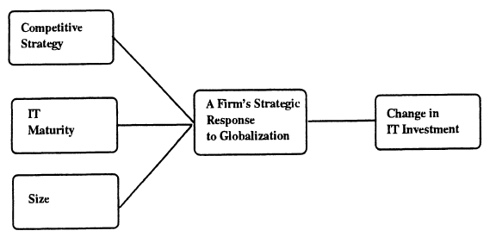
Source: Karimi et al., 1996

The above figure reflects the association among firm’s strategy, investment in IT and globalization. Hence, in this report the author will attempt to describe the progress of IT along with its influence on electronic commerce and business. Furthermore, the author will also endeavor to examine 19th century’s management principles on the various organizational structures as well as to attempt connecting the managerial structures produced by management philosophies and trends in IT transformation in 21st century’s enterprises across the globe. The report finally will try to verify the investigation and offer some suggestions.

- Review of literatures
  - Impact of IT in present era
Digital technology including IT enables creativity as well as the way to sustainability for firm’s creativity in 21st century business. Enterprise progress has the same effect on the industrialization like the effect of steam on its age. In reality, any company that hasn't gained from the technological transformation can hardly envision. Also things like gloves on as machines are used in farming. Farmers utilize computers for documenting manufacture, procurement, financial planning, as well as scientific research (BusinessVibes, 2015). The impact of IT in enterprise can be found in how it can enable the organization to get more competitive, maximize efficiency, preserve cash, enhance client service, standardize connectivity, and advance policy-making in management. This still performs a part in assisting businesses grow internationally and giving workers leverage to insights about businesses whenever and wherever the enterprises call for it (Donohoe, 2019). A plenty of applications of IT are in banking sector. Computerized technology is utilized everyday by banks and financial institutions, from exchanging financial transactions to maintaining track of individual expenses to recording companies’ earnings. Modern IT enables the fast measurement of financial data along with electronic money exchanges (Novinson, 2017).

Figure-2: Impact of information technologies in 21st century’s business advancement
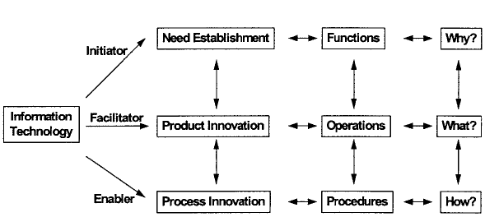
Source: Stephen, 2000

With the awareness and understanding of the IT effectiveness, the vital function has arrived in. Figure-2, shares how the IT can show a way of reengineering in 19th century business to 21st century business era. Over the previous seasons, IT had always been seen like a sustaining function within the company's strategic plan. For instance, integration was restricted to current roles within the company (Stephen, 2000). It is been observed that IT has played various role in 21st century businesses, hence internal changes in organizational structure along with management practices for wider changes in goods, economies and the entire in the social order are definitely be required (Stephen, 2000).

  - Advancement of IT and e-Business & e-commerce
The concept of electronic commerce (e-commerce) means the exchanging of business knowledge, sustaining business dealings along with executing business activities across the networks of commutation through telephones (Vladimir, 1996). To conceptualize the idea of e-commerce in this report, it has been proposed that, based on the category of technology concerned and the level of incorporation into the supply chain enterprise applications, e-commerce is still be the component of a business operations or the whole mechanisms (Boateng, Heeks, Molla, & Hinson, 2011). According to (Fearson & Philip, 1998), the processes or mechanisms could also be involved many types of business operations (such as information exchange) connecting businesses to businesses (B2B), linking consumers to consumers (C2C), involving businesses to consumers (B2C), along with linking government or administration to business (G2B). On the other hand, the origins of electronic business (e-business) can be linked to online sites to facilitate users for transmitting and gathering information commencing the companies’ network server. Several numbers of technical developments in firms’ web browsers have designed the media of internet preference for their organizational information systems (Pant & Ravichandran, 2001). An application of web based business processes has introduced a unique model termed as EBIS (e-business information systems). That EBIS is such a technology based software which utilizing internet oriented technology, its seamless accessibility as well as the browser's ability to incorporate business progressions both in the inside and outside of a corporation (Pant & Ravichandran, 2001).

Considering that business practices as well as resource capabilities vary in design, companies are going to consider diverse directions in accepting and incorporating e-commerce and e-business into their business activities (Boateng et al., 2011). A model named as PERM (Perceived Readiness Model) has been established by (Molla & Licker, 2005) as an e-commerce model for business practice. The model allows structured segments of e-commerce implementation such as “no presence of e-commerce, connected based e-commerce, static based e-commerce, interactive based e-commerce, transactive based e-commerce, as well as integrated or embedded e-commerce” (Molla & Licker, 2005). When businesses achieve a greater degree of e-commerce efficiency, then the businesses are gaining the potential to become more recognizable, expanding business alliances and developing stronger links through their respective business associates and clients. Those business associates and clients help the firms for increasing the opportunity for more competitive advantages that influence on the organizational triumph (Boateng et al., 2011). However, that e-commerce capability largely relies on the nature of a strategy as well as facilities required at the country level (Boateng et al., 2011). Accordingly, the information systems in e-business allow the business for transactions to be carried out in interconnected and extended information storage by eliminating the limitations enforced by various computer technologies, databases as well as apps (Isakowitz, Michael, & Fabio, 1998).

The UK for instance is deemed a few of Europe's leading nations. As being a full-time representative of UN’s (United Nations) Security Council as well as an affiliate of NATO (North Atlantic Treaty Organization) organization, the UK is been considered as convincing nation with having an indispensable economy. According to the UK based e-commerce foundation report in 2019, the foundation reveals popular online payment system (PayPal) is arguably the most common payment method in UK. PayPal has performed not fewer than ever in 2018 with 40 percent of digital based online customers. The utilization rate of credit cards is 23.7% which are yet an additional common payment mechanism, alongside the usage rates of prepaid cards are having as 17.2%. The foundation also discloses that, UK’s 7.94% of GDP has been created from the transactions and selling based on the e-commerce services. In case of the retail sales through the support of e-commerce, a total rate of 10.7% sales performance has been observed from the entire sales operations in UK. For the next year, the e-commerce foundation has expected the business based on e-commerce may produce more than €200 billion (Ecommerce News Europe, 2019).

  - Business challenges for 21st century and IT innovation
This is the latest research questions in current information technology and its proliferation based researches that, whether the tech-push drives adoption or the demand-pull frameworks (Nam & Tatum 1992). A constant and alarming disparity still exists between the intrinsic potential of technology creation as well as the capacity to make it function efficiently (Barton & Kraus, 1985). The discrepancy between technological potential and real business success is a topic of particular serious interest at a moment of intense worldwide business market. Centered on the previous extensive literature analysis of the challenges; administrators faced in filling the distance (Barton & Kraus, 1985). IT is typically deemed a supportive mechanism in its emerging market-world shape. However, as period went by and technical complexity expanded, the utilization as well as influence of IT is drastically growing. This trend of development can be attributed to the advancement in IT (Stephen, 2000). Nevertheless, the technological proliferation or diffusion can be caused by the assumption that the incorporation of IT into an enterprise introduces new technological challenges and stimulates policy as well as creativity to satisfy those challenges (Stephen, 2000).

Barton and Kraus, (1985) identify near about six major obstacles (such as dual role of IT managers, marketing viewpoint, information framework, numerous inside market, promotion versus hype, and safe innovation including risky site) that the executives and managements concerned for introducing digital information technology (IT) should overcome: their incontrovertible parallel position, the diversity of internal businesses to be satisfied, appropriate sensitivity to innovation, the correct extent of advancement, the preference of website for adoption and the requirement for each individual to assume full accountability. IT mechanisms for instance, TPS (transaction processing system), MIS (management information system), DSS (decision support system) as well as EIS (executive support system define IT's extend beyond the administrative assistance. Whereas conventional TPS, MIS, as well as DSS are mainly business management enablers including catalysts, those information system applications have developed to provide organizational assistance that improves basic business technologies such as word management and processing technologies with a complex set of information management systems (Stephen, 2000).

IT intelligence will therefore be integrated into information structures, along with data analytics. In this way, businesses are motivated to function more effectively and react more aggressively internally to changes in the outer market context (Cyr et al., 1997). To fulfill this requirement, it is important to provide EIS software applications established as any unacquainted decision and judgment may bring a company into a competitive inconvenience or possibly even be counterproductive because of the accessibility of knowledge. In addition, the technique top management make decisions is modified to seek more knowledge and knowledge interpretation (Stephen, 2000). The Internet allows a higher level of customized operation in e-commerce, which offers a platform for customer-seller communications. The dynamic virtual world is continuously introducing new demands, forcing businesses to improve their sites, introducing innovative apps to capture consumers and promoting online activity, rendering it a simple and pleasant witness. Company's profits cover reduces sales expenses including manufacturing expenditures (Stephen, 2000).

- Managerial philosophies and its impact on organizational structures
  - Organizational arrangements and structures in existing literatures

The earlier research literatures regarding organizational structures, the assessment on organizational structure like a contingent factor has appeared progressively recurrent. Three conceptual perspectives were proposed by the researchers who tried to understand the structural differences (Pfeffer & Leblebici, 1977). Many scholars have centered on the size of organizations as the key predictor of organizational structure (Blau & Schoenherr, 1971), whereas few of the scholars have acknowledged the organizational impact on business environmental (Duncan, 1972). Along with the last viewpoint highlighted the latest technology including IT as a predictor of the organizational structure (Zwerman, 1970). The report is the type of third concept. In this report the author will try to highlight the information technology (IT) as a predictor of the organizational structure. Nevertheless, the focus on technology like a component influencing the structure of organizations has seemed to just interact with the technology for production employed in the business organizations. Differences in computer technology or IT are not that much addressed. Furthermore the findings of experiments investigating the technology structure connection are incoherent, by Mohr (1971) discovering no evidence; by Woodward (1965) consonant hypothesis and found just a poor connection between technical controllability as well as subordinate involvement in making business and management decisions, a systemic element. This particular section of this report basically tries to unearth different types of organizational structures in existing literatures.

- Traditional organizational structure

This structure is the basic of all the organizational structures, where the structure depicts the general hierarchy inside the organizations. The structure has been found from the books of (Pearce et al., 2000; Robbins & Coulter, 2007; Weihrich et al., 2008; Griffin, 2013; Robbins & Judge, 2013).

Figure-1: Traditional organizational structure

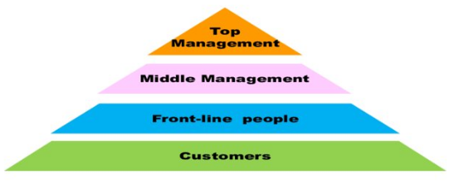

Sources: Pearce et al., 2000; Robbins & Coulter, 2007; Weihrich et al., 2008; Griffin, 2013; Robbins & Judge, 2013

- Simple structure of organization (Pearce et al., 2000; Robbins & Judge, 2013)

The simple structure of organizations refers for that arrangement of the owners or key managers of an organization along with its general employees. The communication between the two parties within the organization is generally in straight line basis as well as direct supervision from the owners to subordinates.

Figure-2: Simple structure of organization

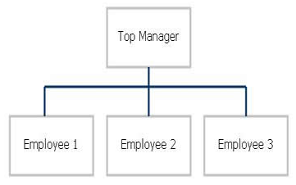

Sources: Pearce et al., 2000; Robbins & Judge, 2013
- Enterprise functioning/functional structure

This structure has been revealed by (Pearce et al., 2000; Weihrich et al., 2008; Griffin, 2013) in their books. Based on this structure the organizations can classified their common competencies and expertise. Each of the departments under this structure is vertically positioned from the president/CEO/Owner to divisions of accounting, finance, operations, marketing, distribution etc., to consumer support, to the workers consigned to a particular service or product.

Figure-3: Enterprise functioning/functional structure

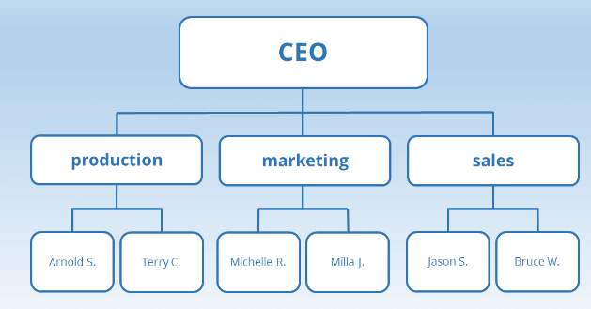

Sources: Pearce et al., 2000; Weihrich et al., 2008; Griffin, 2013

- Department/ divisional structure

This particular structure generally arranges a firm' operations into regional, industry, or service and product categories. The structure is particularly effective if a firm has several areas, industries, or other goods (Pearce et al., 2000; Robbins & Coulter, 2007; Weihrich et al., 2008; Griffin, 2013; Robbins & Judge, 2013).

Figure-4: Department/ divisional structure

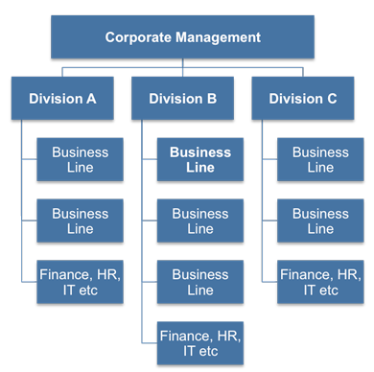

Sources: Pearce et al., 2000; Robbins & Coulter, 2007; Weihrich et al., 2008; Griffin, 2013; Robbins & Judge, 2013

- Matrix structure of organization

A matrix structure of organization is such type organizational structure wherein reporting interactions are defined as a chart, or matrix, instead of in conventional hierarchies. In added meanings, workers have multiple roles in reporting; usually to an operational boss along with a project leader (Weihrich et al., 2008) Griffin, 2013; Robbins & Coulter, 2007) (Robbins & Judge, 2013).

Figure-5: Matrix structure of organization

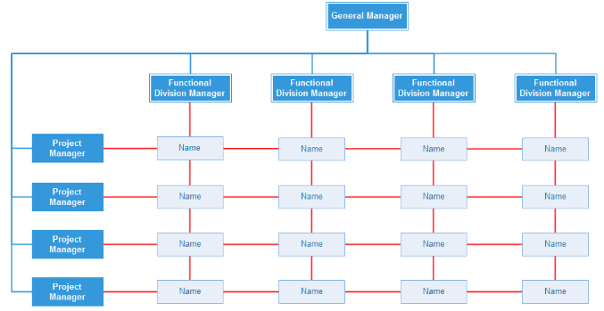

Sources: Robbins & Coulter, 2007; Weihrich et al., 2008; Griffin, 2013; Robbins & Judge, 2013

- Strategic Business Units (SBU)

The SBU organizational structure refers a revenue generator that relies on the consumer division as well as product portfolio. Organizations may be made up of several SBUs, each of individuals within the units are responsible for their own profitability. For instances, General Electric (GE) generally follows such organizational structures (Pearce et al., 2000; Weihrich et al., 2008).

Figure-6: Structure of SBU

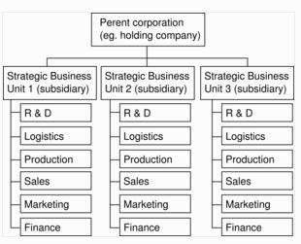

Sources: Pearce et al., 2000; Weihrich et al., 2008
- Holding company structure

Holding company denotes such a corporation which holds other businesses' accumulated stocks. The structure typically applies to such a business that generally does produce or sell any products, but they hold those companies’ shares that manufacture goods as well as services (Pearce et al., 2000).

Figure-7: Holding company structure

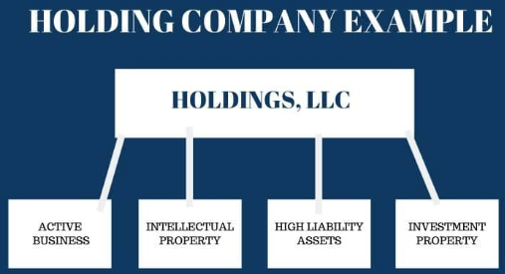

Source: Pearce et al., 2000

- Production/Product team organizational structure

A firm’s productions organizational structure is a very complex of subsections along with their connection as well as links in the production cycle. An item or portion of an item is produced in the stores, or a phase in the manufacturing cycle is accomplished (Pearce et al., 2000; Weihrich et al., 2008).

Figure-8: Production organizational structure
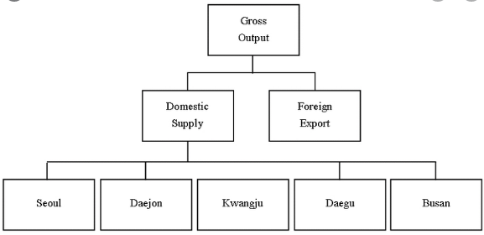
Sources: Pearce et al., 2000; Weihrich et al., 2008
- Conglomerate H-Shape design

Under the conglomerate H-shape design the organizational workers typically assess the progress of each company in such an H-shape enterprise, distribute organizational resources through organizations, and influence assessments about purchasing and distributing enterprises. The fundamental limitation of H-shape architecture is the difficulty connected with the keeping of diversified as well as unrelated firms (Griffin, 2013).

Figure-9: Conglomerate H-Shape design

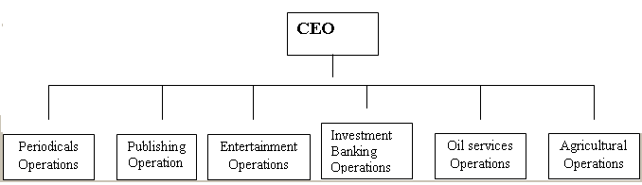

Source: Griffin, 2013

- Global organizational structure

The framework of the global organizational structure is employed for activities which are managed on a regional instead of just a product base. It's used by companies in established industries with limited product ranges (Weihrich et al., 2008).

Figure-10: Global organizational structure

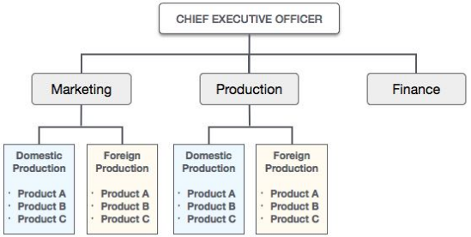

Source: Weihrich et al., 2008
- Virtual organizational structure

A virtual organizational structure refers a transient or persistent set of persons, parties, organizational divisions or whole enterprises that rely on digital links to finish the manufacturing process (Weihrich et al., 2008; Robbins & Judge, 2013).

Figure-11: Virtual organizational structure

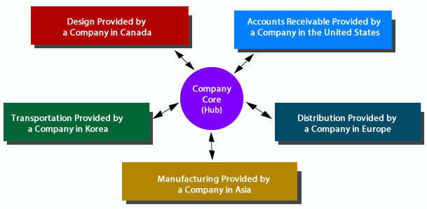

Sources: Weihrich et al., 2008; Robbins & Judge, 2013

- Boundaryless organizational structure

Although conventional organizational frameworks have established vertically and horizontally boundaries as well as structures, boundless organizations are clearly characterized by an absence of frameworks along with a business strategy that is focused on the constant transfer of knowledge and insights for driving creativity, productivity and global prosperity (Robbins & Coulter, 2007; Weihrich et al., 2008; Robbins & Judge, 2013).

Figure-12: Boundaryless organizational structure

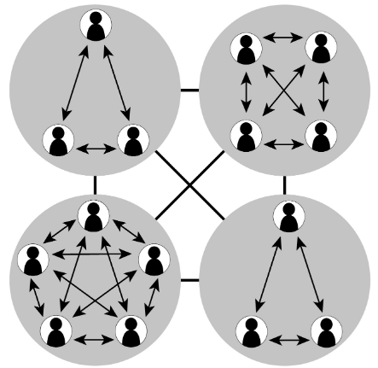

Sources: Robbins & Coulter, 2007; Weihrich et al., 2008; Robbins & Judge, 2013

Based on the related literatures regarding organizational structures, combinations of above organizational structures are widely used in small scale to large scale organization across the globe.

  - Philosophical concepts in management practices (from 19th century to 21st century)

Organization in 21st century has been considered like a mechanism; this picture since the technological heritage including IT keeps casting a large influence throughout the stories tells nowadays regarding philosophy or theories of management. That's not the only concept that's firmly rooted as well as seldom investigated that influences how organizations work (McGrath, 2014). Hence, few theories or a part of 19th century’s management may be obsolete or slow down the growth of 21st century’s business and management practice. In this particular section of the report has tried to share some management theories from the beginning to now. The management theories have been categorized in five phages based on the history of management philosophy (Robbins & Coulter, 2007).

- 1st Phase (Early management)

Under this early management history era, the managers were followed some managerial philosophies based on their mechanism and management arena. The most applicable concepts were,

- Egyptian management for making pyramids as well as Chinese management for making the Great Wall (Robbins & Coulter, 2007).
- In 1400s, Venetians’ management philosophies for the first time in the business history to conduct business in the city of Venice (Robbins & Coulter, 2007).
- In 1776, Adam Smith’s economic philosophy in trade. He wrote a book named ‘The Wealth of Nations’. He shared the ‘Absolute Advantage’ concept for the nation in case of trade (Hill, 2008). Based on the concept, job specialization or work division has been coined up in the literature of management (Robbins & Coulter, 2007).
- Industrial Revolution concept in management has been emerged in late 1800s. Under the concept, it was found economical to produce product in factories rather at domicile. Here the emergence of manager and the managerial philosophies were largely emphasized (Robbins & Coulter, 2007).

- 2nd Phase (Classical approach)

This phase is the basement of formal management theories. The key theories under classical approaches have been discussed below.

- In 1911, the modern management philosophy was born by the hand of F.W Taylor, who provided the Scientific Theory of Management. The theory was based on four principles such as, (i) Replacement of old rule-of-thumb method; (ii) Employee selection, teaching, along with development through scientifically; (iii) Scientifically designing job in organization; and (iv) Scientifically division of work within the organization (Santayana, 2007; Robbins & Coulter, 2007).
- General Administrative Theory has been proposed by Henri Fayol. Under this theory Fayol shared six activities (i) Technical, (ii) Financial, (iii) Commercial, (iv) Safety, (v) Accounting as well as (vi) Management for managers along with fourteen administrative principles for management (Santayana, 2007; Robbins & Coulter, 2007).

Figure-13: Fayol’s fourteenth principles

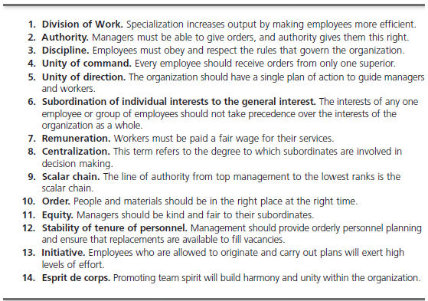

Source: Robbins & Coulter, 2007

- The Theory of Management Bureaucracy has been proposed by Max Weber in 1900s. This included two important components, particularly constructing an entity into a structure and explicitly establishing guidelines for supporting the entity as well as its leaders to control this (Robbins & Coulter, 2007).
- Time and motion study has been established by Frank and Lillian Gilbreth in 1990s. To identify the 'only possible approach' to accomplish a work, Frederick Winslow Taylor started to quantify specific activities inside occupations – calculating both the amount of time needed to accomplish the task including watching the movements. This field of study has also been rooted in ergonomics (Santayana, 2007).

- 3rd Phase (Behavioral approach)

The area of analysis that examines people's behaviors or actions at workplace is termed OB (organizational behavior). That most of what administrators do nowadays when handling individuals, inspiring, guiding, creating confidence, collaborating with a team, resolving disputes etc. has appear from OB literatures.
- Hawthorne Studies by Elton Mayo along with his acquaintances in 1927. The study was conducted on Western Electric Company. Managers that require staff to provide certain influence regarding their circumstance seemed to improve the morale of the employees further. The Hawthorne hypothesis indicates that workers function better if they think particularly cared for or that leadership is informed regarding the current wellbeing of workers (Santayana, 2007; Robbins & Coulter, 2007).
- Early Champions of Human Relations approach by Mary Parker Follett in 1938. (Santayana, 2007).
- The Professional Manager theory in 1930s. A professional worker who doesn't really have a managed connection in the business s/he is working for. Good leaders are responsible to three communities: staff, stockholders along with the common public (Santayana, 2007).
- Theory X and Theory Y was developed in 1960s by Douglas McGregor. The theory explains the two types of people in organization and how to manage them (Santayana, 2007; Robbins & Judge, 2013).

Figure-14: X and Y concept in OB

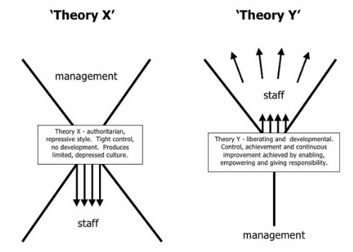

Source: Robbins & Judge, 2013
- 4th Phase (Quantitative and Qualitative approach)

The quantitative method of management theory has been built out of both the mathematical as well as statistical approach since the World War II for solving military troubles (Robbins & Coulter, 2007; Santayana, 2007).

- TQM (Total Quality Management) approach has introduced in organization during the time of 1980s to 1990s. The concept is applied for identifying and minimizing or removing production mistakes, simplifying to manage supply chain, enhancing consumer service as well as maintaining workers are able to prepare rapidly (Robbins & Coulter, 2007; Santayana, 2007).

Figure-15: Concept of TQM

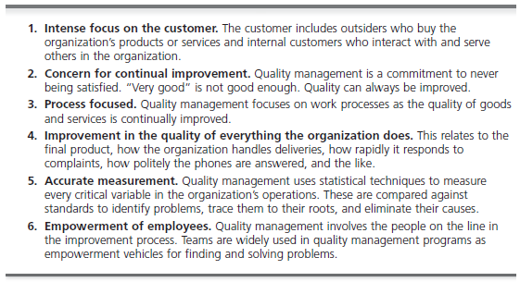

Source: (Robbins & Coulter, 2007; DeCenzo et al., 2016).

- Hedgehog Concept is a developed by crystalline philosophy. The idea is created in the literature Good to Great. The concept emerges from a keen knowledge of the convergence of three spheres (i) what you’re profoundly enthusiastic on; (ii) what you can become the best in world, as well as (iii) what powers your financial locomotive or resource the most (Santayana, 2007).

Figure-16: Hedgehog Concept

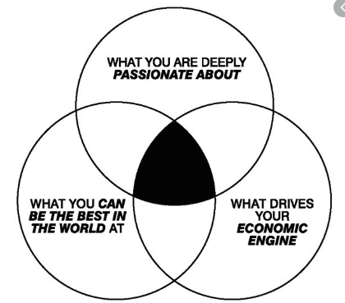

Source: Santayana, 2007

- 5th Phase (Contemporary approach)

At the very beginning of 1960s, the management scholars started looking from outside the organization's borders for whatever is occurring in the external world. The key theories under classical approaches have been discussed below.

- Contingency Approach is a management philosophy that indicates the most suitable management approach depends on the nature of the circumstance including that approach for the longer period embracing a single, static model is defective (Robbins & Coulter, 2007)
- The Systems Approach has been founded in lately 1950s as well as early 1960s. A way of thinking in the area of management that emphasizes the relational existence as well as cooperation of internally and externally influences within an organization (Santayana, 2007).
- Z-Theory was developed by William G. Ouchi in after World War II. The theory has been applied on Japanese companies to revive their firm after World War II calamity. The theory focused on a synthesis of management principles in American and Japanese firms and defined, amongst added effects, by long-standing job protection, cooperation for making decision, sluggish assessment including promotion processes, along with person’s accountability within a cluster background (Santayana, 2007).

Figure-17: Z-Theory

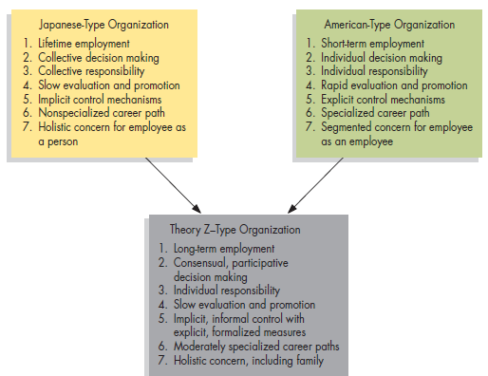

Source: Santayana, 2007

- Analysis and discussion
  - Relationship validation between IT and organizational structure

IT has enormous impact on its user. More specifically, in maintain an organization along with its structure (Khawatreh, Al-Allaf & Al-Utaibi, 2006). In case modern organizational framework, a network structure is built on a series of partnerships with certain companies that support a broad range of activities. The categories of network based organizational structures are static, internal, as well as adaptive (Khawatreh et al., 2006). The essential function of acknowledgement and awareness of IT effectiveness in organizational structure along managing organization has been achieved (Stephen, 2000) due to the advancement of IT revolution in 21st century. The role is crucial to what extent work teams are interlinked with each other. There seem to be three major stages of alignment of work team such as, pooled, sequential, as well as reciprocal (Griffin, 2013). Pooled interconnectedness exists whenever groups within the company have a shared amount of resource yet no interrelatedness among each others. Sequential interconnectedness takes place while the institutional units have to organize the information flow, resources, along with organizational tasks among each others. Furthermore, the reciprocal interconnectedness takes place while information, organizational resources as well as tasks have to be carried back and forward among the working teams (Khawatreh et al., 2006; Griffin, 2013). Hence, the interconnectedness between IT and structure is a common phenomenon and well established research interest (Khawatreh et al., 2006). The figure-18 depicts the relationship between IT and organizational structure.

Figure-18: The relationship between IT and organizational structure.

Source: Silver, Markus, & Beath, 1994

IT impacts two aspects of organizational structure reengineering in the present century, (i) Endorse the components of software architecture redesigning analysis, evaluation as well as designing (ii) Offer critical communications and network connectivity to enable the incorporation including acceleration of revamped task systems (Khawatreh et al., 2006).

IT is a critical part of an organization’s transition (Farbey et al., 1994). IT enhances the potential to adapt throughout this cycle, as well as to react for direct and immediate economic value. It encourages the restructuring of the administrative cycle and allows the range and size of the company to be globalized and decentralized. An unprecedented system of collecting, evaluating and transmitting information from in and outside the company allows the direction and speed of transformation to be identified as well as understood (Stephen, 2000). IT is also identified as a influential force for socioeconomic progress. Even though the speed of technological advancement accelerates, individual scientific knowledge burst simultaneously. The distribution of knowledge as well as the analysis of recent findings occurs in a span of milliseconds in modern times (Stephen, 2000). Throughout the business domain, IT technologies, like collaborative servers, networking as well as telecom, being capable of meeting the requirement for ever better collaboration. For instance, multinational companies, often limited by extreme territorial and logistical constraints, are already enjoying the advantages of networks, that allows towards, among many other aspects, the around the-clock sharing of output efficiency intelligence. Networking further enables the swift execution of management decisions taken at the stage of an enterprise by allowing prompt dissemination of these actions to all stakeholders (Stephen, 2000). Information technologies have challenged the lengthy-standing misconception that, due to spatial constraints, coworkers isolated by several distances will only interact rarely. It enables communications between team associates at various places and also can significantly reduce the period of brand creation (Hammer & Champy, 1993). As a whole, it's been proposed that modern IT structures foster a far more effective, increasingly adaptable, and very dynamic market climate at all the organizational levels than ever before. With study of digital enterprises assisted by virtual world technologies, organizational functionality like just-in-time (JIT) including total quality management (TQM) can indeed be assured (Stephen, 2000).

Figure-19: The impact of IT in organizational structure and business
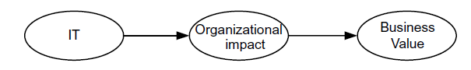
Source: Gustafsson et al., 2008

In a distinct organizational environment, another important task of the organizational structure seems to be organized and regulated actions. Command conditions and opportunities are influenced by the organization’s interconnectivity and information technology. The control of organization seems to be the implicit conceptual framework in most of the academia which presumes that IT affects organizational structure. However the procedures including the power and technological control of organization itself can differ across business. When organizational structure is constructed to organize and regulate behavior, it really is fair to say that perhaps the organizational structure may differ like the IT of organizational management itself can differ (Pfeffer & Leblebici, 1977). Managers need to be mindful that information technology will dramatically modify the organization’s existence. By knowing the organizations, the managers or organizational leaders can't fully effectively design innovative structures or comprehend current frameworks. Managers determine what sorts of programs are going to be installed, what the members of that particular organization are going to do, how the policymakers are going to be handled etc. Furthermore, often the findings are the product of sheer possibility as well as decent and poor skill regarding managing organizational structure in case of the modernization in IT for business and management (Laudon & Laudon, 2015).

  - Relationship validation between IT and management philosophies

It may glance at IT in terms of most of the technological advances that has been seen and the market challenges that the advancement IT bring, and it can also think at IT is now just an additional business segment with all the normal business division in management issues. Yet occasionally clearing the atmosphere and explaining what the business expects by management and its theories too, is beneficial. Let’s judge some basic viewpoint on managerial philosophies towards the advancement of IT in 21st century business, the following management theories would perhaps very vital in organizational structure and IT collaboration (UMO, 2020).

- Role of Scientific Management theory in IT advancement

In the 19th century, the scientific management theory by F.W. Taylor was a great innovation and scientific practice in organization management. The consequence of the impact of that theory is still going on during the period of IT advancement era. The basic concept of the theory was to managing employees scientifically. By modifying as well as refining the process activities were carried out, administrators became able to guide employees in a clear technique to achieve activities. Administrators boost profitability along with raising revenue through increasing the business performance as well as dropping the human mistake. By implementing technology, like computer operating systems, activities traditionally conducted by individuals have now been accomplished by automated devices, reducing tediousness, security issues as well as variety (Duggan, 2017). Recent IT innovation supports quantitative operation regulation as well as overall enterprise management thorough ERP (enterprise resource planning) systems (UMO, 2020). Throughout the mid of 2000s, the power of Taylor’s scientific management exceeded its height, furthermore in nowadays a number of its values reside throughout TQM (total quality management) as well as the methods of Six Sigma. Productivity, total quality, off shoring, work division in organization chart etc. are being smoothly maintained through the of IT advancement (Burley, 2019).

- Impact of Administrative theory in IT advancement

One of the important management theories, which was developed in 19th century named administrative management theory proposed by Henri Fayol. Based on Fayol’s fourteenth management principles and six activities the modern organizations are being designed. Due to the advancement of IT, in several organizations, the influence of information technologies on management philosophies spreads to each unit, as computer operating systems applications have substituted paper-based work organization and direction organism (Duggan, 2017).

- Peter F. Drucker’s management theory in IT advancement

Peter F. Drucker has been honored as the father of modern management. Peter F. Drucker proposed a philosophy which is widely utilized nowadays. Drucker felt executives ought to be managers above everything. He attached significant emphasis to decentralization; knowledge based work, MBO (management by objectives) as well as a method named SMART (Specific, Measurable, Acceptable, Realistic and Time-bound) (Griffin, 2013). Two actions from Drucker’s approach remain the businesses victorious such as, marketing as well as innovation. Recent IT innovation supports reengineering in overall business process, TQM, computer based business operations, data survey, mining, including statistical analyses, human recourse information systems, inventory management etc. and reduce the cost of business as well as increase the efficiency of business activities (UMO, 2020).

- Contingency theory in IT advancement

In theory of contingency, management's principle of risk claims that there is no one who handles perfectly. Style of leadership which proves successful in certain situation in others might be inadequate. Success also based on a number of environmental factors such as the skills of the employees of the leader and the knowledge the leader has at his disposal for making a rational decisions. By the utilization of computing, smart phones as well as other innovation that is constantly accessible, administrators get more knowledge accessible to them than anywhere else. Indeed, quite so much knowledge will take decisions making challenging. To operate effectively, managers must process the data, news, data, as well as other information they obtain in paper, sound, including video platforms (Duggan, 2017).

- System approach in IT advancement

Using the system approach of management to processes helps administrators to consider their business as a dynamic structure comprising of interconnected units. All staffs strive to address the very similar issues by harmonizing the performance of employees’ targets to strategic priorities. Technology allows for simple contact between all organizational areas. Utilizing email, phones, social media networking resources like Facebook, LinkedIn, blogs, wikis, as well as forums, administrators and workers work together around the world to overcome business challenges. Departments or units are connected by enterprise operating systems as well as the entire organization works as a unified team (Duggan, 2017).

- TQM approach in IT advancement

TQM is a specific product of handling sciences. Most performance design methods such as Six Sigma system of quality checks connect their roots to empirical control. Continuously finding new methods to maximize efficiency, the principles of continuous development or improvement are often closely linked to concept of scientific management.This Japanese management contributed to the revolution for quality, relates most of its values to the scientific management. Also, the automobile and armed forces industries have significantly increased the quality of products by emphasizing strategies for optimizing efficiency (Burley, 2019).

- Five forces theory in IT advancement

According to the Harvard professor, Michael E. Porter each and every business have five competitive forces like, new entrant, buyers’ power, suppliers’ power, substitute goods’ forces, along with existing competitors (Pearce et al., 2000). Based on IT innovation, Porter’s theory has initiated ’Business Intelligence’ departments, whose only task is upholding the firm’s competitive awareness along with wide-ranging innovations (UMO, 2020).

  - Relationship validation among IT advancement on management philosophies along with organization structure in 2100s.

A very extensive analyses regarding the relationship between IT adamant and organizational structure along with the relationship between IT advancement and management theories of 1900s to 2100s has been found from the previous section of this report under analysis section. This section basically tries to unearth the validation of connection among IT advancement on management philosophies along with organization structure in 2100s. A very close literature regarding the context has been observed from the study of (Robbins & Coulter, 2007). Figure- 20 shows the connection among the concept.

Figure-20: Validation of connection among the three concepts

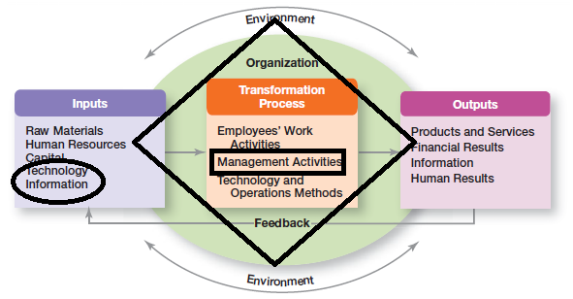

Source: Robbins & Coulter, 2007

= IT as an input of business management.

= Management theories and principles in business activities.

= IT impacts on organizational structure based on management philosophies.

The above image is well enough to provide the validation of the IT impacts on structure and management theories in organization.

  - Impact of IT advancement in automobile industry (A case of (TMC) Toyota Motor Corporation)

The advancement of internet along with IT has evolved as a significant means of trade over the past few decades. IT’s scope and interdependence have given rise to new marketing strategies and fundamentally changed the existing ones (Pant & Ravichandran, 2001). The automobile industry is also not out of this trend. IT has created significant developments in the automobile infrastructure itself, including controlling pollution, entertainment, security devices, and much more. The partnership among the distributors, consumers, and OEMs (original equipment manufacturers) has also been affected by IT. In changing business world of 21st century, new innovations enable the ventures to communicate innovatively with their clients. In the upcoming days, the most productive automobile traders will utilize the best use of IT. There are several directions IT can boost business operations for the 21st century automobile trades (ClearPath, 2020). In followings some supportive roles of IT in automobile industry are given below.

- Amplify the automobile speed and efficiency: The car dealerships hold huge quantities of data. Workers can handle vast datasets as well as process data demanded by different clients with a DBMS (database management system), thereby increasing processing performance and reliability (ClearPath, 2020).
- Advance communication: Communication among the staffs, vendors, and consumers is critical for automobile trading and dealerships. A multiplicity of collaboration technologies have emerged over the decades to include easy as well as cost effectiveness in communication mechanisms like online chatting services, virtual meeting platforms, VoIP (Voice over Internet Protocol) telephones, email services along with video conferencing programs (ClearPath, 2020).
- Inventory management: Automobile businessmen must hold adequate inventory to satisfy consumer demand. Hence, the mechanism of inventory management monitors the amount of every car held by the treading or dealership, activating a request for expanded stock if necessary. Such devices can be linked to the POS (point-of-sale) network, making sure that the network of inventory management is modified for every delivered automobile (ClearPath, 2020).
- Advanced consumer services: For better customer service, The CRM (Customer Relationship Management systems record dealer experiences by every client, enhancing the client service in general. When a client requests with a question, the customer service agent has the opportunity to identify the automobile or component the customer has ordered, the delivery details along with the reference handbook for that object, leading in an improved response capability to their respective automobile customers (ClearPath, 2020).

Automobile business and dealerships can enhance service delivery around the whole automobile enterprise with the latest developments in IT. The similar is happened to the Toyota Motor Corporation (TMC).

- IT advancement in TMC’s automobile business across the globe:

TMC is fully a customer based company. This customer centric approach has been well established by the assist of IT in their business and production management. TPS (Toyota Production System) promotes and facilitates business processes that assist Toyota to lessen waste, perform with basically without inventory as well as boost quality continuously. At Toyota, IT isn't driving business processes but the Toyota’s method of manufacturing does. Technology, nevertheless, acts a crucial role in promoting, facilitating and carrying to the processes generated from complying with TPS to life on a wide range. Throughout the ages, Toyota created a range of certain principles and manufacturing method that endorse the two main principles of Toyota’s TPS. Moreover behind any of these frameworks are the Toyota’s information systems which sustain and facilitate the mechanisms. The roles of IT in Toyota’s TPS are pointed below.

- Practice of JIT based on IT: Toyota maintains one of most superior manufacturing's supply chain networks, operating intimately with distributors to insure parts appear when required. For instance, when a vehicle arrives out from a scrap yard inside Georgetown, the device passes an automated note to seating vendor Johnson Control describing the specific seats layout needed (seats, bucket, leather upholstery, etc.); Johnson Controls generally takes four hours for dispatching those seats according to the Toyota’s preferred sequence. To arrange that JIT, Toyota takes support from ALCS (Assembly Line Control System) program provides the guidance for this (Shmula, 2006).
- Practice of Jidoka based on IT: Toyota utilizes devices at each point of the production line for allowing employees to interrupt production to resolve flaws. These tools can be the same as basic like a rope string over the production line, or a push-button. For certain situations, advanced tracking tools for example the (Performance Management System) PMS of Activplant will notify technicians to machines or robotics issues for actual time (Shmula, 2006). In figure-21, figurine Toyota's latest proprietary technologies including IT to assist the enterprise,

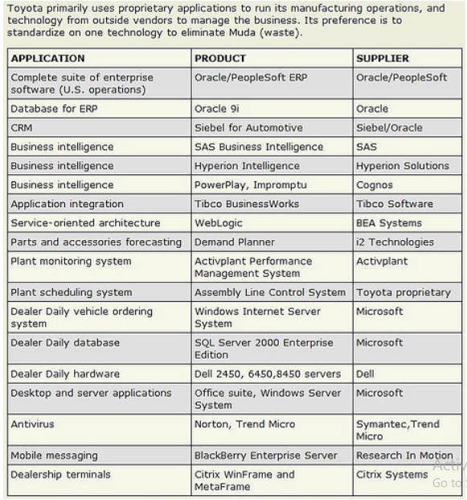

Source: Shmula, 2006
- Practice of Kaizen based on IT: That Kaizen is a system of continuous improvement program. The system is effective for transferring a machine to a production line, so that an employee doesn't have to misuse any time moving for having the item. Or it could include technology, like enabling dealers to exchange car inventory levels utilizing the Dealer Daily, which is an online platform, so consumers are not expected to queue for the automobile they get any further (Shmula, 2006).

- Practice of Andon based on IT: Anywhere practicable, Toyota employs visual monitors, or Andons, like overhead monitors, plasma TV screens, including electronic or digital dashboards to communicate the status of operation easily. Green, Yellow, and Red light have been applied to transmit the signal for the targeted receivers (Shmula, 2006).

- Practice of Poka Yoke based on IT: Toyota utilizes a number of such low-cost, extremely robust instruments to avoid malfunctions in its operations. The system is an electronic sensor, that curtain sensor will signal an alarm if an employee fails for picking up a nut, bolt, cotter pin, or any further necessary component (Shmula, 2006).

- Practice of Genchi Genbutsu based on IT: Genchi Genbutsu means in general as “Go and see for yourself” instead of learning from others. Minimum 50 percent of the information technology staff hired by Toyota is deployed at factory sites to negotiate closely with Toyota’s operations (Shmula, 2006).

In 2019, TMC merges their three IT subsidiaries for creating a comprehensive IT solution for TPS.

Table-1: TMC merges their three IT subsidiaries

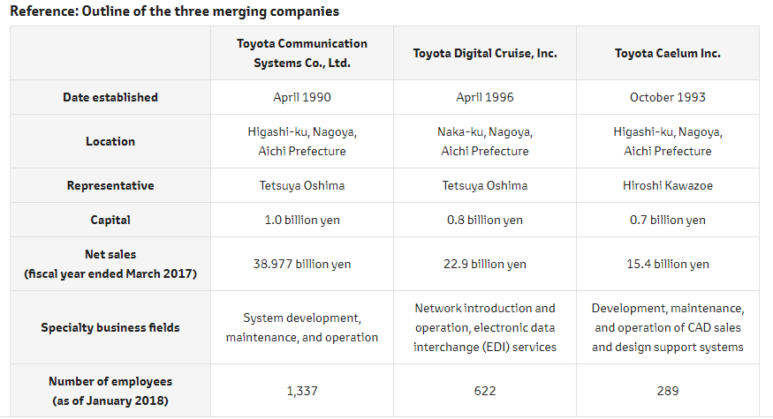

Source: Toyota, 2018

Table-1 shows the nature of those IT subsidiaries. Figure-21, depicts the application of artificial intelligence (AI) named MSPF (Mobility Service Platform) in Toyota for the goal to connect cars, manufacturers and dealers via networking as well as support customers with a feel of overall comfort, thereby committing to the development of an enjoyable mobility community.

Figure-21: Allied car service through MSPF

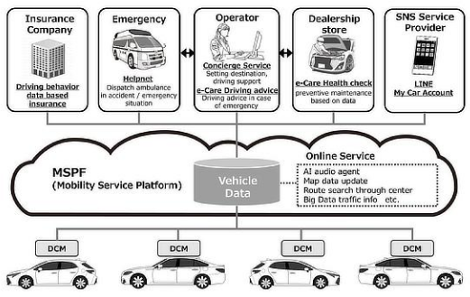

Source: Toyota, 2018
- Conclusion
The report has tried to examine the role of IT as a controller by examining at its relationship with organizational structure and management theories for 21st century business. Thus the consequences of climate, policy and structure with IT will have an impact on output as per the interface viewpoint. Currently the companies will uphold the tradition of creative IT in the particular sector to deal involving the strongest challenging environment. For the consequences of IT evolution in industry, companies will alter the organizational structure to match with the technological development. Organizational structures of the companies require be gradually shaping and modifying. Understanding the importance of IT is incredibly important for the enterprise and company as well as creating the successful organizational structure. In case of any business as well as company can be conveniently communicated and connected with its stakeholders by implementing the IT innovations. The utilization of IT and its association has influenced the people of the association. In fine, the adjustments in revolutionary ITs like electronic based commerce including businesses have substantially enhanced the firms’ organizational structure accompanied by the management philosophies.

References
- Aggarwal, R., 1999. Technology and globalization as mutual reinforcers in business: Reorienting strategic thinking for the new millennium. MIR: Management International Review, pp.83-104.
- Barton, D.L., and Kraus, W.A., 1985. Implementing New Technology. Retrieved from, https://hbr.org/1985/11/implementing-new-technology.
- Boateng, R., Heeks, R., Molla, A. and Hinson, R., 2011. Advancing e-commerce beyond readiness in a developing country: experiences of Ghanaian firms. Journal of Electronic Commerce in Organizations (JECO), 9(1), pp.1-16.
- Burley, K., 2019. Contribution of Scientific Management in the 21st Century. Retrieved from, https://bizfluent.com/info-8042342-impact-technology-management-theories.html.
- BusinessVibes., 2015. The Importance of Information Technology In Business Today. Retrieved from, https://www.business2community.com/tech-gadgets/importance-information-technology-business-today-01393380.
- ClearPath., 2020. INFORMATION TECHNOLOGY IN THE AUTOMOTIVE INDUSTRY. Retrieved from, https://www.clearpathit.com/information-technology-in-the-automotive-industry.
- DeCenzo, D.A., Robbins, S.P. and Verhulst, S.L., 2016. Fundamentals of human resource management. John Wiley & Sons.
- Donohoe, A., 2019. Role of Information Technology in Business. Retrieved from, https://bizfluent.com/facts-5977213-role-information-technology-business.html.
- Duggan, T., 2017. The Impact of Technology on Management Theories. Retrieved from, https://bizfluent.com/info-8042342-impact-technology-management-theories.html.
- Ecommerce News Europe., June 2019. Ecommerce in The United Kingdom. Retrieved from, https://ecommercenews.eu/ecommerce-in-europe/ecommerce-the-united-kingdom/.
- Farbey, B., Land, F.F. and Targett, D., 1995. A taxonomy of information systems applications: the benefits' evaluation ladder. European journal of information systems, 4(1), pp.41-50.
- Fearon, C. and Philip, G., 1998. Self assessment as a means of measuring strategic and operational benefits from EDI: the development of a conceptual framework. European Journal of Information Systems, 7(1), pp.5-16.
- Griffin, R.W., 2013. Fundamentals of management. Cengage Learning.
- Gustafsson, P., Franke, U., Höök, D. and Johnson, P., 2008. Quantifying IT Impacts on Organizational Structure and Business Value with Extended Influence Diagrams. The Practice of Enterprise Modeling, p.138.
- Hammer, M. and Champy, J., 1993. Reengineering the corporation: A manifesto for business revolution, Nicholas Brealey. New York.
- Hill, C., 2008. International business: Competing in the global market place. Strategic Direction.
- Isakowitz, T., Michael B. and Fabio, V. (1998), ``Web information systems introduction’’, Communications of the ACM, Vol. 41, pp. 78-80.
- James, J., 2002. Information technology, transactions costs and patterns of globalization in developing countries. Review of Social Economy, 60(4), pp.507-519.
- Karimi, J., Gupta, Y.P. and Somers, T.M., 1996. Impact of competitive strategy and information technology maturity on firms’ strategic response to globalization. Journal of Management Information Systems, 12(4), pp.55-88.
- Khawatreh, S.A., Al-Allaf, O.N. and Al-Utaibi, G.A., 2006. Impacts of Information Technology on Organizational Structures. Paper presented in, 2nd Jordanian International Conference on Computer Science and Engineering (JICCSE2006), 5-7 December, 2006. Retrieved from, https://www.researchgate.net/publication/289531371_Impacts_of_Information_Technology_on_Organizational_Structures/citations#fullTextFileContent.
- Laudon, K.C. and Laudon, J.P., 2015. Management information systems (p. 143). Upper Saddle River: Pearson.
- McGrath, R.G., 2014. Management’s Three Eras: A Brief History. Retrieved from, https://hbr.org/2014/07/managements-three-eras-a-brief-history.
- Molla, A. and Licker, P.S., 2005. eCommerce adoption in developing countries: a model and instrument. Information & management, 42(6), pp.877-899.
- Nam, C.H. and Tatum, C.B., 1992. Strategies for technology push: Lessons from construction innovations. Journal of construction engineering and management, 118(3), pp.507-524.
- Novinson, E., 2017. Importance of Information Technology in Finance. Retrieved from, https://bizfluent.com/facts-5977213-role-information-technology-business.html.
- Pant, S. and Ravichandran, T., 2001. A framework for information systems planning for e‐business. Logistics Information Management.
- Pant, S. and Ravichandran, T., 2001. A framework for information systems planning for e-business. Logistics Information Management, 14(1/2), pp.85-98.
- Pfeffer, J. and Leblebici, H., 1977. Information technology and organizational structure. Pacific Sociological Review, 20(2), pp.241-261.
- Robbins, S., P. & Judge, TA (2008). Organizational Behavior,(13th ed.,) Prentice-Hall.
- Robbins, S.P., and Coulter, M., 2007. Fundamentals of management. Pearson Prentice Hall.
- Sabherwal, R. and King, W.R., 1992. Decision processes for developing strategic applications of information systems: a contingency approach. Decision Sciences, 23(4), pp.917-943.
- Santayana, G., 2007. A BRIEF HISTORY OF MANAGEMENT “Those who cannot learn from history are doomed to repeat it.” Retrieved from, https://www.zamaros.net/mgt%20reading%202%20-%20history%20of%20mgt.pdf.
- Shmula., 2006. Toyota Information Technology, Retrieved from, https://www.shmula.com/information-technology-at-toyota/205/.
- Silver, M.S., Markus, M.L. and Beath, C.M., 1994. The Information Technology Interaction Model: A Core Model for the MBA Core Course. Information Systems Working Papers Series, Vol.
- Stephen, L.C., 2000. Information technology in business processes. Business Process Management Journal, 6(3), pp.224-237.
- Stephen, L.C., 2000. Information technology in business processes. Business Process Management Journal, 6(3), pp.224-237.
- Toyota., 2018. Toyota Motor Corporation to Merge Three Information Technology Subsidiaries and Create Comprehensive IT Solutions Company. Retrieved from, https://global.toyota/en/newsroom/corporate/21269526.html.
- University of Wisconsin Oshkosh (UWO)., 2020. The Management Theories behind Management Information Systems. Retrieved from, http://www.uwosh.edu/faculty_staff/wresch/Mantheories.htm at 11:30PM on 19th April, 2020.
- Vladimir, Z., 1996. Electronic commerce: structures and issues. International journal of electronic commerce, 1(1), pp.3-23.
- Weihrich, H., Cannice, M.V. and Koontz, H., 2008. Management-globalization and entrepreneurship perspectives.
- Wonglimpiyarat, J., 2016. The innovation incubator, university business incubator and technology transfer strategy: The case of Thailand. Technology in Society, 46, pp.18-27.

