
University of Wales Trinity Saint David
MSc Cybersecurity and Digital Forensics
Module | ACCA7031 — Digital Forensics Analysis
Assignment Title | Digital Forensics Analysis — Task 1: Research Report & Task 2: Digital Forensic Investigation Report
Student Name | Latchiarajan Parthasarathy
Student ID | 2531979
Lecturer | Dr. Mohamed Ghanem

TABLE OF CONTENTS
PART A — TASK 1: DIGITAL FORENSICS RESEARCH REPORT 3
1. Introduction 3
2. Current State of Digital Forensics 3
3. Digital Forensic Tools: Features and Capabilities 3
4. Intersection of Digital Forensics and Cybersecurity 4
5. Emerging Trends in Digital Forensics 5
6. Key Challenges 6
7. National and International Job Market 6
8. Conclusion 6
Task 1 References 7
PART B — TASK 2: DIGITAL FORENSIC INVESTIGATION REPORT 8
1. Case Background and Summary 8
2. Investigation Scope and Objectives 9
3. Evidence Inventory 9
4. Evidence Integrity and Chain of Custody 10
5. Evidence Acquisition and Hash Verification 10
6. Forensic Methodology 11
7. Communication Analysis 11
8. Call Log and Email Correlation 13
9. File and Metadata Analysis 15
10. Chronological Timeline Reconstruction 17
11. Suspect Profiling and Role Assessment 17
12. Critical Evaluation and Conclusion 18
13. Recommendations 19
14. Reflection on Learning and Professional Development 19
Task 2 References 19
Appendices 20

PART A — TASK 1: DIGITAL FORENSICS RESEARCH REPORT
Digital Forensics in Modern Cybersecurity: Current State, Emerging Trends, and Workforce Dynamics

1. Introduction
Digital forensics is the process of finding, obtaining, maintaining the chain of evidence (for a set time), inspecting it, and preparing it for legal purposes [1]. The growth of enterprise endpoints, mobile platforms, cloud environments, and IoT devices has led to more complex attack methods [1]. The increasing number of cybercrimes creates a large amount of digital data, making forensic analysis very useful for companies. Financial institutions and organisations need skilled forensic capabilities [1]. For financial institutions, forensic skills are important for following regulations, securing the chain of evidence, analysing compromises, business recovery, and proving legality [1].

2. Current State of Digital Forensics
Digital forensics has broadened its domain from analysing a desktop computer disk to a multi-domain science, including disk, mobile, network, memory, cloud, and IoT forensics [1]. Using different tools helps recover and connect technical evidence from complex situations [1]. Today, an attack can involve devices and servers in a distributed system, including endpoints, cloud services, and mobile devices. Using only one forensic application can create gaps in the investigation [1]. A multi-tool workflow is needed to collect and connect evidence from different file systems, operating systems, and storage structures.[1].

3. Digital Forensic Tools: Features and Capabilities
This is the domain where open-source tools such as Autopsy and The Sleuth Kit allow file system forensics and data recovery, while commercial tools like AccessData FTK, OpenText EnCase, and Magnet AXIOM provide data indexing, handling evidence from different sources, and automated timeline reconstruction [1]. Mobile forensic analysis needs special tools such as Cellebrite UFED to bypass security layers and extract flash memory [1]. Forensic analysis of volatile memory (RAM) for extracting malicious code, unencrypted credentials, or active network connections requires tools such as Volatility. On the other hand, network trace analysis uses packet analysers such as Wireshark [5].
TABLE I
COMPARISON OF SELECTED DIGITAL FORENSIC TOOLS
Tool | Main Evidence Type | Key Capability | Main Limitation
Autopsy | Disk / Filesystem | Open-source filesystem & artifact analysis | Limited enterprise scalability [1]
FTK | Disk / Digital Media | Distributed indexing & rapid evidence searching | High commercial licensing costs [1]
Magnet AXIOM | Computer / Mobile / Cloud | Multisource evidence correlation & timeline parsing | Resource-intensive parsing operations [1]
Cellebrite UFED | Mobile Devices | Hardware extraction & passcode bypass | High cost and restricted access [1]
Volatility | Volatile Memory (RAM) | Memory process & payload injection analysis | Requires deep OS kernel knowledge [5]
Wireshark | Network Traffic | Deep packet inspection & protocol disassembly | Ineffective on encrypted payloads [5]
As illustrated in Fig. 1, modern forensic investigations increasingly require evidence to be collected and correlated across multiple digital environments [3].
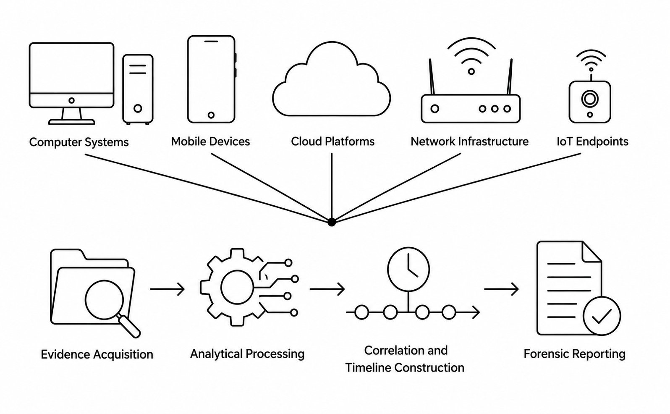
Fig. 1. Major digital evidence sources and forensic investigation workflow, illustration adapted from NIST SP 800-86 [3].

4. Intersection of Digital Forensics and Cybersecurity
Whereas security practices focus on threat prevention, detection, isolation, and recovery, digital forensics provides a detailed analysis of computer systems to understand the event history, identify the affected systems, and determine the scope of a breach or compromise [3]. While security solutions focus on stopping intruders, forensic evidence supports incident investigation, threat hunting, incident response, malware analysis, and data breach investigation [5].
Forensic readiness includes process automation and system preparation for forensic activities. This involves central auditing, preparing RAM and HDD evidence collection, and securely storing data. Proper system logging reduces incident response time and supports the chain of custody through cryptographic hashing. It also helps with legal or disciplinary actions and allows technical remediation without additional preparation [3].
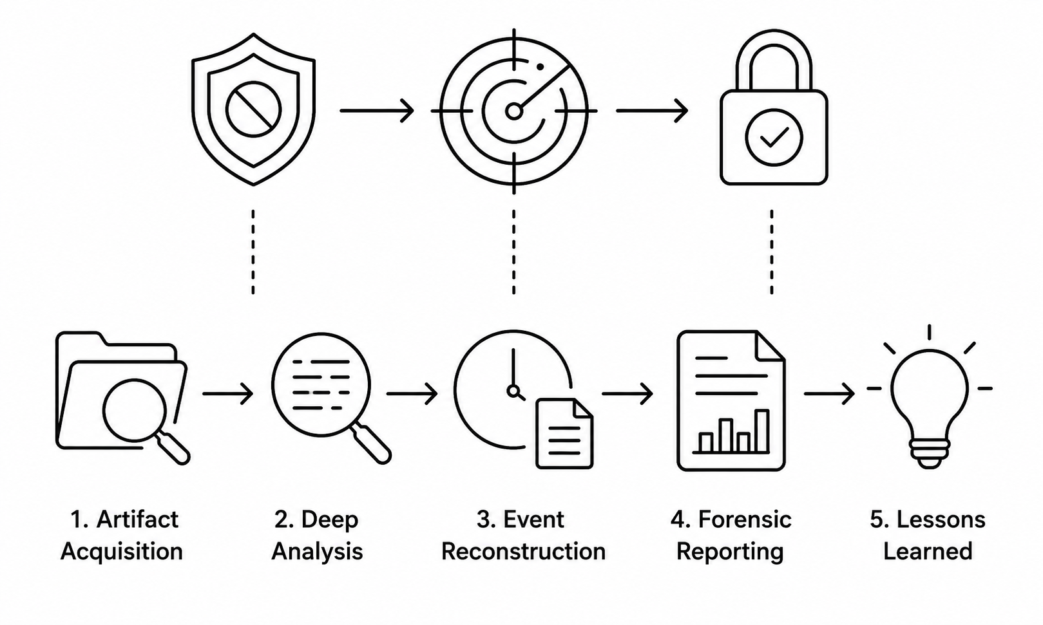
Fig. 2. Relationship between cybersecurity incident response and digital forensics. Source: Author’s illustration based on NIST SP 800-61 and SP 800-86 [5].

5. Emerging Trends in Digital Forensics
The accelerating volume and velocity of digital artifacts have driven the adoption of artificial intelligence (AI), machine learning (ML), cloud-native forensics, remote collection, and automated correlation graphs [5]. Machine learning algorithms significantly improve operational efficiency by automating evidence prioritization, identifying malware access patterns, and analysing unstructured text or multimedia at scale [10]. Quantitative evaluations demonstrate that AI-assisted forensic triage can reduce evidence triage time by up to 35% and lower false positives by 42% [11].
However, AI integration presents notable limitations, including explainability (“black box”) challenges, potential algorithm bias, false positives, and legal validation hurdles [10]. Consequently, strict human oversight and verifiable validation frameworks remain mandatory [10]. Additional emerging developments encompass cloud reference architectures, automated container forensics, remote endpoint collection, and blockchain-based evidence logging [5].
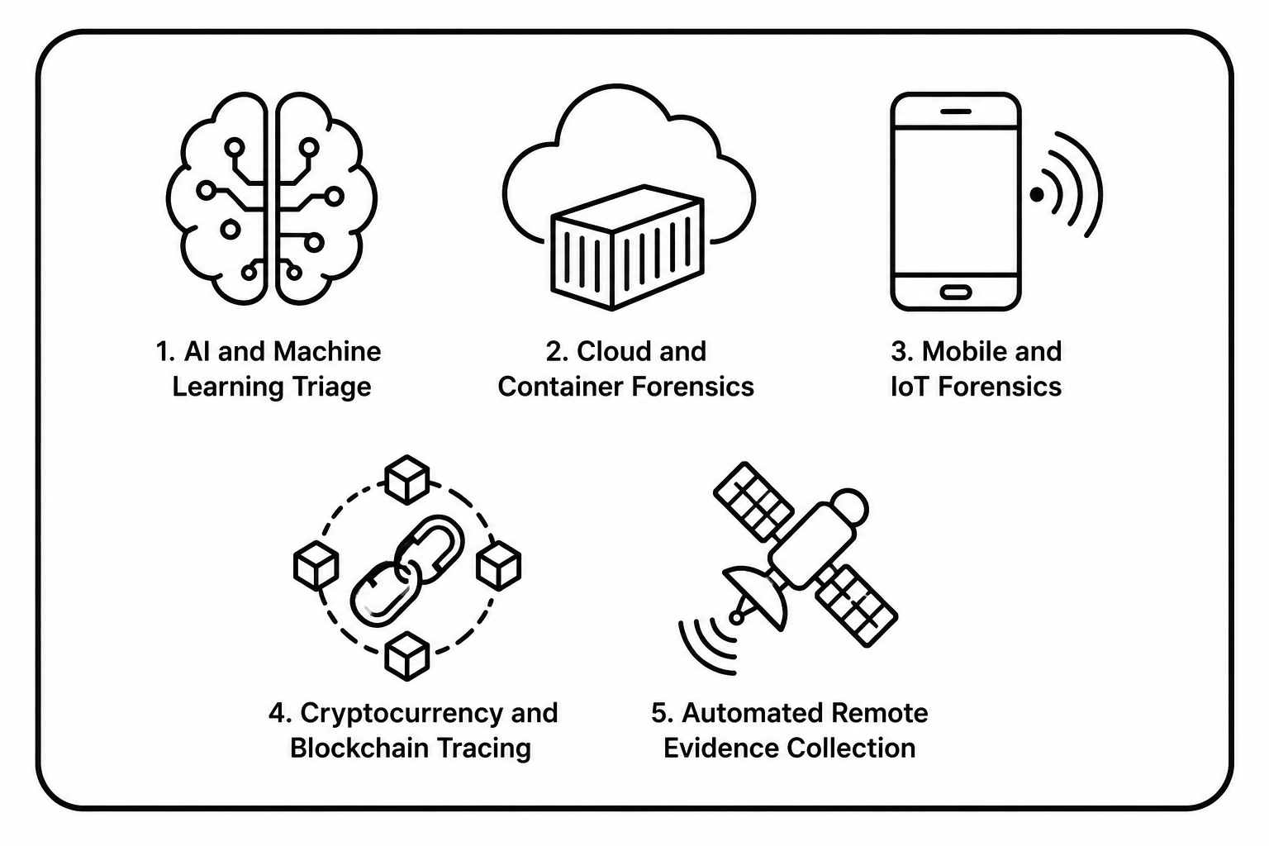
Fig. 3. Emerging technologies shaping digital forensic investigations [5].

6. Key Challenges
Modern forensic investigation faces many technical, legal, and operational challenges [1]. Strong end-to-end encryption, hardware-based mobile boot loaders, and temporary cloud data make data extraction difficult [1]. Mobile devices also create a heavy workload for forensic labs, sometimes making up to 95% of the total workload and causing long investigation backlogs [1]. Anti-forensic techniques, such as malware that erases memory and log files, add to these challenges [5]. Cloud services across different countries also create privacy and legal issues, such as GDPR compliance [1]. These challenges slow investigations, increase technology costs and workload, and may affect the legal acceptance of collected evidence [1].

7. National and International Job Market
The digital forensics job market continues to develop as organisations face increasing cybercrime, complex digital environments and growing volumes of digital evidence. In the UK, technical skills gaps remain in areas such as digital forensics, incident response and cybersecurity, creating opportunities for roles including Digital Forensic Analyst, DFIR Consultant, Incident Response Analyst and Cybercrime Investigator [15], [16]. Internationally, demand is also supported by stricter data protection requirements, increasing cyber incidents and the expansion of cloud and mobile technologies [17], [18]. This indicates that professionals with practical forensic-tool skills, evidence-handling knowledge, analytical ability and cybersecurity expertise are likely to have stronger employment opportunities.

8. Conclusion
Digital forensics is an essential part of modern cybersecurity, expanding beyond traditional desktop disk inspection into cloud, mobile, network, and IoT ecosystems [1]. While AI and automation offer significant opportunities to manage evidence volume, encryption, privacy regulations, and skills shortages remain major challenges [1]. Both the UK and international job markets provide opportunities for professionals with combined cybersecurity and forensic expertise [15]. Students and practitioners should actively build competencies across forensic software tools, networking protocols, operating system internals, cloud security, incident response, evidence handling, and legal standards [1].

Task 1 References
[1] Full article: Digital Detectives in the Making: Introducing Data Security Through Forensic Challenges, Taylor & Francis. [Online]. Available: https://www.tandfonline.com/doi/full/10.1080/10511253.2026.2625781
[2] The Role of Digital Forensic Analysis in Modern Investigations, DergiPark. [Online]. Available: https://dergipark.org.tr/en/pub/ject/article/1445625
[3] Digital Forensic Flow Standard by NIST SP 800-86, ResearchGate. [Online]. Available: https://www.researchgate.net/figure/Digital-Forensic-Flow-Standard-by-NIST-SP-800-86_fig1_358791594
[4] Digital Forensics Investigations on Evolving Digital Ecosystems and Big Data Sharing: A Survey of Challenges and Potential Opportunities, ResearchGate. [Online]. Available: https://www.researchgate.net/publication/393625300
[5] Digital forensic analysis: Advanced methodologies, LNXnetwork S.R.L. [Online]. Available: https://www.lnxnetwork.com/en/articulo-forense-2026.html
[6] NIST Cloud Computing Forensic Reference Architecture. [Online]. Available: https://www.nist.gov/publications/nist-cloud-computing-forensic-reference-architecture
[7] N. Soni, International Journal of Forensic Research, Opast Publishers. [Online]. Available: https://www.opastpublishers.com/editor-info/nishchal-soni-3578
[8] NIST SP 800-86 Digital Forensic Framework, Scribd. [Online]. Available: https://www.scribd.com/document/718778190
[9] DFIR 2026: Memory Forensics, Windows Artifacts, and Incident Response, Hive Security. [Online]. Available: https://hivesecurity.gitlab.io/blog/dfir-incident-response-complete-guide-2026/
[10] A Comprehensive Analysis of the Role of Artificial Intelligence and Machine Learning in Modern Digital Forensics and Incident Response, arXiv:2309.07064. [Online]. Available: https://arxiv.org/abs/2309.07064
[11] Autonomous Forensics: Integrating AI and Machine Learning in Digital Evidence Standards, J. Eng. Res. Rep. [Online]. Available: https://journaljerr.com/index.php/JERR/article/view/1794
[12] Forensic Science International: Digital Investigation, Elsevier BV, SciSpace. [Online]. Available: https://scispace.com/journals/forensic-science-international-digital-investigation-17q5081c
[13] Papers (International), DF&V Lab. [Online]. Available: https://www.dfv-lab.com/papers-international.html
[14] Digital Forensic Investigation Standards in Cloud Computing, Universal J. Comput. Sci. Commun. [Online]. Available: https://www.scipublications.com/journal/ujcsc/article/digital-forensic-investigation-standards-in-cloud-computing-923
[15] Cyber security skills in the UK labour market 2024, GOV.UK. [Online]. Available: https://www.gov.uk/government/publications/cyber-security-skills-in-the-uk-labour-market-2024
[16] Cyber security skills in the UK labour market 2025, GOV.UK. [Online]. Available: https://www.gov.uk/government/publications/cyber-security-skills-in-the-uk-labour-market-2025
[17] Fewer Roles, Same Risk, Garzon Cyber Solutions. [Online]. Available: https://garzoncybersolutions.com/GCS_Insight_Fewer_Roles_Same_Risk/index.html
[18] 2025 ISC2 Cybersecurity Workforce Study, ISC2. [Online]. Available: https://www.isc2.org/Insights/2025/12/2025-ISC2-Cybersecurity-Workforce-Study

PART B — TASK 2: DIGITAL FORENSIC INVESTIGATION REPORT
Mobile Device Investigation: Alleged Theft of the QT-AI-2025 Patent
Case File: DF2025-CLS-07
Field | Detail
Examiner | Latchiarajan Parthasarathy (Student No. 2531979)
Source Evidence File | QT-AI-2025_Patent_Theft_Investigation_Lakshirajan.pptx
Location | UK
Forensic Tool | Cellebrite UFED Physical Analyzer 7.73.0.11

1. Case Background and Summary
This investigation was conducted under a simulated Apprentice Investigator brief for a digital forensics company handling computer, mobile, and digital media casework. The brief alleges the unauthorised access, theft, and attempted sale of QT-AI-2025, an AI-based “Neuro” product belonging to Quantum Tech [3]. Three individuals are named: Emma (alleged perpetrator), Joe (alleged intermediary), and Norman (alleged buyer). Vanessa is referenced only for call-timing correlation [3]. Four mobile devices were submitted: Huawei POT-LX1 P Smart (EX-01), Nokia C2 2nd Edition (EX-02), Samsung SM-A137F Galaxy A13 (EX-03), and Ulefone (EX-04) [1]. Ownership was established from extracted account data, not assumed from the case brief. The report separates forensic fact, reasonable inference, and unsupported assumption throughout.

1.1 Independent Device Acquisition Exercise (Non-Case Evidence)
A separate, non-case training acquisition (personal Xiaomi M2101K7BG Redmi Note 10S) is shown below to demonstrate the workflow; it does not affect the Emma/Joe/Norman findings.
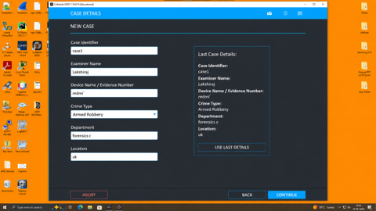
Figure 1.1 — New case created: Examiner “Lakshiraj”, Device/Evidence No. “redmi”, Crime Type “Armed Robbery”, Department “forensics c”, Location “uk”.
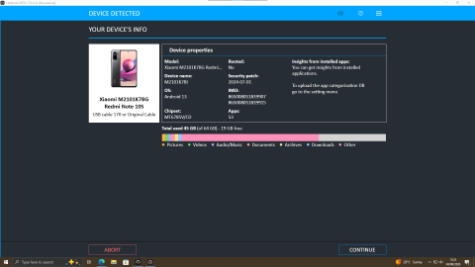
Figure 1.2 — Device properties confirmed: model M2101K7BG, Android 13, not rooted, IMEI, and chipset captured from the device.

2. Investigation Scope and Objectives
- Acquire forensic images of the four extracted smartphones and document chain of custody for each.
- Extract and analyse WhatsApp, Instagram, Facebook, SMS, and email communications to identify contact between Emma, Joe, and Norman regarding the QT-AI-2025 patent.
- Correlate call log and email evidence with messaging evidence to establish whether a coordinated transaction occurred.
- Profile the potential role of each named individual against the evidence, clearly separating fact from inference.
Scope note: this report excludes USB evidence, CAD file analysis, and PDF metadata analysis, none of which were supplied.

3. Evidence Inventory
Evidence Item | Person/Device | Evidence Type | Relevant Artefact | Evidential Purpose
EX-01 | Huawei POT-LX1 P Smart (Peter Dover / “Emma”) | Android ADB — File System | Snapchat, Facebook, Gmail accounts; WhatsApp & Facebook chats; call log; location data | Establishes device owner; links to alleged patent-sale communications
EX-02 | Nokia C2 2nd Edition (unconfirmed, “Norman” working theory) | Android Backup — File System | Location/timeline data | Attribution unconfirmed; location data contains dated anomalies
EX-03 | Samsung SM-A137F Galaxy A13 (unconfirmed, “Joe” working theory) | Android Backup — File System | Camera EXIF location data | Attribution unconfirmed; SIM number mismatch with cited Joe number
EX-04 | Ulefone (not linked) | Android Backup — File System | Device hardware identifiers only | No account, contact or communication link to any named subject

4. Evidence Integrity and Chain of Custody
Chain-of-custody information is limited to the Cellebrite extraction summaries provided [1]. All four devices were preserved in their original state, and analysis was performed only on forensic file-system images, not the original hardware, consistent with ACPO good-practice principles [2]. Examiner name, evidence numbers (EX-01 to EX-04), and forensic tool are recorded consistently across all four extractions [1].
Field | Recorded Value
Examiner | Latchiarajan Parthasarathy (Student No. 2531979)
Forensic Tool | Cellebrite UFED Physical Analyzer 7.73.0.11
Extraction (UFD) File Data Integrity | “Intact” for all four devices
Evidence Number / Serial Number | 12345

5. Evidence Acquisition and Hash Verification
Evidence ID | Device | Extraction Type | Acquisition Window (UTC+0)
EX-01 | Huawei POT-LX1 | Android ADB — File System | 28/10/2025 16:12–16:53
EX-02 | Nokia C2 2nd Ed. | Android Backup — File System | 28/10/2025 16:01–16:03
EX-03 | Samsung SM-A137F | Android Backup — File System | 28/10/2025 11:57–12:36
EX-04 | Ulefone / Note 14 | Android Backup — File System | 28/10/2025 11:25–11:27
Every acquired image hash is machine-verified by Cellebrite Physical Analyzer at the point of extraction (SHA-256) [1], with no indication of post-acquisition alteration for any of the four devices, as recorded in the Image Hash Details exhibits below.
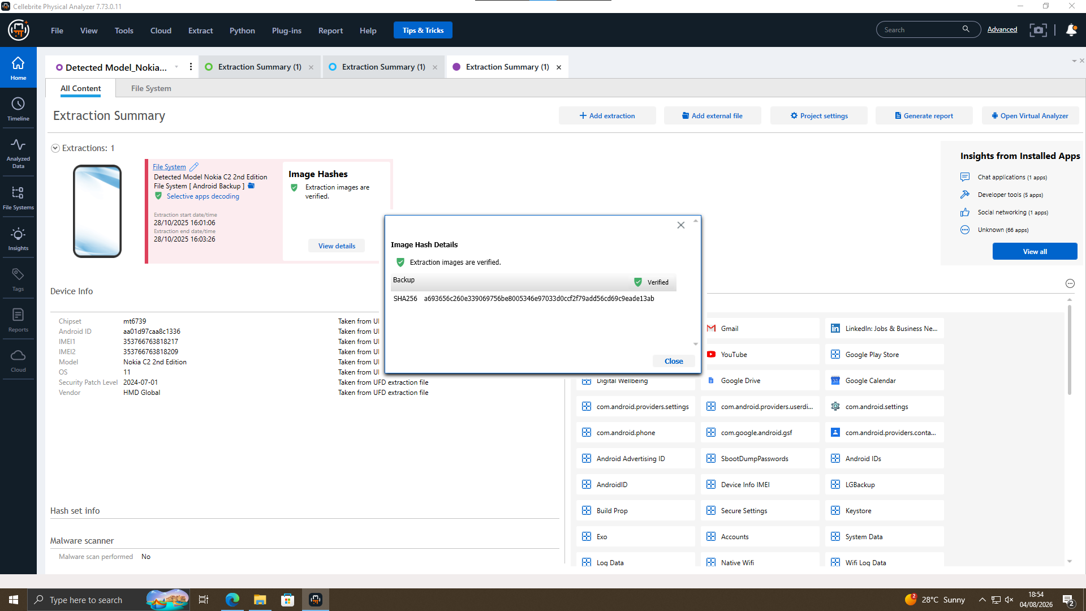  EXHIBIT T2-01 — EX-01 Huawei: Hash Verified | 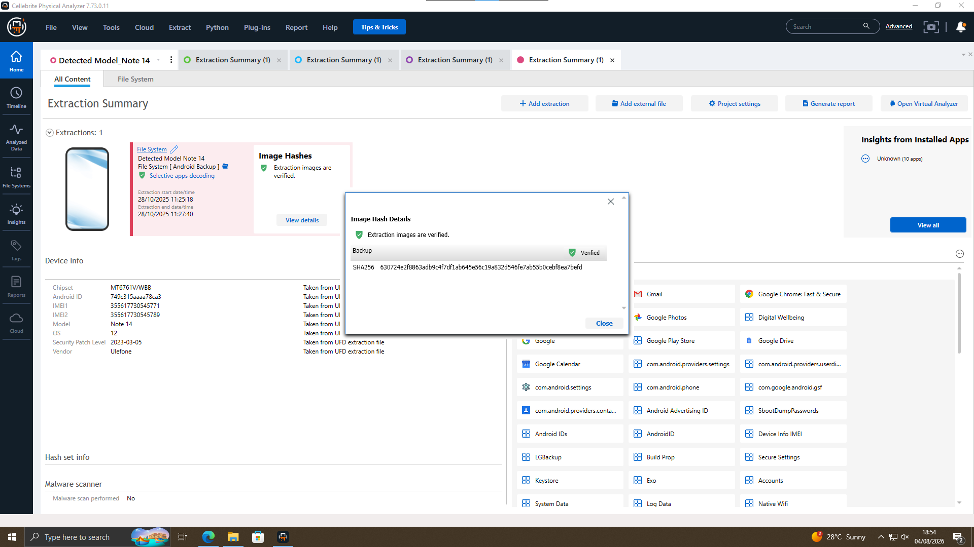  EXHIBIT T2-02 — EX-02 Nokia: Hash Verified
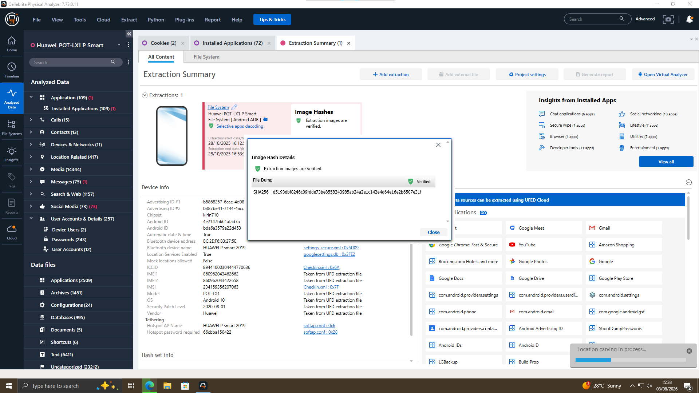  EXHIBIT T2-03 — EX-03 Samsung: Hash Verified | 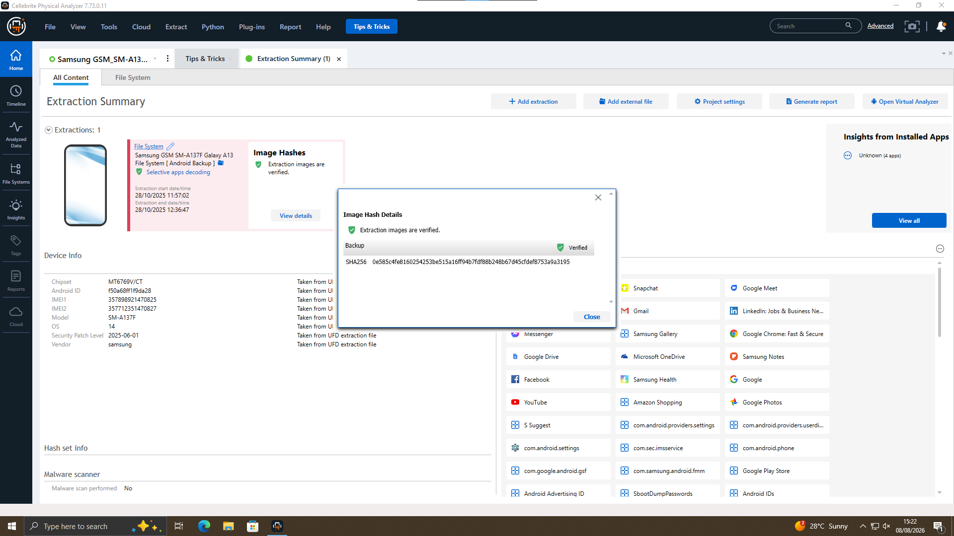  EXHIBIT T2-04 — EX-04 Ulefone: Hash Verified
Exhibits T2-01 to T2-04 — Image Hash Details dialogs for EX-01 to EX-04, all SHA-256 verified.
IMEI, chipset, OS, and security patch level for each device are captured directly from the corresponding UFD extraction file, not manually entered, in the Cellebrite Device Info panel for each of the four extractions [1].

6. Forensic Methodology
The investigation followed five stages — Acquire, Extract, Analyse, Correlate, Report — consistent with ACPO good-practice principles [2], applied across all four devices using Cellebrite UFED Physical Analyzer 7.73.0.11 [1]. This report focuses on the Analyse and Correlate stages, mainly cross-device account, communication, and location data.
- Acquire: forensic file-system images were acquired via Android ADB or Android Backup extraction, with SHA-256 hashes recorded at extraction (Section 5).
- Extract: account, communication, call-log, contact, and location artefacts were extracted using Cellebrite’s parsing modules (WhatsApp, Facebook, Instagram, Device Info, Location Related).
- Analyse: extracted artefacts were examined per device to establish ownership, communication content, and location metadata (Sections 7–9).
- Correlate: artefacts were cross-referenced across devices to build a chronological timeline and assess relationships between named subjects (Sections 10–11).
- Report: findings were compiled into this evidence-led report, distinguishing forensic fact, reasonable inference, and unsupported assumption throughout (Sections 12–14).
No source hardware was analysed directly. All examination was performed on the verified forensic file-system images described in Section 5. No method beyond the Cellebrite extraction summaries was used or assumed [1].

7. Communication Analysis

7.1 Snapchat Account Attribution — EX-01 Huawei
The Snapchat account on EX-01 confirms the name Peter Dover, username peter_dover, phone number +447917162788, and DOB 27/11/1974 [1]. A Lebara SIM-renewal email in the same Gmail account (dovp59@gmail.com) also shows the same number, providing a second source confirming it [1]. A linked Facebook account further supports the same identity.
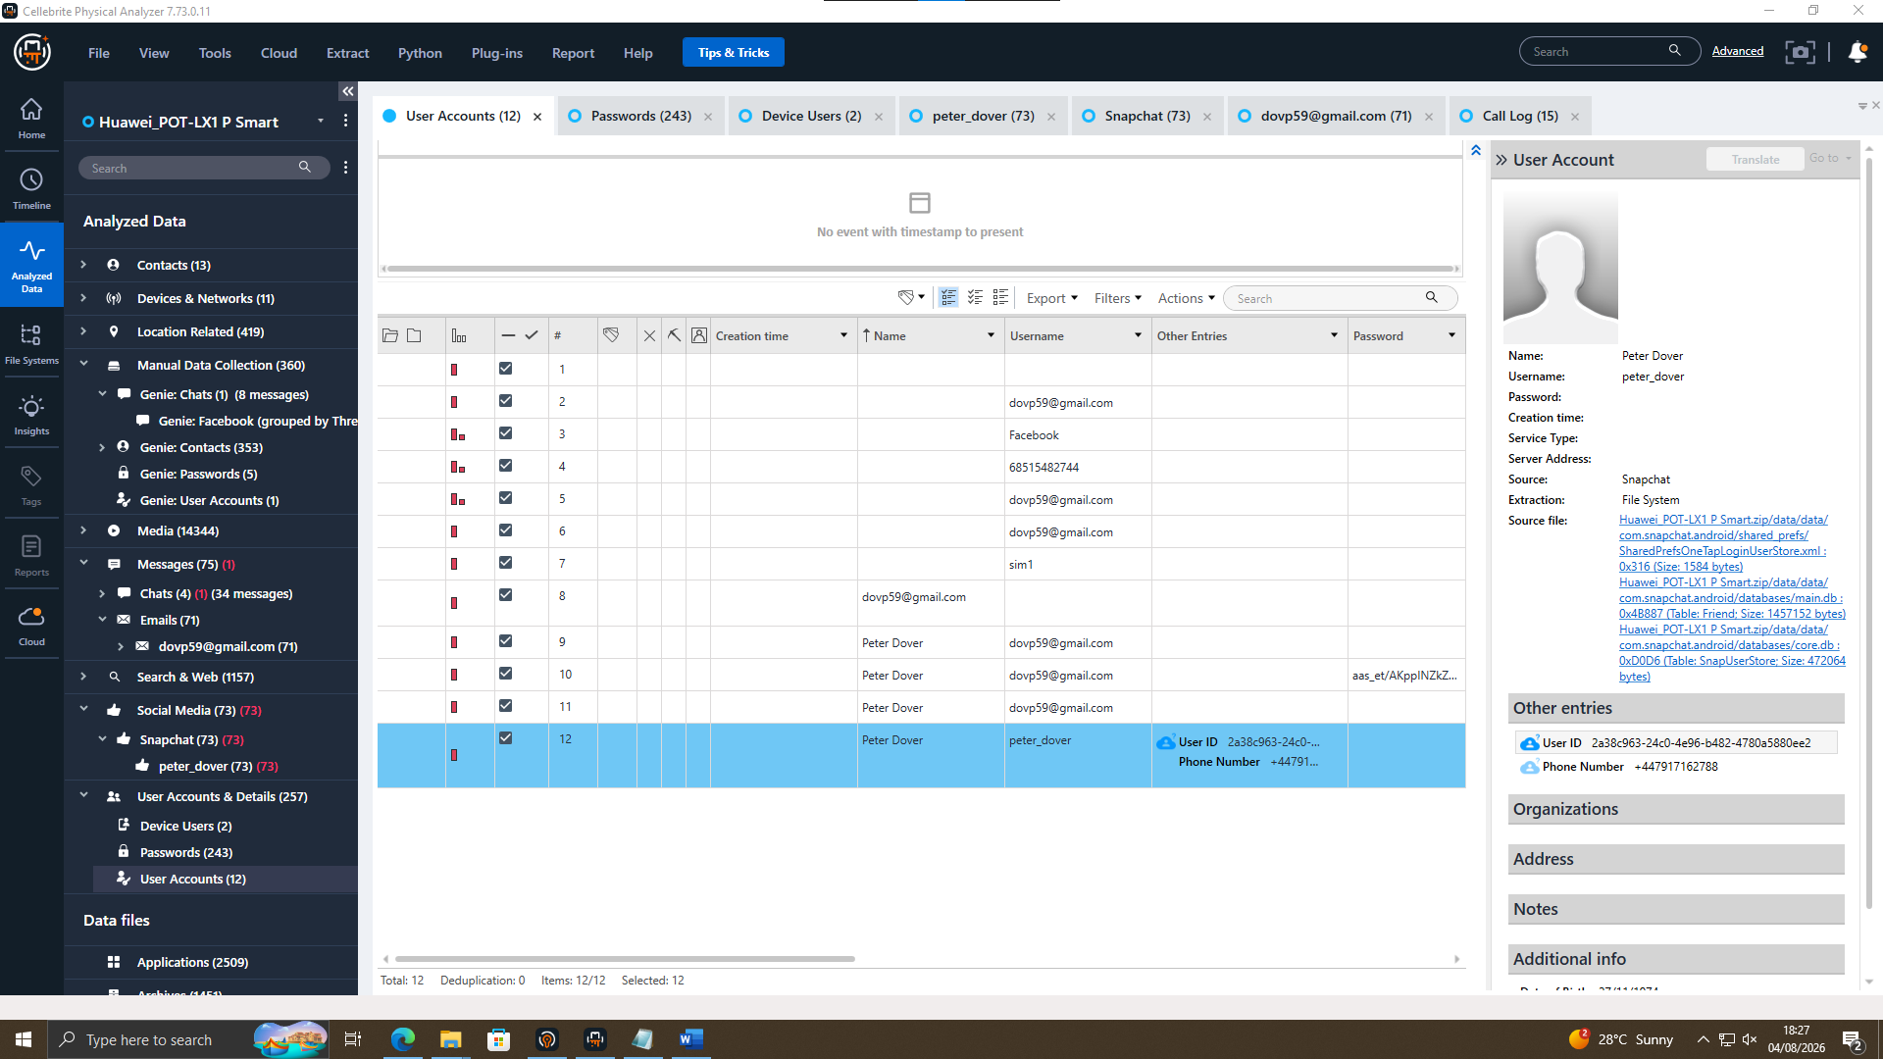
EXHIBIT T2-09 — EX-01 Huawei: Snapchat User Account record, Peter Dover.
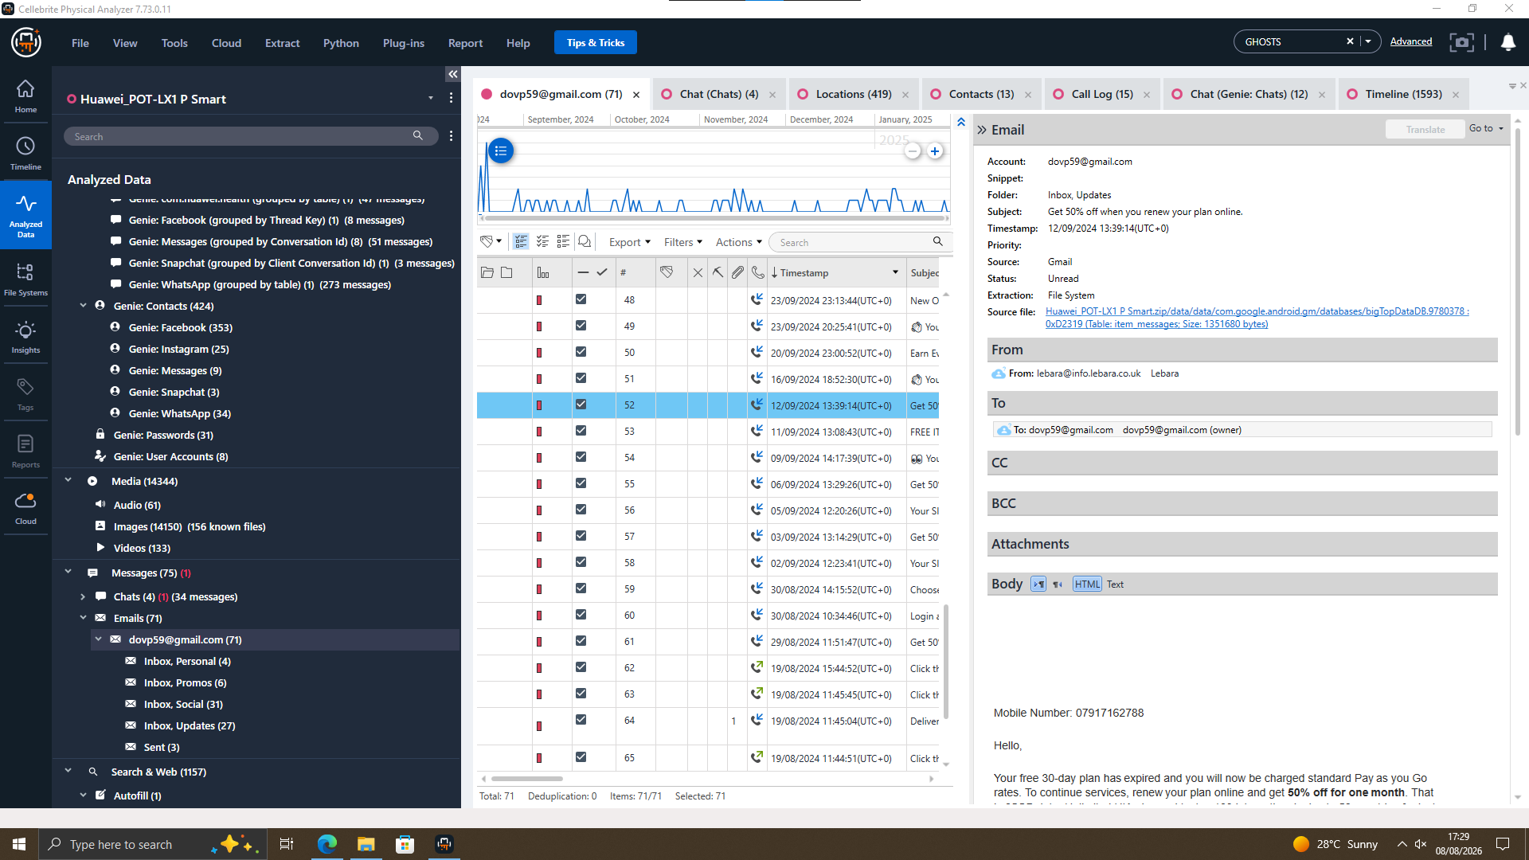
EXHIBIT T2-10 — EX-01 Huawei: Lebara SIM-renewal email, dovp59@gmail.com.

7.2 Facebook Chat — Peter Dover ↔ Norman Smith
Facebook messages on EX-01 dated 31/01/2025, 12:47–12:53 UTC, show Peter Dover and Norman Smith discussing a staged release, a “5M offshore” payment, and ending with “watch ur inbox in 48 hrs” / “we are ghosts.” This suggests a covert financial deal but does not directly mention QT-AI-2025; that link comes from Section 7.3.
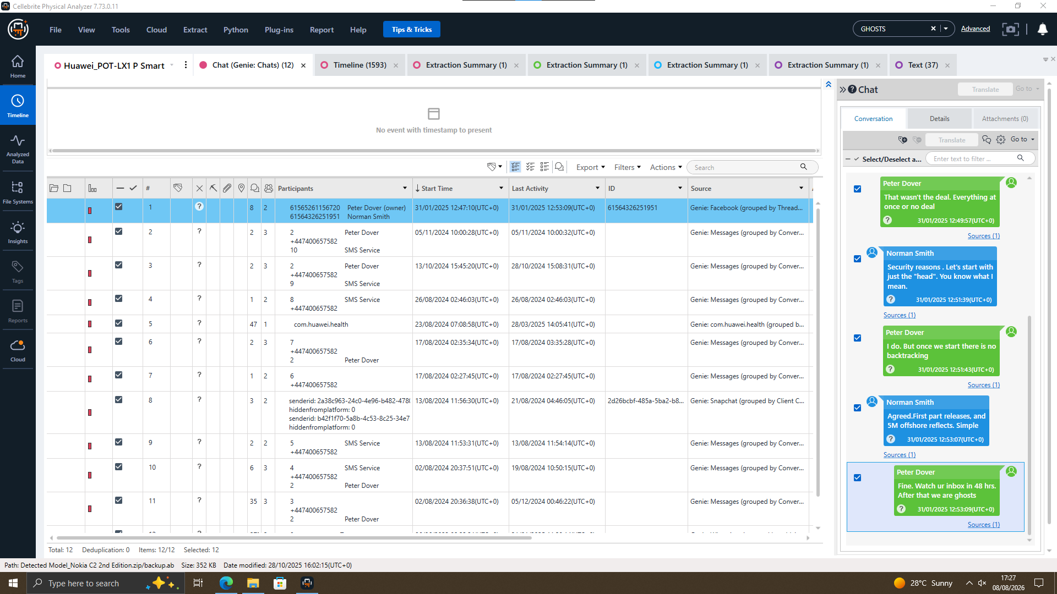
EXHIBIT T2-11 — EX-01 Huawei: Facebook chat, Peter Dover ↔ Norman Smith, 31/01/2025.

7.3 WhatsApp Chat — Patent Sale Discussion
A WhatsApp thread on EX-01 (number +447917162788, saved as “Top-up,” added 21/08/2024) shows the sender offering valuable information about “ABC technologies” and its “new AI based Neuro product” for sale. The reply addresses the sender as “Emma,” while the sender responds “Not exactly Joe,” suggesting the other person is Joe. The sender also mentions meeting clients at a hotel. This is strong evidence linking EX-01 to the case, though no account is named “Emma”; identification rests on the phone number and conversation.
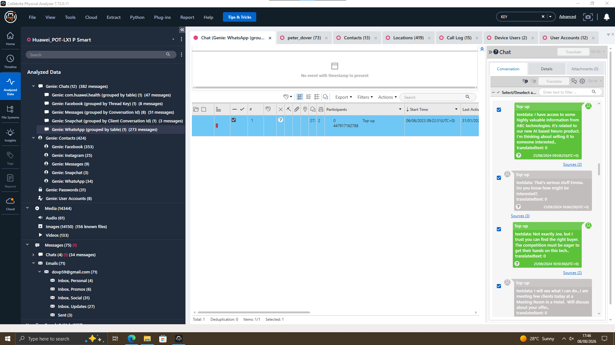
EXHIBIT T2-12 — EX-01 Huawei: WhatsApp chat, patent sale discussion.

8. Call Log and Email Correlation
The EX-01 call log records 15 outbound calls to “Joe Marsh” (+447476538686): 14 not answered and 1 missed [1]. This shows repeated attempts to contact Joe during August 2024, but does not prove any conversation or its content. Norman Smith is also listed as an Instagram contact (normansmith1987), showing contact with both named individuals.
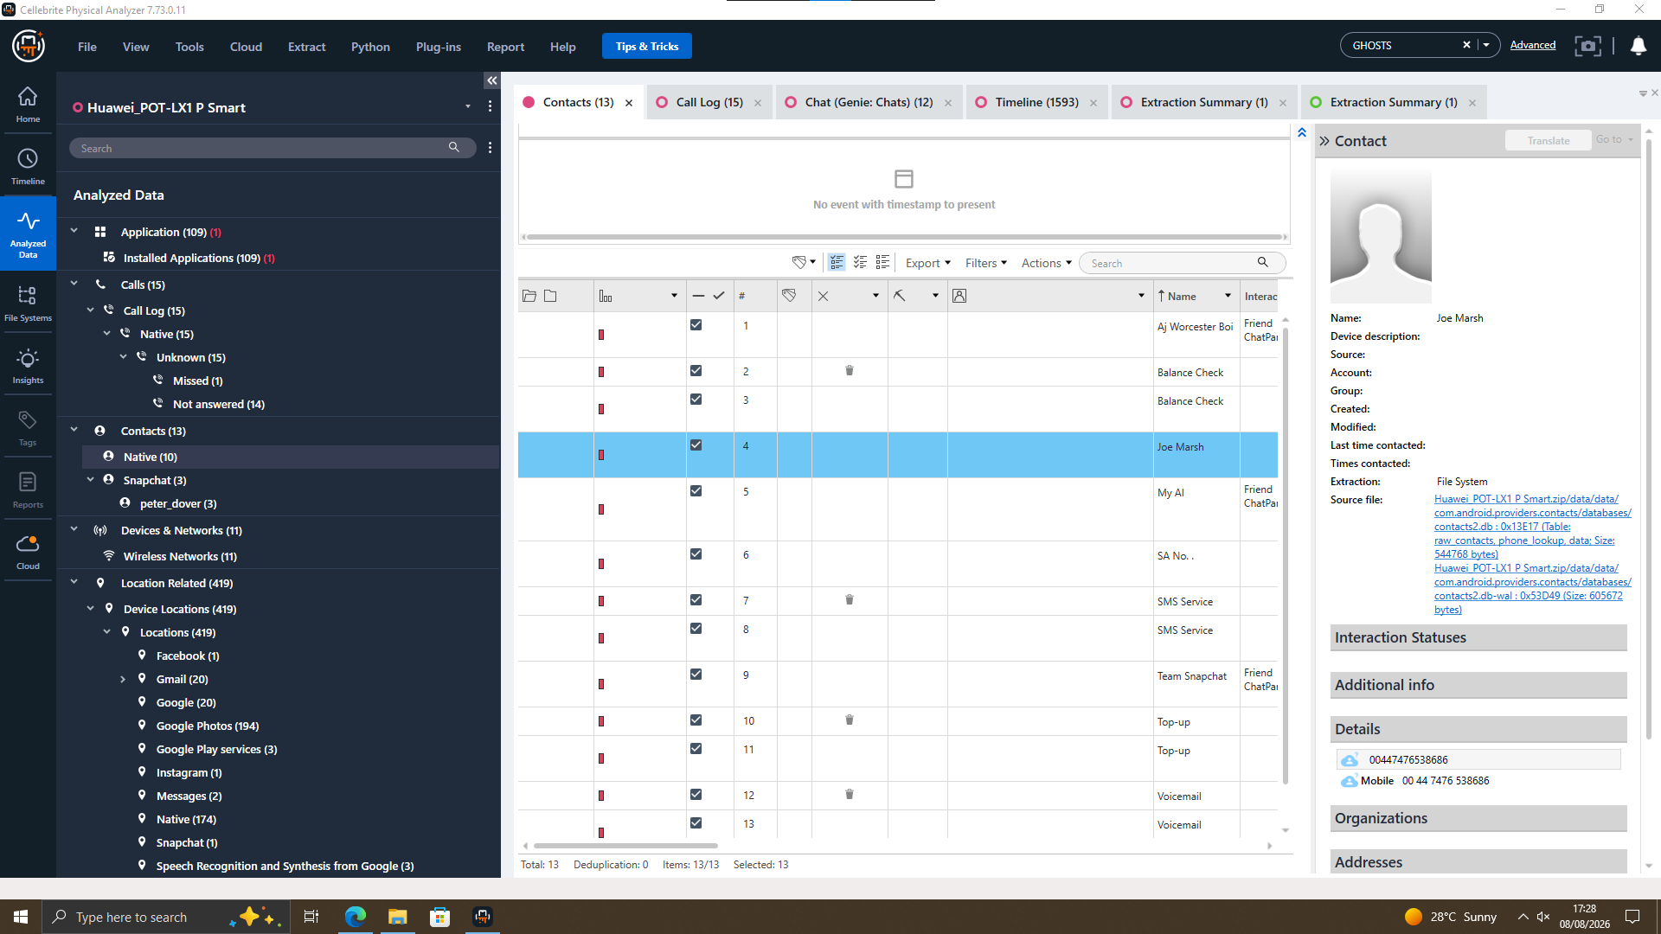
EXHIBIT T2-13 — EX-01 Huawei: saved contact “Joe Marsh.”
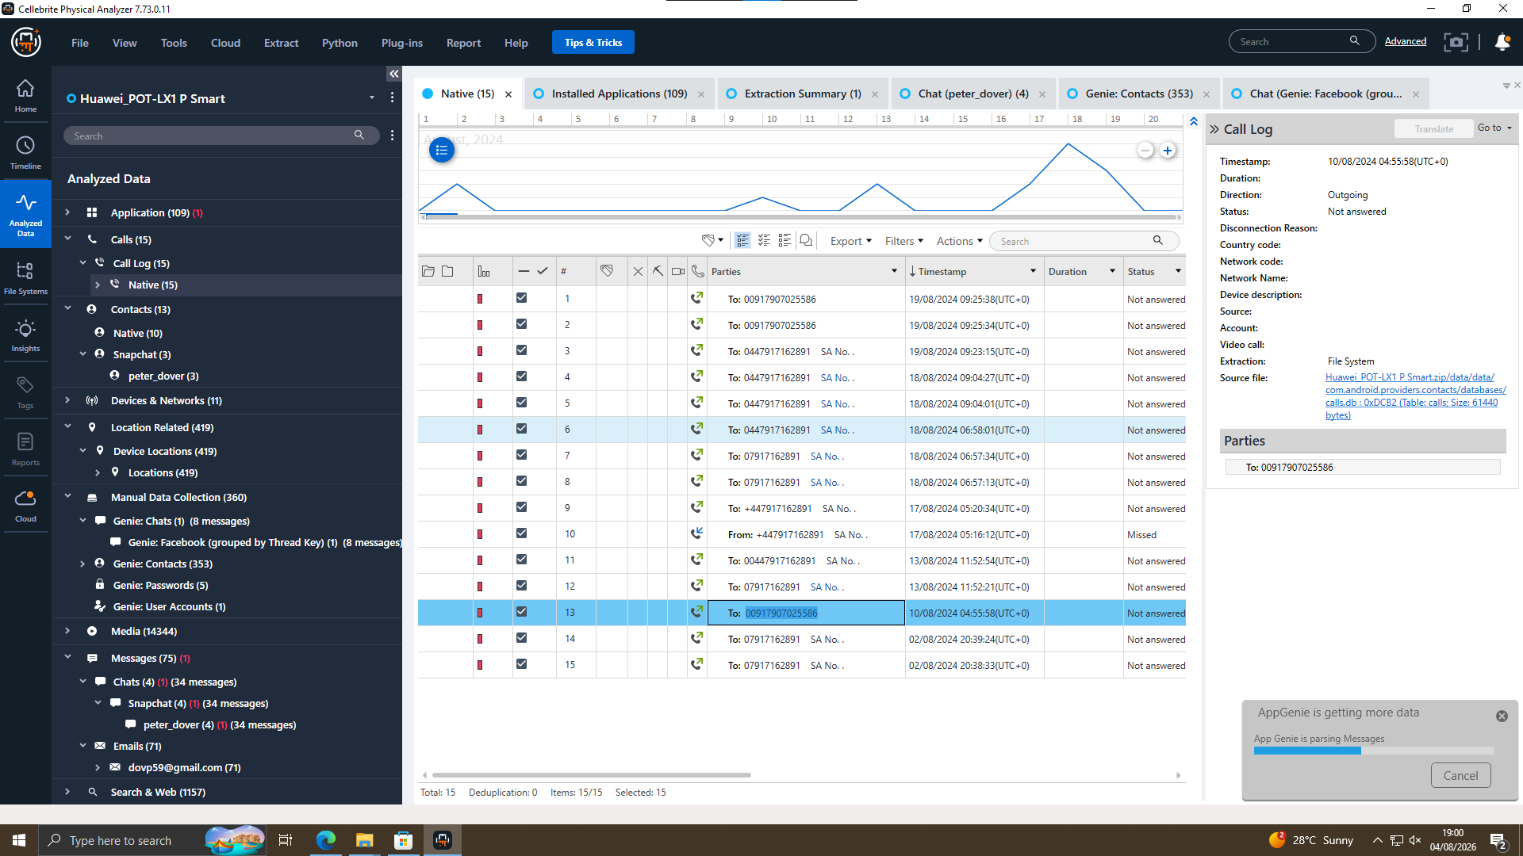
EXHIBIT T2-14 — EX-01 Huawei: call log, repeated unanswered calls.
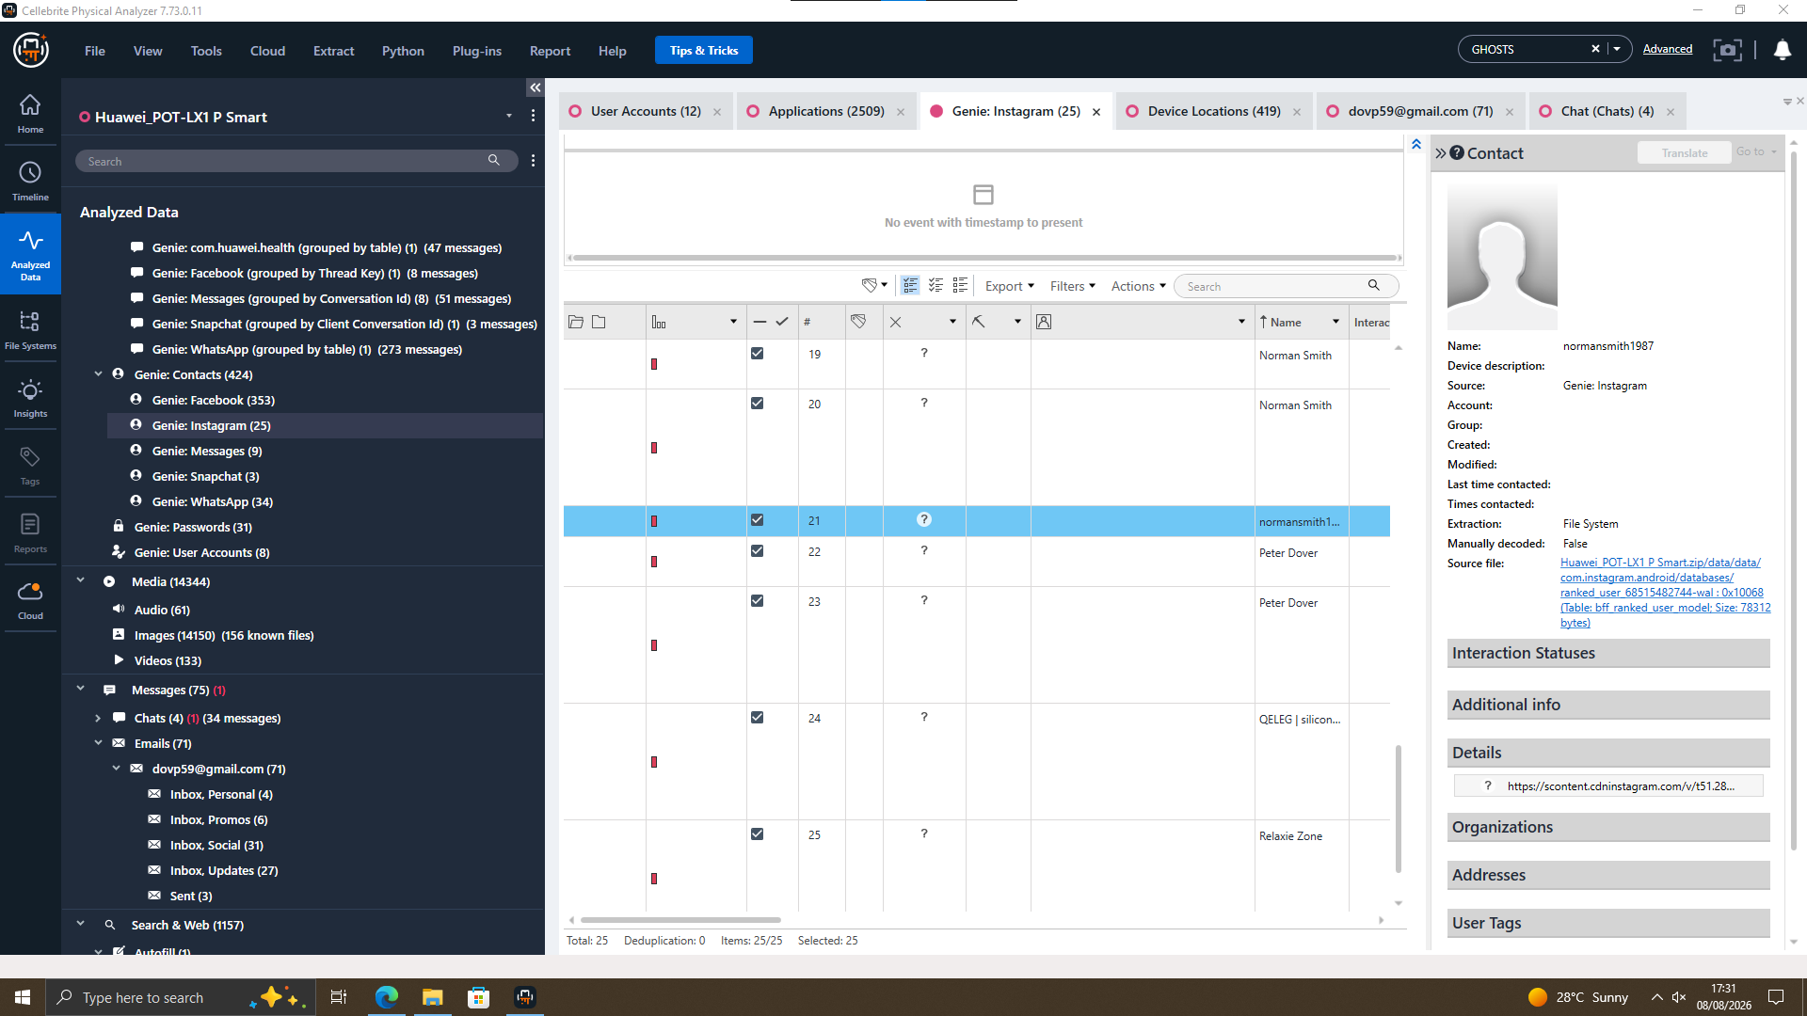
EXHIBIT T2-15 — EX-01 Huawei: Instagram contact, Norman Smith.
No dedicated case email beyond the Lebara SIM-renewal email (Exhibit T2-10) was found; email correlation is limited to Section 7.1’s identity-corroboration role.

9. File and Metadata Analysis
File-level evidence is limited to media location metadata. On EX-01, Google Photos metadata places media in Doha, Qatar (22/11/2024), while EX-03 camera EXIF places media in Paris, France (15/10/2024) [1]. Both are outside the devices’ usual UK history, suggesting possible international travel, but not proving a meeting. EX-02 has location and timeline entries from as early as 2005, before the device model existed. This is a data anomaly and should not be relied on without further validation.
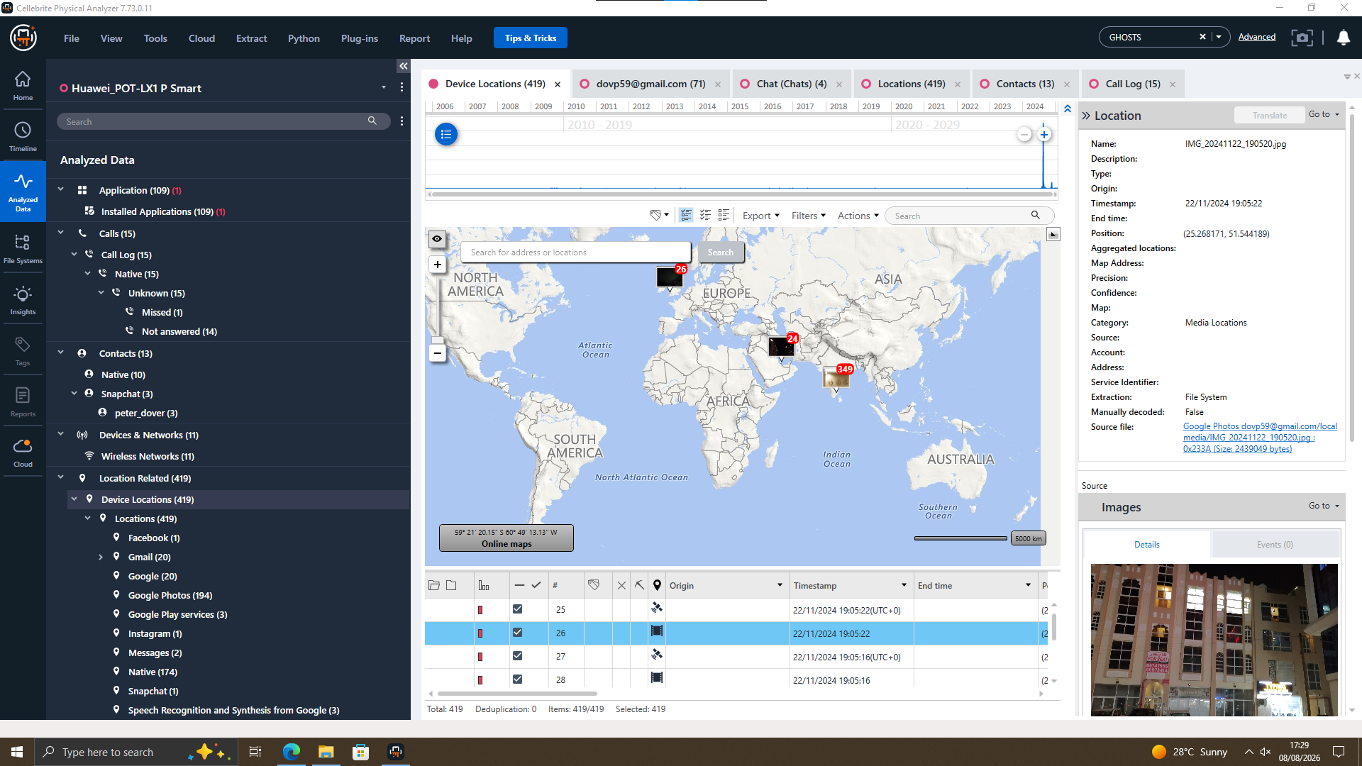
EXHIBIT T2-16 — EX-01 Huawei: media location, Doha, Qatar.
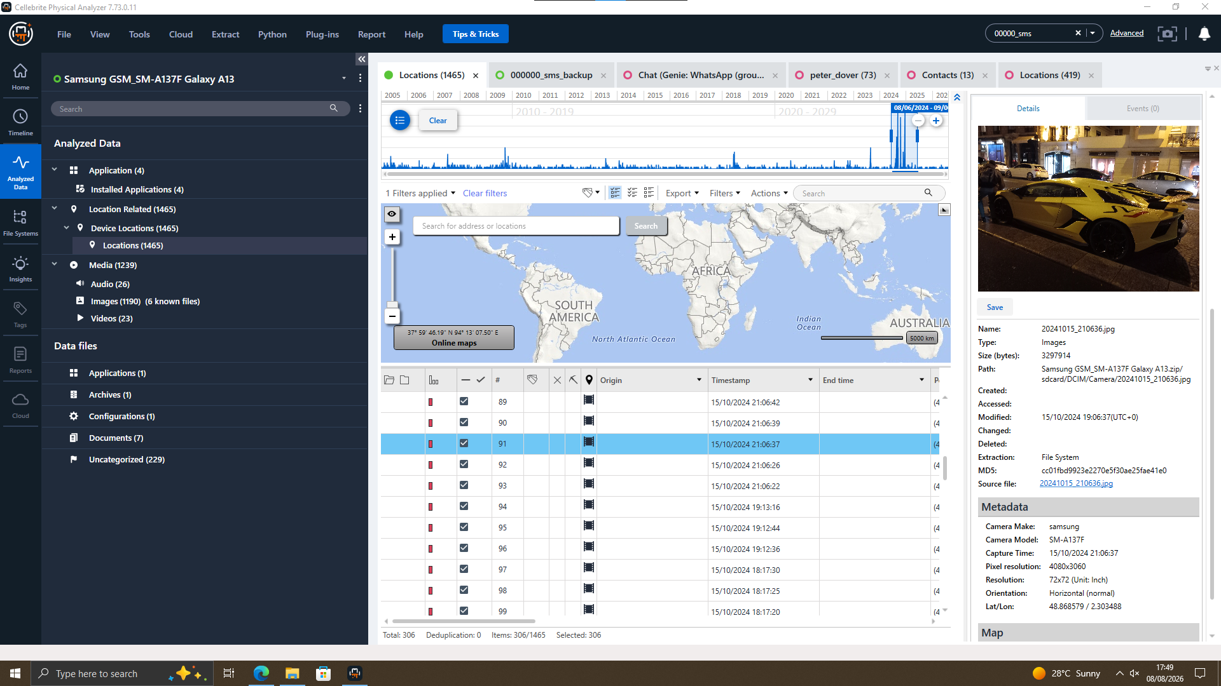
EXHIBIT T2-17 — EX-03 Samsung: media location, Paris, France.
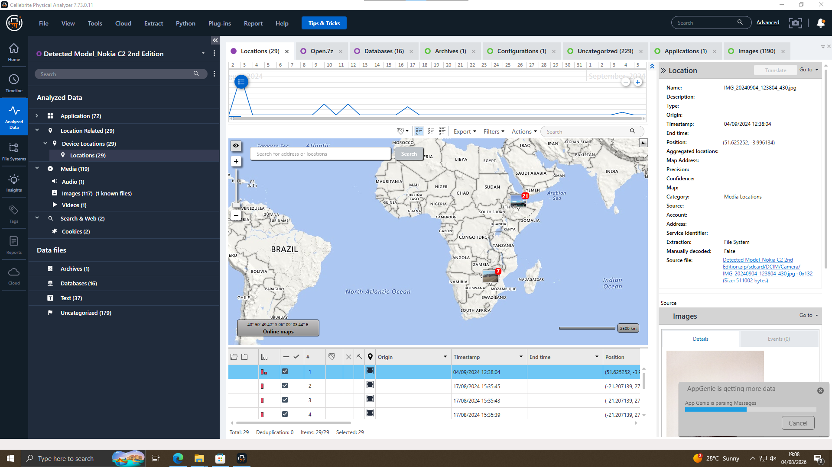
EXHIBIT T2-18 — EX-02 Nokia: location history showing anomalous pre-device timestamps.

10. Chronological Timeline Reconstruction
Date/Time | Source | Person(s) | Event | Significance
17–19/08/2024 | Call log | EX-01 user → Joe/Norman numbers | Repeated unanswered call attempts logged | Directly observed; shows attempted, unconfirmed contact
21/08/2024 | WhatsApp | “Emma” / “Joe” | Patent-offer exchange | Directly observed; central communication evidence
15/10/2024 | Camera EXIF (Samsung) | EX-03 user | Media geotagged in Paris, France | Corroborated by device metadata; inferred travel pattern
22/11/2024 | Google Photos metadata (Huawei) | EX-01 user | Media geotagged in Doha, Qatar | Corroborated by device metadata; inferred travel pattern
31/01/2025 | Facebook | Peter Dover / Norman Smith | “5M offshore” exchange, ends “we are ghosts” | Directly observed; consistent with staged transaction
Only dates directly confirmed in the extracted evidence are shown. Events are presented in strict chronological order; no dates or times have been created or approximated.

11. Suspect Profiling and Role Assessment

11.1 Emma
The evidence shows that EX-01 is owned and used by Peter Dover, confirmed by three linked accounts (Snapchat, Facebook, Gmail) using +447917162788. The same number is addressed as “Emma” in the WhatsApp chat about selling an “AI based Neuro product.” This suggests Peter Dover may be “Emma,” but this is a reasonable inference, not a confirmed match. The Facebook chat with Norman Smith about a “5M offshore” payment supports the WhatsApp evidence but does not name the patent.

11.2 Joe
The evidence suggests the WhatsApp counterparty is “Joe,” based on the reply “Not exactly Joe.” A contact saved as “Joe Marsh” is also on EX-01, with 15 outbound calls to that number: 14 unanswered and 1 missed. This shows an attempted contact channel, not conversation content. The attribution of EX-03 (Samsung) to “Joe” is not supported, as its SIM number does not match Joe’s number and no screenshot confirms it.

11.3 Norman
The evidence shows a connection between Peter Dover and Norman Smith through an Instagram contact (normansmith1987) and a Facebook chat discussing a staged payment (“head” release, “5M offshore”). This suggests a covert transaction. The attribution of EX-02 (Nokia) to “Norman” is not confirmed, as no Google account or identity evidence was provided. The extraction only shows hardware details, with a timestamp anomaly further reducing its reliability.

11.4 Vanessa
No device, account, or communication evidence for “Vanessa” was found in any of the four extractions. The “key call” involving Vanessa is not available in the evidence. Vanessa is mentioned only in the case brief, so her involvement remains unconfirmed.

12. Critical Evaluation and Conclusion
The strongest finding is that EX-01 belongs to Peter Dover, supported by three linked accounts sharing the same phone number and a Lebara email — a reliable forensic fact. The link between Peter Dover and “Emma” is based on one WhatsApp chat and the matching phone number, so it remains a reasonable inference rather than a confirmed identity. The Facebook “5M offshore” chat with Norman Smith supports a covert-transaction narrative but does not directly name the QT-AI-2025 patent; that link depends on the WhatsApp evidence. The Samsung-to-“Joe” and Nokia-to-“Norman” attributions are unsupported, as their account and SIM data do not match, and no evidence for “Vanessa” was found. The Doha and Paris location data provide supporting travel evidence but do not prove a specific meeting. All findings above rest on the available evidence, with unsupported assumptions excluded.

12.1 Evidence Limitations
- No account is literally named “Emma,” “Joe” or “Norman”; identification relies on phone-number matching and in-thread address.
- EX-03 (Samsung) SIM number does not match the number cited for “Joe,” and no corroborating screenshot exists.
- EX-02 (Nokia) has no bound account or identity evidence, and its location history contains timestamps predating the device’s existence.
- EX-04 (Ulefone) has no account, contact or communication evidence connecting it to any named subject.
- The Facebook “5M offshore” exchange does not name the QT-AI-2025 patent; its link to the WhatsApp thread is inference, not directly evidenced.
- Call log evidence establishes only the existence of call attempts, not conversation content.

12.2 Legal Offences
The alleged activity may involve offences under the Computer Misuse Act 1990, Fraud Act 2006, and Trade Secrets (Enforcement, etc.) Regulations 2018 [4], depending on evidence of unauthorised access, dishonest intent, and misuse of confidential information.

13. Recommendations
- Seek further evidence (additional accounts, device unlock, or provider records) to substantiate or refute the EX-02–“Norman” and EX-03–“Joe” attributions before relying on either downstream.
- Preserve and, where legally possible, obtain provider-side records for the EX-01 WhatsApp and Facebook threads to corroborate content and confirm identity beyond phone-number matching.
- Treat the Nokia (EX-02) location and timeline data as unreliable pending further validation of the pre-device-existence timestamp anomaly.
- Retain EX-04 as a peripheral/control item pending any new evidence connecting it to the named subjects.
- Where the evidence indicates a potential ongoing unauthorised disclosure, provide the material to law enforcement and legal counsel for further action.

14. Reflection on Learning and Professional Development
This assessment improved my understanding of digital forensics and its practical application. I developed skills in evidence handling, forensic analysis, communication analysis and evidence evaluation. It also helped me understand the importance of maintaining evidence integrity and distinguishing facts from assumptions.

Task 2 References
[1] Cellebrite Physical Analyzer 7.73.0.11 — Extraction Summaries, EX-01 to EX-04.
[2] Association of Chief Police Officers (ACPO), Good Practice Guide for Digital Evidence — principles referenced for chain-of-custody structure.
[3] Case brief: Apprentice Investigator Programme, Digital Forensics Investigation Assessment (QT-AI-2025 patent scenario).
[4] Computer Misuse Act 1990; Fraud Act 2006; The Trade Secrets (Enforcement, etc.) Regulations 2018, legislation.gov.uk. [Online]. Available: https://www.legislation.gov.uk/ukpga/1990/18, https://www.legislation.gov.uk/ukpga/2006/35, https://www.legislation.gov.uk/uksi/2018/597

Appendices

Appendix A — Exhibit Index
Exhibit | Title | Report Section
T2-01–T2-04 | Image Hash Details, EX-01–EX-04 | 5. Evidence Acquisition and Hash Verification
T2-09–T2-10 | Snapchat account & Lebara email, EX-01 | 7. Communication Analysis
T2-11 | Facebook chat, Peter Dover ↔ Norman Smith | 7. Communication Analysis
T2-12 | WhatsApp patent-sale discussion | 7. Communication Analysis
T2-13–T2-15 | Contact, call log & Instagram evidence, EX-01 | 8. Call Log and Email Correlation
T2-16–T2-18 | Location/EXIF evidence, EX-01–EX-03 | 9. File and Metadata Analysis

Appendix B — Independent Device Acquisition Exercise
Figures 1.1–1.2 in Section 1.1 document a separate, non-case acquisition exercise on a Xiaomi M2101K7BG Redmi Note 10S, performed by the examiner independently of the QT-AI-2025 case evidence, and are retained here for completeness only.

