Qualification: CIPD Diploma in Applied Human Resources

Module Name: Contributing to Resource & Talent Planning in the Organisation

Word Count: NA

Student Name: Darren Bonnell

Student Number: 1810223

CIPD Membership Number: 53274287

By signing below, I confirm that the work/evidence presented is my own, unaided work. I understand the regulations pertaining to candidate malpractice and the action that may be taken as a result.

Signed: Darren Bonnell

Date: 27/05/2020
Candidate name: Darren Bonnell |  |  |  |  | CIPD Membership/registration No.: 53274287
Qualification title: Contributing to Resource & Talent Planning in the Organisation |  |  |  |  | Unique Learner No. (ULN):
Unit code | Unit title |  | Assessment criteria no. | Evidence description | Evidence reference number |  | Assessor  initials | I/V initials if sampled
5ARTP | Contributing to Resource & Talent Planning in the Organisation |  | 1.1 | COVID-19 Intranet Screenshot | EV1
5ARTP | Contributing to Resource & Talent Planning in the Organisation |  | 1.1, 3.3 | CCC COVID-19 Re-deployment Process | EV2
5ARTP | Contributing to Resource & Talent Planning in the Organisation |  | 1.2 | E-mail from HR Business Partner regarding Skills Audit | EV3
5ARTP | Contributing to Resource & Talent Planning in the Organisation |  | 1.2 | Skills Audit Spreadsheet | EV4
5ARTP | Contributing to Resource & Talent Planning in the Organisation |  | 1.2 | E-mail & Skills Audit Spreadsheet sent to Payroll Manager | EV5
5ARTP | Contributing to Resource & Talent Planning in the Organisation |  | 1.2 | Skills and Workforce Hub Survey | EV6
5ARTP | Contributing to Resource & Talent Planning in the Organisation |  | 1.2 | Skills and Workforce Hub Intranet Page | EV7
5ARTP | Contributing to Resource & Talent Planning in the Organisation |  | 1.2 | Witness Statement - Employee Services Officer (Recruitment) | EV8
5ARTP | Contributing to Resource & Talent Planning in the Organisation |  | 1.3 | Ben – re-deployed staff member | EV9
5ARTP | Contributing to Resource & Talent Planning in the Organisation |  | 1.3 | Critical roles advertisement | EV10
5ARTP | Contributing to Resource & Talent Planning in the Organisation |  | 3.1 | Skills and Workforce Spreadsheet | EV11
5ARTP | Contributing to Resource & Talent Planning in the Organisation |  | 3.1 | Cleaning Advice – Intranet Page | Ev12
5ARTP | Contributing to Resource & Talent Planning in the Organisation |  | 3.2 | Witness Statement – Interim Cleaning Services Manager | Ev13
5ARTP | Contributing to Resource & Talent Planning in the Organisation |  | 3.2, 3.4 | Workforce planning meeting with Cleaning managers | EV14
5ARTP | Contributing to Resource & Talent Planning in the Organisation |  | 3.2 | E-mail requesting work on Skills and Workforce spreadsheet | EV15
5ARTP | Contributing to Resource & Talent Planning in the Organisation |  | 3.4 | E-mail from HR Business Partner requesting Workforce planning information. | EV16
5ARTP | Contributing to Resource & Talent Planning in the Organisation |  | 3.4 | Workforce planning spreadsheet | EV17
5ARTP | Contributing to Resource & Talent Planning in the Organisation |  | 3.4 | E-mail from business partner regarding resourcing needs | EV18
5ARTP | Contributing to Resource & Talent Planning in the Organisation |  | 3.5 | Witness statement - manager | EV19
Candidate declaration:
- I confirm that the work/evidence presented for assessment is my own unaided work.
- I have read the assessment regulations and understand that if I am found to have ‘copied’ from published work without acknowledgement, or from other candidate’s work, this may be regarded as plagiarism which is an offence against the assessment regulations and leads to failure in the relevant unit and formal disciplinary action.
- I agree to this work being subjected to scrutiny by textual analysis software if required.
- I understand that my work may be used for future academic/quality assurance purposes in accordance with the provisions of the Data Protection Act 1998.
- I understand that the work/evidence submitted for assessment may not be returned to me and that I have retained a copy for my records.
- I understand that until such time as the assessment grade has been ratified through internal and external quality assurance processes it is not final.
Signature: |  | Darren Bonnell |  |  |  | Date: | 27/05/2020

- Be able to review and evaluate an organisation’s approach to talent planning.

  - Assess how and to what extent the organisation undertakes workforce and talent planning.

In my role as an Assistant HR Advisor for Carmarthenshire County Council during the current COVID-19 pandemic I have had to adjust to the normal ways of working in order to ensure that workforce and talent planning objectives are met which enable the services I support to keep functioning. In order to prepare for this the Authority has developed specific guidance for both managers and employees to keep them updated with all things in relation to COVID-19 (Evidence 1). As explained by Weeks (2019) it is important to ensure that an organisation plans their workforce appropriately in order to ensure that business objectives are met. This is even more important in the current climate particularly the two areas I support which are the Catering & Cleaning services. Not only have both these services remained active as critical workers but there has been a huge demand to increase the numbers of employees in the areas. In particular due to the need for more regular cleaning of buildings and school hubs that have remained open during the pandemic there has been a demand for extra cleaning staff. In order to support this demand, the Authority have looked at different ways to get extra staff to support the services. One of the main ways to do this was to use staff from other areas that were no longer open for business. For example, the Leisure Centres in Carmarthenshire were closed meaning staff who were employed to work in them no longer had a work to do. Steps were then taken to utilise these staff in other areas that remained open which includes the catering and cleaning services. This was done via a re-deployment process which has been specifically designed for the pandemic (Evidence 2). As the weeks have gone by areas that need extra support have been identified and plans have been put in place to ensure the critical areas are able to keep running effectively.

  - Analyse internal and external information relating to the organisation’s future people and skills needs and the availability of talent.

As stated by Blockley (2019) to ensure goals are met companies need to get the right people with the right skills into the right positions. This is vitally important for Carmarthenshire County Council in order to get the right staff in to ensure that critical services are running efficiently during the current pandemic. In order to do this staff including myself were asked to complete a skills audit (Evidence 3). This was a spreadsheet that asked different questions (Evidence 4) of each individuals skills and experiences to give a greater understanding of who if anyone could be utilised in an alternative role to help support the front-line key services. Once I completed the form I e-mailed it to the Payroll Manager (Evidence 5) who was given the task of collating the date. As well as sending out individual skills audits the Authority also requested for staff to actively volunteer to help out in other key areas. This was done by completing a survey (Evidence 6) which then got sent to a newly designed team made up of staff from the Organisational Development section. These staff would then be contacted by one of the team and asked further questions to get a greater understanding of what roles they can be deployed to. A newly designed webpage has also been designed which gives both staff and managers information about the skills and workforce hub (Evidence 7). Whilst the Authority has used internal processes as much as possible the demand for workers in front-line services has meant that there has been a need to recruit externally also. As there has been a need to get new staff in as soon as possible the recruitment process has been amended in order to get these fast tracked. This has allowed the essential worker areas to remain fully functional with new starters being started and in post much quicker than normal. As well as recruiting new staff as an Authority we have sent letters to staff who have recently terminated to see if they would consider returning to their roles (Evidence 8).

1.3 Assess the extent to which current organisational planning activities are addressing potential needs.

As we’re in unprecedented times with needs in different areas changing daily it has been a struggle to ensure that areas have been kept functioning during the pandemic. However, due to the planning and implementation of different tools such as the Skills and Workforce Hub as a business Carmarthenshire County Council has been able to ensure essential areas have continued to run. Whilst the NHS staff have been widely thanked for their role during the pandemic staff within the Authority have also played a crucial part. These include areas such as the school hubs that have been set up which means key workers are still able to go to work while their children attend the hubs. Also, the care sector whether it is in one of the many care homes in Carmarthenshire or in the community have resulted in the need for additional support as a result of the pandemic. The Authority has been able to identify and address the needs and has been able to get the required amount of staff to the areas that most need it. An example of this is an employee Ben (Evidence 9) who works in a Leisure Centre but has been used in other critical service areas to support staff during the pandemic. As the critical needs were identified early and extra resources were given shows that Carmarthenshire County Council did plan efficiently when the pandemic hit. By actively advertising for critical roles (Evidence 10) and being able to fast-track these appointments it has ensured that services have been able to continue to function and support the community.
Evidence 1
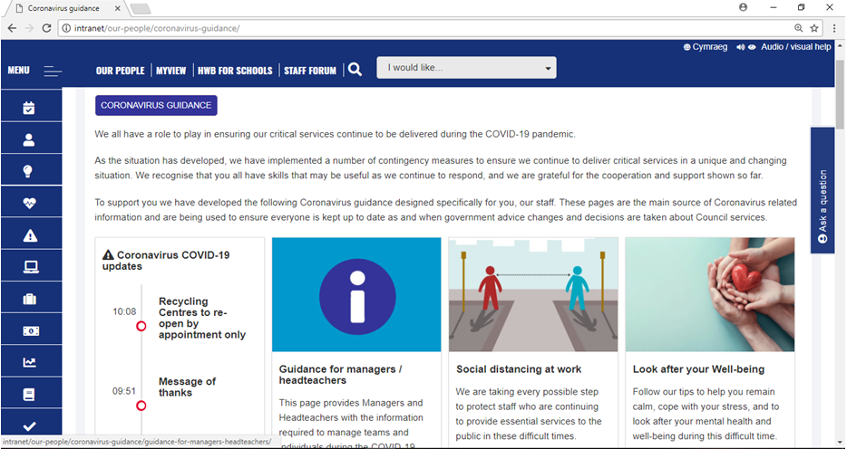

Evidence 2
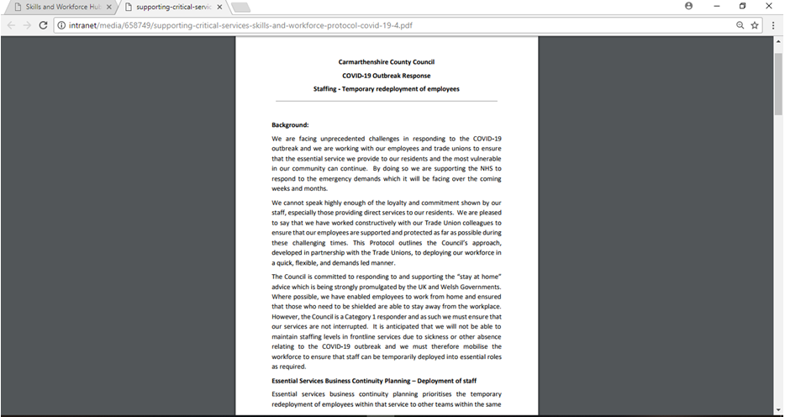

Evidence 3
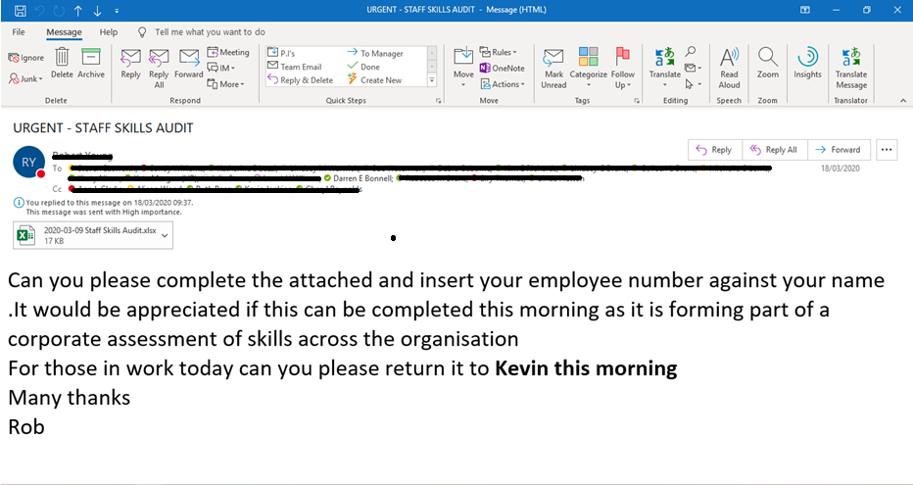

Evidence 4
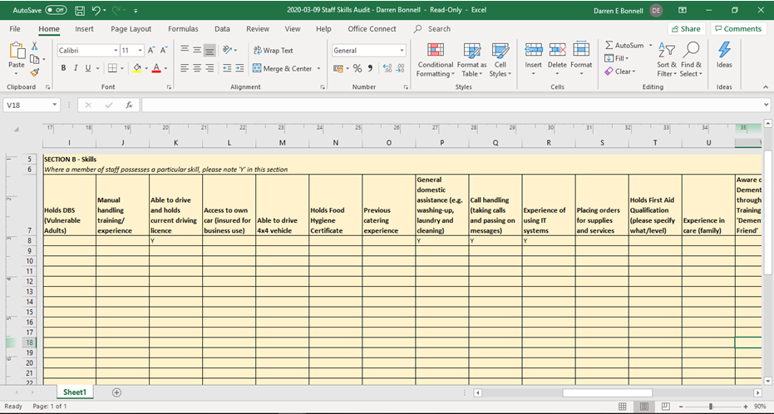

Evidence 5
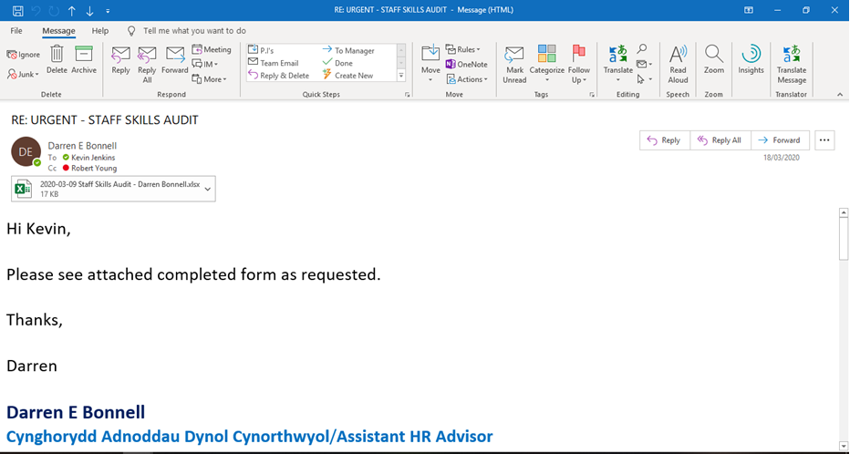

Evidence 6
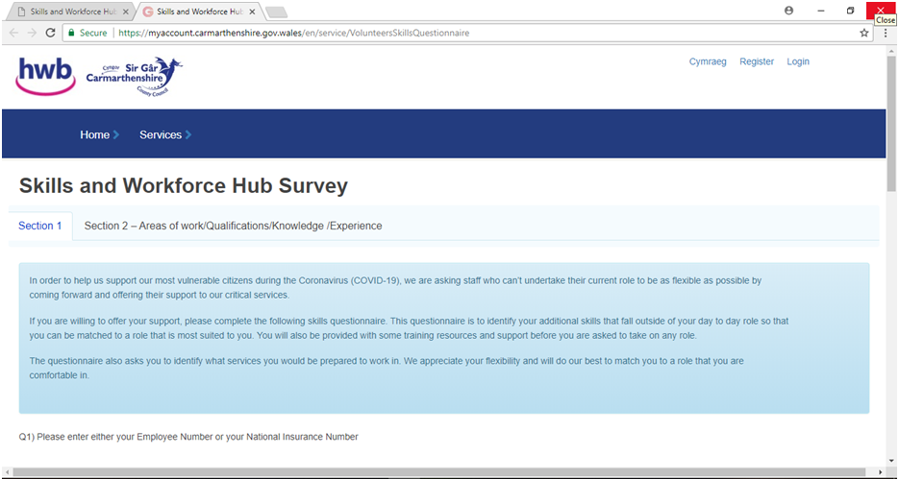

Evidence 7
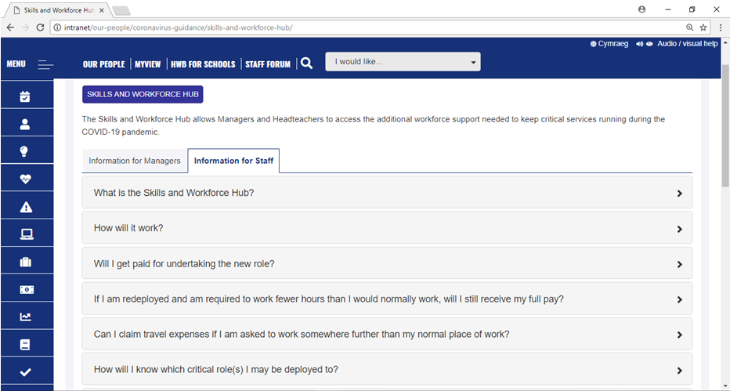

Evidence 8
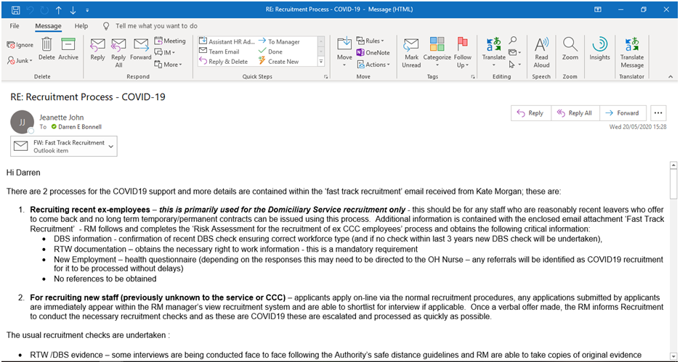

Evidence 9
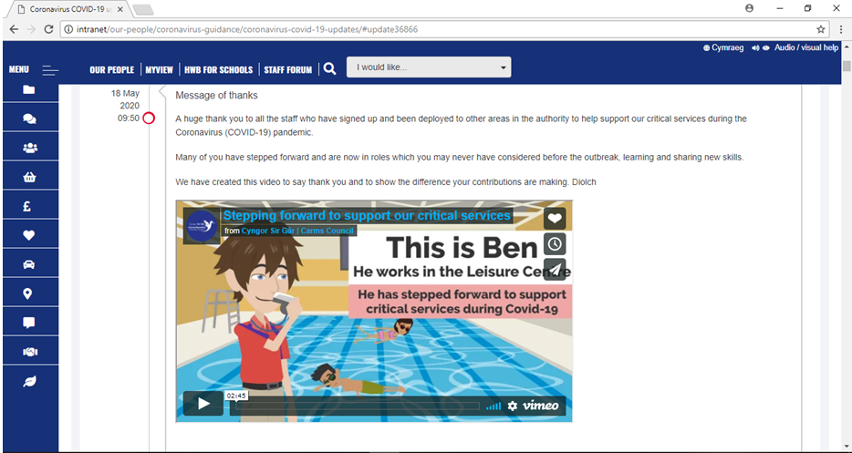

Evidence 10
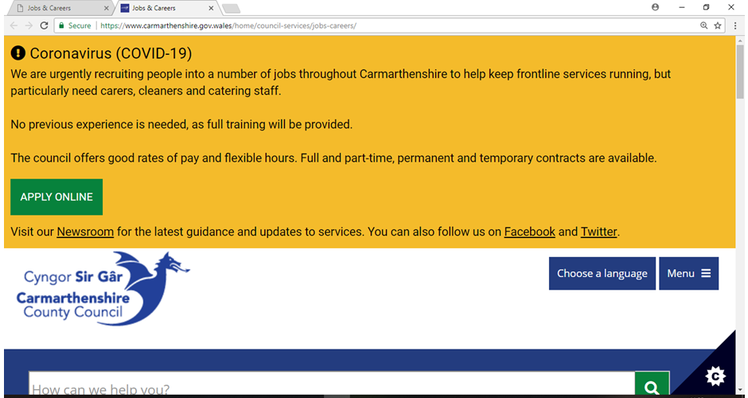

- Be able to recommend ways to improve an organisation’s approach to talent planning.

  - Make reasoned recommendations for how the organisation can maintain an appropriate number of people with the skills required by the organisation.

As previously explained Carmarthenshire County Council has been able to plan effectively to ensure that their key services have been able to continue to function during the current pandemic. However, I do feel that there are potentially further steps that can be taken to ensure this continues to a high standard. These include;

- Using Furlough Scheme – Whilst Carmarthenshire County Council does provide many essential services to the community such as home care there are many other business areas that are not currently functioning meaning some staff are being paid but not working. Whilst steps have been taken to utilise some staff elsewhere through re-deployment this hasn’t been possible for all staff. I would therefore suggest that as an Authority we should use the Furlough Scheme for any staff member not currently working in any capacity. As explained by ACAS (2020) the Furlough Scheme was introduced by the government in order for staff to stop working but remain employed with the government paying 80% of their wages. I would recommend that Carmarthenshire County Council Furlough’s any staff member that is not able to work in any role until they are able to return to work. These would include staff members who have been self-shielding and unable to work from home. I would advise for the Authority to top up the 20% pay so that staff members were not at a detriment and ensured good employee relations going forward. By doing this it would allow the money saved to be distributed to other areas of the business which needed extra resources. This could mean extra staff for areas such as care homes where the risk of absenteeism is higher. By having an increase in numbers, it will ensure the demand for staff will always be achievable.

- Focus on Employer Branding – As explained by Campalani (2020) it is important that companies ensure they take care of their employer brand during the current pandemic. I believe that this is a really important factor in relation to Carmarthenshire County Council and could have a big impact when looking at workforce planning. This is because the Authority is publicly funded which means that it is always heavily scrutinised especially during times of crisis. The public want to know that businesses they are funding are playing a role when dealing with the current pandemic. Whilst I feel there have been some steps in ensuring the brand is looking favourable through social media posts I would recommend that there needs to be far more attention given to the areas that we are supporting during the pandemic and how it is benefiting the public. I would therefore recommend that a strategic team is formed to utilise any communication there is to provide an update of everything Carmarthenshire County Council has done to support the community during the pandemic. This will ensure that the brand is looked at favourably and would mean that it would be an employer of choice. This would result in more people looking at the essential roles that need to be filled and applying for them as they will want to be part of the team supporting their community.
- Additional payments/incentives to work in key worker roles – In Carmarthenshire County Council care workers have been given an additional payment on hours worked over 20 per week. This has encouraged staff to remain at work during the pandemic as well as being an incentive for staff to join or return to the service if they have recently left. I would recommend that an additional payment or incentive is given to all front-line key workers. This would include other areas such as catering, cleaning and refuse. Any staff member that has been turning up to work throughout the pandemic putting their health on the line should be rewarded either with a payment or another incentive such as time off in lieu which can be taken once things settle down. I believe by putting an additional incentive in place it will have a similar result as with care workers which will encourage more staff to apply for the roles as well as keeping them in work which will then allow the service to continue to run smoothly.

- Be able to contribute to people resourcing activities.
3.1 Identify and explain the rationale for a specific resourcing activity within the organisation.
In my role as an Assistant HR Advisor during the current COVID-19 pandemic I have had to adjust to the new ways of working in order to ensure the services I support Cleaning and Catering continue to function. One of the main aspects of my role has been to support and advise on the re-deployment of staff. In particular there has been an increase in demand for cleaning staff to ensure that buildings that have remained opened during the pandemic are regularly cleaned. This is because where cleaners would usually clean a building once a day at the end of the working day they are now being asked to go in several time per day. This has then resulted in an increase in demand for cleaning staff. In order to meet this demand, the council developed a Skills Workforce spreadsheet (Evidence 11) which is a list of volunteers who have put their name forward to be re-deployed in essential areas during the pandemic. As well as using staff from outside the cleaning service new instructions were set up early on to utilise cleaning staff in other buildings should their own have been closed (Evidence 12).

3.2 Agree roles and responsibilities with other contributors to the activity.

As part of my role in supporting my services I have been there to advise the managers on everything to do with the re-deployment process (Evidence 13). As the process has been adapted to incorporate the current pandemic it was my role to ensure that the managers were fully understanding of the process when either taking an employee into the service or when a current employee gets re-deployed out. In order to ensure this was done effectively I met up with the Cleaning managers and discussed all aspects of workforce planning including re-deployment (Evidence 14). As well as giving advice to managers I was involved in working through the Skills Workforce spreadsheet to ensure the staff that have volunteered were able to go into a different role by checking if they had any safeguarding flags on their record or any formal disciplinary information still live (Evidence 15). This is an ongoing exercise undertaken by me and the other HR Advisors.

3.3 Identify organisational procedures and legislative requirements which underpin the activity.

As previously explained there has been a new COVID-19 temporary re-deployment of employee’s process (Evidence 2) developed which gives a detail outline of the new process and the need to re-deploy staff into key positions. I didn’t have any input into designing the process as this was done by the HR Business Partner but my role as previously stated is to ensure that my managers fully understand the new ways of working when undertaking the re-deployment process. As well as this I have needed to ensure my knowledge in employment law is up to date and in line with guidance set out by ACAS. In particular I have had some queries from staff who have been asked to work at an alternative venue to their substantive venue as a result of their building being closed. In order to do this, I have advised my mangers that it would be a reasonable request to ask staff to fulfil their role at a different location but that any detriment to the employee such as excess travel should be addressed.

3.4 Plan and prepare for agreed role, ensuring the availability of any materials or resources required.

In order to ensure that the cleaning service have the required staff during the pandemic I was requested to look at different workforce data to get an idea of the numbers that are currently available to the service (Evidence 16). In order to do this, I met up with the cleaning services managers (Evidence 14) and used a workforce planning spreadsheet (Evidence 17) to get up to date data that could be used going forward. Following the completion of this spreadsheet it was able to identify how many additional staff were required (Evidence 18). As well as recruiting there was also the opportunity to use the re-deployment process to bring in the additional support once the numbers needed were confirmed.

3.5 Undertake agreed role in a timely and accurate manner, in line with organisational procedures and legislative requirements.

In my role as an Assistant HR Advisor I have been able to support on the re-deployment process in a timely and effective way (Evidence 19). With support from my line manager when needed I have been able to give the appropriate advice to the managers I support which include that of the re-deploying of staff. I have managed to ensure that any queries that have arisen have been answered effectively taking into consideration the new process that has been developed for COVID-19 as well as any formal legislation.

3.6 Reflect on the effectiveness of the resourcing activity in meeting required objectives and report back to stakeholders.

During the pandemic times have changed at a rapid pace. With different demands and legislation continually evolving it has been difficult on occasions to keep up with the changing environment. Whilst I feel I have been able to give the appropriate advice to managers which has met their needs as the times have moved so quickly during the pandemic I have had to adjust may way of working in order to be able to give the best support to my managers as possible. As I have been at home working throughout I have had to utilise technology to remain in communication with my managers whether that has been through Skype or Microsoft Teams. I feel the support I have given has been effective as the services I work with have remained functioning with no real problems and staff have been happy in their roles which is evident as no complaints or grievances have been received throughout the pandemic.

Evidence 11

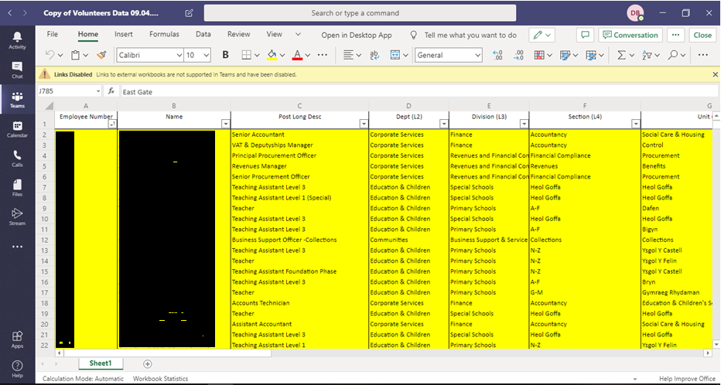

Evidence 12

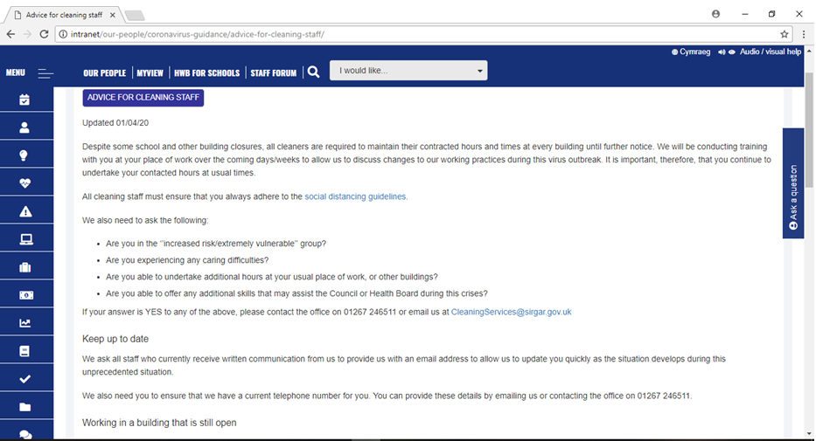

Evidence 13

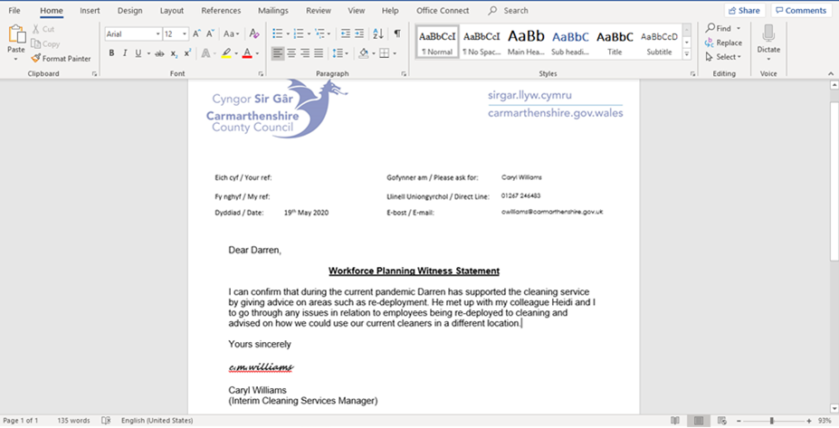

Evidence 14

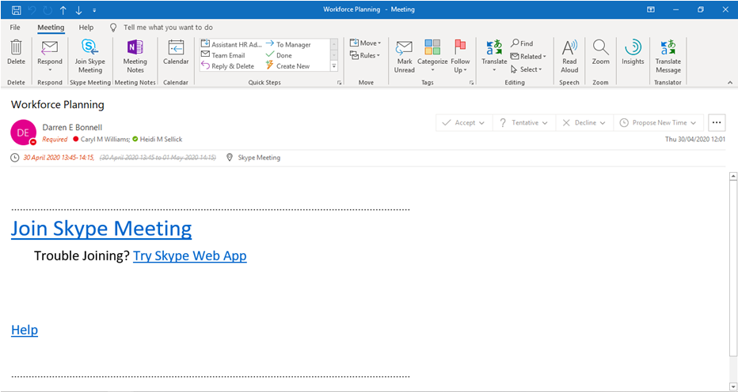

Evidence 15

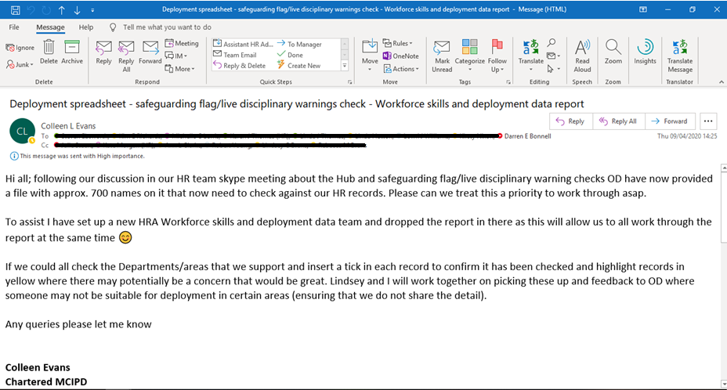

Evidence 16

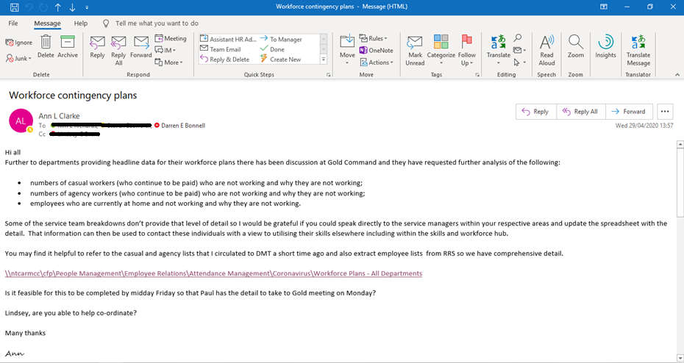

Evidence 17

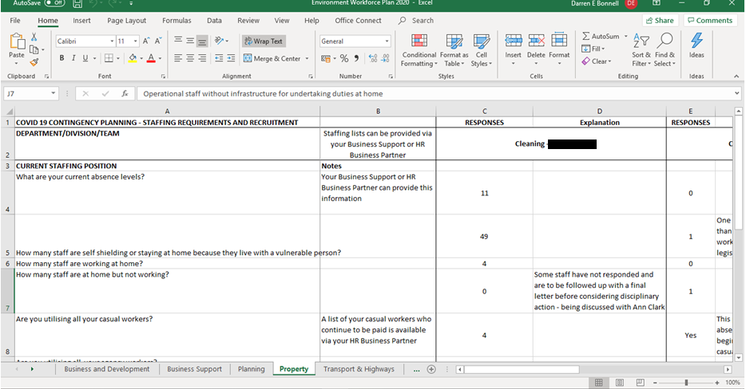

Evidence 18

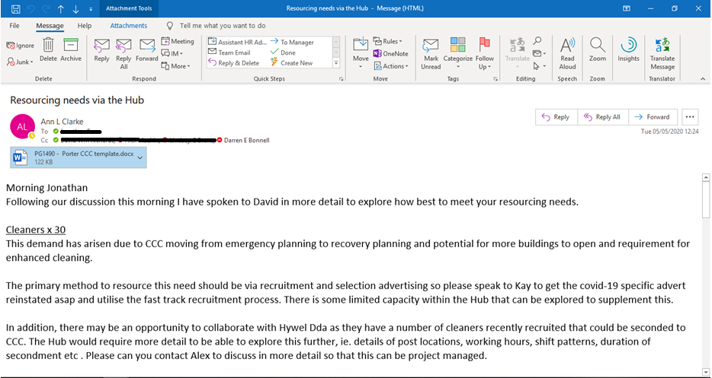

Evidence 19

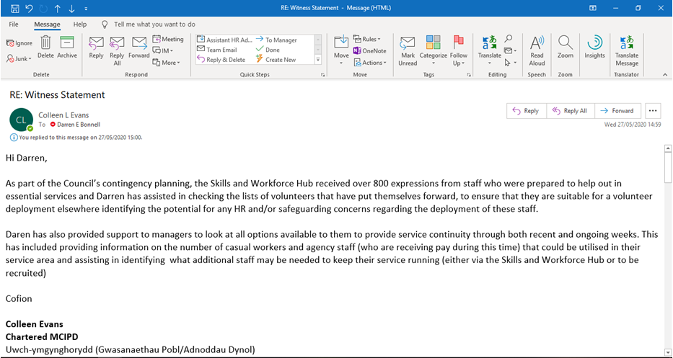

Bibliography

ACAS. (2020, May 19). Coronavirus (COVID-19): advice for employers and employees. Retrieved from ACAS: https://www.acas.org.uk/coronavirus/furlough-scheme-pay

Blockley, S. (2019, March 28). How to draw up a blueprint for workforce planning. Retrieved from Personnel Today: https://www.personneltoday.com/hr/how-to-get-workforce-planning-right/

Campalani, F. (2020, May 20). managing your employer brand during a crisis. Retrieved from Ranstad: https://www.randstad.com/workforce-insights/employer-branding/managing-your-employer-brand-during-a-crisis/

Weeks, A. (2019, May 20). Workforce planning. Retrieved from CIPD: https://www.cipd.co.uk/knowledge/strategy/organisational-development/workforce-planning-factsheet

