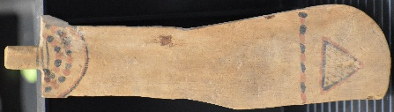
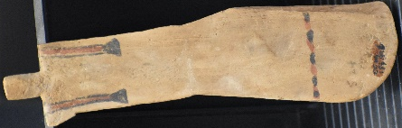
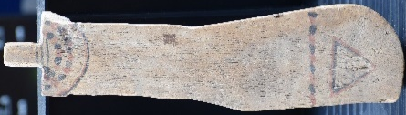

Figure 1 Paddle Doll displaying damage
© Katharina Zinn, 2021
Figure 2 Back of Paddle Doll
© Katharina Zinn, 2021
Figure 3 Front of Paddle doll
© Katharina Zinn, 2021

Personal Artifacts for the Afterlife?
Paddle Doll
Cyfarthfa Castle Museum, Merthyr Tydfil

Object Type: Paddle Doll
Object number: 187.996
Material: Wood, Red Pigment (possibly iron oxide), Blue Pigment (possibly malachite or azurite)
Period: (Unknown, Most likely 11th dynasty)
Provenance: Egypt
Dimensions:
  - Full height – 19.5 cm
  - Thickness – 0.4 cm
  - Width of torso – 3.4 cm
  - Width of belt line – 4.7 cm.

Object analysis by Hadie Watson.

Description:
This paddle doll appears to be a rather rudimentary piece, simple in its design and decoration. It is made out of a flat sliver of wood less that half a centimetre thick and its overall shape is reminiscent of a keyhole. Rather than depicting any legs the object instead in a rounded ‘paddle’ shape which could be from which its name derives. The torso of the doll is narrower than the bottom half, with straight shoulders and lacking arms. The doll’s left ‘shoulder’ shows evidence of breakage suggesting that originally there was a limb here, which is in line with other examples of paddles dolls that have been found. A protrusion from between the shoulders indicates a neck without a head or hair.
The medium itself is a very light weight and soft wood which is very, displaying slight discolouration on the front right-hand side and a small chip in the centre of the pubic triangle that can be difficult to see under certain lighting. The doll is decorated in pigments of red and blue, depicting what appears to be either an Egyptian broad collar necklace (Met museum) or a menat neckalce, a belt or ‘girdle’ and a triangle over the pubic area. The pigments would have been derived from local minerals, the red most likely made up of iron oxide whilst the blue derived from either malachite or azurite (Calvert. 2015). It is difficult to assertatain if the necklace was a ceremonial menat or a more common broad collar which was very common in a funerary outfit (Met Museum).

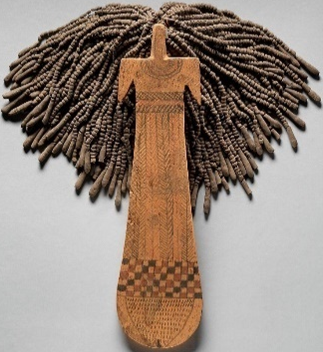
In comparison to other examples of paddle dolls, this item appears to be incomplete, missing not only the forearms but also the voluminous ‘hair’ made up of mud beads strung on linen thread as seen in figure 4.
Figure 4 Complete Paddle Doll

The find site for the object is unknown due to missing records, however when looking at the distribution of other paddle dolls it is most likely to have been located in Thebes, as the majority were excavated in Asasif (Morris. 2011. 75). What we do know is that the dolls were more often than not found in tombs of women (Morris. 2011.75).

There is still to this day, contention as to what purpose these paddle dolls would have served. It used to be believed that with its simplified shape of a female’s body it would have been reminiscent of a toy doll. This theory however is considered outdated as new interpretations have taken its place. (Brooklyn Museum. 2007) Another outdated theory is that the dolls could have been concubines for the dead, similar in magical terms to that of a shabti in that they both would have been figurines animated by funerary magic. (Morris. 2011.71.) This particular theory has been disregarded as the figurines have been located primarily in the tombs of females and so scholars are less inclined to suggest that the objects were meant to be concubines.
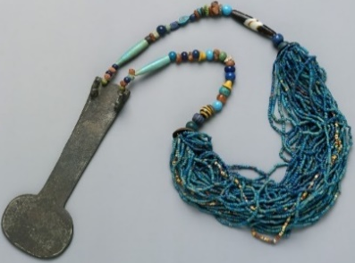
Current presiding theories are that they could be symbols of fertility and rebirth, an artistic representation of women that actually existed, percussion instruments or a combination of these.
Figure 5 Menat Necklace
Morris in particular draws attention to the parallels between the paddle dolls keyhole like shape to that of the weighted back of a menat necklace (Morris. 2011.71.). Adding in that paddle dolls were supposed to have had ‘hair’ that would make nose when shaken it is easy to see the similarities between this and the percussive instruments that the menat necklaces were. It stands to reason that perhaps paddle dolls were used in a similar manner in order to appease a particular god or goddess during a religious ceremony.
The idea that the dolls were representations of real women has been given great consideration as the dolls often were decorated to appear wearing full length gowns or nude with tattoos. This is important to note because both of these depictions show great similarities to a specific group of women known as Khener dancers.
This particular paddle dolls markings depict a girdle which is similar to that of two tattooed female mummies who “possessed tattoos below the waist and above the buttocks” were a girdle or belt would have naturally lain (Morris. 2011.80). These mummies were said to have been identified as two such Khener dancers in service to the goddess Hathor and laid to rest in the funerary complex at Deir el-Bahari. Deir el-Bahari was the home to the mortuary cult of king Nebhepetere and many paddle dolls were discovered here.
Figure 6 Khener dancers at Kenamun's tomb
Moreover, the full length dresses that sometimes decorate paddle dolls are reminiscent of the bright patterned outfits worn donned by the Theban Khener-troupe of Hathor which are depicted in the tomb of Kenamun (Morris. 2011.71-72).

Bibliography
Literature:
Brooklyn Museum. (2007) Paddle Doll. Available at https://www.brooklynmuseum.org/opencollection/objects/3967 [Accessed 13/01/2021]
Calvert, A. (2015) Materials and techniques in ancient Egyptian art. Smarthistory. https://smarthistory.org/materials-and-techniques/ [Accessed 22/01/2021]
Met Museum. Model Broad Collar of Hapiankhtifi. Collection. https://www.metmuseum.org/art/collection/search/546286 [Accessed 07/02/2021]
Morris, E. (2011) Paddle Dolls and Performance. Journal of the American Research Centre in Egypt 47, 71-103.

Images:
Figure 4 – Paddle Doll [Figurine]. Ca 2030 BCE – 1802 BCE. At: The Met Museum, Gallery 106. 31.3.35.a, b
Figure 5 – Menat Necklace [Necklace]. Ca. 1390 – 1353 BCE. At: The Met Museum, Gallery 119. 11.215.450
Figure 6 – Image from Morris. 2011. 88.

