Student Name: Courtney Thomas
Student Number: 1803924
Programme of Study: Ba (hons) illustration Module: Ways of Perceiving (ADAD4010)
Curating a Metaphorical Exhibition - Hallucinations
It is believed that 1 in 20 people have experienced some form of hallucination without the stimuli of drugs or alcohol in their lifetime. Such a phenomenon can occur at any time in a variety of forms that can affect all of the senses, some examples of hallucinations are auditory, visual, and tactile. I have chosen to curate an exhibition that revolves around each of these examples to demonstrate their effects on the human psyche and condition. I find this concept to be fascinating as I believe that hallucinations allow us to peer into an alternative mental state in which the laws of what is possible can be bent and altered. Author Oliver Sacks once said that “hallucinations are defined as percepts, arising in the absence of any external reality - seeing things or hearing things that are not there.” Oliver Sacks ,2012, Hallucinations, Picador; Main Market edition (8 Nov. 2012)
Within my exhibition I would want the audience to question their idea of what is strictly speaking “ordinary” regarding both their own concept of reality as well as the artistic space itself. I would want the audience to be suprised by the level of interactivity that is possible within the exhibition as I think such interaction is vital to provide the narrative that hallucinations are not as alien and far away as we would like to believe. What do we conceive to be real? Are other conceptions strictly speaking “real” while perceived in a hallucinatory state and if so, are they a hindrance or beneficial as to what can they teach us? These are questions I want my audience to ask themselves when observing the exhibition as a whole.
When brainstorming my initial ideas for this project I was reminded of a quote by American journalist Shana Alexander that goes as follows; “The paradox of reality is that no image is as compelling as the one which exists only in the mind's eye.” and this cemented my plan of focusing on the effects of sensory hallucination and how it affects our brains by warping our perceptions as humans.
After researching into a few museum spaces I had decided that the ideal location for a project such as this would be the Art Gallery of Ontario located in Toronto, Canada based on the beautiful design in and outside of the building itself. The building has a large amount of space and is incredibly versatile in the terms of moving and applying interactive pieces, ergo any challenges that may possibly occur when setting them up would be less counteractive to the progression of said exhibition. It is also in this building that one of my artists of interest, Yayoi Kusama, presented her work during March 3rd – May 27th, 2018 and so I know that complicated installations such as hers are possible within this space.
Finally the most interesting aspect of this building is the linear corridors that contain several rooms and spaces, It is for this reason that I believe that my exhibition would be accurately presented. I want to keep each installation separated in such a linear path to demonstrate a journey through each phase of the overall theme to highlight the similarities and differences between three forms of hallucination.
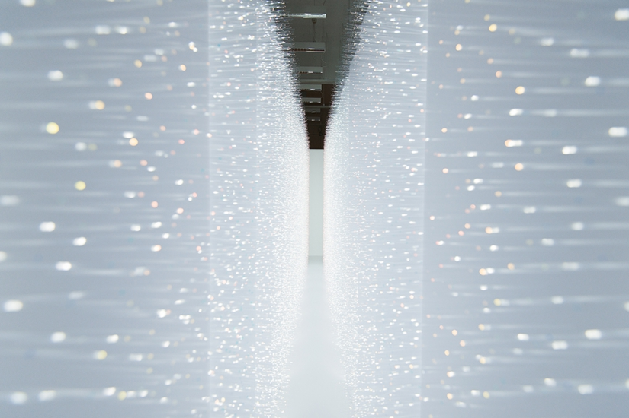
Figure 1.
Tactile Hallucination - Sense of Field by Hitomi Sato
The term tacile refers to the experience regarding touch and the feeling of touching other objects, when experiencing a tactile hallucination the person in question will often encounter sensations of being touched by invisible forces at random. To illuminate this I have chosen to begin the curation with the interactive piece “Sense of Field” by Hitomi Sato.
This installation was created by attaching thousands of transparent threads to two white walls in order to create a narrow corridor. The observer would move through this space and be brushed by the threads that are reflective, this means that they will shimmer as people pass through, giving the illusion that you are being touched by shards of light. I feel that this installation would be perfect as the reflective threads could be an excellent metaphor for the receptors that send information to neurons in the central nervous system which results in the sensation of feeling touch.
I think that this installation would be a fantastic way to begin the exhibition as it really highlights the significance of entering into this space. It acts almost like a doorway, peering into the veil of altered reality, you encounter a physical and visual experience that separates you from the outside world.“Your body is wrapped in the "shimmer" of light.” says Sato “There are countless transparent film hands out of walls on both sides. They are the lighting hair which covers a creature. The faint prominence is reflective and flashes. The grassland of light gives a sense of touch.” Hitomi Sato, 2015, Musashino Art University-Graduation Works Exhibition 2015 | Hitomi Sato Works
I really like how gentle this first piece is over all as its purpose is to make the audience experience an unfamiliar sensation of touch, without being obvious or overbearing. In this way the viewer can walk through the narrow space and decide for themselves how they interpret these sensations, some may enjoy the gentle brush of the reflective tendrils, whilst others may feel uncomfortable within their embrace, regardless each individual will encounter a unique experience as they pass through.
Figure 2.
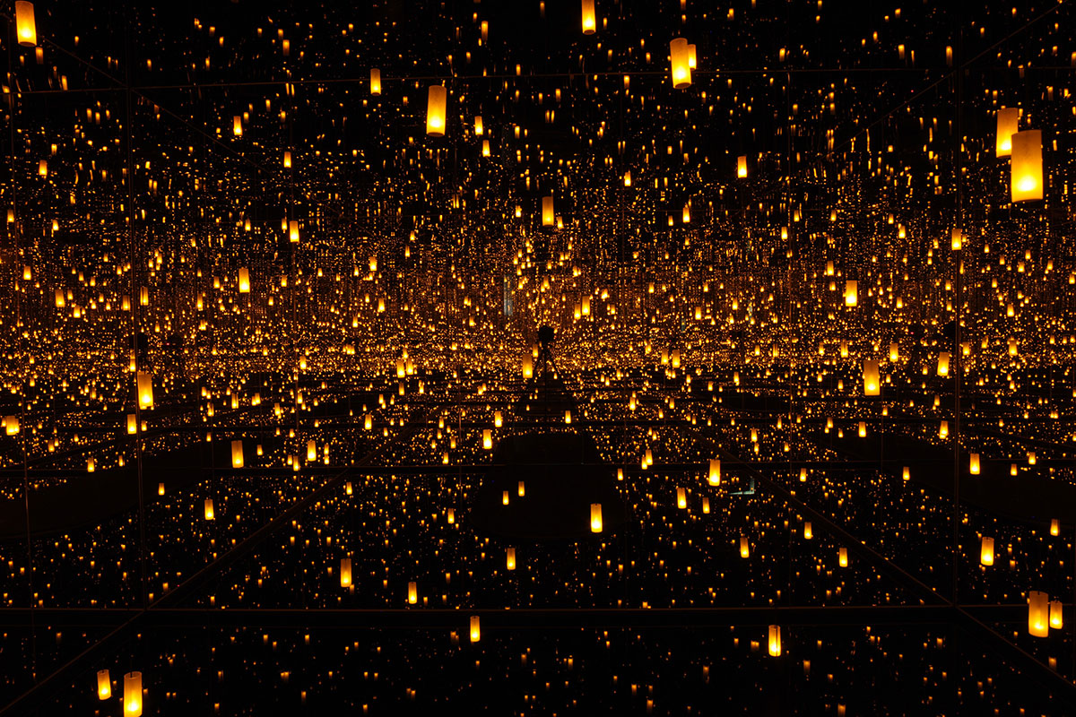
Visual Hallucination - Infinity Mirrors by Yayoi kusama

Once the audience has passed through the first room they will gradually move on to the second that would be themed around visual hallucination. To compliment the previous installation I would display work that elegantly captures the surreal amongst a modern day setting, such as that created by Japanese contemporary sculptor and designer Yayoi Kusama.
“The Infinity Mirrors” created by Kusama is a wonderfully made visual illusion made by carefully placing mirrors and dangling bulbs within a small dimly lit room, giving the illusion that the sea of lights go on forever. I believe that this installation would really impact the audience due to how deceptively vast it appears, the reflections trick your eyes into thinking that the space around you is infinite. The lights within this piece also change colour and patterns every few minutes, creating a completely different visual experience each time.
When viewing this installation I want the observer to question what they see, the moment they step into this space they will see themselves reflected into this beautiful ocean of pattern and I love this because this means that the observer cannot view the piece without being a part of the illusion itself.
When creating this piece Kusama relieved her personal connection to it and has spoken publicly about her mental health and how it impacts her well being and artistic skills. “My art originates from hallucinations only I can see. I translate the hallucinations and obsessional images that plague me into sculptures and paintings” - Yayoi Kusama, Interview by Grady T. Turner for BOMB Magazine, Jan 1, 1999
Despite her struggles, Kusama’s creations are truly something to behold. From her hallucinations she collects fragments of beauty amongst the chaos and translates them into something more physical and compacted, allowing us to peer into her thoughts and see the world through her eyes.
Her art is what connects her hallucinations to the real world, her hands give them shape so that they are present and real. Without her creative nature, Kusuma perhaps would have lived in isolation with her visions, never sharing them with another soul.

I want the audience of this piece to stand amongst the lights and the glass and question what they see, is this reality for the artist? When she stands before you and looks at your shape, are you surrounded by lights at that moment? And finally is it possible to fathom what these visions represent within her psyche?
Questions such as these may be the reason why many people feel disconnected from the visual aspects of hallucination as they feel seperated from artists such as Kusama as she perceives human existence in ways that many will never experience

Figure 3.
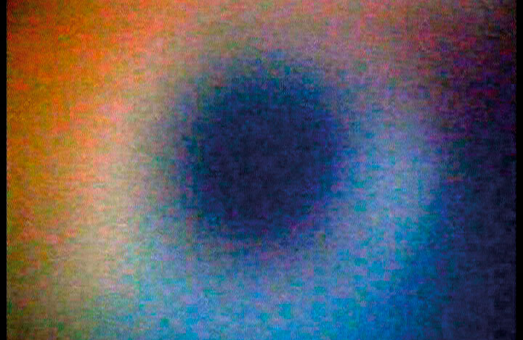
Audio Hallucination - “THE DOPPLER EFFECT” by Pekka Sassi 2004
Audio available here: http://www.av-arkki.fi/en/works/the-doppler-effect/

To conclude the curation I would like the observer to enter the final room which will be as dark as possible in order to focus on audio alongside projections of video work. ‘The Doppler effect’ is an audio / visual installation created by artist Pekka Sassi who creates his work by experimenting with different variety of sounds. Many of his installations include video work and short films often accompanied by separate audio and sound pieces.

In scientific terms The Doppler Effect occurs when the sound frequency made by a moving object, such as a car, increases or decreases based on its distance from the observer. Experiencing the doppler effect via audio can cause confusion and discomfort due to the brain triggering responses that cause you to believe that there is an incoming obstacle approaching you at rapid speed.

I felt that this phenomenon would be perfectly suited to demonstrate how auditory hallucinations might feel to the individual. Auditory stimuli can seriously affect how the brain perceives its current surroundings and can easily trigger emotions such as fear and anxiety based on experiencing vulnerability within the unknown. Using The Doppler effect to recreate this response was ideal as it creates an incredibly familiar yet unusual atmosphere.
While researching this subject I found several books written by authors that have experienced hallucinations such as these. “Musical hallucinations are physiological - “release phenomena” - originating in the now incontinent activity of the brain’s musical networks...” Leo Rangell (2009) Music in the Head: Living at the Brain-mind Border ,Routledge; 1st edition.

Sassi’s audio piece creates a sense of unfamiliar uncertainty as it is as if objects are moving around you from every angle, each time the frequency changes goose bumps can occasionally occur due to the brain reacting instinctively to potential danger.

In conclusion I believe that these pieces compliment each other perfectly and flow together in unison as they are individually vibrant and indisputably fascinating, they leave a long lasting impression but in such a way that does not distract the viewer from the overall theme by outshining its neighboring installation.
Each segment of the exhibition allows the observer to experience hallucinations in a new light, this experience would allow that person to become familiar with this theme by interacting with each piece individually.

Bibliography

Oliver Sacks ,2012, Hallucinations, Picador; Main Market edition (8 Nov. 2012) Ebook: https://www.amazon.co.uk/Hallucinations-Oliver-Sacks-ebook/dp/B009WSCV3A/ref=tmm_kin_swatch_0?_encoding=UTF8&qid=1557168363&sr=1-1
Shana Alaxander
Shana Alexander Quotes. (n.d.). BrainyQuote.com. Retrieved May 6, 2019, from BrainyQuote.com Web site: https://www.brainyquote.com/quotes/shana_alexander_125833

Musashino Art University-Graduation Works Exhibition 2015 | Hitomi Sato Works
Video: https://www.youtube.com/watch?v=A1rbz4LO3mQ

Yayoi Kusama, Interview by Grady T. Turner for BOMB Magazine, Jan 1, 1999 Article: https://bombmagazine.org/articles/yayoi-kusama/
Leo Rangell (2009) Music in the Head: Living at the Brain-mind Border ,Routledge; 1st edition.
Ebook:https://play.google.com/store/books/details?id=L74snmdFvzoC&rdid=book-L74snmdFvzoC&rdot=1&source=gbs_atb&pcampaignid=books_booksearch_atb

Images
http://www.av-arkki.fi/en/works/the-doppler-effect/

https://www.designboom.com/art/hitomi-sato-sense-of-field-installation-05-31-2016/

https://hirshhorn.si.edu/kusama/infinity-rooms/

