BMSK4014 – Problem Solving
Increasing Operational Capacity at Coastal Auto Valet Ltd
(A workplace problem-solving report)
Approximate word count: 3,072 words
Student: Daniel Bussell (2313849)
(BMSK4014)

Table of Contents
EXECUTIVE SUMMARY 3
INTRODUCTION 4
1.DEFINE THE COMPLEX PROBLEM, INCLUDING ITS SCOPE AND IMPACT. 5
1.1 SCOPE, RESTRICTIONS AND IMPACT 6
2. Analyse the problem 7
2.1 Brainstorming and mind-map 7
2.2 Fishbone/Ishikawa analysis 8
2.3 Five Whys 9
3. Propose Alternative Solutions to the Root Cause 10
4. Evaluation and decision 11
4.1 Weighted decision matrix 11
4.2 Cost-benefit analysis 12
4.3 Ratios 13
1. 13
2. 13
3. 14
5. Detailed Plan for Implementing the Solution 15
6. Communicate the Plan to Relevant Stakeholders 16
Conclusion 17
Appendix 18
References 20

EXECUTIVE SUMMARY

Coastal Auto Valet Ltd (CAV) is experiencing a capacity problem caused by growth occurring faster than the current operation model can adapt to. Internal business reports evidently show 30 weekly bookings, 125 vehicles per month, £7,900 monthly turnover, 12 commercial contracts, a 4.9/5 customer rating, a 68% repeat-customer rate, a nine-day average waiting time and the owner working approximately 58 hours per week. Combined these indicators suggest that the problem is not a lack of demand but an inability to convert demand into additional capacity without risking quality, wellbeing and cash flow.
Understanding the root-cause analysis will indicate that staffing, scheduling, owner dependency and resource constraints interact. The likely root cause is a mismatch between Coastal Auto Valet's current owner-led operating model and the level of customer demand it is now experiencing. The geographical location and single mobile unit are contributing constraints within that wider operating-model mismatch, rather than being identified as root causes in their own right. Three alternatives are evaluated: recruiting an additional full-time valeter; redesigning scheduling and workflow; and adding a second mobile unit.
A weighted decision matrix identifies scheduling/workflow redesign as the strongest immediate option because it offers high financial sustainability and feasibility while protecting customer service. The recruitment of a staff member remains a credible second-stage option, but its £3,550 setup cost and estimated £33,740 annual employment cost make it more sensitive to actual demand suggests. A staged approach is therefore recommended: implement workflow redesign immediately, monitor capacity and demand for eight weeks, then trigger recruitment if waiting time remains above five days and demand consistently exceeds the revised capacity threshold.

INTRODUCTION

This report operates under structured problem-solving methods to a complex operational issue at CAV, a Carmarthenshire vehicle valeting and detailing business operating through a hybrid fixed site/mobile model. Defining the workplace problem, analyse causes, propose at least three solutions, evaluate them using a weighted grid and cost-benefit analysis, implement the preferred solution, address stakeholders and communication, and monitorisation of outcomes based on the evidence. The analysis therefore prioritises evidence, interpretation and decision consequences rather than description alone. Welsh Government, (2025) has outlined cars and taxis have accounted for 77.2% of Welsh motor-vehicle traffic in 2024, while Carmarthenshire was among the local authorities with the highest traffic volumes. A report by SMMT (2024) illustrates, the UK owner vehicle tally was over 41 million vehicles in the latest SMMT facts publication, reinforcing the size of the underlying service market. The report defines the problem and its scope, with the use of data collected from CAV’s internal business and using recognised diagnostic tools, proposes and evaluates three realistic solutions, and sets out an implementation, communication and monitoring plan for the preferred option. Its purpose is to support a sound, evidence-based future business decision.

1.DEFINE THE COMPLEX PROBLEM, INCLUDING ITS SCOPE AND IMPACT.

Table below shows the Actual and Desired state: following understanding and scope.
Measure | Current | Target
Evidence | Current state | Desired state
Demand | 30 bookings/week; weekends regularly full | Capacity absorbs sustained demand without excessive overtime
Customer access | Average waiting time about 9 days | Target waiting time ≤5 days
People | Owner works about 58 hours/week; staff report peak pressure | Workload is sustainable and roles are clearer
Quality | 4.9/5 average rating; strong repeat business | Maintain ≥4.8/5 while capacity increases
Commercial growth | 12 commercial contracts; further enquiries exceed capacity | Accept viable additional contracts without displacing existing customers
Finance | £7,900 monthly turnover in internal business evidence | Growth remains cash-positive and profitable
Table 1. Problem definition using the internal Coastal Auto Valet evidence.
CAV has traded for approximately twelve months, offering routine maintenance washes, full valets, paint correction, ceramic coating and commercial fleet cleaning from a fixed roadside site supplemented by a mobile unit. Current trading data show average weekly bookings of around 30 vehicles, monthly turnover of approximately £7,900, a 68% repeat-customer rate and an average customer waiting time of nine days, with the owner working an average of 58 hours per week (CAV internal management information, 2026). Booking records, customer enquiries and staff feedback all point in the same direction: demand has grown faster than the business capacity to fulfil it.
AutoTidy, (2026) and IBISWorld, (2024) has found the UK car valeting and detailing sector itself is expanding steadily, with the domestic market valued at roughly £1.6-1.7 billion, with interior valeting identified as the fastest-growing segment so the underlying demand pressure on Coastal Auto Valet is consistent with a wider sector trend rather than a one-off spike. Departmental vehicle licensing statistics obtained from the Department for Transport (2026) confirm that the vehicle population available to service in Wales continues to grow year on year reinforcing that this addressable market is not the constraint.
The complex problem addressed in this report is therefore: How can Coastal Auto Valet Ltd meet increasing customer demand while maintaining service quality, customer satisfaction and business profitability?
Dörner & Funke, (2017) states that this can be classified as complex problem rather than being complicated: with several plausible causes staffing, equipment, scheduling and the owner-operator model itself, it affects multiple stakeholders with different priorities, several realistic solutions exist, and no single option is obviously correct in advance. Increasing operational capacity, the focus of the analysis that follows and is the mechanism through which the business can meet rising demand without the quality, satisfaction or profitability trade-offs that an unmanaged response would risk.

SCOPE, RESTRICTIONS AND IMPACT
The scope of the problem is limited to the operational and staffing model of the existing business; it does not extend to relocating premises or entering new geographic markets. The solution must operate within realistic restrictions: as available capital is limited, the business has no significant cash reserve beyond monthly working capital, and any new working arrangement must comply with UK employment, insurance and environmental regulation, as seen by the House of Commons Environmental Audit Committee, (2026), and also including trade effluent consent under the Water Industry Act 1991 for the static site Castle Water (2025).
Left unresolved, the impact of the problem is significant. Extended waiting times risk losing price-sensitive and time-poor customers to competitors the owner's 58-hour week is close to levels associated with negative effects on wellbeing (Chartered Institute of Personnel and Development [CIPD], 2025a). Commercial fleet enquiries that could diversify and stabilise income are at this point being declined. The owner is the clear problem owner, but the outcome materially affects staff, customers, commercial clients and any incoming business partner.

2. Analyse the problem

2.1 Brainstorming and mind-map
A paper released by Yalcin et al. (2022) claims that Brainstorming is used to avoid premature commitment to one explanation. This mind-map frames a strategic business review of CAV, aiming to balance customer demand with high service standards and profitability.

Table 2. Mind-map offering a list of areas to begin fact finding.
As it can be seen, being broken down into five operational pillars - People, Process, Demand, Capacity and Finance. Providing a roadmap for scaling up sustainability without burning out or compromising quality.

2.2 Fishbone/Ishikawa analysis
The fishbone analysis offers possibilities for causes, rather than claiming that each one is proven. Carvalho et al. (2021) Validates this with Ishikawa – style mapping is only useful for organising possible causes but not to identify the root cause as further validation is needed.
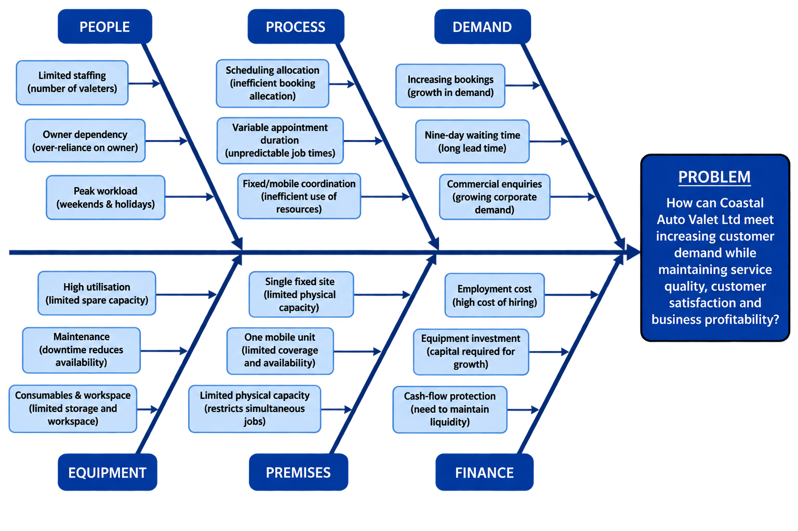

Table 3. Fishbone / Ishikawa, possibility causes.

The Fishbone analysis points towards a system-level capacity mismatch. In particular, people and process appear repeatedly across the evidence: the business has demand, but the current way in which labour, appointments and the owner’s time are organised limits the amount of demand that can be converted into completed work. So People and Process factors appear most directly linked to the visible symptom of a nine-day waiting time. This directed the 5 Whys analysis that followed.

2.3 Five Whys
The five whys analysis here investigates why CAV is experiencing a nine-day waiting time and heavy owner dependency, tracing the root cause from the surface symptom to the fundamental financial constraints.
Stage | Finding | Supporting evidence
Why | Question and answer | Evidence
1 | Why is operational capacity becoming insufficient? Demand is increasing faster than current appointment capacity. | Bookings rising; weekends full; waiting time ~9 days.
2 | Why can capacity not increase sufficiently? Existing staffing and resources are near their limits at peak periods. | Staff report higher workloads; peak capacity is constrained.
3 | Why are staffing/resources constrained? The operating model relies heavily on the existing team and Managing Director. | Owner covers operations, bookings, finance, marketing and customer service.
4 | Why has pressure increased? Demand and commercial opportunities have grown faster than the operating structure. | Commercial enquiries exceed current capacity; owner hours have increased.
5 | Why has the structure not adapted? The operating model was designed around an earlier level of demand. | The internal analysis concludes that the model now requires adaptation.
Table 4. Five Whys analysis.
By systematically pealing through the layers of people, process, and capacity, the analysis reveals that sustainable growth requires moving past temporary fixes—such as working longer hours—to invest in structured scheduling software, expanded physical premises, and strategic recruitment. Al-Rifai, (2025) reinforces this recent research by evaluating 5 Whys across 91 cases and found that many applications fail to establish a complete cause-and-effect sequence or properly validate any root causes. Which for some might be send them back to the beginning.

3. Propose Alternative Solutions to the Root Cause
Three realistic options were developed in direct response to the root cause identified above: each increases the number of people able to deliver chargeable work, though by different means and with different resource, cost and risk profiles.

Option | Description | Resources required | Main barriers / risks
A: Recruit an additional full-time valeter | Employ one experienced valeter to work alongside the owner across static and mobile jobs. | Recruitment advertising, wages, employer National Insurance, uniform/PPE, induction training. | Average UK cost per hire of roughly £6,125 (CIPD, as cited in Recruitment Robin, 2025); employer NI is now 15% above a £5,000 threshold (Xero, 2026); risk of a poor hiring decision or early turnover.
B: Formalise a working partnership, with the partner operating a second mobile unit | Bring an experienced colleague in as a co-owner/co-director. The owner continues to run the static site while the partner operates a second, mobile valeting unit, widening the geographic catchment beyond the current service radius and sharing a profit rather than paying a wage. | Solicitor-drafted partnership/shareholder agreement, Companies House filing, amended public liability and motor trade insurance, agreed profit-share formula, van livery/signage design and application. | Requires clear governance and an agreed exit mechanism; performance and relationship risk if expectations are not documented; British Business Bank (2025) confirms most start-up finance schemes will consider two co-founders, which supports this route.
C: Invest in equipment and extend operating hours | Add a second mobile equipment set and pressure-washing rig, extend weekend hours, and introduce route-optimising booking software. | Capital for a second equipment set, scheduling software licence, marketing of new hours. | Does not add a second skilled operator, so the ceiling on daily throughput remains close to current levels; Gantt-style planning literature notes equipment-led plans still depend on available labour to realise gains (Atlassian, 2026).
Table 3: Three alternative solutions to the identified root cause, with resources and risks.
Option A: offers the most direct response to a staff limitation expansion. Option B: addresses the idea of bringing in a second member that has a stake in the business also. This will bring its own hurdles to overcome. Option C: is the injection of funds into the company while extending the opening hours.

4. Evaluation and decision

4.1 Weighted decision matrix
A weighted grid (decision matrix) analysis was used to compare the three options because it allows several criteria of differing importance to be scored transparently and combined into a single, defensible ranking (Mindtools, 2026; Toolshero, 2026).
Criterion (weight) | A: Recruit valeter | B: Working partnership | C: Equipment & hours
Cost to owner (4) | 3(12) | 4(16) | 3(12)
Speed of implementation (3) | 3(9) | 4(12) | 2(6)
Capacity increase (5) | 4(20) | 5(25) | 2(10)
Risk (4) | 4(16) | 3(12) | 4(16)
Service quality / brand impact (4) | 4(16) | 4(16) | 3(12)
Reduction in owner dependency (5) | 3(15) | 5(25) | 1(5)
Weighted total (max 125) / average ( ♯ ) | 21 / (72) | 25 / (106) | 15 / (61)
Table 6. Weighted decision matrix. Score = 1 (poor) to 5 (strong); weighted score = score × overall weight

These results are taken and placed into a chart to give a visual reference for affirming.

Table 7. Weighted results chart.
As seen by both chart and matrix, the strongest option stands out as B, scoring the highest in both margins, Option A follows in close second as the next desirable outcome. Mindtools, (2026) documents, the limitations of these results are only seen from the owners understanding and rating of each option and to validate this decision further, an additional check will be made from the financial analysis results.

4.2 Cost-benefit analysis
A cost-benefit analysis was then applied to the strongest option B and the second strongest option A, to test whether the grid analysis ranking holds up financially, using current UK employment costs and the business's own trading and pricing data. The analysis is extended over a 3-year horizon, since the setup cost is one-off, but the annual benefit recurs, so a single-year view would understate the gap between the options A / B. Shown here is the balance for Option B, Option A can be found in (Table 9. 3-year cost-benefit comparison of Options A and B) in the appendix.
Cost item (Option B, owner's share) | Year 1 £ | Year 2 £ | Year 3 £ | Total £
Equipment for second mobile unit | 1,775 | – | – | 1,775
Van livery and signage | 500 | – | – | 500
Partnership agreement legal fees and Companies House filing | 475 | – | – | 475
Additional insurance and admin | 150 | 150 | 150 | 450
TOTAL COSTS | 2,900 | 150 | 150 | 3,200
Table 8. Costs for Option B over three years (owner's share, £).

The equipment, livery and legal costs are one-off and fall entirely in the first year, the insurance and admin cost is recurring and is repeated in every year it is paid.
Benefit item (Option B, owner's share) | Year 1 £ | Year 2 £ | Year 3 £ | Total £
Owner's share of incremental revenue from second mobile unit (50% of £60,840 a year) | 30,420 | 30,420 | 30,420 | 91,260
TOTAL BENEFITS | 30,420 | 30,420 | 30,420 | 91,260
Table 10. Benefits for Option B over three years (owner's share, £).
The benefit is modelled as flat across the three years, in line with the static, cautious revenue assumption used throughout the findings from the projections within the previous business plan.

4.3 Ratios
1. Benefit-to-cost ratio = Total benefits =
Total costs
Benefit-to-cost ratio = Total benefits ÷ Total costs = £91,260 ÷ £3,200 = 28.5 : 1
For every £1 the owner puts in, £28.50 comes back over the three years

2. Net annual benefit = annual benefit – annual cost
(First year) = --

Net annual benefit (first year) = Year 1 benefit − Year 1 cost = £30,420 − £2,900 = £27,520
Option B is cash-positive from day one, because the one-off costs (equipment, livery, legal fees) are small relative to the revenue the second unit brings in, and there's no salary to cover before benefits start showing.

3. Net annual benefit = total benefits – total costs =
3
Net annual benefit (total benefits − total costs, spread over the period) = (£91,260 − £3,200) ÷ 3 = £88,060 ÷ 3 = £29,353 per year
This is close to the Year 1 figure, which tells you the option B doesn't rely on benefits building up slowly.

Figure 11: Cumulative net benefit to the owner over a 3-year horizon
Over the three-year period, Option B will generate £91,260 in cumulative owner benefit compared with £35,330, seen by Option A. This means the working partnership generates approximately 2.58 times the cumulative benefit than recruiting a valeter, representing around 158% more benefit to the owners.

5. Detailed Plan for Implementing the Solution
 | Implementation Gantt chart – Option B (Working Partnership)
Partnership terms drafted and signed
Companies house updated
Insurance and liability cover amended
Profit-share and responsibilities agreed
Joint training
Second unit fitted out
New booking system for two operators
Marketing update
Working hours and brakes set
First formal review point
Second formal review point
Weeks from decision to implement | 2 | 4 | 6 | 8 | 10 | 12 | 14 | 16 | 18 | 20 | 22 | 24 | 26
Table 13. Implementation Gantt chart for option B (weeks from decision to full launch).
The Gantt chart has shown that if the first review date (12th week) show lack in capacity or quality targets are not being met. Bringing back the original operator module temporarily while the issue is resolved will avoid any commitment before performance is proven, and an additional review point can be added.

6. Communicate the Plan to Relevant Stakeholders
Keep Informed  Stakeholder power / Interest matrix (Mendelow) | Manage Closely  Commercial Fleet Clients  Existing Staff  Regular Retail Customers  Business Partner
Local Suppliers  Wider community  Monitor | Accountant / Solicitor  Water Company  Keep Satisfied

Daniel (Managing Director)

Power to influence the decision

Interest in the decision

Table 14. Mendelow’s Stakeholder power / Interest matrix

Any person who has the ability to affect or be affected with the business is a stakeholder, Mendelow, 1991, graph as cited in Toolshero, (2026). The stakeholders mention within this matrix are the persons who has influence even slightly, during this complex problem. Following the previous assessment results different methods are utilised for communication during the problem, a table was formulated to express these results placed in the appendix. (Table 15: Communication plan matched to stakeholder needs).

Conclusion
This report has traced a single decision from evidence to recommendation. From internal business facts and tribulations that has followed Coastal Auto Valeting was narrowed down to the challenge of meeting the growth of customer demand without compromising service quality in any form. From fishbone and the five why’s, offered relatable root causes. Following the results and workings out three realistic options were formulated, with further investigations towards each option through weighted data and support form cost benefit analysis helped narrow the search to the strongest option for the business to take. This brought the Gantt chart, stakeholder matrix and communication plan frameworks offering a partnership agreement as the best choice. This option offers Coastal Auto Valet the fastest, lowest risk route to solving the complex problem, as it meets demand while reducing owner dependency while protecting the service quality the brand upholds, with overall customer satisfaction and profitability increase.

Appendix
Measure | Option A: Recruit valeter | Option B: Working partnership
Estimated capacity increase | +15 vehicles/week (to 45) | +18 vehicles/week (to 48)
One-off setup cost (Year 1 only) | £3,550 (recruitment, PPE, training, equipment) | £3,525 (owner's half-share of shared equipment and van livery/signage, plus solicitor and Companies House costs)
Annual recurring cost (Years 1-3) | £33,740 (salary, 15% employer NI, pension, holiday pay) (Xero, 2026) | ≈£300 (additional insurance and admin only — no wage, as the partner draws a profit share, not a salary)
Estimated additional annual revenue (Years 1-3) | £50,700 | £60,840
Net benefit to owner — Year 1 (after setup cost) | £9,410 | £30,420
Net benefit to owner — Year 2 | £12,960 | £30,420
Net benefit to owner — Year 3 | £12,960 | £30,420
Cumulative net benefit over 3 years | £35,330 | £91,260
3-year ROI (cumulative net benefit ÷ setup cost) | ≈995% | ≈2,482%
Estimated payback period | ≈3.3 months | ≈1.4 months
Table 9. 3-year cost-benefit comparison of Options A and B
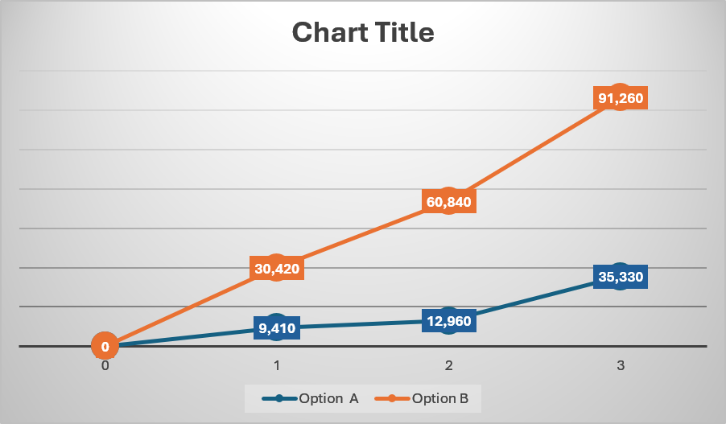
Figure 12: Comparison net benefit over a 3-year horizon

Stakeholder / purpose | Method | Timing | Owner | Evidence
Partner, agree terms | Face-to-face meetings, solicitor correspondence | Weeks 1-3 | Owner | Signed agreement
Staff, role changes | Team briefing | Week 4 | Owner | Briefing notes, sign-off
Commercial clients, continuity | Direct phone call/email | Week 8 | Owner/partner | Client correspondence log
Retail customers, reduced waits | Website update, booking-system message, social media | Week 9 | Partner | Published update, booking data
Insurer/water company, compliance | Formal written notification | Weeks 3-5 | Owner | Confirmation letters
Table 15: Communication plan matched to stakeholder needs.

References

AutoTidy. (2026). 15 UK car wash statistics every mobile valeter should know. https://autotidy.co.uk/mobile-valet-car-wash-statistics/

Atlassian. (2026). What is a Gantt chart? Features & benefits with free template. Atlassian. https://www.atlassian.com/agile/project-management/gantt-chart

British Business Bank. (2025). SME intermediary survey 2024. https://www.british-business-bank.co.uk/about/research-and-publications/small-business-finance-markets-report-2025/sme-intermediary-research-uk-findings

Carvalho, R., Lobo, M., Oliveira, M., Oliveira, A. R., Lopes, F., Souza, J., Ramalho, A., Viana, J., Alonso, V., Caballero, I., Santos, J. V., & Freitas, A. (2021). Analysis of root causes of problems affecting the quality of hospital administrative data: A systematic review and Ishikawa diagram. International Journal of Medical Informatics, 156, 104584. https://doi.org/10.1016/j.ijmedinf.2021.104584

CAV. (2025). Business plan: Coastal Auto Valet Ltd [Unpublished business plan].

Castle Water. (2025). Trade effluent and wastewater for car washes. https://www.castlewater.co.uk/blog/trade-effluent-and-wastewater-treatments-for-car-washes-and-motor-vehicle-detailing

CIPD. (2025a). CIPD Good Work Index 2025: Survey report. https://www.cipd.org/globalassets/media/knowledge/knowledge-hub/reports/2025-pdfs/8868-good-work-index-2025-report-web1.pdf

Department for Transport. (2026). Vehicle licensing statistics, United Kingdom: 2025. GOV.UK. https://www.gov.uk/government/statistics/vehicle-licensing-statistics-2025/vehicle-licensing-statistics-united-kingdom-2025

Dörner, D., & Funke, J. (2017). Complex problem solving: What it is and what it is not. Frontiers in Psychology, 8, Article 1153. https://doi.org/10.3389/fpsyg.2017.01153

House of Commons Environmental Audit Committee. (2026). Hand car washes. UK Parliament. https://publications.parliament.uk/pa/cm201719/cmselect/cmenvaud/981/98105.htm

IBISWorld. (2024). Car wash & motor vehicle detailing in the UK — market size. https://www.ibisworld.com/united-kingdom/market-size/car-wash-motor-vehicle-detailing/5062/
Mindtools. (2026). Decision matrix analysis. https://www.mindtools.com/aksic2i/decision-matrix-analysis/

Recruitment Robin. (2025). The true cost of hiring in 2025: What every employer needs to know. https://recruitmentrobin.com/the-true-cost-of-hiring-in-2025-what-every-employer-needs-to-know/

SMMT. (2024). Motor industry facts 2024. https://www.smmt.co.uk/wp-content/uploads/SMMT-Facts-2024-smaller-size.pdf

Toolshero. (2026). Mendelow matrix, a stakeholder analysis explained. https://www.toolshero.com/strategy/mendelow-matrix/

Welsh Government. (2025). Road traffic: 2024. https://www.gov.wales/road-traffic-2024-html

Xero. (2026). UK National Insurance contributions for businesses. https://www.xero.com/uk/guides/what-is-national-insurance/

