BA International Hotel Management

Food & Beverage Operations

BMIH4002

Student Name: Adrian Marian Oprea
Student ID: 1714749

Assignment 2 Menu Engineering (Practical Task)
Contents

Part-1: Brief Writing 3
Part-2: Menu 5
References 7

Part-1: Brief Writing
The Trinity Hotel's "The Crown and Sceptre" lives up to its 4* city centre reputation with a menu that captures the spirit of classic British cuisine (Walker, 2014). The restaurant's concept was developed with the specific goal of satisfying "discerning locals, tourists, and business travellers" (Spang and Gopnik, 2019) who are interested in enjoying traditional British cuisine in a relaxing and sophisticated atmosphere.
Menu design (Filimonau et al., 2017; Ozdemir and Caliskan, 2015), calorie labelling (Long et al., 2015), and digital food logging (Beijbom et al., 2015) were just some of the studies that informed the construction of the menu. In addition, the menu was heavily influenced by studies looking at the role of aesthetics in influencing customers' perceptions (Magnini and Kim, 2016) and the factors that influence word-of-mouth marketing for restaurants (Jalilvand et al., 2017).
According to the findings of the study, the food and drink items on the menu are an intelligent mix of classic British fare with cutting-edge culinary techniques. This can be seen in both the meal and the drink. Roasted Norfolk Chicken and Fish and Chips are two dishes that are considered to be examples of traditional British cuisine. On the other hand, dishes such as Vegan Shepherd's Pie and Wild Mushroom and Truffle Risotto illustrate the growing demand for plant-based cuisines (Ozdemir and Caliskan, 2015). Alternatives that are suitable for vegetarians, those who avoid gluten, and those who cannot consume lactose were also provided (Bleich, Wolfson, and Jarlenski, 2015; Vanepps et al., 2016). This was done to satisfy the expanding number of individuals who have certain dietary requirements.
When developing the pricing strategy, we took into account both the existing market environment as well as the demographics of the customers we want to attract (Walker, 2014). According to Magnini and Kim (2016), the visual design of the menu is in line with the core principles of the company, and it is straightforward and easy to grasp.
In conclusion, the menu focuses an emphasis on foods that are sustainably obtained and seasonal, in accordance with the existing environmental standards and laws (Filimonau et al., 2017). This is in response to the increased awareness of environmental concerns. Last but not least, the cuisine served at the Crown and Sceptre is an exquisite example of how history and creativity can be harmoniously combined. It was conceived with the intention of providing guests with an authentically British dining experience that adheres to modern expectations.

Part-2: Menu
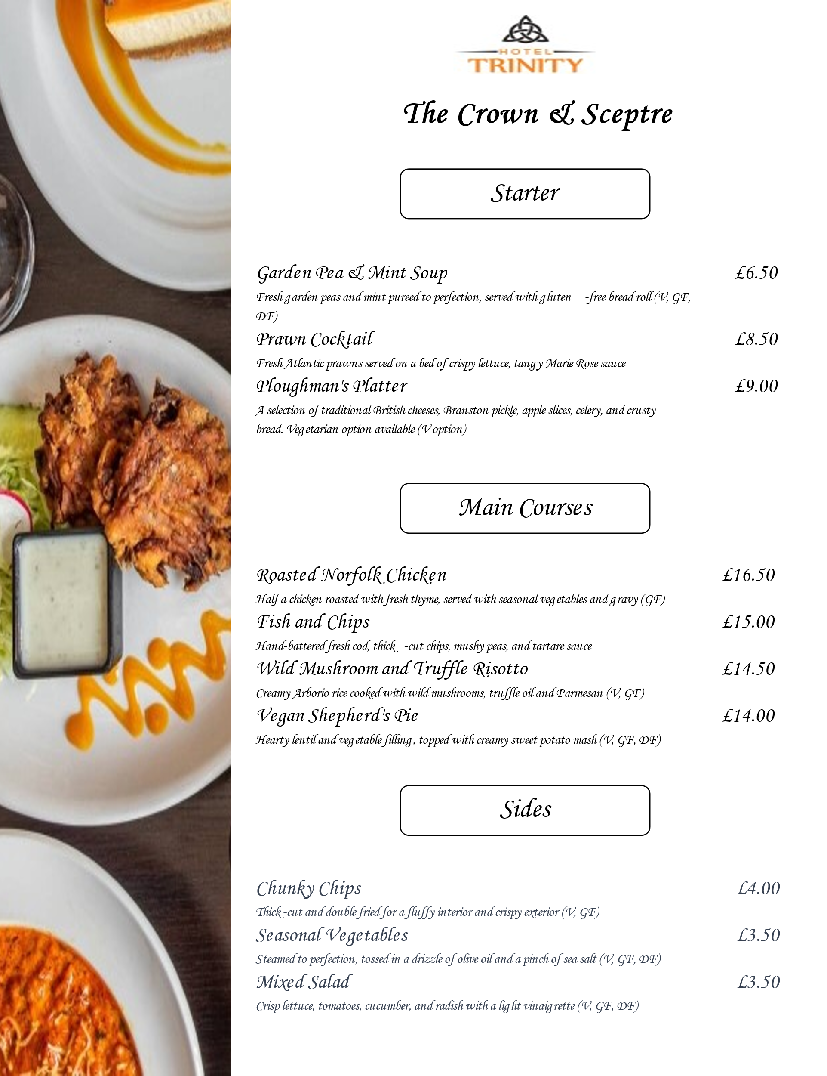
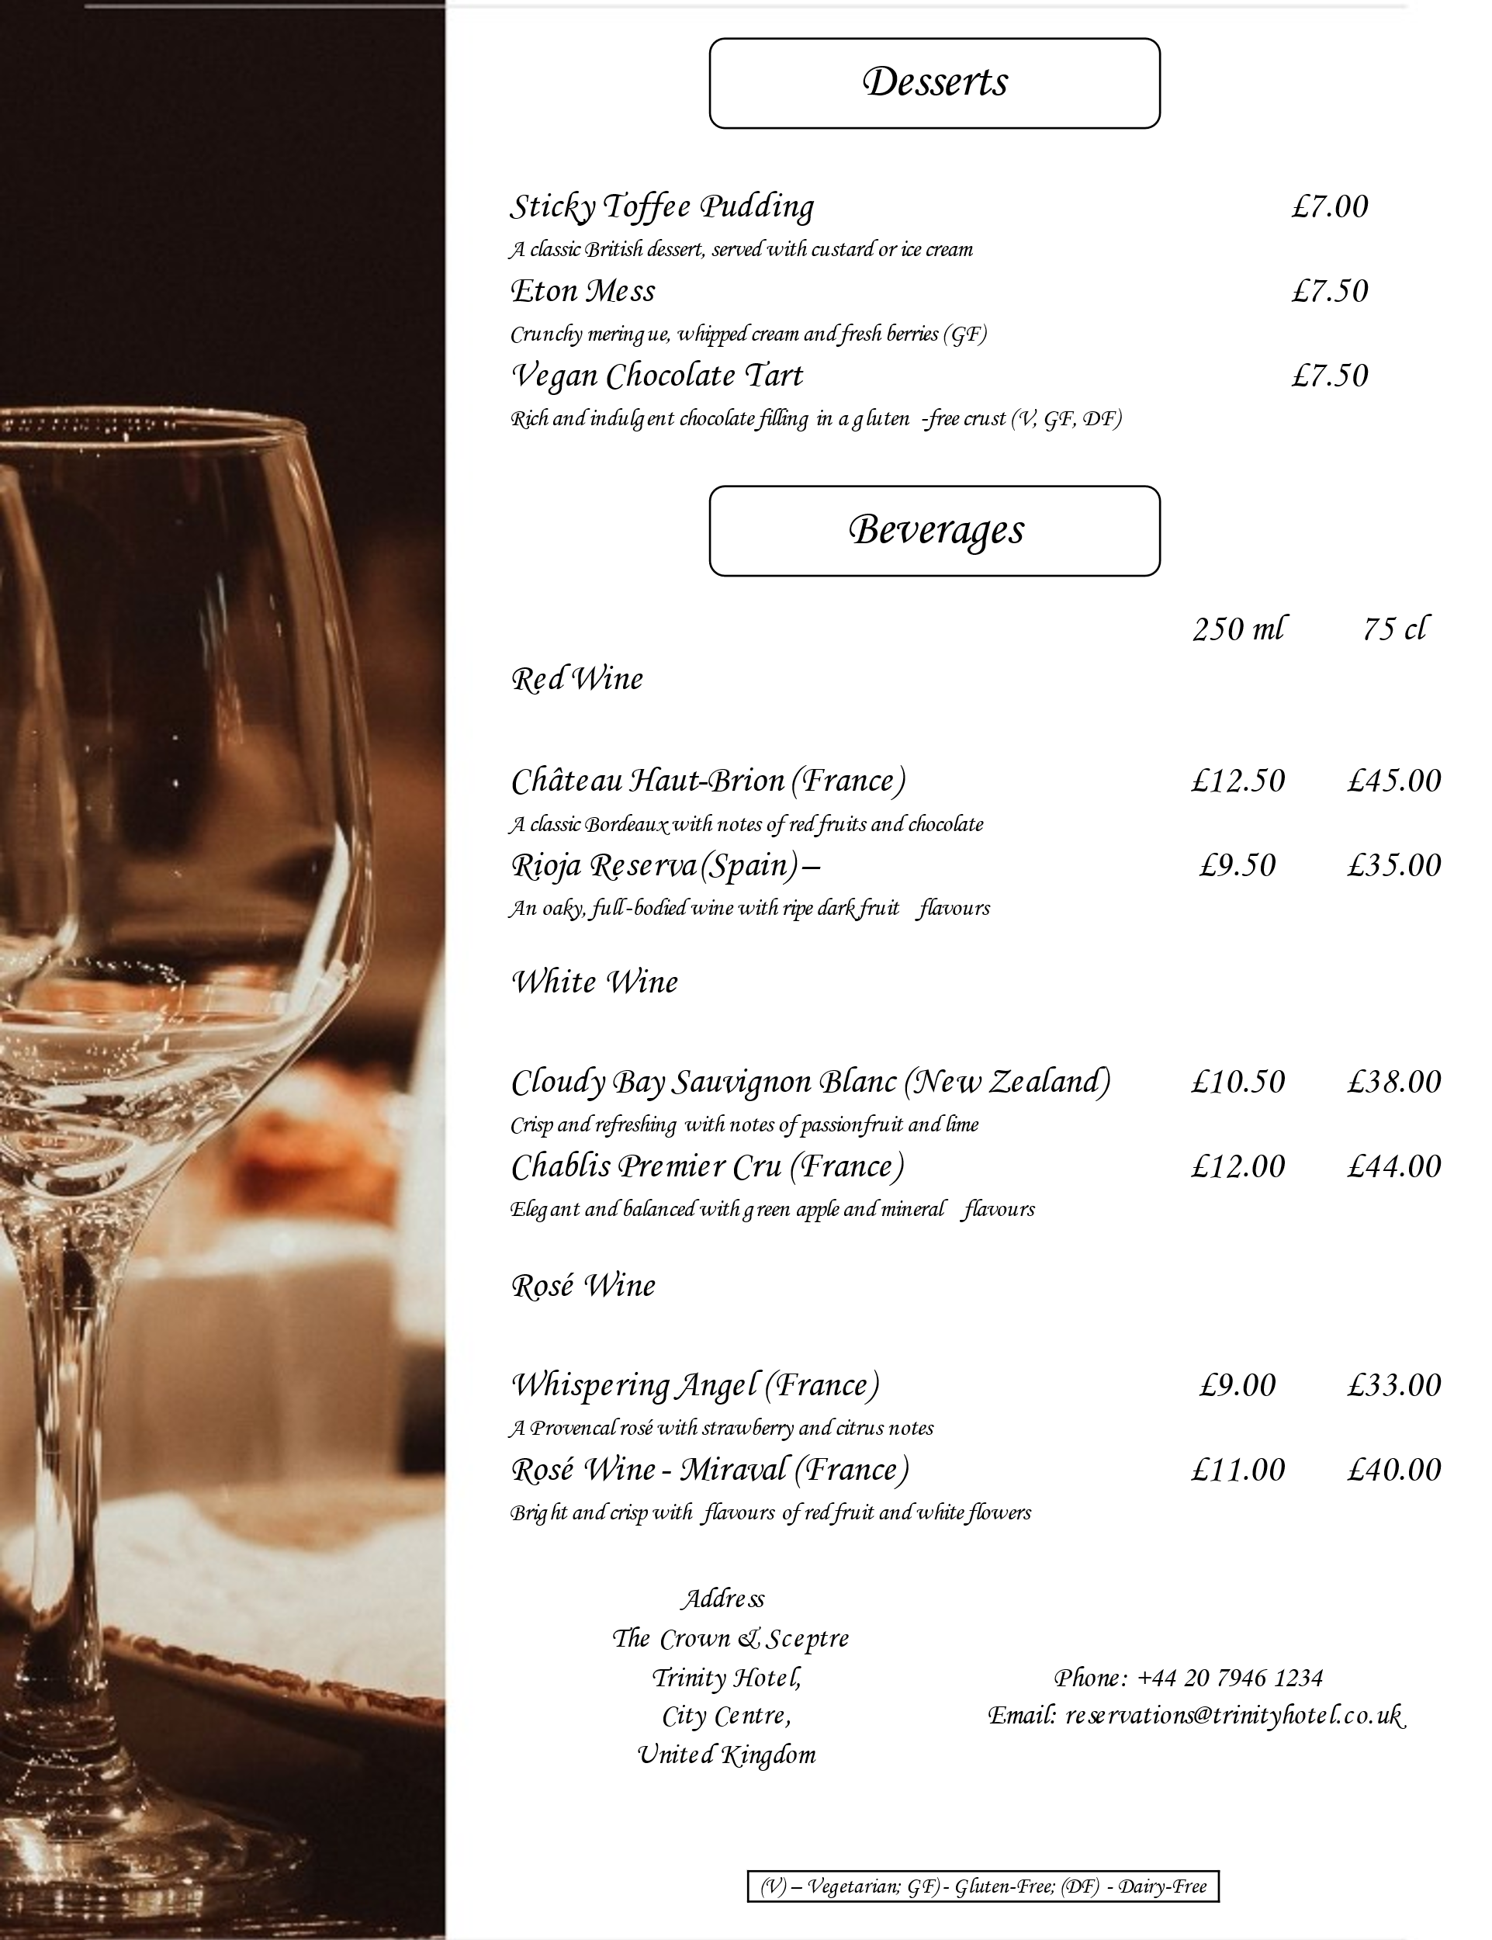

References
Beijbom, O. et al. (2015) ‘Menu-match: Restaurant-specific food logging from images’, in 2015 IEEE Winter Conference on Applications of Computer Vision. IEEE, pp. 844–851.
Bleich, S. N., Wolfson, J. A. and Jarlenski, M. P. (2015) ‘Calorie changes in chain restaurant menu items: implications for obesity and evaluations of menu labeling’, American journal of preventive medicine, 48(1), pp. 70–75.
Filimonau, V. et al. (2017) ‘Nudging’as an architect of more responsible consumer choice in food service provision: The role of restaurant menu design’, Journal of cleaner production, 144, pp. 161–170.
Jalilvand, M. R. et al. (2017) ‘Factors influencing word of mouth behaviour in the restaurant industry’, Marketing Intelligence & Planning, 35(1), pp. 81–110.
Long, M. W. et al. (2015) ‘Systematic review and meta-analysis of the impact of restaurant menu calorie labeling’, American journal of public health, 105(5), pp. e11–e24.
Magnini, V. P. and Kim, S. (2016) ‘The influences of restaurant menu font style, background color, and physical weight on consumers’ perceptions’, International Journal of Hospitality Management, 53, pp. 42–48.
Ozdemir, B. and Caliskan, O. (2015) ‘Menu design: A review of literature’, Journal of Foodservice Business Research, 18(3), pp. 189–206.
Spang, R. L. and Gopnik, A. (2019) The Invention of the Restaurant-Paris and Modern Gastronomic Culture, with a New Preface. Harvard University Press.
Vanepps, E. M. et al. (2016) ‘Restaurant menu labeling policy: review of evidence and controversies’, Current obesity reports, 5, pp. 72–80.
Walker, J. R. (2014) The restaurant: From concept to operation. 7th edn. Nashville, TN, USA: John Wiley & Sons.

