Student Name: Dominic Adam
Student ID Number: 2509010
Assignment Title: Component 2 – Business Improvement Report for Basil’s Bakery
Module Name: Problem Solving and Decision Making
Module Code: LCLM4004
Submission Date: 31st July 2026

1. CASE STUDY OVERVIEW

Basil’s Bakery is an independent artisanal business located in a Coventry retail park, founded in 2015. It specializes in high-quality organic cakes, pastries, and breads, serving local shoppers, retail staff, and nearby industrial and office workers. Sales grew year-on-year until 2019 but fell sharply during the 2020 COVID-19 lockdowns. Although footfall recovered after restrictions ended, sales have stagnated at an average of 25% below 2019 levels since 2023.

Key challenges include fewer visitors to the retail park, widespread hybrid working reducing daily lunchtime visits, unmet customer requests for pre-order and delivery services, rising overhead costs, and unpredictable pricing and supply of organic ingredients. The business is no longer workable in its current form, so targeted changes are needed.

Source: LCLM4004 Component 2 Case Study (2026)
2. PROPOSED SOLUTIONS

Solution 1: Launch Online Pre-Order & Local Delivery Service

This solution introduces a simple online ordering system via social media or low-cost tools like Square Online, plus optional local delivery through a third-party courier or app. Customers can pre-order items for collection or delivery, cutting wait times and reaching people who now work from home. Basil can manage orders between baking tasks, and delivery fees are passed directly to customers. This directly addresses unmet demand for convenience and expands sales beyond the retail park.

Solution 2: Diversify Product Range & Supply Chain

This solution adds more affordable staple lines alongside premium organic products, while sourcing some ingredients from UK suppliers with more stable pricing and supply. It also offers bulk packs for local businesses. This reduces reliance on volatile organic crop yields, appeals to price-sensitive customers, and smooths out ingredient costs. It responds to both rising expenses and shifting spending habits.
3. SOLUTION EVALUATION & SELECTION

3a. PMI ANALYSIS

Solution 1: Pre-Order & Delivery

• Plus, points: Reaches lost customers working remotely; directly meets requests for convenience; low setup cost; fast to launch; keeps focus on core baking strengths.

• Minus points: Adds lesser amounts of admin time; app delivery services charge 20–30% commission; limited control over delivery speed.

• Interesting points: Can start with pre-order only (no delivery needed at first); works perfectly with existing popular products.

Solution 2: Product & Supply Diversification

• Plus, points: Stabilizes ingredient costs; attracts new budget customers; less dependent on retail park footfall; reduces supply chain risk.

• Minus points: Needs new recipes, testing, and supplier checks; may weaken the “premium organic” brand identity; takes longer to see results.

• Interesting points: Can keep organic lines as the core offering; opens up bulk sales to local businesses.

3b. PREFERRED SOLUTION

Preferred Solution: Solution 1 – Online Pre-Order & Local Delivery
This choice is the most effective because it tackles the biggest root causes directly: lost customers from hybrid working, unmet convenience needs, and poor service experience. It requires far less risk or upfront work than changing products or suppliers and can start generating extra sales within 4–6 weeks. It also lets Basil stay focused on baking, rather than fundamentally changing his business model. Solution 2 could be considered later once the ordering service is running well.
4. IMPLEMENTATION PLAN

4a. PLAN DETAILS

Weeks 1–2: Research ordering tools; contact 2 local delivery partners; ask loyal customers what they want.
Responsibility: Basil

Weeks 3–4: Set up pre-order system; list top 10 products; test with 5 regular customers; set delivery charges.
Responsibility: Basil + volunteer helper

Weeks 5–8: Launch service via in-store posters, social media, and emails to local offices; collect weekly feedback.
Responsibility: Basil + delivery partner

Weeks 9–12: Review order data; add latest items; train one part-time helper to manage phones and orders.
Responsibility: Basil + part-time staff

4b. RATIONALE

This phased approach keeps things simple and low risk: testing first avoids costly mistakes, while delaying delivery lets Basil build confidence without extra pressure. Training extra staff later prevents the problem of being too busy baking to answer enquiries. Short timelines mean the business sees results quickly, rather than waiting months for changes.
5. PERFORMANCE MEASUREMENT

5a. KPI & SMART OBJECTIVES

Key Performance Indicator: Total monthly sales revenue (target: return to within 10% of 2019 levels within 12 months).

SMART Objectives:

1. Specific: Achieve 15+ pre-order or delivery orders every week by the end of Month 3.

2. Measurable: Track orders and revenue via the online system; compare to 2023–2025 averages.

3. Achievable: Based on 12+ customer requests already received, plus access to 200+ local office workers.

4. Relevant: Directly addresses lost customers and unmet demand for convenience.

5. Time-bound: Increase monthly revenue by 15% within 6 months; match 2019 sales levels within 12 months.

5b. MONITORING & EVALUATION

Every month, compare sales figures to the KPI, and check what share of orders come from new versus returning customers. Collect short feedback on ordering ease and wait times with every order. If orders are low, run a pre-order discount; if delivery costs put people off, focus on click-and-collect first. After 12 months, review whether the service has stabilized sales, and decide if extra features like bulk ordering are needed. This lets you fix problems early and avoid wasted effort.
6. KEY FINDINGS SUMMARY

• Sales stagnation comes from both external shifts (hybrid working, retail decline) and internal gaps (no convenient ordering options).

• Pre-order and delivery are the fastest, lowest-risk way to reach lost customers and boost revenue.

• Phased planning and clear roles keep implementation simple and manageable.

• Product or supply changes could be considered later once the ordering service is proved.
7. REFERENCE LIST

1. LCLM4004 Module Team. (2026). Problem Solving and Decision-Making Component 2 Case Study. University of Wales Trinity Saint David.

2. Business Gateway. (2025). Online Ordering and Delivery for Small Food Businesses. https://www.businessgateway.co.uk

3. MindTools. (2026). PMI Analysis for Decision Making. https://www.mindtools.com

4. Office for National Statistics. (2026). Home Working Trends in the West Midlands. https://www.ons.gov.uk

5. Square. (2026). Low-Cost E-Commerce Tools for Independent Retailers. https://squareup.com/uk
8. APPENDIX: PMI ANALYSIS TABLE
Factor Solution 1: Pre-Order & Delivery Solution 2: Product & Supply Diversification
Plus Reaches remote customers; meets stated demand; low setup cost; fast results Stabilizes costs; attracts new buyers; reduces supply risk
Minus Small admin work; app fees; limited delivery control Needs testing; brand risk; slower results
Interesting Can start with pre-order only; uses existing products Keeps organic lines as core; opens bulk sales
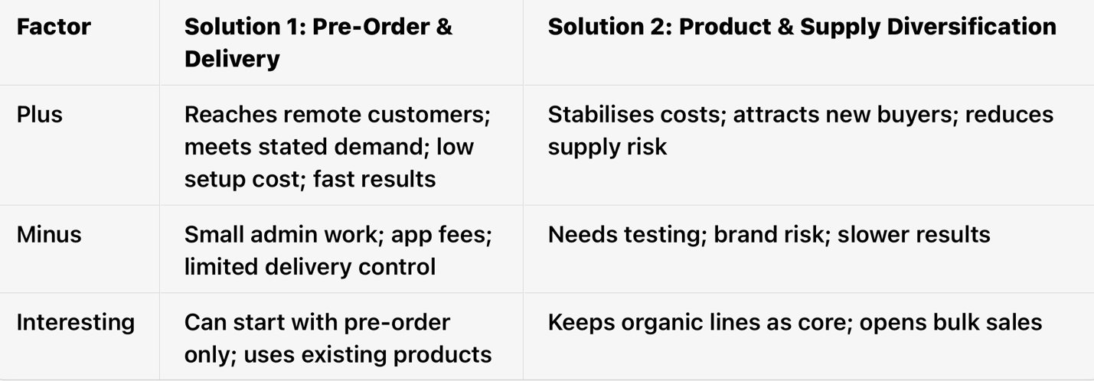
8.APPENDIX: PMI ANALYSIS TABLE

