Hotel Handbook

Student Name: Angela Roxana Faina
Student number: 2108333
Module Title: Foreign Languages and Cultural Awareness BMIH5003
Tutor: Rodrigo Aguilera

Executive summary
In this report, a Hotel Handbook for United Kingdom staff to help manage guest service experiences for the South Korean international visitor has been carried out. Specifically, in terms of international visitors, the staff must focus and comprehend the culture, customs and behavior of the guests in order to deliver quality service delivery. The cultural differences, customs, and behavior of South Korea and United Kingdom is highly distinct which needs to be well considered by the staff for managing guest service experiences for the international visitors
Table of Contents
Executive summary 1
Introduction 4
Key cultural differences, customs and behaviour that must be followed for international visitors with regards to South Korea 4
Do’s and don’ts for the South Korean hotel staff 6
Summary 7
Recommendations 7
References 8

Introduction
Within the hotel industry, it is imperative for staff to deliver quality guest service experiences for increasing brand awareness of the hotel brand as well as to increase client base. Based on such context, in this hotel handbook, the key cultural differences, customs, and behavior between South Korea and United Kingdom has been carried out for assisting the hotel staff to manage guest service experiences. In addition, a list of “Do’s and Don’ts” for the hotel staff has been further included along with two justified recommendations.

Key cultural differences, customs and behavior that must be followed for international visitors with regards to South Korea
In order to assess the key cultural differences, customs and behavior to help manage guest service experience at United Kingdom, the use of Hofstede’s cultural dimension has been carried out for the staff to offer quality services to the South Korean visitors.
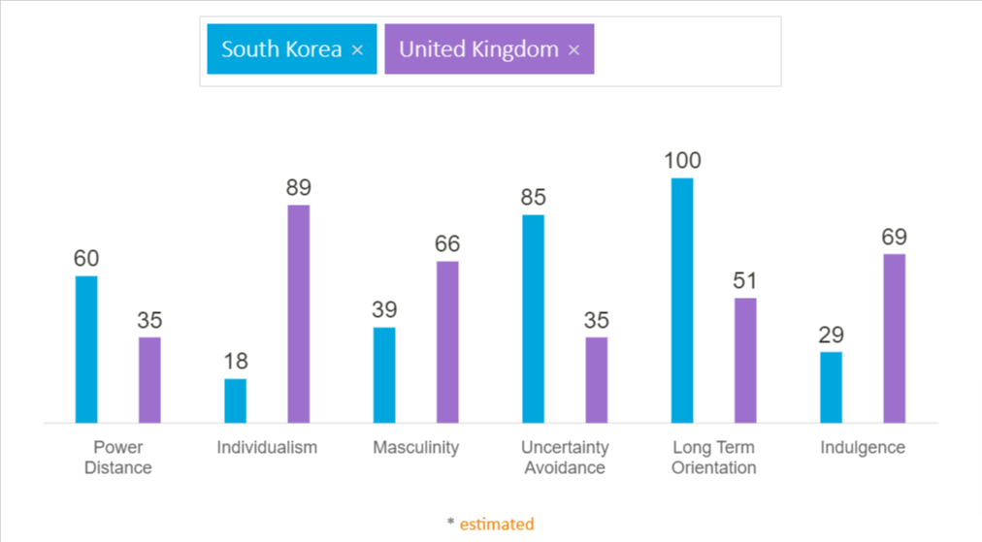
Fig: 1 (Key cultural differences, customs and behavior between South Korea and United Kingdom)
Source: (Hofstede-insights.com, 2023)
The above figure explicitly highlights the key cultural differences, customers and behavior between South Korea and United Kingdom that must be well comprehended by the staff of United Kingdom to help manage guest service experiences in the UK. In terms of power distance, South Korea’s culture, customs and behavior are dominated by hierarchy, inherent inequalities and centralization whereas the customs and behavior of Britishers are based on a sense of fair play where people must be treated equally. On the other hand, based on individualism, the Britishers are highly private and individualist people where personal fulfillment is the belief for happiness whereas the people of South Korea have a collectivist culture where customs and traditions are valued at both personal and professional life.
Other than that, with regards to masculinity, South Korea has a feminine society where workers strive for consensus, quality and solidarity in their working lives. Their behavior and customs are based on compromise and negotiation where flexibility and free time are favored. However, United Kingdom is a masculine society where the behavior and customers are driven by success. Additionally, in British culture, the need to read between the lines is essential, (Irwin, 2020).
In terms of uncertainty avoidance, there are not too many rules or customers in British society but the one’s that must be adhered should be well considered. They are highly flexible to changing and emerging environment. Their behavior reflects strong need for innovation which is well integrated in their deep-rooted culture. On the contrary, South Koreans exhibit high uncertainty avoidance culture. Their customs are followed by rigid codes of belief and behavior and in this culture the emotional need for rules is highly appreciated.
Based on long-term orientation, the customs and behavior of South Korean society is guided by practical examples and virtues. It is one of the most pragmatic culture where the focus on benefiting the society and stakeholders are imperative than company’s profitability. On the other hand, the culture, customs and behavior of UK’s society, the dominant preference in British culture cannot be established with an intermediate score of 51 in this dimension. However, Weinberg (2022) argued that the culture and customs of Britishers highly signifies monetary value, and they work for living.
Lastly, with regards to indulgence, the culture behavior, and customs of British exhibit a willingness to realise their desires and impulses to have fun and enjoy in their life. Their importance on leisure time and spending money as they wish is primitive. However, in the South Korean culture, their customs and traditions are relatively distinct and do not put much focus on leisure time and the retrained by social norms, (Masuda et al. 2020).

Do’s and don’ts for the South Korean hotel staff
Do’s | Don’ts
Treat every guest with equal respect and use both hands when you take or hand something back to them. | Don’t make direct eye contact with the guest.
Value the private life of guests and make a bow when you greet them. | Do not use red ink to write the guest’s name.
Ask for details and offer assistance whenever they require for eliminating confusion. | Presume your own thoughts and understanding on the guests.
Use as much as you can polite pronouns. | Please avoid using number 4, in their culture its bad luck.
Place an extra pair of slippers in the bathroom in the guest room. | Maintain a respectful distance with the guests avoid touching them.
Engage and suggest guests with fun and entertaining activities that can add value to the organization. | Don’t use first name to call them please use Family name.
Value and respect their culture and belief systems for enhancing brand loyalty and quality services, (Onder and Nyadera, 2020). | Judge them based on your behavior, customs and culture.

Summary
In conclusion, it can be stated that the cultural differences, customs, and behavior of South Korea and United Kingdom is highly distinct which needs to be well considered by the staff for managing guest service experiences for the international visitors. Additionally, the need to comprehend the different dimensions are further essential for successfully carrying out their job role and responsibilities while enhance guest’s experiences at an elevated level.

Recommendations
The first recommendation to the staff of United Kingdom is to comprehend the end-to-end guest journey by appreciating their culture, customs, beliefs, and behaviors. This means that the need to create first impressions during their visit is vital while maintaining such rapport in the entire guest stay is also vital for enhancing guest service experience.
The second recommendation is to gather guest feedback. As serving international guests is challenging due to differences in culture customs, and behavior, it is vital to seek feedback from guests for assessing their needs expectations, and experiences during their visit, (Schirmbeck et al. 2020). This in turn can assist the hotel staff to enhance their competencies and capabilities for offering elevated services to future guests.

References
Hofstede-insights.com. (2023) Country comparison. Hofstede Insights. Available at: https://www.hofstede-insights.com/country-comparison/south-korea,the-uk/ (Accessed: March 6, 2023).
Irwin, H., 2020. Communicating with Asia: Understanding people and customs. Routledge.
Masuda, T., Batdorj, B. and Senzaki, S., 2020. Culture and attention: Future directions to expand research beyond the geographical regions of WEIRD cultures. Frontiers in Psychology, 11, p.1394.
Onder, M. and Nyadera, I.N., 2020. The role of non-economic drivers in development planning: The case of South Korea and Turkey. International Journal of Public Administration, 43(4), pp.283-293.
Schirmbeck, K., Rao, N. and Maehler, C., 2020. Similarities and differences across countries in the development of executive functions in children: A systematic review. Infant and Child Development, 29(1), p.e2164.
Weinberg, J., 2022. Can political trust help to explain elite policy support and public behaviour in times of crisis? Evidence from the United Kingdom at the height of the 2020 coronavirus pandemic. Political Studies, 70(3), pp.655-679.

