Portfolio of Writing
Student Name: Jc Stephen Andrada
Student Number: 1650017
Programme of Study: BA Graphic Design
Module: ADAD4018 Ways of Thinking
Tutor: Martin Bush

Task One: Semiotic Analysis = 531 words
Task Two: Manifesto = 538 words
Task Three: Practice-based writing = 531 words
Task 1: Semiotic Analysis
The modern age we know of today that contains such a vast array of media. More than the world has ever seen since the term came to be used as a general phrase to describe the varied ways of communication. This of course refers to not only the traditional print media but also art, radio, television and the digital to mention some. The purpose of this first task is to analyse the underlying meanings of one specific form of transmission, being an image, as well as delving slightly deeper into the ideas that semiotics presents.
One of the important parts of semiology that we all must understand is that the social aspect is integral when assigning meaning to things that we see. May Wong’s Multimodal Communication states that ‘visual imagery has been heralded as a major mode of communication’ since long ago. The signs that we see in front of us and the mental concepts that arise in our minds are simply a direct continuation of what those before us were doing ‘ever since the turn of the millennium’ and that can be considered a language of its own, albeit conducted in a different manner compared to verbal communication. Wong also proposes that there is ‘motivation’ and meaning between the signifier and the signified, that is in no way ‘arbitrary’ but is instead influenced by the societal context it is viewed in.
In a similar manner, John Berger in Ways of Seeing asserts that ‘the way we see things is affected by what we know or what we believe’ (2003). Much like how the symbol of the Caduceus now is heavily associated with medicine, when in ancient Greek mythology, it just referred to the Greek God Hermes. Over time this meaning changed drastically due to the role the symbol played in society and as times changed, so did people’s perceptions of it.
Continuing the idea of semiotics almost being like a language in and of itself, that could be likened to having as much significance as literature, we can turn to Umberto Eco’s A Theory of Semiotics (1976). Eco puts forward his view of how ‘signs’ are produced, that in order for signs to come to fruition, one must exert ‘physical stress’ equivalent to labour, which he described as ‘uttering’. To ‘utter’ or in contemporary terms, to produce a form of media is essentially the same as a person speaking verbally, utilising the body to communicate.
In 2017, F.A.T.H (Argentinian Foundation of Liver Transplant) helped raise awareness of organ donations in the weeks coming up to the celebration of National Organ Donation Day. Contemporary depictions of organ transplants are typically heartfelt and somewhat light, however the image in the analysis presents a bag of ‘trash’ cleverly constructed to appear in the shape of a human heart. As Wong states in Multimodal Communication (2019) the imagery shown has a purpose ‘motivated’ by the thought that nothing should be wasted, even when it comes to human life. The artist behind the image made sure to ‘take into account’ the audience’s perceptions of humanity, to paint a grotesque picture of an otherwise natural death, depicting it as ‘trash’, urging others to ‘stop wasting life.’
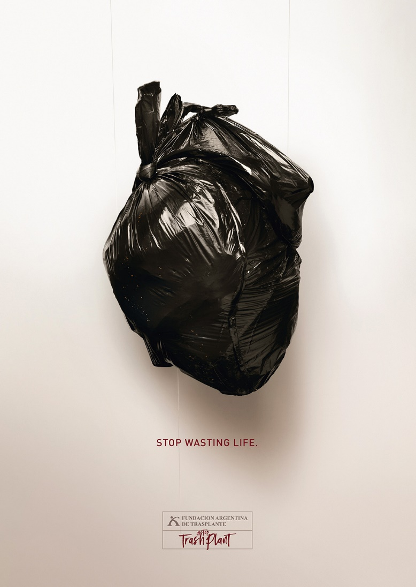
Bibliography
Figure 1: Stop Wasting Life, FATH, 2017
- Berger, J., 2003. Ways of seeing. s.l.:Penguin.
- Eco, U., 1976. A Theory of Semiotics. s.l.:Indiana University Press.
- Wong, M., 2019. Multimodal Communication : A Social Semiotic Approach to Text and Image in Print and Digital Media. s.l.:Springer International Publishing AG.

Figures:
Figure 1: Stop Wasting Life, FATH Advertising Campaign, 2017 Accessed: https://campaignsoftheworld.com/print/stoptrashplant-campaign-to-empower-people-become-organ-donor/ (Accessed on 4th November, 2021)

Task 2: Manifesto
Art:
- Inspiration can take time.
- Experiencing different kinds of art and media are key to growing as both an artist and designer.
- Creativity is not limited to the few, but rather it exists in all of us in some form.
- Artistic success does not necessarily depend or rely on numbers.
- There is no ‘wrong’. If it affected somebody in a meaningful and significant way then it is art, nothing more, nothing less.
- You are not a failure if you find yourself unable to produce something the moment you are instructed to.
- Commercialised art still counts as art, even if it is not to your liking.
- It is okay to imitate, there is value in being able to imitate other artists and it shouldn’t be underestimated or disregarded.

Manifesto focus 1:
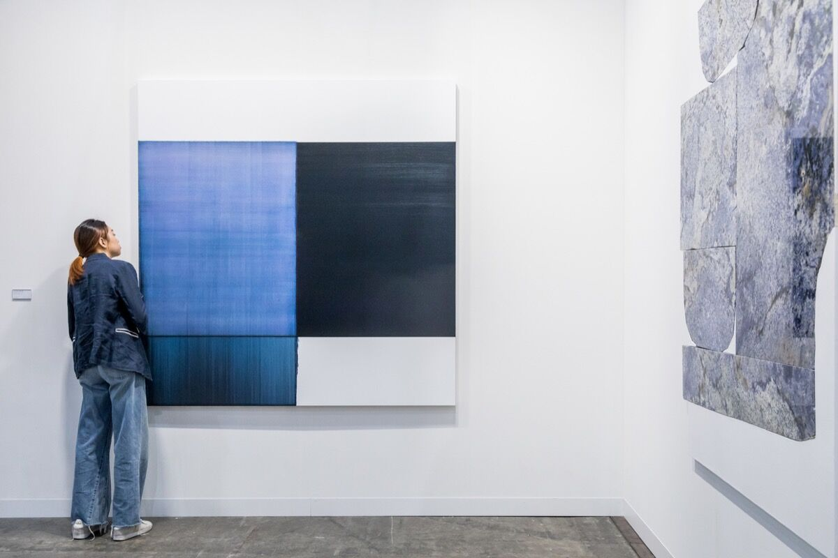
There is no ‘wrong’. If it affects somebody in a meaningful and significant way then it is art, nothing more, nothing less.
Figure 1 Installation view of Sean Kelly’s booth at Art Basel in Hong Kong, 2018. © Art Basel.
The general public have their own understanding of most things, whether it be music, illustration, movies and television. Most people have their own opinions regarding such media, however with the advent of technology and the recent explosion that is the various social platforms available today, said opinions that would normally be non-issues have become overbearing over the past decade. Anonymous faces on the internet behind countless screens became the vocal minority and impose their opinions on others as facts. This has led to the growing confidence in people to simply start declaring on their own terms, what art is and what it isn’t according to their beliefs. In the Theories of Art Today (Danto & Bailey, 2000), it states ten individual characteristics that a piece of ‘art’ must have before it can be considered one. However, the last ‘property’ in the list of ten, states that it must be ‘the product of an intention to make a work of art.’ It can be argued that if the maker of the ‘art’ in question intended it to be so, then it simply is.

Manifesto focus 2:
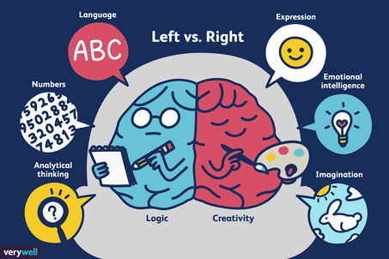
Creativity is not limited to the few, but rather it exists in all of us in some form.
Figure 2 Illustration by Joshua Seong. Verywell, 2017
An effort must be made to dispel ‘the creativity myth’ as referenced in David Kelley’s Creative confidence: unleashing the creative (Kelley, 2013). ‘You may equate “creative” with “artistic”’, however as Kelley elaborates, it is not just a personal quality that exists only in musicians, dancers, or painters, but one should look to scientists and lawyers as an example. Such professions require the usage of their imaginations to their utmost ability just as much as an ‘artistic’ individual would in this ‘myth’ that has been endlessly perpetuated. To think otherwise is the same as limiting one another by restricting oneself to this mindset. The basis of progress and innovation in humanity relies on the creativity of the mind, so it is important to educate current and future generations of their potentials as individuals. This is imperative, as much like developing one’s sense of style from an artistic standpoint, experimentation leads to growth and stifling our creativity would lead to stagnation, which some would say is equivalent to death itself.
Manifesto focus 3:
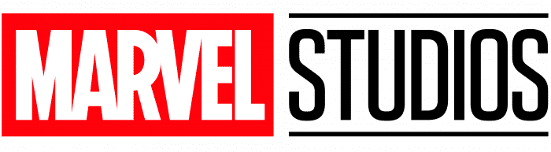
Commercialised art still counts as art, even if it is not to your liking.
Figure 3 Marvel Logo, 2016
In the capitalist society that contemporary art currently resides in, there has been big debates over whether artforms that are influenced by money and revenue can still be considered as art. Award winning director, Martin Scorsese stated his opinion that ‘Cinema as an art form’ is something that can bring about the ‘unexpected’ (2019). Many would argue that the price of commercialisation and commodification is to give up the surprise in favour of creating a predictable, easily reproducible outcome, which Scorsese partly criticises. On the other hand, The Value of Culture (Klamer, 1996) argues that ‘artists transact everyday’ and that ‘there are no inherent characteristics of the arts’ that would distinguish the supposed real art from the non-art, as it is all art just the same within the context of the ‘economic sphere’, which in this case is the industry. Art forms that strictly adhere to a formula can continue to provide an ‘experience’ despite the fact, even if it is mostly via aesthetic fulfilment, Klamer’s book claims that it still ‘transcends’ the idea of monetary value being placed on art.
Bibliography:
- Danto, A. C. & Bailey, W. S. G., 2000. Theories of Art Today. s.l.: University of Wisconsin Press.
- Kelley, D., 2013. Creative confidence: unleashing the creative. s.l.: William Collins.
- Klamer, A., 1996. The Value of Culture. Amsterdam: Amsterdam University Press.
- Scorsese, M., 2019. Martin Scorsese: I Said Marvel Movies Aren’t Cinema. Let Me Explain.. [Online] Available at: https://www.nytimes.com/2019/11/04/opinion/martin-scorsese-marvel.html (Accessed on 5th December, 2021)

Figures:
- Figure 1 Installation view of Sean Kelly’s booth at Art Basel in Hong Kong, 2018. © Art Basel. Accessed: https://www.artsy.net/article/artsy-editorial-sold-art-basel-hong-kong-03-31-18 (Accessed on 7th December, 2021)
- Figure 2 Illustration by Joshua Seong. Verywell, 2017
Accessed: https://blogs.agu.org/sciencecommunication/2018/06/19/on-creativity-in-science/ (Accessed on 7th December, 2021)
- Figure 3 Marvel Logo, 2016
Accessed: https://logos-world.net/marvel-logo/ (Accessed on 7th December, 2021)

Task 3: Practice-based writing
The piece of artwork that I have decided to reflect on is a poster for a past project that I made for a previous course. The brief that was stipulated required me to engage in creating a product with the basis being that it had come from my own creative interests and enquiries. This led me to create a video game concept as the foundation of my project and as a result I produced a poster fit for use in advertisements and marketing for a publisher, as if it were a real product.
My intended purpose of the poster was to showcase the main fictional character of my ‘Action’, ‘Fantasy’, and ‘Sci-Fi’ videogame to draw appeal from my audience of teenagers and gamers in addition to establishing the world that exists in the game as shown by the presence of the city background. The most important aspect here was to generate intrigue in the audience by virtue of just this one poster. To do that, I set out to employ the use of an ‘hermeneutic code’ (Moriarty, 1991), creating a ‘enigma’ in the main character by purposefully using a mask to obscure the figure’s face, leading the audience into wanting to find out what is underneath.
When I was producing this poster, I was relatively new at it, and employed the use of a ‘photomontage’, which as Harry Borgman states in his book Digital Dreams: Exploring the Computer as an Art Medium (2004), the computer is ‘perfectly’ suited for. I attempted to seam together an illustration of myself and an edited image of an alleyway for the poster, and by the end of it, I was very much satisfied with the result. I am still proud of what I was able to accomplish, though having gained more experience in design since then, looking back now only reveals flaws. I feel that what mainly went wrong had to do with the overall composition of my poster. It’s a basic one, with the character positioned in the centre, which I think resulted in a very uninteresting visual piece. I initially had reference images of myself, as well as sketched thumbnails that featured much more dynamic poses, but I decided to opt for the safe route, utilising a more ‘standard’ pose and for this I largely blame my lack of experience at the time as I was venturing into uncharted territory for myself.
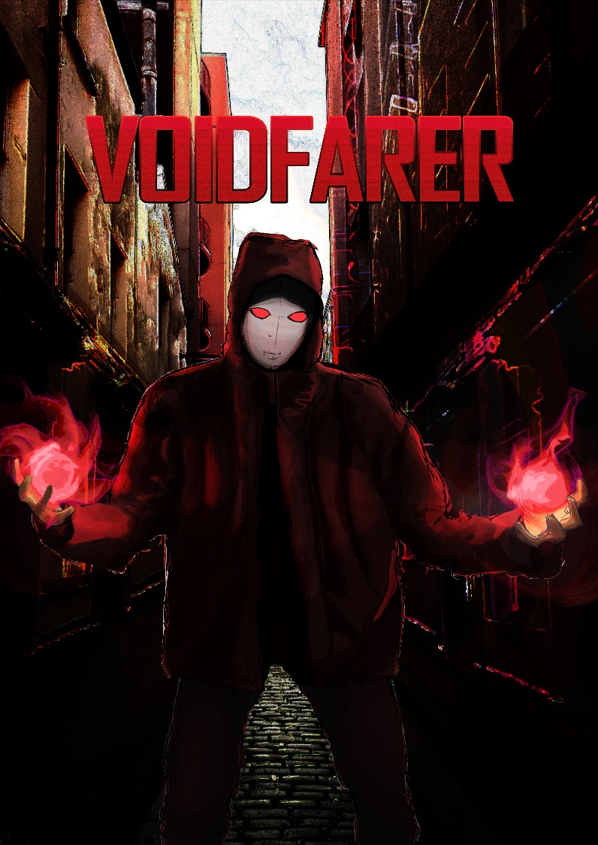
However, I did find that tackling this project helped me increase my overall skill in handling the relevant software and I learnt a lot regarding the digitisation of my physical illustrations through the means of Photoshop. I would argue that this gave me a confidence in using the software that I otherwise would not have if I had chosen another theme for the project entirely. If I had to engage with this brief again, I would certainly try to be more ambitious in the design decisions, especially regarding the composition, to create a more unique product that was truly my own as opposed to conforming to the homogeneity of character posters, present in various forms of media that mostly use a front-facing gesture with a direct mode of address.

Bibliography:
- Borgman, H., 2004. Digital Dreams: Exploring the computer as an Art Medium. s.l.:Xlibris US.
- Candy, L, 2019. The Creative Reflective Practitioner. 1st ed. London: Routledge
- Moriarty, M., 1991. Roland Barthes. s.l.:Stanford University Press.
- Schön, D. A., 1992. The Reflective Practitioner. 1st ed. London: Routledge.

