

What is the true identity of Castle Coch?

School of Architecture, Built and Natural Environment

Course: BSc Architecture

Name: Lucia Batters
Student Number: 2403918
Module code: ACAA 5003
Word count 1820
Date: 11/12/2025

What is the true identity of Castle Coch?
contents
Introduction 3
Location 3
Architect 3
Client/end user 4
Main body 4
Design philosophy and theory underpinning the design 4
Landscape in context to the building 6
Materiality 6
Effects on the senses 6
Construction 7
Conclusion 8
References 9

Introduction

Location
Castle Coch, or red castle, is classed as a grade I listed post medieval building and scheduled monument located in the ancient beech woods in Tongwynlais, Cardiff (Baron, 2024; Cadw, 2025a; Welsh Government, 2025). Castle Coch was taken over and preserved as a national monument due to its successful reproduction of the appearance of a type of 13th-century Castle of which no other authentic versions remain, and secondly due to its use of Victorian decoration and its originality (Floud, 1980). The reason for its listing is how it is 'one of the most major historic buildings in Wales (Baron, 2024).

Architect
The Architect for the original structure was Guilbert the red (Rousham, 1985). The architect for the restored version of Castle Coch was William Burges (Cadw, 2025a). Burges contested the use of machinery in art, and his main aim was to reform the ideas behind the industrial art form (Gregg, 2002). This is slightly controversial when it is considered that he was the son of a Successful civil engineer who had a famous firm on the embankment of Westminster (Cadw, 2025b). Burges himself was also highly respected, particularly for his early career in archaeology and his later one in architecture; however, his true speciality is in interior design (Gregg, 2002). It is clear to see that Burges was well respected, as this allowed him to obtain his first major commission at the age of 35 for Cork Cathedral, before he was then acquired for the survey of Castle Coch (Gregg, 2002; Floud, 1980). Burges concluded from his survey that the 13th-century castle was initially constructed in 2 stages (Floud, 1980). He determined that at first, it had only included the southwest tower, the hall that adjoins it at the east, and a simple curtain wall (Floud, 1980). Burges had to base the majority of this survey on his informed opinion due to the lack of original records (Floud, 1980). Burges provided two routes for action for the castle: one was to leave the ruins as they are, and the other was to restore them as a residence that could be used occasionally in the summer (Cadw, 2025b). In 1872, plans were drawn out by Burges and were undertaken in 1875 (Floud, 1980). In 1881 came the untimely death of Burges at the age of 53, at which point only the banqueting hall of Castell Coch was decorated and furnished, meaning that the castle is most likely not a true representation of Burges' vision (Cadw, 2025b; Gregg, 2002). After Burgess' death, not all of the rooms were completed, and it became disused and was obtained for British and American troops during WW2 (Cadw, 2025b).

Client/end user
Originally, Castle Coch was used by Marcher Lord Guilbert de Clare as a hunting lodge (Cadw, 2025). It later came under the ownership of John Patrick Crichton Stuart, the third Marquess of Bute, who inherited the family's estate when he was a baby (Hyman, 2004; Cadw, 2025). By the time the Marquess had left Oxford, he is believed to have been the wealthiest man in the world (Cadw, 2025). The marquess met Burges in 1865, at which point they discovered their mutual passion for medieval art and Architecture (Cadw, 2025). This shared passion may have been the reason behind the Marquess allowing Burges such free rein on this project, which allowed for such a fantastical scheme to be produced (Cadw, 2025). After Burges' death, there is no record of the Marquess staying at Castell Coch, and it is said that neither of the previous owners spent much time there (Cadw, 2025; Cadw, 2025).

Design philosophy and theory underpinning the design
Before Burges started work on Castell Coch, the castle had been uninhabited and fallen into disrepair over a period of 300 years (Floud, 1980). It was in 1871 that Lord Bute organised the clearing of the undergrowth from the ruins and acquired Burges to record a detailed survey of the castle, in an attempt to reconstruct a similar castle to the original structure (Floud, 1980). The foundations of which Bute would have been surveying date back 700 years, and it has also been determined that the medieval trappings date back to the 13th century, meaning that they were in existence when the castle was used as a hunting lodge; therefore, both the foundations and trappings would have been included within burges survey (Floud, 1980; Cadw, 2025a). Some may say that Burges has created an accurate restoration, as implied by the reasoning behind its status as a national monument (Floud, 1980). Others have a significantly different view, being that the installation of central heating has compromised the authenticity of the reconstruction and that the conical roofs are not a true replication of what used to be (Cadw, 2025b; Gregg, 2002). Bute contests the comments regarding the reconstruction not being authentic by stating that "it is true that some antiquaries deny the existence of high roofs in English medieval military architecture, and ask objectors to point out examples, as nearly every castle in the country have been ruined for more than two centuries and as the few that remain have been converted to modern uses it is not surprising that no examples are to be found,… the case appears to me to be thus: if the tower presented a good situation for military engines, it had a flat top; if the contrary, it had a high roof to guarantee the defenders from the rain and the lighter sort of missiles, Thus an arrow was fired upright; in its downward flight, it might occasion the same accident to defenders as happened to Harold at Hastings” (Floud, 1980, p.10). In support of Butes designs, he attached traces from a variety of manuscripts containing representations of conical turrets and claims that they are all English work; however, he does not acknowledge that these designs were often copied from continental or oriental works, and therefore cannot support claims about Architecture within Wales (Floud, 1980). One aspect that is hard to contest within Burges work is his commitment to ensuring that the client has a scheme that they are happy with, as shown with how Burges designs heavily reflected Bute’s key interests and how he created a scale model of lady Butes bedroom to help convey ideas and make it easier for the client to adjust the designs as needed (Gregg, 2002; Williams, 2003).

Landscape in context to the building
Castell Coch is a small hill fortress that lies on a junction between two types of solid geology, the Cwmyniscoy mudstone and a limestone formation (Hodges, et al., 1897; Baron, 2024). It is clear to see that the original castle was designed to command both the area of Cardiff and the narrow gorge of the Taff (Floud, 1980). The site could hardly have been better chosen to allow the views over its surrounding landscape and with its natural platforms; steep slopes and cliffs, allowing it to stay safe from attackers (Floud, 1980). The impenetrability of the castle is elevated by the fact that the only entrance requires attackers to cross the dry moat by a wooden bridge (Floud, 1980). Castell Coch has a triangular floor plan made up of south, east, and north towers and a gate tower (Clark, et al., 1850). This, paired with its conical turrets and surrounding landscape, creates a fairytale-like scene in the Welsh hills (Floud, 1980).

Materiality
The original castle was believed to have been built from unfaced red sandstone with a timber construction and slate-topped turrets (Floud, 1980; Huntley, 2004; Baron, 2024). When the castle was rebuilt, it was thought to be clad with masonry and had copper gilt weathervanes (Baron, 2024; Cadw, 2025b). The well tower of Castell Coch is constructed of inner and outer stone walls with a rubble core, which has now caused damp in the structure due to the mortar used within the rubble (Cadw, 2025c).

Effects on the senses
The main sense that is explored within Castell Coch is the visual sense. Lady Butes' bedroom is full of decorations, carvings, and paintings that are mainly mimicking nature and bring a variety of colours into the visuals of the room (Williams, 2003; Hodges, et al., 1897). There is also a drawbridge that gives the appearance of a defensive structure, which may pay homage to the original structure, rather than a leisurely retreat, which Bute was hoping to use it for (Floud, 1980). The main visual feature of Castel Coch is its conical-topped turrets that are embedded in the forest, creating this fantastical, fairy tale-like image, as shown in figure 1 (Floud, 1980).
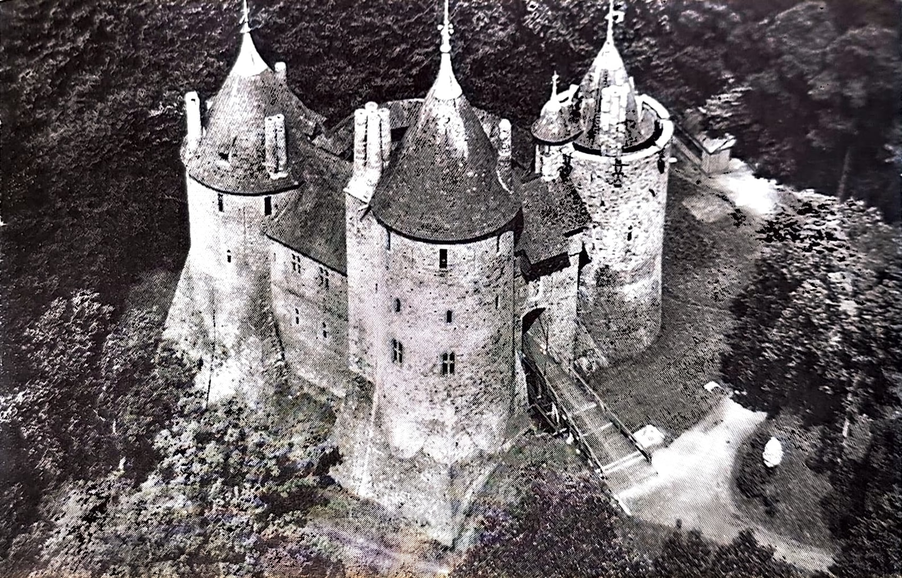
Figure 1 - image of exterior of castell Coch (Floud, 1980)

Construction
The 3 conical-roofed towers, which are topped with weathervanes, were constructed at the end of the 13th century and were restored in the late 19th century (RCAHMW, 2009; Cadw, 2025a; Cadw, 2025b). These 3 conical turrets are what create the castle's unfamiliar and fairytale-like appearance (Floud, 1980). It has also been noted that these towers are the most questionable part of the Castell's restoration, as there was nothing within the ruins to indicate a conical shape or construction of the original turrets; instead, evidence of the opposite remained with the discovery of flat roofing stones and pieces of glazed earthenware tile (Floud, 1980). Some concluded that, due to not a single medieval conical turret roof having survived from the hundreds of castles, it would be safe to say that the conical turrets are not an authentic replication (Floud, 1980). Each of these 3 turrets are at a slightly different height and shape as shown in figure 2 (Floud, 1980). The tallest tower is to the south of the entrance, and on the other side of the entrance is a slightly smaller tower with a smaller and steeper roof (Floud, 1980). The three towers, paired with the connecting walls, forming an irregular ring around the courtyard as shown in figure 3 and figure 4, which is most likely true to its original layout, as it has been noted that Burges did maintain the basic plans of the ruins accurately (Floud, 1980; Gregg, 2002). There is also a wooden balcony over the entrance and a wooden drawbridge on chains; however, it is difficult to determine if these are authentic due to no documentary evidence regarding the detailing of the previous appearance, so Burges had nothing to base his design on (Floud, 1980; Gregg, 2002). It has been presumed that it was during the 15th century that the original castle was purposefully destroyed, as indicated by evidence of both mines and fire being found (Floud, 1980). This levelled the castle to the ground, therefore not leaving much for Burgers to base his replication on (Floud, 1980).
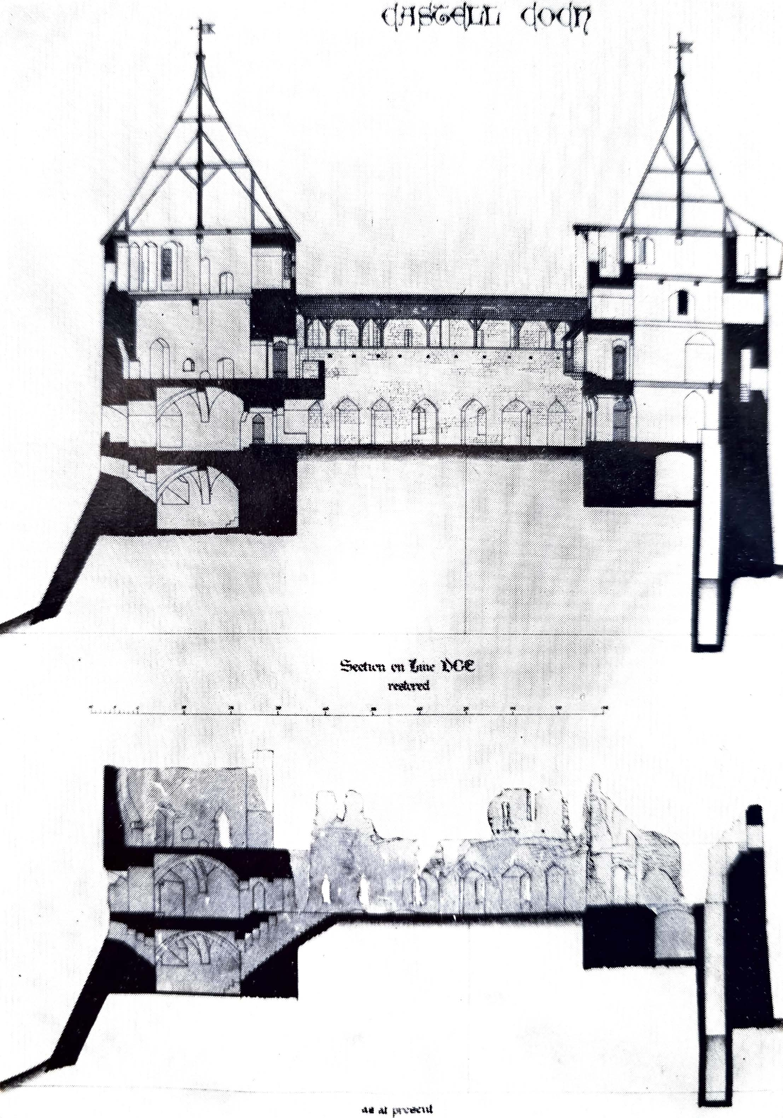
Figure 2 - image showing section through Castell Coch (Floud, 1980)
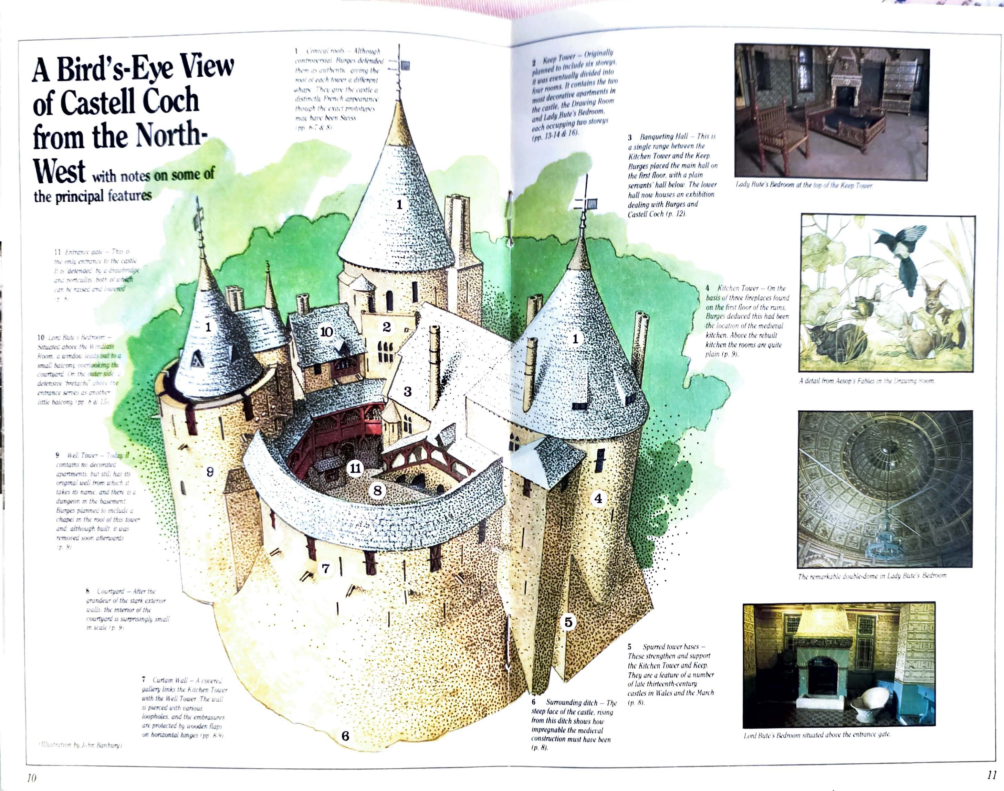
Figure 3 - 3D coloured visual of Castell Coch (Rousham, 1985)
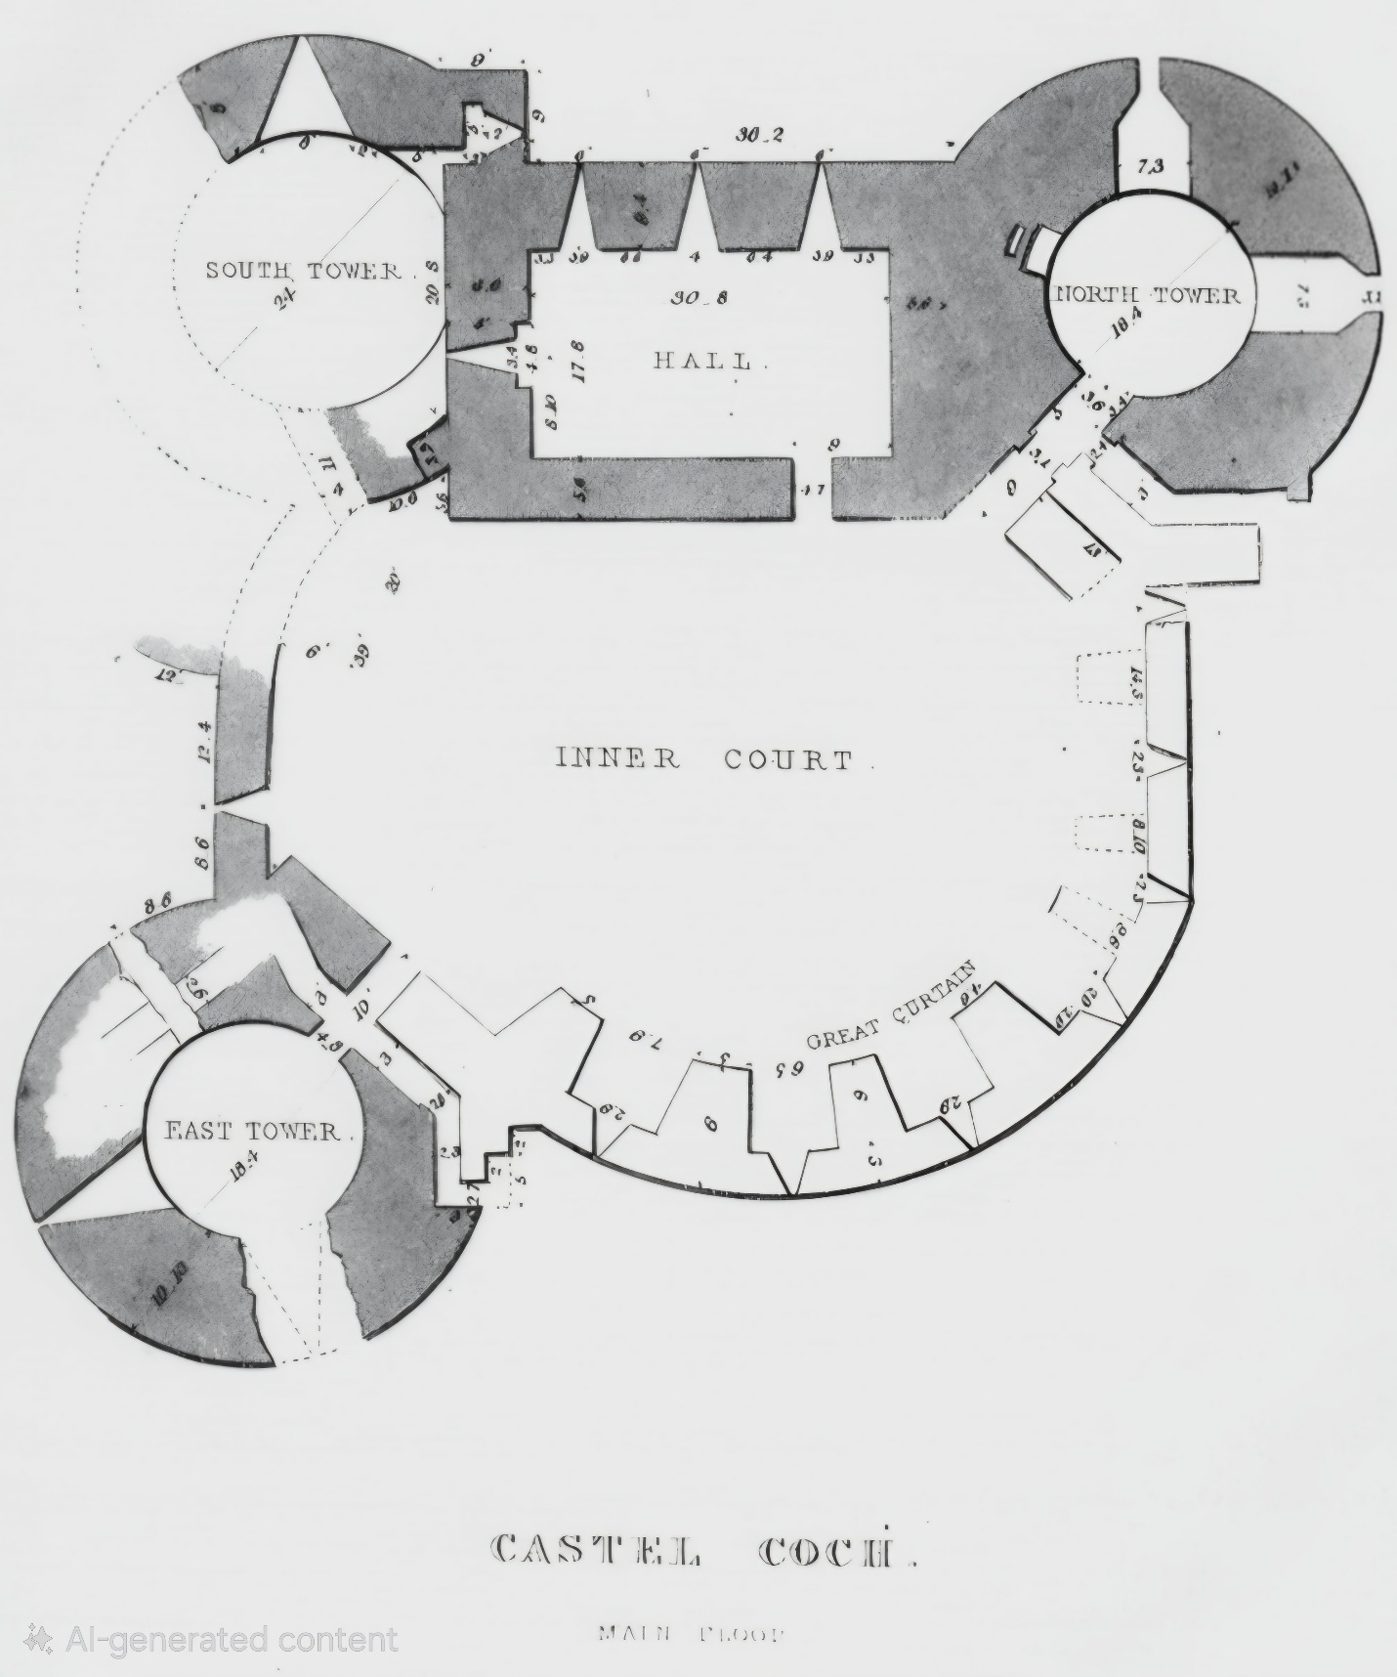
Figure 4 - Floorplan of Castell Coch (Clark, et al., 1850)

Conclusion
In conclusion, Castell Coch does not seem to be a true Welsh castle. Some say that the tiny fortress has more features in common with Norman architectural features, whilst others say that no part of the castle is Norman and instead that it is most likely early English from the reign of Henry III, with some going further afield and claiming that it has a similar appearance to a French chateau (Hodges, et al., 1897) (Clark, et al., 1850) (Philip & Higham, 1980). The castle also had heating installed, therefore not keeping it true to its original Welsh construction, which may have played a role in the locals calling it a folly rather than a restoration, as it was intended to be (Hodges, et al., 1897; Hyman, 2004). It has also been suggested that Burges' designs have a footing in medieval architecture, with experimentation with the fantastical side (Gregg, 2002). A key thing to note is that this fantastical side is mainly created through the conical roofs, which are rooted in Swiss design and used with no justification (Hyman, 2004). Therefore, it is clear to see that the evidence points against traditional Welsh architecture and instead implies that Burges had various influences that he used to form more of a fantasy castle rather than achieving an accurate restoration of the Welsh architecture that had been. Therefore, its true identity is a mixture of various architectural styles and influences.

References
Baron, i., 2024. Archaeological Watching Brief, Cardiff: Red River Archaeology.
Cadw, 2025a. Castle Coch. [Online]
Available at: https://cadw.gov.wales/visit/places-to-visit/castell-coch
[Accessed 14 October 2025].
Cadw, 2025b. More about Castell Coch. [Online]
Available at: https://cadw.gov.wales/more-about-castell-coch
[Accessed 14 October 2025].
Cadw, 2025c. Preserving Castell Coch and restoring its timeless splendour. [Online]
Available at: https://cadw.gov.wales/preserving-castell-coch-and-restoring-its-timeless-splendour
[Accessed 09 December 2025].
Clark, G., Jones, H. L. & Williams, J., 1850. Castel Coch, Glamorgan. Archaeologia Cambrensis, October, Volume 1, pp. 241-252.
Floud, P., 1980. Castell Coch Welsh Office Official Handbook. 12th ed. Cardiff: HMSO.
Gregg, H., 2002. The Literary Lense of William Burges: His work at Cardiff Castle and Castell Coch. Lampeter: University of Wales Trinity Saint David.
Hodges, E., May, P. & De Beck, A. M., 1897. A Vinyard in Wales. The Ludgate, May, Volume 4, pp. 3-8.
Huntley, J. S., 2004. Castell Coch. Journal of the Royal Society of Medicine, 97(2), pp. 90-92.
Hyman, R., 2004. Castle in the sky. British Heritage, May.
Philip, B. & Higham, R., 1980. Current Archeological. London: Current Publishing.
RCAHMW, 2009. Glamorgan: Later Castles. Aberystwyth: RCAHMW.
Rousham, S., 1985. Castell Coch. Cardiff: Cadw Welsh Historic Monuments.
Welsh Government, 2025. Castell Coch. [Online]
Available at: https://www.visitwales.com/attraction/castle/castell-coch-cadw-516101
[Accessed 14 October 2025].
Williams, M., 2003. Lady Bute's Bedroom, Castell Coch: A Rediscovered Architectural Model. Architectural History, pp. 269-276.

Figure 1 – shows the exterior of Castell Coch and its conical turrets surrounded by the forest. – pg.8
Figure 2 - shows a section through Castell Coch and clearly demonstrates how the towers are at different heights. – pg.10
Figure 3 – shows a 3D coloured visual of Castell Coch and shows how there is an irregular ring formation. – pg.11
Figure 4 – shows the floorplan of Castell Coch. – pg.12

