Question: Can Graphic Design really save your life? Explore the association of wellbeing and personal growth in Design in your discussion.

Strcture
Contents list
Introduction-the background of graphic design and the importance of graphic design
Chapter one
Graphic design can call for action
Chapter two
Graphic design can also apply in prevention and control of infectious diseases, it improves social wellbeing.
Chapter three
Graphic design can help the vulnerable group
Chapter four
Graphic design can contribute to environment protection
Conclusion

Introduction

The following essay is about graphic design can save our life in many ways, some more evident than others and it can improve wellbeing and personal growth (Plinth, 2017).

Graphic design is commonly defined as solving problems on a two-dimensional surface (Arntson, 2011), it involves transforming text information into images to improve the effectiveness of conveying information to the public. “This is the Age of Information, not the Industrial Age” (Arntson, 2011, p4). We living in the information age, information penetrate into our daily life. In particular, images are around us all the time. “Images are 'everywhere'. They permeate our academic work and everyday lives. They inhabit and inspire our imaginations, technologies, texts and conversations” (Pink, 2013, pdf11). A growing importance of graphic design has been attributed to the information age, due to its importance in message transmission. Graphic design is a potent tool as it influences others through enlightening, motivating, and entertaining them.
Graphic design can address different area issue in the society. It benefits people in numerous ways. I'll go through how graphic design can encourage people to enlist in the military in the first chapter. The second section discusses how graphic design can be extremely helpful in the diagnosis and management of infectious diseases. The third point is that humanised fonts created by graphic designers can benefit vulnerable groups and increase their happiness. The personal significance of the design can also be seen at the same time. The final point is that graphic designers incorporate the design principles of environmentally friendly and sustainable development, which can protect the environment and conserve resources, ultimately saving all of humanity. In the final section, I'll discuss my writing experience as well as my research into wellbeing and personal development in design.

Chapter one
Graphic design can call for action

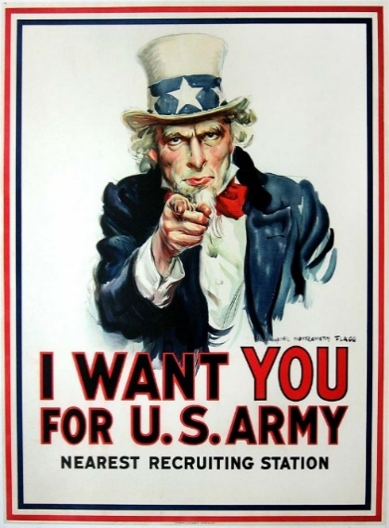
Graphic designers can use graphic language to call for actions. The figure one is the U.S. Army recruitment poster, which features a commanding Uncle Sam pointing his finger at the spectator and pushing young men to serve in the war effort, is one of the most iconic images in American history that was created during World War I. The artwork, "What Are You Doing for Preparedness," was painted by renowned American painter James Montgomery Flagg and initially featured on the cover of Leslie's Weekly magazine on July 6, 1916. Even though the storm signs were obvious, the United States would not declare war on Germany until April of the next year. The U.S. Army later modified the image for a poster with a fresh, memorable call to action. It was printed in excess of 4 million copies between 1917 and 1918 (Clerfem, 2017). Uncle Sam looked straight at the public with firm eyes and his finger seemed to be pointing at everyone who saw the poster. Bright red letters seems like in command tone to urged young men to join the army. As Roberts (2006, p192) stated “graphic design is a powerful tool because it is crucial in the communication of messages. It has a role in persuading, educating and delighting others.”
Fig.1，The famous James Montgomery Flagg “I Want You” Army recruitment poster, from Gary Borkan posters, as part of Lifelines story on recruitment posters. Photo by Gary Borkan

Chapter two
Graphic design can also apply in prevention and control of infectious diseases, it improves social wellbeing.

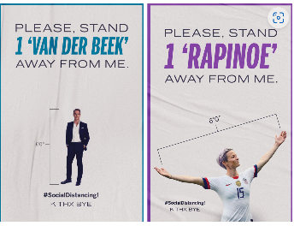
Graphic design make a significant contribution to human health protection. Graphic designers have their own special methods for dealing with sudden catastrophic human disasters in the medical profession, such as the coronavirus, which is the worst threat confronting humanity.

Rosenberg’s (2020) 12 posters figure 2 includes celebrities employed by the artists to encourage social distance among the audience. Because the audience's love, trust, and even imitation of the celebrity is transferred to the love, trust, and imitation of the action, the artists made advantage of the celebrity effect (Rosenberg, 2020).
Fig.2 These clever posters are part of a series of 12, all using celebrities to encourage social distancing. Ben Ostrower

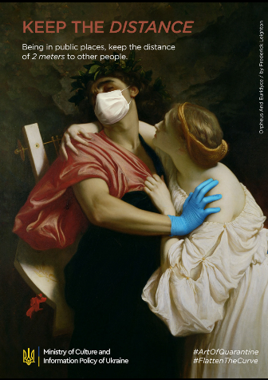
We may claim that maintaining the quarantine is a form of art. This is a campaign called the "Art of quarantine"(2020), launched in collaboration with the Ukrainian Ministry of Culture and Information Security. Because many people continue to flout the fundamental guidelines of quarantine and personal safety during the ongoing coronavirus outbreak, old-fashioned artworks were given the fresh style by artists and provided safe ty and COVID-19 prevention lessons. The goal of this campaign was to limit the disease's spread and reach as many people as possible throughout the world, with this message as part of the worldwide campaign (Art of quarantine, 2020). In the poster, the beautiful woman tries to get close to the man, but the man turns his head away, closes his eyes, wears a mask and pushes her away with a hand with medical gloves. The headline of the poster is, ‘keep your distance’, and it says below, keep two meters apart in public areas to call on people not to get too close.
Fig.3 Art of quarantine, 2020

COVID dealing with unpleasant feelings
The designers use their observational skills to transform the current negative situation into a positive one, and they may even add a little humour to this situation. They do this by reflecting in their designs how people can be happy. Designers use image to represent the messages, guidelines, and policies they feel are necessary to express in order to provide correct information. The importance of the information's transmission and the impact it will have should not be ignored, together with the importance of the information's accuracy. The pervasive use of media-based communication in this process has a considerable impact on how the bulk of society is led. By adding visual components to the information flow, people may direct their attention to a certain topic (Atasoy, 2021).
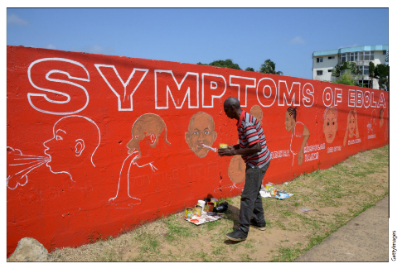
Another example of graphic design applied in contagion. In West Africa during the 2014 Ebola outbreak, Liberian designer Stephen Doe painted walls red to indicate danger and used straightforward iconography to explain the illness' symptoms to a populace that spoke more than 30 different languages and had limited literacy (Lange, 2017). A similar motif can be seen in UNICEF's posters. It is an engaging show that is logically set out, well-organized, and continually educational (Burki,2017).
Fig.4 Hand-painted Ebola mural 2014 by Stephen Doe

By developing innovative problem-solving techniques, graphic design significantly contributes to the prevention, control, and reaction of most diseases. As a result, participation in graphic design is a duty and not a question of personal preference.
Chapter three
Graphic design can help the vulnerable group
The graphic designer will be concerned with more societal groupings in the hope that more individuals can live in equality. Good designers are able to make their audience feel comfortable and provide them convenience. Graphic designers, for instance, employ colour with colour blindness in mind while Typeface designers, creating Braille libraries to aid the blind.


This is the first Braille font of Ali font in China. The name of the font Ali Health Body. First of all, the main use of this font is designed for the drugs of Ali Health Pharmacy. From the shape of the font, and we see that the overall appearance of the font presents a rounded feeling, more with a kind of affinity, giving people a close and warm feeling. It is an emotional design.
Fig.5, AlibabaHealthFont, 2022
Secondly, the stroke turning part of the font is designed in the form of round outside and square inside, and the middle part is loose, so that it does not look so tight. The font outline is clear, presenting simple and generous modeling, greatly improving the recognition. This provides convenience for elderly users and visually impaired people. A narrow body design was adopted in the English design.

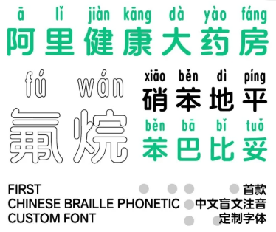
In addition, the designer found that patients often encounter unfamiliar words when buying medicine. In order to make it more convenient for patients to buy medicine, Ali Health Body added phonetic notes to the rare words of medicine, so as to solve the purchasers' difficulty in recognizing the rare words of medicine.
Fig.6, The top dot is in Braille, and the top of the second line Ali Health Font is marked with pinyin. 2022

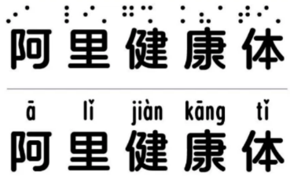
Ali Health also introduced a blind style, which adjusts the matching position of braille characters and Chinese characters, on the basis of following the national standards and norms of Chinese Braille, so as to achieve a more legible effect. Especially when some visually impaired people buy medicine, it is inevitable that there will be some inconvenience, and the design of Braille makes it more convenient for them to take care of themselves in daily life.
Fig.7 Ali Health font will automatically mark pinyin when rare characters appear. 2022

With its simple and friendly design, Ali Health Front is used in the outer packaging of drugs, and its simple typesetting and text design make it easier for the public to select and identify when buying.


It can be seen that the brand customized fonts launched by Ali Health are designed around the keyword of "simple and convenient". Both the simple and legible Chinese font and the Braille design for the visually impaired are of great social significance and strengthen the development direction of the brand.

Chapter four
Graphic design can contribute to environment protection

Graphic design also has a very important part to play, in the aspect of protecting environment. Graphic designers use their own ways to pay attention to some problems in the society, to draw the attention of the society, so that we can better work together on some problems faced by human beings（Pink, 2013). Like white pollution.
Fig.8, Ali Health Front is used in the outer packaging of drugs, it adopted green as the main design, simple style, 2020


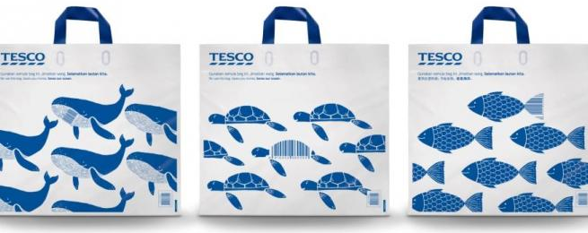
Each year, more than 1 trillion plastic bags are produced worldwide; the majority of them are single-use and end up in landfills and the seas. Tesco developed a creative initiative to lessen Malaysia's plastic waste. The British grocery chain unveiled new recyclable material-made bags. Each of them has a barcode that will give clients a 20cent discount when they purchase at Tesco. So far, the outcomes have been rather amazing. Tesco projects that this year's use of plastic bags in its stores will be cut by 5 million pieces thanks to the Unforgettable Bag (Brandactivation,2018).
Fig.9, Tesco stores in the capital city of Kuala Lumpur are rolling out reusable shopping bags with barcodes that provide customer discounts, 2019
In terms of graphic language, graphic designers use the most straightforward graphics, repeated arrangement of Marine creatures as the theme graphics of the package. It is directly related to the conservation of Marine animals. In terms of color, only blue is used, which not only echoes the ocean theme but also reduces the use of other colors to save resources and protect the environment. In terms of materials, the bag is made of recycled materials, which carries out the theme of protecting the environment.
Fig.10, Tesco stores in the capital city of Kuala Lumpur are rolling out reusable shopping bags with barcodes that provide customer discounts, 2019

Kim and Geissbühler (2018) stated that good design is environmentally-friendly Design makes an important contribution to the preservation of the environment. It conserves resources and minimises physical and visual pollution throughout the lifecycle of the product.

Designers typically apply design thinking to their work and expertly incorporate their own design expertise into their creations. They each have a distinct sense of mission and are aware that their creations must empower people and progress society. They advocate for a better way of life, convey beauty to the audience, and educate people about positive green and sustainable development concepts. This procedure can demonstrate the importance of designers, they contribute to environmental conservation, and they can enhance human wellbeing. Additionally, they create goods that benefit the environment and other members of society. Additionally, social happiness can be enhanced. The designer also improved personally, gaining more knowledge and fitness throughout this time.

Conclusion
In conclusion, graphic design can actually and literally save our lives, now and in the future. By correctly transforming the world into visuals, graphic designers assist the public in grasping information, provoking public understanding and engagement. Designers need present current information to modern taste with up-to-date tools, staying informed about trends, issues, inventions, and developments. Values Our current society is based on processing information more than producing goods (Arntson, 2011).

Graphic design has been employed to inform, persuade, and empower ( Wallersteiner, 2017).
Designers will develop their talents during the design process, either actively or passively, to achieve personal growth. Consequently, society wellbeing may be served better.For instance, designing for vulnerable populations is crucial in the medical and health fields. To further save the environment and resources of the planet, the graphic design also complies with sustainable development principles. They use environmentally friendly and sustainable materials and use as little color as possible to save resources. This is everything being done to rescue mankind and the future. Save the environment is saving the human being. If graphic design is going to be able to save your life, then it is overall value will not be measured only in terms of money.

I have learned more about graphic design as I have gathered materials and written this article. I now understand that graphic design is much more significant than I previously thought. It had really tangible impact to our daily life. This increases my enthusiasm and desire for graphic design. Dougher (2015) stated that as designers, we are frequently expected to solve a wide range of issues, yet our experiences are frequently insufficient to give us the knowledge or comprehension necessary to complete these tasks successfully. Therefore, I will continue to identify skills and experiences I lack, which will motivate me to learn more and live more deliberately. As a graphic designer I need continuous improvement, because education in design is a lifelong pursuit. Continuous change necessitates continuous regeneration, not for someone who likes a leisurely pace and sentimentality. I must approach the fundamental concepts, novel technology, and practice with a flexible and inquisitive mindset if I want to keep up with this rapidly evolving field (Pink, 2013).

I will try my best to improve myself and design more worthwhile works. I hope my works can also be empathetic, warm and practical. In the process of design, I can not only realize my personal wellbeing, but also promote the development of the society when my design can help others to improve their life convenience and happiness

