Development Log – Joseph Long
The project first started off with Chris inviting me to join him on his project about a Goblin attempting to steal beer from a Dwarf. Soon after joining his team we realised we would need a second pair of hands on-board to make this achievable, from there we developed the story more and went through various changed.
It started off as a goblin laying siege on a pub, and the innkeeper (the Dwarf) defending it, a sort of comedy horror somewhat like Gremlins. This then changed into a Tom and Jerry style slapstick comedy where the Goblin would attempt various ways of stealing the beer, all of which would fail in comedic ways. Realising that this would be hard to achieve as comedy is quite objective and we would have to create a lot of various clips that contain comedy as well as the story, resulting in us changing the animation again. The story was that the Goblin would climb a mountain to find this legendary beer, of which those who are worthy can only drink.
While developing this, a story element relied upon having a live action element to it, this would contain a group of people playing a game of Dungeons and Dragons and the protagonist would be our Goblin/the player who plays him. This player would be in a group of people who he is desperate for them to accept, but the DM of the game would be his obstacle and gaining the legendary beer upon this quest would be the way to acceptance. However, during this, it was a struggle to make any of these characters appealing and we would have more than double the amount of manageable characters for our size team, which resulted in that element being dropped. The final decided story ended up being a Goblin has climbed the tall snowy mountain to get to this pub, in getting there the Goblin meets this Dwarf who refuses to allow him to have this beer. The Goblin battles with the Dwarf and proves himself worthy of such a drink, the Dwarf allows him to have the legendary beer but after one sip the Goblin passes out.
The Goblin and Dwarf story was developed near completion and storyboarding/thumb nailing had begun. When we presented our idea to peers we discovered that the story was not appealing, this pushed us towards starting anew and developing what is now called ‘SpellBound’. Early discussions on this new project lead us to still wanting to create a fantasy world but, based upon magic. Initial ideas consisted of a wizard in his tower defending the library within this tower, from a monster that would be eating the books. The group’s first decision upon the story around this was that the wizard and the monster would start off as foes and would become friends by the end of the short. Whilst struggling with any other ideas to what the story would be about the idea of a story wall was given to us from a lecturer to which we took on board to help develop the animation.
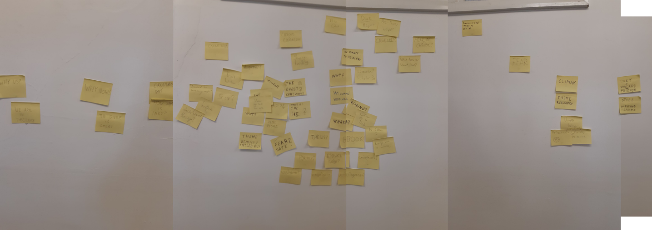
This story wall helped us first pose questions to be answered to enable the development, such as; why is he alone (in the tower)? This is where we combined ideas and decided we would go off a historical view of magic use in terms of public reaction. Making a choice that in the story he was burnt at the steak by his own people, forcing him to be an outcast and remaining in solitude, from these developments the story started to fall into place that, our wizard would be working on a spell and a mysterious creature that came to be known as Inky would start eating ink out of the books and part of his spell. The chase would start causing increasing destruction upon the library eventually leading to a final encounter between the two characters, giving the realisation to our protagonist that he is about to do to this creature what his people did to him. A problem we posed was figuring out why this spell was important though it seems obvious now, at first we couldn’t think of anything but decided that this spell he was creating was to heal his wounds caused by him being burnt at the steak. Getting deeper to the heart of this we have the idea that this spell would heal him physically but the creature would be the first step into him healing is ‘soul’.
The term inkling came about to describe the ink eating creature, however after a while we realised that was already used within a game so we took to calling him Inky and changed him to an Inkcat
Deciding upon a story lead to the treatments and scripts being written primarily by Chris and partly Michal, however they found it difficult to write an act two, where the chase would take place so we decided that each of us would thumbnail ideas out for it. I took it upon myself to write a small script for the chase scene as well as the thumbnails, as I thought I had some interesting ideas that could be presented to the group.

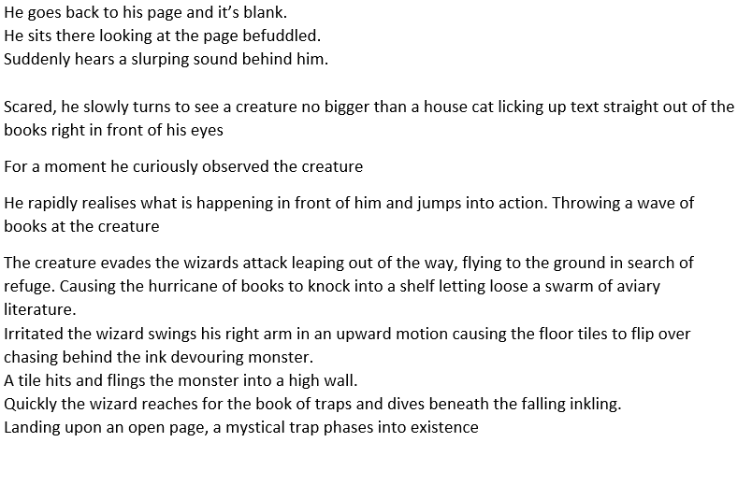
This was written during journey home, while I was trying to play around with the uses of magic and magical items within the world of spellbound, to which the idea of the flying books inspired by Harry Potter and the flipping tiles that was inspired by Marvels, Doctor Strange was well received and kept within the final story, though the tiles were changes slightly. Rather than being flipped they now grow upwards to block the Inkcat’s (Inky) path.
Within this small script I created the thumbnails to match and try help the visualisation of the actions but with the wave of books being thrown at Inky taken out as we realised why so early on would he be quick to destroy the library when he is trying to protect it.
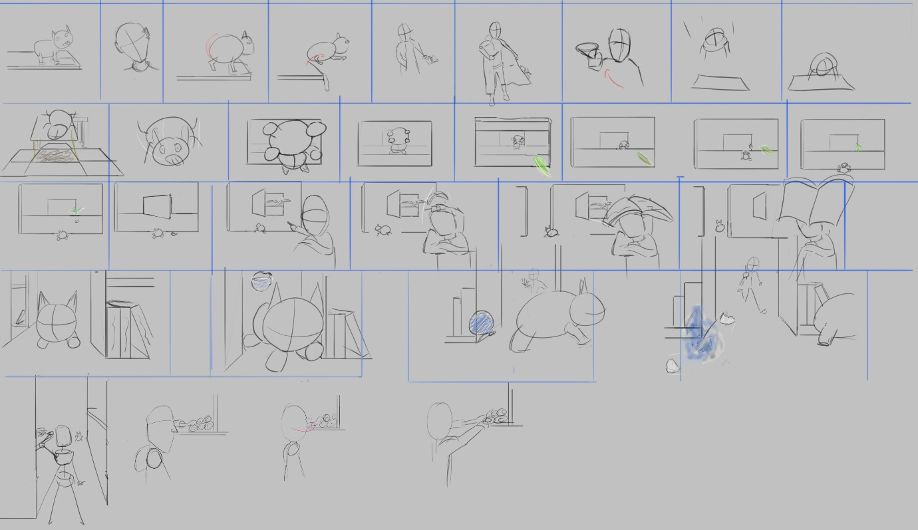
After we all took a look at our ideas, Chris went forwards with creating the final storyboards for act 2 and put together the Leica reel.
During this time we had a discussion about art direction in which we all presented mood boards for what we imaged the look of the animation to be like.
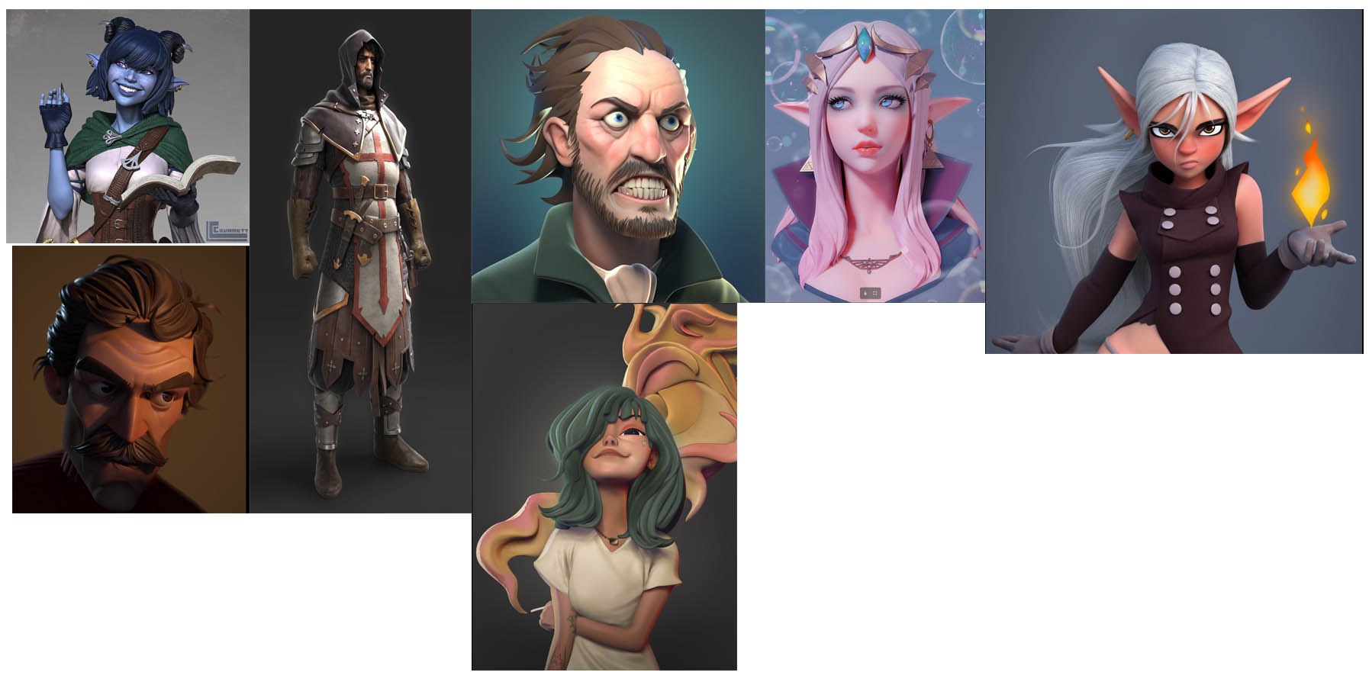
From the discussions on this we decided that we would take a stylised approach both in texture and models towards a medieval look like the blue witch on the top left of the image and the knight next to her.
Me and Chris would be designing initial designs for the character and myself the final design, so moving onto design work of the protagonist, I had yet to start designs on our character due to the lack of direction, we hadn’t yet decided what the gender of our character would be or what their personality would be. Though after the meeting there was more clarity on this, we knew we wanted a strong, confident character which wasn’t a lot to go off going forward with design so thinking upon this more I tried to incorporate some personality into the pose and costume. I figured since the character is trying to heal their scars they must care about what they look like, but they have also been outcast so they must be somewhat of a practical and smart person to be able to live on their own in this cruel world they live and to be able to create their own spell and since the character no longer trusts people as a result of their actions towards them they are secretive. With these ideas I started initial designs in the form of silhouettes;

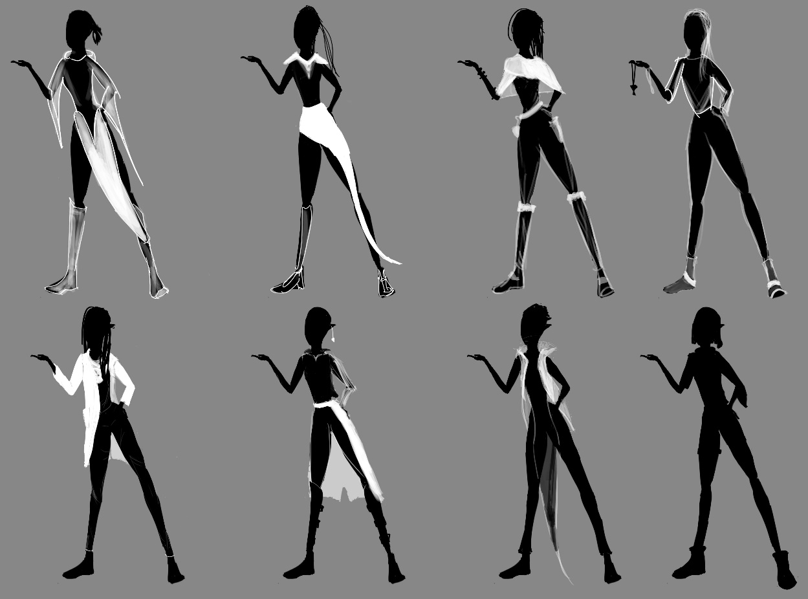
Throughout the silhouettes I tried to give the character a sense of personality within the pose and clothing whilst trying to fir the time period. At this time in the design process I focused more on cloth materials and things that give a medieval, fantasy feel. However the problem with these is that they don’t feel ‘witchy’ enough, like this character could be anything within the world.

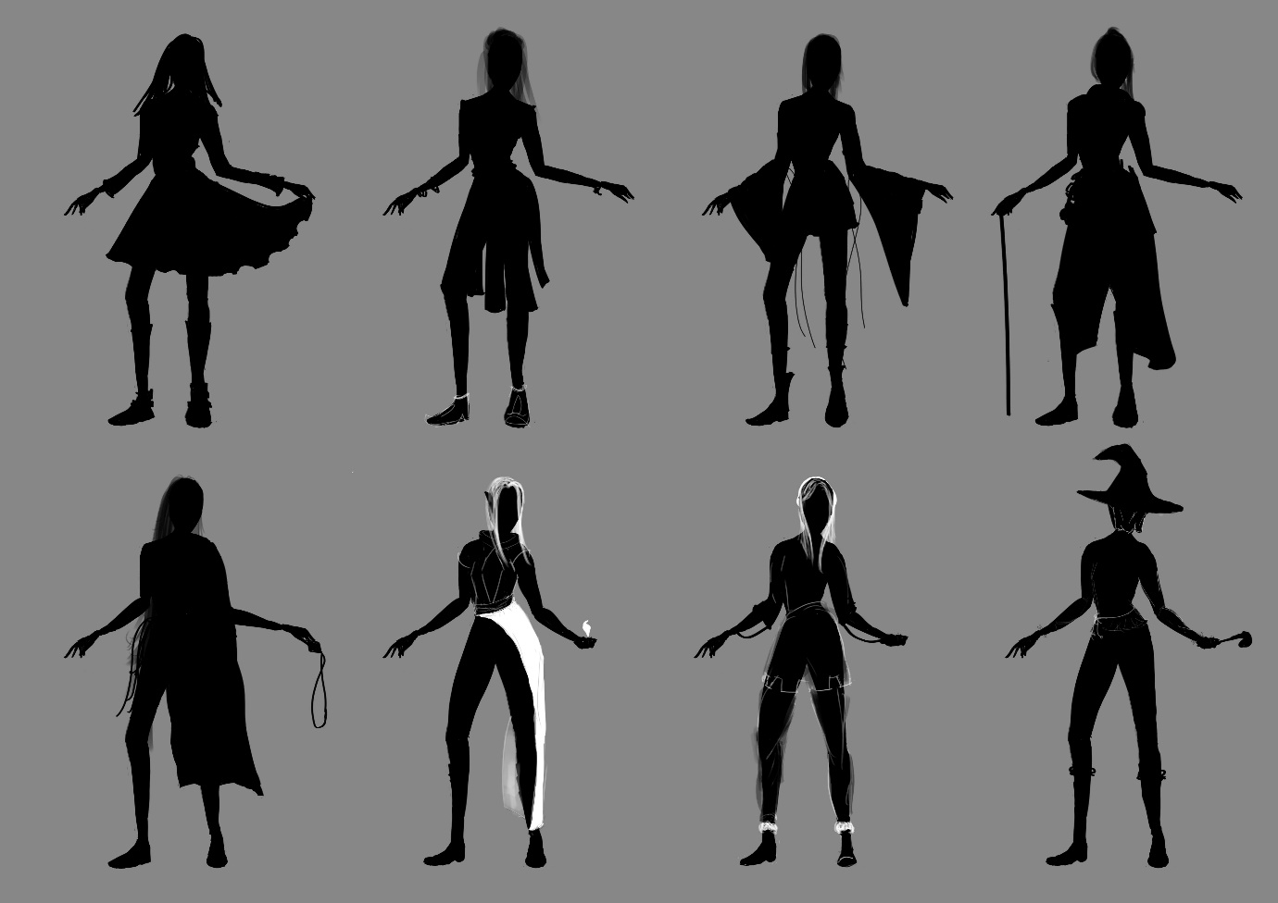

Looking at imagery of witches and other magical characters a common theme within their clothing seemed to be that they all have flowing clothes. The designs from here onwards tried to convey practicality whilst still some sense of fashion that would suit our character and keep them visually appealing. Usually for witch designs it was commonly a form of a gown, one of the cliché’s that I wanted to stay away from which Chris agreed should be done. This was because we didn’t want our character to get mixed in with every other witch design out there and seen as just another one of them, we wanted it to be more unique. However, Michal wished to have a design with a hat, to please him I did one design with a hat on the bottom right of the image with an attempt to break away from the cliché a little by adding a veil to the hat, I chose not to add any flowing clothes there as to avoid going towards the full usual witch look.

Liking these designs I decided to take them forward more, inspired by witches from the video game The Witcher, I thought about playing around with the character wearing a corset

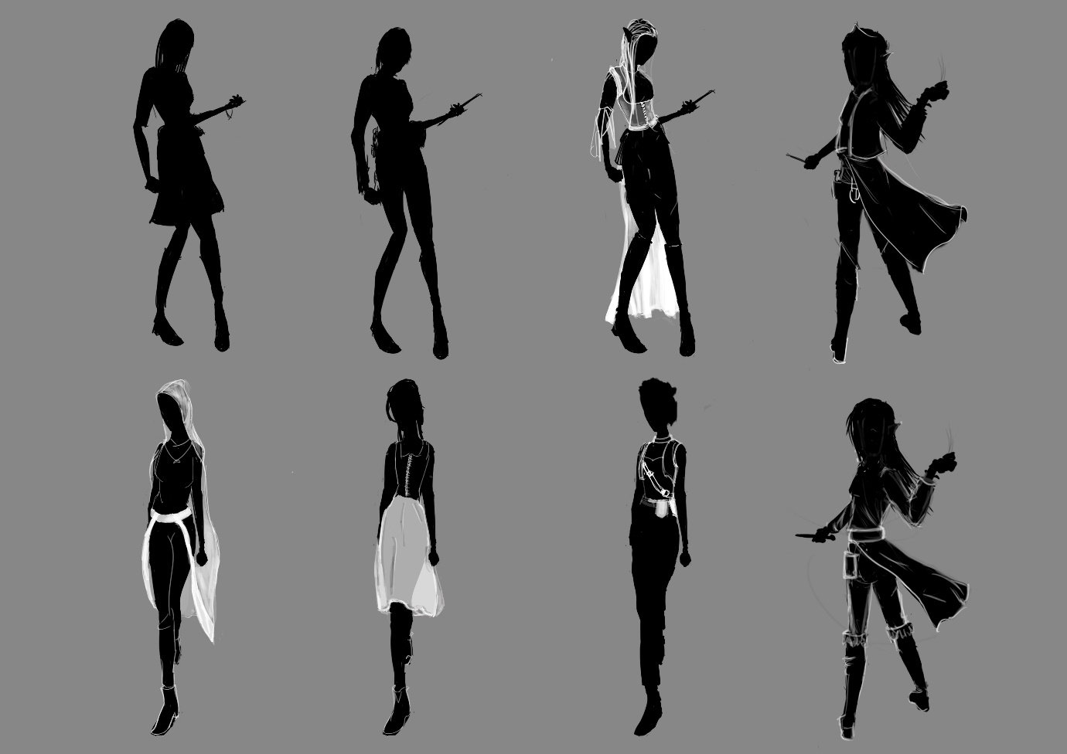
These stayed within the bounds of looking witchy apart from one or two, but this is where the I started to like the corset look with the flowing skirt behind and long boots, I felt it gave the impression of a magic user with elegance perhaps, this was closer to our character but elegance maybe didn’t fit too well due to their circumstances.
After these designs a team meeting took place in which we chose our preferred character designs, here we discovered that me and Chris had both been designing female characters to which we decided we would make the character a witch. We decided would keep the corset and a skirt with trousers and the addition of a belt. Although all hair shown from mine and Chris’ designs was liked, it was suggested that I come up with more hair designs for the character, any other additions was up to me.
It was now my responsibility to create a final design and look to the character, from what was discussed within the meeting I took that away and worked on a few variations of the clothing.
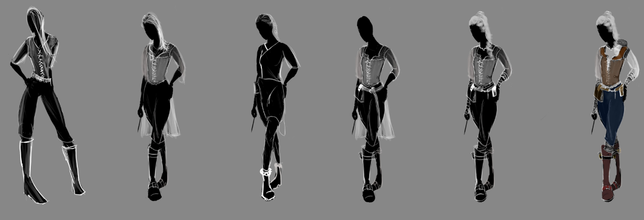
Sticking with the corset and flowing clothes along with the medieval leather look, I combined them to which was well received, however after colouring the last variant it started to look more like a cowgirl than a witch. Seeing these, the group started to like the idea of a shawl and a skirt closer to one of the half skirts I had done previously.
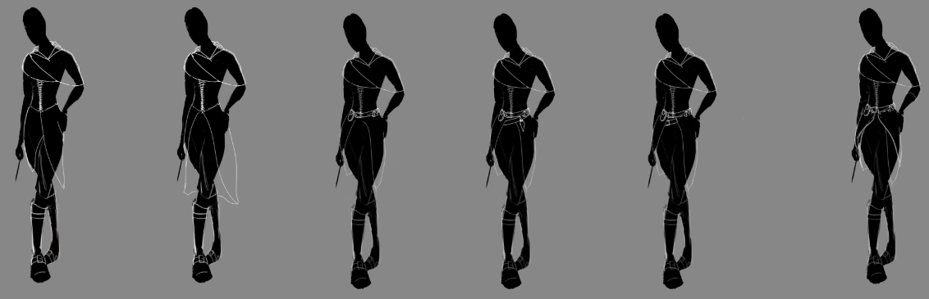
Within these hair was ignored whilst I figured out a nice design for the clothing, to which we all agreed upon the last design on the right. This contain a mixture of inspirations such as Korra from The Legend of Korra, Triss from The Witcher 3 and Sypha from Netflix’s Castlevania series.
The design for the clothes had to stay practical for our character who became ‘Joanna Kilner’ as she’s been outcast and alone for many years, she needs clothes that would keep her warm and are practical to enable her to carry equipment she may need at any given moment.
Based on this I started the first line art for our character Joanna.

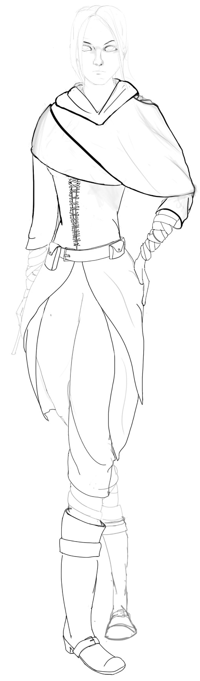
To create this, I started with a silhouetted pose and drew the body from that, I then built up the clothing upon it. I had some trouble with drawing and creating a face at first, but took a look at some comic book characters faces and saw how they are drawn which inspired this look.
The other two in the group were happy with this design and for me to go forward with adding colour to it which includes the burn marks for the character.

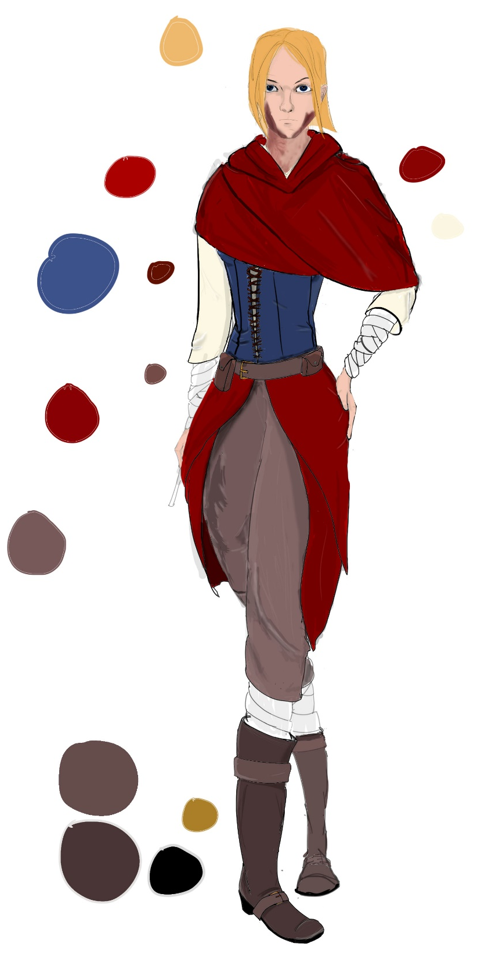
Here the character is fully coloured and shaded, I started with a flat base colour and built upon that adding carious shades, whites and blacks to add folds and where light hits the character. We were quite happy with the colour pallet and design of the character, however I noticed there were a few issues such as the pose itself and a design flaw in the skirt. To make the overall design work better the skirt and shawl should be designed to look similar as if they are one piece. Seeing this I began another line art with some minor changes.

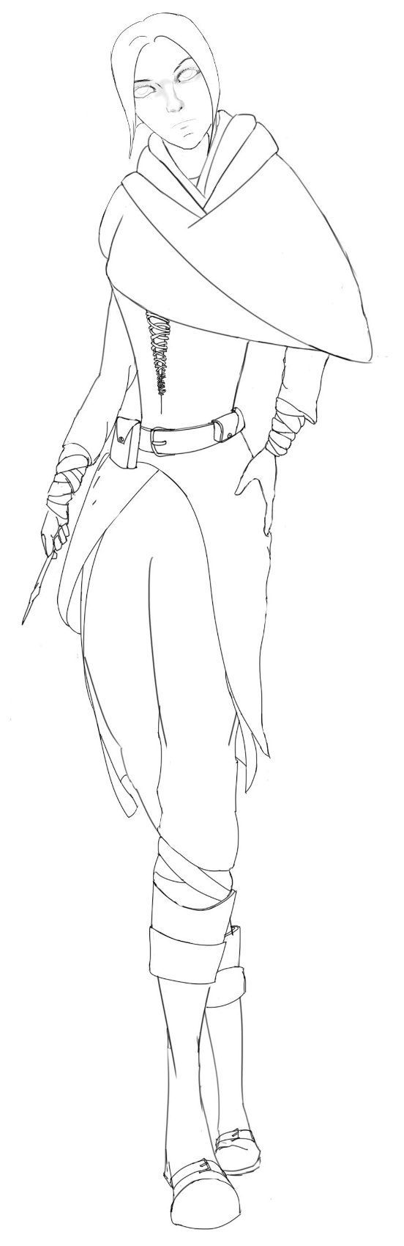
The pose itself has changed slightly to a more comfortable looking position, as well as giving it a bit more personality and making it less static. The overall look I believe is better, but is still subject to change.

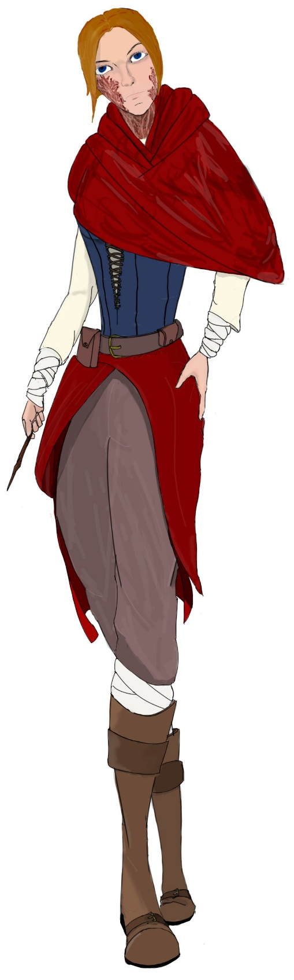
This was coloured using the same technique as the last but as I learnt from painting the last one there are some minor improvements to the colour overall. The burns have been a bit more intensified as it is a crucial part to the characters personality and in the previous version she didn’t look much like she had been burnt at the steak, as well as the burns on her face looking somewhat similar to nine o’clock shadow.

Project thoughts
Currently I believe the project is moving at a good pace and I am in a good position to start modelling the characters, we know what we want the character to look like and who she is as well as her actions within the animation. Before modelling does take place I will be making sure everyone is one hundred percent happy with what we have got and make any changed if need be.

