

Cover Page

BSc Health and Social Care
Changemakers: Creativity and Value Creation
BMHP5014

Component 1: Online Portfolio of Set Exercises

Student Name: Hajar Orriti
Student ID:232810 1
Lecturer: Dr. Precious Osayuki Igbinigie

Task 1 – Concept Map
Create a concept map that outlines the relationship between creativity, value creation, and health and social care improvement. Within the concept map, explain how these concepts interact in a health and social care context (250 words).
Please refer to week 1 content

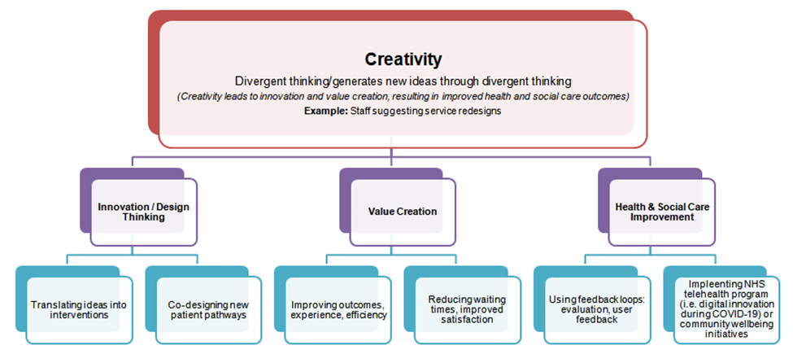

Figure 1: Relationship Concept Map
The concept map is drawn on Amabile's Componential Theory of Creativity (1983), explaining how creativity is evident from innovation, creative thinking, motivation, and value creation. —developing new ideas, which contribute to enhancing the health and social care environment/services. In this, some real-world examples are telehealth/telemedicine, AI diagnostics, etc., supporting accessibility, yet challenges can be digital inequality (Greenhalgh et al., 2016; Abdallah et al., 2025).

Task 1 – Concept Map
Figure 1 is a multi-level structural concept map, which primarily refers to creativity as the foundation for innovation. It works as a fuel engine to favour divergent thinking, ensure novel perspectives, and reframe existing issues (via creative processes like brainstorming/co-design), which enables health professionals to propose new solutions to patients (Abraham, 2016). Creativity relies on design thinking (works based on participatory strategies) to translate creative ideas into practical interventions.
This entire process leads to focus on the value creation (particularly in the health and social care field), which typically implements revolutionary solutions, contributing to improved patient outcomes alongside better staff and patients experience, high accessibility to the benefits, and cost reduction (Greenhalgh et al., 2016). Examples include telehealth and telemedicine for virtual/online appointments to optimise resources with a reduction in waiting times during the COVID-19 pandemic and community-based care approaches. Applying Amabile's Componential Theory of Creativity (1983), creativity is evident if professionals merge expertise, creative thinking, and intrinsic motivation in multidisciplinary health and social care teams (Abdallah et al., 2025).
However, leadership and robust organisational culture are the mediators, as the importance of supportive leadership, psychological safety, and resources is inescapable in enabling the workforce to experiment/bring creative ideas. Moreover, technology (i.e. telehealth, digital tools, AI, data analytics) enables and amplifies unique solutions for invention (Greenhalgh et al., 2016). Herein, feedback loops (via assessment, service-user feedback, and reflective working) advocate persistent progress due to which creative attempts are refined/implemented, which implies interconnectedness of the three discussed concepts (Abraham, 2016). Despite potential barriers of digital inequality and staff resistance to change, creative thinking, innovation, and value creation drive efficient processes, person-centred care, and enhanced patient well-being through fostering evocative action.

Task 2 - Self-Reflection of Group Activity
Complete a self-Reflection on the Convergent/Divergent thinking class activity using a reflective model (250 words, 1 source)
Please refer to Week 2 content.
With the help of Gibbs' reflective cycle (1988), the divergent/convergent thinking activity has been reviewed below—a group activity where I discussed leadership styles (i.e. transformational, transactional, situational, etc) with peers to explore their influence on creativity/decision-making in the healthcare sector.

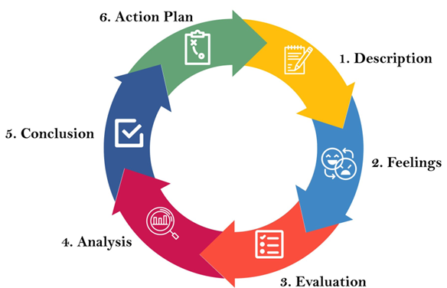
Figure 2: Gibbs' Reflective Model ​(1988)

Description: In this activity, I comprehensively researched to generate multiple ideas addressing leadership problems in the healthcare setting and then converged them into an effective solution (the most suitable leadership approach for innovation/enhanced patient care). In this regard, I discussed several strengths and weaknesses of all the styles with my group members.
Feelings: Initially, I felt uncertain about what kind of ideas could be helpful and what could be wild guesses, as I had not much knowledge about all three types of practicality. However, this feeling stopped me from continuing to participate at a point, yet I was motivated to share ideas and know others' perspectives.
Evaluation: Divergent thinking (based on group discussion) helped me focus on all the possibilities to explore a wide range of ideas/solutions (i.e. using AI or digital media for patient support), while convergent thinking enabled me and my group to select situational leadership as the best-fit style based on its feasibility/adaptability, effectiveness, and need.
Analysis: This class activity demonstrated the significance of creative confidence with both convergent and divergent thinking in developing options to resolve any issue and make a final decision (Zhu et al,2019). However, it could not assist in ensuring structured evaluation of how leadership can drive/hinder innovation, which is crucial to transform new ideas into practice/innovation.
Conclusion: The concerned activity highlighted my need to balance open ideation with creative brainstorming, criteria-centred decision and environmental dynamics.
Action Plan: In the future, I will focus on idea-generation criteria with inclusive participation and profound research before moving on, alongside adding a service-user to validate priorities and conduct a pilot test for a low-cost solution.

Action Plan: In the future, I will focus on idea-generation criteria with inclusive participation and profound research before moving on, alongside adding a service-user to validate priorities and conduct a pilot test for a low-cost solution.

Task 3 - Case Study of a UK innovation
Write a concise case study analysis of an innovative project or initiative within the NHS or UK social care. Focus on how creativity was used to drive change and the value it created for patients or service users (400 words, 2 sources).
Please refer to Week 3 content
Telehealth as Quick Innovative Responses for Chronic Disease Management: A Case Study of the

Overview: The NHS has been adopting numerous home initiatives for improvements for many years; however, its recent innovative project/initiative example was the introduction of telehealth and remote monitoring pathways in the UK (Salisbury et al., 2017). It not only focused on providing remote consultations to patients suffering from chronic and long-term conditions (i.e. COPD and heart failure) but also assisted their families in lowering waiting times in queues and reducing the need to admit patients to the hospital (McKinstry et al., 2021). This innovative and creative initiative of providing health support from home consisted of sensor technology, AI personalisation, self-management tools for patients, and clinician dashboards to continue care, which became significant during the COVID-19 pandemic due to lockdowns and the need to follow social distancing measures(Salisbury et al., 2017; McKinstry et al., 2021).
Creativity & Value Creation: In this case, the creativity was evident from the operations of clinicians and digital teams who started rethinking the existing issue and moulding it from 'hospital-centred service care' to 'supported self-management' via video, phone calls, and patient management apps (McKinstry et al., 2021). It was a valuable initiative due to reducing unnecessary hospitalisation, increasing patient confidence, and providing early intervention after detecting the deterioration. This technology-based approach supported personalised monitoring and focused on user-centric design (value created in Patient-Centred Care Area), provided remote consultation (value created in Efficiency Area), and engaged the rural population (value created in Accessibility Area).
Implementation Factors: To implement this innovation, some imperative factors focused on were effective leadership to leverage digital transformation, strong communication and collaboration between IT teams, clinicians, service-user groups, and pilot testing. Unfortunately, barriers faced in this journey were a lack of digital literacy and staff resistance at the initial stage. These challenges were mitigated through specific strategies such as proper training, co-designing with patients, and effective communication of possible benefits to the workforce (McKinstry et al., 2021).
Evaluation & Outcomes: NHS (all Trusts across the UK) reported a rapid reduction in the rates of emergency admissions alongside high patient satisfaction. Its sustained effects remained the long-term retention of existing workflows, high funding, and persistent growth with evaluation using defined metrics like admission rates (McKinstry et al., 2021).

Task 4 - Research Task
Identify a current issue in health and social care (e.g. e.g., mental health stigma, access to care for vulnerable populations). Find two pieces of academic research (journal articles) that explain the reason for this problem. Paraphrase the findings of each article (300 words, 2 sources).
Please refer to week 4 content.

Social Isolation in Older Adults
In recent times, the health and social care (H&SC) sector has been dealing with numerous issues of patients. Still, the most current problem affecting the UK aged population is the social isolation among older adults, a feeling of loneliness. According to Blazer (2020, p.990), today, this issue has become an inevitable public health concern, particularly in higher-income countries, because it directly causes poorer mental and physical health of individuals. Blazer (2020) worked on previous research (Kemperman et al., 2019) concept and found multiple reasons for loneliness in people over 45 years, including lack of social circle/participation, mobility and sensory impairments, social-demographic and environmental constraints.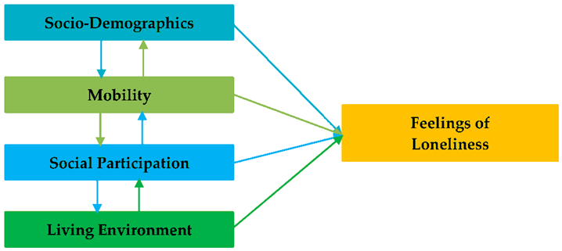

Figure 3: Factors Causing Social Isolation in the Ageing Population (Kemperman et al., 2019)
On the contrary, another quantitative research presented by Iamtrakul and Chayphong (2022) underscored that 64% of chronic diseases in the older population (aged 60 or above) living alone cause social loneliness. To avoid this mounting issue, effective intervention to overcome this issue can be community-centric befriending services that can be offered to older people via digital platforms; intergenerational programmes connecting youngsters (i.e. students) with older adults through some shared activities; and mobile outreach to keep an eye on the vulnerable population's health checks and their social engagement in different events.
A recent study (Paquet et al., 2023) supported these actions by highlighting that combined social and health interventions, such as (e.g., befriending with activity-based approaches), can be effective than a single-component intervention. Similarly, technology can play a vital role in reducing geographic barriers to engage older adults in different activities to overcome their social isolation; however, it is only possible through digital inclusion support at the governmental level. Moreover, its implementation relies on accessibility of the older population, cultural suitability, and sustainable funding (Iamtrakul, 2022; Paquet et al., 2023).

Task 5 - Podcast
Record a two-minute Podcast introducing your idea for component 2 using https://www.rev.com/onlinevoicerecorder The MP3 audio must be downloaded and embedded as a file (see guidance video on how to do this here: https://www.youtube.com/watch?v=D21isId0agw) or an accessible OneDrive link if using a chromebook (make accessibility – anybody) before inserting into your portfolio. Check the accessibility of the link before submitting.
Please refer to week 4 & 6 content.

[please insert file or link here]

Task 6 - NHS Leadership Framework Analysis
Write a short summary (200 words) explaining the key components of the NHS Leadership Framework. Then, choose one component and describe (150 words) how a leader might use it to encourage creativity and improve care in the NHS (2 sources).
Please refer to week 7 content.
Summary: The NHS Leadership Framework typically promotes considerate and inclusive leadership behaviours/competencies to support the workforce, bring improvements, and ensure improved patient outcomes in healthcare management (Collins et al., 2020). Its core components are inspiring shared vision, providing quality care, involving teams, assessing service quality, and benefiting people. This framework generally maintains psychological safety for staff's experimentation, reports existing problems, and proposes innovative solutions through significant leadership styles (i.e. transformational promoting creativity, transactional favouring performance, or situational style promoting adaptability). The framework recognises that NHS Leaders are accountable for communicating organisational vision clearly, involving all stakeholders, and eliminating implementation barriers. For creativity and value creation, NHS leaders are responsible for allocating resources efficiently, adopting risk-tolerant behaviour for safe trialling, and promoting the culture of evaluation and scaling processes (Collins et al., 2020).
The NHS Leadership Framework mainly depends on the transformational leadership style for sharing a clear vision, promoting creativity, and encouraging healthcare teams to adopt change/innovation (Collins et al., 2020). The NHS's transformational leaders adapt to the behaviour of inspiring a collective vision, being a risk-taker, and accepting novel ideas. This kind of leadership style in the NHS reduces the fear of failure and engages staff to share solutions to existing challenges by incorporating technology and contributing to patient outcomes. For example, transformational leadership of the NHS allowed introducing the telehealth medium (innovation with collaboration) to reduce long waiting times and provide remote/home consultancy (Greenhalgh et al., 2016; Salisbury et al., 2017).

Task 7 - Self-Reflection Journal Entry
Write a short journal entry about what you learned in this module. Focus on how your understanding of creativity and value creation withing H&SC has changed and how it has informed your professional practice (200 words).
Please refer to week 9 content.

This module proved to be a life-changing experience for me and worked as a turning point for my knowledge. For instance, it significantly enriched my understanding of major concepts, including creativity and value creation and their relationship, particularly in the health and social care sector. It informed me that patient-centred innovation is crucial for significant improvements in healthcare/patient outcomes. By analysing numerous case studies in this module, I found what kinds of basic leadership styles are available for the healthcare sector, like the NHS and what specific style (transformational leadership) is adopted within the system to foster a creative and supportive culture. In this module, I learned that advanced technology (i.e. AI, telehealth, etc) is essential for efficiency, but still its challenges (digital literacy, staff resistance, security, ethical application, etc) can exacerbate healthcare inequalities. Throughout this module, I progressively connected theoretical models of creativity with practical approaches such as design thinking as a problem-solving approach, use of divergent and convergent thinking to propose solution(s), and focus on effective value creation that comes from the combination of creativity, innovation, extensiveness, teamwork, and ethics (Abraham, 2016). After being a part of this module, I am confident enough to perform well as a leader in the health and social care sector in future by adopting these principles. I will further apply my lessons in my academic, personal, and professional life by proposing suitable and required solutions (as a small-scale pilot of the Digital Befriending Hub proposed above).

Reference List

Abdallah, A., Yunfei, S., Opoku‐Mensah, E., Ankrah, S., and Tuffour, Priscilla., (2025). From Green Human Resource Management to Sustainability: Examining Direct and Configurational Mechanisms Through the Componential Theory of Creativity Creativity and Psychological Safety. Creativity and Innovation Management, pp.1-60.
Abraham, A., (2016). Gender and creativity: an overview of psychological and neuroscientific literature. Brain imaging and behavior, 10(2), pp.609-18.
Blazer, D., (2020). Social isolation and loneliness in older adults—a mental health/public health challenge. JAMA psychiatry, 77(10), pp.990-91.
Collins, E., Owen, P., Digan, J. and Dunn, F., (2020). Applying transformational leadership in nursing practice. Nurs Stand, 35(5), pp.59-66.
Gibbs, G. (1988). Learning by Doing: A Guide to Teaching and Learning Methods. Oxford Polytechnic.
Greenhalgh, T., Jackson, C., Shaw, S. and Janamian, T., (2016). Achieving research impact through co‐creation in community‐based health services: literature review and case study. The Milbank Quarterly, 94(2), pp.392-429.
Iamtrakul, P. and Chayphong, S., (2022). Exploring the influencing factors on living alone and social isolation among older adults in rural areas of Thailand. International journal of environmental research and public health, 19(21), p.14572.
Kemperman, A., Berg, P.v.d., Weijs-Perrée, M. and Uijtdewillegen, K., (2019). Loneliness of older adults: Social network and the living environment. International journal of environmental research and public health, 16(3), p.406.
McKinstry, B., Alexander, H., Maxwell, G., Blaikie, L., Patel, S., Guthrie, B., and Group, Technology Enabled Care TeleCOVID (2021). The use of telemonitoring in managing the COVID-19 pandemic: pilot implementation study. JMIR formative research, 5(9), p.e20131.
Paquet, C., Whitehead, J., Shah, R., Adams, A., Dooley, D., Spreng, R., Aunio, A., and Dubé, L., (2023). Social prescription interventions addressing social isolation and loneliness in older adults: Meta-review integrating on-the-ground resources. Journal of Medical Internet Research, 25, p.e40213.
Salisbury, C., O’Cathain, A., Thomas, C., Edwards, L., Montgomery, A., Montgomery, A., and Hollinghurst, S., (2017). An evidence-based approach to the use of telehealth in long-term health conditions: development of an intervention and evaluation through pragmatic randomised controlled trials in patients with depression or raised cardiovascular risk. Programme Grants for Applied Research, 5(1), pp.1-468.
Zhu, W., Shang, ., Jiang, W., Pei, M., and Yanjie, A., (2019). Convergent thinking moderates the relationship between divergent thinking and scientific creativity. Creativity Research Journal , 31(3), pp.320-28.

