Sabba Shahzad (2025733)
Jonathan Wyatt
work-related stress faced by uk employees
Problem solving and decision making
(BMSW4004)
Task 2

Contents

Introduction – Page 2
The nature and impact of the complex problem on employees and their organisations – Page 3
Cause-and-effect analysis of the complex problem – Pages 4-5
PESTEL analysis of the macro-environmental factors contributing to the complex problem – Page 6
Evaluation of alternative solutions to work-related stress with an aim of choosing the most appropriate solution among these alternatives – Page 7
Plan to implement the decision and success indicators to measure the effectiveness of my decision – Pages 8-9
Conclusion – Page 10
References – Page 11

Introduction

In this report I will be explaining the points that I spoke about in Task 1 of my assignment which I have mentioned within my contents page (page 2). I will also be presenting a plan to that I used to make the decision I did to solve the problem of work-related stress faced by UK employees as well as discussing the success indicators to determine how effective my decision was.
Work-related stress is affecting many people within the UK which is having a huge impact on their health mentally, physically, and emotionally. Stress has become very common as a lot of people now struggle with it. The main cause for UK organisations becoming unsuccessful is stressed employees. Due to work-related stress employees are lacking performance which has a huge impact on organisation success as employees are not motivated as well as not working to the best of their ability.

The nature and impact of the complex problem on employees and their organisations

Work-related stress faced by UK employees is when employees are not mentally and emotionally stable. Stressed employees are impacting organisations within the UK massively as they are failing. This is due to individuals lacking work performance; they are less motivated and not working to the best of their ability. Work-related stress is a massive problem as it is causing many employees to be absent from work whilst others just cannot cope and have to quit their jobs. This is leaving businesses with less experienced staff and ultimately forcing them to pay training costs for new recruits which is resulting in organisations losing money and becoming unsuccessful.
The complex problem is affecting businesses massively as many employees are having to quit their jobs in order to focus on themselves and improve their health due to the impacts stress has had on them. As a result of this it is affecting businesses causing them to potentially lose customers and receive more frequent complaints as they have inexperienced staff who don’t always have the best communicational skills. Lack of valuable skills makes it hard for an individual to know what is expected of them especially at work.
‘Stress damages productivity’ (Hannah Weinhold, July 2018). This is because many employees within the UK who are suffering with stress are unable to concentrate at work and feel disengaged. Employees are lacking motivation and determination which is causing them to provide a negative service to their customers even when they don’t mean it. This is also due to many stressed employees in the UK suffering in silence. Stressed employees tend to isolate and deal with the problem alone which can worsen the problem due to the effects it can have on an individuals health causing long term and critical illnesses. This can have a huge toll on the businesses success as well as finances which can result in a business failing completely.
‘All the above will result in a deterioration in the company or organisation performance, in terms of sales and profitability’ (Liz Makin, September 2017).

Cause-and-effect analysis of the complex problem

To understand the causes of work-related stress faced by UK employees I used a cause-and-effect analysis called Fish Bone Analysis. I will be discussing what I determined from the method I used; I began with identifying what the effect was for work-related stress and then expanded by suggesting what I believed to be the causes of the problem. The following diagram is my Fish Bone Analysis.
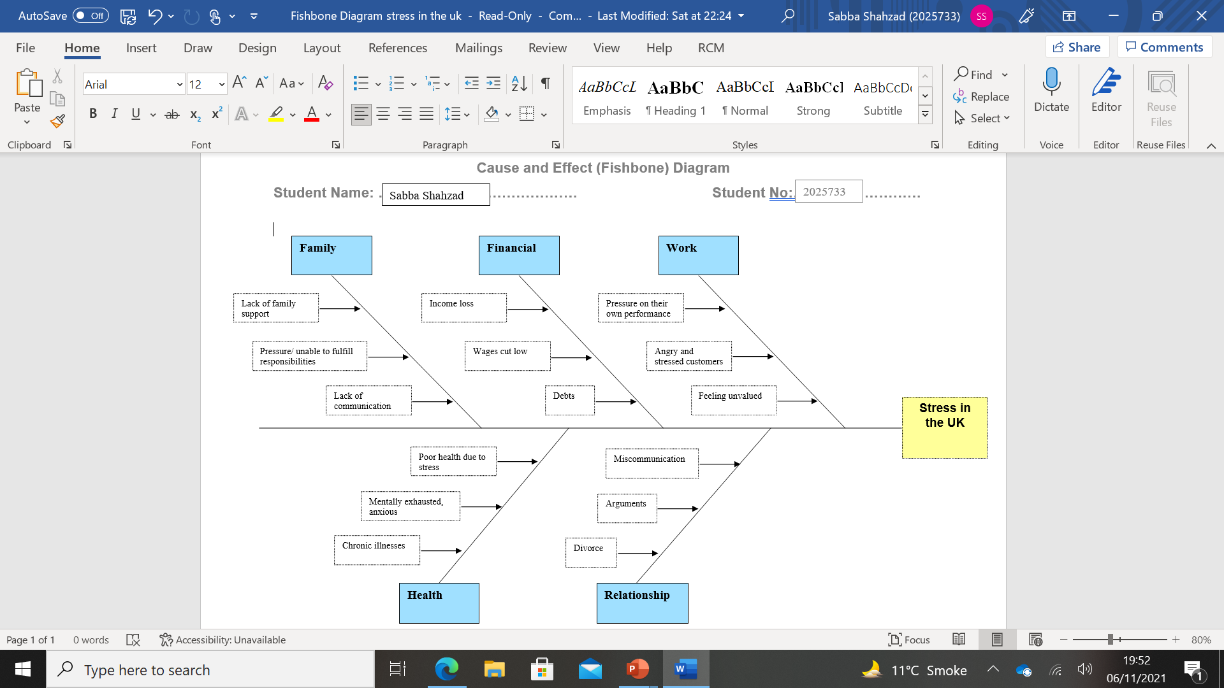
I believe the causes for work-related stress faced by UK employees is due to family, finances, work, health, and relationship.
Family stress can be caused by either family pressure or lack of family support. Individuals feel a sense of relief with family support however sometimes, when struggling with stress it can make it harder for one to open up to family about struggles and issues making stress a lot worse.
Financial stress can be caused by either wages being cut low or income loss due to losing a job potentially.
Stress can also be caused due to work and this can often impact ones work performance. During the work environment employees often face people who are complaining, shouting, angry and arguing and this can sometimes make employees feel unvalued and disrespected which can cause them to become stressed. When this happens employees often lack performance at work and tend to be less determined and less motivated which leads to businesses becoming unsuccessful.
Stress also impacts ones health due to the strain it can have on the body. It can make someone feel mentally exhausted. Constant stress for a long period of time can affect health in various ways. A person can develop a number of illnesses from stress which can force them to become absent from work. Also, stress can sometimes affect the memory causing people to suffer with memory loss due to their mental health not being stable.
Relationships can also be another reason as one suffering with stress is most likely to isolate themselves and be out of character. This can lead to miscommunication, arguments, falling out and if married divorce even.

PESTEL analysis of the macro-environmental factors contributing to the complex problem

A PESTEL analysis is when we look at impacts from the outside of an organisation which may be causing stress in employees. In a PESTEL analysis we look at the following factors: Political, economic, social, technological, environmental, and legal and how they are contributing to the problem of work-related stress faced by UK employees.
Politically since the Covid-19 outbreak the government has suggested it is vital for all employees working within the NHS to get the coronavirus vaccinations in order to stay employed however, some NHS workers have refused. Due to not following government policy many employees in the NHS are losing their jobs. This is causing health stress to arise in employees.
Economical can cause financial stress due to debts/arrears. This can be because of less work hours or lower wages. This has a connection with the political factor due to not following government policy, losing their job, and income loss.
The social factor can cause health stress in UK employees as they can be mentally, physically, and emotionally affected due to bullying, discrimination and feeling devalued.
Technological causes financial as well as health stress. Financial due to losing a job meaning no income. Health caused by work overload. Work overload can have a strain on employees as they constantly worry about failing, not satisfying customers and if they are at risk of potentially losing their job. It also causes employees to make more frequent mistakes at work.
The environmental factor can cause health stress due to pollution. This is because many employees are either absent or have lost/quit their job due to stress forcing employers to get cover staff and the travelling is causing more pollution in the environment. Pollution affects the health negatively.
Finally, legal factors can trigger family, relationship, and financial stress. Family stress can be caused by family breakdowns due to unfulfillment of responsibilities. Relationship stress can be caused by disagreements, arguments, divorce, and domestic abuse. In worst case scenarios both of these causes of stresses can also cause financial stress due to court fees.

Evaluation of alternative solutions to work-related stress with an aim of choosing the most appropriate solution among these alternatives

To evaluate, there are many solutions employers can use to minimise work-related stress in their employees some of which are:
- Employers can try to hire more employees as it can reduce work overload. Work overload can cause an individual to make more frequent mistakes. Employers should not expect employees to take on more work than capable regardless of a rise in sales. If sales increase the number of staff within the organisation must also increase.
- Employers should engage with, respect, value and praise their employees more. They can offer extra training to allow employees to develop in their career and give them greater job opportunities. Rewarding employees reduces stress and improves employees work productivity leading to organisational success.
- Employers should take more of an interest in their employees. They should take time out to get to know their employees and try and interpret what they like within their time at work. For example, get to know what an employee likes and get it for them for their birthday or as a thank you gift for their hard work and appreciation. Showing interest in your employees interests will definitely make employees feel more engaged with and welcome.
- Employers should encourage employees to take annual leave when they recognise lack of work performance. This does not mean employers bring up the fact that they have noticed a change in their employees work performance or ask personal questions. Employers should try and discuss the benefits of taking time off work to their employees and the importance of focusing on themselves.
- Employers should resolve problems as soon as to prevent them from escalating. Employers could emphasise the importance of team effectiveness and the impact it has on business success. A friendly work environment can surely reduce stress and make one more willing to come into work every day.
I believe the most appropriate solution is alternative 2. I determined this decision by using a PMI (Plus, minus, interesting) analysis. This allowed me to overview the positives, negatives, and interests.

Plan to implement the decision and success indicators to measure the effectiveness of my decision

In order to implement my decision I used a method called PMI analysis. PMI stands for Plus, minus, interesting. It is a method which allows you to brainstorm and expand upon the positives, negatives, and interests of a decision. Once the pros and cons have been weighed up the PMI analysis enables you to finalise a decision in this case come up with the most appropriate solution to reduce work-related stress faced by UK employees.
Based off of my PMI analysis I believe the most appropriate solution is alternative 2; ‘Employers should engage with, respect, value and praise their employees more. They can offer extra training to allow employees to develop in their career and give them greater job opportunities. Rewarding employees reduces stress and improves employees work productivity leading to organisational success’ and this is how I determined my decision; my PMI is available below:
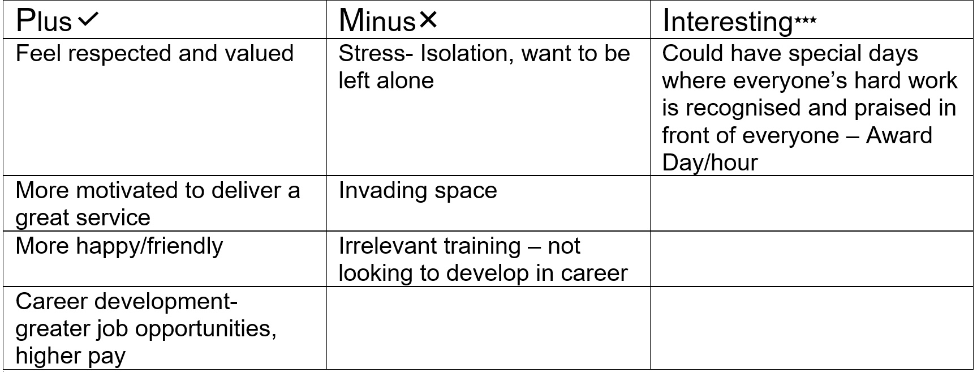

By using a PMI I was able to brainstorm both the positives and negatives of my decision and the positives outweighed the negatives.
This solution can successfully reduce work-related stress faced by UK employees as they will feel respected, valued, and happy which means they will be more motivated to provide their customers with great customer service. Also, the career development will offer employees greater job opportunities sometimes with a higher wage meaning financial stress will not be something they suffer with.
Furthermore, there are negatives however once a stressed employee realises they are cared for and their feelings are being put into consideration by their employer it will reduce the stress.
Using the information I got from my PMI I believe that the decision I made on the most appropriate solution for the complex problem will definitely ease work-related stress in employees. This means my decision was effective. Stressed employees within the UK are most definitely common however, I believe with my decision on the solution the number of stressed employees in the UK can majorly be reduced as employers show their employees they are valued and their hard work is always recognised.

Conclusion

To conclude, stress has/is affecting many employees within the UK however, there any many ways in which employers can reduce the level of stress within the work environment. Stressed employees have a huge impact on business success therefore, employers need to try to ensure they can minimise stress as much as possible in their employees.
Work related stress may have increased especially due to the covid-19 pandemic and work overload however, as it is slowly calming down I believe employers should start to think of ways in which they can make thing somewhat normal again at work in order for employees to want to come to work daily.
Work related stress especially in the UK affects many individuals however, if employers put their employees first and try and reduce the chance of work-related stress by putting their employees into consideration we as a nation can 100% succeed in our businesses.

References

7 Simple Ways to Reduce Stress in the Workplace (quantumworkplace.com)
20 Ways Employers Can Reduce Stress in the Workplace - Harish Saras
Beat stress at work | NHS inform
Plus Minus Interesting (PMI) framework for lateral thinking [Free template] (conceptboard.com)
The 2020 UK workplace stress survey | Perkbox
The impact of stress on businesses and organisations, Online Courses, Business Mentoring, Business Coaching, Stress management, Tips (makinithappen.co.uk)
What Is The Impact Of Workplace Stress On Productivity? - Wellspace (yourwellspace.com)
Work-related stress, anxiety or depression statistics in Great Britain, 2019 (hse.gov.uk)
Work-related stress | Health Information | Bupa UK

