- Introduction

Communication is the process of exchanging information between two or more individuals and comprise three elements: the sender who sends the information, the message which needs to be delivered, and the receivers who receive the information. The transmission of messages from sender to receiver could be affected by noise (Nordquist, 2019).

Since the beginning of time, humans have used a variety of communication methods. First, they used smoke signals, which China used the most, and then the carrier pigeon, which delivered human letters. In the pre-modern era, people communicated using the following methods: the postal system, newspapers, radios, telegraphs, telephones, televisions, the internet, email, and text messages. Nowadays, we could communicate with one click on social media, which is quick and cheap (KalamTime, 2021).

- Models Of Communication
Although there are many models of communication, in this module we have studied only three of them, so I will explain Shannon and Weaver, Schramm's model, and Berlo's model below.
  - Shannon and Weaver model
“The Shannon and Weaver model is a linear model of communication that provides a framework for analysing how messages are sent and received (Drew, 2019).” It has been created in 1948 and have six concepts:
- Sender (Information source) – The sender is the person who composes and sends the message.
- Encoder (Transmitter) – An encoder converts the message into a signal or binary data using a machine.
- Channel – Through channels, messages are sent out to the recipients.
- Decoder (Receiver) - The function of a decoder is to convert signals or binary data into messages, or to receive signals and translate them into messages.
- Receiver (Destination) - In general, the receiver is the recipient of the message or the place where the message is to be delivered.
- Noise - In simple terms, noise is anything that interferes with the delivery of a message, such as the environment, people, etc., which prevents the message from reaching the intended recipient.

`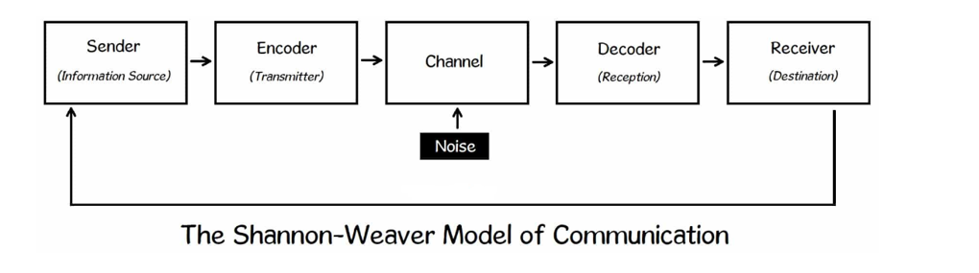

The purpose of this post is to explain the Shannon and Weaver communication by sharing the case study of Maria and Pedro as well as some additional examples:

Pedro was working outside on construction in a noisy environment when his wife Maria called him and asked if he would be able to buy a chicken after work. He responded in the affirmative without hesitation. Pedro immediately went to the kitchen when he arrived home and Maria asked him where the chicken she had requested was. Pedro responded with which chicken, as you asked me to come to the kitchen after work. The above case study illustrates how the messages from Maria (Sender) were transmitted incorrectly to Pedro (Receiver). He was working outside where there was a lot of noise, and instead of asking his wife to repeat what she was saying or to call her back and confirm before returning home, he just went to the kitchen, as he thought his wife had asked him to meet her there. We can see how noise affects communication based on Shannon's model.
The hotel where I work uses Woki Toki to communicate between staff, and every department has a channel to use it. One day, the reception called us and asked if we could help a guest from room 332. During that moment, I was in the breakfast area, which was very busy, and understood room 222. In lieu of asking the reception to confirm the room number again, I knocked on the door, but nobody answered, so I opened the door with my key and there was a couple. This is another example of how noise affects how messages are sent.

  - Schramm (1954)
The Schramm model is defined as a cyclical communication model in which a message or information, as well as its feedback or acknowledgement, passes back and forth between sender and receiver. According to this model, the message should be understood between the sender and the recipient, and it was first developed by Wilbur Schramm in 1954 (Bhasin, 2020). Schramm’s models have the following elements:
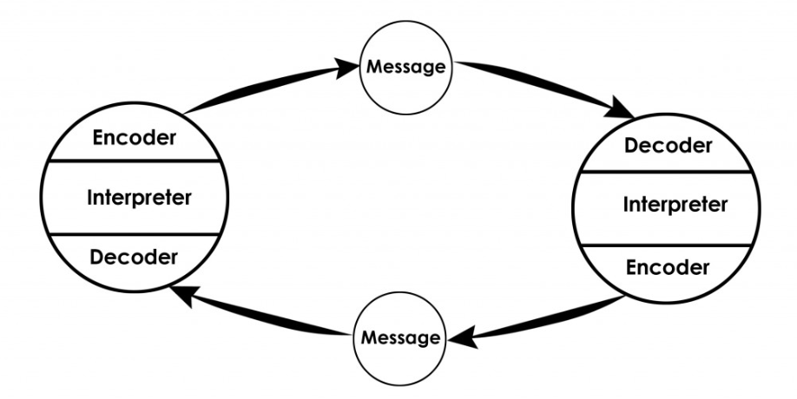

- Source – The source is the sender who wants to send a message. He is identified as a source because he is responsible for composing a message that must be sanded. It is important that the message is clear and easy to understand for the receiver. In this model, the source of a message represents the originating element from which communication begins, but it is also the point at which the communication concludes. In other words, the sender becomes the receiver and vice versa (Bhasin, 2020).
- Receiver – A receiver is the individual who receives a message from a sender and is often called a decoder. As Schramm points out, there are several factors to consider in order to ensure that the decoded message was understood. Also, the receiver must be able to understand the source correctly, and both parties should share certain characteristics, such as language, culture, understanding, etc. Because messages cannot be decoded if the sender does not speak the same language as the receiver (Bhasin, 2020).
- Message – A message is the content that is sent from the sender to the receiver. It may take the form of text, audio, video, or a combination of all of these components. The form of communication depends on the sender and the recipient and messages might be verbal or non-verbal. In every communication model, messages play an incredibly significant role as if the recipient receives the message, then it means communication has been successful.
- Feedback – Feedback is a process in which the receiver transmits data from the sender, meaning the receiver decoded and understood the messages sent by the sender. It is crucial for the sender to get feedback on whether the receiver understood the message correctly. As a result, communication becomes more effective (Bhasin, 2020).
- Noise - Messages are disrupted by noise, resulting in a failure of the message and the communication process. As a result of noise, the message is diluted, as well as the meaning of the message may be altered (an example is Maria and Pedro case study). If the Maria and Pedro case study was used the Schramm model, Maria should receive feedback from Pedro which confirms that he received the message to buy a chicken not to come to the kitchen.

  - Berlo (1964)
The SMCR model developed by Berlo is similar to others and is a linear model without feedback. He identified the factors that may influence communication in his model. As described by Berlo in his 1960 model of communication, the SMCR model describes the various components that make up the basic communication process. Berlo SMRC model is composed of four components, and everyone has them factors which could affect communication:
- S-Sender – Communication Skills, Attitude, Knowledge, Culture.
- M-Message – Content, Elements, Treatment, Structure, Code.
- C-Channel – Hearing, Seeing, Touching, Smelling, Tasting.
- R-Receiver – Communication Skills, Attitudes, Knowledge, Social System, Culture
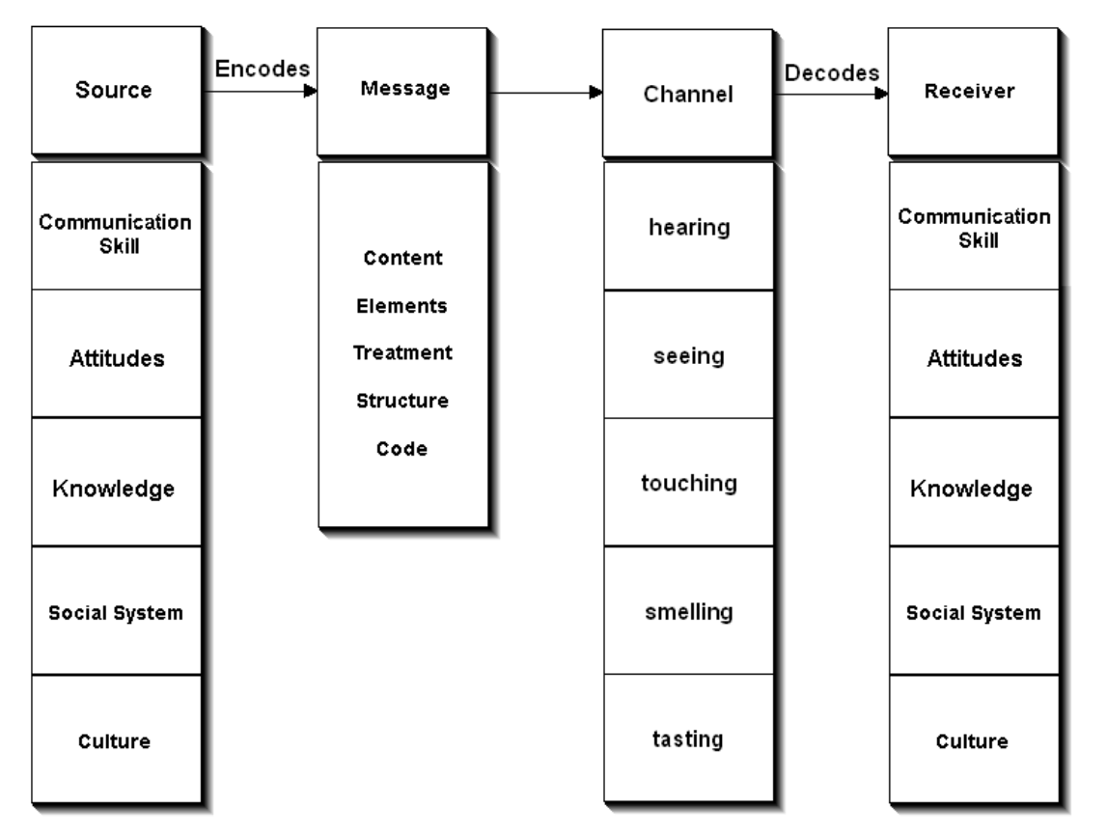
(businesstopia, 2018)
Among Berlo's criticisms was the absence of any noise in his model, which might affect communication, as well as the lack of feedback included. Furthermore, the persons between whom the communication takes place should be very similar to ensure successful communication according to Berol's model.
As an example of Berlo’s model is the Professor and the Village People case study. Professor asleep while smoking his cigarette and because of this, started a fire. He went to the Village and started to scream to the people with advanced academic phrases such a “The edifice is being consumed by a great conflagration!”. People totally ignored him as they did not understand his academic language. As in this case study, it is very easy to understand Berlo's model since there is a big difference between Sender and Receiver. Most messages cannot be delivered to the Receiver as communication skills, attitude, knowledge, and culture negatively affected delivery. The people would understand and help the professor if he came to the village and said, "My house is on fire.".

- Communication Skills
  - Verbal Communication – Any communication that involves the use of words in order to transmit information is considered verbal communication. In addition to being spoken, these words may also be written (Skillsyouneed, 2011). We also have to pay attention to the words we choose, tone, and pitch to have a successfully verbal communicating. We have four types of verbal communication:
- Interpersonal – The term interpersonal refers to a one-on-one conversation with a person. It may be conducted over the telephone, in person, or on the Internet.
- Intrapersonal – In interpersonal communication, you talk to yourself or act on your imagination. As an example, you plan your day for tomorrow and see what you can accomplish.
- Small group communication – Small group communication refers to communication that involves more than two people. The size of the group should be such that everyone is able to interact with each other.
- Public communication – A public communication occurs when one person speaks to a group of people. An example of this is when we presented our presentation in front of the class (harappa.education, n.d.).
  - Non-Verbal Communication – Communicating non-verbally refers to sending a message by using body language, facial expressions, or gestures without talking. Non-verbal communication we are using separately or together with verbal communication. An example is when we have a public communication and to be successful, we should use both verbal and non-verbal communications.
Case Study – A Day with the Chief
Mark uses both verbal and nonverbal communication in this case study. I would do completely different than Mark did at the meeting with his CEO, Mrs. Brown, if I were in Mark's position. As soon as she asked him about the company's fit with his own professional goals, with legs crossed, he started ranting about how wrong the London Office is and how people should be paid better. A poor choice of words was used in this case, as your problems should have been discussed with your local manager not at your reward meeting with the CEO.
Since I am working in a hotel, one of my coworkers has autism, and she loses her speech when she has a meltdown. In order to encourage her and show that we care, I use both verbal and nonverbal communication. She is answering with both text (verbal) and body language (nonverbal).
  - Listening
Communication and success as a professional are based on listening skills. Many people confusing Listening with Hearing:
- Hearing - The ability to hear is the ability to detect sounds physically. In physiological terms, it is the act of receiving sounds.
- Listening - When you are listening, you must pay attention to both verbal and nonverbal communication, as well as determine the meaning of the messages being sent. Fostering interpersonal relationships with colleagues, leaders, and clients requires effective listening (Quintanilla and Wahl 2020).

- Advantages and Disadvantages of Communication Technology
With the time Communication Technology make the communication much easier but bring and advantages and disadvantages:
- Advantages
- Access the information
- Improve communication
- Social Media
- E-Commerce
- Gives voice to those who normally wouldn't speak up
- Disadvantages
- Reduce face to face communication
- Bullying and cyber-skyping
- Unsafe (Ramey, n.d.).

- Conclusion
Our ability to communicate with people is one of the most significant tools we possess. It has been demonstrated that if we are to build meaningful relationships with service users, careers, and other individuals, we must possess strong communication skills. Taking the time to communicate properly can be very helpful in resolving several concerns and issues. To live a fuller and happier life, one must communicate their thoughts and feelings. Therefore, it is of paramount importance to learn the art of effective communication in order to effectively convey one's message.

Drew, C. (2019). 7 Key Concepts | The Shannon-Weaver Model of Communication. [online] The Helpful Professor. Available at: https://helpfulprofessor.com/shannon-weaver-model/.

Bhasin, H. (2020). Schramm model of communication | Elements, Advantages & o understand sometLimitations. [online] Marketing91. Available at: https://www.marketing91.com/schramms-model-of-communication/.

businesstopia (2018). Berlo’s SMCR Model of Communication - Businesstopia. [online] Businesstopia. Available at: https://www.businesstopia.net/communication/berlo-model-communication.

Skillsyouneed (2011). Verbal Communication Skills | SkillsYouNeed. [online] Skillsyouneed.com. Available at: https://www.skillsyouneed.com/ips/verbal-communication.html.

harappa.education. (n.d.). Verbal Communication - Types, Meaning And Definition Of Verbal Communication - Harappa. [online] Available at: https://harappa.education/harappa-diaries/verbal-communication-and-its-types.

Ramey, K. (n.d.). Advantages and Disadvantages of Communication Technology in an Organization |. [online] Available at: https://useoftechnology.com/advantages-disadvantages-communication-technology-organization/.

Nordquist, R. (2019). Learn About the Art of Communication and See How It’s Used Effectively. [online] ThoughtCo. Available at: https://www.thoughtco.com/what-is-communication-1689877.
‌
KalamTime (2021). Evolution of Communication from Ancient to Modern Times. [online] KalamTime Blog. Available at: https://www.kalamtime.com/blog/evolution-of-communication/.
‌‌
Liubinienė, V. (2009). Developing Listening Skills in CLIL. [online] Available at: https://www.kalbos.lt/zurnalai/15_numeris/14.pdf. Pg.89

Quintanilla, K. M. and Wahl, S. T. (2020) Business and professional communication: KEYS for workplace excellence. Fourth edition.; International student edition. Los Angeles: SAGE pg.93

‌

‌

‌

‌

‌

Shannon and Weaver Model of Communication - Businesstopia
What is Communication? Verbal, Non-Verbal & Written | SkillsYouNeed

