

Task 1 – Reading Task Template
Upload your photo of your A3 in-class notes here:
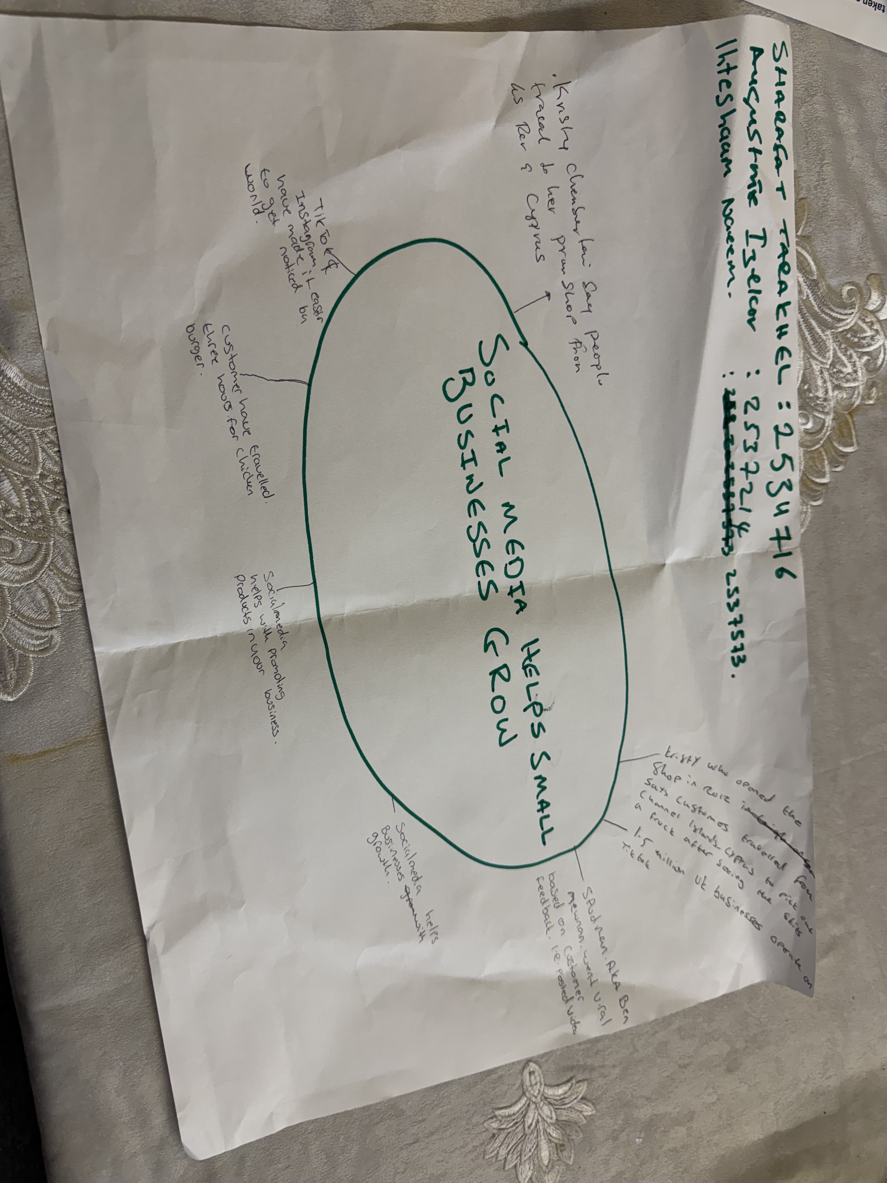

1. Answer these questions using the sentence starters below
a. What is the main idea of the text?
The main idea is social media platforms like TikTok and Instagram have transformed small, local businesses into viral sensations, allowing owners to turn "likes" into sustainable livelihoods through authentic, person-to-person marketing.
b. What are two key points?
One key point is that viral content, even when posted by customers rather than the owner can drive massive physical footfall, with people traveling hours or even across countries to visit a specific shop.
Another key point is the shift in marketing strategy where "people buy from people," meaning that relatable, authentic skits and "subliminal marketing" are now more effective at building brand awareness than traditional advertisements.

c. What part of the text did you find most important? Why?
The most important part is the insight from marketing expert Faye Martin regarding "authentic, relatable" content, because it explains the psychological reason why consumers are drawn to viral businesses, they prefer genuine human connection over being directly sold.
d. Was anything unclear or difficult to understand?
I was not sure about how these small businesses managed the logistical challenges of a "tenfold" increase in trade or how they maintained quality when their customer base suddenly exploded overnight due to a viral trend.
e. How did your group help you understand the text better?
My group helped me by discussing the various examples provided, such as the sandwich shop and the prom dress boutique, which helped me see that viral success applies to many different types of business sectors.
3. One sentence reflection
I have learned that digital literacy and a strong social media presence are now essential tools for business growth, as they allow even the smallest side hustle to reach a global audience.
Question: What did you find challenging about this task?
The hardest part was selecting only two key points from the text because there were so many impactful examples of how digital skills have fundamentally changed professional practice for modern entrepreneurs.

