Student Name: Ionela Lacramioara Balta  Student ID: 2208099  Module Title:Foreign language and cultural awareness  Module Code:BMIH5003  Lecturer:Lisa Bassler  Date:09-02-2024 | 
ASSIGNMENT 1: PORTFOLIO
(4 Components)

Component 1: Professional Reflection (500 words +/- 10%)

Weighting: 25%
Throughout my Level 4 placement at Premier Inn in Corby, my responsibility was to ensure that visitors got attentive service throughout breakfast. One morning, a guest from the Middle East was observed diligently scouring the buffet in quest of something. In an effort to assist, I approached the individual and, upon observing that his plate was devoid of food, recommended the bacon and eggs dish, which is favoured by several guests. Nevertheless, the guest appeared surprised and promptly refused, distancing themselves from the buffet. Perplexed by his response, I subsequently discovered that some individuals from the Middle East follow dietary regulations that forbid the consumption of pork, rendering my advice culturally offensive.
This particular episode exemplifies the potential for cultural misunderstandings stemming from a limited grasp of international dining protocols and religious dietary constraints. Regrettably, I unintentionally caused the guest discomfort by failing to take into account his cultural and religious customs while trying to offer assistance. Abramson and Moran (2018) stress the importance of developing a methodical comprehension of cultural disparities in order to anticipate and alleviate any challenges in cross-cultural engagements. Hofstede's cultural dimensions theory could have offered valuable insights into the high-context nature of Middle Eastern cultures. For instance, Middle Eastern civilizations have a collectivist orientation, prioritising close-knit family structures and social networks, where individuals are expected to demonstrate allegiance to the collective. Within this particular framework, food serves not only as sustenance but also as an integral component of the communal identity and religious practices (Hofstede Insights, 2023). The guest's dietary limitations are linked to a communal religious affiliation that forbids the consumption of pork. A comprehension of collectivism would have emphasised the significance of being attuned to community norms and practices, such as eating regulations.
To successfully overcome these cultural differences and improve the quality of service for guests, hospitality staff can implement certain essential developmental and behavioural modifications. Participating in thorough Cultural Sensitivity Training, which include an examination of Hofstede's cultural dimensions, may provide personnel with the necessary understanding to anticipate and honour the many cultural backgrounds of guests. Furthermore, implementing Inclusive Communication involves tactfully enquiring about visitors' dietary preferences or limitations to prevent making assumptions and to ensure that the service provided meets the specific needs of the guests (Maheshkar and Sharma, 2018). Finally, using Reflective Practices, such as Kolb's Experiential Learning Cycle, enables staff to examine and derive knowledge from their interactions, promoting ongoing enhancement in cultural proficiency and service provision.

References:
Abramson, N.R. and Moran, R. (2018) Managing Cultural Differences: Global Leadership for the 21st Century. 10th Ed. Abingdon: Routledge.
Hofstede Insights (2023). Country comparison tool. [online] www.hofstede-insights.com. Available at: https://www.hofstede-insights.com/country-comparison-tool?countries=saudi+arabia.

Maheshkar, C. and Sharma, V. (2018) Handbook of Research on Cross-Cultural Business Education. Hershey: IGI Global.
‌
Component 2: Training Plan (500 words +/- 10%)

Weighting: 25%

Identified cultural misunderstanding (in a few words) :
An staff at the Level 4 Placement Hotel unintentionally suggested bacon to a visitor from the Middle East, without considering the passenger's cultural and religious dietary constraints that forbid the ingestion of pork. This incident highlights a notable deficiency in cultural knowledge and sensitivity, stressing the necessity for extensive training in comprehending and valuing the varied cultural backgrounds of guests. The lack of cultural understanding and compassion among the hotel workers is shown by this error. It emphasises the immediate necessity for thorough training focused on promoting comprehension and admiration for the many cultural origins and preferences of visitors (Hofstede, Hofstede, and Minkov, 2010).
Training plan (Why/What//Who/Where/When):
In order to tackle and prevent similar cultural misinterpretations in the future, including regarding food inclinations, the Premier Inn in Corby has implemented a focused training programme. The main goal of this strategy is to improve the cultural awareness and communication abilities of the hotel's staff. This include the food and beverage crew, receptionists, and cleaning staff, providing them with the essential knowledge and skills to successfully understand and appreciate the varied cultural backgrounds of their visitors.
The training sessions are thoughtfully organised to occur on the hotel grounds, guaranteeing optimal accessibility for all staff members. The training programme is designed to span a duration of three months, taking into account the hotel's uninterrupted operation and the diverse schedules of its staff. This configuration enables the provision of sessions at different intervals throughout the day, encompassing morning, afternoon, and evening time periods. Such schedule flexibility guarantees that all staff members have adequate chance to participate without affecting the hotel's daily flow ( Hampden-Turner and Trompenaars, 2020).
The training delivery method has been diversified to include interactive workshops, e-learning modules, and lectures by guest speakers that specialise in cultural diversity and successful communication. This comprehensive approach aims to involve staff in hands-on activities and in-depth conversations, highlighting the crucial importance of cultural sensitivity in their day-to-day encounters with visitors. Anticipated is the creation of a learning environment that deeply engages individuals and encourages thoughtful contemplation. This environment is expected to improve both the quality of service provided and the happiness of guests. Additionally, it is expected to foster a workplace culture that values inclusivity and respect (Abramson and Moran, 2018).
Premier Inn is making a proactive effort to address the cultural awareness gap among its workforce by investing in this thorough training campaign. The hotel's focus to establishing a warm and accommodating atmosphere for both guests and workers is evident in its commitment to cultivating cultural awareness and excellence in hospitality service. The hotel aims to establish a standard of excellence in hospitality by consistently improving education and enhancing skills. This commitment ensures that all guests, irrespective of their cultural heritage, are provided with considerate and tailored service that recognises and respects their distinct preferences and requirements

References:
Abramson, N.R. and Moran, R. (2018) Managing Cultural Differences: Global Leadership for the 21st Century. 10th Ed. Abingdon: Routledge.
Hampden-Turner, C. and Trompenaars, F. (2020) Riding the Waves of Culture. 4th Ed. London: John Murray Press
Hofstede, G., Hofstede, G.J. and Minkov, M. (2010) Cultures and organizations: software of the mind. 3rd Ed. New York: McGraw-Hill.

Component 3: Student Self-Reflection (500 words +/- 10%)

Weighting: 25%
When considering my experience in the hospitality sector, I find that Gibbs' Reflective Cycle offers a systematic framework for my personal growth in understanding different cultures. This approach consists of six steps: Description, Feelings, Evaluation, Analysis, Conclusion, and Action Plan. These stages facilitate a thorough reflection on events and promote a more profound comprehension of the importance of cultural awareness (Markkanen et al., 2020).
Description: The first time I interacted with guests from various ethnic backgrounds was enlightening. I experienced a situation when my insufficient comprehension of a guest's dietary limitations resulted in unease and humiliation. This encounter served as a clear and undeniable realisation of the deficiencies in my cultural competency, namely in acknowledging and honouring the complexities of cultural difference in culinary customs.
Feelings: This encounter elicited a blend of feelings. At first, I felt embarrassed for not anticipating the problem with food restrictions, and then I became frustrated with myself for not being adequately prepared. Nevertheless, these emotions evolved into a powerful drive to enhance my comprehension of ethnic variety and its crucial influence on client contentment and exceptional service.
Evaluation: Upon reflection, I acknowledged the relevance of this episode in emphasising the crucial role of cultural understanding in the hospitality industry. Positive interactions with guests not only increase satisfaction, but also have a significant impact on a hotel's reputation and overall performance (Christiansen, Branch, and Karmowska, 2020). The occurrence emphasised my need to anticipate and honour the varied requirements and preferences of visitors, a crucial element of hospitality that goes beyond simply providing service to encompass sincere concern and comprehension.
Analysis: I came to the realisation that cultural awareness in the hospitality industry stretches beyond simply avoiding misunderstandings or offences. It involves enhancing the visitor experience by recognising and appreciating variety. Hofstede's cultural dimensions theory elucidated the intricacy of cultural identities, underscoring that customs such as food limitations are profoundly ingrained in cultural values and beliefs. The theoretical framework compelled me to transcend superficial acknowledgments of cultural differences and adopt a more sophisticated and empathic approach to visitor encounters.
Conclusion: My experience emphasised a crucial lesson. Cultural awareness in the hospitality industry goes beyond just having knowledge about diverse cultures. It requires a continuous dedication to acquiring knowledge, understanding others' perspectives, and being able to adjust to new circumstances. I have come to understand the significance of actively pursuing knowledge about the cultures of our visitors and being receptive to learning from each and every contact (Abramson and Moran, 2018). Implementing this method not only avoids misinterpretations but also enhances the quality of the service, promoting a hospitable and inclusive atmosphere for all patrons.
Action Plan: In order to strengthen my cultural competency, I will actively seek out and utilise a diverse range of resources to advance my own growth and development. This encompasses engaging in workshops, extensively perusing literature on cultural studies, and employing reflective methodologies such as Gibbs' Reflective Cycle to scrutinise daily interactions. Through the implementation of a perpetual learning strategy, my objective is to enhance both my cultural wisdom and my ability to foster an all-encompassing and considerate atmosphere within the hospitality industry.
References:
Abramson, N.R. and Moran, R. (2018) Managing Cultural Differences: Global Leadership for the 21st Century. 10th Ed. Abingdon: Routledge.
Christiansen, B., Branch, J.D. and Karmowska, J. (2020) Cultural Factors and Performance in 21st Century Businesses. Hershey : IGI Global
Markkanen, P., Välimäki, M., Anttila, M. and Kuuskorpi, M. (2020). A reflective cycle: Understanding challenging situations in a school setting. Educational Research, 62(1), pp.46–62.
‌

Component 4: Training Presentation (6 Slides)

Weighting: 25%
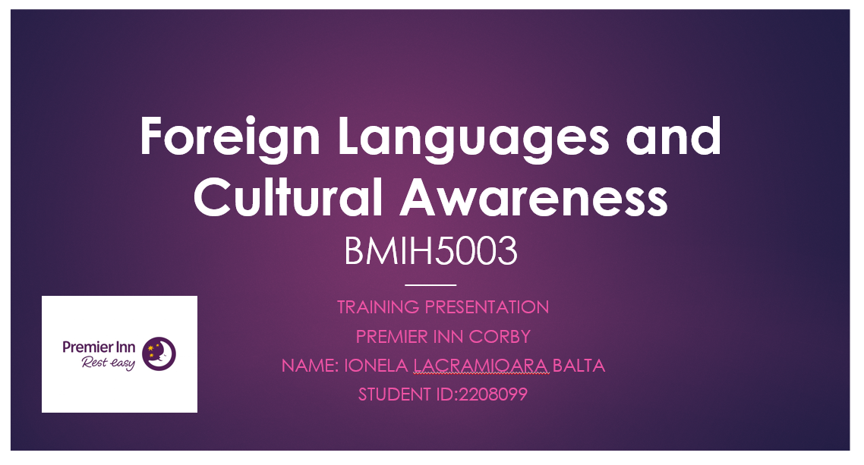
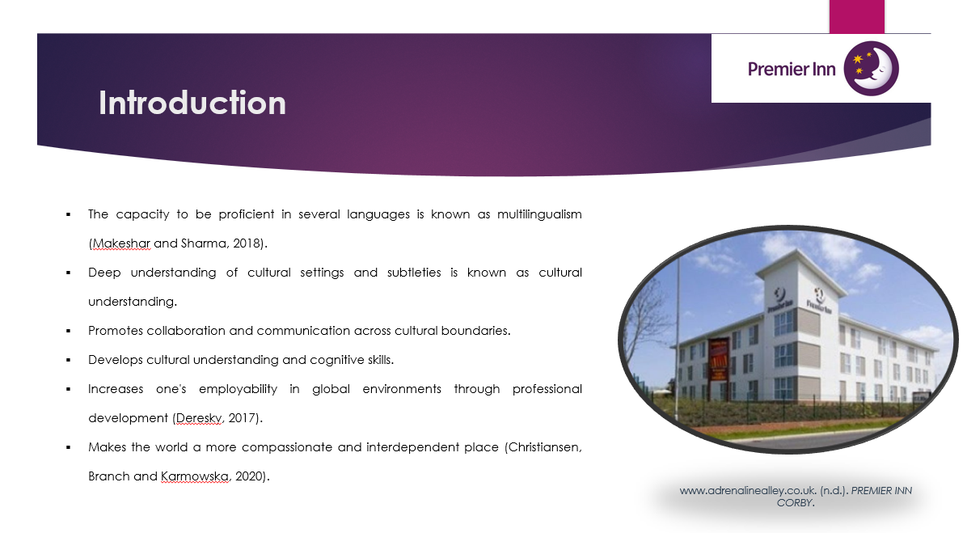

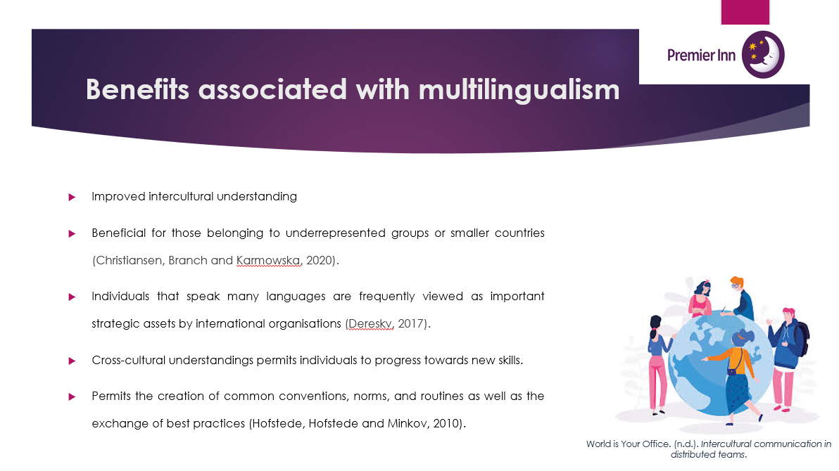
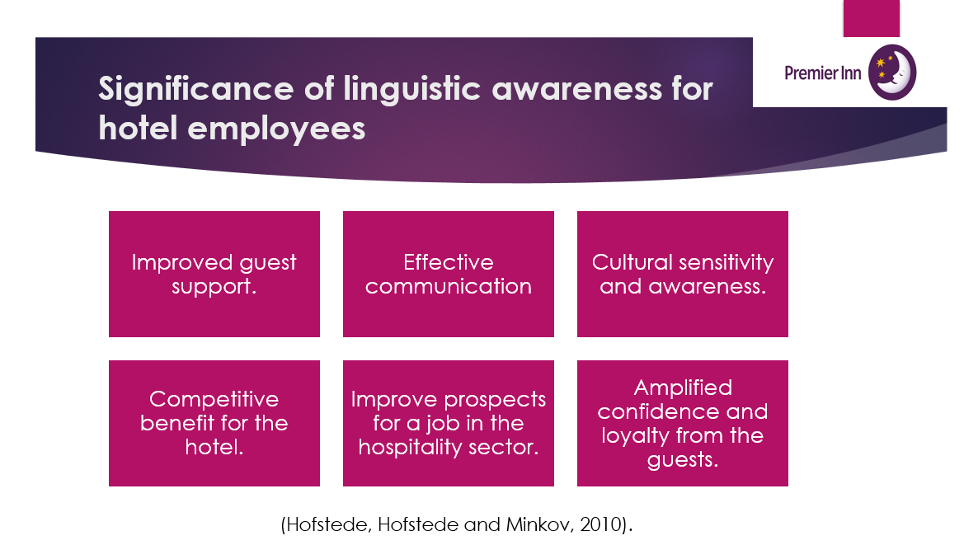
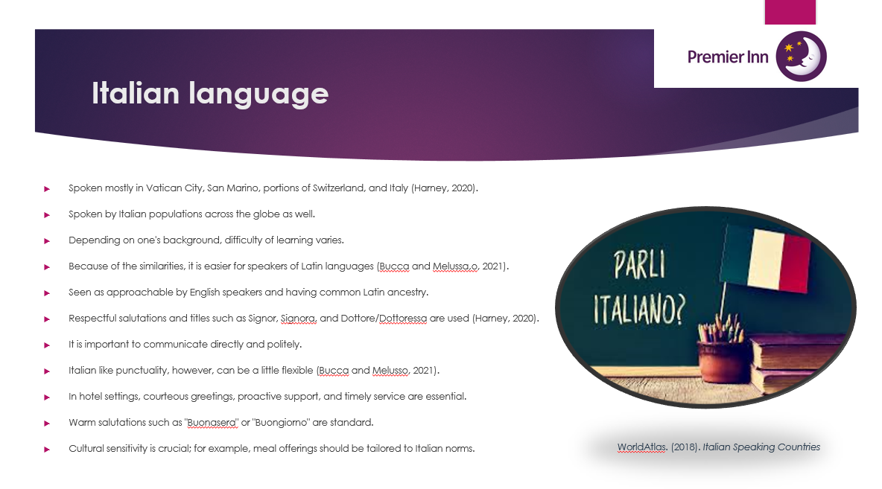
References (no screenshots):

- Anna Germana Bucca and Melluso, F. (2021). Language and Hospitality. The Function of Language in Shaping a Welcoming Setting. LESLLA Symposium Proceedings, [online] 14(1), pp.399–409. Available at: https://lesllasp.journals.publicknowledgeproject.org/index.php/lesllasp/article/view/6266.
- Christiansen, B., Branch, J.D. and Karmowska, J. (2020) Cultural Factors and Performance in 21st Century Businesses. Hershey : IGI Global.
- Deresky, H. (2017) International Management: Managing Across Borders and Cultures: Text and Cases. 9th Ed. Harlow: Pearson Education Ltd.
- Harney, N.D. (2020). Interculturalism, Inequality and Hospitality in Italy. Ethnos, pp.1–19. doi:https://doi.org/10.1080/00141844.2020.1806898.
- Hofstede, G., Hofstede, G.J. and Minkov, M. (2010) Cultures and organizations: software of the mind. 3rd Ed. New York: McGraw-Hill
- ‌Maheshkar, C. and Sharma, V. (2018) Handbook of Research on Cross-Cultural Business Education. Hershey: IGI Global.

