Leoni Lewis
ACDA5004
Project management and research methods

Contents
Individual Project Report 2
Risk Management 2
Identify risks: 2
Code of Practice 4
Quality Assurance Issues 5
Quality Plan 6
Process Requirements 7
Defect Removal Process 7
Project Plan 8
Screenshots of Project 9
References 12

Individual Project Report

Risk Management
Risk is the chance or possibility of loss, damage, injury or failure to achieve objectives which can be caused by unwanted or uncertain actions or event. Risk management is the planned and systematic approach to the identification, evaluation and control of risk. Risk management is implemented to secure the future of a project and ensure it can continue to function.
Effective risk management identifies what could go wrong, what repercussions this may have and what can be done to reduce the possibility of a risk occurring. Risk management can ensure that if a risk does occur impact is kept to a minimum. Risk management should be a forever changing document which alters throughout the organisation’s activities. [1]
Resource Priority Database (RPD) wishes to create and maintain identification and management of risks. Objectives are:
- Ensure that risk management is clear and consistent.
- Manage risk effectively and to the best of our ability.
- Anticipate and respond to any change that effects the organisation.
- Compliance with the basic legal legislations as a standard.
- Put procedures in place to prevent death, injury, damage and losses.
- Identify all risks and the impact they could have.
Objectives will be achieved by:
- Setting out clear roles and responsibilities within the organisation.
- Identify and state any risk that could arise when producing documents and considering options.
- Demonstrate risk management within the activities of the organisation.
- Ensure all employees are aware of the importance of effective risk management.
- Maintaining a document of identified risks, procedures of how to control said risks and information available on these.
- Monitor risk management and always identify ways to improve.
Our risk management procedure incorporates 5 steps:

Identify risks:
[2]
Employees who have the responsibility of identifying risks should be aware of the potential events that could affect the organisation. These events would impact the organisations costs, timescales and scope. To identify risks the following techniques could be used:
- Review the risk prompt list to determine if any of the identified areas of risk may be relevant. These are:
- Economic Risks.
- Environmental Risks.
- Technical Risks.
- Security Risks.
- Project Risks.
- Operational Risks.
- Legal Risks.
- Financial Risks.
- Governmental Risks.
- Personnel Risks.
- Establish a group brainstorming session to identify any risks that may know have been brought up.
- Examine project schedules and identify any areas that are falling behind.
- Examine project budgets and identify any costs that were not anticipated.
Subsequent to identifying risks they can be added to the risk register which will state the risk and the steps being taken to reduce or subdue said risk. Risks can then be categorised against the potential impact to organisation on a scale of 1 to 10. The risks will also be classified against the likelihood of the risk happening. These two categories can then be multiplied to provide us with a total risk score between 1 and 100. [3]
Bellow 30 = Green
Between 31 and 59 = Amber
Above 60 = Red
Risk actions:
Risk Impact | Score | Review Period
No Action | < 10 | None
Monitor as necessary: Less serious but could have a serious effect on key services. | 10-29 | Every 3 Months
Monitor as necessary: Less serious but could cause a serious impact on key services. | 30-49 | Monthly
Important Risks: Potential to affect provision of services. | 50-59 | Weekly
Key Risk: Could affect services. | 60+ | Immediate
Immediate action needed: Serious threat to organisational services. | 80+ | Immediate

The reasoning behind creating a risk action table which categorises threats is to have the opportunity or reduce or remove the threat. The organisation will also be prepared with an action plan should a risk arise. Red zone risks are likely to have the biggest impact on the project and should therefore be concentrated on the most, however both amber and green risks should be reviewed to keep risk at low level, be prepared to respond if the risk was to rise in severity and ensure that green and amber risks don’t develop into red risk.
Risk responses:
Avoid: change an aspect of the project so that the risk is removed.
Reduce: reduce the chance of the threat occurring or the impact it could cause.
Accept: accept that threat may be encountered due to unavoidable circumstances.
Within the organisation there will be a named individual who is responsible for managing, monitoring and controlling risks. There will also be a named individual who will carry out any response to risk or sets of risks. Each risk will be assigned to a single individual, one individual can be responsible for multiple risks however consideration will be taken when looking at workload and the individual’s ability.

Code of Practice
Three questions are produced when looking at sustainable development:
What impacts are modern media and the internet having on social development, environmental protection, cultural diversity and governance.
What extent do these impacts enhance sustainability and to what extent do they produce new sustainability challenges?
Do the economic, social, political and cultural implications of these impacts imply that we need to revise, rethink or readjust our understanding of what sustainability means from the ways in which it was defined?
To analyse sustainability issues within our project we will implement the widely used framework published by the Forum for the Future in 2002. Which looks at the type of impact that results within the different elements within the framework, the level or order of impact and the different stages within the life cycle of the project where impact occurs.
The biggest issue within society is the increase in population across the world. Due to this rise and lack of regulations demand for energy, food, water and security is in high demand. This could have a big impact on the project due to its disaster-based focus and demand for keeping water and food in stock.
Economic issues include climate change and its effects being present within the next decade. Protecting ecosystems and ensuring positive waste/contamination management schemes are followed is paramount. [4]
Due to these
To ensure sure we display our commitment as a project to work in the public interest and accept our professional duty we have decided to follow the BCS code of conduct. To implement and execute this we will work together to address issues within our project to ensure we uphold standards and conduct the project professionally and fairly.
- We will have due regard for public health, privacy, security and wellbeing of others and the environment.
- Have due regard for the legitimate rights of third parties.
- Conduct our project without discrimination on the grounds of sex, sexual orientation, marital status, nationality, colour, race, ethnic origin, religion, age or disability, or of any other condition or requirement.
- We will only undertake to do work or provide a service that is within our professional competence.
- We will NOT claim any level of competence that we do not possess.
- Aim to develop our professional knowledge, skills and competence on a continuous basis, maintaining awareness of technological developments, procedures and standards relevant to our project.
- Respect and value any alternative viewpoints and seek, accept and offer criticisms of work.
- Avoid injuring others, property, reputation or employment by false, malicious or negligent action or inaction.
- Disregard and refuse any offer of bribery or unethical inducement.
- We will carry out our responsibilities with due care and diligence in accordance with relevant authorities’ requirements while exercising our professional judgement at all times.
- Aim to avoid situations that may cause a rise in conflict of interest between us and relevant authorities.
- NOT disclose or authorise disclosure for personal gain/ to benefit of third parties, confidential information unless permission has been provided by relevant authorities or is required due to legislation.
- NOT misrepresent or withhold information on the performance of our project or take advantage or the lack of knowledge/inexperience of others. [5]

GDPR was introduced on 25 May 2018, applying European Union data protection rules universally across member states. Now that the UK is looking to leave the EU within 2019 will this alter how UK businesses operate and what protections are given? Although GDPR is a piece of EU legislation, the UK was one of the biggest contributors towards it. The UK has always has strong views on keeping data protection laws as they are, this was seen when they passed the Data Protection Act 2018. [6] [7]
When the UK is leaves the EU the UK will officially be a third country and will need to be whitelisted to ensure data flows between the UK and the rest of Europe. This will require a strong data protection framework to ensure the safety of sensitive information is paramount. The UK government has stated they will seek an agreement with the EU to ensure the flow of data is smooth without the need for anything additional. However this agreement can only be enforced after the UK leaves.

Quality Assurance Issues
The largest quality concern relating to IT projects is providing customers with systems that meet their requirements within a price that they can afford. To achieve this goal quality needs to be considered and implemented within the product. The level of quality that is required will have an impact on time and cost however, the more that quality is considered at the start of a project the less it will cost to correct issues at the end of the project.
Quality characteristics, software quality can be measured by using six levels of quality characteristics these include:
Functionality: has the system met the functional requirements of the user?
Reliability: does the system have faults and if so how long does it take to rectify these?
Usability: are individuals able to use the system easily or is training required?
Efficiency: what resources are required for the system to work?
Maintainability: are modifications of the software easy?
Portability: is the software able to be developed into another environment?
In order to check if the end product is fit for purpose checking against quality criteria which was specified earlier in the project is important. Quality criteria should be specific, measurable and achievable.
To ensure quality within our project is controlled affectively a project quality plan, quality criteria, quality control procedures, quality assurance procedures and acceptance criteria will be created.
Quality assurance will be performed like an audit, it will be performed to ensure that all procedures are in place and are being performed correctly. For each section of the project quality criteria will be specified, quality control can then refer to the criteria to check that the criteria has been met. Quality assurance will then confirm that procedures specified have been followed and all necessary checks have been performed.

Quality Plan
To begin we will create a quality plan that specifies individual standards that apply to our project. These standards can be modified as the project progresses. Standards can be produced from industry level standards or can be developed in house. The plan will specify how, when and who the quality control and quality assurance processes will be undertaken. Quality control will be undertaken by a member of staff within the project, however quality assurance will be handled by somebody outside the project who can report back to the project team. Separating these two will ensure that the process is transparent and reduces conflict of interest issues.
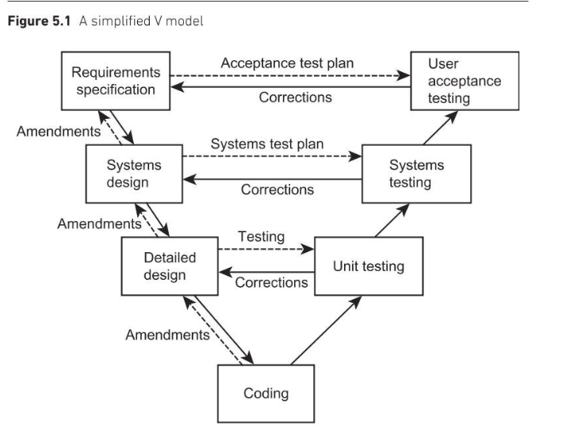
Implementing the V Model within our project will be useful within the system development process. Solid lines will represent progress within the project and dotted lines represent quality control.

Process Requirements
Entry requirements will state what will exist before the process can begin. These requirements will be documented, agreed and signed off. If designing the product starts before requirements are agreed issues could arise if requirements are then altered. Designs may need to be reworked at an increased cost or time.
Implementation requirements state how the process will be done. Implementation requirements will specify what techniques and software tools will be used and how they will be used.
Exit requirements state what will be needed for a successful project sign-off.

Defect Removal Process
To remove a defect within a produce it firstly needs to be identified. This is normally easy to do but can be costly if defects arise later on in development. To ensure defects are identified and removed efficiently we will apply these techniques:
- Reviewing what has been produced and checking for errors.
- Having multiple individuals review a document to ensure that it meets the quality criteria specified.
- Review the product to identify defects in a planned, independent, controlled and documented manner.
- Paired programming which allows somebody to produce the product at a workstation while the other individual checks what is being produced and advices them of any alterations.
- Static testing by analysing the product.
- Unit testing to undertake basic testing of the software ensuring each function works as expected.
- Integration testing to check that systems are communicating effectively with each other.
- Systems testing to run the whole system on the infrastructure to check advanced issues such as: does the system run on the infrastructure used? Are response times within the tolerances set in the requirements? Will the system cope with the planned workload?
- User acceptance to check if users can operate the system and that it meets set requirements. Where issues are found they can be recorded for the system to be reworked and retested.
- Regressing when a fault is found and corrected an agreed set of test data will be run through the system to ensure that the original error has been corrected.

Project Plan
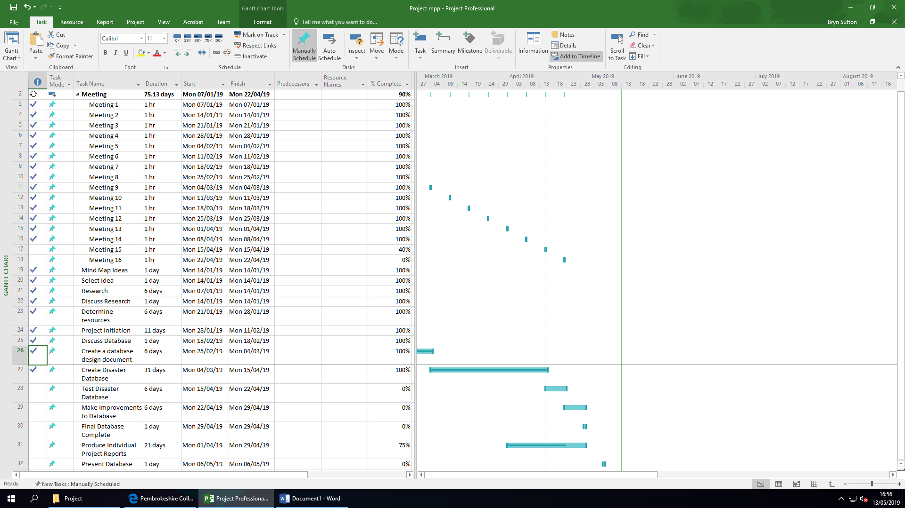
(Top) Before
(Bottom) After
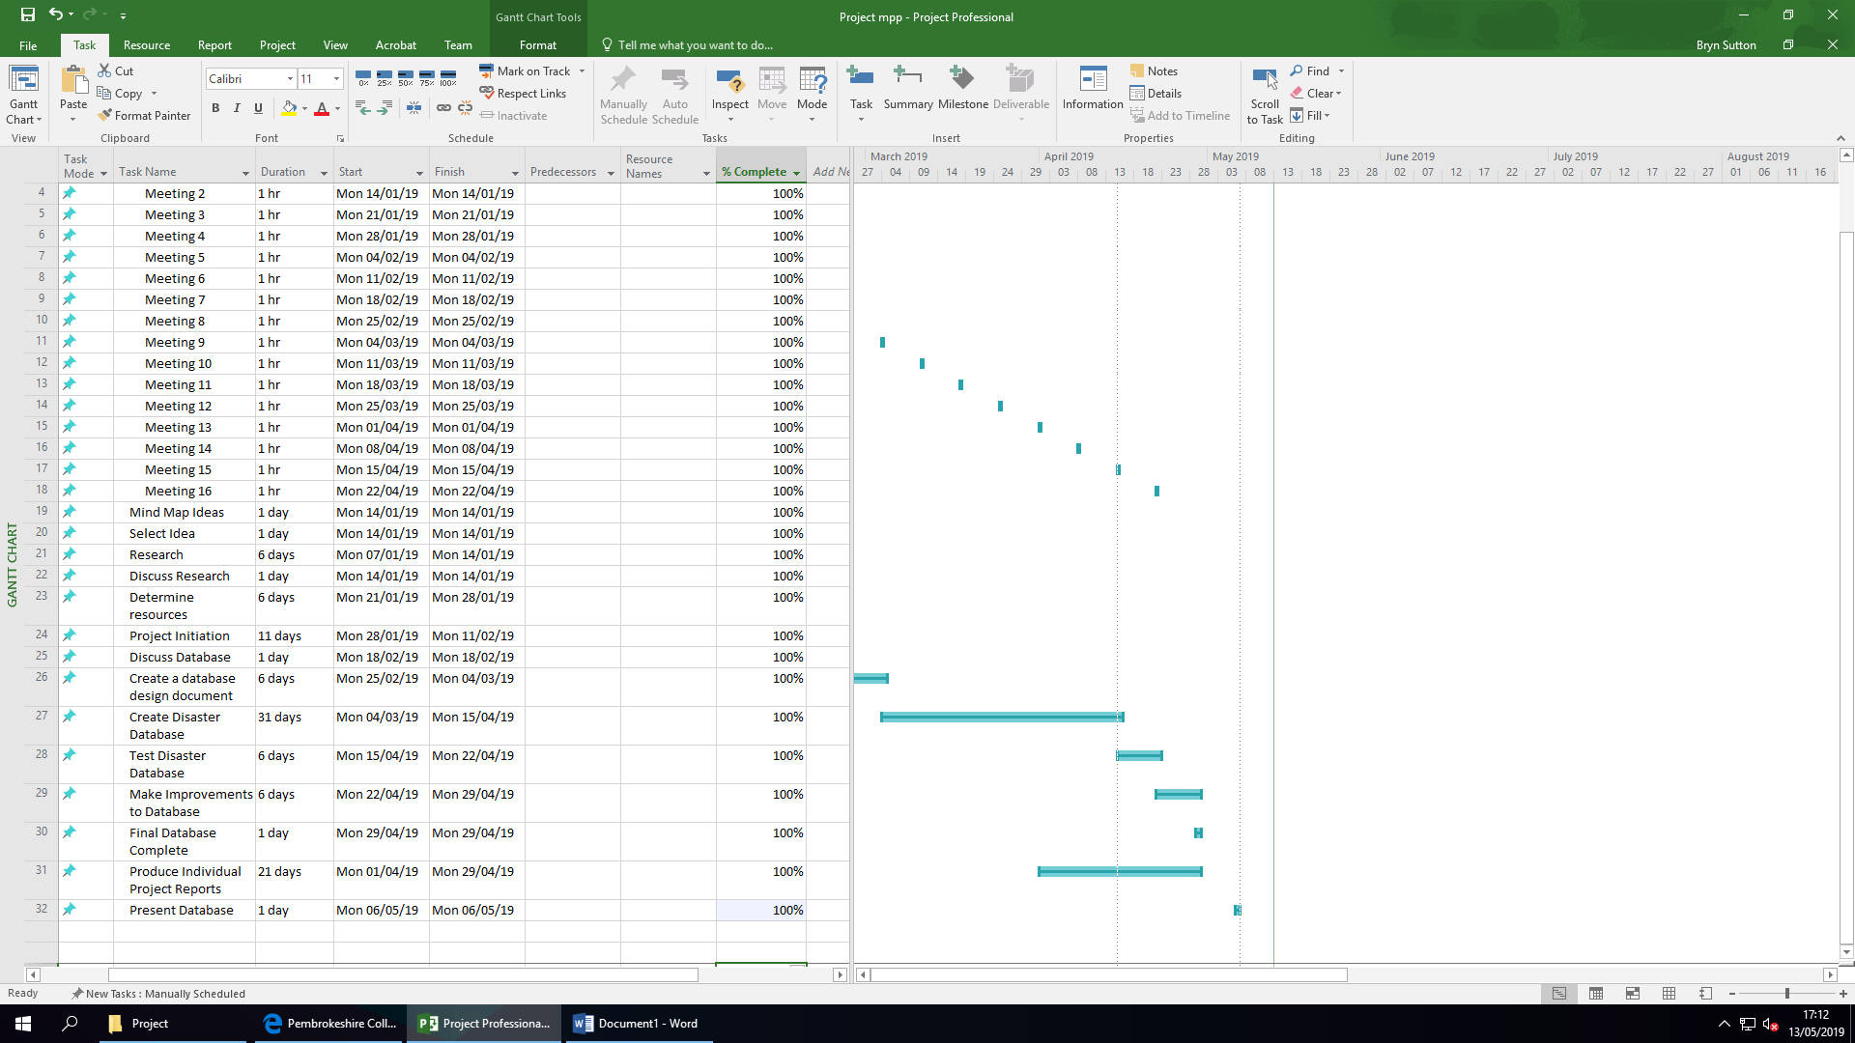

Screenshots of Project
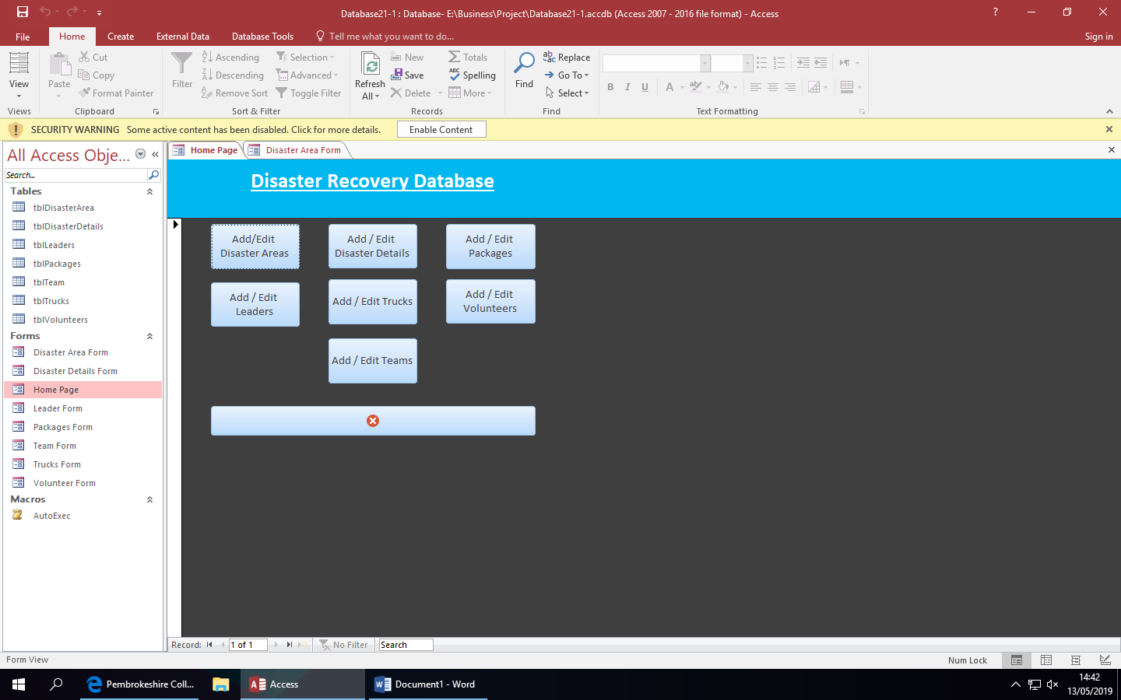
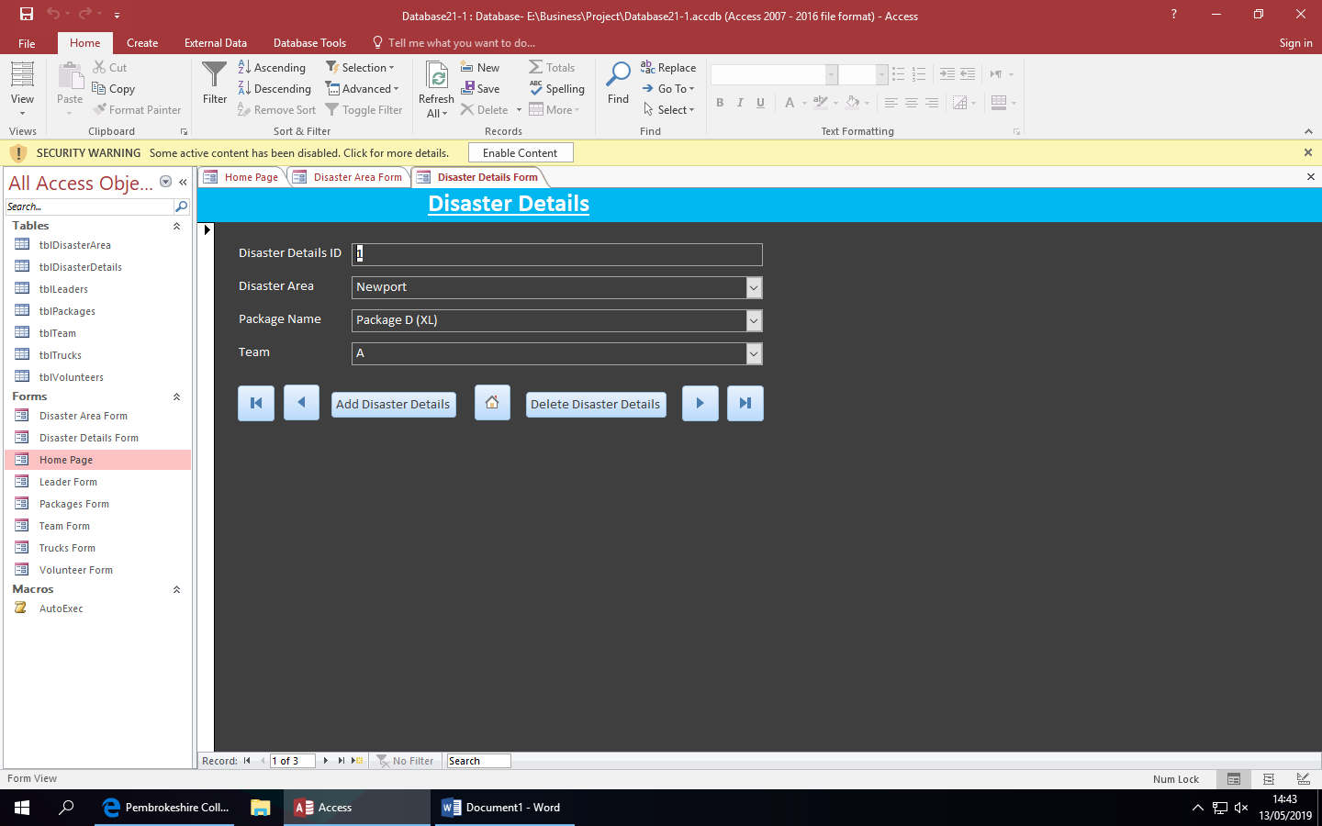
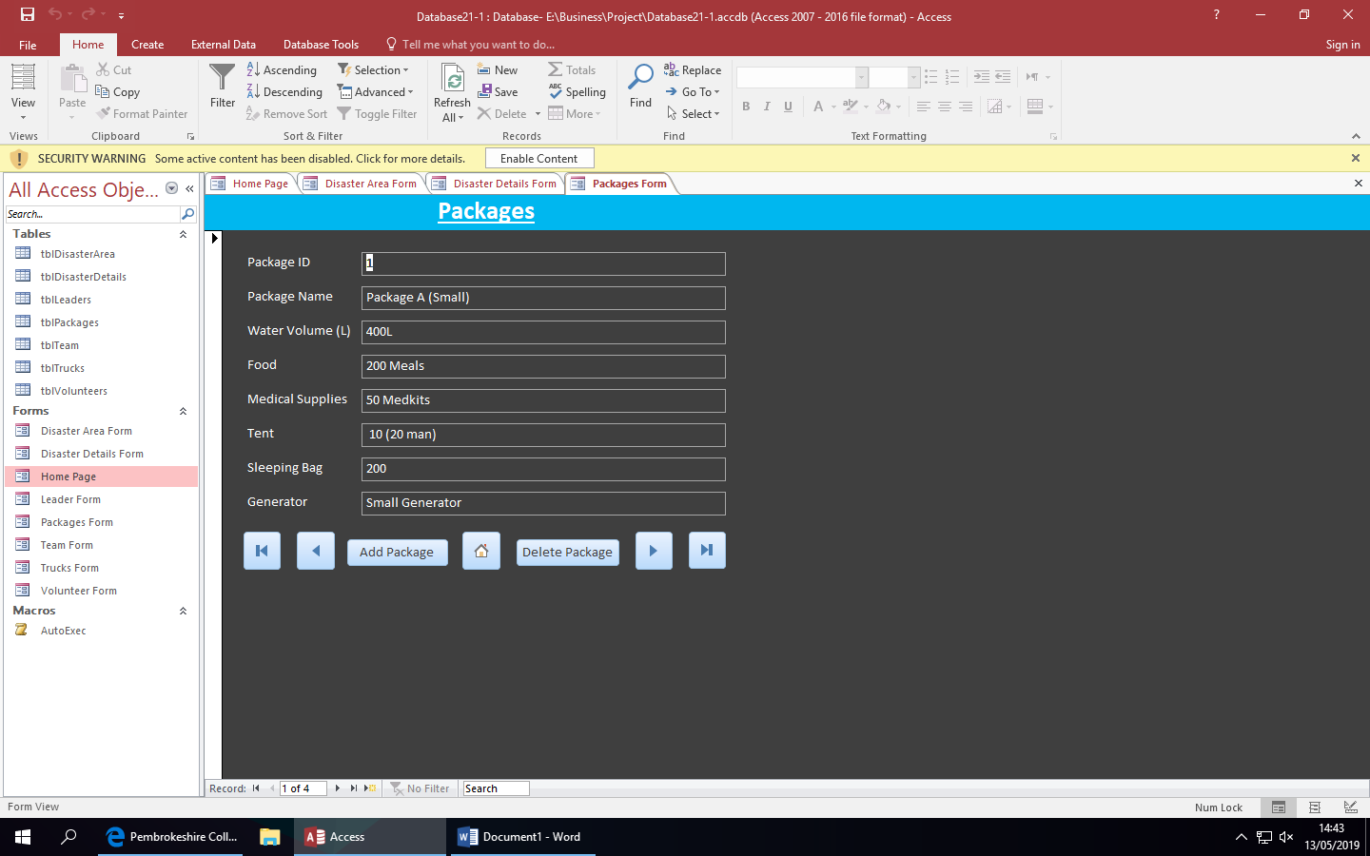
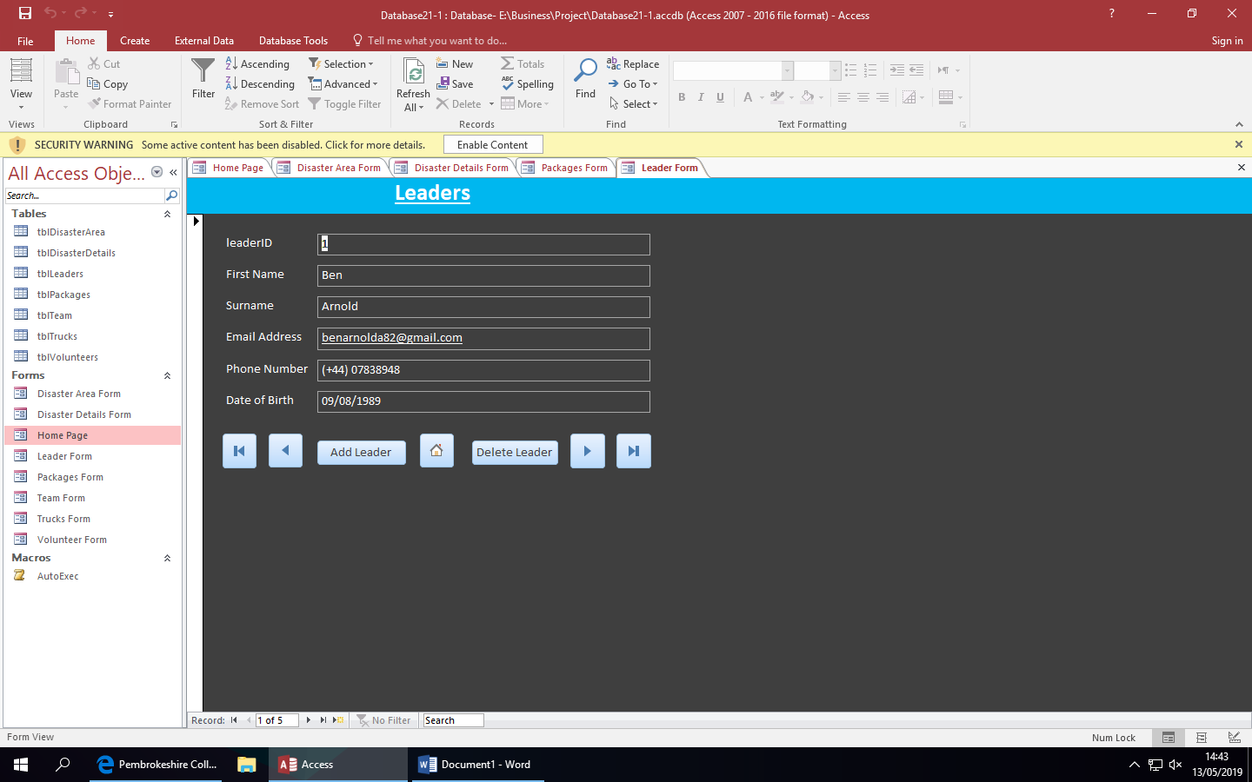
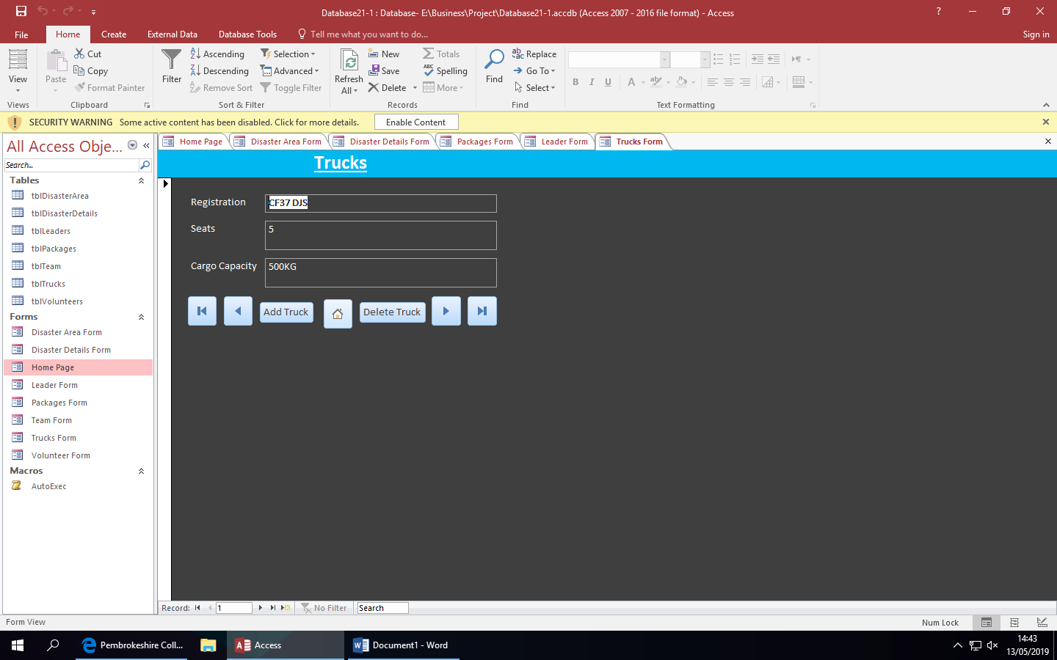
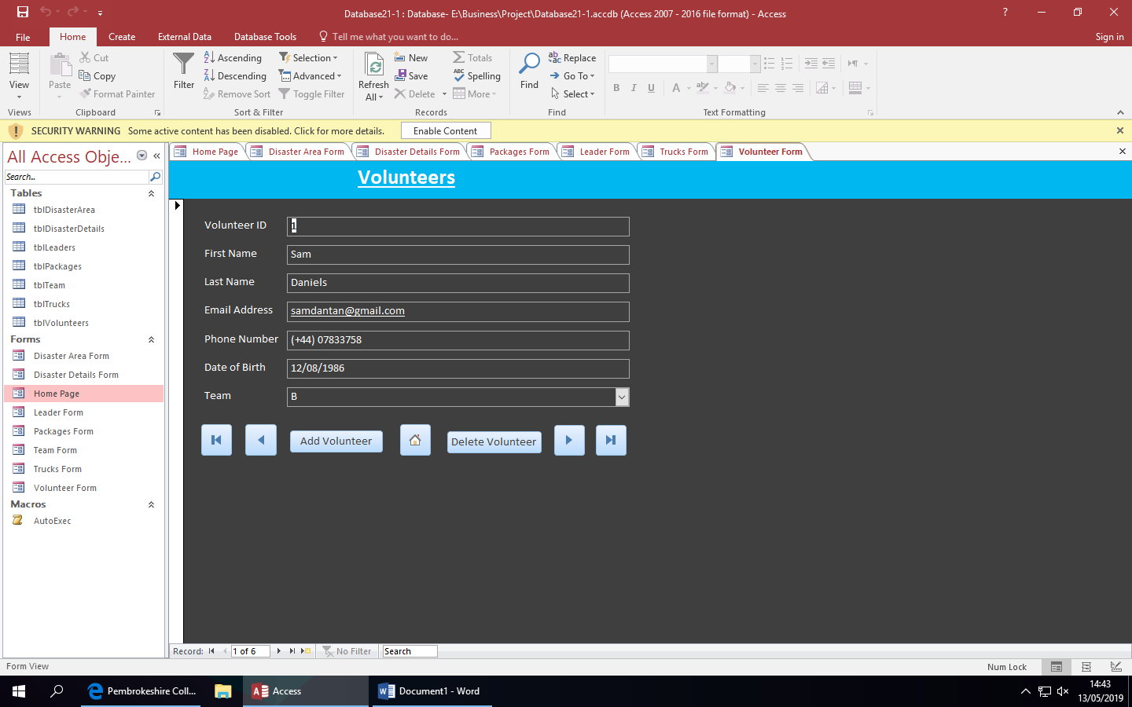
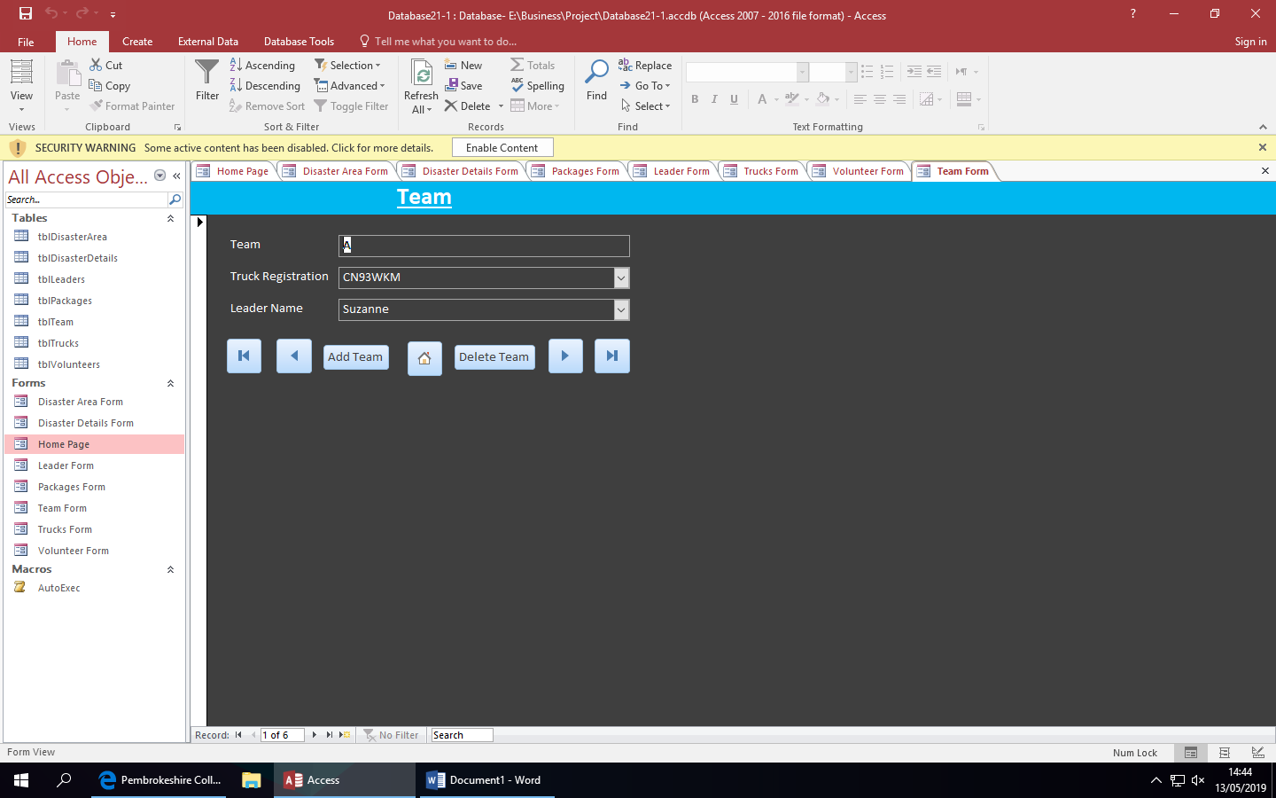

References

[1] | S. Ray, “Project Manager,” 2017. [Online]. Available: https://www.projectmanager.com/blog/risk-management-process-steps.
[2] | B. Jutte, “Project Smart,” [Online]. Available: https://www.projectsmart.co.uk/10-golden-rules-of-project-risk-management.php.
[3] | B. Barklet, Project Risk Management, 2004.
[4] | C. Ecology, “Sustainability and Sustainable Development,” 2019. [Online]. Available: http://www.circularecology.com/sustainability-and-sustainable-development.html#.XNjNWo5KhhE.
[5] | T. C. I. F. IT, “BCS Code Of Conduct,” [Online]. Available: https://www.bcs.org/category/6030.
[6] | Eugdpr.ORG, “GDPR FAQs-EUGDPR,” 2019. [Online]. Available: https://eugdpr.org/the-regulation/gdpr-faqs/.
[7] | B. News, “Brexit All You Need To Know,” 2019. [Online]. Available: https://www.bbc.co.uk/news/uk-politics-32810887.

