Task 1: Locating Sources
Identify and locate three different sources (a report, a journal article, and a website) related to the question
“What employability skills do university graduates need to succeed in the workplace?”
Show how you used keywords, search terms, and Boolean operators to find them, and explain how you know which type of source each one is and why it is appropriate for the research question.

Source Type & Why It Is Appropriate | URL/DOI | What search engine did you use? Google/Online Library/Library AI Assistant | Keywords/Boolean Operators Used
Journal Article | https://librarysearch.uwtsd.ac.uk/discovery/fulldisplay?docid=cdi_proquest_journals_3156913714&context=PC&vid=44WHELF_UWTSD:44WHELF_UWTSD_VU1&lang=en&search_scope=MyInst_and_CI&adaptor=Primo%20Central&tab=Everything&query=any,contains,%22employability%20skills%22AND%22University%20Graduates%22AND%22Workplace%22&offset=0 | Online Library | "employability skills" AND "University Graduates" AND "Workplace"
Report | https://www.managers.org.uk/wp-content/uploads/2021/09/employability-skills-research_work-ready-graduates.pdf | Google | “Employability skills” AND “ University Graduates” AND “report” “workplace”
Website | https://www.grb.uk.com/career-advice/graduate-employability-skills/#guide | Google | “Employability skills” AND “ University Graduates” AND “workplace”

Task 2: Evaluating Information (CRAAP Test)
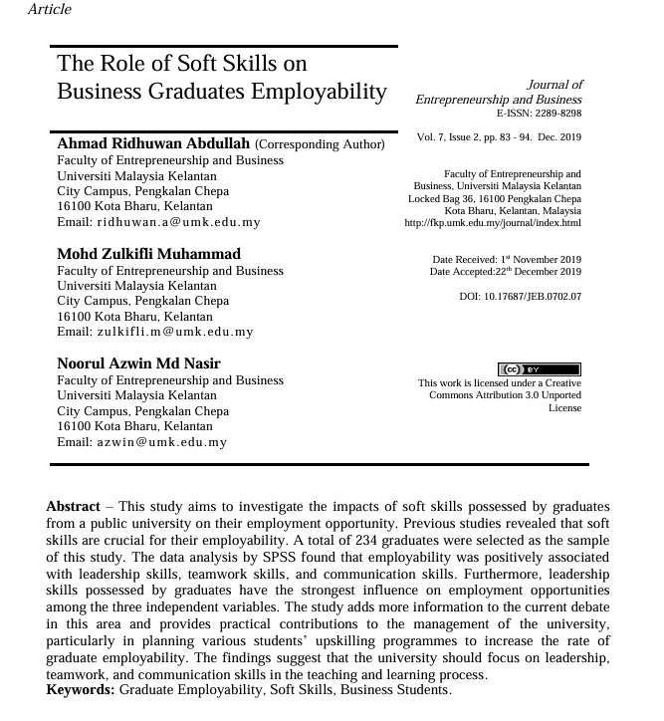
otYour colleague has forwarded you a source from a peer reviewed journal, and they are not sure whether it is appropriate to use and has asked for your help. Your task is to evaluate the source by using the CRAAP Test to assess its appropriateness for the following question “What employability skills do business university graduates need to succeed in the workplace?”

CRAAP Test
Currency | Yes, because this study aims to investigate the impacts of soft skills possessed by graduates from a public university on their employment opportunity.
Relevance | This article is absolutely relevant to the research because this article found the employability was positively associated with leadership skills, teamwork skills, and communication skills.
Authority | The author is Ahmad Ridhuwan Abdullah.  Faculty of emperorship and business.
Accuracy | This work was licences
Purpose | That info exist because it so useful to know what you need to succeed for your workplace
Task 3: Source Analysis
Your manager has provided you with a short extract from a source and has asked you to analyse the source by Identifying one strength, one weakness, and providing a brief explanation of the strength and weakness identified.
If you want to read the article online, please click the following link: https://www.universitiesuk.ac.uk/latest/news/strong-demand-graduates-employers

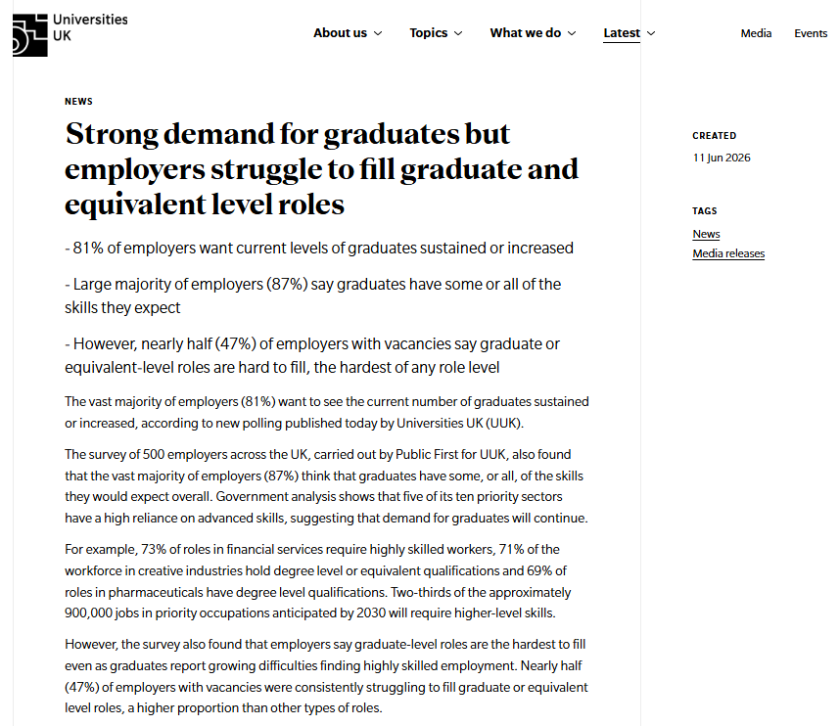
.

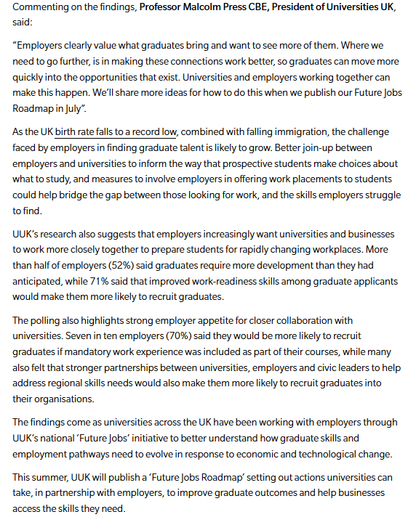

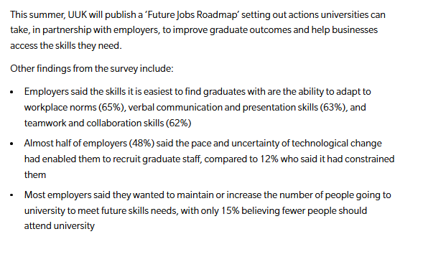

Strength of the Source:

Weakness of the Source:

