Manifesto

- Creating artwork for people to enjoy in their own home

- We are surrounded by beautiful Nature Everyday

- Being Environmentally aware is important

- Lucy Arnold’s work makes me appreciate Art

- Creating your own style of work can be hard

- Pleasing people with your work can be a challenge

- Being different from others is always good

- Having your own opinion can be tricky today

‘We are surrounded by beautiful Nature everyday’,
Nature created this world first and gives us so much enjoyment and inspiration that I can use in my artwork. I love the aesthetic that nature creates everyday with the help of seasons and the weather to contribute to the effect it has on this environment. All these factors help me design and create artwork in different views and lights. My focus now is the leaves as we have had autumn and enter winter the colours of the leaves and shapes change depending on the type of trees, we get rid of most the green colours and enter quite natural earthy colours such as yellows, reds, oranges, and browns these create me a colour palette to build my designs around and the beauty of the merging colours. For me nature mostly leaves, and flowers have always been my inspiration and helped me develop my artwork to a point where I see it being used I everyday life.

‘Lucy Arnold’s work Makes me appreciate art’,
Just like my inspiration for nature she has this fascination with Nature and the beauty it can bring to us. She says, ‘the profusion of colour, pattern and design in nature captivates me.’
Lucy Arnold – 2015 - https://marinmoca.org/artist/328/lucy-arnold/

This helps her explore the ideas and create her avenues of realistic watercolour pieces. Her artwork inspires me to love nature and how she sees the insects and nature as precious and beautiful to be displayed and created into artwork that is appreciated today. She shows that we should love and look out for how we treat and respect the environment around us. This is a great way to build up an audience today given we are so eco-friendly enthusiastic and protest harmful chemicals to try and protect our world in our future. Mainly using paints to create these beautiful designs “painting allows me to reveal the beauty I discover in small, intimate details of nature.” She says this is how she sees her work.
https://marinmoca.org/artist/328/lucy-arnold/

‘Creating you’re your own style of work can be hard’
For me trying to find an area of art I would enjoy, and love has always been difficult, I have never really seemed to fit into a certain category that we define such as fine art or graphic design ect. These are all very broad subjects and can have so many directions but non ever suited me personally. For me I am always about creating patterns and doodling my ideas and inspirations to paper to make a pattern and see where that takes me. Within Surface Pattern and Textiles, I’ve found this a much more enjoyable course and development in my life and artwork towards wherever I go and finding something that I finally feel like I fit into and can feel a sense of home in work that I’m creating. This gives me so much more confidence and boosts my energy to create more so that I build up a portfolio of all work to one day help me find a good career in the future. I’ve always loved art and just drawing; it always gave me a way to relax and just take my mind away do to be able to continue that in my life at uni is amazing.

References:

Lucy Arnold –
2015 - https://marinmoca.org/artist/328/lucy-arnold/
https://lucyarnold.com

Christian Dior
Miss Dior – what would you do for love?
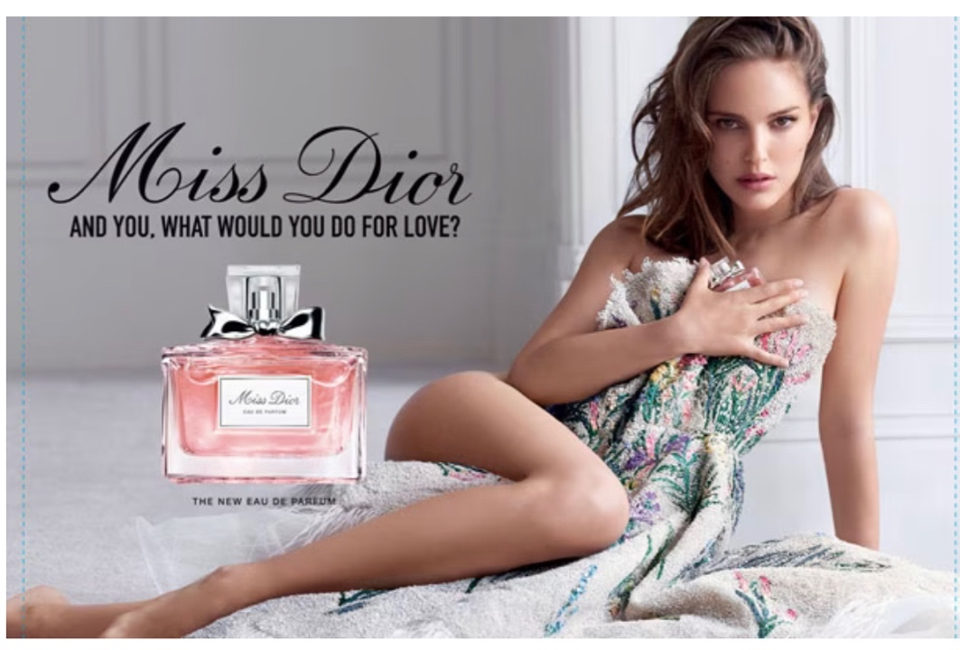

Christian Dior’s perfume advert on Miss Dior features Natalie portman sitting down and holding her dress up like it’s about to fall, like she hasn’t zipped or tied I up. The dress itself looks a bit like a blanket that she is just holding up. The colours of the dress stand out against a very plain background, the pastel pinks and yellows with this strong emerald, green leaf pattern across it. while the background of the advert id very plain and mainly features the use of a white colour , it’s a very simplistic poster not too much is going on and it keeps the beauty of the perfume alive. The bottle itself is a like rectangle shape with a bow on the top relating back to female, ‘A beautiful symbol of what luxury and beauty can provide us in times of difficulty’
- Natalie Portman – 6th September 2021 - https://www.harpersbazaar.com/uk/beauty/fragrance/a37394963/natalie-portman-beauty-interview/
said herself showing her impact and opinion on the perfume to build up a sense to capture people in and tell them how they will feel when they buy it.

With regards to the slogan, it grabs your attention with a rhetorical question and how it draws you in to think of your answer to it. ‘Rhetoric is the artful use of language, and the purpose of rhetoric is to persuade the audience.’ – What Are Three Rhetorical Purposes for Campaign Advertisements? - By Kevin Johnston-https://smallbusiness.chron.com/three-rhetorical-purposes-campaign-advertisements-37417.html
The bold black writing is something that you see first and in the tv advert it is repeated many times through the advertisement. The way it shows Happiness and ‘seeking joy and falling back in love’ is how it is descried to be and smell like. To see beauty through the darkness.
‘I think re-embracing beauty, joy, and nature is really how Miss Dior started’
Natalie Portman – March 22nd, 2022 - Natalie Portman on the Power of a Bold Red Lip-https://www.instyle.com/celebrity/natalie-portman-miss-dior-fragrance-interview
Guiding us to love, happiness within the scent itself. with our own interpretations of love and happiness it’s trying to bring us into what they are seeing and how we can feel and see it too. A deeper meaning behind it is showing us that Beauty products are tools of self-expression ‘what is my scent? what is my lipstick? what makes me feel most like myself?’
these are all great questions women ask themselves every day, how can we be us and be happy in our lives.

‘A timeless chic of miss Dior in a floral fragrance’ the floral element adds to the idea being sold of beauty and how we see nature and flowers as beautiful and vibrant and can cheer people up. Like a bouquet of flowers, you give someone can make them smile and be happy, well they are portraying that the perfume can do the same, it can make someone smile and be joyful is they wear this scent. If they feel better about themselves and how one thing can change someone’s emotions. Looking back into why the perfume was made, Christian made it as a tribute to his sister and how he wanted to represent her as this figure in his life a beauty. Which makes every woman in peoples life feel special when they get told they are beautiful, like a big confidence boost today.

References:

- Natalie Portman – 6th September 2021 - https://www.harpersbazaar.com/uk/beauty/fragrance/a37394963/natalie-portman-beauty-interview/
- What Are Three Rhetorical Purposes for Campaign Advertisements? - By Kevin Johnston-https://smallbusiness.chron.com/three-rhetorical-purposes-campaign-advertisements-37417.html
- Natalie Portman – March 22nd, 2022 - Natalie Portman on the Power of a Bold Red Lip-https://www.instyle.com/celebrity/natalie-portman-miss-dior-fragrance-interview

Nature vs Challenge

Nature and challenge have always been in competition with each other and are complete opposites today. Nature will always be in our lives through plants to animals to coastal lands and reserves that we today are fighting to keep alive and protected. ‘In addition, conservation trusts own long stretches of coast, most prominently the National Trust, the Norfolk Wildlife Trust and the royal society for the protection of birds.’
Future Nature - (W M Adams) - Conserving nature’ - (page 5)
He talks about the different ways we as humans are trying to protect nature at all costs and to preserve the wildlife that we see today. Most of these trusts are supported by donations from the public, which we donate when we visit these wonderful places and enjoy the beautiful nature, we try to protect every day.

Although we have this beautiful nature it comes with challenges that we as humans are making it impossible to save the wildlife.
‘It became clear that land use outside nature reserves and protected areas was becoming increasingly damaging to wildlife and scenery’
Future Nature - (W M Adams) - Conserving nature’ - (page 32)
Adams is right, today we have a lot of causes that have been affecting wildlife such as pollution that is having big damages in this world, from cars petrol and diesel that we use that is polluting the air that we breath and animals that are suffering from inhaling the fumes. Pollution has been a big problem in our world that we have struggled to cut down on. Whilst we put harmful chemicals into society and chop down trees that we need to make paper, but this effects the homes and oxygen we have in our world. To help improve this we have echo friendly substances that we are trying in society’s from like types of paper and objects we use in our everyday life.

‘Lately, it seems, Mother Nature has been trying to get our attention. Its signals are increasingly loud, strident, and hard to miss. Some have been lethal.’
The struggle of our time: human Nature vs Mother Nature –
( https://carnegieendowment.org/2015/11/12/struggle-of-our-time-human-nature-vs.-mother-nature-pub-61971)
Human nature vs Mother nature is the biggest thing to be challenged through all time our biggest issue is climate change that mother nature brings on us, it has affected us dramatically with the ice melting in Antarctica and making penguins and polar bears losing their homes and becoming extinct. Animals throughout life have been extinct because of human nature that has affected the way animals live and survive. We have fought against animal testing and cruelty and more people are becoming vegan to protect the animals and this world. But not only has this effected animal it has affected humans too through mother nature’s forces.
‘According to the United Nations, the current number of storms, floods, and heat waves is five times greater than it was in 1970.
This lack of effective action is not just due to certain corporations and countries pushing their fossil fuel-oriented agendas at the expense of the common good. It is also due to human nature.’
- The struggle of our time: human Nature vs Mother Nature –
( https://carnegieendowment.org/2015/11/12/struggle-of-our-time-human-nature-vs.-mother-nature-pub-61971)
This shows that mother nature is challenging human nature and destroying our homes and peoples lives. The effect it has on people is huge their whole lives have been changed and won’t be the same again. I think that if we respect and protect nature to help save our life but not only ours but the wildlife around it, to protect it means making sure we go echo friendly, cut back on pollution and saving animals.

Nature and challenge will always be in completion throughout the rest of our lives but just even the small little things we do can change this from being catastrophic in the future.

References:

- Future Nature - (W M Adams) - Conserving nature’ (book)
- The struggle of our time: human Nature vs Mother Nature –
( https://carnegieendowment.org/2015/11/12/struggle-of-our-time-human-nature-vs.-mother-nature-pub-61971) – (news article)

- Charlotte Smith

