Applied Leadership and Management in the Workplace
Module Assignment Submission
Student Name: | Janine Davies
Student Number: | 2408610
Module No: | BMSK5013
Module Title: | Knowledge Management

Statement of Confirmation of Authenticity
By the act of making this submission, the student declares that this is the work of the student named above. The work has not, in whole or in part, been knowingly presented elsewhere for assessment, or where assessment has been built on a previous assessment, this has been identified. Where materials have been used from other sources it has been properly acknowledged. If this statement is untrue, the student acknowledges that an assessment offence has been committed.
Attention is drawn to the plagiarism and unfair practice policies of both the University and of ILM.

Table of Contents
Contents
Introduction. 3
Section 1 Evaluating the Concept of Knowledge Management. 4
1.1 The Relationship Between Data, Information, and Knowledge 5
1.2 The Relationship Between Individual and Organisational Knowledge 6
1.3 The DIKWA Model and How It Works 7
1.4 Introducing the SECI Model 8
1.5 Practical Implementation of the SECI Model in My Business 9
1.6 Comparing the Models in Practice 10
2.0 Knowledge Management Framework 11
2.1 Establishing a Business Case for the Collection and Distribution of Knowledge 12
2.2 Requirements to Create, Store, and Implement Knowledge 13
2.3 Identifying Current Systems for Storage of Information. 14
2.4 Defining Current Knowledge Assets Within My Business 15
2.5 Key Performance Indicators (KPIs) 16
2.6 Information Required 18
2.7 Systems to Protect Confidentiality, Integrity, and Availability of Information 19
Conclusion 20
References 21
Appendix A 22

Introduction.
This assignment critically evaluates the role of knowledge management (KM) within a business context, with specific application to Lil Puddings. It explores the relationship between data, information, and knowledge, as well as the connection between individual and organisational knowledge in supporting business performance.
The assignment examines the DIKWA and SECI models to evaluate how knowledge is created, shared, developed, and applied within an organisation. Both models are analysed in relation to business activities such as staff training, customer service, production planning, and decision making.
The second part of the assignment focuses on the practical implementation of knowledge management within the business. This includes the development of a knowledge management framework, identification of knowledge assets and storage systems, and the use of key performance indicators to measure effectiveness. It also considers the information required for decision making and evaluates systems used to maintain confidentiality, integrity, and availability of information.
Overall, the assignment demonstrates how effective knowledge management can improve organisational performance, support operational consistency, enhance decision making, and contribute to long term business growth.

Section 1 Evaluating the Concept of Knowledge Management.
Within Lil Puddings, data, information, and knowledge are closely connected and play an important role in supporting effective decision making and organisational performance.
Data refers to raw facts and figures that have not yet been analysed or given meaning. Within Lil Puddings, this includes daily sales figures, customer orders, ingredient quantities, stock levels, and customer feedback. Kumar (2020) explains that data can exist in various forms, including numbers, text, images, and statistics. On its own, data has limited value because it does not provide context or understanding.
When data is organised, analysed, and interpreted, it becomes information. For example, weekly sales reports can identify which cupcake flavours are most popular, which days generate the highest sales, and which products contribute most to revenue. This information provides greater insight into business performance and allows patterns and trends to be identified more easily.
Knowledge is created when information is combined with experience, understanding, and professional judgement. Within Lil Puddings, analysing sales information alongside customer purchasing behaviour has helped identify that certain cupcake flavours are more popular during weekends and seasonal events. This knowledge enables production levels to be adjusted to meet customer demand more effectively, reduce waste, and improve profitability.
The relationship between data, information, and knowledge is important because it supports informed decision making throughout the business. Accurate knowledge can improve operational efficiency, enhance customer satisfaction, and contribute to business growth. However, the effectiveness of this process depends on the quality, accuracy, and reliability of the original data. If inaccurate or incomplete data is collected, it may result in misleading information and poor business decisions. This highlights a limitation of the DIKWA model, as the quality of knowledge produced is dependent on the quality of the data collected. Therefore, information must be regularly reviewed and evaluated to ensure that decisions are based on accurate and relevant evidence.

1.1 The Relationship Between Data, Information, and Knowledge
Knowledge exists at both an individual and organisational level, and the relationship between the two is important for long term business success (Sen, 2024).
Individual knowledge refers to the skills, experience, understanding, and creativity developed by employees through practice and observation. Within Lil Puddings, this includes baking techniques, decorating skills, customer service abilities, and practical judgement developed through daily experience. Much of this knowledge is tacit, meaning it is difficult to document or communicate formally.
In contrast, organisational knowledge is knowledge that has been shared, structured, and embedded within the business. This includes documented recipes, pricing strategies, preparation methods, supplier information, and customer service procedures. Organisational knowledge enables the business to operate consistently and reduces reliance on individual employees.
The relationship between individual and organisational knowledge is important because businesses rely on employees transferring their skills and experience into systems and processes that can be shared across the organisation. If knowledge remains only with individuals, valuable skills and experience may be lost when employees leave the business. Documenting recipes and decorating methods enables employees to follow consistent standards and maintain product quality.
However, not all knowledge can be transferred easily. Practical skills, creativity, and instinctive decision making are often developed through experience and may be difficult to capture within formal systems. This highlights a limitation of organisational knowledge management, as businesses must continue to rely on communication, observation, and practical learning to support effective knowledge sharing.

1.2 The Relationship Between Individual and Organisational Knowledge
Knowledge exists at both an individual and organisational level, and the relationship between the two is important for long term business success (Sen, 2024).
Individual knowledge refers to the skills, experience, understanding, and creativity developed by employees through practice and observation. Within Lil Puddings, this includes baking techniques, decorating skills, customer service abilities, and practical judgement developed through daily experience. Much of this knowledge is tacit, meaning it is difficult to document or communicate formally.
In contrast, organisational knowledge is knowledge that has been shared, structured, and embedded within the business. This includes documented recipes, pricing strategies, preparation methods, supplier information, and customer service procedures. Organisational knowledge enables the business to operate consistently and reduces reliance on individual employees.
The relationship between individual and organisational knowledge is important because businesses rely on employees transferring their skills and experience into systems and processes that can be shared across the organisation. Within Lil Puddings, this is particularly important as the business grows and additional staff are recruited. If knowledge remains only with individuals, valuable skills and experience may be lost when employees leave the business.
Transferring individual knowledge into organisational knowledge supports staff training, operational consistency, and business growth. For example, documenting recipes and decorating methods enables employees to follow the same standards and maintain product quality.
However, not all knowledge can be transferred easily. Practical skills, creativity, and instinctive decision making are often developed through experience and may be difficult to capture within formal systems. This highlights a limitation of organisational knowledge management, as businesses must continue to rely on communication, observation, and practical learning to support effective knowledge sharing.

1.3 The DIKWA Model and How It Works
The DIKWA model explains how data is transformed into information, knowledge, wisdom, and action. The model provides a structured approach to understanding how organisations use information to support decision making (GeeksforGeeks, 2023). See Appendix A.
Within Lil Puddings, the model can be applied through the analysis of sales data and customer purchasing patterns. Daily sales figures represent data. When these figures are organised and analysed to identify trends, they become information. This information develops into knowledge when combined with experience and understanding of customer behaviour. Wisdom is demonstrated when informed decisions are made based on this knowledge, such as adjusting production levels to meet customer demand. The final stage, action, involves implementing these decisions to improve efficiency, reduce waste, and increase profitability.
One strength of the DIKWA model is that it highlights the importance of accurate data in supporting business decision making. It also provides a clear framework for transforming raw data into meaningful knowledge that can improve organisational performance.
However, the model has limitations. It presents knowledge development as a structured process, whereas business decisions are often influenced by experience, intuition, and changing market conditions. In addition, the model does not fully account for tacit knowledge, such as baking skills and decorating techniques, which are difficult to measure or document. Although the model is useful for understanding how information supports decision making, it does not fully reflect the complexity of knowledge creation within a practical business environment.

1.4 Introducing the SECI Model
While the DIKWA model focuses on how knowledge develops from data, the SECI model explains how knowledge is created and shared within organisations. Developed by Ikujiro Nonaka and Hirotaka Takeuchi, the model focuses on the interaction between tacit and explicit knowledge (TheBusinessProfessor, 2025).
Tacit knowledge refers to personal experience, skills, and insights that are difficult to document or communicate formally. In contrast, explicit knowledge can be recorded, stored, and shared through documents, procedures, manuals, and digital systems.
The SECI model consists of four stages: Socialisation, Externalisation, Combination, and Internalisation. These stages form a continuous cycle that supports the creation, sharing, and development of knowledge within an organisation.
The model is particularly relevant to Lil Puddings because much of the business relies on practical experience, including baking, decorating, production planning, and customer service. Unlike the DIKWA model, which focuses on transforming data into knowledge, the SECI model recognises the importance of interaction, communication, and shared experience in developing organisational knowledge.
A key strength of the SECI model is that it reflects how knowledge is created and transferred in real working environments. It recognises that valuable knowledge often exists within employees and can be shared through observation, collaboration, and experience. However, the model can be challenging to implement fully within a small business, as limited time, staffing, and resources may restrict opportunities for formal knowledge sharing and documentation. Despite these challenges, the model provides a useful framework for understanding how knowledge can be developed and retained within an organisation.

1.5 Practical Implementation of the SECI Model in My Business
The SECI model can be applied within Lil Puddings through the creation, sharing, and development of knowledge during daily business activities.
Socialisation occurs when employees learn baking and decorating techniques by observing and working alongside experienced staff. Through practical experience and interaction, tacit knowledge is shared without formal documentation.
Externalisation takes place when practical knowledge is converted into explicit knowledge through written recipes, preparation methods, and training guidance. This enables important knowledge to be communicated and accessed by other employees, helping to maintain consistency across the business.
Combination involves bringing together different forms of explicit knowledge, such as sales records, customer feedback, stock information, and pricing data. Analysing this information supports decision making and improves operational efficiency.
Internalisation occurs when employees apply documented knowledge in practice and develop their own skills and understanding through experience. As employees use recipes, procedures, and training materials, this knowledge becomes part of their daily working practices.
The SECI model is valuable within Lil Puddings because it supports knowledge sharing, staff development, and operational consistency while reducing reliance on individual employees. However, some practical skills and creative techniques remain difficult to document fully, meaning that observation, communication, and experience continue to play an important role in employee development.

1.6 Comparing the Models in Practice
Both the DIKWA and SECI models support knowledge management within Lil Puddings, although they focus on different aspects of organisational knowledge.
The DIKWA model is most useful for supporting decision making through the analysis of data and information. For example, sales figures and customer purchasing patterns can be analysed to identify popular products, improve stock management, and reduce waste. The model provides a structured approach for transforming raw data into meaningful knowledge.
In contrast, the SECI model focuses on how knowledge is created and shared between individuals within the organisation. This is particularly relevant within Lil Puddings, where important skills, such as baking techniques, decorating methods, and customer service practices, are developed through observation and practical experience rather than written instructions.
A key difference between the models is that DIKWA takes a data focused approach to knowledge management, whereas the SECI model recognises the importance of communication, collaboration, and tacit knowledge. In practice, the SECI model reflects the daily operations of the bakery more effectively because many tasks rely on employee experience and knowledge sharing.
However, both models have limitations. The DIKWA model does not fully account for tacit knowledge or informal learning, while the SECI model can be difficult to apply consistently in a busy small business environment where time and resources are limited. Overall, the models are most effective when used together. DIKWA supports data driven decision making, while the SECI model explains how knowledge is created, shared, and developed within the organisation.

2.0 Knowledge Management Framework
To manage knowledge effectively within Lil Puddings, a knowledge management framework is required to support the creation, sharing, storage, and application of knowledge throughout the business (Bloomfire, 2026).
Knowledge is created through activities such as baking, problem solving, customer interactions, and staff training. It is shared through communication, observation, and documented procedures to ensure consistency in working practices and service standards.
Knowledge is stored using both manual and digital systems, including recipes, preparation methods, sales records, stock information, and supplier details. These systems enable employees to access reliable information when required and support operational efficiency.
The framework also supports the application of knowledge in areas such as production planning, stock control, customer service, and employee training. Applying knowledge effectively helps maintain product quality, improve decision making, and support business growth.
Continuous improvement is an important part of the framework because organisational knowledge must be regularly reviewed and updated to remain relevant. Customer preferences, food trends, and operational requirements can change over time, meaning the business must adapt its products, services, and working practices accordingly.
To measure the effectiveness of the framework, key performance indicators can be used, including reductions in waste, improvements in customer retention, increased sales, and enhanced employee performance.
Overall, the framework supports the principles of both the DIKWA and SECI models. DIKWA supports the use of data and information for decision making, while SECI focuses on the creation and sharing of knowledge between employees.

2.1 Establishing a Business Case for the Collection and Distribution of Knowledge
Knowledge collection and distribution are important within Lil Puddings because they support operational efficiency, consistency, and informed decision making. Knowledge is a valuable organisational resource that can improve business performance and support future growth.
Collecting knowledge enables important business information, such as sales data, customer preferences, recipes, and supplier details, to be recorded and used effectively. For example, analysing customer purchasing patterns can improve production planning, reduce waste, and ensure popular products are available when demand is highest.
Distributing knowledge ensures that employees have access to consistent information and established working practices. This supports staff training, improves communication, and helps maintain product quality. It also reduces the risk of important knowledge being lost if an employee leaves the business.
The DIKWA model supports this process by demonstrating how data can be transformed into useful knowledge for decision making. Similarly, the SECI model highlights the importance of communication, observation, and shared experience in transferring knowledge between employees.
Effective knowledge management can improve productivity, reduce errors, increase customer satisfaction, and help the business respond to changing customer expectations and market trends. Within Lil Puddings, this may involve monitoring customer preferences, seasonal trends, and social media influences to support product development and improve customer experience.
Workplace culture also plays an important role in supporting knowledge management. A positive culture encourages communication, teamwork, learning, and knowledge sharing among employees. Policies and procedures help establish clear expectations and promote consistency in areas such as customer service, food hygiene, and operational standards.
However, successful knowledge management depends on employee engagement and a willingness to share knowledge. In small businesses, informal communication is often relied upon, which can lead to inconsistencies if important knowledge is not documented and shared across the organisation.

2.2 Requirements to Create, Store, and Implement Knowledge
Effective knowledge management within Lil Puddings requires clear processes for creating, storing, and implementing knowledge throughout the business (Athuraliya, 2024).
Knowledge is created through activities such as staff training, customer interactions, problem solving, and practical experience gained during daily operations. For example, new recipes may be developed through experimentation, while improvements in efficiency may result from experience during busy trading periods.
Once created, knowledge must be stored in a structured and accessible manner. This includes recipes, preparation methods, training materials, sales records, and supplier information. Effective storage ensures that important knowledge remains available and can be accessed when required.
Knowledge is implemented when employees apply information and experience within their daily tasks. For example, following standard recipes helps maintain product quality, while analysing sales information supports production planning and stock control.
The DIKWA model supports this process by transforming information into knowledge for decision making, while the SECI model explains how knowledge is shared and developed through communication and experience. However, successful implementation depends on employees actively using and sharing knowledge. If procedures are not followed consistently, the benefits of knowledge management may be reduced.

2.3 Identifying Current Systems for Storage of Information.
Effective knowledge management within Lil Puddings depends on having systems in place to store, organise, and retrieve business information.
The business currently uses a combination of manual and digital storage systems. Recipes and preparation methods are recorded in printed guides and notebooks to support consistency in production. Sales information is stored through a point of sale system, enabling customer transactions, popular products, and sales trends to be monitored. Spreadsheets are also used to record stock levels, supplier information, and business costs.
These systems support the storage of organisational knowledge and enable information to be shared across the business. Documented recipes and procedures provide employees with access to consistent information, supporting staff training and product quality. The systems also support the DIKWA model by enabling data to be collected, processed, and transformed into information and knowledge for decision making. In addition, documented recipes and procedures represent explicit knowledge within the SECI model, allowing knowledge to be shared throughout the organisation.
Digital storage systems provide several advantages, including improved accessibility, faster retrieval of information, easier updating of records, and enhanced opportunities for data analysis. However, paper based records may be lost, damaged, or become outdated, while poorly organised digital files can make information difficult to locate.
From a Resource Based View perspective, the bakery's recipes, customer purchasing information, supplier relationships, and staff expertise represent valuable organisational resources that contribute to business performance. Effective storage systems help protect these resources and ensure that important knowledge remains accessible.
The VRIO framework can be used to assess whether these resources provide a competitive advantage. The bakery's unique recipes, customer knowledge, and staff expertise are valuable resources that may contribute to business success. However, the organisation must have effective systems in place to store, access, and share knowledge. Without appropriate knowledge management systems, valuable organisational knowledge may be lost or underutilised (Manmohan Hebbar, 2026).
As the business grows, cloud based systems and centralised databases could further improve accessibility, collaboration, security, and long term knowledge retention.

2.4 Defining Current Knowledge Assets Within My Business
Knowledge assets are valuable resources that support the performance, competitiveness, and growth of Lil Puddings. These assets consist of both explicit and tacit knowledge that contribute to the effective operation of the business.
Explicit knowledge includes documented recipes, preparation methods, pricing strategies, supplier records, sales information, and customer service procedures. These assets can be recorded, stored, and shared easily, helping to support consistency, operational efficiency, and informed decision making.
Tacit knowledge includes the skills, experience, and expertise developed through practical experience. Within Lil Puddings, this includes baking techniques, decorating skills, time management, and customer service abilities. This type of knowledge is often more difficult to capture and share because it is developed through observation and experience rather than formal documentation (Hajric, 2024).
Customer knowledge is an important asset. Information relating to customer preferences, purchasing behaviour, and feedback can support product development, improve customer satisfaction, and help the business respond to changing market demands. Supplier knowledge, including information about pricing, reliability, and delivery schedules, also supports effective stock control and purchasing decisions.
From a Resource Based View perspective, these knowledge assets represent valuable organisational resources that contribute to business performance. The knowledge held within recipes, customer relationships, supplier networks, and employee expertise can provide benefits that are difficult for competitors to replicate.
The VRIO framework can be used to evaluate whether these knowledge assets provide a sustainable competitive advantage. The bakery's unique recipes, customer knowledge, and staff expertise are valuable resources that support business success. However, their value can only be fully realised if the business has effective systems in place to capture, store, and share knowledge throughout the organisation (Manmohan Hebbar, 2026).
These knowledge assets support product quality, customer satisfaction, and business growth. However, if valuable knowledge remains with individuals and is not transferred into organisational knowledge, there is a risk that it may be lost when employees leave the business.

2.5 Key Performance Indicators (KPIs)
Key Performance Indicators (KPIs) are used within Lil Puddings to measure the effectiveness of knowledge management and assess overall business performance (Day, 2023). KPIs provide measurable targets that enable the business to monitor progress, identify areas for improvement, and support informed decision making.
A gap analysis was conducted to compare the current performance of the business with its desired objectives. The analysis identified areas requiring improvement, including cost control, customer retention, marketing performance, product consistency, and employee productivity. The results of the gap analysis were then used to establish realistic and measurable KPIs. Table 1 outlines the current performance, desired targets, and identified performance gaps, while Table 2 identifies the actions required to achieve these targets and the methods that will be used to monitor progress

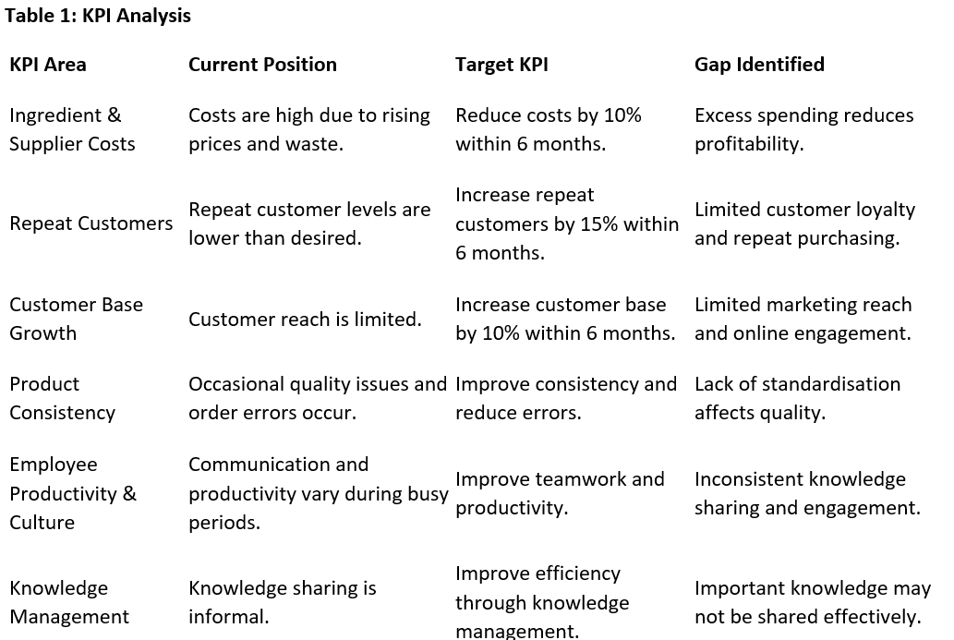

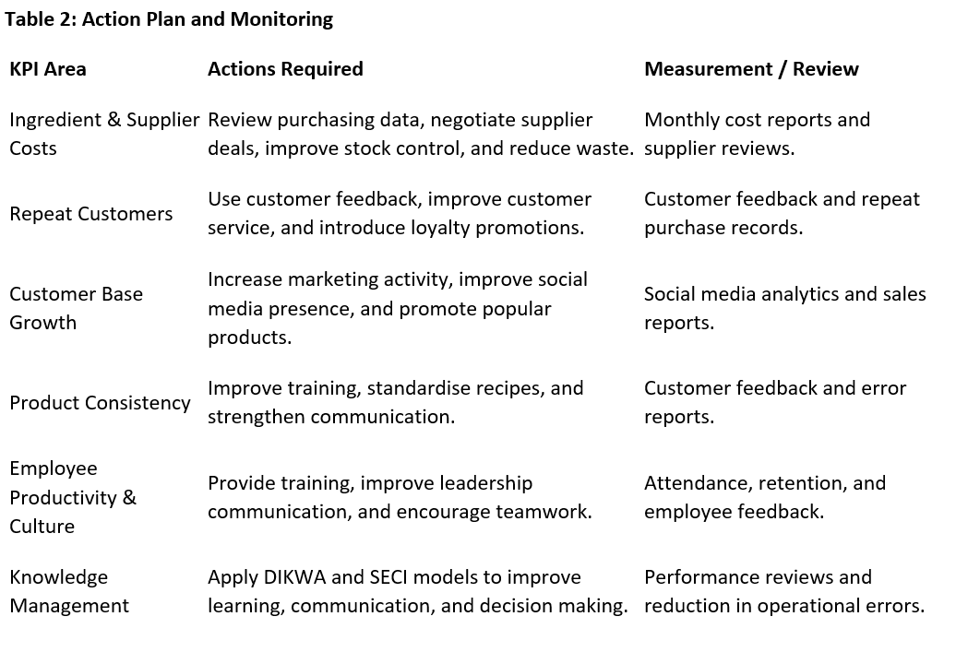
The gap analysis demonstrates that improvements are required in several areas to support the continued growth of Lil Puddings. Ingredient and supplier costs, customer retention, and knowledge sharing have been identified as priorities because they directly influence profitability, operational efficiency, and customer satisfaction.
Knowledge management plays an important role in achieving these objectives. The DIKWA model supports the use of business data and information to improve decision making, while the SECI model encourages knowledge sharing and staff development. Together, these approaches can help reduce operational errors, improve communication, and support continuous improvement throughout the business.
Employee productivity and workplace culture can also be monitored through KPIs such as staff attendance, employee retention, customer feedback, and productivity levels. These measures can help assess whether knowledge management practices are contributing to improved organisational performance. However, some aspects of knowledge, particularly tacit knowledge, practical experience, and creativity, are difficult to measure accurately. Therefore, both quantitative performance measures and qualitative feedback should be used to evaluate the overall effectiveness of knowledge management within the business.

2.6 Information Required
To support effective decision making and monitor business performance, Lil Puddings requires access to accurate and relevant information across a range of business activities.
Operational information, such as sales figures, stock levels, and production schedules, is required to manage inventory and ensure products are available to meet customer demand. Customer information, including purchasing behaviour, preferences, and feedback, helps the business improve product offerings and enhance customer satisfaction.
Financial information is also important and includes costs, revenue, profit margins, and supplier pricing. This information supports budgeting, purchasing decisions, and overall financial planning. In addition, employee information, such as training records, skills, and availability, helps ensure staff can perform their roles effectively and maintain operational standards.
Access to accurate and up to date information is essential for effective knowledge management. However, information is not always completely reliable. For example, customer feedback may be biased if it is collected from a limited number of customers, which could result in inaccurate conclusions. This highlights a limitation of the DIKWA model, as inaccurate data can lead to unreliable information, knowledge, and business decisions (Bolton, 2023).
Therefore, information should be regularly reviewed and evaluated to ensure it is accurate, relevant, and suitable for supporting decision making within the business.

2.7 Systems to Protect Confidentiality, Integrity, and Availability of Information
To protect business information, Lil Puddings must ensure the confidentiality, integrity, and availability of information, commonly referred to as the CIA triad (Team, 2024). These principles help ensure that information is secure, accurate, and accessible when required.
Confidentiality involves protecting sensitive information from unauthorised access. Within Lil Puddings, this includes employee records, financial information, supplier agreements, customer details, and business recipes. Password protected systems and restricted access to digital files can help ensure that confidential information is only available to authorised individuals.
Integrity refers to maintaining the accuracy, reliability, and completeness of information. This can be achieved through accurate data entry, regular reviews of business records, and updating documents when changes occur. Maintaining integrity is important because inaccurate information can lead to poor decision making and operational inefficiencies.
Availability ensures that information can be accessed when required to support business operations. Employees need access to recipes, stock records, schedules, and operational procedures to perform their roles effectively. Digital storage systems and regular data backups can help ensure that important information remains available and protected from loss.
Maintaining an appropriate balance between security and accessibility is essential. Excessive restrictions may reduce efficiency, while weak security measures can increase the risk of data loss, unauthorised access, or errors. Therefore, appropriate controls must be implemented to protect information while ensuring that it remains available to support the effective operation of Lil Puddings (Team, 2024).

Conclusion
This assignment has demonstrated the importance of knowledge management in supporting the performance and growth of Lil Puddings. It has shown that knowledge management involves not only the collection and use of data and information, but also the sharing of experience, skills, and organisational learning.
The DIKWA model highlighted how data can be transformed into information, knowledge, wisdom, and action to support effective business decision making. However, the assignment also identified that the quality of decisions depends on the accuracy and reliability of the data collected.
In comparison, the SECI model provided a practical explanation of how knowledge is created and shared through communication, observation, and experience. This is particularly relevant within Lil Puddings, where many important skills are developed through practical learning and employee interaction.
The assignment also demonstrated how a knowledge management framework can support operational efficiency, staff development, product consistency, and customer satisfaction. In addition, the identification of knowledge assets, storage systems, and key performance indicators highlighted the role of knowledge management in supporting continuous improvement and business performance.
Overall, both the DIKWA and SECI models provide valuable approaches to knowledge management. While DIKWA supports data driven decision making, the SECI model explains how knowledge is created, shared, and applied within the organisation. Using both approaches together enables Lil Puddings to manage knowledge more effectively, support business growth, and maintain a competitive advantage in the future.

References
Athuraliya, A. (2024). How to Build a Knowledge Base for Your Organization | Creately. Creately. https://creately.com/guides/knowledge-base/
Bolton, P. (n.d.). Statistical literacy guide How to spot spin and inappropriate use of statistics. https://researchbriefings.files.parliament.uk/documents/SN04446/SN04446.pdf
Day, B. (2023, April 24). What Is A KPI? Definitions And Examples. Forbes Advisor. https://www.forbes.com/advisor/business/what-is-a-kpi-definition-examples/
GeeksforGeeks. (2023, July 31). DIKW Pyramid | Data, Information, Knowledge and Wisdom | Data Science and Big Data Analytics. GeeksforGeeks. https://www.geeksforgeeks.org/data-science/dikw-pyramid-data-information-knowledge-and-wisdom-data-science-and-big-data-analytics/
Groh, K. (2024, February 22). Knowledge Management: Importance, Benefits, Examples [2025]. Valamis. https://www.valamis.com/hub/knowledge-management
Hajric, E. (2024). The Different Types of Knowledge. Knowledge-Management-Tools.net. https://knowledge-management-tools.net/different-types-of-knowledge
How to Create a Knowledge Management Framework | Bloomfire. (2026, March 25). Bloomfire. https://bloomfire.com/blog/knowledge-management-framework/
Kumar, A. (2020, March 3). What is Data? Discover Its Definition, Types, and Importance. Simplilearn.com; Simplilearn. https://www.simplilearn.com/what-is-data-article
Manmohan Hebbar. (2026, January 6). VRIO Framework: Competitive Advantage Analysis. Whichframework.org; Which Framework. https://whichframework.org/frameworks/vrio-framework.html
Sen, A. (2024). Organizational Knowledge and Knowledge Management - A New Framework. American Journal of Management Science and Engineering, 9(1), 1–12. https://doi.org/10.11648/j.ajmse.20240901.11
Team, C. W. (2024, November 13). What is the CIA Triad (Confidentiality, Integrity, Availability)? Cyber Security News; CybersecurityNews. https://cybersecuritynews.com/cia-triad-confidentiality-integrity-availability/
TheBusinessProfessor. (2025, February 23). SECI Model - Explained - TheBusinessProfessor. TheBusinessProfessor. https://thebusinessprofessor.com/seci-model-explained/

Appendix A
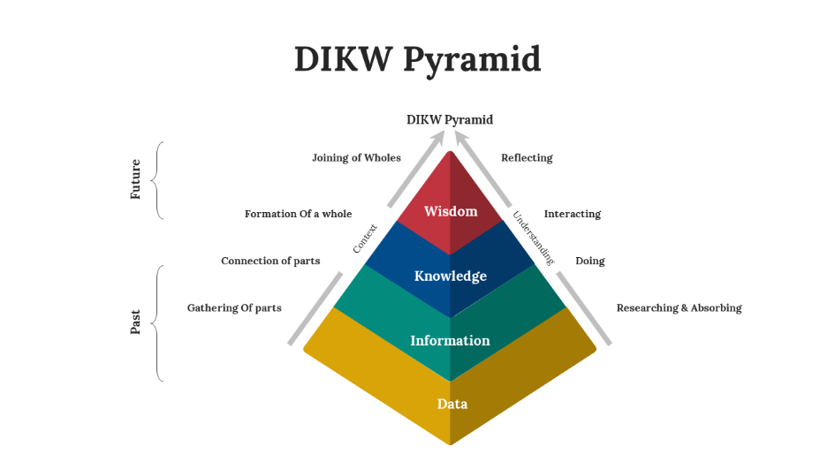
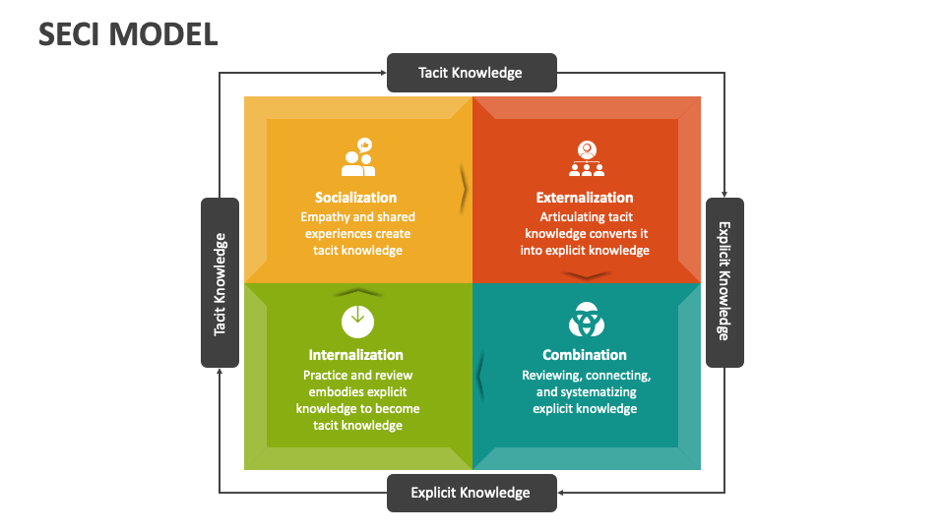
CIA TRIAD


