

Assignment 1: E-Portfolio
Learning in the Digital Era ACCA4025
Valentina Todeva | Cloud Computing | Student ID: 2022690

Essential skills for study
and employment

Essential skills for study

Essential skills are the abilities that individuals need for work, learning and life. they're utilized in the community and therefore the workplace, in numerous forms and at different levels of complexity. But will mention some that are important to me. [1]

1.Research skills:

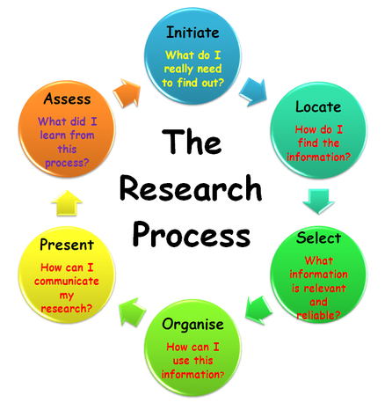 [2]

2. Time Management skills:

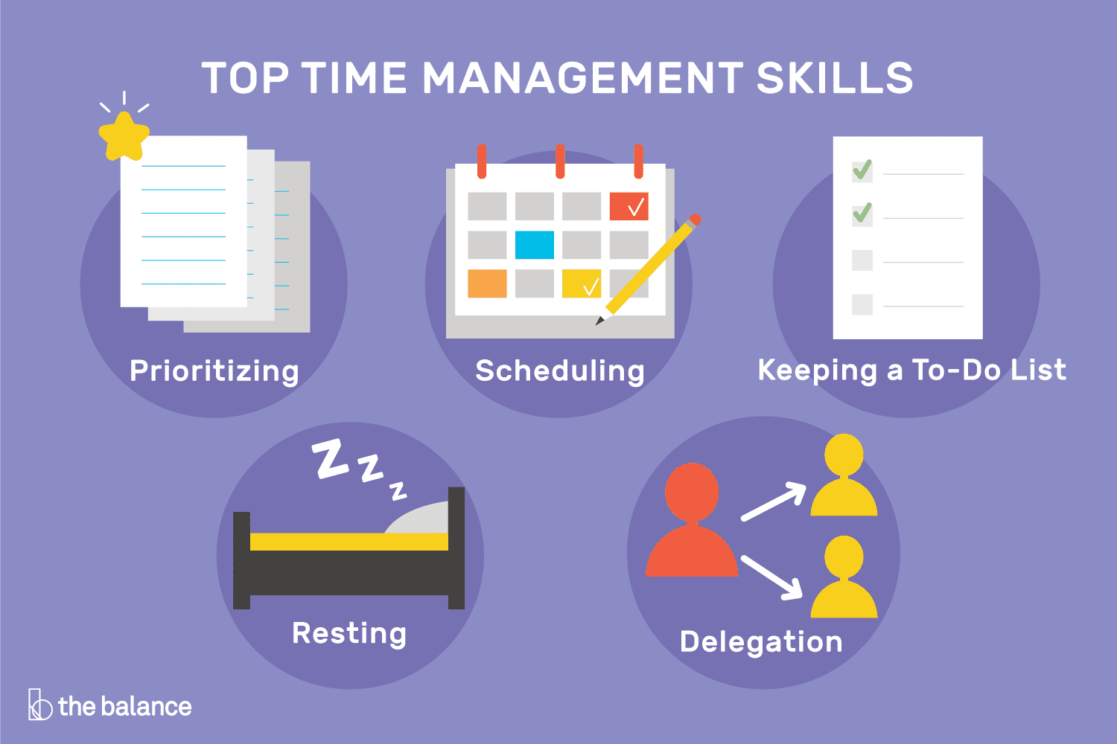 [3]

3. Note –taking skills:

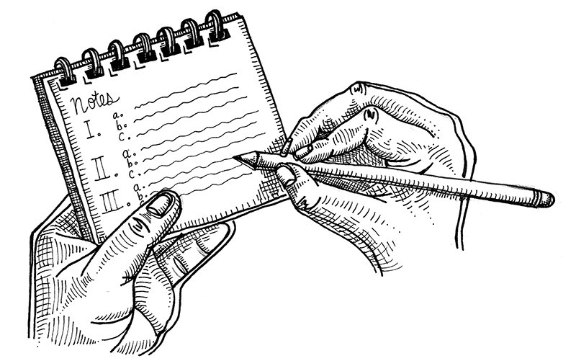 [4]

4. Learning skills:

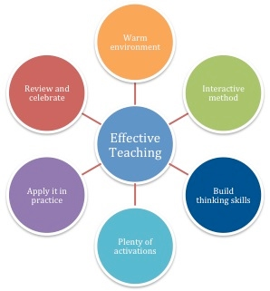 [5]

5.Critical thinking skills:
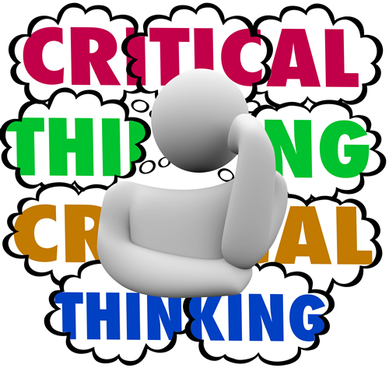 [6]

6. Academic writing skills:
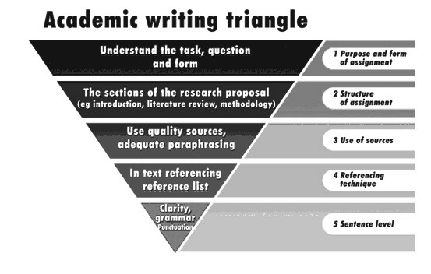 [7]

Employment skills for study
Employment is a set of achievements, skills, understandings and personal qualities that make graduates adapt more quickly to work and succeed in their chosen professions, which benefits themselves, the workforce, the community and the economy. Studying at university can provide you with a plus in your future career. However, whether or not you have got a first-solving’s degree and a relevant subject for the career you need, you'll possibly be competing against others who have the identical or similar academic qualifications. Employability isn't something that may be easily ignored considering your employability from an early stage is probably going to extend the prospect that you simply are successful in your chosen career.
Here are some of Employability Skills for a successful career:

- Communication and Interpersonal Skills.
- Problem-Solving Skills.
- Self-Motivation.
- Working under Pressure.
- Organizational skills.
- Team Spirit.
- Learning Skills.
- Number and Data Skills. [8]

Development of Skills
The Development of such skills will support me to find the job I want. Because I will have the necessary knowledge and skills witch, I will know how I could start in the field in which I have always dreamed of realizing. [9]

Bibliography

[1] | Essayzone.co.uk, "Essayzone.co.uk," 2021. [Online]. Available: www.Essayzone.co.uk. [Accessed 27 04 2021].
[2] | V. Library, "Virtual Library," 2021. [Online]. Available: https://www.virtuallibrary.info/research-process.html. [Accessed 27 04 2021].
[3] | Dotdash, "The balance careers," 04 2013. [Online]. Available: https://www.thebalancecareers.com/time-management-skills-2063776. [Accessed 27 04 2021].
[4] | E. Powell, "The vermont cynic," 10 11 2017. [Online]. Available: https://vtcynic.com/culture/life/different-note-taking-styles-affect-learning/. [Accessed 27 04 2021].
[5] | M. Felmore, "Maike Felmore BPT1501 Portfolio," 2015. [Online]. Available: https://sites.google.com/site/onlineportfolio56248849/home/effective-teaching. [Accessed 27 04 2021].
[6] | E. Ullman, 14 05 2018. [Online]. Available: https://www.eschoolnews.com/2018/05/14/5-ted-ed-lessons-to-help-you-teach-critical-thinking-skills/. [Accessed 27 04 2021].
[7] | ResearchGate, "ResearchGate," ResearchGate, 2008. [Online]. Available: https://www.researchgate.net/figure/The-Academic-Writing-Triangle-21_fig2_228567769. [Accessed 27 04 2021].
[8] | Simplilearn, "Why are Employabiliti Skills Important," Why are Employabiliti Skills Important, pp. 1-1, 30 03 2021.
[9] | J. Manktelow, Personal Development Plan, London: Mind Tools Ltd., 2007-2014.

Top of Form

Bottom of Form

