2019
Paval Thekkan (1808661)
Personnel Resourcing and Development
7/1/2019
The Project Proposal

Contents
Research proposal (Task 1) 3
Advantages and disadvantages (Task 2) 4
Conclusion (Task 3) 5
Recruiting selection (task 4) 6

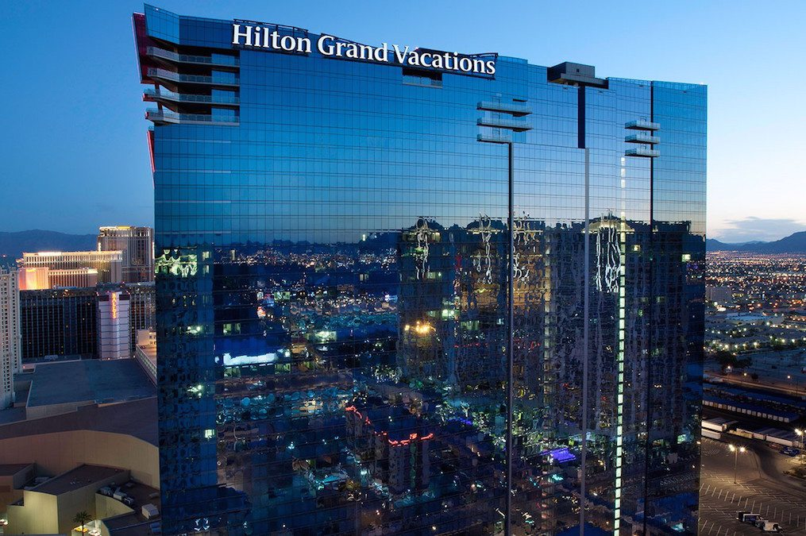

Research proposal (Task 1)
The Hilton hotel is an international hotel chain spread in all the world and is one of the largest
hospitality company, it counts more 570 properties in more than 85 countries and they got more
than 169.000 employees to work in their brand where they have full time workers and flexible work. (Hiltonhonors3.hilton.com, 2019)
in this report will display the advantages and disadvantages results of primary and secondary
research and the discussion about the costumer service can be effect from the flexible work in the
hospitality industry .
The chosen organization is about the costumers service in all the department of the Hilton hotel.
Every department have their proper way to engage and to manage the situations with costumers.
Every single member of the staff need to be always courteous and kind with the costumer, for
Make sure the client is always satisfied from their work.
Every costumer is different from the others so the staff need to be always prepared to manage
Inconvenient situation with the costumer and need to be always happy and display big smile even if
If the guest is in the wrong side because they are displaying the image of the Hilton hotel.
The costumer service is very important for the Hilton hotel because only if the clients are
Satisfied from their accommodation, they are going to come back for stay again in the hotel so the
Hotel give more interest in this field because the revenue of the hotel is based everything on the
Costumers accommodation and to their satisfaction. (Stevens, n.d.)
In the costumer service is very important the employee training for the good work of the staff with
Guests of the hotel, so the hotel provide to do employee training to make sure to give the maximum
Satisfaction to the costumers of Hilton hotel.
In the organization is very important the employee training and development because these implies
The skills, the knowledge and the attitudes of the staff all of these transitions are concentrate on
Two types of initiative:
- To improve the present and the future employees performance by increasing the various
Skills of individuals to achieve efficiently tasks and organizational goals.

- The employee training is used to have a facilitate work and to have learning experience and the acquisition of job related knowledge and skills. (Sparrow and Hiltrop, 1994)
The employees training is very useful to encourage the staff to do work which they are not trained
and all of these can make simple their work with some simple steps where they learn from these
trainings. (Wilson, 2009).

The Hilton hotel have the staff which are employed working permanently and temporarley, the staff
Are employed to work full time and part time, almost all the staff are in full time but they have a small
Percentage which are part time and we can call flexible work as well. The flexible work is about the
employees give some Freedom in deciding how the work will be done and how they’ll coordinate their
schedules with other Employees, the employer have a minimum and maximum number of hours to
work the days and the core time which all employees must be present. (Stredwick and Ellis, 2005)
the Hilton hotel have part time workers which are important for the hotel. (Nienhueser, 2005)

Advantages and disadvantages (Task 2)
flexible work can have advantages and disadvantages in both sides for employee and employer as
well and can effect the work of all the hotel including the Hilton hotel. The flexible work can effect
all the work of the hotel in all the department because in every department they got staff working in
flexible way and the employees can work efficiently or not, so need always be very careful to recruit
workers in flexible work and understand if it’s worth to recruit people in this kind of jobs and for this
reason the flexible work got a lot of advantages and disadvantages and I’m going to put a list here
for the Hilton Hotel:
the top advantages for employees are:
- they got more time to meet family and friends
- decreased commuting time on gas expenses
- have more control the working environment and time schedule
- can work during hours and that can fit energy cycles best
the top disadvantages for employees are:
- have more problems to work as effectively and have problems to communicate with the people of the staff
- working from home can make problem to the availability of work
- no clear dividing between work and home
the top advantages for employers are:
- improvement of employee and tardiness
- decrease absenteeism and tardiness
- decrease worker turnover
- complement company image as a family-friendly place to work
the top disadvantages for employer are:
- the worker might not work efficiently without supervision
- compressed work weeks may mean client availability suffers
- feelings of favoritism when only certain employees have work that can be done remotely(Taylor, 2005)

in the hospitality industry is a good practice to have people to work with flexible work because in this kind of business tend to have more people to work with this condition.
In the Hilton hotel the good practice are:
- The staff members area of responsibility and job description the staff members performance history, problem solving abilities, sense of collaboration and fit with the request
- Put the arrangement in writing
- Be creative in considering how flexibility may work in each department
The poor practice in Hilton hotel are:
- The employees cannot work efficiently like the full time workers
- If the supervisor check the work of employees with a camera, he or her cannot see all their work in one time, need to check again and again for see any problem with their work

Conclusion (Task 3)
The flexible work is very important for the Hilton hotel, like in all the companies and hospitality
Industry and the flexible work can effect the good costumer service because sometimes the
Employees and the employer doesn’t work efficiently how the Hilton hotel asks, so for this reason
Sometimes the guests can have a poor costumer service for the flexible work. In every department
Of the Hilton hotel can have staff with flexible work and need always careful to recruit people who
Want really work because the reputation of the hotel can be compromised from their work.
The Hilton hotel is considered one of the best hotel and with the costumer service so all the guests
expect a high quality service but sometimes they can achieve the opposite of high quality so the
Hilton hotel need to be good to the personnel development and employee engagement.
The flexibility work is about the part time jobs and the jobs can be done from home, the part time
Has done in order to achieve greater numerical flexibility of labour and reduce labour costs. (Beardwell and Claydon, 2007)
In Hilton hotel shows an increment in flexibility work because they are looking for people to work in
Part time because the people who work part time they don’t need to pay more taxes on them. The
Flexible work can have a lot of advantages and disadvantages for the employer and employee.
The part time workers have a minimum and maximum hours to work and they have more freedom
To change their schedule hours with other employees. The flexible work is very important for Hilton
Hotel and for their workforce because they can be helpful during the weekends the people working
part time. In the Hilton hotels needs a high number of team members for the parties like weddings,
Christmas parties and they can recruit the people just for these kind of occasions for this reason is
very important to have people in flexibility work practices in the form of numerical flexibility.

Recruiting selection (task 4)
The interviews are the most popular selection tool to recruit the people on the work force.
The interviews is a controlled conversation between the employer and on person to evaluate and to
understand the abilities of the person and to check if he or her is suitable for the work. The
interview can be more than one stage can be on telephone or one to one in a proper formal way.
They are different types of structured interview, but they have a number of common features:
- The interaction between the individuals is standardised as much as possible
- All the candidates will be asked the same questions of others
- Replies are rated by the interviewer on preformatted rating sales
- Dimensions for rating are derived from critical aspects of on the job behaviour(Anderson and Shackleton, 1993)
The two most important and popular structured interviews techniques are behavioural and situational interviews and for now is still the most popular way to recruit the people.
The Hilton hotels interviews are standard like the other hotels they will call for arrange an interview and need always to present dressed in formal way and they will ask a series of questions to answer in right way, if the interested person will reply in the right way the person will be passed or if he do something wrong that means they don’t recruit the person for the workforce.
The series of questions Hilton will ask are the following and with them I write a list of answers as well(WorkNearYou, 2019):
- Tell us about yourself?
Is important to speak very clearly and calm, need to say the hobbies and the various works done related to the hotels
- What you can tell us about Hilton hotels?

It is important to answer with interest and show the knowledge about the Hilton hotels saying when is born and when is made the first hotel etc.

- Why do you want to work for Hilton hotels?

The person who is doing the interview need to be positive and show which abilities and capacity it owns , for make the interviewer choose him or her for the chosen job

- What is your greatest strength?

Highlight the proper strengths which is important to join the workforce

- What is your greatest weakness?

Try to do not say weakness

- Where do you see yourself in the next 5 years?

Try to be ambitious on the life and the career because the Hilton hotel are looking for people to manage all the situations.

- Why should I hire you?

Give some reasons to hire you and show them the proper abilities to make sure to get the place of work(WorkNearYou, 2019)

References
Anderson, N. and Shackleton, V. (1993). Successful selection interviewing. Oxford: Blackwell Business.
Beardwell, J. and Claydon, T. (2007). Human resource management. Harlow, England: Prentice Hall/Financial Times.
Hiltonhonors3.hilton.com. (2019). Our Portfolio of Hotel Brands - Hilton Honors. [online] Available at: https://hiltonhonors3.hilton.com/en/explore/brands/index.html [Accessed 4 Jul. 2019].

Nienhueser, W. (2005). Special issue: Flexible work - atypical work - precarious work?. Mering: Hampp.

Sparrow, P. and Hiltrop, J. (1994). European human resorce managent in transition. New York: Prentice Hall.
Stevens, D. (n.d.). Brilliant customer service.
Stredwick, J. and Ellis, S. (2005). Flexible working. London: Chartered Institute of Personnel and Development.

Taylor, S. (2005). People resourcing. London: Chartered Inst. of Personnel and Development.

Wilson, J. (2009). Human resource development. London u.a.: Kogan Page.
WorkNearYou. (2019). Hilton Hotels Interview: 10 Must Know Questions and Answers. [online] Available at: https://worknearyou.net/hilton-hotels-interview-questions/ [Accessed 4 Jul. 2019].

