

Programme- BA Business Management

Module code: LCBB5000

Data Handling and Business Intelligence

Assessment 2

Student name: Cristina Caraman (2125666)
Lecturer: Dr Xavier Manieni

Submission date: 03.09.2023

Table of Contents
Part 1 3
Hotel Reservation Dataset 3
Preprocessing the data using Excel 3
Analysing the data using Excel 7
Visualisation and Interpretation of the data using Excel 12
Part 2 14
2.1. Gender distribution in the Student_Score database 15
2.2. Qualification statistics for reduced/ free lunch 16
2.3. Mean and Median value for qualification statistics 16
2.4. Mean and Median value of pre-test and post-test scores 17
2.5. Clustering 17
2.6. Data Mining and Text Mining methods 19
2.7. Advantages and Disadvantages of SPSS and Excel 21
Reference 23

Part 1

Hotel Reservation Dataset
The Hotel Reservation dataset is downloaded which is available in the spreadsheet format. It contains the data of the booking information of the guests arriving at the hotel for a period of six years (2017 to 2022). The types of variables inserted in the spreadsheet are Booking_ID, Demography, Room Type, Meal Type, Parking Required, Arrival, Market Type, Repetition, Lead Time, Special Requests, Average Price and Booking Status. Microsoft Excel framework is used to pre-process, analyse and visualise the data. The analysis required in this section is to determine the increase or decrease in average price over the years, i,e., from 2017 to 2021. With the use of functions and formulas, the learner shall also consider the use of two alternative functions to solve the analysis.

Preprocessing the data using Excel
Data preprocessing is the method that uses raw data and makes it acceptable for analysis. Data preprocessing involves steps like “Data Cleaning”, “Data Integration”, “Data Transformation”, “Data Reduction”, “Data Discretisation” and “Data Normalisation”. Data preprocessing is required for performing any sort of analysis, as the raw data needs to be prepared for analysis free from errors.
Step 1: The first step is to establish the original dataset where data that needs processing is collected and stored.
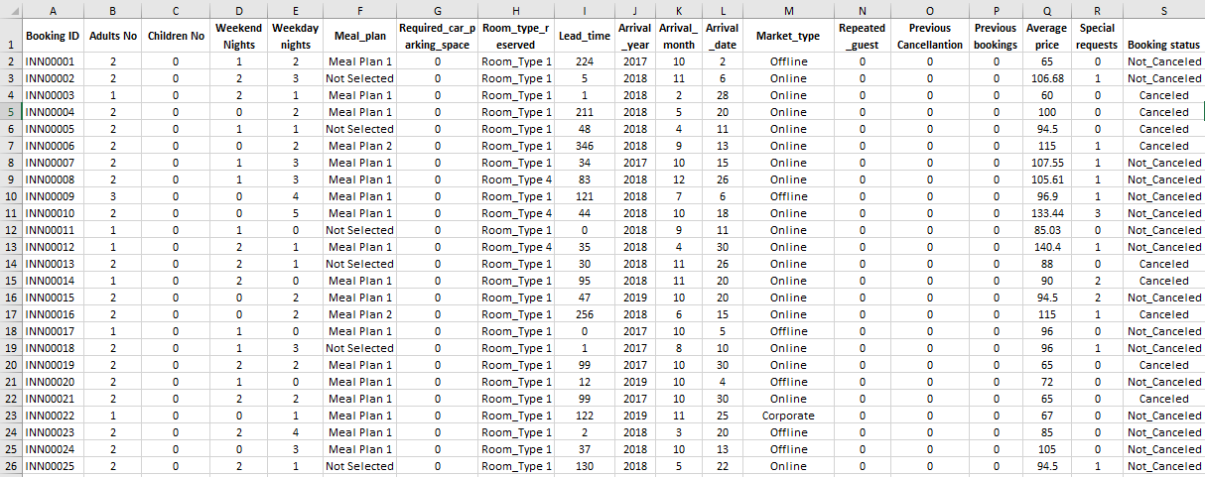
“Figure 1: The Hotel Reservation Dataset”
“Source: Course Material”
Step 2: The next step is to eliminate unnecessary cell formatting. For this purpose, the whole dataset is selected and the Autofit Row Height and Autofit Column Width are clicked. This option is available in the Format option, under the Home section. This will allow specific rows and columns to be extracted into separate sheets for analysis.
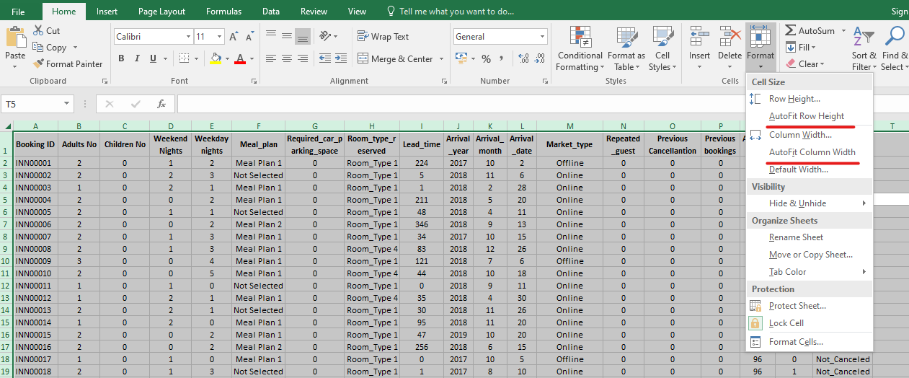
“Figure 2: Format Cells”
“Source: Created by Cristina Caraman”
Step 3: The Sort and Filter option is clicked under the Home section. This is done by selecting the header row. This will allow the identification of inconsistencies in the data within each specific column. For analysis purposes, the concerning columns are Arrival_Year and Average_Price.
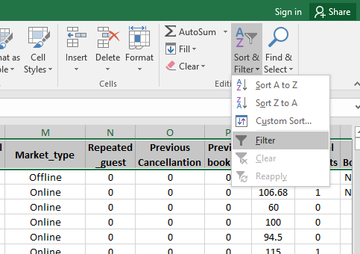
“Figure 3: Sort and Filter”
“Source: Created by Cristina Caraman”
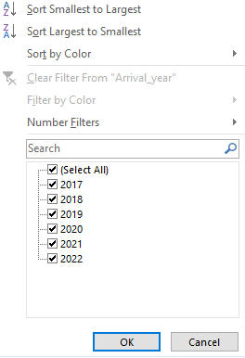
“Figure 4: Filtering the Arrival_year column”
“Source: Created by Cristina Caraman”
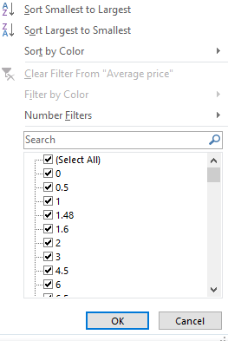
“Figure 5: Filtering the Average Price column”
“Source: Created by Cristina Caraman”
Step 4: It is observed that the Average price column consists of missing values. These values must be removed to perform analysis. This is done by selecting only the null values rows from the table (only the rows where the price is zero) and removing those rows altogether.
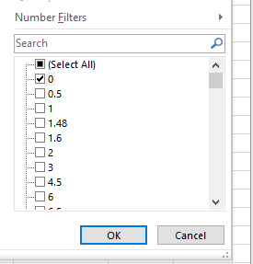
“Figure 6: Selecting the null values using the dropdown list for the price column”
“Source: Created by Cristina Caraman”
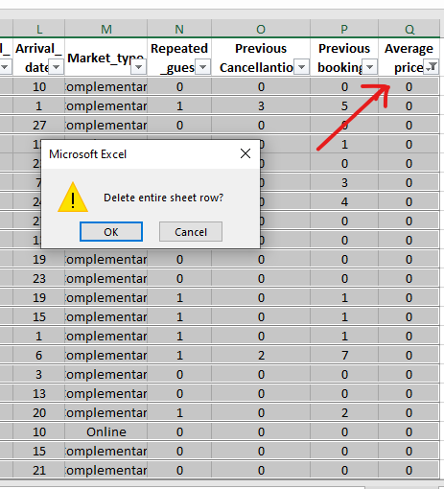
“Figure 7: Deleting the average price rows containing null values”
“Source: Created by Cristina Caraman”

Analysing the data using Excel
IF formula
The data points that are required for evaluation purposes are extracted and inserted in a structured manner for analysis purposes. Thus, the Average price and Arrival year data points are extracted from the entire table and placed accordingly in a structured table. The conditional formula is used to extract the summation value for individual years. Figure 8 depicts the use of the condition formula SUMIF(), to prepare the new dataset. The syntax given below depicts the conditional formula used in this case. The range "A: A" is the “lookup range”, followed by the criteria and range "B: B" is the “return range”.

"Syntax: SUMIF (A: A, "2017", B: B)"
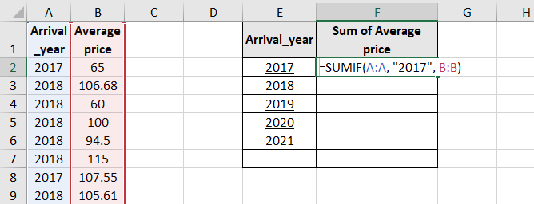
“Figure 8: Extraction of required fields”
“Source: Created by Cristina Caraman”

The complete dataset is prepared for the required analysis which contains the Arrival year and Sum of Average price, and is shown in Figure 9.
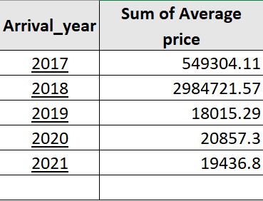
"Figure 9: Analysis dataset using the conditional formula"
“Source: Created by Cristina Caraman”

PIVOT table
PIVOT tables in Excel enable analysts to report large amounts of data in the datasets into a condensed and summarised format, only taking into account the needed fields and data (Domino et al., 2021). The Hotel Reservation dataset contains large amounts of records which need proper structuring for analysis. This can be achieved using the PIVOT feature using the following steps-
Step 1: The whole dataset that should be summarised or condensed as per the analysis is selected.
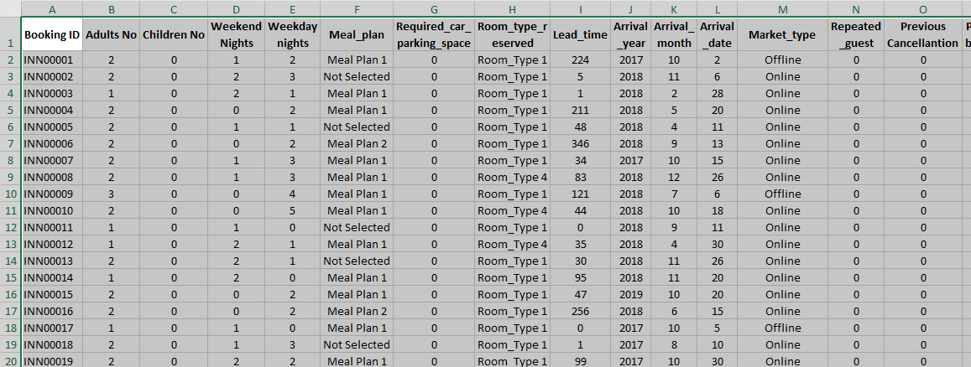
“Figure 10: Selection of all the rows and columns of the required dataset”
“Source: Created by Cristina Caraman”

Step 2: The Pivot table option is found under the Insert section of the Excel framework. This option is selected.

“Figure 11: Inserting the Pivot table”
“Source: Created by Cristina Caraman”
Step 3: Upon clicking the Pivot Table option, a new window appears labelled Create Pivot Table. This window requires information about the table range and whether the PIVOT table should be inserted in the new worksheet.
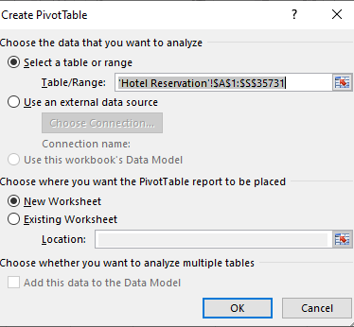
“Figure 12: Create Pivot Table”
“Source: Created Cristina Caraman”

Step 4: The new worksheet appears where the Pivot table pane is obtained. Required fields for analysis can be selected using the checklist provided beside each column name. The required conditions can be selected as well. For this particular case, we will need the Arrival Year and Average Price column. A structured table similar to Figure 9 can be created by extracting the required values from the pivot pane. It is noted that the Arrival year must be dragged into the filter column to observe individual outcomes. The complete procedure is depicted in the figures below.
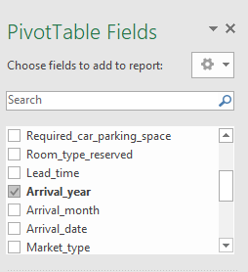
“Figure 13: Inserting Arrival Year field”
“Source: Created by Cristina Caraman”

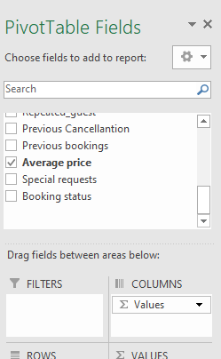
“Figure 14: Inserting Average price field”
“Source: Created by Cristina Caraman”
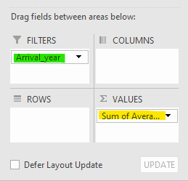
“Figure 15: Dragging values in the required panes”
“Source: Created by Cristina Caraman”

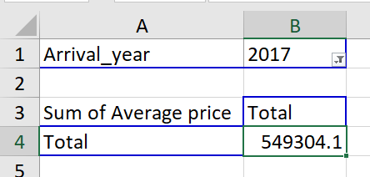
“Figure 15: Extracting values using Pivot tables”
“Source: Created by Cristina Caraman”

Visualisation and Interpretation of the data using Excel
The line chart depicted below visualises the data estimated in the previous section of the analysis. The issue that needs to be answered is whether the total average price has encountered escalation or depreciation from 2017 to 2021.
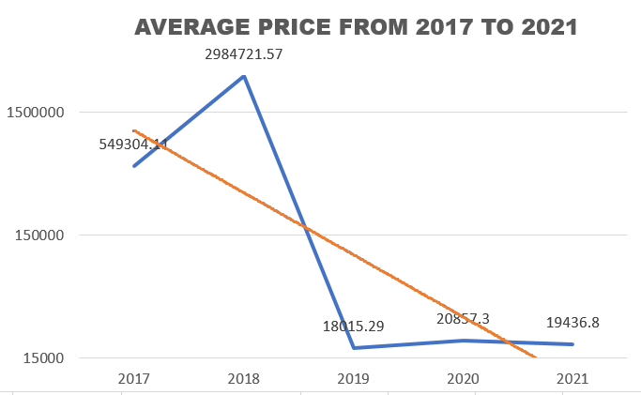
“Chart 1: Line depiction of the average price trend from 2017 to 2021”
“Source: Created by Cristina Caraman”

Interpretations:
- From Chart 1, it is established that there is an initial upward trend from 2017 to 2018 if the total average price is considered. The overall growth observed during this period was more than four times the initial value.
- From 2018, the total average price observed a downward trend till 2021. The maximum downfall was observed from 2018 to 2019 by nearly 99.3% which was tremendous. Not much growth was observed from 2019 to 2021.
- The maximum average price of the hotel bookings was observed in 2018 (£ 2984k) and the minimum average price of the hotel bookings was observed in 2019 (£18k).
- Overall it can be established that the hotel business encountered a decline in the average price value from 2017 to 2021 by approximately 96%.

Part 2

The “Student_Score.csv” database is obtained from the source. This database consists of 2133 records and 14 fields.
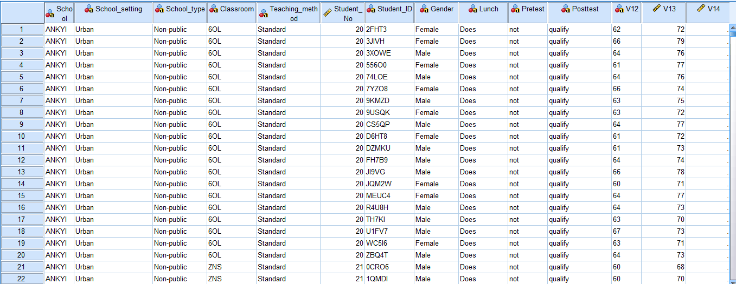

“Figure 1: Demonstration of the student_score.csv dataset”

“Source: Created by Cristina Caraman”

2.1. Gender distribution in the Student_Score database
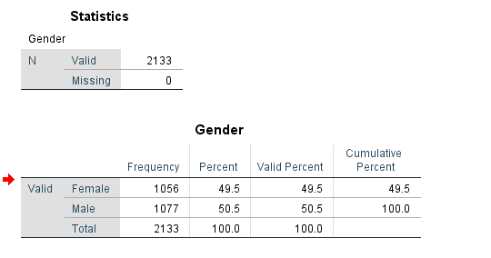
“Table 1: Frequency distribution of the gender of students”
“Source: Created by Cristina Caraman”

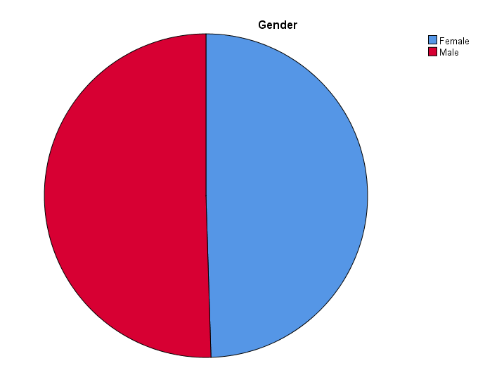
“Chart 1: Gender Distribution”
“Source: Created by Cristina Caraman”

A total of 2133 students were estimated for the study. The percentage of male students is 49.5% and the percentage of female students is 50.5%. Although the male students are slightly more than the female students, the distribution of each gender is nearly half of the overall percentage.

2.2. Qualification statistics for reduced/ free lunch
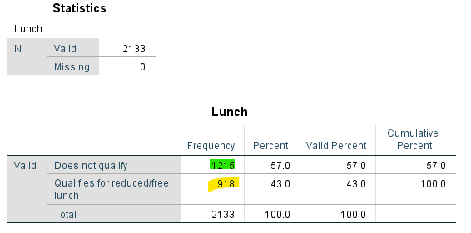
“Table 2: Distribution of qualified and disqualified students for reduced/free lunch”
“Created by Cristina Caraman”

Out of the 2133 students, only 918 (43%) students qualified for the reduced/free lunch. 57% (1215) of the students failed to qualify for the reduced/free lunch.

2.3. Mean and Median value for qualification statistics
The mean value for the total number of students who qualified and did not qualify for the reduced/ free lunch -
The median value for the total number of students who qualified and did not qualify for the reduced/ free lunch -

2.4. Mean and Median value of pre-test and post-test scores
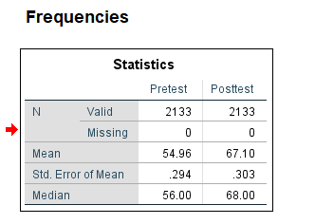
"Table 4: Mean and Median differences between pretest and posttest scores"
“Source: Created by Cristina Caraman”

Table 4 depicts the overall test of 2133 students and depicts the differences in the mean values and the median values for the pretest scores and post-test scores. The average pretest score is 54.96 and the median pretest score is 56, which means that half of the student's marks are achieved on either side of the value. The average post-test score is 67.1 and the median post-test score is 68. Higher post-test scores are achieved by students as compared to their pretest scores.

2.5. Clustering
K means clustering
K-means clustering is an unsupervised clustering method which means that the total population or observations are divided into clusters containing similar characteristics and significantly different from each other (Nainggolan et al., 2019). For this case, the ‘k’ or the number of clusters selected are two - Z Score(Pretest) and Z score (Posttest). Two clusters have been formed for both cases. Cluster 1 contains 993 students and Cluster 2 contains 1140 students.
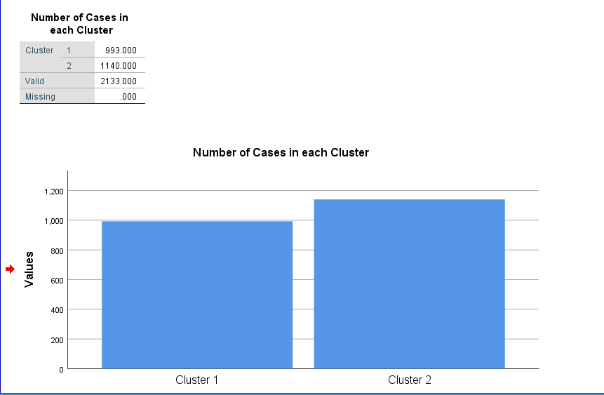
"Chart 2: Segmentation of clusters"
"Source: Created by Cristina Caraman"

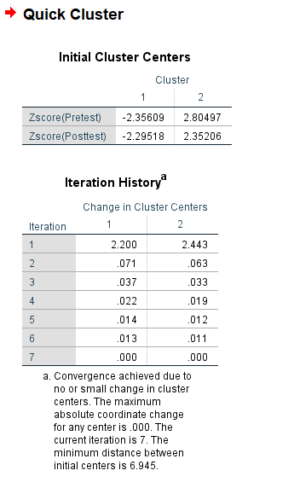
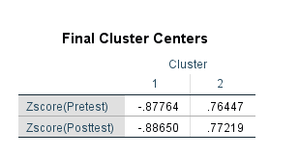
"Table 5: Initial Cluster Centres and Final cluster centres"
“Source: Created by Cristina Caraman”
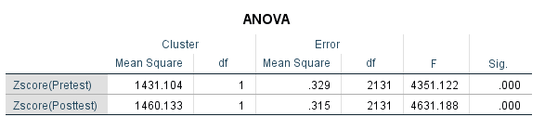
“Table 6: ANOVA table and statistical significance”
“Source: Created by Cristina Caraman”

Cluster centres are the points that signify the mean value of the points located in the cluster. The initial and final cluster centres for pretest and post-test scores are observed in Table 5. Table 6 contains the ANOVA table which describes the statistical significance between the cluster centres for both the variables. It is observed that the mean values for cluster 1 and cluster 2 are 0.87 and 0.76 respectively for the pretest scores and 0.88 and 0.77 for the post-test scores. The statistical significance in Table 6 indicates that the mean values are significantly different from each other. Both the pretest and the post-test scores are much more dependent on cluster 1 than cluster 2.

2.6. Data Mining and Text Mining Methods

Data Mining
With the availability of data skyrocketing with each passing day, it has become significant for businesses to efficiently manage big data. As the abundance of data is overwhelming, businesses seek to gather relevancy in the data that is collected. Meaningful insights have become predominantly important in business analysis and the development of long-term strategic goals aligned with those insights. Data mining is only the meaningful derivation of available data (Ernawati et al., 2021). The usefulness of data mining simply lies in eradicating intuitive decision-making and solely focusing on numerical methods and informed decision-making. Various uses of data mining can be forecasting future values to mitigate threats and risks, maintaining and updating warehouses, and exploiting opportunities to stay ahead in the competitive market. The segmentation of customers can be observed through the lens of various data mining methods, which can help extract meaningful trends and patterns in the data.
Clustering: Clustering is the method of segmenting different data points based on relevant characteristics (Hossain, 2019). The grouping of data into subsets is a common way to target specific customers, and this method is widely applicable in data mining. For example, retailers may group products based on brand, customer preference, price or geographic preferences. Various types of clustering available are based on partition, density-based, grid-based or hierarchical.
Association: As the term suggests, association is a data mining method where the analyst looks for correlations or relationships between data points (Surya Narayana et al., 2021). This is useful, especially in deriving hidden insights that are usually overlooked, which may reveal useful information. The method is prominent in the marketing segments and building companies' strategies that drive more income by adjusting variables accordingly. Associations can be single-dimensional, where one specific data point is focused on concerning time. It can also be multi-dimensional, where the focus is widened between multiple variables and their coexisting relationships.
Visualisation: The transformation of data points into a graphical format is a justified data mining method (Inusah et al., 2022). This is essential in any sort of business, large or small, to be able to communicate efficiently with the stakeholders. Business operations are more optimal with increased communication efficiency, which is achieved through visual reports. Data visualisation can take the form of comparisons, histograms, heat maps, density plots, correlation plots and so on, depending on the type of information that needs to be contemplated.

Text Mining
Like numerals, text and characters are also part of the large amounts of data that are used regularly. Text mining is retrieving or extracting meaningful insights from unstructured textual data in databases. It is a type of data mining relevant to textual data and is related to the techniques of "Natural Language Processing". Data mining, if associated with textual formats, allows businesses to gain insights from customer feedback, articles, journals, social media or news sources. While several benefits of text mining could be the cost-effectiveness, a diverse range of applications and ability to tackle large datasets, the main downsides could be the introduction of noise in the outcome and the requirement of highly advanced skills. Some of the methods of text mining are mentioned below.

Automatic Document Classification
In this method of text mining, a large number of online documents and textual formats can be categorised based on certain attributes. Classification of documents is based on categorisation, identification and analysis of the documents. The classification of textual formats can be done by supervised techniques such as labelling, unsupervised techniques such as clustering, or rule-based techniques such as sentiment analysis.
Keyword-Based Association: This technique specialises in considering certain keywords and analysing the behaviour and correlation among them. First, the preprocessing stage is dealt with and later the correlation between the keywords is established. This is a very time-efficient method, as no manual effort is required.

2.7. Advantages and Disadvantages of SPSS and Excel
SPSS
“SPSS (Statistical Package for the Social Sciences)” is an accumulation of statistical software used primarily in social sciences, such as education, economics and healthcare. The easier use of statistical software is its primary feature, whereas other features include data documentation and management data (Rahman and Muktadir, 2021). SPSS supports relational databases, spreadsheets and textual formats for predictive and descriptive analysis.

Advantages of SPSS | Disadvantages of SPSS
- The main advantage of SPSS is the user-friendly GUI (Graphical User Interface), which has maximum capabilities.  - A deeper statistical capability is instilled in the software package, which allows smarter sensing of data, such as the ability to form variables by reading information. A wider array of statistical extensions are already built-in this system.  - SPSS supports a lot of file formats such as Stata and SAS, along with spreadsheets.  - SPSS, with increased facilities, is also compatible which distinguishes it from other statistical software. It can operate on Windows, LINUX and Mac OS.  - Accuracy in predictive analysis of the target variable is achieved using SPSS, which is advantageous for researchers. | - The commercial licence is a major disadvantage concerning the software package, given its lucrative perks. For many sections, it can be costly even after discounts.  - The visual graphs in the output are not so easily customisable as compared to other frameworks like Excel, which can be problematic.  - Some of the modules and add-ons are not easy in terms of usability. Also, the program might have slow-running issues, given its heavy consumption due to such add-ons.

Microsoft Excel
Excel is a software developed by Microsoft that allows users to clean, store and analyse data by providing a spreadsheet environment (Rouse, 2020). The analysis and visualisation of data can be done using a diverse range of formulas, functions and charts. Compatible with "Microsoft Windows" and "Mac OS", various features of the software encapsulate cell formatting, formulas and functions, PIVOT table, graphs and charts, management and CRM. Excel can be used for inserting, validating, filtering, sorting, analysing and visualising data in a structured manner. Its user-friendly attribute enabled it as a mainstream software for statistical purposes.

Advantages of Excel | Disadvantages of Excel
- The advantage of Excel is the unlimited insertion of data, allowing it to be more frequent due to its simplicity.  - The formulas and functions allow the calculation and retrieval of data in a faster and more efficient manner.  - Compared to traditional paperwork systems, the spreadsheet facility allows the organisation of multiple sheets in a single workbook which is more easily accessible.  - Password protection allows the safety of datasets, and along with the user-friendly nature of the software, Excel stands out to be more conventional. | - The operational downfall occurs with the growth of data, and the program turns slow with more add-ons and extensions.  - Most advanced formulas and functions are unfamiliar to users, sometimes leading to learning from scratch. This leads to hectic reporting at times.  - Compared to SPSS, many statistical features are missing in Excel, some of which need to be downloaded manually depending on the task. But it is only used for spreadsheet purposes.  - Compared to other smarter alternatives, Excel is prone to errors. Heavy calculations such as predictive analysis may not be completely reliable.

REFERENCE

Bryant, L.A., (2021). Statistical skills for the workplace: A practical approach to teaching methods with Excel. The Palgrave Handbook of Political Research Pedagogy, pp.289-300.
Domino, M.A., Schrag, D., Webinger, M. and Troy, C., (2021). Linking data analytics to real-world business issues: The power of the pivot table. Journal of Accounting Education, 57, p.100744.
Ernawati, E., Baharin, S.S.K. and Kasmin, F., (2021). A review of data mining methods in RFM-based customer segmentation. In Journal of Physics: Conference Series (Vol. 1869, No. 1, p. 012085). IOP Publishing.
Hossain, M.Z., Akhtar, M.N., Ahmad, R.B. and Rahman, M., (2019). A dynamic K-means clustering for data mining. Indonesian Journal of Electrical Engineering and computer science, 13(2), pp.521-526.
Inusah, F., Missah, Y.M., Najim, U. and Twum, F., (2022). Data mining and visualisation of basic educational resources for quality education. International Journal of Engineering Trends and Technology, 70(12), pp.296-307.
Nainggolan, R., Perangin-angin, R., Simarmata, E. and Tarigan, A.F., (2019), November. Improved the performance of the K-means cluster using the sum of squared error (SSE) optimized by using the Elbow method. In Journal of Physics: Conference Series (Vol. 1361, No. 1, p. 012015). IOP Publishing.
Rahman, A. and Muktadir, M.G., (2021). SPSS: An imperative quantitative data analysis tool for social science research. International Journal of Research and Innovation in Social Science, 5(10), pp.300-302.
Rouse, M. (2019). What is Microsoft Excel? - Definition from Techopedia. [online] Techopedia.com. Available at: https://www.techopedia.com/definition/5430/microsoft-excel.
SuryaNarayana, G., Kolli, K., Ansari, M.D. and Gunjan, V.K., (2021). A traditional analysis for efficient data mining with integrated association mining into regression techniques. In ICE 2020: Proceedings of the 3rd International Conference on Communications and Cyber Physical Engineering (pp. 1393-1404). Springer Singapore.

