

Postgraduate/Distance Learning
Assignment coversheet & feedback form

THIS SHEET MUST BE THE FIRST PAGE OF THE ASSIGNMENT YOU ARE SUBMITTING (DO NOT SEND AS A SEPARATE FILE)

For completion by the student:
Student Name: Fernanda Paiva

Student University Email: 1808194@student.uwtsd.ac.uk

Module code: HPCA 7008  Module title: Heavenly Discourses | Student ID number:  1808194 |  |  | Educational support needs:  Yes/No  no
Assignment title: Essay Based on a Sky Journal

Assignment due date: 24/08/2020
This assignment is for the 1st 2nd 3rd 4th 5th 6th X module of the degree
I confirm that this is my original work and that I have adhered to the University policy on plagiarism.
Signed ……Fernanda Paiva………………………………………………………
Email submission:if you are submitting this form via email, please tick this box □
(as a substitute for your signature) to confirm that you agree to the above declaration.
Assignment Mark
1st Marker’s Provisional mark
2nd Marker’s/Moderator’s provisional mark
External Examiner’s mark (if relevant)
Final Mark

NB. All marks are provisional until confirmed by the Final Examination Board.

For completion by Marker 1 :
Comments:

Marker’s signature: |  |  | Date:
For completion by Marker 2/Moderator:

Comments:

Marker’s Signature: |  | Date:
External Examiner’s comments (if relevant)

External Examiner’s Signature: |  | Date:

Assignment 2 – Essay Based on a Sky Journal
Word Count: 2.981
Introduction:
Alexandra Harris argued that ‘the sky is a tuning fork (…) setting the key for the music’ and Rebeca Solnit claimed that ‘the sky isn’t just a reflection of mood but a creator of one’, with these ideas in mind, the aim of this research was to observe how the weather affects my inner life and vice versa, how my inner life influences my interpretation and relationship with the weather. The results will be discussed via two themes: Space and Quality of Weather and Weather, Identity and Culture. The first one is about the differences between experiencing weather indoors versus outdoors with a discussion on ‘good weather’ and ‘bad weather’; with the following theme considering the weather as a creator of identity.

Weather talk is known as trivial but, as Tanya Dalziell has pointed out, in the twenty first century it has taken a more urgent and serious connotation becoming what she called ‘utterly essential global talk’, with the emergence of a new genre of literature named ‘cli-fi’ as a reflection of it. In addition to climate change, the situation with the COVID-19 pandemic, which Jeffrey D. Sachs said to be the ‘greatest crisis since World War II and its greatest economic calamity since the Great Depression’ is of key importance to be mentioned, for although not directly connected with the remit of this paper, they were present in the background of my observations due to their current relevance.

Reflexive Considerations and Methodology:
I am a 36 years old professional astrologer who is originally from São Paulo in Brazil but have been living in the UK for the past 12 years. My first idea for this assignment was to watch the sunrise through my window and contrast the sky’s vastness with the reclusiveness of the lockdown, which started in the UK in March this year in response to the COVID-19 pandemic. I was consistently struggling with waking up at dawn and finding hard to have a schedule for my observations. The shift into observing the weather patterns in relation to my inner life happened at the end of May, with my observations being conducted from June to July in Brighton, where I have been temporarily living for the past five months before I go back to São Paulo in September this year. I have been travelling consistently between Brazil and England since last year, living half year in each country, and I am currently going through a process of reclaiming my roots and reconnecting with Brazilian culture, something that has had an impact on the research and it will be discussed further in this paper.

For this research I have used reflexive methodology, which Breda Gray claimed to be ‘a way of addressing the presence of the knower in the known’, a process in which emotions are a ‘crucial aspect of method’ as it is ‘a way of apprehending the world’; an argument also brought up by Stacy Keltner who claimed that emotions are ‘a vital communication with the world’. As I was observing the weather in connection to emotional responses, reflexive methodology seemed to be the most fitting for that purpose for it validates emotions as a way of interacting with the world, rather than something irrational devoid of truth or value. As Audrey M Kleinsasser argued, reflexive methodology ‘enables the researcher to present a more passionate, wise, and rich account’ and I hope to be able to achieve at least some of it in this paper.

1) Space and Quality of Weather

In this section I will compare and contrast my experience of the ‘good’ and ‘bad’ weather, both indoors and outdoors, with the pandemic and lockdown implemented for some of the time that I conducted my observations.

The idea of ‘good weather’ has always been a common feature in my life; on weather forecasts on tv, on people’s comments and hopes for the weekend, etc. It usually implies a hot and sunny day when people can be carefree and enjoy themselves outdoors more. During the process of writing my sky journal it became clear how personally the ‘good weather’ was actually bringing up ambiguous feelings within myself which I will discuss later. The ‘good weather’, in my view, is especially designed to be experienced outdoors where it can potentially become a full body experience, like the one described in this entry from my journal written on 10 July 2020:

The carelessness of the ‘good weather’; I don’t think much about anything apart from the sensual enjoyment that the weather provides me once is here. The sun on my skin, the warmth, the beautiful colours around, the sounds…

Tim Ingold claimed that ‘to inhabit the open is (…) to be caught up in the transformations of the weather-world’, implicating that we are not separated but immersed in weather. I noticed during this research that being outdoors evoked a very different experience of the weather as it became much more physical and embodied than when I was indoors; see Figures 1 and 2 where I captured moments of merging with the good weather on the beach, and notice how compellingly bright and warm it looks.

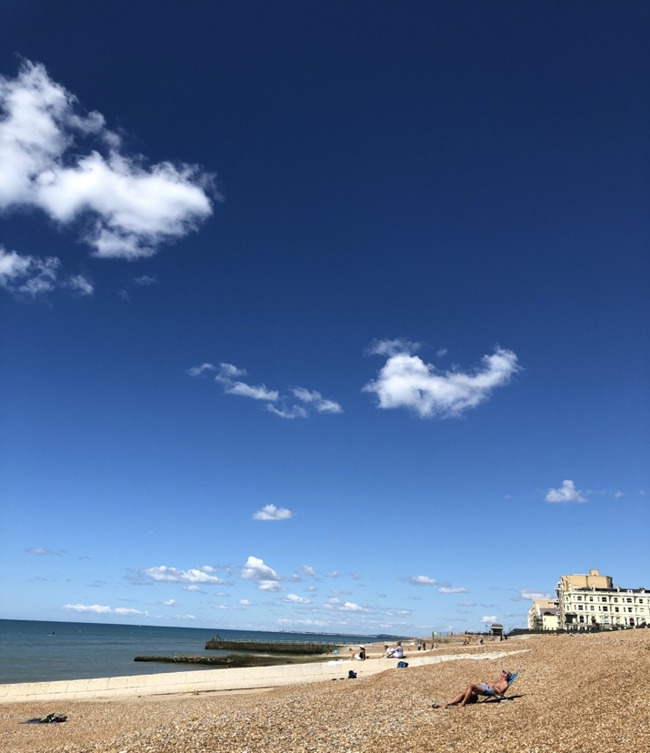
Figure 1: Fernanda Paiva (1984), Sunbathing, Summer 2020, Brighton, UK.

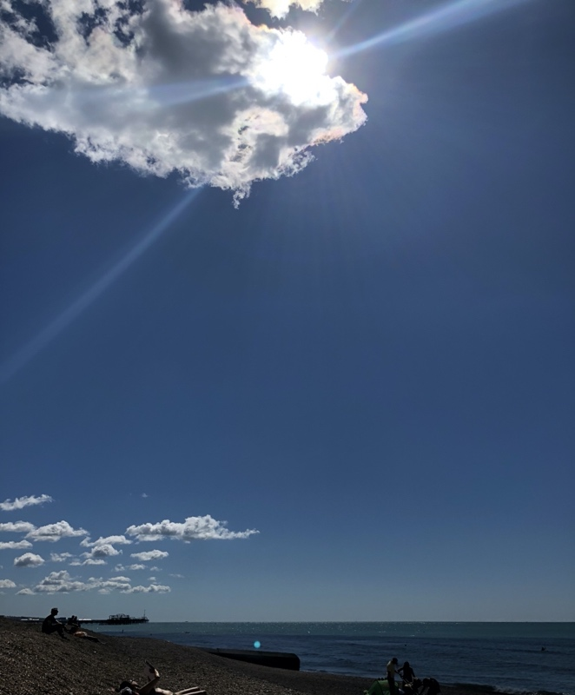
Figure 2: Fernanda Paiva (1984), Walking Among Clouds, Summer 2020, Brighton, UK.

Every time I was out, as described in the previous passage from the journal, my experience of the weather in relation to nature was very similar to what Ingold described as a ‘comingling’, I became the weather when I was outdoors and consequently had a stronger feeling of interconnection with everything around me; see Figure 3 showing a self-portrait representing this process.

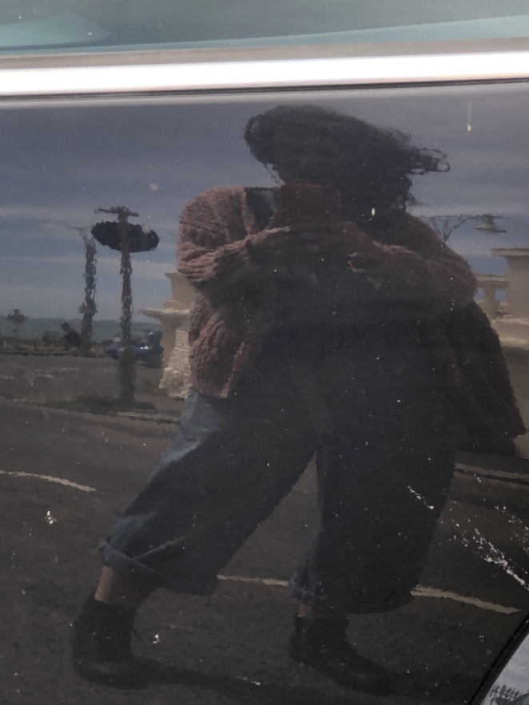
Figure 3: Fernanda Paiva (1984), Weather-World, Summer 2020, Brighton, UK.

This feeling of becoming the weather was not always welcomed by me though, as recorded on 5 July 2020:

The wind still going crazy, I tried sleeping with the window slightly open but had to close it sometime during the night, I can’t remember. I don’t feel like leaving the house at all with this much wind. My ears ache.

This quote reflects my resistance to go out and become part of the weather when it was not ‘good’, that is, when it was windy or rainy for example.

In contrast to experiencing the ‘weather-world’ mentioned by Ingold, is Susan Allen Toth’s idea of weather as a ‘theatre of seasons’ when observed through the comfort of your window, see Figure 4, in contrast to Figures 1 and 2, with an image of a sunny day experienced indoors.

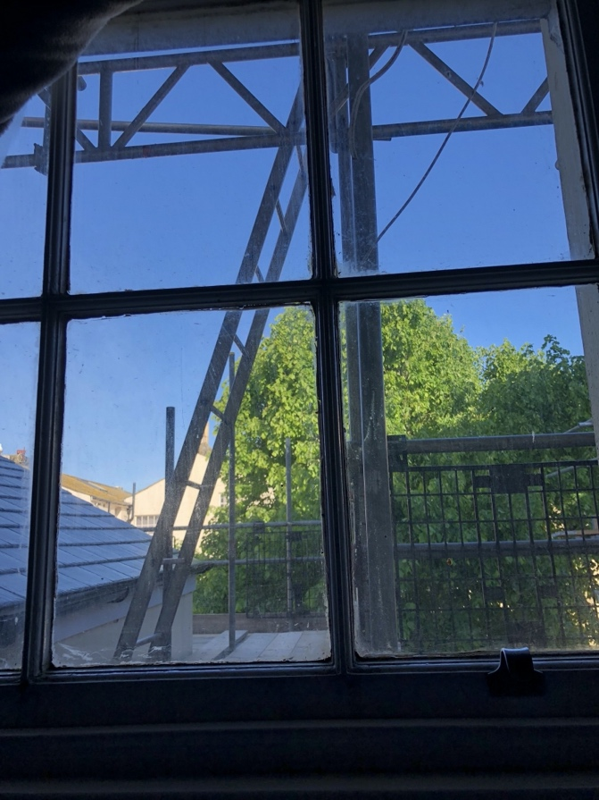
Figure 4: Fernanda Paiva (1984), Through the Window, Summer 2020, Brighton, UK.

With the observations from my window, witnessing the ‘good weather’ from indoors was a rather distracting experience to me and very different from what I felt outdoors, on 31 July 2020 I wrote:

The ‘good weather’ is such a distraction! The seagulls are really loud, the noises around the neighbourhood; builders, workers of all sorts… I get irritable as I try to concentrate and go inwards; a terrible allergy today is also preventing me from working much. I don’t enjoy the feeling, and the sunshine outside seems to be laughing at my attempts to be serious and productive today.

In this excerpt from my sky journal, the irritation that I felt when the weather was sunny whilst I had to be indoors doing my work, reflects another discovery made through my observations. During this research, it became clear to me that I actually enjoy the ‘bad weather’ very much as it naturally resonates with my tendency to be more introspective. For that reason, grey skies and rain are actually calming and a source of comfort to me, as revealed by this quote written on 19 July 2020:

Woke up and shortly after started to rain outside. This soft rain brings me such a sense of relief, the confirmation that I don’t need to be anywhere else. It comforts me.

This sense of being comforted by the rainy weather was also documented a month earlier on 21 June 2020 when I wrote:

Woke up and there is a light storm happening, I slept with my window open so when I woke up I was able to smell the weather. There is something comforting about it. I enjoy the ‘bad weather’ as it gives me license to be introverted and melancholic, I don’t have to be happy and actively outside socializing.

On both passages from the journal I used the word comfort and comforting when describing the rainy weather, and in the two occasions I was experiencing it from my window as I strongly resisted going out for a walk when the weather was not dry.

As I worked on my sky journal and observed the differences between the ‘good weather’ and the ‘bad weather’ I realised that even a sunny hot summer day in England can sometimes be challenging for me as its energy is so compellingly extroverted and a lot of the time this is not my natural disposition. I conclude this section agreeing that the sky and weather are a tuning fork and mood creator like Harris and Solnit have claimed it to be, but in a much more compelling way once you’re in Ingold’s ‘weather-world’ rather than indoors. From indoors I experienced the weather in a less embodied way, but it still powerfully set the tone and general atmosphere, and sometimes there was a battle between how I felt within and the flux of weather, like for example struggling when I was feeling sad on a sunny day.

2) Weather, Identity and Culture

In this section the weather in relation to memory and cultural identity will be discussed as during my research, I caught myself thinking a lot about Brazil in contrast to my surroundings, and my identity in connection to cultural inheritance.

Jens Schneider said that ‘identities are difficult to grasp because of the boundedness of their ‘enactment’ to specific contexts’ and Kirsten McGavin talked about people having different identities in different places as a common feature amongst migrants. Who I am is in a constant flux of discovery, and that can be connected with the weather patterns too. I feel like a different person in different climates, and as a foreigner in England I live in a liminal space between what Claire Sutherland called ‘Self and Other, insider and outsider, citizen and alien.’

Harris pointed out that ‘cultures have climatic sensitivities (…) weather feelings can be shared by thousands of people linked by a vast web of cultural influences’, for example in England, she said, ‘days of sunshine and warmth do not come as standard but as gifts to be honoured and rejoiced in’, which is very different from what the weather can be like in Brazil. Brazilian weather has plenty of sunny days, and in fact, it can often get unpleasantly hot. I always thought that my adaptability to the English weather was connected to this fact, of how uncomfortable I felt exposed to the overrated tropical summer. But as I worked on this research, it became clear to me, as I go through a process of reclaiming my Brazilian cultural inheritance, how lonely my life is in the UK in comparison to there. A fact which made me wonder if the solitude in the UK is also triggered by the common featured grey skies, as this kind of weather reflects a sense of solitude and melancholy as discussed in the previous section. See Figures 5 and 6 contrasting São Paulo’s sky with a typical English cloudy day recorded in one of my walks around Brighton.

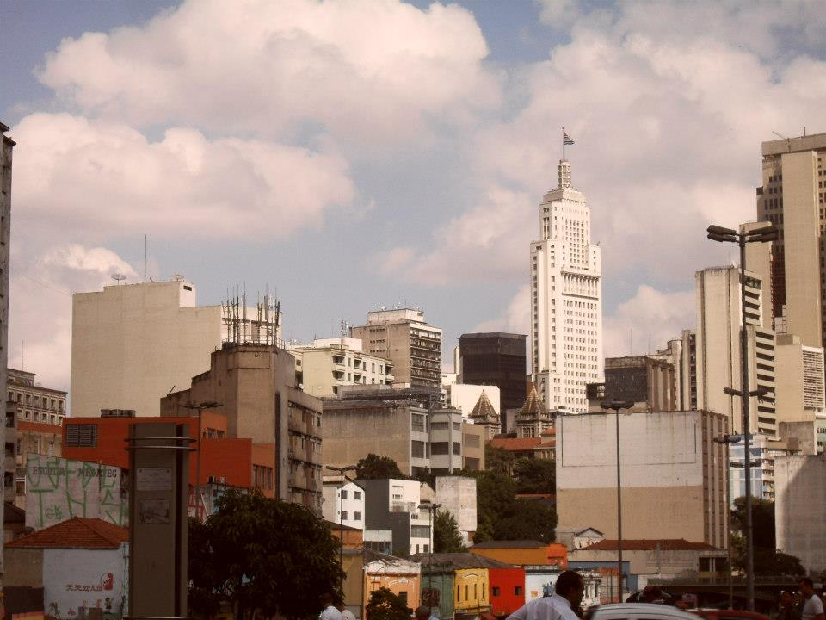
Figure 5: Fernanda Paiva (1984), São Paulo's Sky, Spring 2013, São Paulo, Brazil.
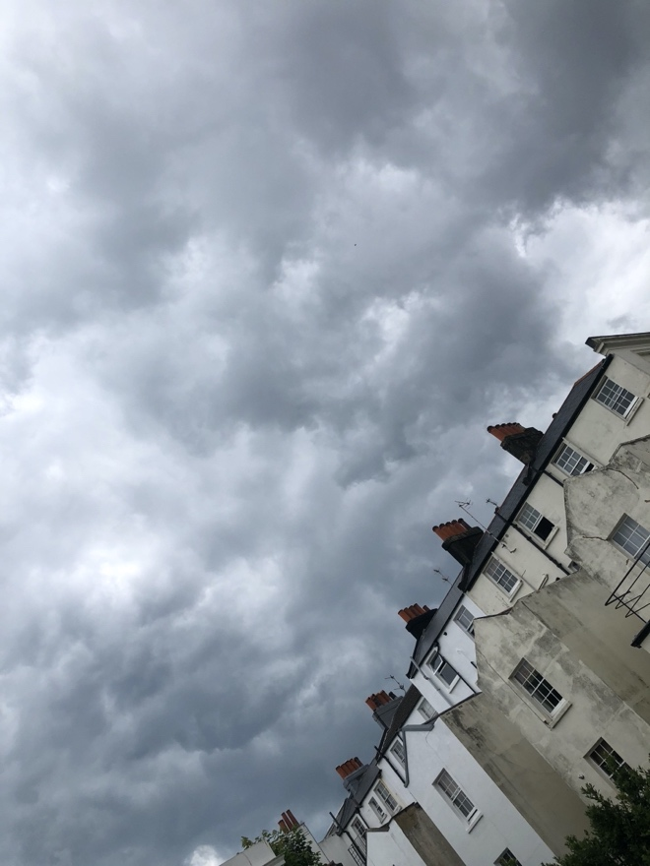
Figure 6: Fernanda Paiva (1984), English Skies, Summer 2020, Brighton, UK.

On 7 July 2020 I wrote about England’s grey sky in relationship to solitude:

With the grey weather for most of the day the general atmosphere was melancholic although I was trying to commemorate my achievements, and I thought a lot about the importance other people have in my life and how alone I am when I’m living in the UK.

Toth have also lived for a while in the UK and she spoke about the ‘misgivings’ of weather in England as a reminder of her identity; in her words: ‘they remind me, among other things, that I am undeniably American. I have been shaped by a loud, brash, show-offy climate (…) that is part of who I am, a woman apt to erupt in unrestrained chortling laughter (…) unexpectedly emotional, often given to sweeping gestures’. I also feel that I have been made by a somewhat ‘show-offy climate’ and I will never forget how much joy thunderstorms brought me, perhaps similarly to Coleridge, which Harris said loved thunderstorms as it allowed him ‘to vent passions long held within’. On 4 July 2020 I wrote about a storm, depicted on Figure 7, from my window in Brighton:

The storm, albeit shorter in duration here in the UK compared to the ones in Brazil, excites and makes me feel like dancing in my room. The relief is tremendous, and the sounds and smells bring me childhood memories of thunderstorms and how content I used to feel without electricity temporarily. The television set would not work, and we had to sit by candlelight and talk to each other. I used to love that when I was a kid.

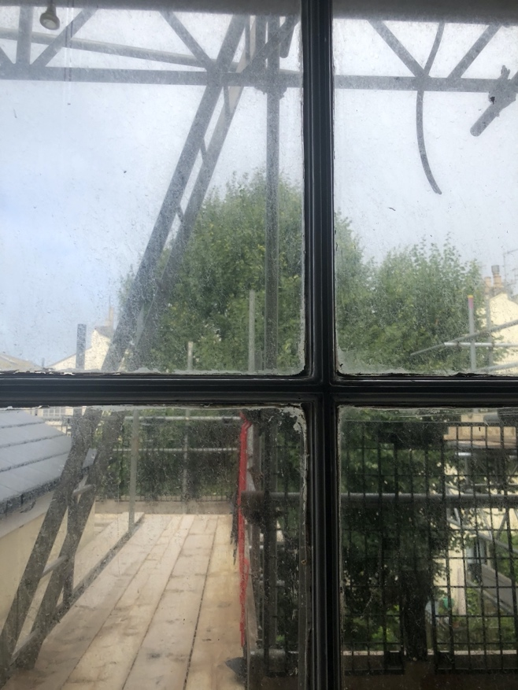
Figure 7: Fernanda Paiva (1984), Stormy Weather, Summer 2020, Brighton, UK.
My appreciation for thunderstorms reflected on the quote above also relates to my need for being in touch with my emotional life. If emotions are a way of apprehending the world as Gray and Keltner spoke about, the freedom to be expressive found in Brazilian culture is very soothing and affirming of my sense of self as well; see Figure 8 depicting a typical coming thunderstorm in São Paulo.

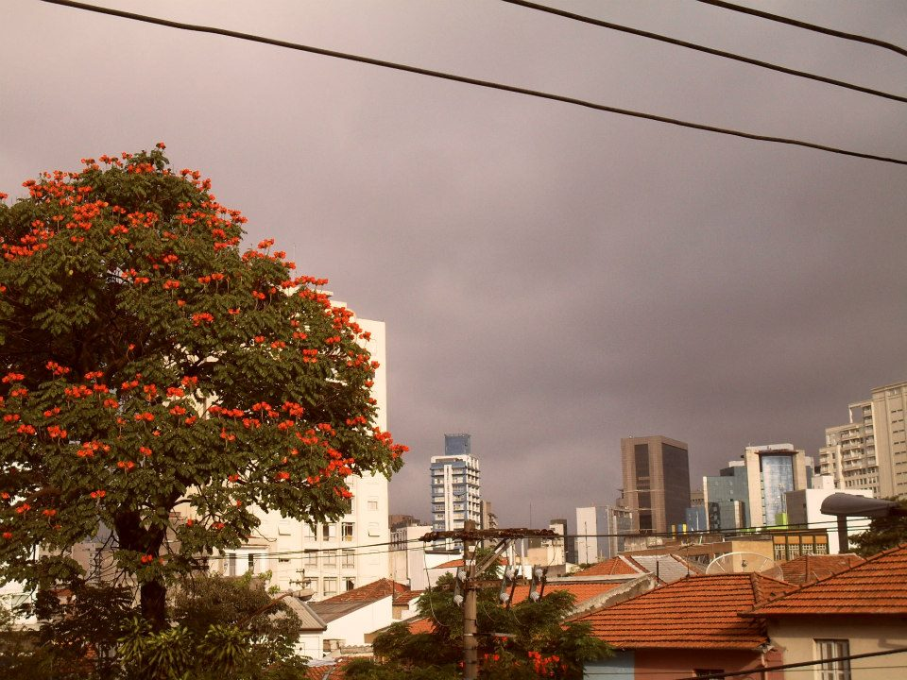
Figure 8: Fernanda Paiva (1984), Coming Storm, Spring 2013, São Paulo, Brazil.

As Loth talked about her midwestern weather being part of who she is, I am also made of tropical weather. I feel my feelings intensely, and I too am capable of crying or laughing loudly if that is what is happening inside me; in my perception, rationality is not such a priority in Brazil as it is in England.

Weather and identity creation can also relate to memory, Harris said that ‘our weather is made up of personal memories and moods; an evening sky is full of other evenings’. I observed that in my journal on 13 July 2020:

There are memories attached to certain kinds of weather as well; right now, for example, this is the weather of taking an afternoon nap at my grandmother’s house, it is hot and muggy but also voluptuous with a lazy feeling. I can visualise the house, the smells. There is almost no wind at all, and everything seems to be suspended in the air, on hold. No phone calls, no urgency, no movement. We softly drift into the air…

In the above passage the idea of weather as an identity creator relates not only to cultural inheritance as previously discussed, but also to personal memory demonstrating once again, that the sky, as Harris has claimed, is a tuning fork and powerfully resonates with my inner life and vice versa.

Final Thoughts:

As I progressed with my work for this paper, it became clear that the flux of weather makes me think about the flux of life, nothing is permanent. It is a mood creator as Solnit and Harris have both claimed, as its presence is so compelling, the ‘good weather’ being a distraction when I was trying to concentrate and work for example, but it can also be related to identity formation. Weather can feel homely and create a sense of belonging to a place or not, and, at the same time, weather can also contribute to a sense of self thorough memory.

In the process of doing this research and exploring concepts of identity, belonging and cultural inheritance in relationship to weather, I wondered for how much longer I will be able to inhabit this liminality before choosing where my home is. According to Lailufar Yasmin and Thomas Fisher, one of the solutions for the current pandemic and crisis is restricting air travels from now on, something that would make my current lifestyle impossible. But when I felt oppressed by the escalating uncertainties of the current situation, the pandemic and imminent life changes, long walks and being outdoors was the antidote. Being embedded in Ingold’s ‘weather-world’ seems to have provided me not only physical, emotional and mental relief but also a wider perspective on problems. As Claudia Baracchi claimed ‘looking at the sky, one beholds not only the inhuman, but the inhuman in oneself’, talking about the sky as a way of connecting with something larger, a practice I found very soothing during my research on the weather and my emotional life. The regular changes in the weather gave me license to accept my inner life’s flux and changes of moods, helping me also to accept life’s changes more gracefully.

Conclusion:
Based on Alexandra Harris’ idea of the sky as a tuning fork and Rebecca Solnit’s argument of the sky as a mood creator, this research aimed at observing the weather patterns in connection to my inner life via two different themes: Space and Quality of Weather, and Weather, Identity and Culture. The chosen methodology was reflexive as it considers emotions a valid way of apprehending and communicating with the world and, for that reason, fitted well the purpose of this research.
In the section entitled Space and Quality of Weather I compared and contrasted my experience of the ‘good weather’ versus the ‘bad weather’, that is, sunny days compared to rainy days, in relation to being outdoors or indoors. It was discussed how by being outdoors the experience of weather becomes more compelling and embodied, even though the weather still set the tone powerfully when I was indoors. Tim Ingold’s idea of the ‘weather-world’, being immersed in the weather, was contrasted with Susan Allen Toth’s vision of a window being a ‘theatre of the seasons’ when observing the weather from indoors.
The next theme, Weather, Identity and Culture, discussed the weather as a creator of identity through either cultural inheritance or personal memory. I explored the idea of how my Brazilian heritage, with its tropical weather being a strong part of it, has had an impact on how I tend to feel and express my emotions, in contrast to England, where I have been living for the past twelve years, and its typical cloudy weather.

Table of Images:

Figure 1: Fernanda Paiva (1984), Sunbathing, Summer 2020, Brighton, UK.

Figure 2: Fernanda Paiva (1984), Walking Among Clouds, Summer 2020, Brighton, UK.

Figure 3: Fernanda Paiva (1984), Weather-World, Summer 2020, Brighton, UK.

Figure 4: Fernanda Paiva (1984), Through the Window, Summer 2020, Brighton, UK

Figure 5: Fernanda Paiva (1984), São Paulo's Sky, Spring 2013, São Paulo, Brazil.

Figure 6: Fernanda Paiva (1984), English Skies, Summer 2020, Brighton, UK.
Figure 7: Fernanda Paiva (1984), Stormy Weather, Summer 2020, Brighton, UK.

Figure 8: Fernanda Paiva (1984), Coming Storm, Spring 2013, São Paulo, Brazil.

Bibliography:

Baracchi, Claudia, ‘Looking at the Sky: On Nature and Contemplation’, Research in Phenomenology, Vol. 39, No. 1, (2009), pp. 13-28.

Dalziell, Tanya, ‘Weather’, in Gail Jones: Word Image, Ethics, (Sydney: Sydney University Press, 2020), pp. 23-48.

Fisher, Thomas, ‘Viral Cities’, in Designing our Way to a Better World, (Minnesota: University of Minnesota Press, 2010), pp. 116-126.

Gray, Breda, ‘Putting Emotion and Reflexivity to Work in Researching Migration’, Sociology, Vol. 42, No. 5, (October 2008), pp. 935-952.

Harris, Alexandra, Weatherland: Writers and Artists Under English Skies, (London: Thames & Hudson Ltd, 2017 [2015]).

Ingold, Tim, ‘Earth, Sky, Wind and Weather’, The Journal of the Royal Anthropological Institute, Vol. 13, (2007), pp. 19-38.

Keltner, Stacy and Maurice Merleau-Ponty, ‘A Review of The Phenomenology of Perception’, in Philosophical Writings, ed. by Margaret A. Simons, Marybeth Timmermann and Mary Beth Mader, (Illinois: University of Illinois Press, 2004), pp. 159-164.

Kleinsasser, Audrey M., ‘Reflexivity, and Good Data: Writing to Unlearn’, Theory into Practice, Vol. 39, No. 3, (Summer 2000), pp. 155-162.

McGavin, Kirsten, ‘(Be)Longings: Diasporic Pacific Islanders and the Meaning of Home’, in Mobilities of Return, ed. by John Taylor and Helen Lee, (Australia: Australian National University Press, 2017), pp. 123-145.

Sachs, Jeffrey D., ‘COVID-19 and Multilateralism’, Horizons: Journal of International Relations and Sustainable Development, No. 16, (Spring 2020), pp. 30-39.

Schneider, Jens, Tineke Fokkema, Raquel Matias, Snežana Stojčić, Dušan Ugrina and Constanza Vera-Larrucea, ‘Urban Belonging and Intercultural Relations’, in The European Second Generation Compared, ed. by Maurice Crul, Jens Schneider and Frans Lelie, (Amsterdam: Amsterdam University Press, 2012), pp. 285-340.

Solnit, Rebecca, ‘Reaching for the Sky’, in Storming the Gates of Paradise, (California: University of California Press, 2007), pp. 140-175.

Sutherland, Claire, ‘Home and Belonging’, in Reimagining the Nation: Togetherness, Belonging and Mobility, (Bristol: Bristol University Press, 2017), pp. 27-44.

Toth, Susan Allen, ‘A Window on the Weather’, in Leaning into the Wind, (Minnesota: University of Minnesota Press, 2003), pp. 61-74.

Toth, Susan Allen, ‘Other Weather, Other Places’, in Leaning into the Wind, (Minnesota: University of Minnesota Press, 2003), pp. 24-38.

Yasmin, Lailufar, ‘The State of the World Order in the Time of Corona Virus: Time for a Responsible Connectography’, Daniel K. Inouye Asia-Pacific Center for Security Studies, (2020), pp. 1-3.

Alexandra Harris, Weatherland: Writers and Artists Under English Skies, (London: Thames & Hudson Ltd, 2017 [2015]), p. 245; Rebecca Solnit, ‘Reaching for the Sky’, in Storming the Gates of Paradise, (California: University of California Press, 2007), pp. 143-144.
Tanya Dalziell, ‘Weather’, in Gail Jones: Word Image, Ethics, (Sydney: Sydney University Press, 2020), p. 27.
Jeffrey D. Sachs, ‘COVID-19 and Multilateralism’, Horizons: Journal of International Relations and Sustainable Development, No. 16, (Spring 2020), p. 30.
Breda Gray, ‘Putting Emotion and Reflexivity to Work in Researching Migration’, Sociology, Vol. 42, No. 5, (October 2008), p. 936; Stacy Keltner and Maurice Merleau-Ponty, ‘A Review of The Phenomenology of Perception’, in Philosophical Writings, ed. by Margaret A. Simons, Marybeth Timmermann and Mary Beth Mader, (Illinois: University of Illinois Press, 2004), p. 162.
Audrey M. Kleinsasser, ‘Reflexivity, and Good Data: Writing to Unlearn’, Theory into Practice, Vol. 39, No. 3, (Summer 2000), p. 157.
Tim Ingold, ‘Earth, Sky, Wind and Weather’, The Journal of the Royal Anthropological Institute, Vol. 13, (2007), p. 19.
Tim Ingold, ‘Earth, Sky, Wind and Weather’, The Journal of the Royal Anthropological Institute, Vol. 13, (2007), p. 19.
Susan Allen Toth, ‘A Window on the Weather’, in Leaning into the Wind, (Minnesota: University of Minnesota Press, 2003), p. 63.
Jens Schneider, Tineke Fokkema, Raquel Matias, Snežana Stojčić, Dušan Ugrina and Constanza Vera-Larrucea, ‘Urban Belonging and Intercultural Relations’, in The European Second Generation Compared, ed. by Maurice Crul, Jens Schneider and Frans Lelie, (Amsterdam: Amsterdam University Press, 2012), pp. 285-286; Kirsten McGavin, ‘(Be)Longings: Diasporic Pacific Islanders and the Meaning of Home’, in Mobilities of Return, ed. by John Taylor and Helen Lee, (Australia: Australian National University Press, 2017), p. 129.
Claire Sutherland, ‘Home and Belonging’, in Reimagining the Nation: Togetherness, Belonging and Mobility, (Bristol: Bristol University Press, 2017), p. 42.
Harris, Weatherland, pp. 15-16; p. 362.
Susan Allen Toth, ‘Other Weather, Other Places’, in Leaning into the Wind, (Minnesota: University of Minnesota Press, 2003), p. 38.
Harris, Weatherland, p. 229.
Harris, Weatherland, p. 15.
Lailufar Yasmin, ‘The State of the World Order in the Time of Corona Virus: Time for a Responsible Connectography’, Daniel K. Inouye Asia-Pacific Center for Security Studies, (2020), p. 3; Thomas Fisher, ‘Viral Cities’, in Designing our Way to a Better World, (Minnesota: University of Minnesota Press, 2010), p. 121.
Claudia Baracchi, ‘Looking at the Sky: On Nature and Contemplation’, Research in Phenomenology, Vol. 39, No. 1, (2009), p. 25.

