

Task 1 – Reading Task Template
Upload your photo of your A3 in-class notes here:
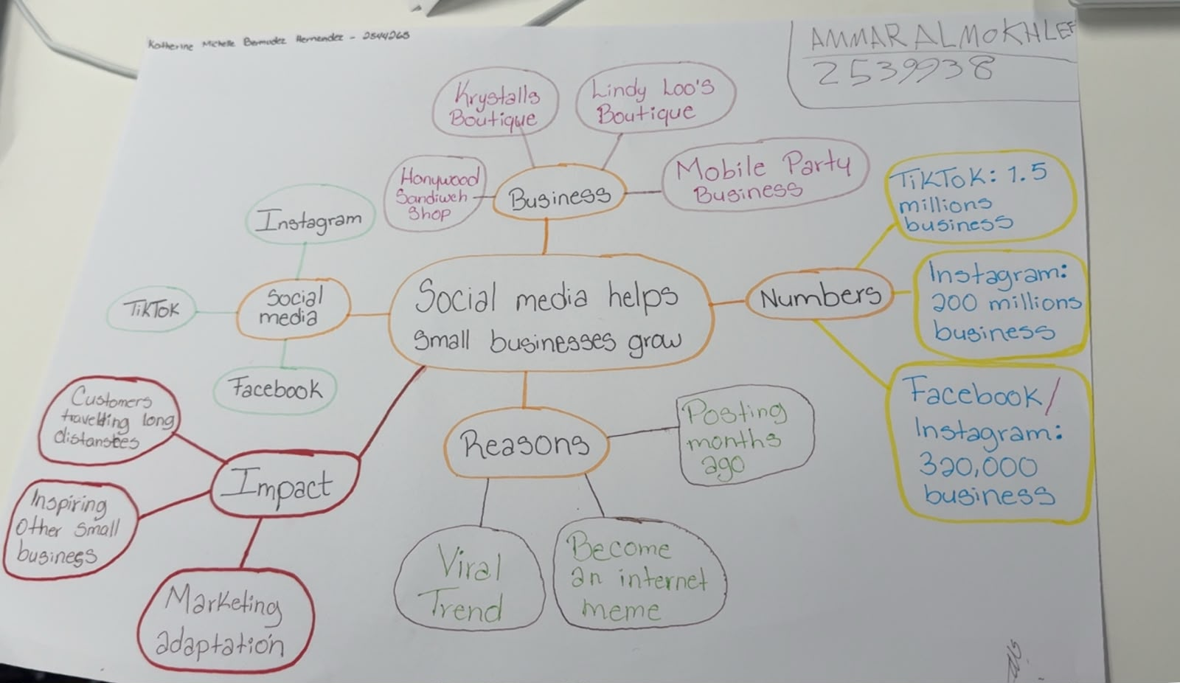

1. Answer these questions using the sentence starters below
a. What is the main idea of the text?
The main idea of the text is that social media helps businesses get more customers and become successful
It shows how apps like TikTok and Instagram can help small businesses grow
b. What are two key points?
One key point is that social media helps businesses get more customers.
Another key point is that sharing interesting content on social media can help a business become more popular
c. What part of the text did you find most important? Why?
I think all parts of the text are important, but I liked the part about Murat, the 42-year-old business owner. I was surprised that some people travelled a long way just to try his chicken burger. I think this part is important because if I know someone travelled far to try a restaurant, I will be curious to try it too. This happened to me when I went to Supernova restaurant. It is about one hour from my area, but I went because my friend came from Saudi Arabia and wanted to try it. I think it was worth it, but I would not travel to another country just to eat a burger.
d. Was anything unclear or difficult to understand?
I was not sure about the part about Kristy Chamberlain and her shop. The text says that teenagers travelled from far away, even from Cyprus, to buy dresses. I was confused because they are teenagers, so I wondered how they travelled such a long way. I also noticed that the text says “teenagers” and does not say if they were boys or girls, even though the shop mainly sells dresses.
e. How did your group help you understand the text better?
My group helped me by discussing the mind map together and sharing different ideas. This helped me understand the text better and correct some misunderstandings.

3. One sentence reflection
Question: What did you find challenging about this task?
The hardest part was nothing because I understood the task well.

