INTRODUCING THE MODERN WORKPLACE(LCBB4003)
STUDENT NAME:ION DULUMAN
STUDENT ID:1917721
TUTOR NAME:DR.GREGORY COWAN

STRUCTURE AND CULTURE OF ASDA
Table of Contents
Introduction 2
Description of structure and culture of ASDA 2
Analysis of how these factors leads to organizational performance 4
Application of relevant theories and models of organizational culture and design 6
Conclusion 8
References 9

Introduction
Every business in order to sustain and survive in a highly competitive market has to make use of effective strategies to strengthen its stand in the market. A relation between organizational structure, culture, people and process helps in identification of how it leads to greater organizational performance and higher productivity of a business. ASDA is a supermarket retailer founded in 1949 having headquarters in Leeds located in West Yorkshire. In this study, a description of structure and culture of ASDA and an analysis of how these factors affect organizational performance has been determined. Along with that, application of relevant theories and models has been made up in connection with organizational culture and design.

Description of structure and culture of ASDA
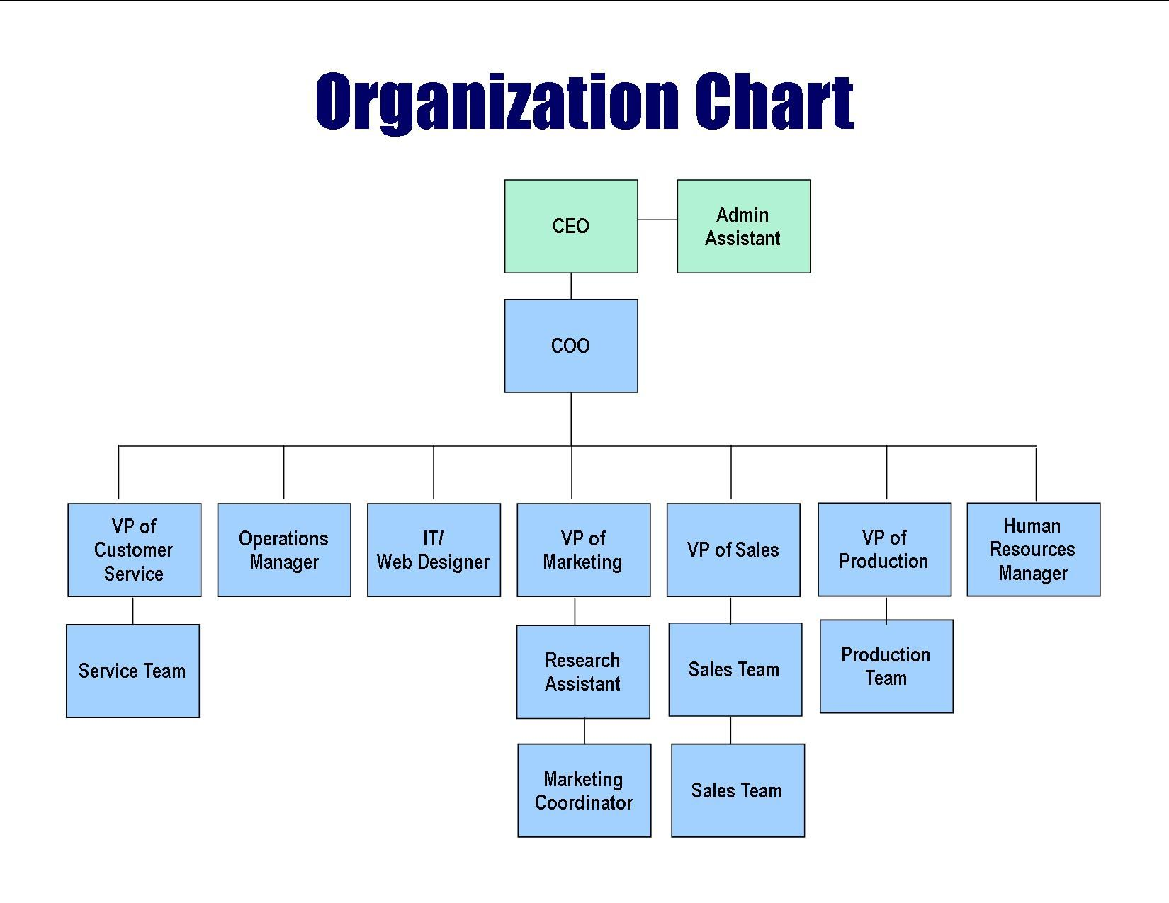
Figure 1: Organizational Structure
(Source: corporate.asda.com, 2020)
Organizational Structure and People
An organizational structure is a key fundamental element in building up an organization. Organizational structure is essential for ensuring that an organization is able to specialize its work among different departments for ensuring span of control and a chain of command. In perspective of ASDA, a formal hierarchical structure consists of numerous functional departments. Therefore, hierarchical structure for ASDA is one in which there are greater levels in an organization where management of communications becomes difficult and decisions are mainly taken by senior members who sit at top hierarchy for motivating employees and taking significant decisions. For instance at ASDA, CEO is head who deals with day to day administration of business and is accountable to COO and Admin Assistant. VP of Customer Service looks after a service team for effective functioning of a customer service department (corporate.asda.com, 2020). There prevails an operational manager who is responsible for managing project team and operational activities carried out to final supply of raw materials. IT/Web Designer is accountable for designing and running design of a business. Similarly, VP of marketing is accountable to a Research Assistant and Marketing Coordinator for ensuring sales and marketing activities are conducted properly. In addition to that, VP of Production has held responsibility of managing the production team to ensure production of materials is carried out for effective functioning of business. Along with that, an HR Manager is held responsible for managing welfare of people and recruitment of newer staff within organizational context.
Organizational Culture
In contrast to that organizational culture is a role culture that executives and top officials need to adapt with for specifying significant roles by an organization. A concept of organizational culture can be analysed as a consisting of values within a business that cannot be easily changed or controlled upon (Kervienen and Kilian Bareja, 2018). Hence, organizational culture has been defined as a group that learned basic activities of adoption and integration that have been working well enough for perceiving, thinking and feeling as a response to those problems. Sustainability is a key issue that needs to be widely developed for adoption of a firm's engagement with an institutional environment within a family business life cycle. Levels of coordination across different departments and its compatibility with prevailing norms constitute the basis of organization culture (Sharma and Sharma, 2019). For instance, ASDA generates high levels of campaigns and programmes for helping it to be a better leader in a business process. Having more than 500 stores, it provided employees with toolkits, briefing materials as well as focused on community engagement programmes through a designated Community Life Hub encouraging consumers and employees for joining and energizing employees towards enhancing stores in business (corporateculture.co.uk, 2020). ASDA has a proud history of incorporating significant beliefs within its organization which includes offering consumers with best service offers for being able to save money and live a better life. Roger Burnley, CEO of ASDA has been successful enough in implementing major cultural changes within its organizational performance. As such a company has aimed at maximization of profits it is ensured that leaders identify employees to be handled with care and recognition. Therefore, ASDA having acquired greater than 145,000 people serves 18 million people on a weekly basis (corporate.asda.com, 2020). It has a range of stores and supercentres necessary for running an organization in a significant manner. Similarly, by focusing on innovative strategies and sustainable development, ASDA has been fostering a culture of transparency and flexibility within its organization. Stores at ASDA have been founded on principles of offering shoppers with leadership to generate everyday low-prices and enable staying true to save money and live in a better way.

Analysis of how these factors leads to organizational performance

Linkage of Organizational Structure and Culture
An organizational structure as well as culture plays a crucial role in achievement of organizational goals. Organizational structure as well as culture guides employee’s behaviour towards attainment of strategic objectives of a business (O'Neill et al. 2016). Different levels of cultural and structural influences are fostered in based upon tasks skills, training as performed by an organization. As for ASDA, organizational structure and culture has a significant influence upon achievement of its business goals. Organizational structure and culture can enhance performance by fostering upon proper communication and invention in its strategic approaches. A negative impact is created through identification of employees of an organization. A bad working environment can be created to ensure creation of a proper working environment for an organization. Structure is mainly determined by authority and responsibility of different positions within an organization. It is in this manner that relationships between people are shaped up and behaviour of employees is affected significantly. Employees at ASDA are cooperative and friendly for adopting with a flexible organizational culture. Organizational culture also adopts an influential factor necessary affecting behaviour of employees for an organization. Basic organizational culture of ASDA consists of core beliefs and ideas in an organization (Wahyuningsih et al. 2020). It is through them that generations of values and beliefs are adopted in guiding behaviour of employees at a workplace. International organizations are better able to maintain a progressive structure through enabling formation of an effective process in employee empowerment programs, and constant involvement, consistency, adaptability as well as mission.
Relationship between organizational Structure and culture on performance
The basic culture of ASDA is complemented by a hierarchical structure where a company focuses on an effective consumer service for respecting other people’s values, beliefs and culture. A company like ASDA focuses upon provision of significant levels of consumer services for its consumers. It aims at excelling in values, beliefs as well as culture of a company (Alaarj et al. 2016). ASDA has aimed at excelling in all fields of operations and believes in working with full integrity. The Company has underwent many changes in its structure, one of which being when it had been acquired by Walmart, but culture was such that it ensured provision of equality and egalitarianism for ensuring employees remain loyal to its business. This type of a culture has been worked upon to implement smooth changes in its merger done with Wal-Mart. The employees are reliant upon basic organizational values which include provision of equal roles and responsibilities. Secondly, ensuring that employees are fair in their approach and make no differentiation between employees for evaluating performance has been ASDA’s main focus. Moreover, being respectful and towards employees and ensuring polite nature in business has helped in making employers and businesses proud of their organizational culture.
Role of Leadership and attributes determining effective leadership at ASDA
Leadership has a crucial role to play in influencing strategic management processes. It facilitates an organization for executing effective strategies in order to vision. Leadership ensures that an effectiveness of process, facilitation of drawbacks of a process and fresh strategies are in alignment for sustenance of constant growth (Jabbar and Hussein, 2017). Leadership is influenced mainly by strategizing processes and facilitation of strategic management within its organizational process. As ASDA follows a hierarchical structure, it has adopted an autocratic style of leadership in which decision making is carried out by experienced and senior leaders who are trained for their organizational approach (corporate.asda.com, 2020). An experienced and highly competitive environment demands for leaders who are transformational in nature. A lot of risks are adopted in a transformational style of leadership which ensures leaders need to trust upon their leaders and managers effectively. Due to high levels of transparency, employees are aware of decisions taken upon by a company for running them in an efficient manner. Therefore leaders play a crucial role in ensuring that hierarchical structure is interpreted through actions taken in by business managers visible towards employees. Employees are well-aware of decisions taken up by a company to ensure decisions are taken in a smooth manner. Underlying story of ASDA lies in pioneering people with visionary ideas and beliefs. It offers consumers the best values and services to enable saving money and living in a better way.

Application of relevant theories and models of organizational culture and design
Behavioural Approach and factors affecting difference in individual behaviour
A behavioural approach to management makes focus upon human relations as well as employee well-being. Rather than simply setting up tasks and focusing upon human relationships’ a behavioural style of leadership is focused on keeping workers satisfied as well as motivated. Some of underlying factors affecting differences in individual behaviour:-
- Diversity which is a key component as people come from differing parts of the UK, and how diversity creates conflicts in business that can affect performance of ASDA.
- Positioning and delegation of roles and responsibilities between superiors and subordinates creates a situation in which individual conflicts as well as differences occur.
- In case of non-transparency in business work done by individuals are less appreciated by business and yielding better results is done through achieving more rewards so that team performance is enhanced for ASDA.

Theoretical Approaches
Hoftestede’s Model of Organizational Culture
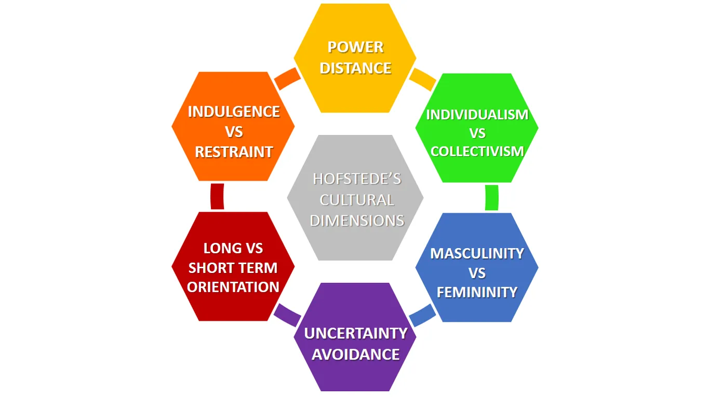
Figure 2: Hoftstede’s Model of Organizational Culture
(Source: Influenced by Block and Walter, 2017)
In perspective of “Power Distance”, Hofstede’s power dimension is responsible for respective teams accountable for their own performance. In case of ASDA, a hierarchical structure is encompassed, wherein, those belonging to higher level enjoy greater satisfaction and delegation of responsibilities are carried out in contrast to other team members. Considering, “Masculinity vs. Femininity” it is viewed that male employees dominate female counterparts in a decision making process of an organization (Andrijauskienė and Dumčiuvienė, 2017). ASDA adopts a masculine culture, wherein there is under-representation of strength and dominance of male superiors. In an aspect of “Individualism vs. Collectivism”, Hoftestede’s perceived that individuals come in together with a common belief of exchanging ideas and discussing upon things with innovative ideas. ASDA adopts a collective culture as its basic culture is enshrined in setting up a flexible atmosphere through a collective approach (Block and Walter, 2017). Considering “Uncertainty Avoidance Matrix”, such an index level refers to tolerance levels based on comfortable as well as uncomfortable situations. ASDA adopts a significant aim of reducing these types of situations to ensure employees are prepared for all types of challenges. In an aspect of “Long term Orientation vs. Short Term Orientation” it is viewed that organizations acquiring a long term relationship towards employees feel attracted towards ASDA organization and focus on basic long term goals. In an aspect of “Indulgence vs. Restraint” an organization like ASDA controls gratification of employees needs through strict control and adopting an autocratic form of leadership in its organizational culture.

Hierarchical Model
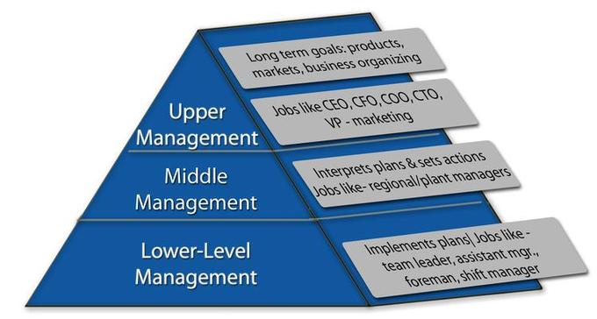
Figure 3: Hierarchical Model
(Source: Influenced by Smarzhevskiy and Solovev, 2020)
A hierarchical model is such in which lower levels are under hierarchy of larger-level units. Structure and hierarchy are defined in terms of organizational hierarchy that have lesser bearing on an organization. Based on hierarchical structure, it is evident that people belong to top level are ones who supervise lower level people in an organization. In hierarchical structure, management of an organization is therefore divided into Top Managers, Middle Managers and Front-line Managers. In an organization composed of CE, the task of preparation of corporate plans lies with the Board of Directors. Middle managers are accountable for operational plans for guiding daily activities of business (Smarzhevskiy and Solovev, 2020). On other hand, first level managers make use of communication for managing internal and external organizational processes.

Conclusion
ASDA is a British trailer that sells a wide range of items including clothing and home-electronics as well and toys and beauty products. In order to maintain effective performance, a business has to take care of its organizational structure and culture. Upon evaluation, this study has signified a description of organizational structure and culture of ASDA. Along with that, ways in which these factors lead to greater organizational performance has been made. Similarly, identification of behavioural approach and factors affecting individual difference through application of relevant theories and models has been made in this study.

References
Alaarj, S., Abidin-Mohamed, Z. and Bustamam, U.S.B.A., 2016. Mediating role of trust on the effects of knowledge management capabilities on organizational performance. Procedia-Social and Behavioral Sciences, 235, pp.729-738.
Andrijauskienė, M. and Dumčiuvienė, D., (2017), October. Hofstede’s cultural dimensions and national innovation level. In DIEM: Dubrovnik International Economic Meeting (Vol. 3, No. 1, pp. 189-205). Sveučilište u Dubrovniku.
Block, J.H. and Walter, S.G., (2017). Hofstede’s cultural dimensions and modes of entry into entrepreneurship. In Exploring the Entrepreneurial Society. Edward Elgar Publishing.
Corporate.asda.com, (2020). About ASDA. Available at: https://corporate.asda.com/ [Accessed on 2 August 2020]
Corporate.asda.com, (2020). About company facts. Available at: https://corporate.asda.com/our-story/company-facts [Accessed on 1 August 2020]
Corporate.asda.com, (2020). About leadership. Available at: https://corporate.asda.com/our-story/leadership [Accessed on 3 August 2020]
Corporateculture.co.uk, (2020). About ASDA Community Life. Available at: https://corporateculture.co.uk/case-studies/asda/ [Accessed on 4 August 2020]
Jabbar, A.A. and Hussein, A.M., (2017). The role of leadership in strategic management. International Journal of Research-Granthaalayah, 5(5), pp.99-106.
Kervienen, P. and Kilian Bareja, I., (2018). Brand and Culture-The external influence on the internal A case study of culture building in relation to brand and challenges with the concept of building culture from the outside-in.
O'Neill, J.W., Beauvais, L.L. and Scholl, R.W., (2016). The use of organizational culture and structure to guide strategic behavior: An information processing perspective. Journal of Behavioral and Applied Management, 2(2), p.816.
Sharma, P. and Sharma, S., (2019). The role of family firms in corporate sustainability. The Oxford Handbook of Management Ideas, p.427.
Smarzhevskiy, I.A. and Solovev, D.B., (2020). Model of Organizational Behavior in a Hierarchical Structure. E&ES, 459(4), p.042003.
Wahyuningsih, S.H., Sudiro, A., Troena, E.A. and Irawanto, D., (2019). Analysis of organizational culture with denison’s model approach for international business competitiveness. Problems and perspectives in management, (17, Iss. 1), pp.142-151.

