
University of Wales Trinity St Davids
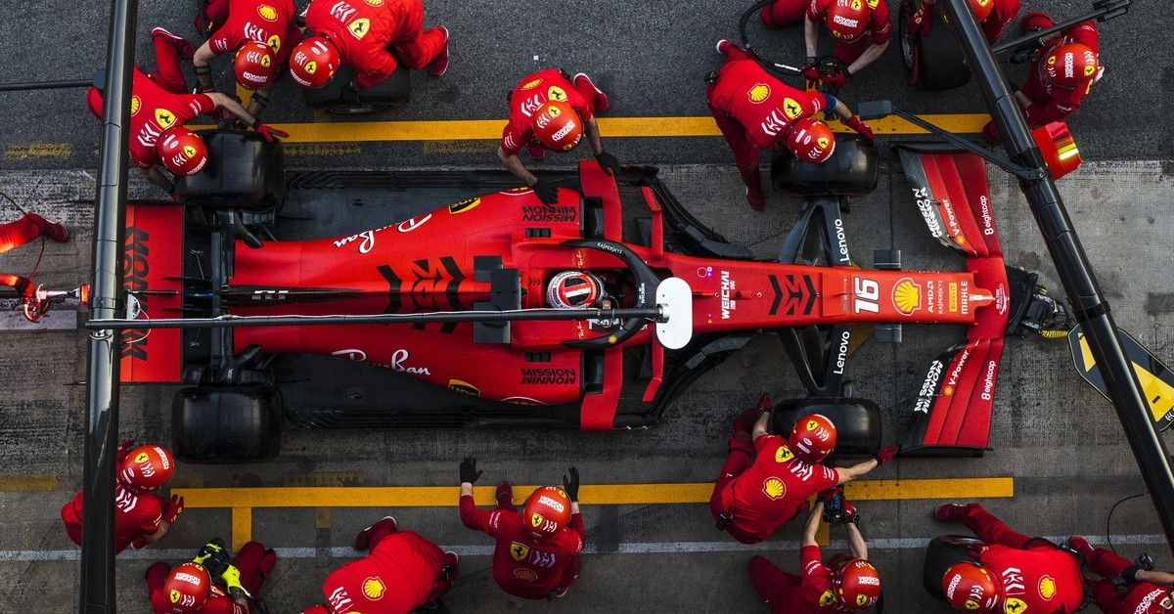
Sustainability in Formula One

Author: Dylan Huw Davies
Lector: Kerry Tudor

Student Number: 2100937
Course title: Motorsport Engineering
Date: 16/12/2
Contents
1.0 Introduction 3
2.0 Environmental Impacts 4
2.1 Carbon Footprint 4
Transportation Carbon Footprint 5
2.2 Pollution, Waste generation, Environmental 5
2.3 Resource depletion 6
3.0 Sustainable Practices and Legislation 7
Current Practices and Legislation 7
Motorsport uk 7
3.1Alertantive fuels 7
Race Cars 7
Truck Transportation 8
3.2 Recycling, Emission regulations, Environmental 8
Future practices and legislation 8
Formula 1 8
4.0 Sustainability and Technological Challenges 10
4.1 Technological Development 10
Motor Generator Unit-Kinetic (MGU-K) 11
Future Technological Development 11
4.2 Economic, Social and Political challenges 11
4.3 Motorsport and Automotive comparison 12
5.0 Future Outlook 13
5.1 Sustainable strategies and solutions for the future 13
Sustainable Transportation 14
Environment 14
Waste Management 15
5.2 Effect on the customer, manufacturer, and Government 15
6.0 Referencing 17

Figures
Figure 1 carbon by 2030. Effort included efficient engines, alternative fuels and promoting sustainability (Ida Wood, 2023). 4
Figure 2 F1 2023 route (Nagle, 2023) 5
Figure 3 Electricity production (Poynting, (2023) 5
Figure 4 Fossil Fuel Remaining Reserve (Stephens, Ross, Mussgnug, Wagner, Borowitzka, Posten, Kruse, Hankamer, 2010). 7
Figure 5 Roadmap For different Motorsport championships (FIA, 2023). 10
Figure 6 KISS Programme (FIM,2022) 13
Figure 7 New F1 route ( Paolo, 2022) 14
Tables
Table 1 Motorsport UK Sport For Climate Action Framework (Membro, 2021) 7

1.0 Introduction

The motorsport industry, known for its speed and innovation, faces a pivotal moment as sustainability becomes a priority. This report delves into the environmental impact of motorsport, its current sustainable initiatives, technological challenges, and proposes strategies for a greener future. As engineers shaping mobility's future, we must lead with sustainability in mind for a more eco-conscious motorsport industry.

2.0 Environmental Impacts

2.1 Carbon Footprint
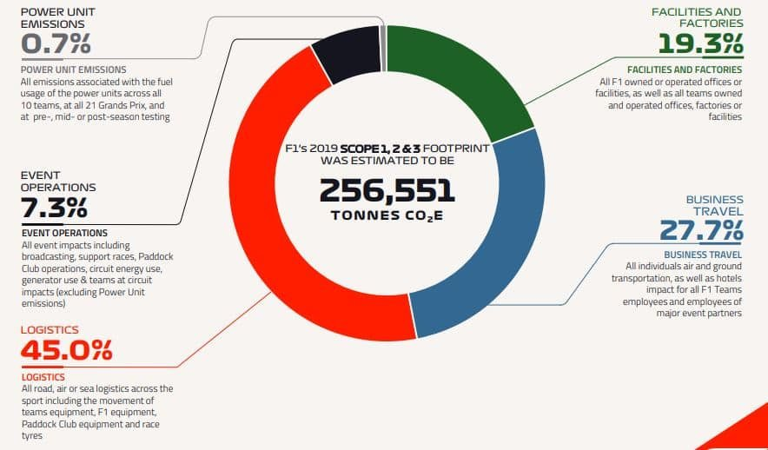
Formula 1 total carbon footprint is a quarter of a million tonnes, with just 0.7% from racing cars. Despite this small percentage, the sport is committed to becoming net zero.
Figure 1 carbon by 2030. Effort included efficient engines, alternative fuels and promoting sustainability (Ida Wood, 2023).

In a season 45% of CO2 produced is by logistics, which is 64 times more than power unit emissions. The second largest CO2 producer is business travel, giving a total of 186,512 tonnes of CO2 produced. Suggesting the major cause of CO2 production is business traveling and transport of equipment.
Figure 2 F1 2023 route (Nagle, 2023)
This is down to the season calendar that takes place all around the world. In the 2019 calendar, f1 done 69,374 miles just from travelling to each circuit, with the new 2023 calendar there has been an increase in 11.6% miles. From 2 the inefficient route can be seen for the 2023 calendar (Nagle, 2023).

Transportation Carbon Footprint
2000 Tons of formula one freight is moved each race, which is transported by airplane or sea freight, a total of 131,995 Km is travelled throughout the season using Boeing 747 Planes, this includes food, oil, spares, and the cars. Boeing 747 uses approximately 1 gallon of fuel every second, burning 5 gallons per mile (Homer, 2022. Typical Jet Fuel used in a Boeing 747 produces 9.75 kilogram of c02 per gallon (U.S. Energy Information Administration, 2023). Roughly, 3303.18 Tonnes of c02 are produced alone just from burning fuel. Now accounting for all travel including transport good by vehicles teams flying back to base, 80000 Tonnes of c02 is produced (Paolo, 2022).

2.2 Pollution, Waste generation, Environmental
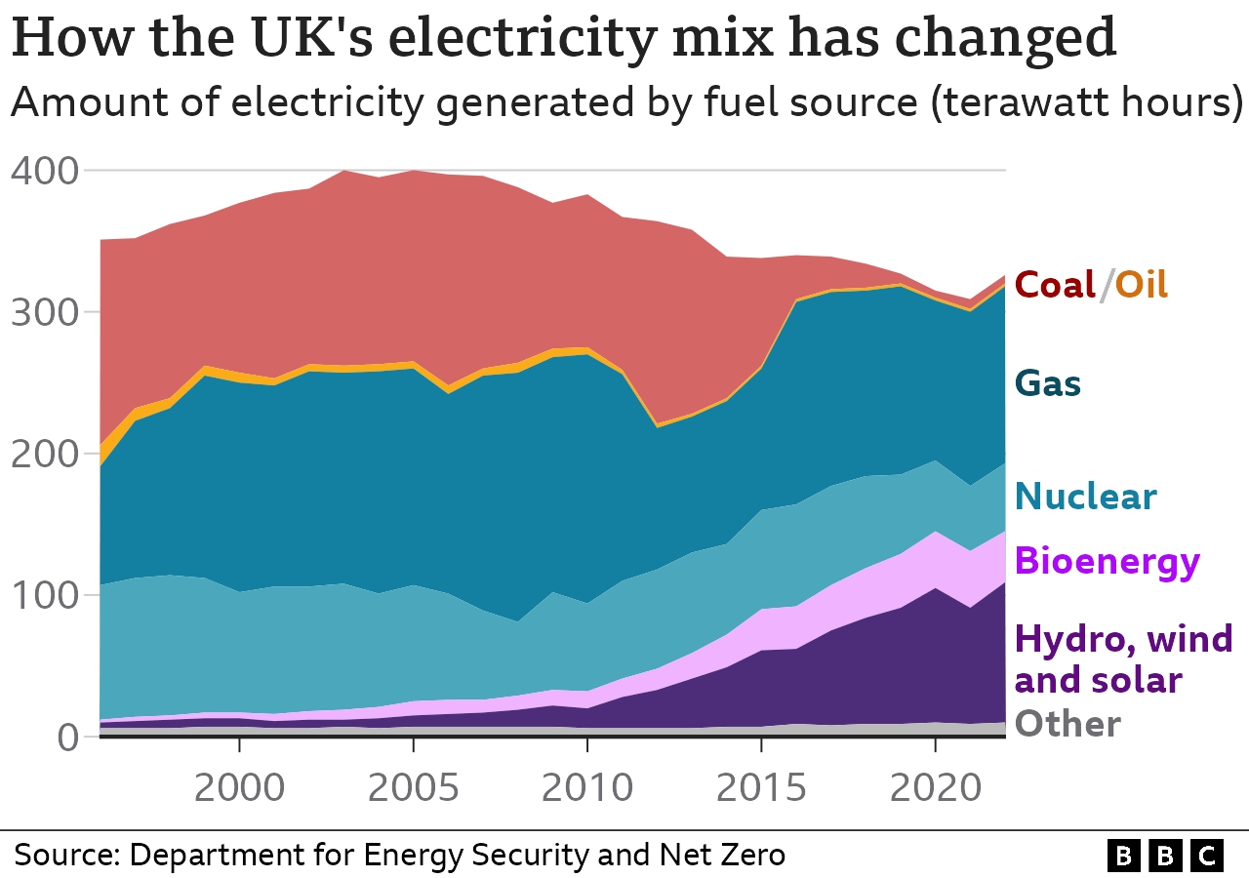
With many Motorsport championships gaining more following after covid like formula, saw an increased in investments in racing circuits. In certain cities, the development of tracks may lead to the demolition of green areas, displacing existing residents, or encroaching upon valuable green spaces. The influx of traffic and crowds during races can disrupt daily life for locals. Additionally, waste accumulation around the track poses a risk of environmental pollution. Water and tree removal along roadsides can contribute to coastal degradation and harm wildlife, including birds and other creatures. In the long term, it can be argued that noise pollution, litter, and the carbon footprint from these events have the most damaging effects (Öztopcu, 2023).
Figure 3 Electricity production (Poynting, (2023)
With new electric work vehicle and energy intensive process like the carbon fibre process larger amounts on electricity is needed. The majority of the UK energy, where the majority of F1 one Team Base is produced from fossil fuels (67.6%), 30.7% from low carbon sources, 11.3% from renewable and 19.3% from nuclear as seen in figure 3 (Poynting, 2023). Knowing this can Formula One guarantee that the energy they are provided is from 100% sustainable sources has in their sustainability plane it accounts for team factories.
As known F1 tracks take up huge amounts of land, where forests have to be cleared, which therefore destruction of natural habits and ecosystems take place. In 2020 there was news a RIO F1 racetrack plan that would causes the deforestation of 180,00 trees that had reach ecosystem filled with capybaras, caimans. The plan was slammed by environmentalists and even Sir Lewis Hamilton had clearly disagreements with the plan (The Guardian, 2020). Many tracks like spa cause deforestation which can have drastic effects on biomass and worsen climate change. Since 2010 deforestation has removed 1 peta-gram of carbon every year and makes air pollution wrong(Soken-Huberty, Emmaline ,2022). Is the development and planning of new tracks sustainable anymore and do the impacts overcome the financial benefits.

2.3 Resource depletion
Automotive components used in motor vehicles, including plastics, rubber, glass, lubricants, coolants, and fuel, are predominantly derived from naturally occurring minerals and metals. Despite the removal or modification of comfort-related components in racing vehicles compared to mass-market versions, both types of vehicles still rely on the same range of natural resources for manufacturing, use, and maintenance. This dependence means that motor sport is intricately linked to a broader pattern of natural resource consumption worldwide, which has been identified as a significant factor in the environmental degradation on a global scale, (Dingle, 2009).
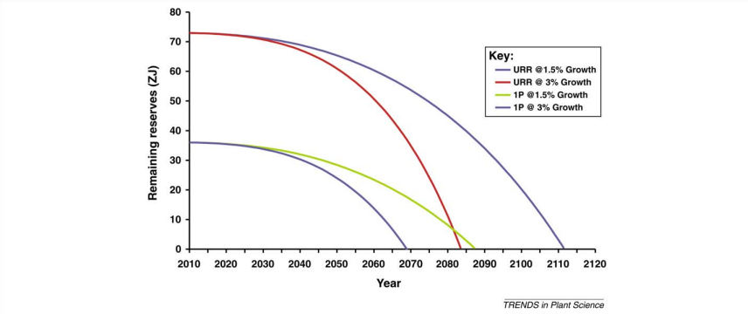
Carbon Fibre composites are used greatly in many of f1 components, around 85% of F1 cars are made up of them (Thomas, 2013). Carbon fibre has had an increase in production waste rate due to cut offs and nearly 98% of components and manufacturing composite waste were burnt in landfill in the UK (Jin, Chevali, Wang, 2020). Carbon Fibre production is an energy intensive production, the manufacturing energy intensity of carbon Fibre composites is greater than that of conventional metals. Carbon Fibre composites with 50% fibre volume fraction to be roughly 800 MJ/kg, whereas that for conventional steel is only 50 MJ/kg energy intensive (Sunter, Morrow, Liddell, Sunter, Morrow & Cresko, 2015).
Figure 4 Fossil Fuel Remaining Reserve (Stephens, Ross, Mussgnug, Wagner, Borowitzka, Posten, Kruse, Hankamer, 2010).

As stated in section 4 the majority of power produced comes from fossil fuels and its predicted that the reaming reserve will run out latest 2112, this depletion rate is based on 100% fossil fuel of course if more renewable sources are used it will increases (Stephens, Ross, Mussgnug, Wagner, Borowitzka, Posten, Kruse & Hankamer, 2010).

3.0 Sustainable Practices and Legislation

Current Practices and Legislation

Motorsport UK
Motorsport UK joined the (UNFCCC) United Nations Framework Convention on Climate Change as a signatory in March 2021, pledging to uphold its five guiding principles and integrate them into its strategies as seen in Table 1.
Table 1 Motorsport UK Sport For Climate Action Framework (Membro, 2021)
The Sport for Climate Action Framework key principles are:
1 | Undertake systematic efforts to promote greater environmental responsibility
2 | Reduce overall climate impact
3 | Educate for climate action
4 | Promote sustainable and responsible consumption
5 | Advocate for climate action through communication
This sets the stage for broader dissemination of the sustainability message within their territories, paving the way for long-term success in environmental initiatives and taking similar roadworks that the FIA are currently. (Membero, 2021). This is a major step to a more sustainable motorsport future in the UK.

3.1Alertantive fuels

Race Cars
Currently f1 are using a hybrid power unit which produce more power using less fuel by using specialised sustainable fuels and an energy recovery system that produced power at a zero cost of emissions (F1, 2019). Formula One currently uses E10, 10% renewable ethanol, whole formula two and three used a 55 percent sustainable fuel during the 2023 season (Coleman, 2023). New fuel choice that mostly likely be implemented in 2026 when f1 fuel supply will be 100% sustainable will be hydrocarbon Mixes. Ethanol is mostly to be used in the fuel mix because it cheap but a drop in fuel will be used.

Truck Transportation
In 2023 DHL announced that European races are being delivered using biofuel trucks, reducing emission by 60%, compared to petrol. The new trucks run on HVO (hydrotreated vegetable oil) (Formula 1 and DHL, 2023). HVO are renewable fuel that is created from vegetable oil or used cooking oil, which are made of paraffinic hydrocarbons, therefore resulting in low carbon content (Cummins Inc, 2022).
This practice supports sustainability by reducing greenhouse gas emissions and reliance on fossil fuels, while utilizing renewable resources like vegetable oil that is a large waste product.
Pat Symonds, a prominent figure in the industry, highlights the importance of not letting fuel generation overshadow food production. "Can the fuel be created using non-food bio sources, municipal waste, or carbon capture? Any method that acquires carbon and hydrogen without competing for land use, unlike some 'generation one' fuels," explained Symonds (Ida Wood, 2023).

3.2 Recycling, Emission regulations, Environmental
Many circuits like Spa-Francorchamps have signed a sustainable Development Polic to improve sustainability at the track, this includes:
- Controlling the carbon impact of transportation
- Sorting and managing waste.
- Limiting single use consumption
(Spa Grand Prix, 2021).
A handbook has also been provided to spectators to help reduces littering and recycle their rubbish more. More Sorting centres have been put in place to allow plastics and food waste recycling around the track. Spa aims to develop a more sustainable circuit that has reduced its environmental impact by optimizing social and economic effects.

Future practices and legislation

Formula 1
Formula 1 is swiftly embracing sustainability, aiming to achieve a net-zero carbon footprint through ultra-efficient logistics, 100% renewable energy use in facilities, and a mandatory 10% biofuel content in petrol by 2021. With F1 engines boasting an impressive 50% thermal efficiency, the sport plans to continue this trend, working towards a net-zero carbon hybrid internal combustion engine. Initiatives include replanting trees, using synthetic fuels, and collaborating with the automotive sector. This commitment is evident in partnerships with teams like Mercedes, which is already powering its factories with renewable energy, leading the charge towards a greener future for motorsport (Benson, 2019). F1 sustainability aims are to also to recycle, reuse or composted any waste within the events and start using recycle/ zero plastic material, secondly incentives will be used to help fans travels to races circuit in zero/lower carbon footprint methods, like bus, walking , cycling and hybrid/electric (Ross, Johnston, 2020).F1 want to also create 100% renewably powered facilities, factories and venues by using 100% renewable electricity at all f1 fatalities (Sustainability strategy, 2022).

4.0 Sustainability and Technological Challenges

4.1 Technological Development
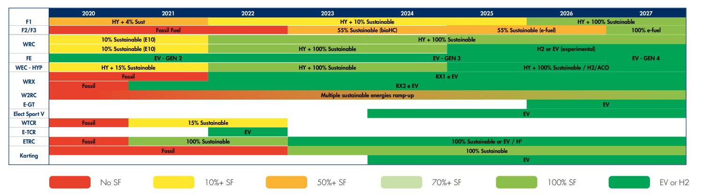
The FIA has released a roadmap for the changes of different motorsport championships to sustainable energies for powering vehicles. This shows that the motorsport industries
Figure 5 Roadmap For different Motorsport championships (FIA, 2023).
are putting in new practices and legislation to become more sustainable in the future. WRC was the first FIA championship to use a 100% sustainable fuel, in the first year there was a reduction in 512 tonnes of c02 compared to the fuel used previously. This data raises the question: why haven't more motorsport championships made this leap, especially considering its success with major champions like WRC. As F1 usually being the driving force in new advancements seem to be holding off to switching to 100% sustainable fuels straight away (FIA, 2023). F1 took a significant step towards sustainability with the introduction of the hybrid power unit in 2014, resulting in a 35% reduction in fuel consumption, the maximum fuel flow rate for engine speeds equal to or above 10,500 rpm is limited to 40% less Compared to their predecessors (STĘPIEŃ, 2016). However, given that this was a decade ago, rapid advancements in technology suggest that a quicker adoption of cleaner technologies could have been expected, especially considering F1's role as a showcase for future sustainability in sports (F1’s hybrid engines redefine motorsports’ environmental impact, 2023). Recently, WRC has opted to discontinue hybrid-powered rally cars by 2025, returning to petrol engines to make the cars lighter and less complicated. This decision comes despite the fact that these hybrid systems were only introduced in 2022 to improve performance. However, it's noteworthy that they will now be running on 100% sustainable fuel. This development raises the question of whether Formula One can push closer to using 100% sustainable fuel as well sooner than thought (Top Gear ,2024)
Transitioning Formula One to 100% sustainable fuel is challenging. The fuel must meet F1's high performance demands while being sustainable and avoiding competition with food sources for feedstocks. Crafting this fuel requires tailored combustion properties and a robust supply chain to meet F1's substantial volume needs. Despite obstacles, this shift presents an opportunity for innovation and reflects F1's commitment to a greener future (Noble, 2023)

Motor Generator Unit-Kinetic (MGU-K)
F1 Has achieved remarkable levels of overall efficiency. Currently, the MGU-K can generate 120kW, equivalent to 160bhp, for almost the entire lap. The electric components are already highly efficient, operating at around 95% efficiency, which is 47% more efficient than that Internal Combustion Engine used resulting in reduce emissions for more power, therefore leaving a smaller carbon footprint (Fagnan, 2016)

Future Technological Development
In recent years, Formula 1 teams have advanced engine tech with direct injection, electric assistance, and turbocharging. Analysis at Monte Carlo shows low energy recovery, prompting calls for rules favouring tech like turbo-compounding. The suggestion is to allow full freedom in developing the internal combustion engine (ICE) and energy recovery system but significantly less pump fuel per race. This aims to foster innovation for greener racing (Boretti, 2020).

4.2 Economic, Social and Political challenges
Socially, F1's plan relies on fans to make sustainable choices, such as using public transport or offsetting their air travel. However, influencing individual behaviour on a global scale is challenging. Additionally, F1's 2030 sustainability goal focuses on the emissions of the F1 business and teams, not the larger footprint of its fanbase (Thomas, 2020)
Politics have been around in F1 for many years now affecting how the sport works and how its perceived. The FIA has modified the guidelines governing driver behaviour to forbid "political, religious, or personal" remarks that haven't been expressly authorized by the organization in the past. Rule breakers face six-figure fines and even racial banning. There are two important things missing from this FIA action. First and foremost, there aren't many acts that are politically neutral. The race itself is tacitly supporting one side in both conflicts by calling off the Russian Grand Prix in reaction to the turmoil in Ukraine and holding the race in Saudi Arabia despite the country's ongoing military operation against Yemen (Bancroft, 2023) which has drastic consequences for the environment.
Formula 1 faces significant economic challenges in its quest for sustainability. The sport's high-tech nature involves immense costs in research and development, particularly for sustainable technologies like efficient engines and aerodynamics. Transitioning to sustainability also demands new infrastructure, from EV charging stations to upgraded facilities, posing substantial initial investments. Teams must carefully weigh short-term costs against long-term gains, balancing the potential benefits of reduced operating costs and improved image against the immediate financial burdens. Additionally, sponsors' hesitancy to align with sustainability initiatives due to brand concerns can limit funding. Ticket sales, a major revenue source, could be affected if fans perceive sustainability efforts negatively. Moreover, the unpredictability of regulatory changes towards greener technologies adds another layer of financial uncertainty for teams. These economic hurdles highlight the complex landscape F1 navigates as it strives for a more sustainable future.

4.3 Motorsport and Automotive comparison
Currently the Government has announced the no new internal combustion engine cars are not allowed to be sold in the UK from 2030 (GOV.UK., 2020) as they plan to accelerate greener transport. Where else F1 has decided to become carbon net zero by 2030, by using sustainable fuels in an internal combustion energy. Both industries have come up with two different solutions however, the government solutions seem to be rushed and not thought through. Recently the ban has been increased to 2035 and that net zero by 2050, to give more time for preparation (Moldrich, Curtia, 2023). The main problem for the automotive companies is the current electric infrastructure in the UK, however three have been changes to improve this. 16,000 public chargers have been installed around the UK but it easily and more practical to own an electric car (Jolly, Jasper ,2023). How can Automotive electrical Cara be sustainable in the UK if 67.6% of its energy still comes from fossils fuels. A large change in infrastructure must take place introducing greener and cleaner energy sources to make the automotive electric cars sustainable when they are being used to the customer.

5.0 Future Outlook

5.1 Sustainable strategies and solutions for the future
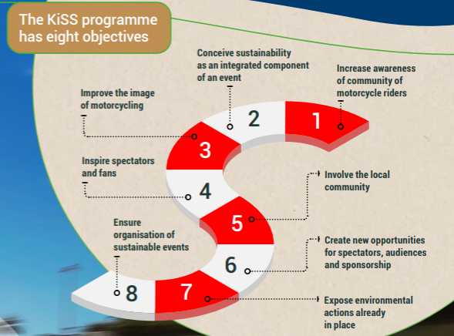
A strategy applied by FIM is the KISS programme (Keep it shiny and sustainable), which is an efficient way to help organisers apply environmental action.
Figure 6 KISS Programme (FIM,2022)
KISS has help raise awareness of sustainability issues during multiple sporting events, for example KISS has provided a anti wood waste, recycling areas, planted trees and given flyers with environmental tips at many different circuits to help them become sustainable.
KISS has had support from local governments to set up food trucks with Kmo food and worked with charities to donate uneaten food from the hospitals to reduce waste.
Kiss has helped provided bus services to help avoid people using cars and a bicycle parking area were provided to help reduce the overall carbon foot print the circuit produces at events.

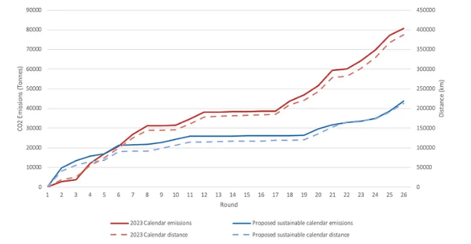
Sustainable Transportation
Figure 7 New F1 route (Paolo, 2022)
A future strategy that Paolo implied on doing was to propose a more sustainable calendar route for F1 that would drastically reduce the distance travelled in season. The new calendar route would reduce CO2 emissions by 45.5% (Paolo, 2022). There have been development in a direct replacement sustainable jet fuel that is made from renewable raw materials and reduces greenhouse gas emissions up to 80% over the fuels LC (life cycle) compared to using the standard jet fuel used today (Sustainable aviation, 2022).
A major sustainable strategy that can be used is to reuses litters of engine oil and cooking oil for reuse in other applications like transportation, that would reduce waste and save money (FIM, 2022.). Formula 1 can apply this into there trucks currently used for transporting component and equipment needed for race weekends.

Environment
Formula 1 should prioritize investing in existing tracks with sustainable practices, rather than developing new ones that harm the environment and communities. Enhancing these tracks, which likely already reduce their carbon footprint and use renewable energy, aligns with global sustainability efforts. Improvements could include solar panels, water recycling, and promoting public transport. F1 can showcase its commitment to sustainability without causing additional harm, fostering partnerships with local communities for mutual benefit and responsible event management.

Waste Management

To reduce waste during Formula 1 races, mandating the use of biodegradable materials for all items sold at the event can significantly minimize environmental impact. Requiring vendors to offer biodegradable food containers, utensils, cups, and packaging encourages sustainable practices among fans. Additionally, implementing a policy to donate all unused food to charities further reduces waste and benefits local communities by addressing food insecurity.

5.2 Effect on the customer, manufacturer, and Government.
The transition of Formula 1 (F1) towards sustainability has profound effects on consumers, manufacturers, and governments. F1's adoption of eco-friendly practices like biodegradable materials and energy-efficient technologies not only inspires consumers to make sustainable choices but also drives demand for green products beyond the sport. This heightened awareness can influence purchasing decisions and encourage investment in green technologies by teams and sponsors, creating a positive cycle of sustainability. For manufacturers in the automotive and racing industries, F1's shift prompts investment in green technologies, leading to advancements in fuel efficiency and electric vehicles. This innovation cascades through supply chains, promoting sustainability in various industries. However, consumers attending F1 events may face increased ticket prices due to the costs of eco-friendly practices, impacting accessibility. Fans also express concerns about potential performance trade-offs and logistical challenges during race weekends. F1 teams bear financial burdens in transitioning to sustainability, affecting competitiveness and potentially leading to job implications. Governments may introduce stricter regulations and infrastructure investments in response to F1's sustainability efforts. These challenges underline the complexity of F1's journey towards sustainability, emphasizing the need for collaboration among stakeholders to ensure a balanced transition.

6.0 Referencing
- Ida Wood, (2023). Explained: The chemistry behind F1’s sustainable fuel future · RaceFans.
- FIM_Sustainability_Report_2022. (2022.).
- FIA ENVIRONMENTAL REPORT 2023. (2023.).
- Dingle, G. (2009). Sustaining the race: A review of literature pertaining to the environmental sustainability of motorsport. International Journal of Sports Marketing and Sponsorship, 11(1), 80–96. https://doi.org/10.1108/ijsms-11-01-2009-b006
- Öztopcu, A. (2023). Environmental sustainability in sport: formula 1’s SDGs responsiveness. Environment, Development and Sustainability. https://doi.org/10.1007/s10668-023-04243-4
- Benson, A. (2019) Formula 1 launches a plan to become carbon neutral by 2030, BBC Sport. Available at: https://www.bbc.co.uk/sport/formula1/50382898 (Accessed: 10 March 2024).
- Membero F. (2021). Sustainability Strategy.
- Nagle, F. (2023) Decarbonising Formula One, Fathom Consulting. Available at: https://www.fathom-consulting.com/decarbonising-formula-one/ (Accessed: 11 March 2024).
- Ross, H., & Johnston, M. C. (2020). Future Sustainable Practice for Formula 1 Logistics
- F1’s hybrid engines redefine motorsports’ environmental impact (2023) KARREP. Available at: https://karrep.com/f1s-hybrid-engines-redefine-motorsports-environmental-impact/#:~:text=Compared%20to%20their%20predecessors%2C%20the,confines%20of%20the%20race%20track. (Accessed: 12 March 2024).
- F1 (2019) Formula 1 announces plan to be net zero carbon by 2030: Formula 1®, Formula 1. Available at: https://www.formula1.com/en/latest/article.formula-1-announces-plan-to-be-net-zero-carbon-by-2030.5IaX2AZHyy7jqxl6wra6CZ.html (Accessed: 12 March 2024).
- Top Gear (2024) Goodbye hybrids: WRC is set to ditch its electric motors to go petrol-only in 2025, Top Gear. Available at: https://www.topgear.com/car-news/hybrid/goodbye-hybrids-wrc-set-ditch-its-electric-motors-go-petrol-only-2025 (Accessed: 12 March 2024).
- Noble, J. (2023) Why F1’s Sustainable Fuel Challenge is a ‘different beast’, Autosport. Available at: https://www.autosport.com/f1/news/why-f1s-sustainable-fuel-challenge-is-a-different-beast/10431304/ (Accessed: 12 March 2024).
- Sustainability strategy (2022). Available at: https://corp.formula1.com/wp-content/uploads/2019/11/Environmental-sustainability-Corp-website-vFINAL.pdf (Accessed: 12 March 2024).
- Thomas, D. (2020) Davos 2020: Can formula 1 really go ‘carbon neutral’ by 2030?, BBC News. Available at: https://www.bbc.co.uk/news/business-51226066 (Accessed: 12 March 2024).
- Boretti, A. (2020) Energy flow of a 2018 FIA F1 racing car and proposed changes to the powertrain rules, De Gruyter. Available at: https://www.degruyter.com/document/doi/10.1515/nleng-2018-0171/html (Accessed: 12 March 2024).
- STĘPIEŃ, Z. (2016). A new generation of F1 race engines – hybrid power units. Combustion Engines, 167(4), 22–37. https://doi.org/10.19206/ce-2016-403
- Fagnan, R. (2016) Technique - the MGU-K and MGU-H explained, Motorsport.com. Available at: https://us.motorsport.com/f1/news/technique-the-mgu-k-and-mgu-h-explained-791187/2986353/ (Accessed: 12 March 2024).
- Homer, T. (2022) How much fuel does an international plane use for a trip? HowStuffWorks Science. Available at: https://science.howstuffworks.com/transport/flight/modern/question192.htm (Accessed: 12 March 2024).
- U.S. Energy Information Administration - EIA - independent statistics and analysis (2023) EIA. Available at: https://www.eia.gov/environment/emissions/co2_vol_mass.php (Accessed: 12 March 2024).
- Formula 1 and DHL introduce biofueled trucks for European races (2023) ... Available at: https://corp.formula1.com/formula-1-and-dhl-introduce-biofueled-trucks-for-european-races-in-2023-season-reducing-carbon-emissions/ (Accessed: 12 March 2024).
- Hydrotreated vegetable oil (HVO) explained | cummins inc.. (2022) Available at: https://www.cummins.com/news/2022/07/01/hydrotreated-vegetable-oil-hvo-explained (Accessed: 12 March 2024).
- Coleman, M. (2023)) F1’s Sustainable Fuels of the future: How the sport’s race cars are going carbon neutral, The Athletic. Available at: https://theathletic.com/5118313/2023/12/07/f1-sustainable-fuels-regulations/ (2023) (Accessed: 12 March 2024).
- Paolo (2022) An alternative calendar could cut F1’s logistical carbon emissions by almost half, Medium. Available at: https://medium.com/@paolofeser/an-alternative-calendar-could-cut-f1s-logistical-carbon-emissions-by-almost-half-eea755e40c04 (Accessed: 13 March 2024).
- Spa Grand Prix (2021) Sustainable development policy, Spa Grand Prix. Available at: https://www.spagrandprix.com/en/sustainable-development-policy#:~:text=SPA%20GP%20has%20signed%20a,%2C%20inclusion%2C%20integrity%20and%20vigilance. (Accessed: 13 March 2024).
- Thomas, G.P. (2013) Materials Used In Formula One (F1) Cars, AZoM.com. Available at: https://www.azom.com/article.aspx?ArticleID=8194.
- Jin Zhang, Venkata S. Chevali, Hao Wang, Chun-Hui Wang,Current (2020) status of carbon fibre and carbon fibre composites recycling, Volume 193.
- Sunter, D., Morrow, W. R., Liddell, H. P. H., Sunter, D. A., Morrow Iii, W. R., Cresko, J. W., & Iii, W. R. M. (2015). The manufacturing energy intensity of carbon fiber reinforced polymer composites and its effect on life cycle energy use for vehicle door lightweighting
- Poynting, M. (2023) ‘Renewables, Nuclear and Fossil fuels: the UK’s Changing Energy Mix’, BBC News, 10 May. Available at: https://www.bbc.co.uk/news/business-63976805.
- Sustainable aviation (2022) Neste. Available at: https://www.neste.com/products-and-innovation/sustainable-aviation?gad_source=1&gclid=Cj0KCQjwncWvBhD_ARIsAEb2HW-2CrWUv4GwQGByK8HGs1QTrcelroFDQ4jYFudcfoEkg2mXEFmTO-kaAp2XEALw_wcB (Accessed: 13 March 2024).
- ‌ Stephens, E., Ross, I. L., Mussgnug, J. H., Wagner, L. D., Borowitzka, M. A., Posten, C., Kruse, O., & Hankamer, B. (2010). Future prospects of microalgal biofuel production systems. In Trends in Plant Science (Vol. 15, Issue 10, pp. 554–564). https://doi.org/10.1016/j.tplants.2010.06.003
- “Rio F1 Racetrack Plans Add Fuel to Brazil Deforestation Row.” The Guardian, 15 Oct. 2020, www.theguardian.com/world/2020/oct/15/rio-f1-racetrack-plans-add-fuel-to-brazil deforestation-row.
- Soken-Huberty, Emmaline (2022). “10 Negative Effects of Deforestation.” Human Rights Careers, www.humanrightscareers.com/issues/negative-effects-of-deforestation/.
- GOV.UK. (2020) “Government Takes Historic Step towards Net-Zero with End of Sale of New Petrol and Diesel Cars by 2030.” GOV.UK, www.gov.uk/government/news/government-takes-historic-step-towards-net-zero-with-end-of-sale-of-new-petrol-and-diesel-cars-by-2030.
- Moldrich, Curtia (2023). “Andy Palmer on the UK’s 2030 Engine Ban.” CAR Magazine,, www.carmagazine.co.uk/car-news/motoring-issues/uk-hybrid-petrol-diesel-ban/.
- Jolly, Jasper (2023). “UK Installed Record 16,000 Public Electric Car Chargers in 2023.” The Guardian,, www.theguardian.com/business/2023/dec/26/uk-installed-record-16000-public-electric-car-chargers-in-2023#:~:text=The%20UK%20installed%20a%20record.
- Bancroft, K. (2023) Driven by politics: Formula 1 as a reflection of societal issues, www.kcl.ac.uk. Available at: https://www.kcl.ac.uk/news/driven-by-politics-formula-1-as-a-reflection-of-societal-issues.
- ‌ Unresearched (2020) CO2 emission reduction, LONGRUN. Available at: https://h2020-longrun.eu/co2-emission-reduction/ (Accessed: 17 March 2024).
‌

