Environmental Logo Quiz

 | Logo | Organisation
1 | 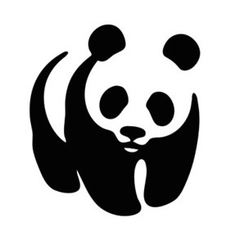 | World Wildlife Fund (WWF) Our ultimate goal has always been “people living in harmony with nature” - so we're about respecting and valuing the natural world and finding ways to share the Earth’s resources fairly.
2 | 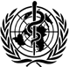 | World Health Organization WHO is the directing and coordinating authority for health within the United Nations system. It is responsible for providing leadership on global health matters, shaping the health research agenda, setting norms and standards, articulating evidence-based policy options, providing technical support to countries and monitoring and assessing health trends.
3 | 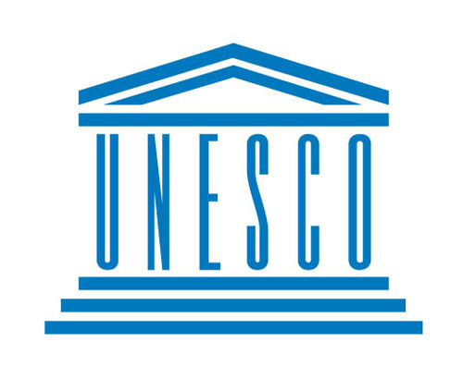 | Unesco The United Nations Educational, Scientific and Cultural Organization. It’s purpose is to contribute to peace and security by promoting international collaboration through education, science, and culture in order to further universal respect for justice, the rule of law, and human rights along with fundamental freedom proclaimed in the United Nations Charter.
4 |  | Friends of the earth We stand for:  - A beautiful world We depend on the planet, so let’s keep it in good shape.  - A good life A healthy planet is one that works for people too.  A positive relationship with the environment Acting together for the planet and everyone who lives on it.
5 |  | Greenpeace The underlying goal of all our work is a green and peaceful world - an earth that is ecologically healthy and able to nurture life in all its diversity.
6 | 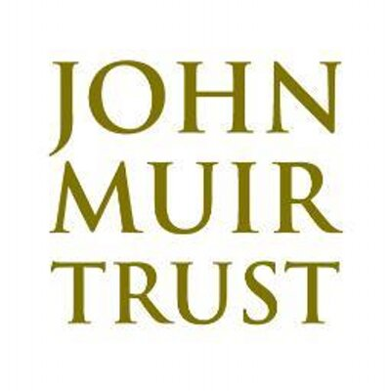 | John Muir Trust The John Muir Trust is a UK conservation charity dedicated to protecting wild places. Founded in 1983, the Trust takes its inspiration from John Muir (1838-1914), the Scots-born founder of the modern conservation movement. Like Muir, the Trust believes in protecting wild land for its own sake – and because we believe wild places are essential for people and wildlife
7 | 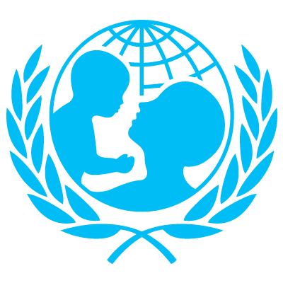 | Unicef UK is a registered charity. We raise funds through donations from individuals, organisations and companies and we lobby and campaign to keep children safe. Unicef UK works in schools, hospitals and with local authorities in the UK

