Learning in the Digital Era
ACCA4025
Component 1: E-portfolio

Submitted by: Marcus Gilkes

Student number:
2529012

Date: 5 March 2026
Table of contents
Contents
E-portfolio link 2
Screenshot of e-portfolio cover page/ welcome page 3
Task 1 3
Screenshot of ‘Essential Skills’ 4
Screenshot of ‘Reflection’ 4
Task 2 4
Screenshot of mind map 5
Link to mind map 5
Screenshot of the academic poster 5
Link to the academic poster 6
Task 3 6
Screenshot of automatic referencing tool 7
Task 4 7
Screenshot of each page of e-portfolio 8

E-portfolio link

Marcus Gilkes Portfolio

Screenshot of e-portfolio cover page/ welcome page



Screenshot of ‘Essential Skills’
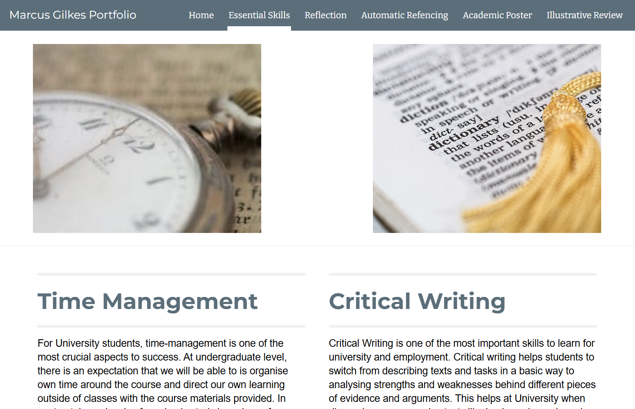
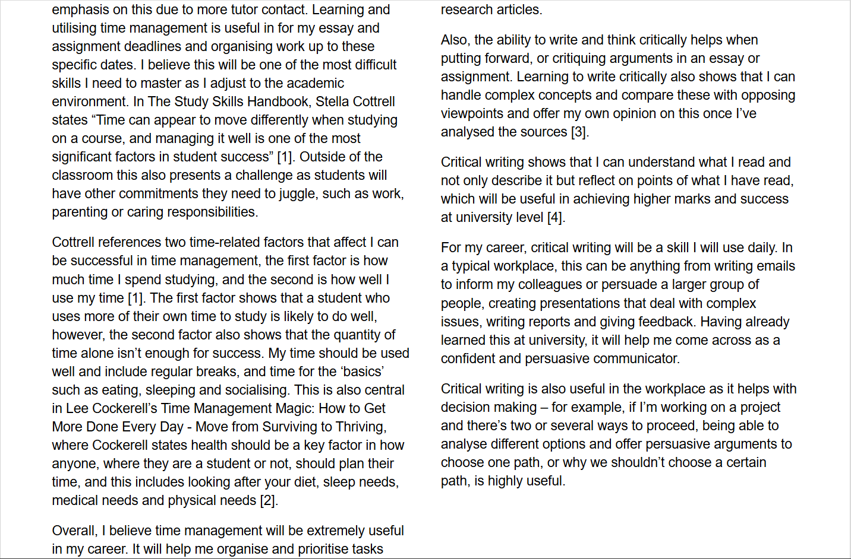

Screenshot of Reflection

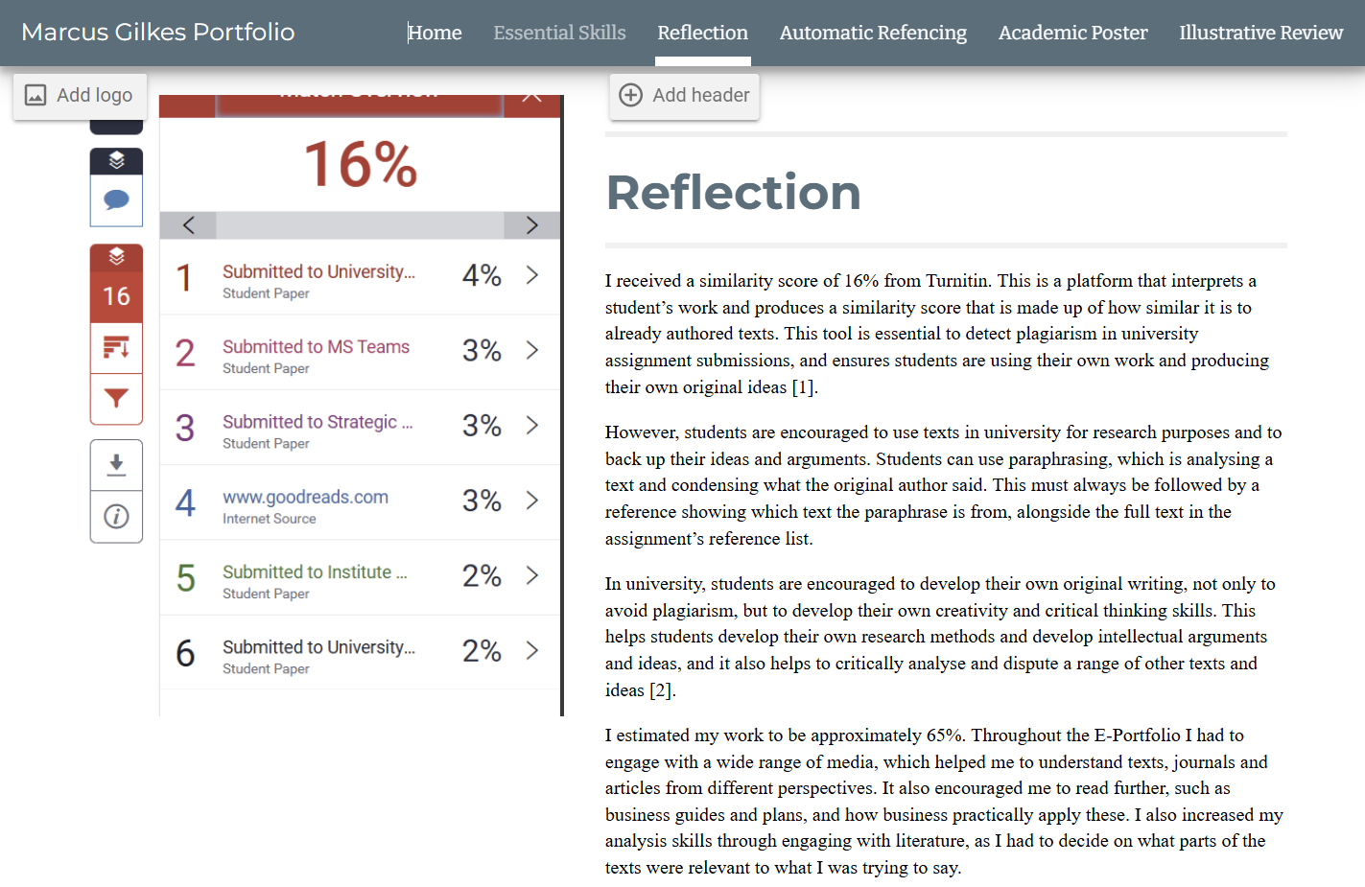

Screenshot of Mind map
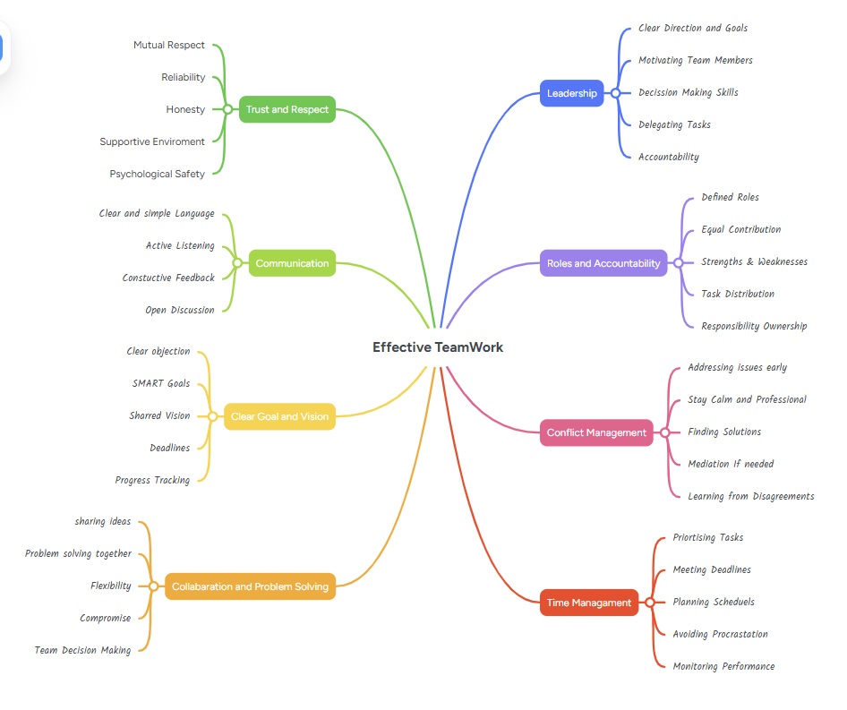

Effective TeamWork - MindMeister Mind map

Screen shot of Academic Poster
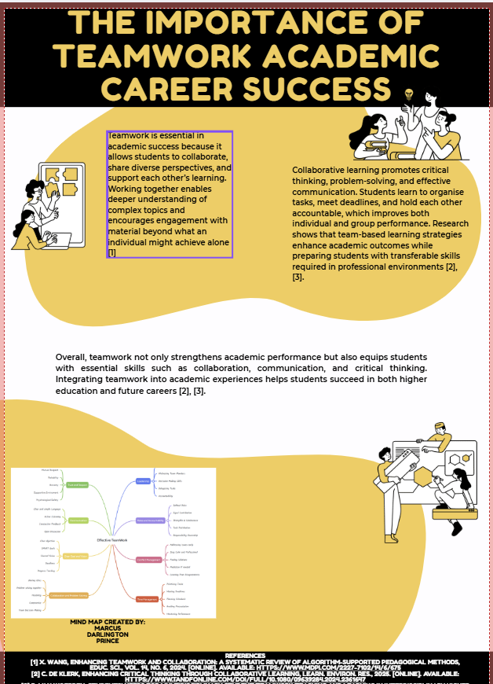

https://www.canva.com/design/DAHA1GUd1z8/Djkxunq65xD5AEz8aAPw9A/view?utm_content=DAHA1GUd1z8&utm_campaign=designshare&utm_medium=link2&utm_source=uniquelinks&utlId=hfbc8509424
Screen shot of Automatic Referencing
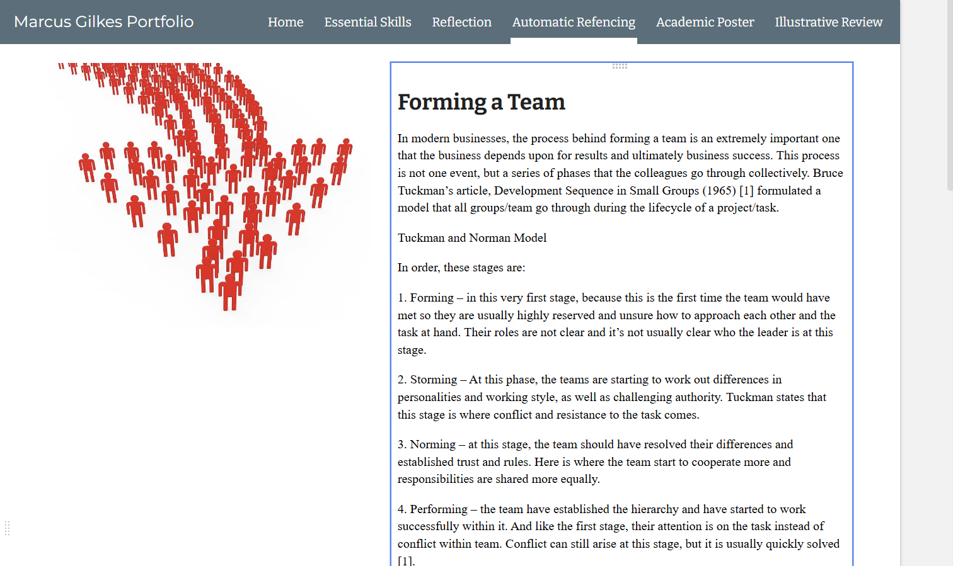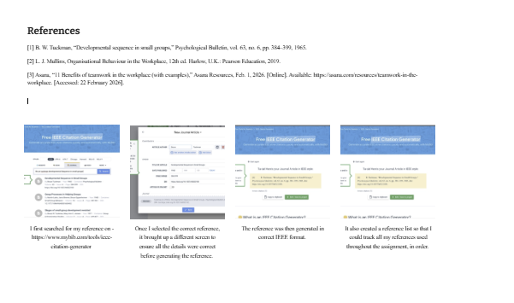
Screen shot of all pages



