
ASSIGNMENT
2
Academic and employability skills,
a reflection of selected topic’s module
MODULE | Academic and Employability skills
MODULE CODE | BMSW4001_LON
LECTURER | Barbara Chinyani
STUDENT | Camilla Torello
STUDENT ID | 2001042

Table of Contents
Introduction……………………………………………… page 2
Reflection Model………………………………………... page 2-3
Academic and Employability Skills……………………. page 4
Time Management ……………………………………... page 4-5
Public Speaking …………………………………………. page 5-6
Online Learning Experience……………………………. page 6-7
Conclusion………………………………………………... page 7-8
References ………………………………………………. page 9-10

Introduction
This report aims to provide a clear explanation of the topics discussed, combined with the personal reflection that I developed during their analysis: comparing my knowledge before and after the module “Academic and Employability Skills”. It will reflect on my learning in relation to the topics discussed during the lessons and a further personal analysis and review.
To do this I will choose 3 key skills that are primary to achieve my desired path in life and the experience that I have acquired during my career. The skills to be discussed are:
1.Time Management
2. Public Speaking
3.Online Learning Experience.
I have chosen these three because in my SWOT analysis I considered them as my strengths and they are essential for: my work, my personal and, my professional development - especially for my future intended career. To explain this in detail I will describe what I knew before, how I interpreted them during my studying period and, what impact they will have on my life.

Reflection Model
Reflection is described as “power in being able to help you develop your understanding of the way you learn, the subjects you are studying and to define your longer-term goals. It can help to promote critical thinking and problem-solving skills, both of which are key to academic success. But it has further used that relate to life skills: it is an essential part of personal development and prepares you for the world of work, encouraging you to develop the habit of analysing your actions or events and considering the consequences.” (Gillett, Hammond, Martala, 2009).
Reflection is a powerful tool necessary for progression in life and can create an effective action plan for the future. It is a useful method to analyse and give an encompassing conclusion to any given text. My chosen model of reflection to complete the task was the Gibbs reflective cycle. Gibbs was an Oxford professor of English who, in 1988, published the article “Learning by doing”. In his editorial he divided the learning method and structure into 6 cycles, with each stage allowing anyone to learn from experience and develop a different perspective from recognising mistakes or learning from a positive outcome.
The cycle stages are as follows:
1. Description of the experience
2. Feelings (personal or others) during the experience
3. Evaluation (of everyone)
4. Analysis (environment or circumstances)
5. Conclusion and outcome (positive or negative)
6. Action plan for future experience
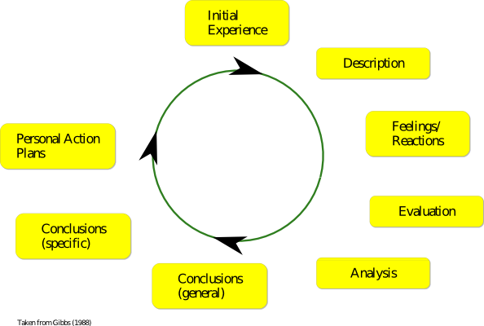

I chose this model as I found this cycle easy to follow and comprehend as it coaches an individual using factual based feedback - it takes you through a logical process which allows for clear understanding and reflection, making it more widely accessible to everyone. Using this method,
I will:
1 Describe what I knew before learning the skills above
2 Contextualize my previous feelings
3 Evaluate my findings during the lesson time
4 Outline and highlight my discoveries
5 Come to a conclusion reflecting on my outcome
6 Create an action plan for the future setting my personal goals
Academic and Employability skills
University can change lives, even beyond the possession of a degree; lectures themselves can change a person’s way of thinking and their actions in everyday existence. Academic and employable skills are transferable skills that are targeted to make every individual student reflect on their abilities, opportunities, and prospects for the future. I consider myself one of these students. The course, as outlined above, aims to develop skills, and discover unseen capability.
The main topics that we analysed regarding our university path were: Time Management, reflection, CV and cover letter writing, public speaking, online learning, referencing, academic writing, analytical and critical thinking, summarising and paraphrasing.
Personally, I have found that my approach to accomplishing tasks and setting goals has changed drastically. Throughout the course so far, a variety of topics have been highlighted and discussed, but with this report I will analyse the three which are most relevant to me which are: time management, public speaking, and online learning experience because, as I mentioned before, these are the most relevant to my career and personal life goals.
Time Management
Time management is described as, “managing time effectively so that the right time is allocated to the right activity.” (Juneja, 2015).
I personally prioritise time management. I currently manage a household (2 children, a partner a dog and the house), 24 colleagues (as a line manager) and am undertaking a University degree. Before starting my studies, I always thought my time management was one of my stronger skills. I effectively delegate at work, in my household and focus on prioritising jobs.
During the lesson we analysed, using the Eisenhower method, how time management can be used proficiently. The previous President of the USA highlighted a defined concept: that time should be used effectively, not just efficiently (mindtools, 2019). To be efficient is not enough therefore, with his theory, he declares that every individual should divide and analyse the task before undertaking it.
He creates 4 categories:
1 The urgent and important
2 The important but not urgent
3 The urgent but not important
4 The non-important and not urgent
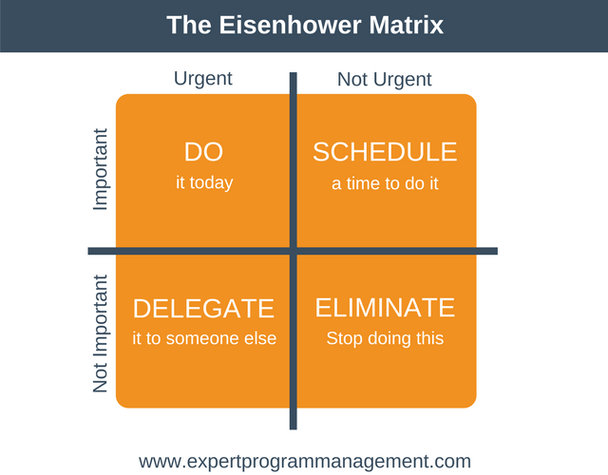

Using this concept allows an individual to: establish what needs to be prioritised and completed, what can be scheduled and planned, what can be delegated and at the end, what can be discarded.
I discovered that to organise and spend time planning is the only way to succeed. I also think that the Eisenhower matrix can be effective but a bit restrictive as we cannot always delegate and if we have the time, we can do some other non-urgent tasks. On reflection after the lesson, I considered my time in a different way, as I now try to avoid doing unnecessary tasks myself and use my time more productively. Discovering this I have realised that my time management is still well structured, and I can still classify it as one of my strengths but, as with everyone, I need to focus more on setting goals and be effectively planning tasks without distractions.
I have found that Brian Tracy’s book “Eat that frog” also made me realise how, even if I manage my time productively the majority of the time, as an action plan I should reflect on this: “instead of clearly deciding what you want to do, you continuously react to what’s happening around you.” (Tracy, 2013). Moving forward I will try to not just react to the circumstances, but I will be proactive in pursuing my goals, motivating myself into action and focus on the key results I desire.
Public speaking and giving presentation
Public speaking is described as “ the process or act of performing a speech to a live audience. Public speaking is commonly understood as formal, face-to-face speaking of a single person to a group of listening”. (Mishra, 2019) Before starting university, my public speaking was limited to my workplace, my public being my colleagues when I had to hand over work communications or notices. I was always confident in carrying out speeches because my audience consisted of people that I know. During the course I discovered the importance of preparation required before presentations, the opening time frame to catch the public’s attention and the effective speech necessary to be successful.
Although during this term I encountered a lot of challenges in delivering an effective speech during my assigned presentations, I now upon reflection have started using the following strategy:
- I conduct research before undertaking the presentation
- I make sure I use my tools wisely (like pictures or bullet points)
- I gain confidence by studying the topic in depth
- I practise my speech with another person for feedback
- I make sure my intentions are evident.
- I contain my speech within the allotted time using concise information
I naturally gesticulate and use non-verbal communication to express myself, so I try to enrich my presentations utilising these gestures. Maintaining eye contact and a steady position are good methods of improving a public speech.
Reflecting on myself I discovered that I gained a lot of confidence once I fully comprehended the speech topic. Being nervous is a natural, common feeling prior to a speech but using gestures or movement has really helped me to channel the stress during the presentation as these are natural movements for me and aid my expression of information.
Improvement is still necessary as English is not my first language so often, I require translation of words that I consider effective. On the bright site I believe that I’ve practised and improved a lot and I always ensure my key point is highlighted. The action plan that I need to put in place is regarding my positive attitude of the outcome; it is difficult for me to be satisfied with everything I say and so I want to work on this aspect by being focused on what is most likely to please the audience.

Online learning experience
I personally found online learning (also called E-learning) a great resource. I started my journey with online learning once I joined a large company in terms of work. I have used an online learning platform in the last 5 years as my company utilises its universal capacity, flexibility, and convenience. Online learning is the most effective way to remotely learn information, permitting a company to create an equal and indiscriminate system of learning in different environments. I always enjoyed following my courses from the comfort of my house or office. It also allowed me to achieve a level 4 on HR management and different leadership courses whilst on maternity leave.
Online learning is described as “the acquisition of knowledge which takes place through electronic technologies and media. In simple language, e-learning is defined as learning that is enabled electronically”( Tamm,2019). Interactive online learning, such as Microsoft teams, was new to me. The system Moodle, an online platform for class materials, was a more familiar tool. Despite the knowledge that I already had, I positively reflect and realise that E-learning has a great improvement and benefit on my studies, as it saves me a lot of time traveling to London. I certainly can say that it made me realise that my productivity has improved a lot.
It also allows me to work at my own pace and time restrictions which works effectively when I need to find a balance between my work, University and home life and responsibilities.
The only downside is that I have not had the pleasure of meeting my peers or other students and the lecturers in person which has been a drawback when speaking in class as I lack familiarity. Although, I can positively say that support and advice from the University, the lecturers and the IT department was always good.
I can finally say that my online journey is positively impacting my life, especially because the COVID-19 pandemic has made me discover how University has been efficient in adapting and tailoring online courses and I realise how inspirational this has been to me - reflecting on my skills remotely and interactively. I also positively found out that despite the limited human interaction, I had a lot of good interaction with all the other students and as such, I will always choose an online course instead of a physical one if I have the choice.
Conclusion
In order to be successful in life, whether that be: an University path, new career or your personal life, you must grasp the aforementioned skills above. Without these you lack organisation and personal agency to complete important tasks in a timely manner - Time Management. You cannot keep pace with the ever-changing technological age we’re in, tapping into unlimited resources and accessibility - E-Learning. You cannot coherently communicate with the public whether that’s peers, colleagues, or friends, to convey information or opinions concisely and accurately with apt attention - Public speaking.
From analysing my strengths and weakness and assessing the importance of each of these topics I will aim to improve upon my Time Management, Online Learning experience and Public speaking by committing to each of them. I will try to follow the Eisenhower model to utilise my time well. I will equally explore the vast opportunities Online Learning has and hopefully use it further my academic experience. For my public speaking I will practice my timing and techniques to communicate effectively while staying calm and in control. To conclude I will provide myself with the best possible skill set to succeed in my chosen path, as I would encourage any individual to also.

References
Bruce Eli, (2017), What is Online Learning?, Eztalks,[Online]. Available at: https://www.eztalks.com/elearning/what-is-online-learning.html [Accessed on 20 December 2020].
Catlin Gabel (2020) Experiential Learning, Catlin Gabel School, [Online].Available at : https://www.catlin.edu/about/strategic-initiatives/experiential-learning [Accessed on 25 November 2020].
Dwight D. Eisenhower (1954). Address at the Second Assembly of the World Council of Churches.[Online]. Available at: https://web.archive.org/web/20150402111315/http://www.presidency.ucsb.edu/ws/?pid=9991 [Accessed on 22 November 2020].
IAD,(N.D.), Reflection: what is it and why is it useful?, Institute for Academic Development, University of Edinburgh,[Online Pdf].Available at: http://www.docs.hss.ed.ac.uk/iad/Learning_teaching/Academic_pastoral/Reflect/Reflection_explanation_HO.pdf [Accessed on 13 December 2020].
Gibbs, Graham (1988). Learning by doing: a guide to teaching and learning methods. London: Further Education Unit. ISBN 978-1853380716.

Juneja Prachi (2020), Time Management - Meaning and its Importance, Management Study Guide, [Online]. Available at: https://www.managementstudyguide.com/time-management-skills.htm [Accessed on 14 December 2020].

Luxafor (2020) The Eisenhower Matrix: Time and Task Management Made Simple,[Online].Availble at: https://luxafor.com/the-eisenhower-matrix/ [Accessed on 22 November 2020].

Mishra Abha, (2019), What is Public Speaking? Quora [Online]. Available at: https://www.quora.com/What-is-public-speaking [Accessed on 18 December 2020].
Mindtools, (2019), Gibbs’ Reflective Cycle, Helping People Learn From Experience, Emerald Work, [Online]. Available at: https://www.mindtools.com/pages/article/reflective-cycle.htm [Accessed on 25 November 2020].
My Word of Work, (2020), Transferable skills to help you take your next steps, Skill Development Scotland, [Online]. Available at: https://www.myworldofwork.co.uk/transferable-skills-help-you-take-your-next-steps [Accessed on 20 November 2020].
Nottingham.ac (N.D.), Gibb’s Cycle, [Online]. Available at: https://www.nottingham.ac.uk/nmp/sonet/rlos/placs/critical_reflection/models/gibbs_cycle.html [Accessed on 25 November 2020].
SkillsYouNeed (2017), Communication Skill, [Online]. Available at: https://www.skillsyouneed.com/ips/communication-skills.html#:~:text=Many%20of%20these%20are%20essential%20skills%20that%20most,the%20National%20Association%20of%20Colleges%20and%20Employers%20%28NACE%29. [Accessed on 18 December 2020].
Tamm Sander, (2020), What is E-Learning, E-Student, [Online]. Available at: https://e-student.org/what-is-e-learning/ [ Accessed 20 December 2020].
Tichar Mary Rose, (2019) The Eisenhower Matrix, Inside Out Career Direction. [Online]. Available at: https://insideoutcareer.com/the-eisenhower-matrix/ [Accessed on 22 November 2020].

Tracy Bryan, (2013) Eat That Frog!: Get More Of The Important Things Done Today, Hodder
Paperback publisher, second edition.

Tuttar Janet, (2019) 6 Great Methods to Improve Public Speaking Skills, Speak and Conquer [Online]. Available at: https://speakandconquer.com/how-to-improve-public-speaking-skills/ [Accessed on 18 December 2020].

Conclusion

