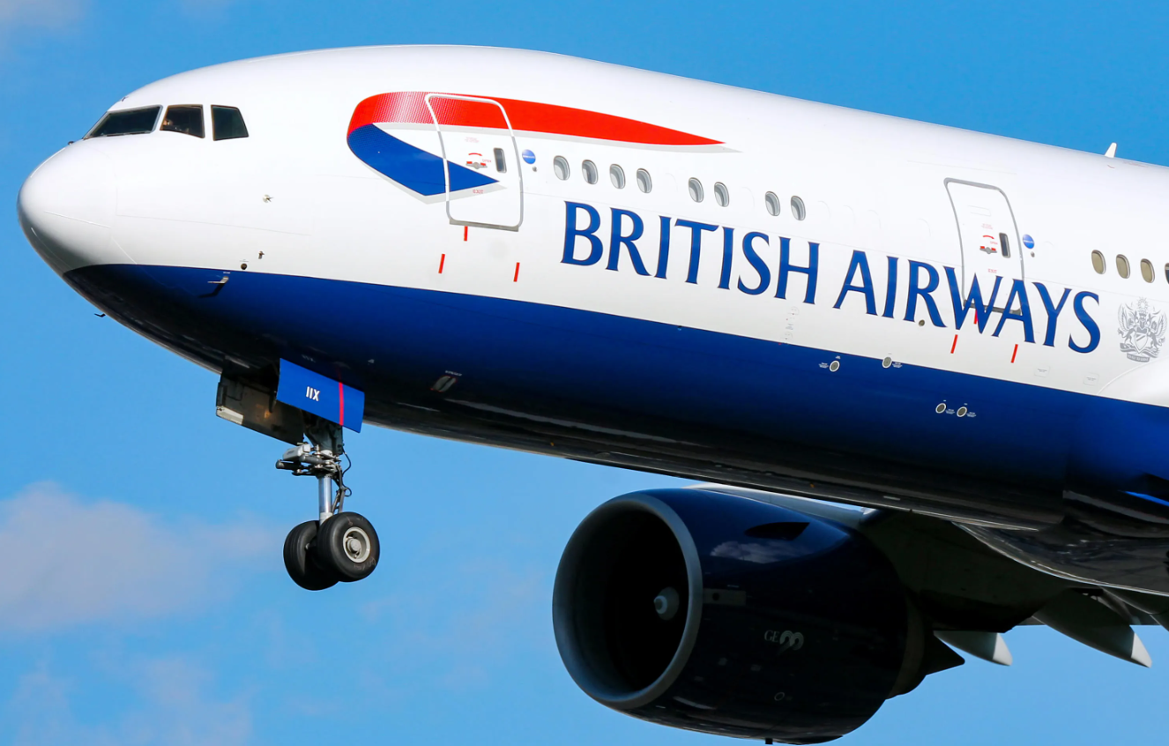
Business Environment of British Airways

Module: Introduction to Business
Module code: LCBB4007
Module Leader: Aderemi Ojebode
Assignment title: Component 1: Essay

Table of Content

Introduction......................................................................................................................P 3
Business Environment Issues (PESTEL)........................................................................P 4, 5
SWOT Analysis of British Airway's Competitive position and Success...........................P 5, 6
Financial Impact before, during and after the Corona Virus Pandemic...........................P6, 7
Conclusion.......................................................................................................................P 7
References......................................................................................................................P 8

Introduction

British airways are a global airline (British Airways, 2023) which operates as a public limited company, previously operating as a private limited company. The mission of British Airways is ‘connecting Britain with the world and connecting the world with Britain. Their goal is to ‘become the world’s most responsible airline (Hayr, 2014) British Airways provides an airline service, helping many people fly across the world to many different countries.

Business Environment Issues

Political
A political factor affecting British Airways is Brexit because it may cause restrictions which may not be able to allow British Airways to operate globally, affecting their operations. Another factor is that travel restrictions have been removed, meaning that it is easier for the airline to travel to other countries, meaning there is more demand. This affects the business because it makes them more popular and increases their success rate. (Panda, 2023)

Economical
The pandemic has had a heavy impact on the airline, as it has with every other business. For example, prices have risen, meaning fuel has become more expensive than it was before. This has forced British Airways to increase their prices, which could be an issue with customers. The costs of oil increased due to the conflict between Russia and Ukraine, which has also been a reason why fuel costs have risen. (Panda, 2023)

Social
Employment and lifestyle can be two social factors which affect the operations of British Airways because if people are not employed, they won’t have money to spend on holidays all the time compared to those who are employed and have a lot of money. This would mean that they might lose out on some customers as unemployment is rising from 3.8% to 4.3% from 2023 to 2024 (Elliott and editor, 2024) Lifestyle also affects the operations because people who constantly go on holidays are always going to be travelling using British Airways or other airlines, which helps their business.

Technological
A technological factor which has an impact on British Airways is information and communication resources (learn, 2022). These are ways the airline interacts with its customers and stakeholders. These resources must be efficient, as businesses rely on this to keep customers in touch etc. Using the best technology ensures effective communication, which means they can communicate easily and give faster responses.

Legal
Although British Airways is a popular airline amongst people, there have also been times where they have faced fines for failure to comply with legalities. For example, on the 8th of July 2019, there was a data breach where 500,000 customers had their details such as personal information and credit/debit card details stolen by hackers. They were fined £183 million by ICO, a British Regulator, for failing to keep their consumers, employees, and other stakeholders’ information/data protected (The Economist, 2023).

Environmental
Pollution is one of the environmental issues that is now being considered by most airlines. Pollution may impact the operations of British Airways because many airlines are trying to be environment friendly, therefore airlines must operate in a way to reduce the harm caused to the environment. To help reduce this, British Airways (2023) states that they are on a mission to be carbon net zero by 2050 to help create a sustainable environment.

SWOT Analysis of British Airway's Competitive position and Success

Strengths
According to Ting (2023) we can determent that British Airways, the UK's leading airline, has built a strong brand image due to customer trust and loyalty. This has led to economies of scale advantages. The airline has launched a subsidiary called Open Skies, offering business class for US-European traffic. With Heathrow Airport as its main hub, British Airways has large aircraft capacity. With a merger with Iberia, it aims to become the second largest European airline after Air France. A strength for the airline is that they have had very low accidents (Momin, 2021). This shows that the airline is a safe company, which also attracts customers because they feel secure knowing that their aircraft are safe, and they are less likely to be involved in accidents. Because of this, many people prefer to fly with British Airways; they had 33 million passengers (about twice the population of New York) in 2022. (Statista Research Department, 2024)

Weaknesses
A weakness for the airline is that it heavily depends on the UK market. (British Airways, 2023). This is a weakness for the business because a change in the UK market, and consumer trends may affect the revenue of the business; if people within the UK aren’t using the airline, British Airways will lose out on sales revenue and therefore decline.

Opportunities
However, this can be an opportunity for British Airways because they can expand their business into emerging markets, where flying out is becoming an increased demand such as Asia and Africa. (The Strategy Story, Admin, 2023). This is good for British Airways because they don’t need to rely on the UK market.

Threats
A threat which British Airways may face is the increase in competition (The Strategy Story, Admin, 2023) For example, easyJet, Ryanair and Loganair, which are seen as cheaper alternatives. This is a threat because consumers may prefer to use these airlines over British Airways, causing them to lose out on revenue.

Financial Impact before, during and after the Corona Virus Pandemic

The pandemic had a great impact on British Airways due to the restrictions which were placed on businesses and people at the time. For example, people were forced to follow social distancing rules imposed by the government, forcing many people to stay within their homes (Hamawandy et al., 2021). Due to these restrictions, British Airways lost 74% of their passengers, causing their sales to decrease rapidly, also meaning they lost a lot of profits (Statista Research Department, 2024).
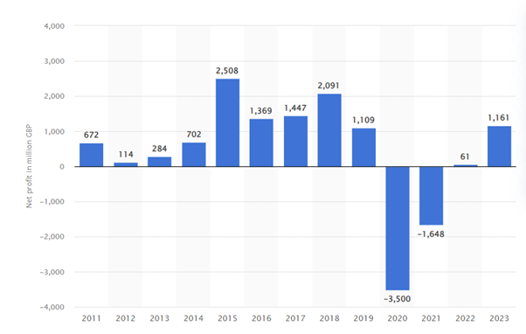This graph emphasizes the impact of the pandemic on the airline, as it shows, British Airways was at its peak in 2015, with a net profit of £2,508 million, however, this dropped tremendously by 60.08% in 2020 to -£3,500 million due to the global lockdown. Statista Research Department (2024) shows a rapid increase of £1,852 million net profit in 2021 and further rising of £2,809 in 2023, there is clear visual evidence of the British Airways making rapid financial recovery from the pandemic.

Conclusion
Ensuring that British Airways follows these rules and uses these factors will create a higher success rate for the airline as it will help improve their services, although British Airways have recovered from the pandemic, they still rely on the way they respond to consumers and how they operate to create more sales revenue. Failure to comply with business regulation will result in issues for the business and may cause them to collapse, impacting a decrease in their success and sales revenue, causing their business to fail.

References

admin (2023). British Airways SWOT Analysis - The Strategy Story. [online] The Strategy Story. Available at: https://thestrategystory.com/blog/british-airways-swot-analysis/#google_vignette.
British Airways (2023). About BA | Information | British Airways. [online] Britishairways.com. Available at: https://www.britishairways.com/content/information/about-ba.
Elliott, L. and editor, L.E.E. (2024). UK real pay grows at fastest rate in two years as unemployment rises. The Guardian. [online] 14 May. Available at: https://www.theguardian.com/business/article/2024/may/14/uk-pay-unemployment-rises-bank-of-england-interest-rate-cut#:~:text=The%20ONS%20said%20unemployment%20rose.
Hamawandy, N.M., Ali, R., AL .Bewani, H.A.W., Jamil, D. bdulmajeed, Rahman, S.K. and Othman, B.J. (2021). The financial Impacts of (COVID-19) on financial reporting quality Airlines Companies: British Airlines. The journal of contemporary issues in business and government, [online] 27(2), pp.5264–5271. Available at: https://cibgp.com/au/index.php/1323-6903/article/view/1429.
Hayre, A. (2014). GRIN - Business Strategy of British Airways. A Case Study. [online] www.grin.com. Available at: https://www.grin.com/document/287089.
learn, future (2022). Technological Factors. [online] FutureLearn. Available at: https://www.futurelearn.com/info/courses/managing-company-culture/0/steps/216768#:~:text=Technological%20factors%20include%20production%20techniques.
Momin, A. (2021). British Airways SWOT Analysis 2021. [online] pestleanalysis.com. Available at: https://pestleanalysis.com/british-airways-swot-analysis/.
Panda, I. (2023). An Analysis of British Airways - 954 Words | Essay Example. [online] IvyPanda. Available at: https://ivypanda.com/essays/an-analysis-of-british-airways/#:~:text=Political%20factors%20affecting%20British%20Airways.
Statista Research Department (2024a). British Airways plc: net profit 2011-2019. [online] Statista. Available at: https://www.statista.com/statistics/1007530/net-profit-british-airways-plc/.
Statista Research Department, (2024). British Airways: number of passengers 2022. [online] Statista. Available at: https://www.statista.com/statistics/734311/british-airways-passenger-figures/#:~:text=In%202022%2C%20British%20Airways%2C%20including.
Statista Research Department (2024b). Topic: British Airways. [online] Statista. Available at: https://www.statista.com/topics/5372/british-airways/#editorsPicks.
The Economist (2023). The Economist - World News, Politics, Economics, Business & Finance. [online] The Economist. Available at: https://www.economist.com/.
Ting, H. (2023). AN ASSESSMENT OF HOW TO ACHIEVE COMPETITIVE ADVANTAGE AND ALLEVIATE ORGANIZATIONAL WEAKNESSES: INSIGHT FROM BRITISH AIRWAYS HE TING 6317195009 AN INDEPENDENT STUDY SUBMITTED IN PARTIAL FULFILLMENT OF THE REQUIREMENTS FOR THE MASTER’S DEGREE OF BUSINESS ADMINISTRATION GRADUATE SCHOOL OF BUSINESS SIAM UNIVERSITY 2023.

