Data Security and Compliance

Name: Oskar Kazimierski
Student Number: 2212605
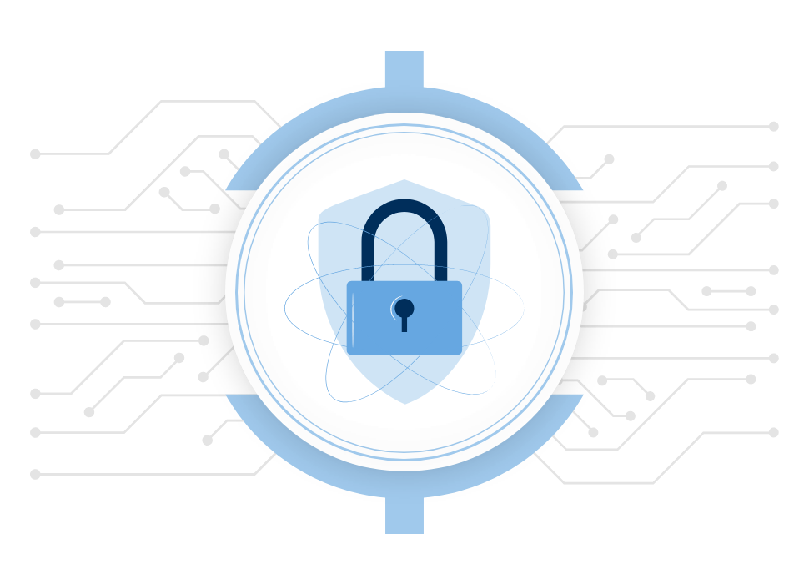

Task 1 – Research in data and security compliance 3
Cryptography 4
Security technologies 5
Conclusion 7
Task 2 – StresSolution Case Scenario 8
Organisation Structure 8
Policies and Procedures 8
Compliance (Laws and Ethics) 9
Governance and Strategic planning for security 10
Risk Management 11
Contingency Plan 12
Protection Mechanism 13
References 13

Overview of the coursework
I have been set to complete 2 different tasks within this coursework and these both will be covered within this essay. In the first task I have been asked to discuss multiple different topics which I have to research myself. These vary from physical security to security technologies such as firewalls and vpns. Task 1 must include graphs, charts or diagrams and it also needs to follow the ieee referencing.
In task 2 I have been set a case scenario and from this I need to design and discuss my own approach to meet the need of the company's new information security unit. Once again task 2 must follow the ieee standard.

Task 1 – Research in data and security compliance
Within data security and compliance there are multiple things which need to be covered and some of which are crucial. To start off with, physical security is an essential part of any company/business, and this is why it needs to be covered within this essay. Physical security of a company is simply protecting their hardware, personnel and networking devices such as the companies' servers, routers, end devices and many more.
Protection of physical security must be thoroughly thought out by the company/business as there are many things that they need to be aware of. For example, the company may need to consider where they're based as things such as weather can affect the physical security. If a company is based in an area where floods or heavy winds are a common thing then the company will need to take this into account by using steadier walls and maybe they could consider having all their equipment on the second floor of the building in the case of a heavy flood. Also, heavy winds can disturb the connection of the network as things such as cabling, and wires can be affected. This is backed up by [1] “Hurricanes and storm winds can damage property, uproot infrastructure, and create flying debris, as well as disrupt communications, power supplies, and transport.”
Another physical security measure that needs to be considered is protecting the room where the hardware is stored in. Within most companies, there will be a designated room where they store all their servers, routers and switches. This specific room should be the most protected room within the building as there are people who try and break into these sorts of rooms. To maximise protection on the hardware, the company should consider having much thicker walls so that anyone trying to break in has a much harder time. These walls should be steel reinforced to make it pretty much impossible to break into. In addition, the server room should only be accessible by authorized individuals to increase the protection even more. To do this, the company could install face recognition or fingerprint recognition on the door and only give access to authorized individuals. This will eliminate the risk of employee manipulation within the company.
Furthermore, another security measure than can be enforced to maximize the protection of physical hardware is to setup cameras. Preferably these cameras should be live 24/7 with someone looking at them constantly. Also, the server room which was previously mentioned should contain something such as a motion camera which detect any movement within the room. If there is any sort of movement then the cameras would let off an alarm that will alert the staff. Having a camera also gives you the ability to show them to the authorities if something did ever go wrong.

Cryptography
Cryptography is used by anyone who has a device which is connected to the global network. For example, this can range from an ordinary person who uses a mobile phone to a well-known company or business. Cryptography is simply a process of making sure that the message which was sent is only intended to reach that specific person and no one else. Back in the early days of messaging and the internet, there wasn’t much security, and this made it incredibly easy for hackers to steal data and information which was sent out by companies. Due to this, every company had to start increasing their security as vital information was getting intercepted by hackers. Cryptography is an essential part of any business, and this source shows [2]“Cryptography is one of the most important tools businesses use to secure the systems that hold their most important data assets.”
There are 3 separate types of cryptography, and these are symmetric key cryptography, asymmetric key cryptography and hash function cryptography. Each of these have their own upsides and downsides to them. To start off with, symmetric key cryptography uses a system where there's only one secret key that is used to both encrypt and decrypt a message. By using this method, the communication must exchange the same key which was used to encrypt the message otherwise the person receiving the message won't be able to decrypt it. One downside of symmetric key encryption is that this may cause trust issues between 2 parties as once again only the exact same key can be used. The major downside of symmetric key encryption is that if someone manages to intercept the key then they're able to decrypt the message which was sent. In addition, it would take more time to receive another key which would then be used to follow the same process again.
On the other hand, asymmetric key encryption is a lot more secure, and this is because this method uses 2 separate keys to both encrypt and decrypt a message. Asymmetric encryption uses one public key and one private key, and this is more commonly known as public key encryption. As this method uses one private key, this means that it prevents unauthorized access to anyone who it was not intended for. In addition, there are many protocols which rely on asymmetric cryptography, and these are the transport layer security and safe socket layer security. From this I can infer that the security of an asymmetric key is exceptionally strong.
However, with all these positives there are going to be a few downsides to it and one of which is that it can be incredibly slow compared to the symmetric key method. This is backed by the following source of [3] “Even though asymmetric encryption provides more protection to the keys; they are comparatively slower than symmetric encryption. “Furthermore, if someone loses the private key then this results in him not being able to decrypt the message which he received. Without that private key, the individual won't be able to decrypt the message and he won't be able to get another private key. In addition to this, this method will use up a lot more resources compared to the symmetric key system which is another drawback.
To finalise cryptography, there is one more thing which needs to be mentioned and that is hash function. A hash function is simply a mathematical equation which takes a numerical value and turns it into a fixed size string output. The hash function is commonly used within data structures, and it's used to authenticate information and checking messages.
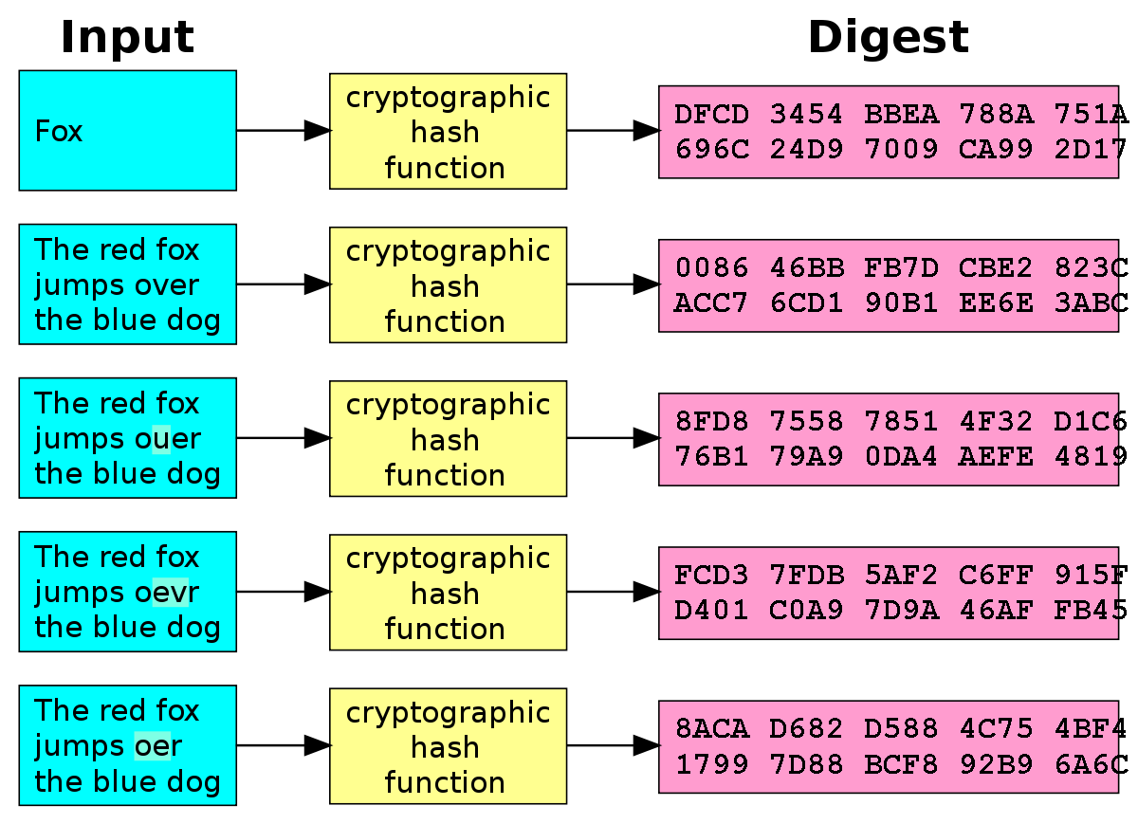
Above is an example of how a hash function is both inputted and outputted. As can be seen the input is all entered as a string and then using the hash function it gets converted into a numeric and string value. This makes it pretty much impossible for any to decode without a specific key.

Security technologies
There are many ways to ensure that a network, end device or a company database can be secured, and these will all be covered. To start off with, security is the number 1 most important thing for a company or even an ordinary person who has connection into the world wide web. [4] “according to the latest available data, there are approximately 14.76 billion connected IoT devices”. This means that companies and ordinary people must take security of their devices into consideration. Everyone holds personal data and information on their devices such as bank accounts, home addresses, emails, passwords and the list goes on. This is why it's so essential that everyone has the best security possible. For example, if a hacker was trying to break into a network or even someone's device and they're security it poor, then the chances are they will be able to break in easily. This is why we have multiple security measures that can be taken into place.
The first security measure that can be taken is to have a firewall on any device or network which is used by someone. A firewall simply acts as a shield to protect your devices from malicious attacks, and it can also filter through any data that seems suspicious. A firewall can be used both on a device such as a computer and it can also be used on a companies or personal network. Majority of people and companies will use a windows-based operating system on their devices, and this means that the device will have a windows defender on there. This means that the computer has the best security as this is constantly updated by Microsoft to prevent hackers from being able to break in. Each time a new hack gets discovered, Microsoft will come up with an update to prevent the new hack and this is why it's essential to keep your devices up to date. In addition to this, the firewall can see every bit of data that’s going in and out of the network. If this firewall sees something unusual or suspicious then it will straight away block it from entering the network. Without a firewall, it would be incredibly easy for hackers to send in viruses or other bugs to devices and this would cause all your personal information to be leaked. With this information, the hacker can either use it for themselves to commit crime or instead they could sell it on the black market for a lot of money. Either way, your personal data will be in someone's hands that you wouldn’t want it to be in.
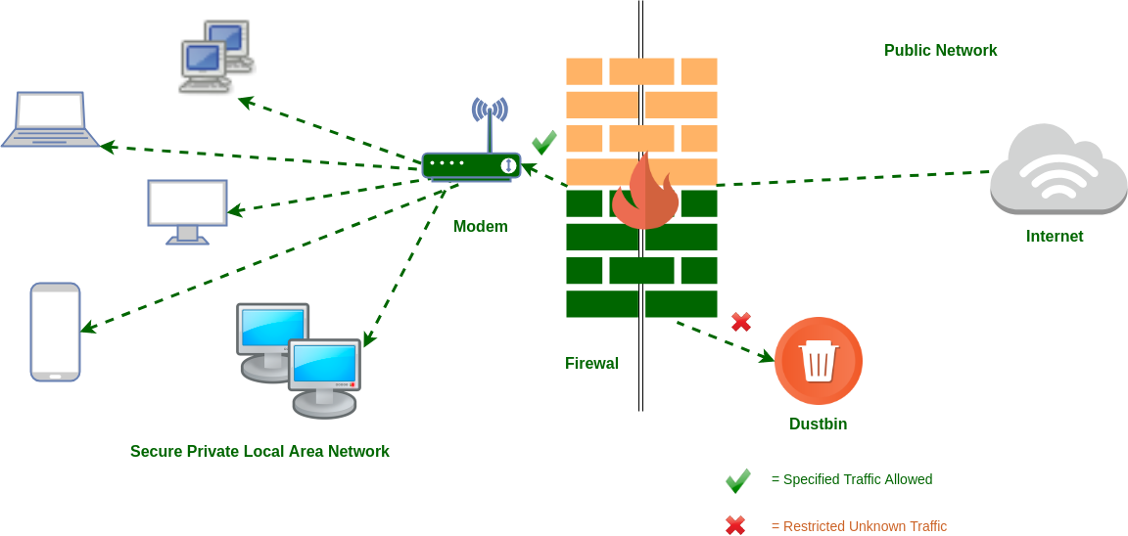
Another security measure which can be taken is by using a virtual private network (vpn). A vpn will simply make your device appear in a place where it isn't. For example, your able to connect to servers all around the world where they allocate you with an Ip address and this is beneficial in multiple different ways. If you're living in the United Kingdom, you can connect to a Spanish server within one or two clicks. The benefits of this are extremely good because if someone were trying to locate your device, it would appear in a completely different country and location. A vpn simply makes it impossible for someone trying to track your device and to track any data or information that you're sending or receiving, and this is supported by the following source [5] “A VPN is a complex networking technology that helps you to access the internet in a secure and private environment. At its core, it does two things to reduce the risk of an external party tracking your digital presence online.” All the above shows how incredible a vpn can be for security reasons however people don’t only use it for security reasons. As an example, Netflix puts out different shows and movies in different countries and with a vpn you can switch to any country which you'd like and have the whole catalogue of their movies and shows. In addition, some people use 3rd party websites to stream live sport of movies and people would use a vpn to make sure that no one can detect where they're watching it from which is once again another benefit to a vpn.
A vpn isn't only useful for an ordinary user and it's also perfect for any company. A vpn as stated has enhanced privacy which is crucial to a company. A company should do anything that they can to have the best security possible in case of data leaks which can cost them millions or even they could get shut down by the authorities. Also, let's take a company that operates overseas as an example. If a company site is based in Brazil and wanted to access data or content from their other facility which is based in China, then it's simple to do this with a vpn. This can be hugely beneficial because there is a huge time zone difference between them meaning if the site in Brazil were working at 3pm and they needed data or content from the site in China, but it was out of the working hours, with this vpn they can simply get everything they need. Most companies shut off their network or access to data in out of work hours which is done as a major security measure, and this is why a vpn would come in incredibly handy.
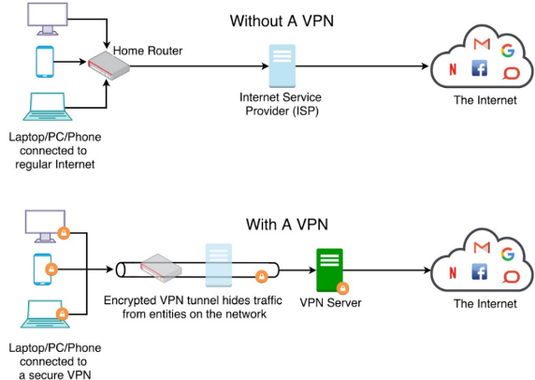
With all these benefits of a vpn, there will obviously be a few downsides to it as well. One of the major disadvantages is that it slows down your connection speed significantly however with the correct vpn, the connection speed will be better than others. Another disadvantage is that it doesn’t 100% guarantee privacy, but the chances are significantly increased. Also, a vpn is a monthly subscription which obviously means that it costs money, however I believe that it's worth the money due to the benefits.

Conclusion
To conclude my research in security and compliance I now understand why security is such a big factor in any company or any individual. The security of a company is specifically crucial to get correct as without it the company could go bankrupt or owe millions upon millions of pounds. The security structure of a company should be thoroughly thought out before anything. The company should have some sort of plan before the business gets up and running. For example, the company will need to have a rough idea of what they're network is going to look like, whether it needs to have multiple servers, multiple routers and whether they need to connect to a data centre. All of these need a high standard of security to minimize the risk of someone being able to break in.
Even though the security needs to be exceptional for a business, the average user of the internet also needs to make sure that they're security is to a high standard. This is due to hackers being able to obtain your private and confidential information that they can then use to commit crimes with. For example, a hacker can use your information to buy products online, use your identity to commit crimes or even sell your information to someone else. This is why it's essential to ensure that the security level is the best that it can be. I would suggest the average user to have a vpn always enabled to minimize the risks of getting hacked.

Task 2 – StresSolution Case Scenario
In Task 2 I have been shown a case scenario of a company by the name of StresSolution and I've been asked to usen my knowledge and understanding from task 1 to design and discuss my own approach to meet the need of the company's new information security unit. There are multiple factors which need to be considered and discussed.

Organisation Structure
An organisational structure is key to any company including StresSolutions. Without a structure, the company simply won't be able to operate and the whole plan will go to waste. A good organisational structure will consist of many factors and some of them are a strong relationship with the employees, chain of commands, trust and a well-thought-out decision-making process. Without any of them the structure of the company will fail, and it would most likely result in the company losing money as they go. It's essential that the structure is discussed with everyone involved in the company as this helps to brainstorm more ideas and to have a stable structure.
In the case of StresSolutions, I would make sure that anyone who's apart of the company has a say on what's going on with the company and what things they believe would benefit the structure of the company. However, it's important that every idea that’s brought up is well thought out and I would recommend that the people higher up brainstorm the advantages and disadvantages of the idea.

Policies and Procedures
To ensure that a company is ran correctly, the employees must follow many policies and procedures otherwise this could result in some employees getting fired and this also includes StresSolutions. Policies and procedures are simply implemented by the top people within a company, and these must be followed by anyone who works in that company. These policies and procedures will state what the employees can and cannot do. In addition to this, without any policies or procedures it leaves the organisation exposed to liability. We will be implanting a bunch of policies and procedures within StresSolution for the employees to follow. In the case of an employee breaking the company's policy, the employer has the right to dismiss the worker due to misconduct. Furthermore, if an employee were to break any of the set rules, then this shows to the company that the employee isn't trustworthy. An employee will only get fired if they breach a significant rule in the company and this is supported by the following source [6] “A larger-scale breach or failing to comply with legislation could result in severe penalties such as much more punishing fines or even in certain circumstances a jail sentence.” For example, in a cyber security company, if there was a rule that stated that no data from inside the company can be shown to anyone or discussed outside of work and one employee breached this rule then this would result in huge consequences both by the company and potentially by law enforcement. This is because this is a major rule to break in a company that is there to protect networks and people's data.

Compliance (Laws and Ethics)
Legal and ethical compliance are simply laws which need to be abided by any company and these are set by the government to ensure a safe and productive working environment within a company. Computer ethic laws are there to set moral standards of the use of computers and electronics. This involves both the hardware side of things and the software side.
There are 10 different ethic rules when it comes to computers and some of these rules are extremely important. This is supported by the following source [7] “The Computer Ethics Institute provides their Ten Commandments of Computer Ethics as a code of computer ethics.” For example, one rule is to always respect the copyrights and licensing rules which is an extremely important. If this rule is abided, then the consequences can be severe, and this could result in the company or person getting a lawsuit which could cost millions or in a more extreme circumstance this could result in extensive prison time. Another key ethical requirement is to responsibly use the computer hardware, data and the software which simply means not to commit any offences by using these. The last important ethical requirement is to ensure the privacy of the employees, company and the customers.
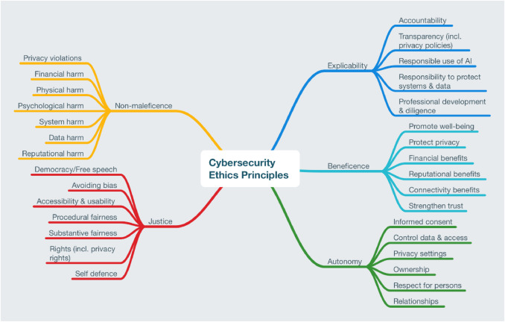
For StresSolutions I would highly recommend them abiding by every single one of the laws and ethics and this is because they're a company which specialises in the cyber security aspect, and they also use online presence to sell their services. Things such as copywrite and the correct use of their machines should be taken extremely seriously as if they abided these laws then the company will face major consequences. This could result in the company being shut down by the government or they might even have to pay a large sum of money.
Governance and Strategic planning for security
Governance and strategic planning are a crucial security feature of any company, and this helps in managing and enhancing its security posture. Both play key roles in in complying with regulations, business objectives and effectively mitigating risks. The governance aspect of security is there to monitor, guide and control a company's activities. The governance is also there to establish and maintain a framework that ensures the security strategy aligns with the companies' goals. There are multiple things which come under the governance security, and these include policies and procedures, risk management, compliance and roles and responsibilities. On the other hand, strategic planning for security is planning a roadmap to achieve security objectives and this is relative to any company. For example, for a cyber security company, the roadmap will consist of many things that need to be achieved in securing their data from others and in securing their own data. Once again there are multiple things which come under strategic planning for security and these are risk assessments, security objective and their goals, resource allocation, incident response planning and security awareness and training. Each of these are incredibly important in making sure that a company has a strong strategic plan for their security.
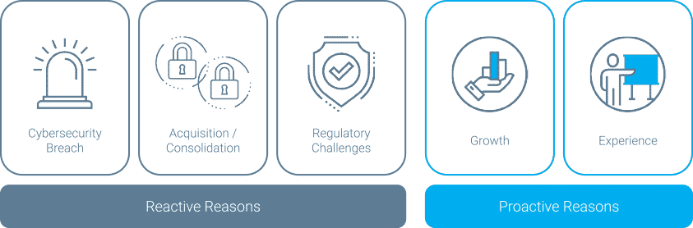
For StresSolutions, I would highly recommend them to follow the governance and strategic planning for security. There are so many different things which come under this and that is why I would make sure that each one of them things is thought out correctly. The governance aspect will include exactly how the company decides to execute its authority, control and direction of the organisation. This is incredibly important for a company that deals with cyber security and data management. Without strong authority, the company could face issues such as their employees not working to their highest standards.
A solid structure for a company like Stresolutions is essential as they provide services to other companies. StreSolution will need to structure for a few things such as which company needs which service, how quickly they can provide this service and how will this service operate to their customers.

Risk Management
Risk management plays a huge role within any company, and this is also implemented in every company. Risk management is there to protect the company from potential threats or potential losses while the company is actively operating. In addition, risk management will identify, access and control any given threats to an organisation. Risk management covers any little detail that could go wrong and this needs to be done to the best of the companies' ability.
An example is that the company will have to plan out for any technology issues that may arise while the company is up and running. Things such as computers, servers, routers and switches will need some sort of backup plan in the case of them breaking down. The key one here is to ensure that there's a backup server that the company can use in the case that they're main server goes down. A server going down within a company could drastically impact the company and this is why there should always be a backup plan, and this is backed up by the following source [8] “Businesses can face several pitfalls when they don’t put resources and consideration into backing up their data. They are more vulnerable to various security threats from internal or external sources. You’ll want to be aware of these risks to create the right strategy and protect your company.” This goes for any of the devices such as the computers or routers which go down. Another example of risk management would be to plan for any natural disaster which may occur within the area. A good risk management plan would investigate any past natural diesters that have happened within the area, and they should plan for the respective natural disasters. If a company was based in an area where there have been earthquakes, then the company will need to plan for that. Furthermore, risk Managment doesn’t only cover physical damage and instead they can also plan for things such as financial uncertainties. To plan for this, the company should maybe consider keeping money aside in the case of a low-income month or even in the case of a lawsuit by their competitors. I would implement every one of these examples to StresSolutions as I believe they will highly benefit from them.
A company should think about what risks are worth taking and what risks aren't worth taking. Even though I mentioned natural disasters earlier, if a company is based in an area where there are close to no disasters then this should be avoided by a company as the chances of one occurring are slim to none. In addition, a risk such as a natural disaster has a high-risk level but it's incredibly unpredictable and this means that it will be impossible to manage effectively. This is because a company might plan for something such as a tsunami but if another natural disaster occurs such as a tornado, then that means the plan will fail as they're 2 completely different things. However, a good example would be having multiple key cards into the server room, and this would be effective in the case of someone losing a key card which could result in the company needing to install a new protection system.

Contingency Plan
A contingency plan is once again another essential thing which needs to be completed and done correctly by the company. The purpose of a contingency plan is to try and minimize any impact of potential risks if an unexpected event was to occur. The contingency plan is there as a backup plan which protects the projects timeline, quality and the budget in the case of an unexpected event. An example of something which could be implemented in a contingency plan would be property insurance. This would help the company against things such as damage to the building via a natural disaster or even something such as someone trying to break in or damage the property.
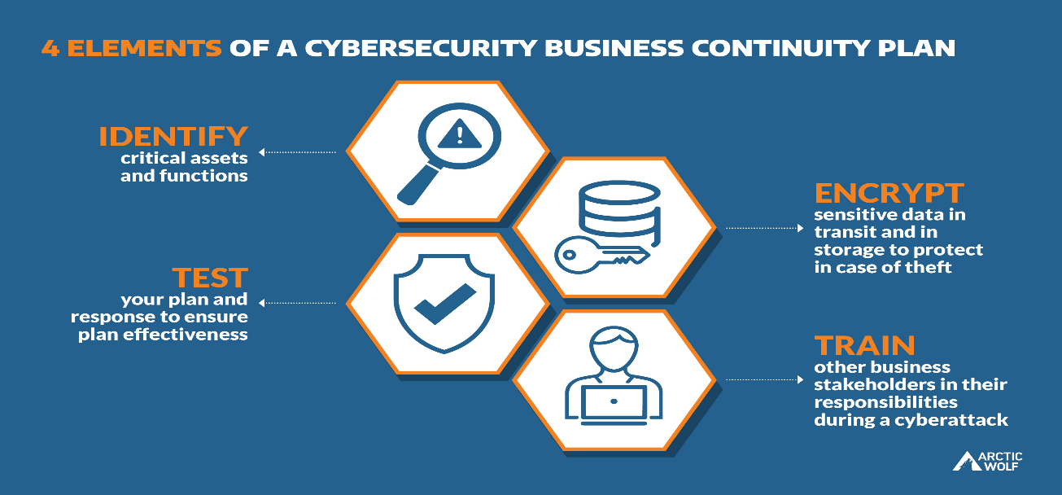
For StresSoltion, I would defiantly recommend them to make a strong contingency plan. To start off with, I would implement property insurance into their plan. This is because property insurance will cover many different things such as any damage to their property whether it's done by someone or a natural disaster. In addition, this will also cover all their technology inside the company such as expensive servers, computers, routers, switches and this is important because StresSolution is a company that specialises in the cyber security aspect of technology. This means that their technology is extremely important to them, and they need to keep it as secure as possible. In the case of someone breaking in and trying to steal their machines, the property insurance will also cover them.
In addition to this, I would also include backups of the companies' servers within the contingency plan. This is especially important because the company is dealing with large amounts of data from other companies, and they also deal with data recovery. There could be many things that could disturb or break a server and I would make sure that StreSolutions has at least one other backup server within their facility. I would setup a connection between the 2 servers so that all their data is held on 2 separate servers in the case of one of them going down. There are rare occurrences where a server could be completely wiped resulting in a complete loss of data which is unrecoverable.

Protection Mechanism
For StreSolutions I would recommend the highest protection which is available. Due to the company dealing with people's data and that they are a cyber security company they will need the best of the best security. To start off with I would implement a firewall into any devices that they can. The firewall will filter through their network and will pick out anything that looks suspicious, and it will block it. This will protect StresSolutions from hackers who use things such as viruses, Dos attacks and even phishing emails.
Another protection mechanism that I would implement would be to ensure that the server room is highly protected. For example, I would but thick steel walls around their sever room and, I would put the server at least on the 1st floor of the building. In addition, I would implement a key card system into the room, and I would only give out key cards to authorized people and this is supported by [9] “A server room needs to be fully secured and only permit authorised access for properly trained personnel. Whether it’s a basic lock and key, electronic keypad and passcode, or a swipe card system, you need the right level of security in place to keep your systems and staff safe.” Furthermore, the inclusion of 24/7 cctv operation is a must in and around of the server room to further increase the security.
To further add to the protection mechanism list, I would install a vpn service on every device that StresSolution uses. A vpn is key to any company that deals with networking and cyber security as this will give a device a completely different Ip address which means that it can't be tracked by hackers.

References

[1] | J. S, “Physical safety: Natural disasters and extreme weather,” CPJ, 29 july 2021. [Online]. Available: https://cpj.org/2018/09/physical-safety-natural-disasters-and-extreme-weather/. [Accessed 2 december 2023].
[2] | B. Nancholas, “What is cryptography?,” University of york, N/A N/A N/A. [Online]. Available: https://online.york.ac.uk/what-is-cryptography/. [Accessed 2 december 2023].
[3] | A. Bhattacharaya, “Symmetric Vs. Asymmetric Encryption which is more Secure,” Encryption computing, 8 May 2021. [Online]. Available: https://www.encryptionconsulting.com/symmetric-vs-asymmetric-encryption-which-is-more-secure/. [Accessed 2 December 2023].
[4] | J. Howarth, “80+ Amazing IoT Statistics (2024-2030),” Exploding Topics, 3 November 2023. [Online]. Available: https://explodingtopics.com/blog/iot-stats. [Accessed 2 December 2023].
[5] | A. Risukhin, “Can You Be Tracked With A VPN?,” Clear Vpn, 3 august 2023. [Online]. Available: https://clearvpn.com/blog/can-you-be-tracked-with-a-vpn/. [Accessed 2 december 2023].
[6] | N/A, “he consequences of poor IT security for your business,” Cara, N/A N/A 2022. [Online]. Available: https://cara.uk.com/the-consequences-of-poor-it-security-for-your-business/. [Accessed 5 december 2023].
[7] | E. Conrad, “Computer Ethics,” Science Direct, N/A N/A 2017. [Online]. Available: https://www.sciencedirect.com/topics/computer-science/computer-ethics. [Accessed 5 december 2023].
[8] | N/A, “Why Data Backup is Important for Your Business,” Kirbtech, N/A N/A N/A. [Online]. Available: https://kirbtech.com/importance-of-data-backup-for-business/. [Accessed 5 december 2023].
[9] | N/A, “Where is the best location to design a server room?,” First choice cabling, N/A N/A N/A. [Online]. Available: https://www.firstchoicecabling.co.uk/news/where-is-the-best-location-to-design-a-server-room/. [Accessed 5 december 2023].

