CURATION, COMMENTARIES AND COMPOSITIONS
Lily May Rogers

Words: 1221
Student Number: 1701669
Programme of Study: BA Illustration
Module: M4X01559
Tutor: Gwenllian Beynon

Imagined Exhibition – ‘HYBRID’
The aim of this exhibition is to examine the presence of nature, and specifically animals, within selected pieces of artwork. Using links to the progression of folk art – from traditional designs to contemporary illustration, the exhibition will explore common themes amidst the chosen works that tie the pieces together. The title of the show, ‘Hybrid’, is taken from Broglio’s (2011: 18) established idea of ‘hybridity’ – what it means to be ‘both human and animal’.
The primary artists will be Katy Horan and Alexandra Dvornikova. This essay will discuss one example of each artist’s work, as an indicator of their respective styles. This will allow an observation of the links between their illustrations and traditional folk art, as well as outlining themes within their work such as folktales, the influence of animals, and the intertwining of humanity with the natural world.
In order to accomplish maximum impact from the intended message of the show, the exhibition will be hosted in Sophia Gardens at dusk, outdoors in a forest clearing. The pieces will be displayed on and amongst the trees, subtly illuminated by lamps as the natural daylight fades. The aim of assembling the event in this environment is to reflect the content of the artwork as closely as possible into real life, thus creating a replica of the art’s atmosphere that the audience can immerse themselves in. This can be related to the philosophical concept of mimesis, a notion explored by thinkers as early as Plato and Aristotle. The term can be described as encompassing the ‘imitative relationship between art and life, as well as [. . .] the relationship between an artwork and its audience’. (Potolsky, 2006: 1)

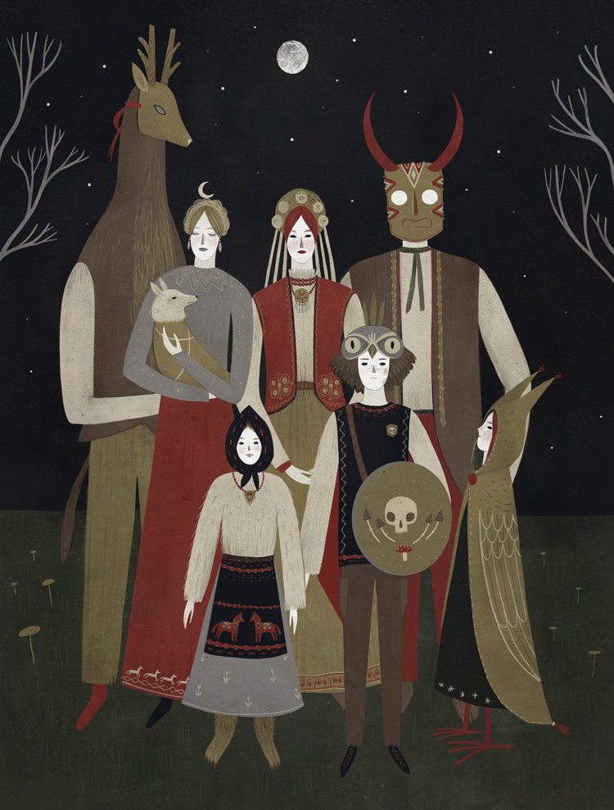

Alexandra Dvornikova (2016) Untitled

This illustration by Alexandra Dvornikova is a prime example of the specific fusion of themes the exhibition will aim to portray. Her work is predominantly inspired by Russian folklore and fairy-tales – an influence evident in the subject matter and tone of her art. The illustration style itself maintains a quaint, somewhat naïve quality throughout her pieces, upholding the roots of traditional folk artwork even as her peculiar characters and environments contradict this naivety to accommodate the strange, often dark narratives of Eastern European folklore.
The scene in this piece above, one of three of Dvornikova’s works that will feature in the exhibition, depicts a group of people, perhaps a family, gathered together outdoors. This setting immediately establishes a connection to nature in the artwork, as does the muted, earthy colour palette made up mostly of natural browns and greens. The clothing of the gathered figures displays traditional European styles, including layered vests, skirts and cloaks, all embellished with the patterns and detailing closely associated with long-established folk designs.
Perhaps the most notable aspect of the piece, and indeed the most significant in relation to this exhibition, is the presence of the animal masks. These can be seen in a spectrum of animal to human, depending on how much each person is obscured by their animalistic facades. Furthermore, it can be noticed upon closer inspection that some of the characters have additional animal features as well as the masks. Two of the younger figures at the front of the gathering appear to have non-human legs and feet. This raises the question of whether the masks are intended to embroider a sense of wilderness and animal nature onto the otherwise human figures, or to disguise the existing animal characteristics with more of the same. Broglio’s Surface Encounters brings forth the speculation of how ‘art calls us to consider and negotiate this animal other’ (2011: 17) – though Dvornikova’s piece invites us to question this cataloguing of animals as ‘other’ and delve into the divide of what constitutes human or animal.
The second artist featuring in the exhibition will be Katy Horan. Her piece shown below, one of three presented in the exhibition, is titled When the Horned Maidens Gather. As with Dvornikova’s work, the piece is a modern illustration that embraces traditional themes and designs. As suggested by the title, the scene depicts a group of women with horned heads, again emphasising a blurring of lines at the edges of humanity, and reinforcing Broglio’s aforementioned concept of hybridity. Interspersed amidst the women are various animals and trees, distributed in such a way that almost renders the piece itself a patchwork pattern of sorts, reflecting that of the quilt featured in the scene.
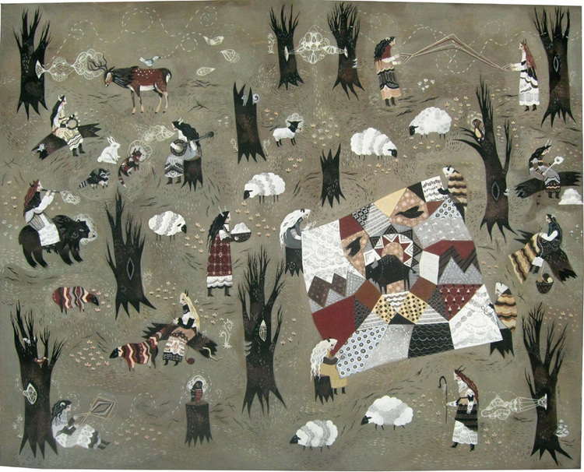

Katy Horan (2008) When the Horned Maidens Gather

In further relation to the principal theme of the exhibition is the activities of the women, some using wool to knit garments. These garments are worn not only by the women themselves but also by selected animals. This brings a cyclical element to the piece when considering the sheep dotted throughout the scene, bringing forth the idea of a merging of resources provided by the animals. The wool from the sheep is subsequently worn as an extra skin by humans in the form of clothes – then returned back to the animals as an amalgamation of animal material and human craftwork. Coleridge (1836: 216) has discussed ideas relevant to this relationship in his essay On Poesy or Art, stating that art is ‘the mediatress between, and reconciler of nature and man. It is, therefore, the power of humanizing nature’.
In order to draw links between these contemporary illustrators and traditional folk designs, the exhibition will include an example of a folk textile piece. This embroidered bedcover shown below displays typical folk-style patterns, namely stylised flora and twining plants, and various animals interspersed throughout the design.
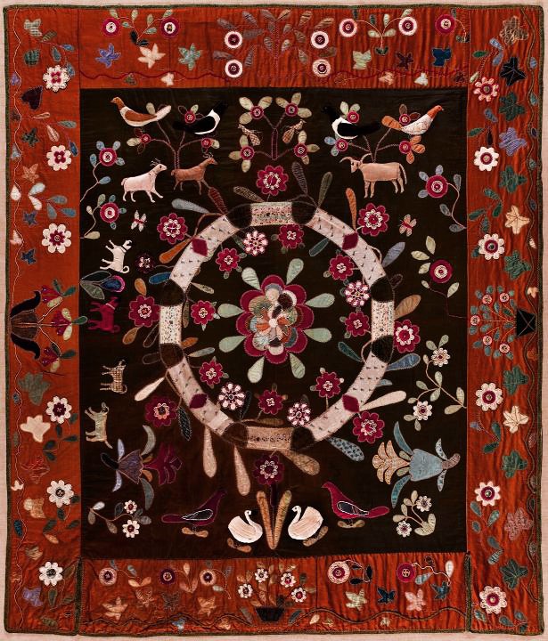

Appliquéd and Embroidered Pictorial Bedcover (c. 1835)

The presence of this piece in the exhibition will act as a parallel between real life and the elements of the displayed illustrations. For example, Horan’s When the Horned Maidens Gather depicts a quilt within the scene, and Dvornikova’s work utilises traditional folk patterns akin to those in the bedcover.

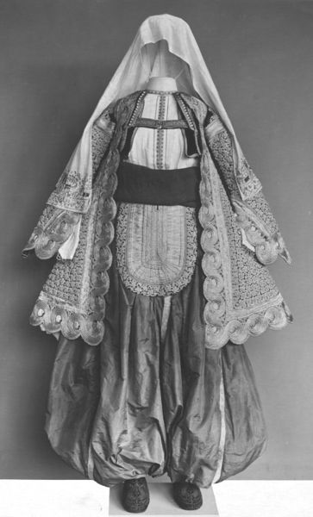

Serbian Folk Costume (c. 1850)

Another feature of the exhibition will be a physical example of traditional European folk attire. This outfit is comprised of a woman’s jacket, trousers, shoes, waistcoat and headscarf, all embroidered with a raised pattern of flowering plants. The purpose of including this in the exhibition is to recreate elements of Horan’s and Dvornikova’s illustrations as solid, palpable objects that exist outside the parameters of the images.
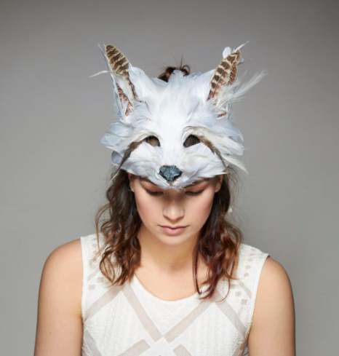

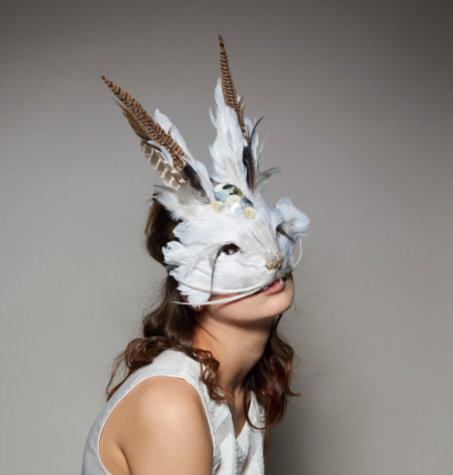
This idea will be explored further in the final element of the exhibition, comprised of physical animal masks that visitors can try on. The aim of this interactive element is to allow the audience to fully immerse themselves in the atmosphere of the exhibition, whilst also boosting its profile. Viewers will be encouraged to post photographs of themselves to Twitter, Instagram and Facebook wearing their favourite masks in the forest surroundings, using the hashtag ‘#HybridShow’ to create an online array of interactive images from the audience.
Curious Fair (2016) Luxury Animal Masks

In conclusion, it is hoped that the audiences of the exhibition will experience the essence of, as put by Coleridge (1858: 330), the ‘union and reconciliation of that which is nature with that which is exclusively human’. Through viewing the selected works in a woodland setting, the aim is for the viewer to connect the content of the art with the atmosphere around them – and in interacting with the pieces, becoming a part of this recreated environment themselves.

BIBLIOGRAPHY
Appliquéd and Embroidered Pictorial Bedcover (c. 1835) [Wool, silk, cotton and beads]. American Folk Art Museum, New York. Available at: http://collection.folkartmuseum.org/objects/823/appliqued-and-embroidered-pictorial-bedcover (Accessed 30 April 2018)
Broglio, R. (2011) Surface encounters. Minneapolis: University of Minnesota Press
Coleridge, S. (1836) The Literary Remains of Samuel Taylor Coleridge, Volume 1. London: William Pickering
Coleridge, S. (1858) The Complete Works of Samuel Taylor Coleridge, Volume 4. New York: Harper and Brothers
Curious Fair (2016) Luxury Animal Masks. Available at: http://www.curiousfair.co.uk/product-category/masks (Accessed 29 April 2018)
Dvornikova, A. (2017) Untitled [Digital painting]. Available at: http://allyouneediswall.tumblr.com/post/165987063400 (Accessed 29 April 2018)
Horan, K. (2008) When the Horned Maidens Gather [Acrylic and gouache on wood]. Available at: http://www.katyart.com/in-the-deep-dark/a5igibqr3rphr9vlgv7nho96sdht1f (Accessed 29 April 2018)
Potolsky, M. (2006) Mimesis. London: Routledge
Serbian Folk Costume (c. 1850) [Silk and cotton]. Victoria and Albert Museum, London. Available at: http://collections.vam.ac.uk/item/O351553/waistcoat-unknown (Accessed 30 April 2018)

